Problem link:

<https://leetcode.com/problems/remove-nth-node-from-end-of-list/description/>

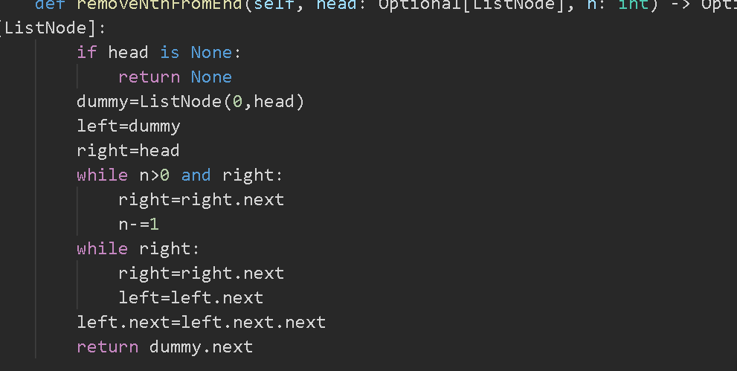

Delete a node but the head of the linkedlist is not given

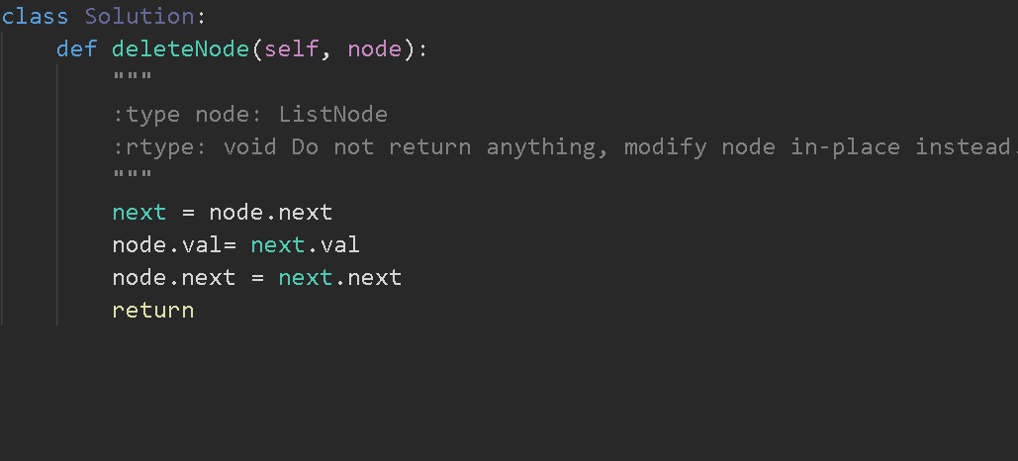

**Check if a linked list is Circular Linked List**

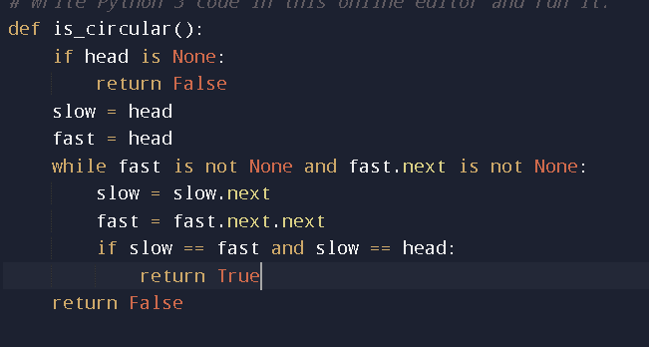

Problem link:

<https://leetcode.com/problems/remove-nth-node-from-end-of-list/description/>

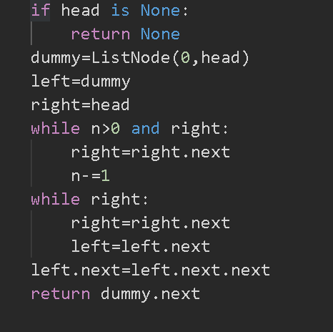

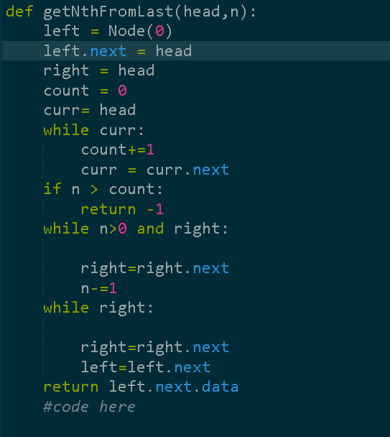

Problem link:

<https://practice.geeksforgeeks.org/problems/intersection-point-in-y-shapped-linked-lists>

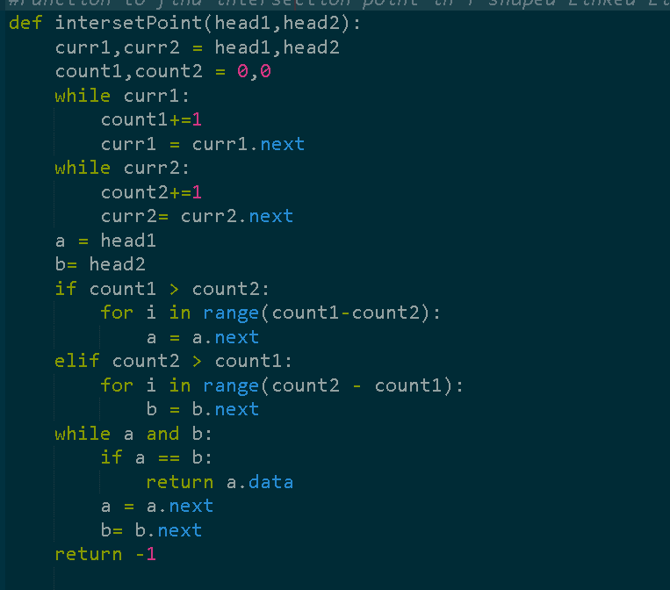

Problem link:

<https://practice.geeksforgeeks.org/problems/intersection-of-two-sorted-linked-lists/1>

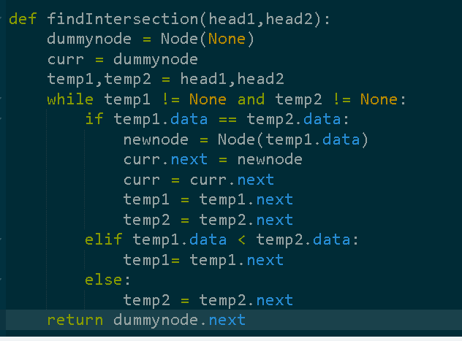

Problem link:

<https://practice.geeksforgeeks.org/problems/intersection-of-two-linked-list/1>

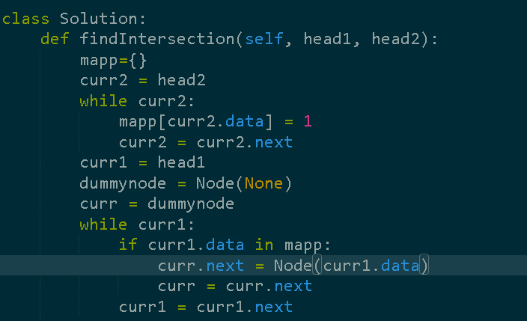

If sorted 🡪 two pointers

If unsorted -> hashmap

Problem link:

<https://practice.geeksforgeeks.org/problems/add-two-numbers-represented-by-linked-lists/1>

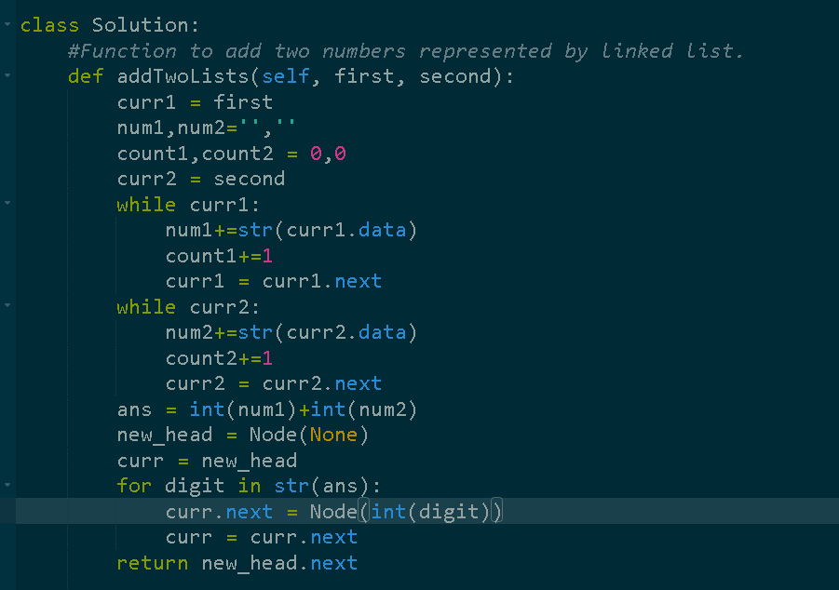

Problem link:

https://leetcode.com/problems/reverse-nodes-in-k-group/description/  
  
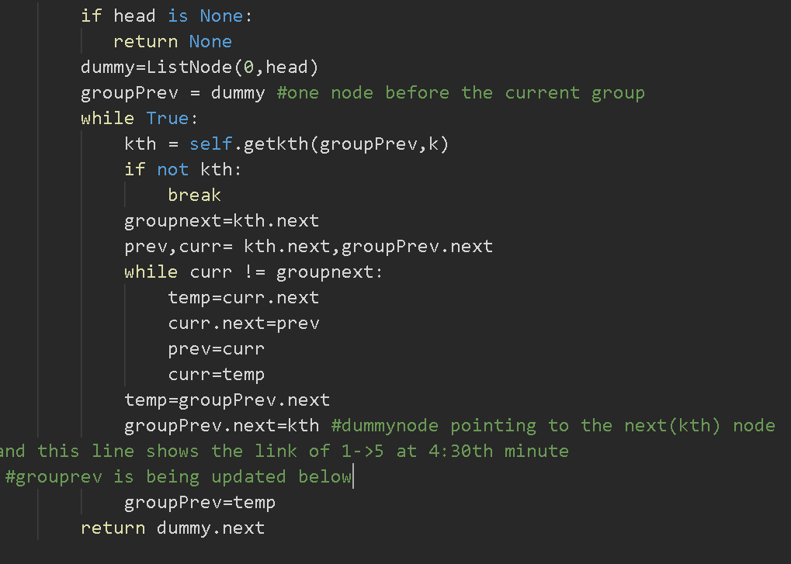

Problem link:

<https://leetcode.com/problems/swapping-nodes-in-a-linked-list/description/>

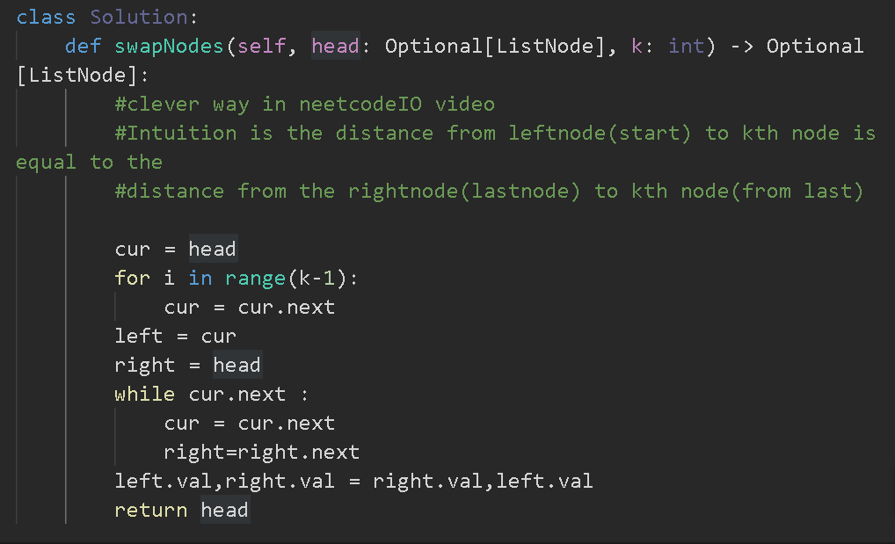

Problem link:

<https://leetcode.com/problems/palindrome-linked-list/description/>

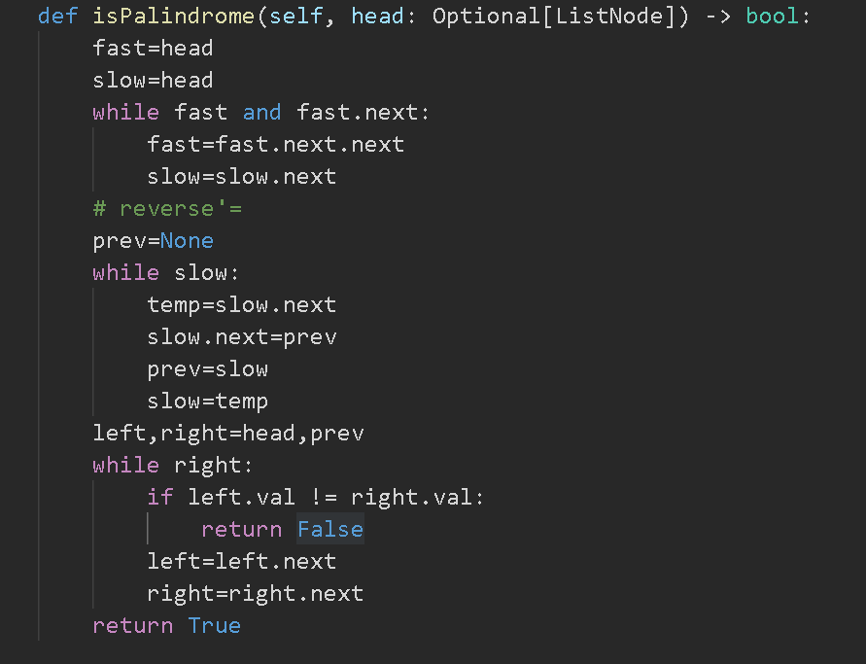

Problem link:

<https://www.geeksforgeeks.org/rotate-a-linked-list/>

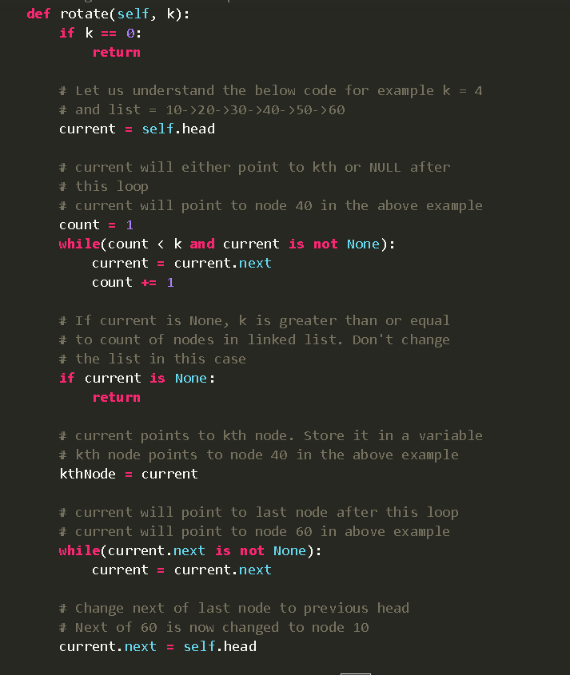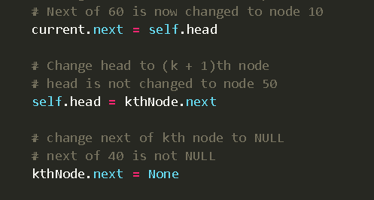

Problem link:

<https://www.geeksforgeeks.org/rotate-doubly-linked-list-n-nodes/>

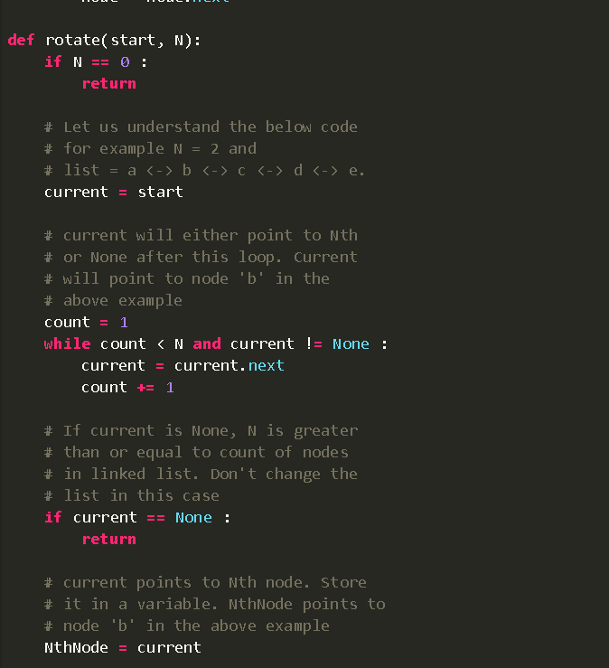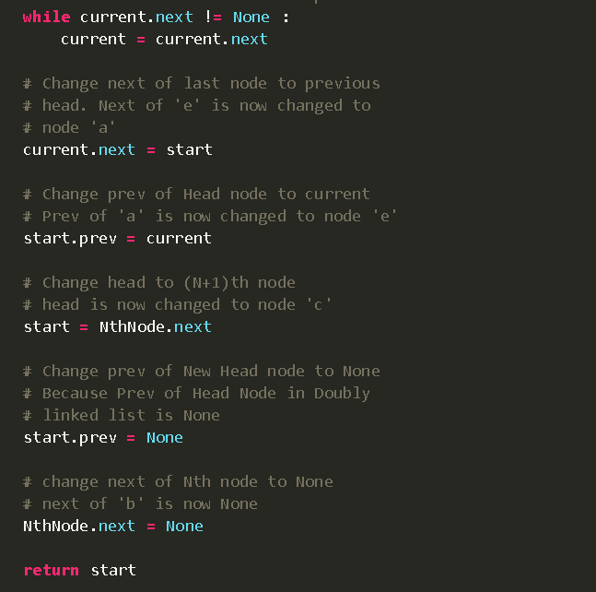

Problem link:

<https://leetcode.com/problems/merge-nodes-in-between-zeros/description/>

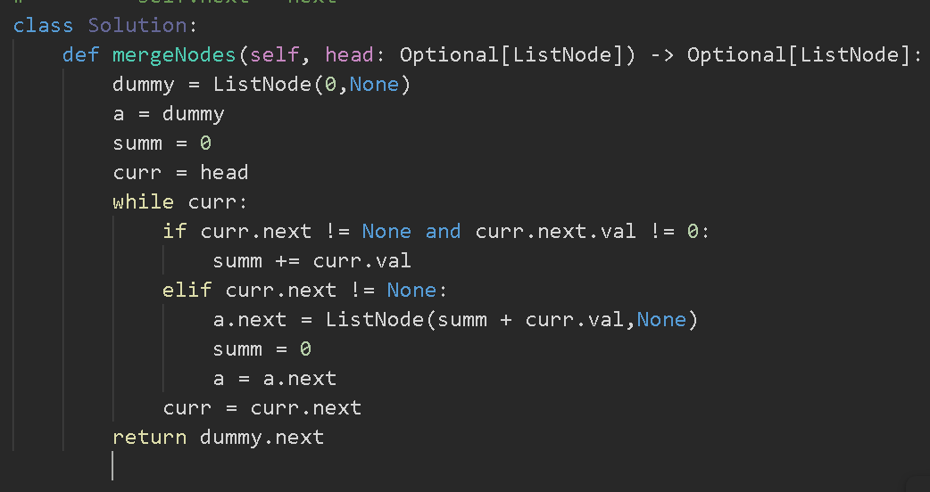

Problem link:

<https://leetcode.com/problems/swap-nodes-in-pairs/description/>

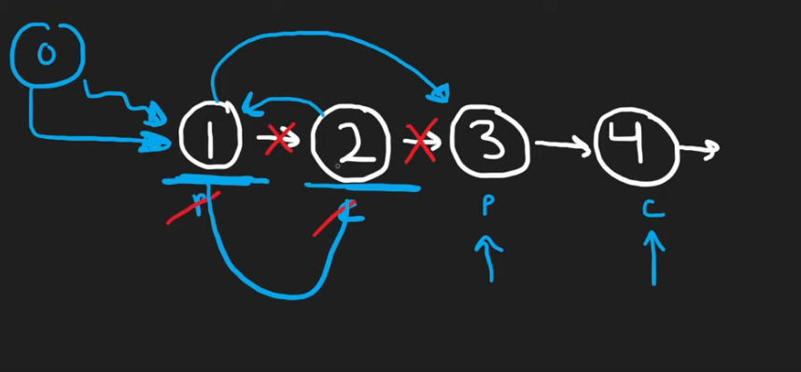

Prev -> node before the start of a newpair(next pair)

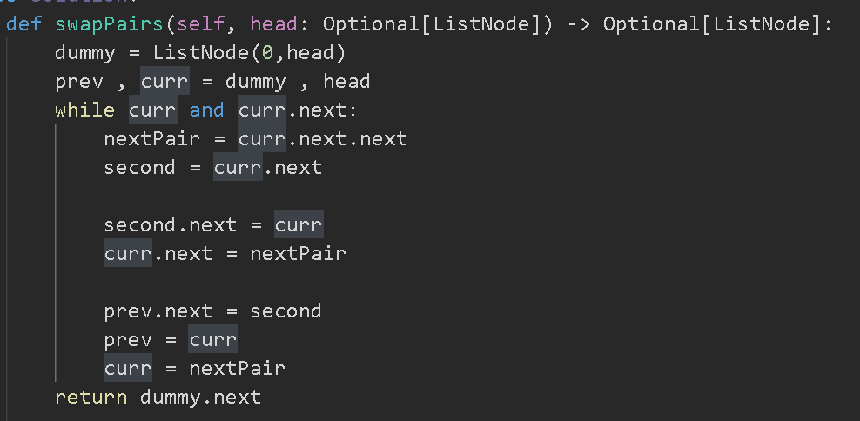

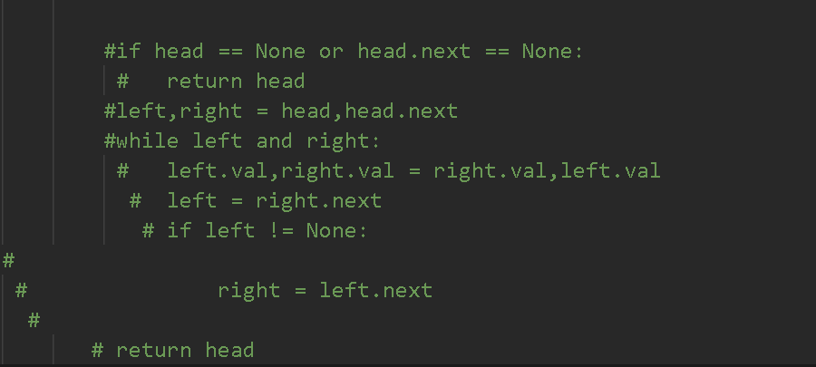

Problem link:

<https://leetcode.com/problems/maximum-twin-sum-of-a-linked-list/>

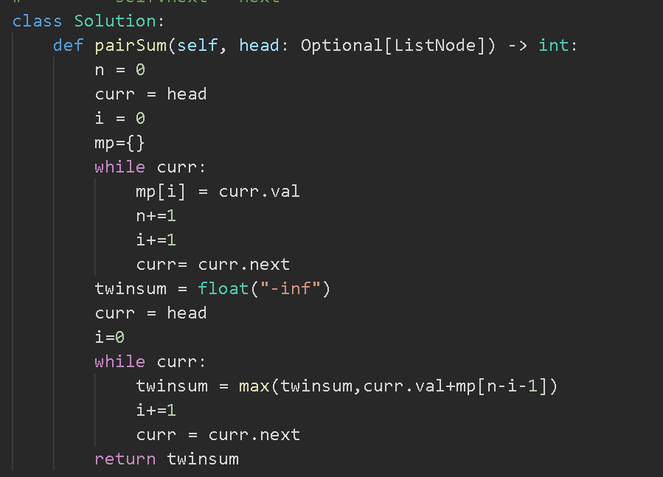

Problem link:

<https://leetcode.com/problems/find-the-minimum-and-maximum-number-of-nodes-between-critical-points/solutions/>

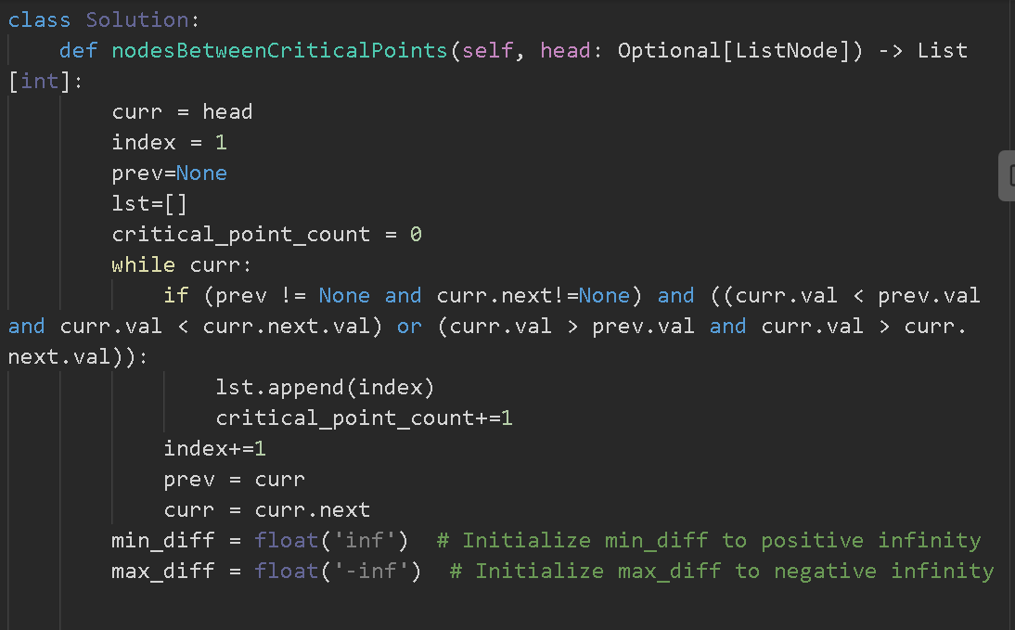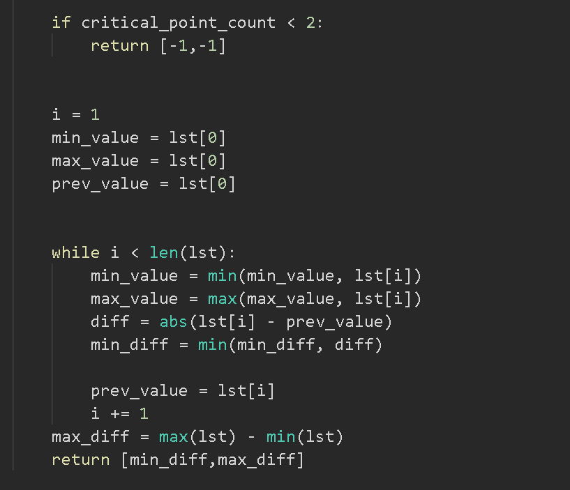

Problem link:

<https://www.geeksforgeeks.org/delete-n-nodes-after-m-nodes-of-a-linked-list/>

