

**Akana**

**Reference Architecture**

Akana

Reference Architecture

V8.4.x

March 2018

Copyright

Copyright © 20178Rogue Wave Software, Inc. All rights reserved.

Trademarks

All product and company names herein may be trademarks of their registered owners.

Akana, Akana Platform, Akana API Platform, SOA Software, Community Manager, API Gateway, Envision, Lifecycle Manager, Policy Manager, and Cloud Integration Gateway are trademarks of Rogue Wave Software, Inc.

[www.akana.com](http://www.akana.com)

[info@akana.com](mailto:info@akana.com)

www.roguewave.com

Disclaimer

The information provided in this document is provided “AS IS” WITHOUT ANY WARRANTIES OF ANY KIND INCLUDING WARRANTIES OF MERCHANTABILITY, FITNESS FOR A PARTICULAR PURPOSE, OR NON-INFRINGEMENT OF INTELLECTUAL PROPERTY. Akana may make changes to this document at any time without notice. All comparisons, functionalities and measures as related to similar products and services offered by other vendors are based on Akana’s internal assessment and/or publicly available information of Akana and other vendor product features, unless otherwise specifically stated. Reliance by you on these assessments / comparative assessments is to be made solely on your own discretion and at your own risk. The content of this document may be out of date, and Akana makes no commitment to update this content. This document may refer to products, programs or services that are not available in your country. Consult your local Akana business contact for information regarding the products, programs and services that may be available to you. Applicable law may not allow the exclusion of implied warranties, so the above exclusion may not apply to you.

Contents

Chapter 1 | Introduction 4

Chapter 2 | Reference Architecture 5

Chapter 3 | Secured Architecture 6

Highly Secured Architecture 6

Highly Secured – Highly Available Architecture 7

Chapter 4 | Minimalistic Architecture 8

Chapter 5 | Environment Promotions 9

# Introduction

# Reference Architecture

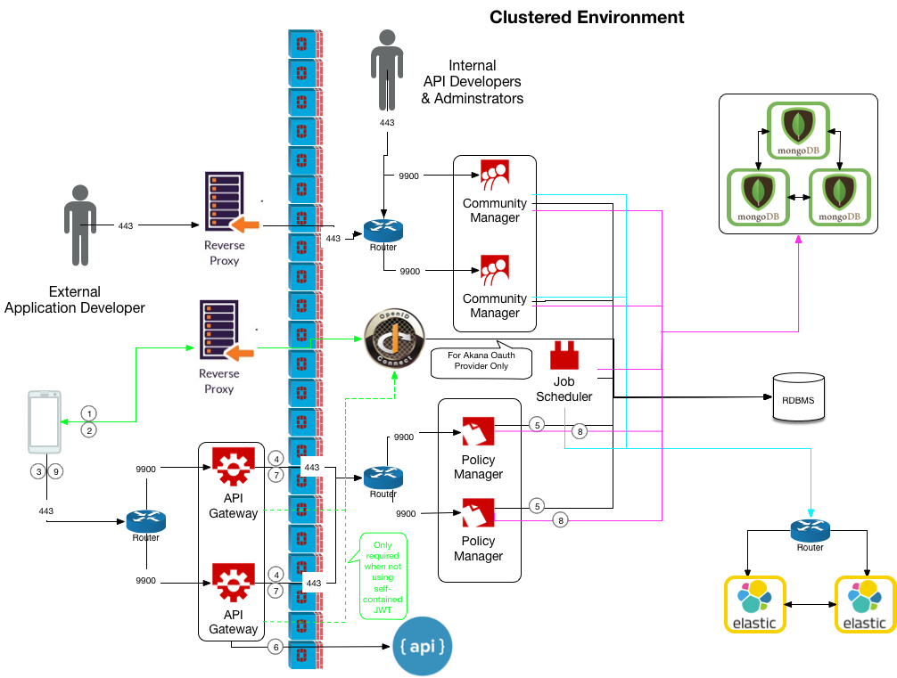



(installed.png)

1. Consuming Application invokes Oauth server to receive access token
2. Access token is returned to the consuming application, once authentication is validated
3. Consuming Application invokes an API hosted in the Akana Gateway
4. Akana Gateway, acting as the Policy Enforcement Point, reaches out to the Policy Manager, acting as the Policy Decision Point, to authorize and authenticate the consuming application.
5. Policy Mangers receives data from the RDBMS.
6. API Gateway invokes the downstream API, Physical Service
7. API Gateway saves analytical Information about the request/response
8. Policy Manager stores the analytical data in MongoDB
9. The response is returned to the Consuming Application

# Secured Architecture

## Highly Secured Architecture

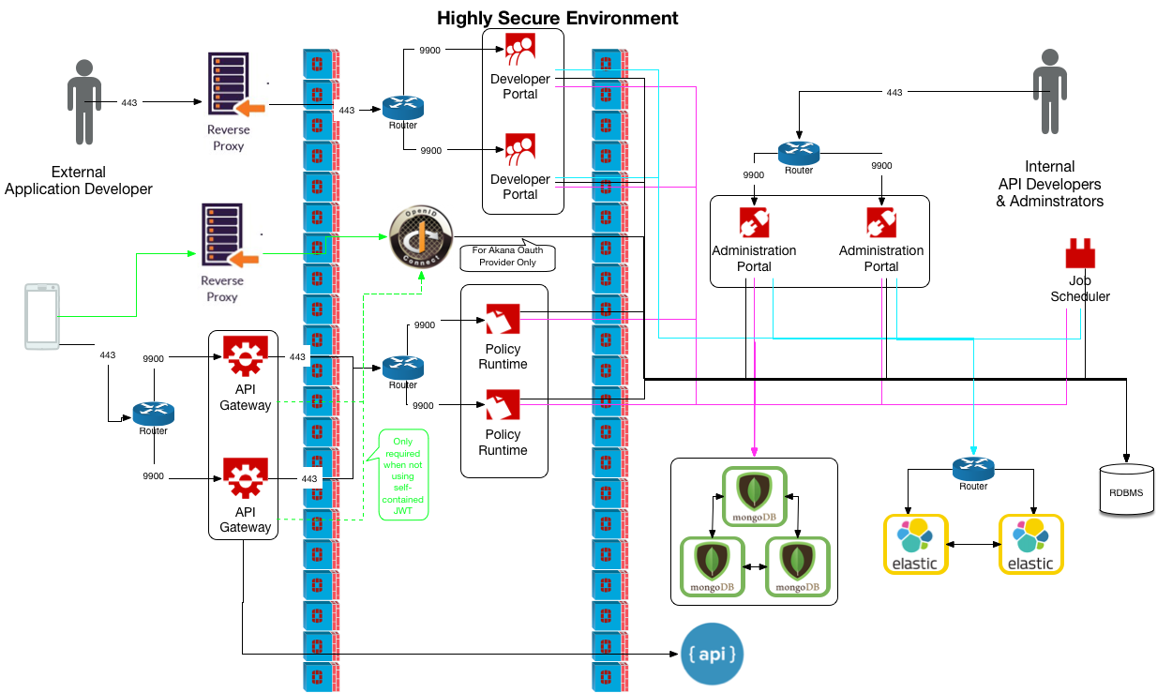

## Highly Secured – Highly Available Architecture

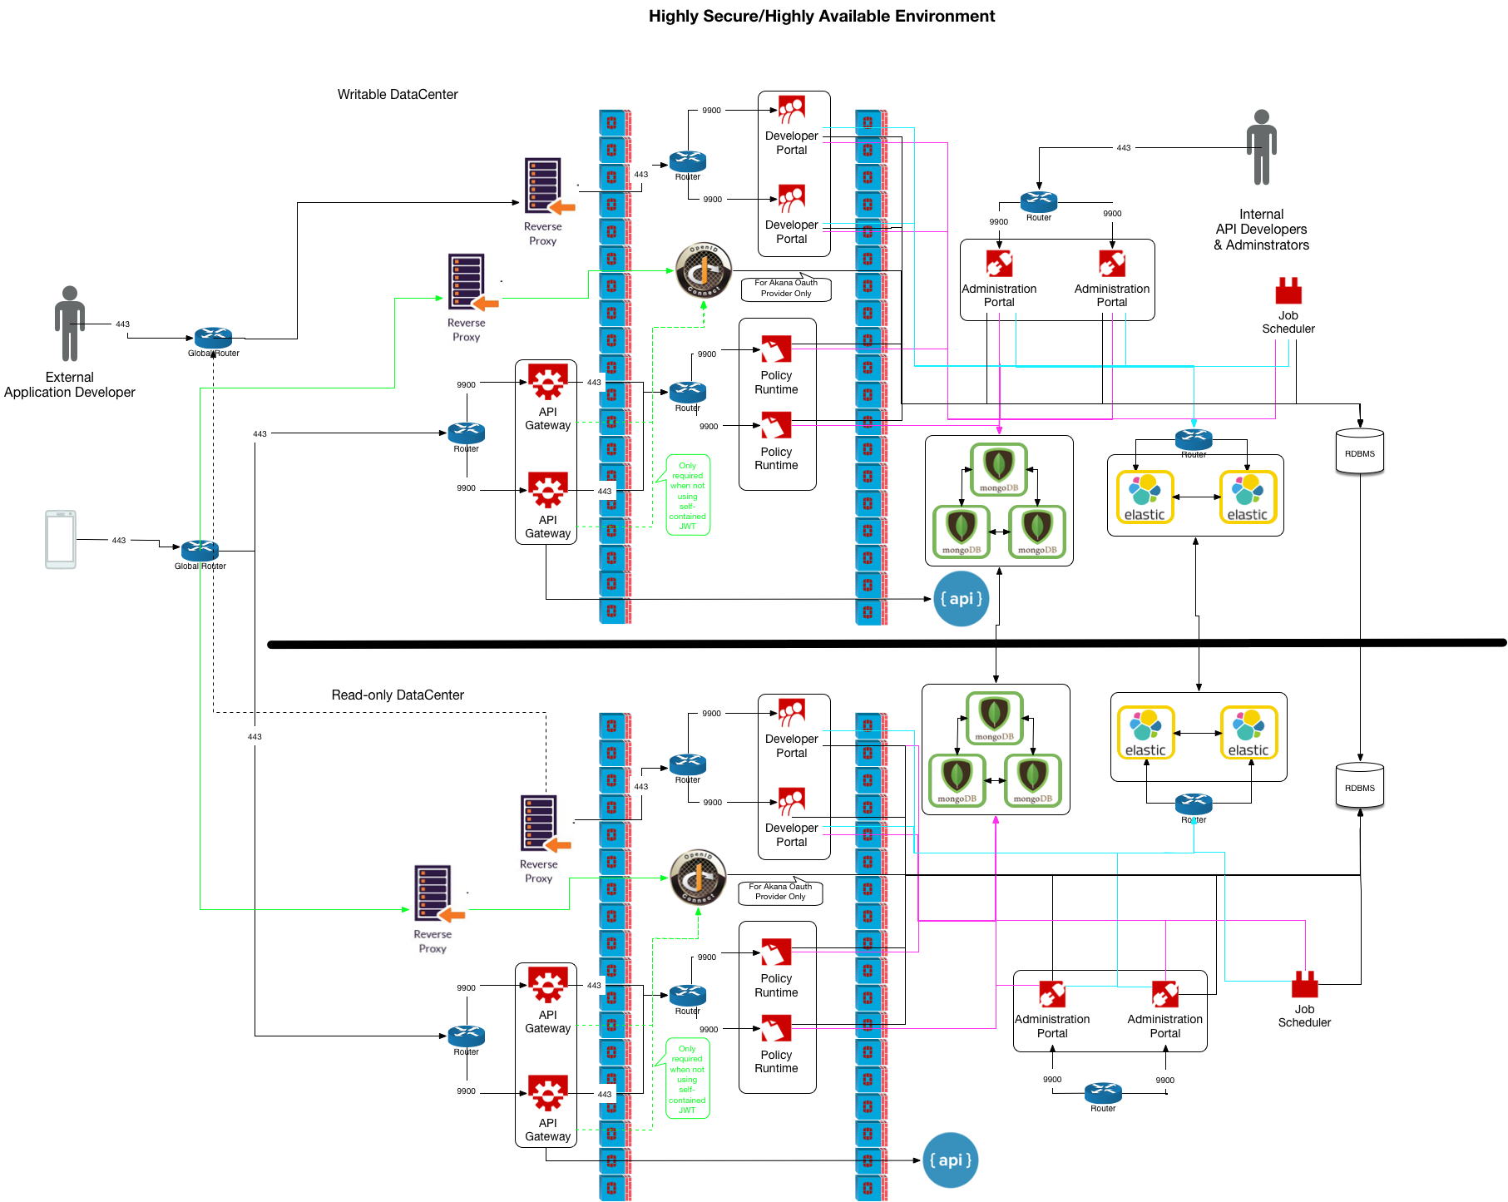

## Highly Secured Architecture with Internal Gateways

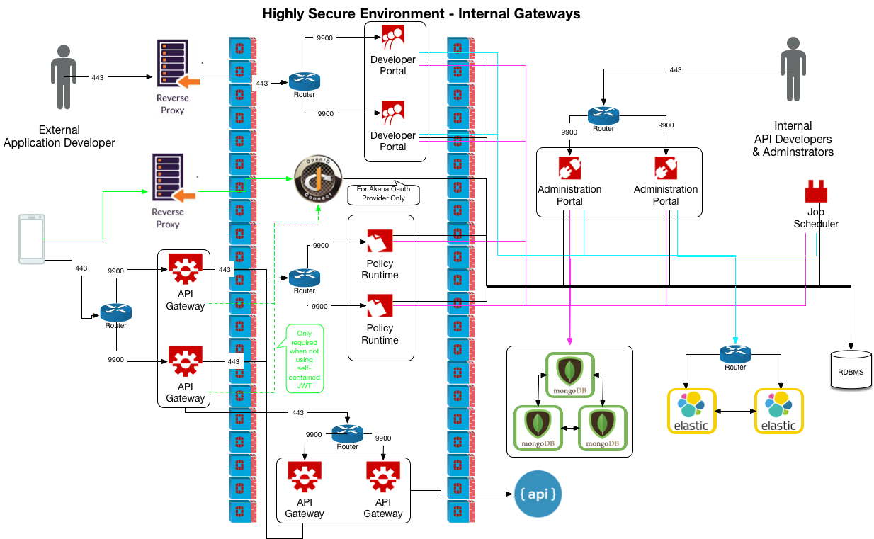

# Minimalistic Architecture

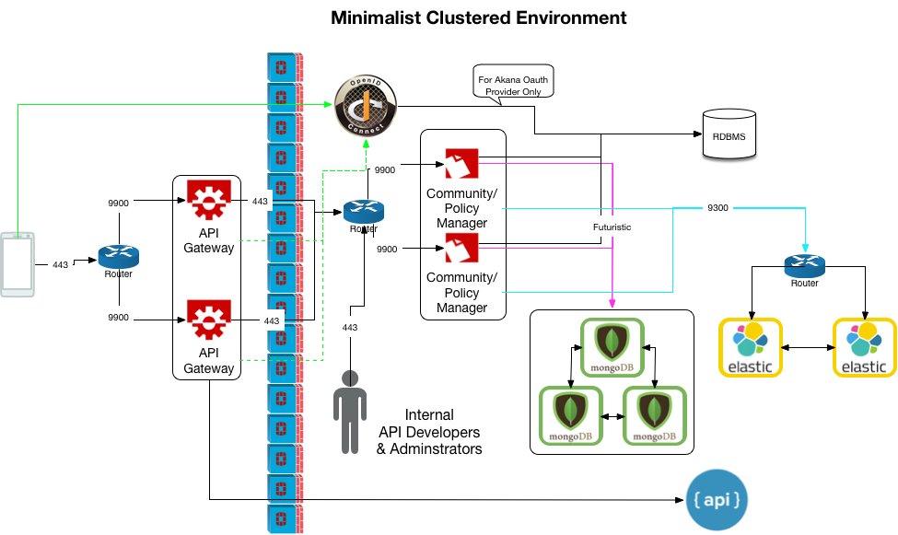

# Environment Promotions

