MIDTERM PROJECT SUMMARY
OXFORD MODERN SCHOOL
INTEGRATED ERP SYSTEM
Generative AI-Assisted ERP System Design
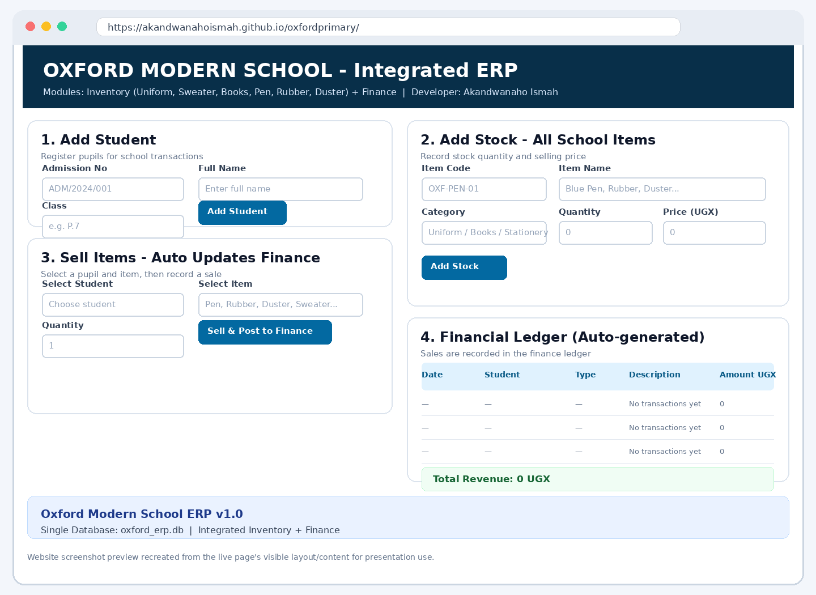
Figure 1: Website layout preview (recreated from visible page content, not a direct browser capture).

1. Introduction
This project proposes a simple Enterprise Resource Planning (ERP) system for Oxford Modern School. The idea is to bring related school activities together instead of handling each one in separate records. The prototype focuses on pupil details, school-item stock and the financial records created when items are sold. The website is available at https://akandwanahoismah.github.io/oxfordprimary/.

Why the system is useful
- It can help staff keep pupil and school-item information organised.
- It can reduce repeated data entry and common manual recording errors.
- It is designed to connect stock movement with the financial record of a sale.
- It provides a practical example of how ERP systems share information across business functions.

2. Main modules and how they work together
The proposed system has two connected functional areas. The pupil-records module stores basic pupil information, while the inventory and finance functions track school supplies and the money associated with sales.
Module | Information managed | Main purpose
Pupil records | Admission number, pupil name and class | Identify the pupil involved in a transaction.
Inventory | Item code, item name, category, quantity and price | Track school items such as uniforms, sweaters, books, pens, rubbers and dusters.
Finance ledger | Date, pupil, item, quantity, transaction type and amount | Keep a record of sales and calculate revenue.

Expected sales process
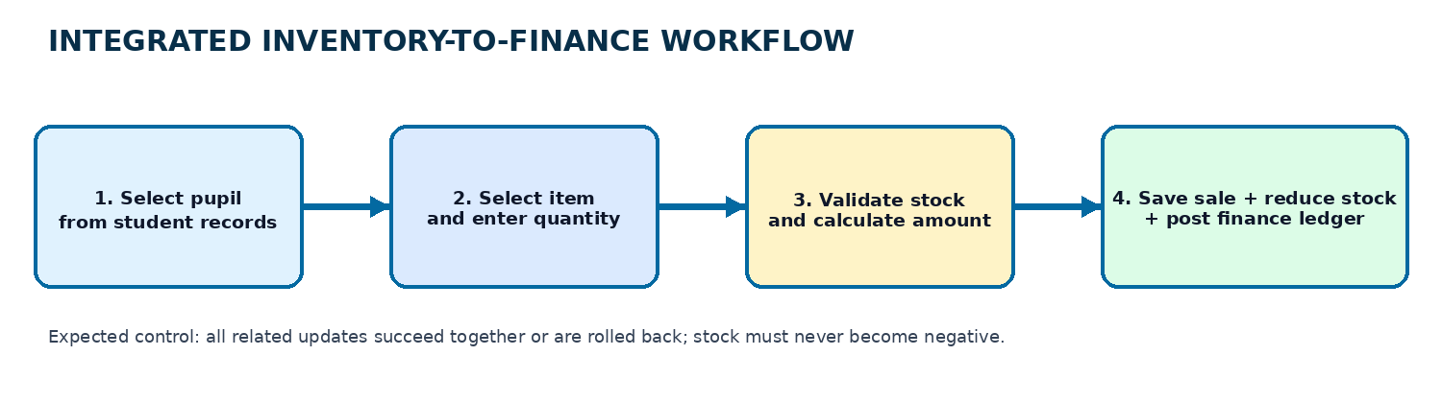
Figure 2: Expected workflow from pupil selection to stock and finance updates.
For example, when a pupil buys a book, the user should select the pupil and the book, enter the quantity, and submit the sale. The system should check that enough books are available, calculate the amount, reduce the stock, and add a matching entry to the finance ledger. These updates should be treated as one transaction so that stock is not changed if the financial record cannot be saved.

CRUD operations
CRUD means Create, Read, Update and Delete. Users should be able to add new pupils and items, view existing records, edit incorrect information and remove records only when doing so will not damage transaction history. For financial records, a controlled correction or reversal is often safer than permanent deletion.

3. System architecture and database design
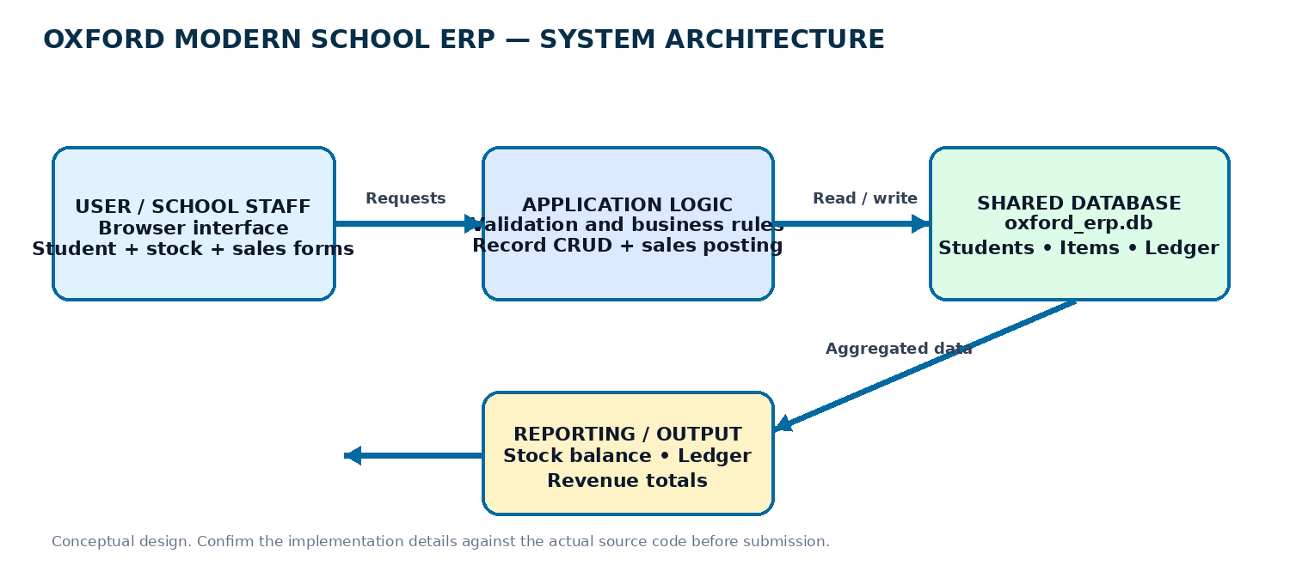
Figure 3: Conceptual architecture of the proposed ERP.
The design has a browser interface for staff, application logic that checks information and applies business rules, and a shared database where the records are stored. Reports read the same records to show stock levels and financial totals. This structure supports the ERP principle of a single source of truth.

Proposed database structure
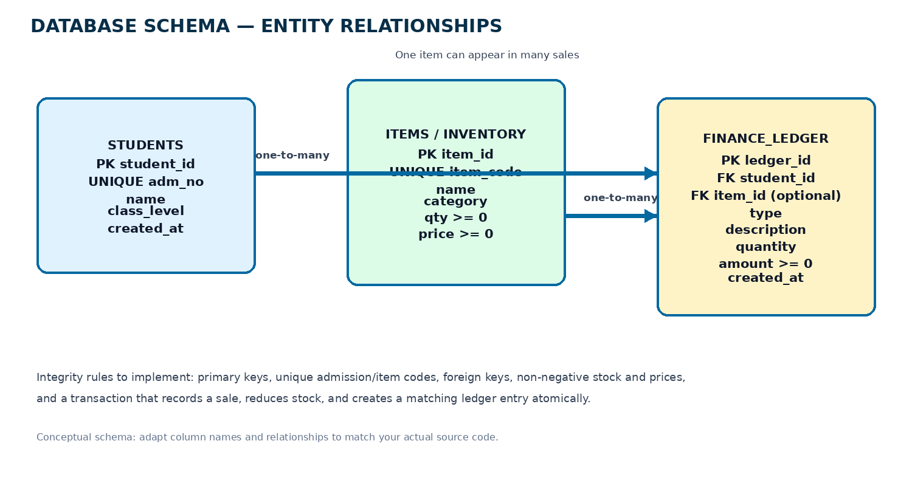
Figure 4: Proposed database entities and relationships; verify names against the actual code.
Table | Important controls
Students | A unique student ID and a unique admission number; required name and class.
Items | A unique item code; quantity and price must not be negative.
Finance ledger | Links a transaction to an existing pupil and, where relevant, an item.
Primary keys identify records, unique constraints prevent duplicate admission or item codes, and foreign keys link transactions to existing records. Input validation should reject missing names, invalid quantities and negative prices. The sale process should update stock and create the finance entry together. The proposed schema is a design guide; the final report must match the actual database used.

4. AI support, testing and limitations
Generative AI can help plan modules, suggest database tables, explain relationships, draft validation rules and identify useful tests. However, AI-generated suggestions are not automatically correct. They must be compared with the source code and tested in the running application. The student should disclose AI use according to the lecturer's policy and keep a truthful record of the prompts used.

Prompt log template
Prompt/task used | What to record
Plan the two ERP modules | The actual prompt and which design ideas were retained.
Propose the database tables | Whether table names and constraints matched the real implementation.
Suggest validation and tests | Which tests were run and what happened.
Troubleshoot an error | The real error, proposed fix and how the fix was verified.
Only include prompts and debugging examples that genuinely occurred. Do not claim a test passed unless it was actually performed.

Testing checklist
- Create a pupil and check that the record appears in the list.
- Try a duplicate admission number and confirm that it is rejected.
- Add a school item and verify its quantity and price.
- Attempt to sell more items than are in stock; the system should reject the sale.
- Make a valid sale and check that stock decreases and the finance ledger gains a matching entry.
- Refresh the application to see whether saved records persist.

Current limitations to verify
The public website shows the intended forms and ledger layout, but a visible interface alone does not prove that database persistence, CRUD actions or sale posting work. Test the live system and source repository before making claims. The screenshot in this summary is a recreated preview, so replace it with a genuine browser screenshot for final evidence. A real deployment would also need secure login, user permissions, backups and audit logs.

5. ERP theory, conclusion and final checklist

ERP principles and Business Process Reengineering
ERP systems connect information that might otherwise be stored in separate departments or files. In this project, the intended integration is between pupil records, inventory and finance. A shared database can reduce duplicate entry and make information easier to reconcile. Business Process Reengineering (BPR) means reviewing and improving the process itself, not simply turning the same paperwork into a website. Here, the goal is for one valid sale to trigger the related stock and finance updates in a controlled workflow.

Build versus buy
Building a custom prototype | Configuring an existing ERP
Good for learning and tailoring a small workflow. | Can provide mature modules, reports and established controls.
Requires development, testing, maintenance and security work. | May involve licensing, hosting, training, data migration and configuration costs.
May need major changes to support many users safely. | Can reduce custom coding, but the organisation may need to adapt its processes.

Conclusion
The Oxford Modern School ERP prototype is a practical way to explore how pupil records, stock management and financial transactions can be connected. Its value depends on more than the appearance of the website: the data relationships, validation rules and integrated sale workflow must work correctly. Testing, documentation and honest evaluation of AI assistance are therefore essential parts of the project.

Before submitting
- Confirm the prototype runs and demonstrate two connected modules.
- Verify Create, Read, Update and Delete functions where appropriate.
- Check that the actual database and ER diagram match the submitted code.
- Add real screenshots of the application and successful/failed tests.
- Complete the AI prompt log with genuine prompts and verification steps.
- Write the required 250–500-word reflection independently, using your actual experience.
- Remove any placeholders and ensure the final document follows the lecturer's instructions.
Website: https://akandwanahoismah.github.io/oxfordprimary/
http://localhost/OxfordModernERPismah/

AKANDWANAHO ISMAH
26BSCS0103W

