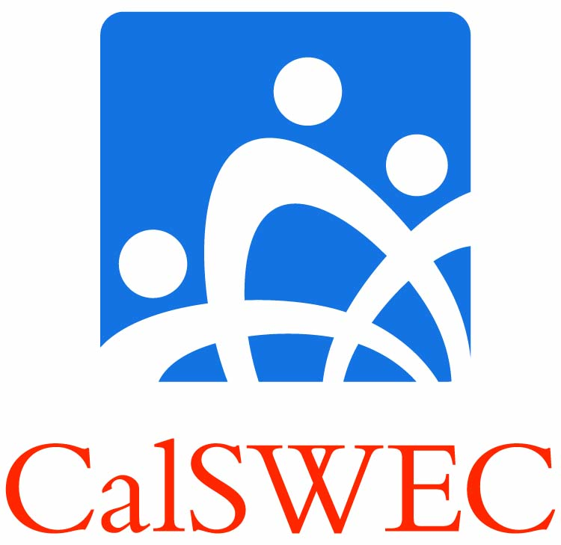 | CAlifornia Social Work Education Center  University of California, Berkeley  School of Social Welfare

Background:
- CalSWEC is the nation’s largest collaborative of schools of social work, public agencies, and foundations working together to provide professional education, student support, in-service training, and workforce research.
- CalSWEC has a 20 plus year history of developing professional social workers for public sector practice in the fields of children’s service, mental health and aging.
- Originally created as an academic institution and public agency partnership between the University of California at Berkeley’s School of Social Welfare, the California Department of Social Services and the County Welfare Directors Association of California, to address the need to produce social work professionals for careers in the public sector serving disadvantaged persons and communities.
- Our established infrastructure now includes all 21 California State Universities and Universities of California with accredited Social Work Programs, all 58 California County Mental Health and Social Service Departments, State Agencies, the California Chapter of the National Association of Social Workers, and other professional associations and foundations.

Public Service Mission:
- UC Berkeley’s commitment to excellence in education and research is enabled by the removal of barriers to accessing professional education and training, and by providing services which provide broad public benefit.
- The CalSWEC partnership facilitates UC Berkeley’s mission by integrating education and practice to assure effective, culturally competent service delivery to the people of California through practice and empirically based curriculum development, student stipends, educational support and job placement services.
- UC Berkeley’s leadership in supporting CalSWEC is resulting in the preparation of professionals for careers in the publicly supported services focusing on underserved populations and to advance social work’s commitment to the poor and the services upon which they depend.

The Workforce Development Partnership:
- CalSWEC has an active advisory board that is comprised of all 21 of schools of social work dean or director, county welfare directors, mental health directors, NASW and foundations.
- Through a committee structure the CalSWEC Board develops content and policy on curriculum development, research, evaluation and workforce development issues in our 3 primary fields of practice—child welfare, mental health and aging.
- CalSWEC co-chairs (with the California Department of Social Services) the Statewide Training and Education Committee, which develops recommendations for statewide training standards and coordinates their implementation.
- CalSWEC has membership in the County Welfare Directors Association’s Child Welfare and Adults Committees, the Mental Health Planning Council Human Resources Committee, and California Healthcare Workforce Development Council where we participate in efforts to assess the workforce needs of the public agencies.

Results:
- We have supported over 6400 MSW and BSW graduates for employment in public sector child welfare, community mental health and aging services.
- Since 1992 our workforce development efforts have almost doubled the number of MSWs in the child welfare workforce from 21% to 40.5% in 2011.
- Our workforce development efforts have successfully addressed calls for culturally-competent service providers, with 66% of our graduates being non-Caucasian, and 42% having second language capabilities.
- In 1992 MSWs worked in 38 out of 58 counties, in 2011 CalSWEC prepared MSW’s now work in 54 out of 58 counties.
- On average 95% of our graduates are hired into public child welfare, mental health or aging social services.
- CalSWEC develops and manages the coordinated delivery and evaluation the California Common Core Curriculum for Child Welfare Social Workers and Supervisors.
- Since 1994 CalSWEC has supported over 35 research based curriculum development projects.

Funding:
- Our success in operating a world-class social work education and training consortium is also evidenced by our history of managing grants and services from 38 varied funders including the U.S. Department of Health and Human Services and California State Departments of Mental Health and Social Services; foundations such as Archstone, Zellerbach, Stuart, Walter S. Johnson, Hewlett-Packard, California Endowment and California Wellness; the County Welfare Directors Association of California; and twenty-one individual colleges and universities across our state.
- CalSWEC’s programs provide in excess of $40 million annually in student and educational support with our partner schools contributing nearly $13 million annually in indirect forgone match for child welfare

Specific information about the many programs and services offered through the CalSWEC partnership including full and part-time educational programs, MSW and BSW stipends, statewide training coordination, curriculum and training development, research activities, and our library, are available on our website at http://calswec.berkeley.edu.

