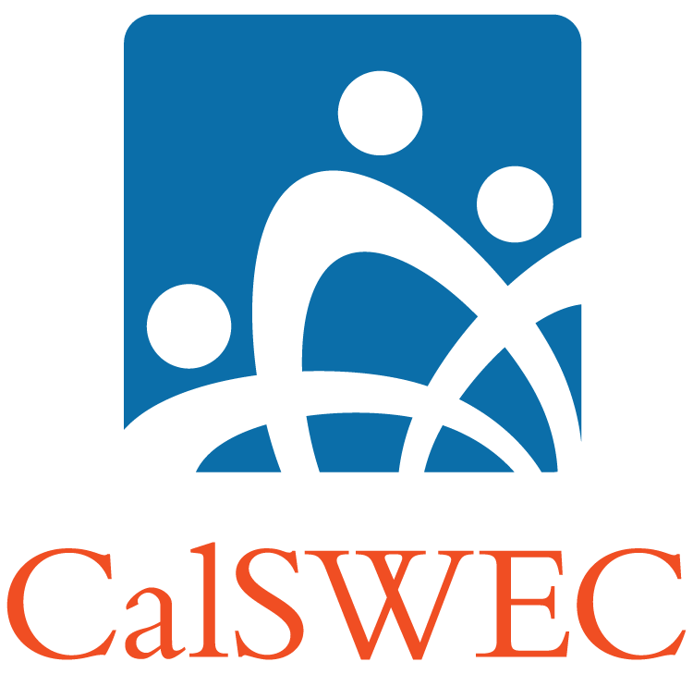 | Suggested AB12 Training Plan | 

Accessing Training
Official AB12 training materials are posted on the CalSWEC website at http://calswec.berkeley.edu/CalSWEC/OtherTraining_AB12.html. The materials have been approved by CDSS and the AB12 Youth Engagement, Informing, and Training Focus Area Team. They are available for use at no cost. Sections of the materials may be used and modified for specific audiences, but any modifications of the factual information within the curriculum may result in provision of incorrect information to training participants.

It is recommended that county agencies consult with the regional training academies for training related to AB12. Further, it is recommended that teams of trainers be used whenever possible to present multiple points of view in the training room.

In order to help county agencies identify ongoing training and as part of the effort to coordinate AB12 training, it is expected that any organization offering training within a county will inform the county in advance of the date and location of the training.

Training Sequence
This recommended training sequence (see below) is designed to start with providing basic information to supervisors and managers. Following training of supervisors and managers, the sequence recommends spreading awareness to social workers/probation officers and stakeholders through distribution of informing materials followed by a wide implementation of the brief basic training (AB12 Overview) provided by supervisors in unit teams.

Once supervisors, managers and social workers/probation officers have the basic knowledge, it is recommended that agencies fine tune the knowledge building through the establishment of easily accessible avenues for social workers and supervisors to get questions answered through online materials, development of coaching or mentoring teams who can offer assistance, and ongoing advanced training.

The next step in the process is to provide training to stakeholders such as foster parents and youth via the basic modules (AB12 Overview, Youth Orientation) and more advanced training (Role of the Caregiver in AB12, Transition Planning for Youth).

The next step is to provide advanced training to social workers/probation officers. Prior to implementing the more advanced training modules, it is important to identify audiences. In some cases, advanced training will be limited to social workers/probation officers working directly with non-minor dependent youth. Other agencies may prefer to train a wider audience. In either case, once the audience is identified, transfer of learning processes should be established prior to training implementation. The most effective way to encourage transfer of learning is through the participation of social worker/probation officer and supervisor in a learning plan that includes pre and post training goal setting follow-up and assessment.

Once the transfer of learning system is in place, the advanced training modules will be offered. The modules are designed to be flexible, so agencies may identify key segments from particular modules to offer to particular audiences. It is recommended that agencies review the modules to determine which will best meet their needs. See below for a brief synopsis of each module.

Beyond the advanced modules that focus on specifics related to AB12, there are training modules available which will assist social workers/probation officers in delivering services to youth. These should be offered ongoing as brief trainings, online modules or unit meeting topics.

The final step in training implementation is an ongoing review of implementation and outcomes to identify training gaps. As the program is implemented additional training needs will become clear. These needs may be met with additional advanced training (there are several topics still under development) or review of advanced training materials in supervision or in unit meetings.

Training Sequence
Step 1 | Provide supervisor / manager training (AB12 Overview).
Step 2 | Distribute informing materials social workers, probation officers and stakeholders. Post materials in offices.
Step 3 | Supervisors introduce AB12 to units (Supervisor Implementation Plan with AB12 Overview).
Step 4 | Establish access to experts (analyst, coaches, mentors) for trouble shooting and questions, make resource materials (FAQs, Primer) easy to access via supervisor or intranet.
Step 5 | Offer training to caregivers, youth, and other stakeholders.
Step 6 | Identify of audiences for advanced modules (see synopses below).
Step 7 | Establish transfer of learning system (goals, supervisor follow-up, online and coaching resources).
Step 8 | Provide advanced training (Partnering to Serve Emerging Adults, Social Worker Practice, Probation Officer Practice, Eligibility, Benefits, Legal Process).
Step 9 | Provide ongoing training to social workers/probation officers and stakeholders on specialized topics to enhance services provided to youth (Resources, Financial Aid, Transition Planning)
Step 10 | Monitor implementation to identify ongoing training needs.

Recommended Modules
Basic Modules
AB12 Overview | This 1-hour ppt-based training module provides a comprehensive overview of AB12 and is intended for a variety of audiences including child welfare and probation staff, caregivers, and community partners.
Implementation Guide for Supervisors | This implementation guide was developed for supervisors to help staff become familiar with the legislation and the nuances of the law. It provides background materials for review and reference, provides materials to introduce this bill to the supervisor’s unit, and provides tools for implementation.
AB 12 Youth Orientation | This 90 orientation for youth was designed to be shown in a group setting, but it can also be used to facilitate a one on one conversation with a youth while reviewing the slides at a computer. It provides a comprehensive overview of AB12 and can also be used with a variety of audiences including child welfare and probation staff, caregivers and community partners.

Advanced Modules for Staff
Case Management for Social Workers | This curriculum is intended to provide social workers with information about the role of the social worker as case manager in assisting non-minor dependents to access the benefits available via AB12 and increase autonomy and independence.
Case Management for Probation Officers | This curriculum is intended to provide probation officers with information about the role of the social worker as case manager in assisting non-minor dependents to access the benefits available via AB12 and increase autonomy and independence.
Understanding Benefits for Transition Aged Youth | This curriculum is intended to provide social workers, probation officers, eligibility workers and other stakeholders with information about the changes to benefits available to non-minor dependent youth as a result of the Federal Fostering Connections to Success Act, AB 12 and the 2011 Budget Bill. Different segments of the training may be used depending on the audience and their level of knowledge about eligibility.
AB 12 and the Court: Essentials of Legal Processes | This curriculum provides an overview of the Rules of Court developed for AB 12, including the hearing processes and the role of the Court. It provides some information about the experience for non-minor dependents in the Court process. A more advanced curriculum will be developed in early 2012 that explores the experience of the non-minor dependent in court more thoroughly.
Essentials of AB12 Placements and Licensing | This basic curriculum is intended to provide caregivers, social workers, and probation officers with technical information about the types of placement available for non-minor dependent youth in extended foster care and the licensing requirements and placement agreement components for the various placements available to non-minor dependent youth. There is a more advanced module also available (see below).
AB 12 Housing and the SILP | This practice oriented curriculum is intended to provide social workers and probation officers with information about the types of placements available for non-minor dependent youth in extended foster care. It will focus primarily on the SILP and working with youth to make these placements successful. It will be consistent with and supplement the Essentials of AB12 Placements and Licensing curriculum.
Eligibility for Social Workers and Eligibility Workers | This training will provide more advanced technical eligibility information for social workers and eligibility workers.
Fiscal Processes | This is an advanced training on the fiscal process related to AB12 benefits and eligibility. It is intended for staff who will be working directly with and managing fiscal processes related to AB12 implementation.
Technical Aspects of Transition Planning | This training will provide social workers, probation officers, and caregivers with specific information about transition planning.

Advanced Modules for Stakeholders
Partnering to Serve Emerging Adults | This curriculum provides an overview of the developmental and psychosocial transition of adolescents to adults. It is intended for caregivers, service providers, CASA volunteers, youth and any stakeholders who may be involved with providing services to non-minor dependent youth.
Transition Planning for Youth | This one hour training for youth provides basic information about transition planning including the purpose of the plan, who will develop the plan with the youth and the content of the plan.
Youth Allies – Supporting Youth in Transition | This training will provide information about supporting youth in transition planning to caregivers and others who work with youth.
Role of the Caregiver | This curriculum focuses on the role of the caregiver in the transition process for youth, including information for caregivers about emerging adults and adolescent brain development.

Implementation Support Materials
Desk Guide: Understanding Benefits for Transition Aged Youth | This desk guide will cover all of the information outlined in the Understanding Benefits for Transition-Aged Youth curriculum, and can be used by county staff on an ongoing basis as they work.
AB12 Primer | This guide provides basic AB12 information in an easy to use online format.
AB12 FAQs | These FAQs can be used as a first line of defense for getting answers to basic questions.

Specialized Modules to Enhance Services to Youth
AB12 Implications for Financial Aid | This curriculum will provide caregivers and CASAs with a general understanding of the financial aid and other educational resources and supports available to non-minor dependent youth.
AB12 Overview for Post-secondary Education Professionals | This training provides education professionals with information about AB12 to assist them in meeting the educational needs of non-minor dependent youth.
AB12 and Higher Education for Child Welfare Professionals | This curriculum will provide social workers and probation officers with specific information about their role in assisting non-minor dependent youth to access higher education.
Resources Online Guide and Training Curriculum | The Resources Online Guide helps professional staff access resources to help young adults in transition from the foster care system to independent adulthood. The trainer guide and powerpoint may be used to supplement the online guide by providing a guided overview of the resources and how to access them. The online guide may also be used by youth.

