Percent of CalSWEC Graduates Hired By Cohort and Time of Hire – Jan. 2012

MSW GRADUATES
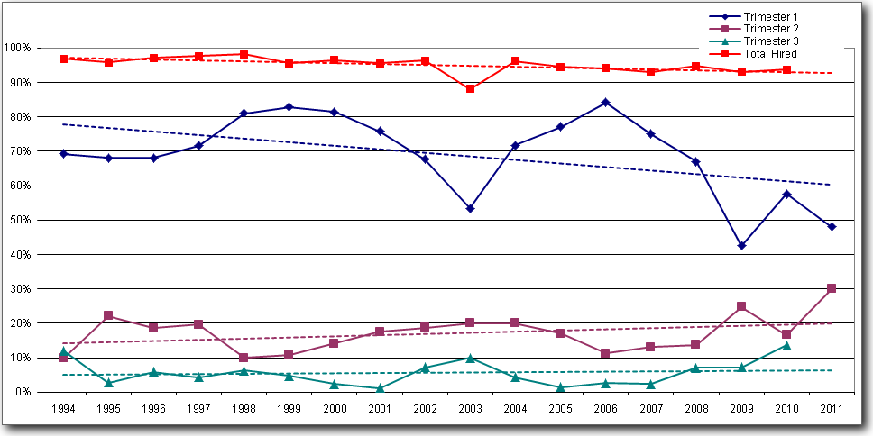
BASW GRADUATES
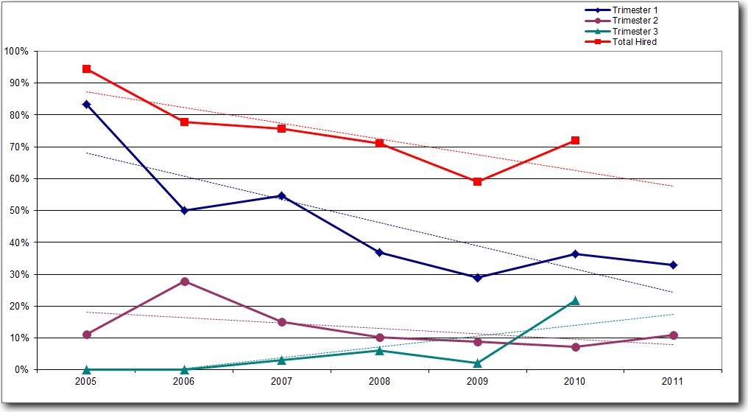
MENTAL HEALTH GRADUATES
