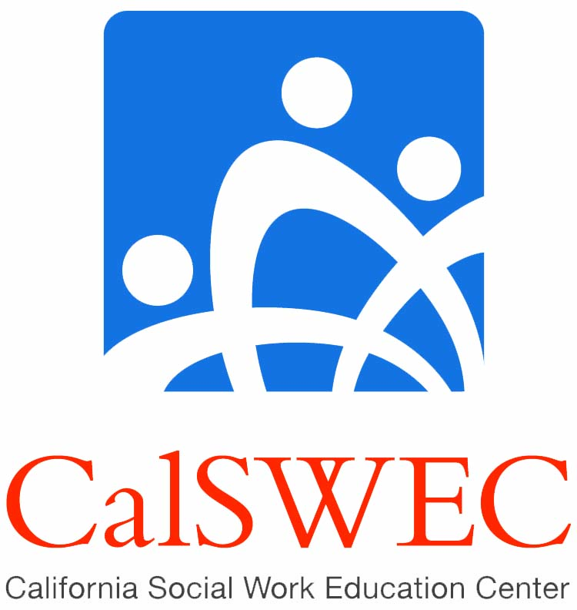

Frequently asked Questions
IV-E HIRING OPTION PAYBACK 2012

Updated May 16, 2012

- Is the graduate required to sign an addendum?
There is no addendum for the 2012 graduates. The graduate may pursue employment under the terms of the current student contract if he/she wishes. Project coordinators can determine whether to have the student sign a written agreement with their school.

- Is there a deadline for deciding to follow the new option?
Each student must let his/her project coordinator know by graduation whether he/she wants to follow the original contract or follow the 2012 Hiring Option.

- Which non-profit agencies meet the employment obligation requirement?
In order to maintain the spirit of the Title IVE Stipend program in so much that it is intended to serve public child welfare services, the approval for a graduate to work in a private non-profit is contingent upon verification that the county has a formal relationship or affiliation with the public child welfare agencies in their area. These agencies must serve Title IVE clients—defined as services for children in foster care (voluntary or involuntary) or emancipated foster youth. A qualifying agency must meet at least one of the following criteria: (a)the agency must be listed on the CalSWEC website as a qualifying agency serving IV-E children and families, (b) the project coordinator verifies that the agency serves as a qualifying non-profit for IV-E field placements, or (c) the county may provide the Project Coordinator with a letter, list or link to show that county or state has a formal affiliation with the county or state child welfare department. Please note that the position itself must provide services to IV-E children and/or their families.

- When can the non-profit employment obligation begin?
If a graduate secures employment in a qualifying IV-E non-profit before the six month statewide CWS search has elapsed and the six month statewide CWS search requirement has been satisfied, the graduate’s employment obligation period may begin no earlier than six months after graduation. The employment obligation period is not retroactive to the date of hire at the non-profit (if it is earlier than the initial six month search period. This is the same as last year’s requirements.)

- What if a graduate claims they cannot travel to an interview because of finances?
If a graduate wishes to pursue a hardship for this reason, the current waiver policy applies.

- Can CalSWEC graduates apply for non MSW required positions, such as case aides in county child welfare services and have them count toward their employment obligation?
CalSWEC graduates are not obligated to apply for non-MSW positions such as Case Aides. However if they wish to apply and secure employment in county child welfare positions, these jobs will count towards their employment obligation.

- If a graduate wishes to repay his or her stipend, can the repayment plan be extended so that there are lower monthly payments?
Maybe, changing the repayment terms can be done through an administrative process and is subject to the approval of your school. This may involve an extension of the repayment time period beyond 5 years. Graduate must check with his/her Project Coordinator.

- Do the new policies apply to the 2010 and 2011 cohorts as well?
No, the policy regarding the employment obligation is set for each cohort depending on the economic trends and hiring available each year.

Q9. What is the search obligation of the graduates?
Both the contract and the addendum specify that the graduate must engage in “reasonable search efforts” and maintain “satisfactory documentation” of the search efforts. The definition of these terms is specified below.

Reasonable search efforts: Are defined as making applications to all public CWS or CDSS agencies within the required area and keeping satisfactory documentation of the employment search. Further, the search must be intensive, ongoing and documented in a coherent manner in order to present a reliable picture of the employment search. If the graduate indicates that he/she did not get written documentation of the outcome of the employment process he/she must make a written request to the county for documentation so that it can be provided to his/her project coordinator when submitting the request for search approval. All graduates must complete electronic interest cards to those counties which provide such, so that they are notified by email when the county is recruiting for child welfare social worker positions.

Satisfactory Documentation: Entries must include names of all agencies contacted during the search period, positions and level of positions applied for, date of application, name, telephone number and email of persons contacted during the entire employment search period. All responses from counties-electronic interest card, response card, test notification, score, and place on list, interview dates, and job offer must also be documented. Copies of written and/or electronic correspondence are necessary as supporting documentation and must be attached to search forms.

CalSWEC’s central office will work with all project coordinators as a group to review cases to ensure the requirements are applied in a uniform and standardized manner across all of the programs.

Q10. How often must a graduate search for employment?
The definition of reasonable efforts (as defined above) is “intensive, ongoing and documented in a coherent manner in order to present a reliable picture of employment search” indicates that a graduate must search until s/he has secured employment. Identifying a minimum number of searches would likely result in the graduate missing an application, and therefore employment opportunities. Therefore the reasonable search effort standard as referenced above relies on the graduates’ professional efforts and documentation.

Q11. Under the 2012 Hiring Option policy, once a graduate has fulfilled his/her statewide search obligation how long must he/she search for employment in a qualified non-profit?
The graduate must search for an additional six months for employment in a qualified IV-E non-profit. The Project Coordinator must review and approve the search as meeting the requirement for “satisfactory documentation” and a “reasonable and on-going search”. If the graduate’s statewide search is approved and the graduate has not begun a position in a qualifying non-profit, the graduate must continue to search statewide in county child welfare. If the county position is offered and the graduate has not begun a job in a qualifying non-profit, the graduate must accept the position in county child welfare. Not doing so, will result in the graduate going into monetary payback status.

Q12. Will CalSWEC continue to do county hiring scans?
CalSWEC has historically gathered and forwarded payback-eligible county job postings to campus project coordinators, and will continue to do so as they are completed. As CalSWEC becomes aware of openings in child welfare, this information will be posted on CalSWEC’s Twitter page at (http://twitter.com/CalSWECGradJobs). As a result, graduates can follow CalSWEC on Twitter or Facebook (http://www.facebook.com/home.php?sk=group_100617546663064) for county employment opportunities. Only public-sector payback-eligible and potentially payback eligibile positions will be posted on these pages. Although CalSWEC will post all known vacancies to these sites, students must also search for vacancies on their own. The list of California counties may be found at http://www.csac.counties.org/default.asp?id=7.

Q13. Will CalSWEC do a hiring scan for private non-profits?
No. We have gathered lists of IV-E qualifying non-profits by region. It is posted on our website for Project Coordinators. This list is not exhaustive, as some agencies may close or new agencies may open which meet the definition of qualifying non-profit. Project coordinators are responsible for ensuring that positions in the qualifying non-profit provides social work services to the child welfare IV-E population.

Q14. Will all CalSWEC graduates be applying for the same positions?
Yes, unless the graduate has already been hired by a county child welfare agency, the California Department of Social Services or a tribal position.

Q15. Does the statewide search apply to the master level positions only?
No, graduates may apply and take a position which does not require a master’s degree, as long as it is in a county public child welfare agency, California Department of Social Services or a tribal organization.

Q16. Are any counties having an especially difficult time recruiting IV-E graduates?
Some of the small, rural, and remote counties continue to have difficulties recruiting IV-E graduates. These counties use an agency known as Merit Services Systems to recruit qualified applicants, screen applications and coordinate testing and interviewing activities.

Q17. Can students apply to agencies outside of California?
No. The only exception is applying at tribal organizations.

Q18. Do students have to continue searching for county positions after being hired at a qualifying IV-E non-profit?
Once the project coordinator has reviewed and approved the graduate’s six month search and the graduate has been hired and begun a qualifying position in a qualifying IV-E non-profit, the graduate may end his/her statewide, county search. The graduate must check with their project coordinator.

Q19. What qualifying positions are available at CDSS (California Department of Social Services)?
CDSS recruits consultants to serve as trainers and consultants on specific projects which are qualifying positions. The individual counties who used State Adoptions in the past are now responsible for providing adoption services to children in the foster care system. The graduate should check with their project coordinator if he/she has questions.

Q20. How does continuing in an MSW degree program affect payback obligations for BASW students?
As of the 2011, the policy was changed so that BASW graduates must do only a one year payback before entering the MSW program. However, the issue of deferring payback so that a BASW student may go directly into a MSW program is being considered by CalSWEC and the California Department of Social Services at this tijme. It has not yet been given final approval.

Q21. What is the current hiring picture?
At this time many counties which had delayed or frozen hiring of MSW level Child Welfare Workers in previous years have begun recruiting and filling their vacant child welfare positions. There has been an increase in the number of social work openings due to an increase in social worker retirements, new positions in county adoptions added (as the state is no longer handling adoptions for the counties) and social work positions in Fostering Connections after 18 (formerly known as AB 12) has been implemented.

Q22. If a graduate accepts a county child welfare position and begins work, then quits prior to the two year obligation being met, will their search timeline begin again?
No. If a graduate accepts a county child welfare position and quits prior to completing the two year obligation, they will go into immediate monetary payback, unless they are taking a job as a child welfare worker in another county. His/her payback is pro-rated based on how many months they worked in the qualifying agency. The graduate should check with their project coordinator if this occurs. Graduates may leave one county child welfare position and go to another county child welfare position without going into payback, as long as there is no break between jobs and the graduate completes the two year employment obligation. If the graduate is laid off by the agency due to agency budgetary reasons, this may not apply. The graduate should check with the project coordinator.

Q23. Are students required to apply to non-MSW positions in county public social services agencies?
No, but it is encouraged as these positions often lead to MSW level positions and are more likely to be payback eligible.

Q24. How does the hiring process vary by county?
Not much variation exists. Counties announce (on their Human Resource websites) the dates and conditions on recruitment for exams. Their personnel staff review applications for minimum qualifications, perform written and/or oral exams and set up dates for the qualified applicants to be examined. These exams are assigned points, and applicants are placed on eligibility lists. Applicants are then notified by email and/or regular mail their individual score and ranking on the list. Students should be aware that interviewers will not usually provide specific feedback to the applicant on their interview.
Smaller counties (there are 30 of them) use the Merit Services System (MSS) to screen applications for these counties. (A list of counties which use Merit Systems may be found on the Merit System website found at http://mss.ca.gov .) When a county child welfare agency is hiring they ask for this “certified list” and are provided a limited number of the top scoring candidates and their contact information to arrange for a hiring interview. As candidates are hired or waive their place on the list, candidates with lower scores move up in the ranking and can be called for interviews as additional positions become available. These lists are generally accessed for a period of six months (though not always.)

Q25. How has the county hiring process changed in the past few years?
At times of increased applications for county social worker positions and with advancing technology, more counties are using electronic screening methods to review applications for minimum qualifications. This means that graduates need to be careful to indicate on their electronic applications which classification (title of position) is open. These systems also electronically check for the minimum qualifications of education, experience and skills, so it becomes increasingly important that the graduate complete the application, carefully following the directions. Some electronic screening includes checking for specific words in the job description sections (such as case management, writing court reports, assessing for risk and safety, etc.) The applicants should use the descriptions in the job recruitment flyers (insofar as they apply to the individual’s experience) when listing job duties.

Q26. Do graduates have to apply in every California-county for any MSW level child welfare position?
Yes, as county positions become available and are advertised graduates must apply for these vacancies.

Q27. What is considered a tribal organizations?
Different types of tribal organizations exist throughout the state. Some rancherias or reservations hire social services workers. Urban areas have tribal Indian service agencies. Some are federally funded and are autonomous.

Q28. Do agencies which provide non-profit services to the Native American population meet the payback obligation as a tribal position or as a qualifying non-profit position? If the agency is funded and operated by a recognized tribe and the position provides services to Native American children and families, the position could qualify for payback in the same way as a county child welfare position does. If the agency serves the Native American population, but it is funded and operated by someone other than a tribe, it may meet the requirements of a qualifying non-profit.
Graduates should check with his/her project coordinator.

Q29. Are positions in Adult Services in county public social service agencies payback eligible?
No. The mission of the Title IV-E Stipend program is to get more BASW and MSW graduates into public child welfare to work with at-risk children and their families.

Q30. Why is application to public social services agencies required?
This is what is required by the contract. Additionally, counties continue to want to hire CalSWEC
IV-E graduates to ensure that they have a qualified, well educated workforce.

Q31. Even though the stipend is for 18 months for full time IV-E students, do IV-E need to work a full 24 months for payback?
Yes.

Q32. How does the waiver/exception work for graduates who have not been hired after 12 months?
If the graduate notified their project coordinator that they planned to follow the Hiring Option for the 2011 cohort, and if the graduate did a well-documented and reasonable search as reviewed and approved by their project coordinator, in both county agencies (six months) and qualifying IV-E non-profits and not found employment, they may apply for a waiver to his/her project coordinator. These waivers are then reviewed by CalSWEC.

Q33. Is the graduate required to take the first qualifying county child welfare position that is offered to him/her?
Yes, the contract states that if the student/graduate declines appropriate employment, the student agrees to repay any support provided by University and costs incurred by university or its fiscal agent in securing repayment [Student Contract, Article II,(C) (2)].

Q34. Do positions as social workers/counselors in public schools meet the employment obligation?
Only if the position is IV-E funded and provides child welfare services to the foster care population.

Q35. When does the search timeline start?
At graduation, even if students begin applying sooner.

