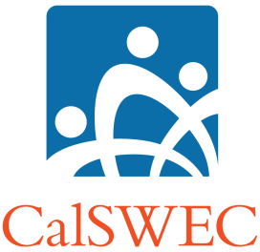 | 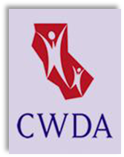 |  | 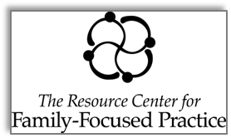 | 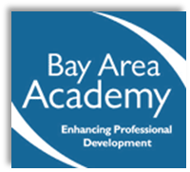
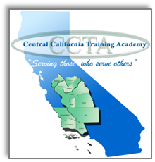 |  | 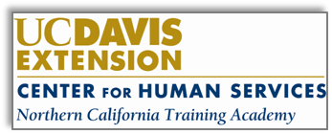 |  |   

OPERATING PRINCIPLES AND STRUCTURES
FOR STATEWIDE TRAINING EFFORTS

Version 2.1 | 10/3/13

About This Document

This document articulates the operating principles of California’s university-based regional child welfare training system. It is intended to guide the coordinating partners in their work together, as well as to structure the decision and information-sharing process for coordinated, statewide training projects.

Operating Principles of the Coordinated System

The coordinated system:
- Shares information freely and promotes open communication;
- Is based on participatory decision-making processes;
- Acknowledges a responsibility to resolve disagreements in good faith, honors agreements once they are made, and communicates about necessary changes in priorities as necessary;
- Promotes time efficiency, cost effectiveness, and quality training products;
- Mutually agrees upon priorities for statewide training initiatives, and upon levels of coordination for these priorities;
- Maximizes resources by using common curricula whenever possible;
- Promotes fairness and benefits from the participation of all of the entities involved.

Operationalizing These Principles

Each of the coordinating partners work on projects for their region, and collaborate at a regional and statewide level for selected projects. CalSWEC convenes structured meetings/forums to promote coordination. These include:

- RTA Directors Strategic Planning Meetings
Frequency: Quarterly, or monthly, based on need
Purpose: Set priorities for statewide projects; strategize about how to address statewide training issues & how to work with CDSS, CWDA, STEC and other stakeholders; address problems/troubleshoot on coordination issues.
Attendance: Directors and select Management of RTAs/UCCF/LA DCFS/CalSWEC/RCFFP, CDSS Training Bureau staff, CWDA representative(s).

- RTA/UCCF/RCFFP/LA DCFS All-Staff Strategic Planning Meetings
Frequency: Annually
Purpose: Use staff resources to build upon priorities identified by the directors; build relationships between staff to promote sharing of knowledge and resources; build knowledge-base in specific areas of interest.
Attendance: All RTA/UCCF/LA DCFS/RCFFP Program Staff (determined by RTA/UCCF/DCFS/RCFFP); CDSS representatives; CalSWEC program staff.

- CalSWEC Board Committees (Child Welfare, Curriculum, Research and Development, Workforce Development)
Frequency: Three times yearly, in February, May, September (meetings all occur on the same day)
Purpose: Identify and enhance the linkages between pre-service and in-service training within CalSWEC; act as an advocacy group with CDSS to assure regional and university representation on statewide training issues; act as a forum for CDSS to bring new initiatives and changes into CalSWEC; act as a liaison between the RTAs and the full CalSWEC board.
Attendance: RTA/UCCF/RCFFP/LA DCFS Directors attend committees as needed. Schools of Social Work, CDSS and CWDA have designated seats on the Board and Committees. A Deputy Director-level CWDA rep participates in the Child Welfare Committee.

- Statewide Training and Education Committee (STEC)
Frequency: Quarterly
Purpose: On behalf of, and in consultation with, CalSWEC/CDSS/CWDA/the RTAs and UCCF/LA DCFS Training Unit/RCFFP, set standards for statewide public child welfare training and coordinate their implementation.
Attendance: Directors and designees from RTAs/UCCF/LA DCFS/CalSWEC/RCFFP; CalSWEC; CWDA Regional Children’s Committee representatives; CDSS; county staff development personnel; title IV-E stipend project coordinators; Caregiver Training Reps, CASA reps, State Adoptions Reps, CFPIC reps, others as designated by the STEC Charter. (County representatives are approved via CWDA Children’s Committee Regional Subcommittees)

Subcommittees of STEC:
- Content Development Oversight Group (CDOG)
Frequency: Twice yearly in-person, monthly via conference call/web conference
Purpose: Oversee the development and revision of statewide curriculum products, including the Common Core Curricula. STEC provides guidance and approves final products.
Attendance: Directors and/or designees from RTAs/UCCF/LA DCFS/CalSWEC; CWDA Children’s Committee representatives from STEC; CDSS; county staff development staff; other STEC members as needed; content experts as needed.

- Macro Evaluation Team
Frequency: Twice yearly
Purpose: Develop and implement strategic plans for a coordinated method to evaluate training; develop and implement tools to improve evaluation, such as a bank of knowledge test items; identify technical assistance needs for counties and RTAs/UCCF/LA DCFS; coordinate and provide such technical assistance; facilitate exchange of information and knowledge about evaluation of training
Attendance: Directors and/or designees from RTAs/UCCF/LA DCFS/CalSWEC/RCFFP; CalSWEC; CWDA Children’s Committee representatives; CDSS; county staff development staff; other STEC members as needed.

- CWS/CMS Training Curriculum Alignment Team (TCAT)
Frequency: Quarterly
Purpose: Address training and curricular issues for CWS/CMS training, including updates to new user training and meeting training needs for new versions of CWS/CMS.
Attendance: A subcommittee of STEC, reports to STEC via CDOG, convened by CalSWEC and co-chaired by Northern and Central RTA: RTA CWS/CMS staff, CDSS, the Office of Systems Integration (OSI), and county staff.

- Technology and Learning Committee
Frequency: Convenes via technology every 2 months
Purpose: Support the CDSS, CalSWEC, the schools of social work, the regional training academies, and counties of California to develop and deliver education materials and training that is responsive to its partners and that uses various modalities of technology to deliver high quality education, statewide.
Attendance: Directors and/or designees from RTAs/UCCF/LA DCFS/RCFFP; CalSWEC; Title IV-E Program representatives from universities; CDSS; county staff development staff; other STEC members as needed.

- Ad hoc work groups
Frequency: Varies by need; primarily meet via conference call
Purpose: STEC convenes ad hoc work groups to develop strategies for specific projects, frequently associated with a strategic plan. These groups make recommendations to CDOG, the Macro Evaluation Team, or to STEC directly.
Attendance: Regional representatives are sought for each of these groups. Content or subject-matter experts may participate in these groups.

