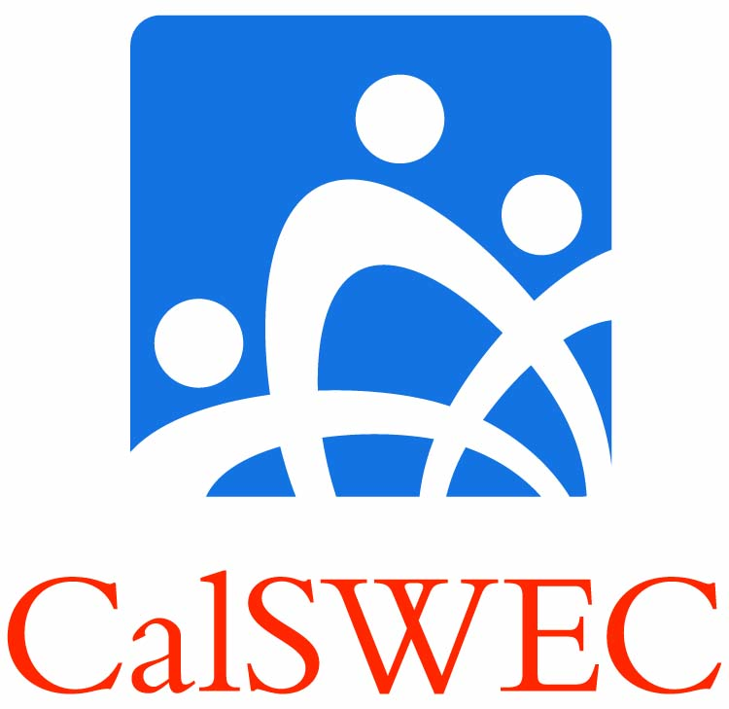 | Program Completion Guide:  Title IV-E Students and Graduates | Insert your school’s logo here

Introduction
This Program Completion Guide gives you information about the steps to take when your path through the Title IV-E Stipend Program does not follow expectations. Note that the requirements differ somewhat for public social services or California Department of Social Services (CDSS) employees who return to school.

Read the Student Contract provisions and obligations very carefully, and make certain you understand the sections regarding school completion, employment search, qualifying employment, and when to contact your Project Coordinator (PC) regarding any exceptional circumstances. This guide is intended to clarify some of the contract provisions by providing examples of what kinds of situations may occur and how to resolve them.

In the ideal case, you will complete the academic program successfully, meet search requirements for a qualifying position, obtain such a position, and work at that position for the required two years and beyond. However, circumstances may create a different scenario.

Whatever the situation, communicating with your PC promptly will often prevent problems from developing or worsening. Your PC will assist you in determining whether an informal or formal process is needed to resolve the situation. An issue directly related to noncompliance with Student Contract requirements demands a formal process. If a formal process is required, you will need to fill out a Petition Form.

Three basic situations may cause an “irregular” course of events. Any of these should trigger your contacting your PC to seek advice on how to proceed. Asking before taking action will help to prevent problems.

- Completing School. These issues may include a wide range of issues from illness or family circumstances to problems with completing coursework, finding and completing field placements, or issues involving security clearances.

What to do: Speak with your Project Coordinator to determine a plan of action. The situation may be resolved informally, or a Request to the School for delay in completing the academic program or other requirement may be needed.

- Finding Work/Job Search. These issues most frequently occur when the graduate does not follow the search provisions, OR, despite having followed the search requirements, the graduate does not find a position in a timely manner. Problems in qualifying for a position (not passing the exam or interview, not passing security clearance) may also fall into this category.

What to do: Make sure you are complying with search requirements and correctly documenting your search. Contact your PC for advice if you do not understand the requirements. Use the Twitter and Facebook CalSWEC Jobs accounts for help finding a position. If you experience problems in qualifying for a position (exam, interview, or security clearance), contact your PC immediately. The PC often can assist you in finding solutions.

- Issues with Completing Employment Requirements. Issues may arise during the course of your completing the employment obligation. These issues may involve changes in life circumstances and/or wanting to change employers during the obligation period. It is important for you to remember that employment requirements end only when you have completed the entire period of qualified employment.

What to do: If you anticipate wanting to change employers or you have any question of whether a job you are planning to accept will be a qualified one under your contract, contact your PC immediately BEFORE you accept the position.

Contacting the PC is also required if you want to change employers during the employment obligation period. This is true whether you have been working in qualified employment or have obtained permission to work in a non-profit. If you leave a specific non-profit position, you must begin a second qualified employment search, re-starting the search clock from the point at which you took your most recent position, either qualified public CW employment or a qualified non-profit position. If you do not find qualified CW employment in the second search, you must still file a Petition with the PC BEFORE you search for or accept a qualifying non-profit position. The PC will be able to determine whether the job qualifies or s/he may be able to help you petition to have it approved. Failure to make sure a job is approved may result in any time you have spent working in the position being disallowed as part of employment obligation.
It is very important to complete all program requirements, including the employment obligation. Please note that IV-E support received, because it involves federal funds, CANNOT be discharged in the event you file for bankruptcy.

Conclusion
In the above cases, the key element is contacting your PC right away if difficulties arise at any stage in your progress through the program. This step will give you the opportunity to address the situation in an informed way, may lead to resolving your situation informally, and will help to protect you from encountering further problems. As noted above, when a formal process is required, your PC will inform you of the Petition process and give you the appropriate forms to complete.

