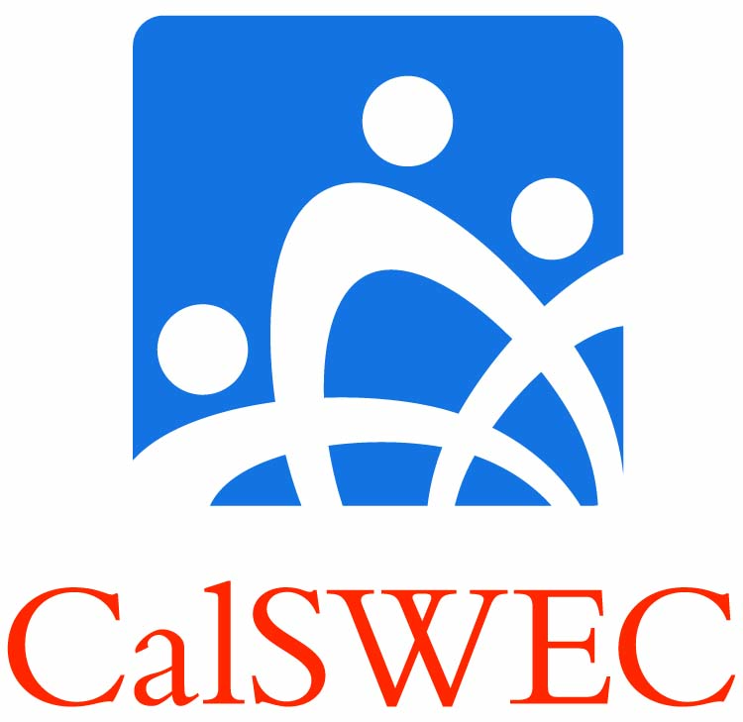 | Project Coordinator Guide:  Title IV-E Petition Processes

This guide addresses the steps you, as Project Coordinator (PC), need to take to address the challenges students and graduates may face in completing the Title IV-E Stipend Program. These challenges may occur at three major stages: (1) completing school, (2) finding qualified work, and (3) completing the employment obligation.

ORIENTATION
To alert students about what to do if problems arise, CalSWEC strongly suggests that you:
- Include the Program Completion Guide in the student orientation packet. This should help the student understand there are remedies to problems they may encounter.
- Make clear to the students that if they encounter challenges as they proceed in the program, communicating promptly with you, the PC, will often prevent issues from developing or worsening.
- Make clear that you will assist them to determine whether an informal or formal process is needed to resolve the situation.

FORMAL PROCESS
If a formal process is required (an issue directly involving noncompliance with Student Contract requirements), you will need to give the student/graduate:
- The Petition Form to complete
- The Student/Graduate Guide: Title IV-E Petition Process
- The Monetary Repayment Agreement for signature, to take effect if the petition is denied or if the student/graduate fails to meet prescribed conditions (You keep a copy of this agreement.)

PETITION PROCESS
- The student completes the Petition Form and submits it with supporting documentation to you and to your Principal Investigator (PI). Third-party verification is required for any claim of disability. A petition to extend time to complete the academic program goes to the school.
- You and your PI review the petition in light of the contract, regulations, and the documentation submitted and make a decision to affirm or deny the petition. You record your decision on the Petition Recommendation Form.

Then you scan and send the petition and supporting materials to:
iv-e_petitions@berkeley.edu.

- The Title IV-E Program Director reviews the matter and informs the PC and PI within 30 days of the decision to affirm or deny the school’s recommendation.

The decision of the IV-E Director is final.

QUALIFIED EMPLOYMENT CHANGES DURING OBLIGATION PERIOD
If a graduate wants to change employer during the obligation period, s/he must notify you, the PC.
- If the position is a qualified county, CDSS, or Tribal job, an immediate email note to you and a submitted job verification form are sufficient.
- If the position is NOT a qualified one, the graduate must notify you and resume a renewed and documented search for a qualified position at the point at which the graduate left off in the prior job search. The minimum time required for the renewed search is six (6) months. If the search is unsuccessful, the graduate may then file a petition seeking permission to search for a non-qualified job.

All of the above information is set forth in greater detail in the PC Guide.

