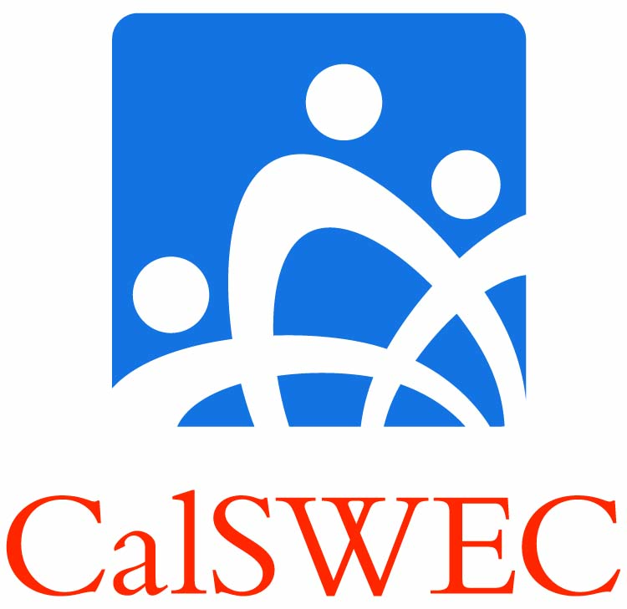 | Student/Graduate Guide:  Title IV-E Petition Process | Insert your school’s logo here

While CalSWEC and your university Title IV-E Stipend Program anticipate that you will be able to complete your program successfully and begin your career in child welfare services, challenges may arise due to personal circumstances or changes in the job market. The Petition process is designed to resolve these challenges. Please read this guide carefully and bring any questions you have to your Project Coordinator (PC).

Read the IV-E Student Contract (Contract) carefully. It provides the basic obligations the university program has to you and you have to the program. Because it is an agreement you sign, the Contract is the controlling document in any disagreement arising between you and the Program.

If you seek delay in completing the academic program at your school, you should make your request to the school through your Project Coordinator.

Petition to the University IV-E Program

If your circumstances involve any exception to the general program completion, job search, or employment obligation requirements as outlined in the Contract, request and complete the Petition Form provided by your PC and submit any supporting documentation with the form.

Petitions should be filed in cases where:
- You wish to delay completion of the Title IV-E program, or
- You wish to modify or be relieved of any contractual program obligation.

Examples of b) include: delay of program completion due to death, disability, or similar incapacity.

Petitions in writing must be submitted to the PC BEFORE you undertake any voluntary action. No action should be taken until a decision on the petition has been reported. If the Petition is decided in your favor, your duty is to abide by the decision.

CalSWEC August, 2017

