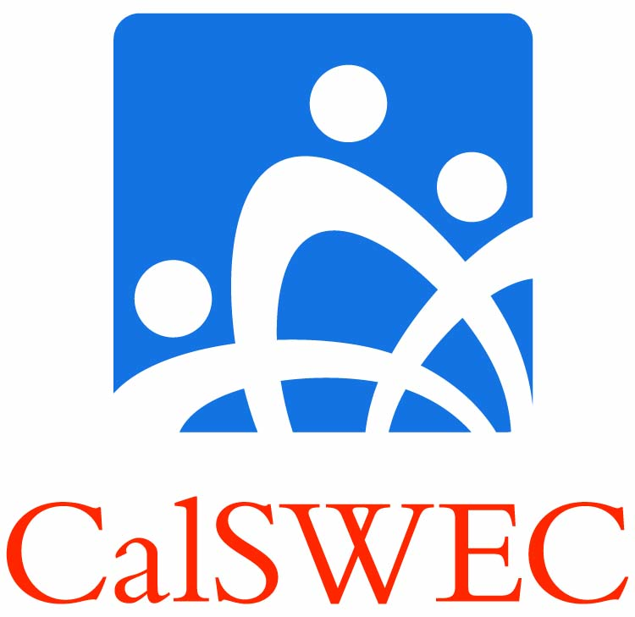 | Title IV-E Student/Graduate  Petition to CalSWEC | Insert your school’s logo here
Please complete this form and return to the Project Coordinator of your program.
Be sure to include any documentation that you believe supports your Petition.
If you have questions as you complete the form, please consult your Project Coordinator.

- What is the basic purpose of your petition? Please check one:

- Extension of time to complete employment search

- Delay in completing employment obligation

- Permission to modify employment obligation requirements

- Delay of repayment after leaving program

- Other (please specify):

- Please state briefly and clearly why you believe this petition should be granted. You may use additional space on the reverse if needed.

- Are there any special circumstances that you believe should be considered in evaluating your petition?
Yes No
If you checked Yes, please briefly describe the circumstances:

- If your petition is for modification of employment requirements, have you completed the required comprehensive employment search and documentation?
Yes No

Please print your name, sign, and date:

Print your name
Your signature |  | Date
Your School
Class year

Please submit this form, along with all supporting documentation,
to your Project Coordinator. Project Coordinator will forward to CalSWEC for decision.

