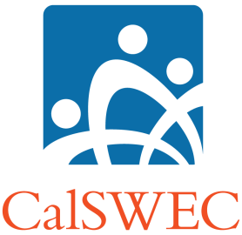

**“Employment Verification Form” Instructions**

This form is to be used to verify the graduate’s work during the employment obligation period. Please replace your current form with this form immediately.

1. Adapting the form for the School:
   1. Insert the name of the School at the top in place of **[SCHOOL NAME]** and at the end of the bottom line of the form.
   2. (Optional) Insert the school logo at the top right of the document.
2. Obtaining employer verification:
   1. Send the document to the graduate with instructions that the graduate is to fill out **PART A:** and that **PART B:** is to be filled out by the Personnel/Human Resources at the Agency where the graduate is employed.
   2. The signed document is to be sent back to the Project Coordinator.
3. Project Coordination certification
   1. The Project Coordinator will fill out **PART C:**
   2. PC will fill out and sign the bottom of the form.
4. This form is to be filled out quarterly or every 6 months during and until the graduate’s employment obligation is completed.

**“Employment Obligation Fulfillment Form” Instructions**

This form is to be used to summarize or compile all of the graduate’s work during the employment obligation period on a six-month schedule.

1. Adapting the form for the School
   1. Insert the name of the School at the top in place of **[SCHOOL NAME]**
   2. (Optional) Insert the school logo at the top right of the document.
2. This document is to be filled out by the PC or the Administrative Assistant.
   1. Fill in the graduate’s name and contact information.
   2. List all of the graduate’s employment information in fulfillment of the work obligations in the middle section. Include beginning and end date(s) of all agencies and positions. If the graduate worked the entire time at one agency, only one row need be filled in.
   3. Enter the end date of the work obligation at the end of the middle section.
   4. PC will fill in and sign the bottom of the form.