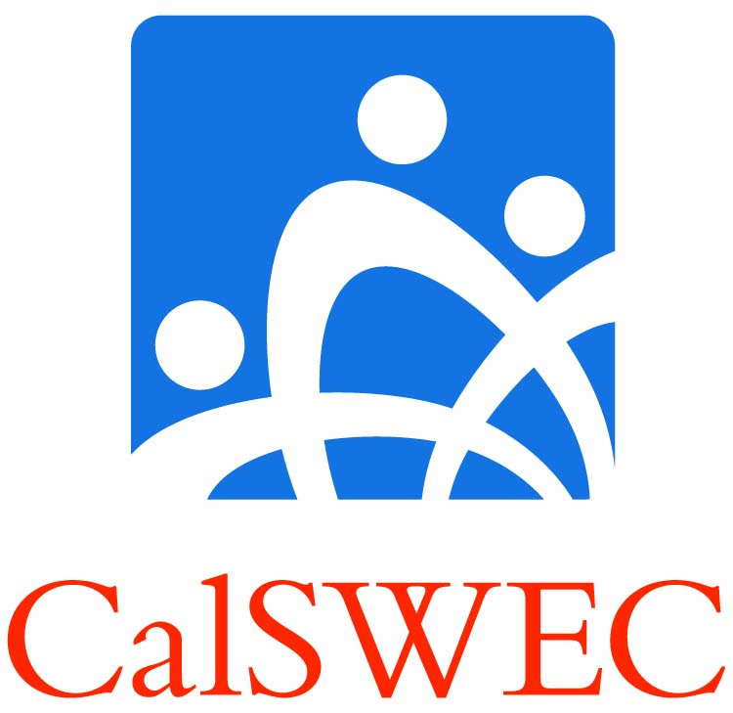

**Updated CalSWEC Title IVE Graduate Hiring Options**

**For Project Coordinators**

**2012 Cohort only**

***What was done to understand the child welfare job market?***

* Meetings and information gathering sessions with county child welfare partners.
* On line survey with over 80% of the counties reporting and 75% of the project coordinators reporting.
* CalSWEC’s Workforce Development Coordinator gathered county level information from around the state on hiring activity.

***What was found about the child welfare job market?***

* Variability across the state with regard to projected hiring in the county child welfare agencies.
* Increase from 2011 hiring due to upcoming realignment and county budgets stabilizing.
* Counties are more positive in their projections for hiring for 2012-2013.

***Title IV-E Hiring Projection***

* The estimated number of CalSWEC IV-E full time students graduating in May/June 2012 is 325 MSWs and 55 BASWs.
* In looking at recent trends, the 2011 IV-E cohort hiring increased overall. Compared with 2010, there was more hiring in the 1st trimester, with hiring continuing into the 2nd and 3rd trimesters of the year.
* At this point in time 85% of the 2011 IV-E MSW cohort and 67% of the 2011 IV-E BASW cohort have been hired by either the county or qualified non-profit organizations. There was also an increase in Merit Services Systems hiring in 2011-2012.
* When compared with previous cohorts at the same timeframe, 94%, 89%, 88%, and 81% of the 2007, 2008, 2009, and 2010 MSW graduates respectively were hired, and 73%, 53%, 40%, and 65% of the 2007, 2008, 2009, and 2010 BASW graduates respectively were hired.

***Hiring and Search Options for the 2012 Cohort only***

* CalSWEC has attempted to strike a balance between the realities of the current labor market and the contractual obligations of the Title IV-E master contract as well as the IV-E student contract.
* The hiring and search options below allow more flexibility from the student standpoint while maintaining clear accountability to search for and secure employment in the target employment market—the public child welfare agencies.

**2012 Hiring Option**

* If the Option is chosen, graduates from the 2012 cohort are expected to apply statewide, upon graduation to county child welfare and CDSS. Graduates *may* also apply to tribal welfare agencies.
* If after six months the graduate is not hired in county public child welfare services, the graduate may *request to search* in California non-profit organizations that provide services to IV-E populations, as well as schools and probation agency’s positions serving IV-E clients. If the graduate is not hired by a qualifying IV-E non-profit, he/she must alsocontinue searching in the public sector county child welfare agencies as well.
* If upon review by the PC, the graduate is deemed to have completed a statewide comprehensive and documented search for six months, and accepts and begins employment in an approved position in a qualifying IV-E non-profit, the graduate may discontinue their search in county public child welfare and begin their employment obligation.
* Graduates who choose the 2012 Hiring Option *must* commit in writing to their respective schools that they are choosing the option by Graduation 2012.

**Process**

* After a period of not less than 6 months post-graduation and before a non-profit search can be approved, search documentation must be reviewed by the Project Coordinator to determine if a thorough, comprehensive and statewide search in county public child welfare has been done.
* If the graduate search meets the standard below, she/he can be approved to begin their employment obligation in a qualifying IV-E non-profit. However, the start date for the employment obligation can be no earlier than the date of approval of the graduate’s documented search in county child welfare.
* If after one year the graduate has not secured employment in public child welfare or an approved non-profit organization, the graduate may apply for a waiver or exception.

**Search**

* Reasonable search efforts are defined as making applications to all social worker recruitments in public county Child Welfare Services and the California Department of Social Services (CDSS) in positions that work with IV-E children and families. Graduates *may* also apply to tribal child welfare agencies in the time frames set forth above. If the graduate is MSW level, they must apply to all MSW level positions in county child welfare services. They may apply to positions in county child welfare that are not at the MSW level, although it is encouraged that they do apply. The BASW students must apply to all child welfare positions in which they meet the minimum qualifications.
* The search must be intensive, ongoing and documented in a coherent manner in order to present a reliable picture of employment search.
* Graduate must keep satisfactory documentation of the employment search and provide to the Project Coordinator for review.

**Employment Guidelines**

* Requests to search in county or non-profit organizations serving child welfare clients are reviewed by Project Coordinator no later than 6 months post-graduation and approved based on the graduate meeting the required search obligation. The start date for the employment obligation begins after the public sector search is approved and is not retroactivelyapplied to the employment obligation.
* Qualifying employment in a non-profit organization is defined as those agencies affiliated with the public child welfare system to deliver services to Title IV-E eligible children and families.
* Employment in a qualifying non-profit organization is approved only after the job search is successfully reviewed and approved.
* If graduate is already employed by a county public child welfare agency and in a social worker position other than an MSW level child welfare position, their employment may count towards the obligation. It is expected that they will apply and look for promotions in their county of employment.
* MSW graduates *may* apply and secure child welfare positions that do not require an MSW level degree in county child welfare and have it meet their employment obligation. BASW graduates *may* apply and secure child welfare positions in a county child welfare agency that does not require a BASW and have it meet their employment obligation.

**Note:**

**All other provisions in the student contract are binding when a graduate chooses the 2012 Hiring Option.**

**Attachment A**

**Examples of Search Scenarios**

* (A) Graduate selects Hiring Option 2012 and upon graduation searches statewide in county public child welfare positions and CDSS for 6 months, submits comprehensive documentation to Project Coordinator for review. PC reviews and approves as such, graduate begins searching in qualifying IV-E non-profits, in addition to continuing statewide search for county public child welfare. Graduate is offered and begins a position in a qualifying non-profit. Graduate may discontinue search of statewide county child welfare positions and begin employment obligation.
* (B) Graduate selects Hiring Option 2012 and upon graduation searches statewide in county public child welfare positions and CDSS for 6 months, submits comprehensive documentation to Project Coordinator for review. PC reviews and approves as such, graduate begins searching in qualifying IV-E non-profits, in addition to continuing statewide search for county public child welfare. Graduate is offered position in county child welfare. Graduate must accept position in county public child welfare. Graduate begins employment obligation in county position.
* (C) Graduate selects Hiring Option 2012 and upon graduation searches statewide in county public child welfare positions and CDSS for 6 months, submits comprehensive documentation to Project Coordinator for review. PC reviews and approves as such, graduate begins searching in qualifying IV-E non-profits, but discontinues statewide search for county public child welfare. Graduate searches only in qualifying IV-E non-profits. Graduate accepts position in qualifying non-profit. Graduate has not met requirements of a search and cannot begin employment obligation (because graduate failed to continue searching in county child welfare.)
* (D) Graduate selects Hiring Option 2012 and upon graduation searches statewide in county public child welfare positions and CDSS. In Month 3, graduate is hired for a "potentially payback-eligible" at a qualifying IV-E non-profit agency. Graduate must continue to search statewide in county child welfare. In Month 7, graduate submits comprehensive documentation to Project Coordinator for review. PC reviews and approves search, and graduate begins payback in qualifying IV-E non-profit starting at the date of successful search review.

**Attachment B [ *INSERT SCHOOL LOGO HERE*]**



**For 2012 Graduating Students**

The Hiring Option was developed for the 2012 cohort after compiling information across the state about the current economic conditions and projected hiring of Social Workers in the county child welfare departments. It appears that not only will there be more openings in child welfare, there continues to be a strong support for the education and employment of IV-E graduates. It is projected that:

1. Many experienced social workers plan to retire in the coming year, opening up entry level positions.
2. As child welfare supervisors and managers retire, current experienced line social workers will promote to these positions, opening up available entry level positions.
3. There will be a need for more MSW’s for Adoptions programs in county child welfare as a result of the state shifting these services to the local counties.
4. AB 12 is now being implemented requiring additional social workers to provide services to these youth.
5. County budgets are stabilizing. Those counties who have held off hiring social workers until the fiscal picture was more clear are beginning to fill these positions. Counties are more positive in their projections for hiring for 2012-2013.
6. At this point in time 85% of the 2011 IV-E MSW cohort and 67% of the 2011 IV-E BASW cohort have been hired by either the county or qualified non-profit organizations. There has been an increase in Merit Services Systems hiring in 2011-2012.

**2012 Hiring Option**

* If the Option is chosen, graduates from the 2012 cohort are expected to apply statewide, upon graduation to county child welfare and CDSS. Graduates *may* also apply to tribal welfare agencies.
* If after six months the graduate is not hired in county public child welfare services, the graduate may *request to search* in California non-profit organizations that provide services to IV-E populations, as well as in schools and probation agency’s positions serving IV-E clients. If not hired by a qualifying

IV-E non-profit, graduates must alsocontinue searching in the public sector county child welfare agencies as well.

* If upon review by the PC, the graduate is deemed to have completed a statewide comprehensive and documented search for six months, and accepts and begins employment in an approved position in a qualifying IV-E non-profit, the graduate may discontinue their search in county public child welfare and begin their employment obligation.
* Graduates who choose the 2012 Hiring Option *must* commit in writing to their respective schools that they are choosing the option by Graduation 2012.

**Process**

* After a period of no longer than 6 months and before the non-profit can be approved, search documentation must be reviewed by the Project Coordinator to determine if a thorough, comprehensive and statewide search in county public child welfare has been done.
* If the graduate search meets the standard below he/she can be approved to begin their employment obligation in a qualifying IV-E non-profit. However, the start date for the employment obligation can be no earlier than the date of approval of the graduate’s documented search in county child welfare.
* If after one year the graduate has not secured employment in public child welfare or an approved non-profit organization, the graduate may apply for a waiver or exception.

**Search**

* Reasonable search efforts are defined as making applications to all social worker recruitments in public county Child Welfare Services and the California Department of Social Services (CDSS) in positions that work with IV-E children and families. Graduates *may* also apply to tribal child welfare agencies in the time frames set forth above. If the graduate is MSW level, they must apply to all MSW level positions in county child welfare services. They may apply to positions in county child welfare that are not at the MSW level, although it is encouraged that they do apply. The BASW students must apply to all child welfare positions in which they meet the minimum qualifications.
* The search must be intensive, ongoing and documented in a coherent manner in order to present a reliable picture of employment search.
* Graduate must keep satisfactory documentation of the employment search and provide to Project Coordinator for review.

**Note:**

**All other provisions in the student contract are binding when a graduate chooses the 2012 Hiring Option.**