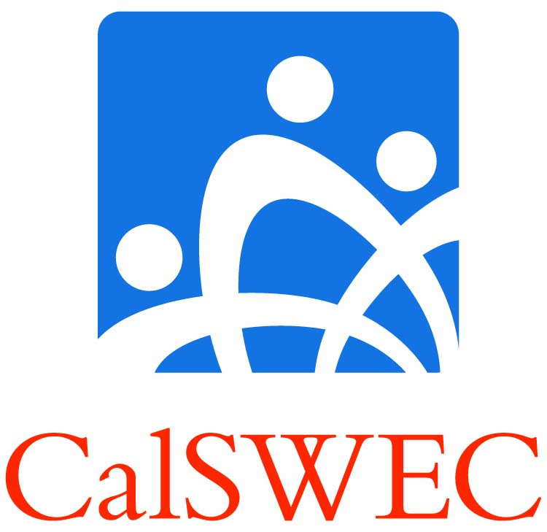

**Updated CalSWEC Title IVE Graduate Hiring Options Synopsis**

**2012 Cohort only**

**Background -** Meetings and surveys with CalSWEC IV-E partners determined that the hiring in 2011 has improved somewhat, but is still not at the level that would guarantee county employment for the 2012 graduates.

**2012 Hiring Option (for 2012 cohort only)**

* If the Option is chosen, graduates from the 2012 cohort are expected to apply statewide, upon graduation to county child welfare and CDSS. Graduates *may* also apply to tribal welfare agencies.
* If after six months the graduate is not hired in county public child welfare services, the graduate may *request to search* in California non-profit organizations that provide services to IV-E populations, as well as schools and probation agency’s positions serving IV-E clients. If the graduate is not hired by a qualifying IV-E non-profit, he/she must alsocontinue searching in the public sector county child welfare agencies as well.
* If upon review by the PC, the graduate is deemed to have completed a statewide comprehensive and documented search for six months, and accepts and begins employment in an approved position in a qualifying IV-E non-profit, the graduate may discontinue their search in county public child welfare and begin their employment obligation.
* Graduates who choose the 2012 Hiring Option *must* commit in writing to their respective schools that they are choosing the option by Graduation 2012.
* For complete details contact one of the participating [**IV-E Project Coordinators**](http://calswec.berkeley.edu/CalSWEC/IV-E_Schools_PCs.pdf).