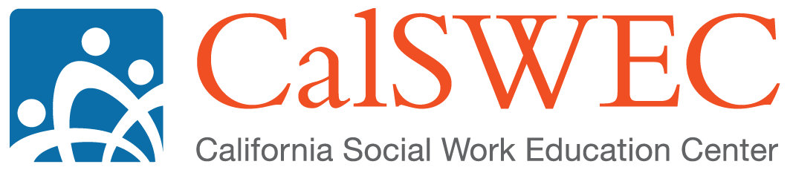

**Common Core 3.0 Curriculum Development Plan**

***Content Development***

The plan for the common core revision includes development of:

1. 20 online modules
2. 24 classroom based curricula
3. 20 field activities
4. Field advisor / coach curriculum

The training we develop will consist of:

1. 26.5 hours of online content
2. 18.5 days of classroom content

Although these modules will incorporate content from existing sources, there will be a need to develop new content.

***Phased Development Plan***

New information about resources available for content development requires revision to our original timeline to allow for a longer development period. RTA Directors have agreed to take a phased approach to the curriculum development, starting with development of one practice block. CalSWEC will develop the materials identified in the Assessment block, updating the Child and Youth Development, Assessment, and CMI curricula, including developing the online modules, classroom modules, field guide, and evaluation materials. Following curriculum development, the materials will be reviewed and vetted by the CC3.0 Revision Team and then piloted with a core cohort in place of the current Child and Youth Development, Assessment, and CMI curricula. The Assessment block of content will then be finalized, and implemented as part of Core statewide. Concurrently, but over a longer period of time, additional curriculum development will be ongoing for the other blocks. Using this timeline, phase 1 will be completed in FY 13/14 and FY 14/15. Phase 2 will begin in FY 13/14 and continue through FY 15/16 and FY 16/17.

**Phase 1:**

The table below identifies the revised timeline for the first phase of curriculum development and piloting and operationalizes the tasks to be completed:

|  |  |  |
| --- | --- | --- |
| ***Timeframe*** | ***Goal*** | ***Tasks*** |
| **July 2013 – August 2013** | Content definition (developing initial sets of learning objectives) | * Development and review of 64 sets of learning objectives |
| **July 2013 – October 2013** | Stakeholder review / comment period | * Development of stakeholder engagement tools * Meetings with various stakeholder groups * Review and synthesis of stakeholder feedback |
| **November 2013 – October 2014** | CalSWEC (with CDOG oversight) develops the proposed content (100 level, 200 level, field) and evaluation materials for the Assessment block  CalSWEC (with CDOG oversight) develops curriculum for field advisors | * Development of 4 classroom curricula (1 with standardized content, 2 with standardized content and delivery) * Development of 3 online modules * Development of 2 field activities * Content vetting (through review by regional representatives, subject matter experts, key stakeholders, CDSS) * Incorporation and synthesis of feedback from vetting process * Development of evaluation materials |
| **November 2014 - February 2015** | Vet and revise new curriculum materials  Build capacity for field-based and distance learning | * Facilitate review of assessment block curricula and integrate feedback * Begin pilot delivery of portions of the Field Advisor Curriculum (Assessment block overview and field advisor orientation) * Provide statewide train the trainer event for field advisor trainers |
| **March 2015 - July 2015** | Pilot and revise new materials  Continue building capacity for field-based and distance learning  Implement Assessment Block | * Pilot new assessment content * Revise materials based on pilots * Conduct regional train the trainer events for assessment content * Implement new assessment content * Identify and address barriers to field and online training |

**Phase 2:**

The table below identifies the revised phase 2 timeline for curriculum development and piloting and operationalizes the tasks to be completed:

|  |  |  |
| --- | --- | --- |
| ***Timeframe*** | ***Goal*** | ***Tasks*** |
| **November 2013 - June 2016** | CalSWEC and regions develop additional content blocks (100 level, 200 level, and field) and evaluation materials | * Develop 20 classroom curricula (6 with standardized content) * Develop 17 online modules * Develop 18 field activities * Develop evaluation materials |
| **July 2016 – October 2016** | Vet and revise curriculum materials | * Complete content vetting (through review by regional representatives, subject matter experts, key stakeholders, CDSS) * Incorporate feedback from vetting process * Conduct regional pilots of individual blocks |
| **November 2016 - March 2017** | Pilot and revise curriculum materials  Implement other blocks | * Conduct pilots of the full core 3.0 (including evaluation tools) in large and small counties * Regions complete training of field advisors * Final revisions of common core content and evaluation tools * Complete regional train the trainer events for common core trainers * Implement common core 3.0 statewide |