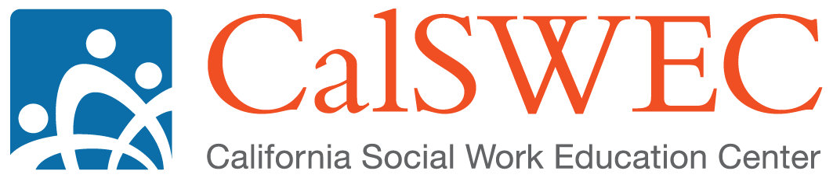

***Common Core 3.0 Talking Points***

1. **Current Common Core For New Child Welfare Social Workers in California**
   1. The Common Core for new social workers was developed as part of the first CFSR / PIP process to address the need for standardized training. The PIP included two key requirements for Common Core
      1. it must be statewide standardized training for all new social workers
      2. it must be evaluated to show that it is effective
   2. The first version of Common Core (version 1.0) launched in 2005
   3. Common Core content is currently organized by stand-alone key topic areas identified as priority topics for new social workers.
      1. There are 6 topics with standardized content (learning objectives, trainer tips, training content, powerpoint slides, etc.)
      2. There are 14 topics standardized only to the level of the learning objectives. For these topics, regions develop their own curricula which must meet the identified learning objectives
2. **Impetus for Common Core Revision**  
   While evaluation shows that trainees gain knowledge and skills about the topics in current Common Core, new social workers need more help putting these topics together into skill-based social work practice with families. In an effort to address this concern, a statewide group embarked on a collaborative process to revise Common Core (we call it Common Core 3.0).
3. **Re-imagining Core Training**
   1. CC3.0 introduces three changes to help ground the training in social work practice:
      1. **Focus on Practice Areas as a framework for the training**
      2. **Use of multiple modalities**
      3. **Sequencing content to reinforce training after some time in the field**
4. **Focus on Practice Areas**

The training is divided into practice areas to provide social workers with integrated practice skills in 5 key practice areas.

* 1. It starts by providing a foundation of concepts and key information that are interwoven throughout practice (e.g., teaming, ethics, federal and state laws) and then centers training on five key practice areas:
     1. Engagement
     2. Assessment
     3. Service Planning
     4. Monitoring and Adapting
     5. Transition
  2. These practice areas were identified because they incorporate concepts from the most significant practice innovations affecting child welfare in California:
     1. The Child Welfare Core Practice Model currently in development
     2. Katie A.
     3. the California Partners for Permanency project
     4. Safety Organized Practice

1. **Shifting Modality**  
   Beyond re-imagining the way social work practice is presented in core, the Common Core 3.0 concept also incorporates a wider range of training modalities, including
   1. on-line knowledge based learning
   2. classroom skill based learning
   3. field learning

This involves shifting some knowledge-based content outside the classroom with online learning modalities, using classroom time to focus on skill based training, shifting some skill-based content outside the classroom with field training.

Through these modalities, Common Core 3.0 will provide new social workers with opportunities to focus on skills in the classroom and reinforce skills with application of concepts in the field.

1. **Sequenced Content (100/200 Levels)**
   1. New social workers will start with a series of 100 level content courses for each practice area. This will provide the entry level knowledge social workers should have as soon as possible after hire.
   2. After some field experiences social workers will receive additional 200 level training providing more in-depth skill practice.

Following completion of 100 level content, social workers will be introduced to the field through 21 directed field experiences with field advisors to support field-based learning.  After completing the field activities, trainees return to the classroom for additional training to deepen knowledge and skills.

1. **Common Core 3.0 Evaluation**
   1. Knowledge tests will continue for select areas, the primary focus will be on evaluating key practice skills
   2. Stakeholders and the revision planning group identified new social workers' skill acquisition in two areas as evaluation priorities:
      1. Accurate assessment of safety and risk
      2. Developing strength-based, achievable case plan activities grounded in assessment of strengths and needs as the first areas to evaluate
2. **Where are we in the revision process?**
   1. We completed a stakeholder feedback process to finalize the content for CC3.0
   2. CalSWEC is developing the content for the assessment block this year
   3. Regional training academies are developing content for the other blocks over the next two years
   4. Curriculum vetting will start in November 2014
   5. Piloting will start in March 2015
   6. Common Core 3.0 will be fully implemented by the end of fiscal year 16-17
3. **Next Steps**
   1. Over the next 2 years, CalSWEC, CDSS, training academies, and counties will be working together to prepare for CC3.0 implementation. This includes:
      1. Building county capacity for field training
      2. Building systems to support online learning and CC3.0 sequencing
      3. Developing trainer knowledge and skills to support CC3.0
   2. Identify your next steps to prepare for CC3.0 implementation. Think about:
      1. Who will serve as field advisors in your county?
      2. How will you ensure new workers have access to identified field experiences?
      3. How will you ensure new workers have protected time to complete elearning modules?

To see all the learning objectives for CC3.0, visit http://calswec.berkeley.edu/common-core-30