Listing-level cage-free check on Spain’s top-5 grocery retailers – 2026-Q2
Snapshot 2026-05-04. n = 67 chicken shell-egg SKUs across Mercadona, Carrefour, Lidl, Eroski (with subsidiary Caprabo) and DIA. Quarterly rerunnable scraper at scraper/.
A SKU (stock-keeping unit) is a single unique product listing in a retailer’s online catalogue, identified by a distinct product name and package configuration (e.g., “Huevos camperos L EROSKI 12u” is one SKU). The analysis counts SKUs, not units sold.

Method
The scraper records every chicken shell-egg SKU listed on each retailer’s online catalogue (Spain-specific sites: mercadona.es, carrefour.es, eroski.es, caprabo.es; DIA via the Soysuper.com aggregator because dia.es blocks automated access; Lidl has no online shell-egg listings). Each SKU is classified by EU production code (0 organic, 1 free-range, 2 barn, 3 caged) using an explicit production-system field where available (Carrefour Tipo de produccion; Mercadona mandatory_mentions; Eroski / Caprabo product-detail caracteristicas), otherwise by keyword in the SKU name (ecologico, campero, suelo, jaula and Catalan equivalents). SKUs with no signal are flagged unknown.
Two central estimates are reported because each makes a different assumption about unknown-class SKUs:
- CF (0%) – treats every unknown as not-cage-free. Conservative lower bound. Wilson 95% CI included.
- CF (33%) – each unknown SKU is counted as 0.33 cage-free, anchored to Spain’s national production cage-free share (approximately 33%, WATTPoultry 2023). Formula: (cf + unknown * 0.33) / n. Reflects the premise that unlabelled Spanish egg SKUs are more likely caged than cage-free.
Each estimate is compared against the prior (50% CI from EggTrack 2024, OBA, and retailer disclosures) to flag retailers whose observed listing mix diverges from reported cage-free shares.

Results
Table 1. Cage-free share estimates by retailer.
Retailer | n | Mix (0/1/2/3/?) | Prior (50% CI) | CF (0%) | CF (33%)
Mercadona | 7 | 0/2/0/4/1 | 65 (62–68) | 29 | 33
Carrefour | 11 | 2/4/5/0/0 | 100 (98–100) | 100 | 100
Lidl | 0 | n/a | 100 (99–100) | – | –
Eroski | 20 | 2/4/8/1/5 | 43 (32–58) | 70 | 78
Caprabo | 19 | 5/3/9/0/2 | 100 (95–100) | 89 | 93
DIA | 10 | 1/1/4/0/4 | 58 (52–63) | 60 | 73
CF (0%): unknowns counted as not cage-free (= conservative lower bound). CF (33%): each unknown counted as 0.33 cage-free (anchored to Spain’s national cage-free production share of approximately 33%). Prior from EggTrack 2024, OBA May 2025 benchmark, and retailer disclosures.
Of the 5 retailers with listings data, 2 have their CF (0%) inside the prior 50% CI (Carrefour, DIA) and 1 has its CF (33%) inside it (Carrefour). With a well-calibrated 50% CI, 2–3 out of 5 falling inside would be expected; the low count for CF (33%) suggests the prior estimates and listing-level data are measuring somewhat different things (volume-weighted corporate reports vs SKU counts).
Table 2. Production-code breakdown (chicken shell eggs only).
Retailer | n | 0 organic | 1 free-range | 2 barn | 3 caged | unknown
Mercadona | 7 | 0 | 2 | 0 | 4 | 1
Carrefour | 11 | 2 | 4 | 5 | 0 | 0
Eroski | 20 | 2 | 4 | 8 | 1 | 5
Caprabo | 19 | 5 | 3 | 9 | 0 | 2
DIA | 10 | 1 | 1 | 4 | 0 | 4
Carrefour matches the prior cleanly. All 11 unique SKUs across Madrid + Barcelona postcodes expose Tipo de produccion on the detail page; classification is 100% explicit, all cage-free. The 100% point estimate sits inside the 98–100 prior.
Mercadona shows the largest negative gap. Four of seven shell-egg SKUs carry the regulator-required criadas en jaulas (“caged hens”) disclosure; two are camperas (free-range); one 24-pack is unclassified. CF (0%) gives 29% (Wilson 95% CI: 8–64%); CF (33%) gives 33%, 32 pp below the prior of 65%. Three non-exclusive explanations could reconcile the gap: (1) corporate figures report sales-volume share, not SKU count, and the two camperas lines may carry disproportionate volume; (2) regional warehouse variation – the scraper queries a single Madrid warehouse (mad1), while Mercadona operates 15+ regional hubs with potentially different assortments; (3) reporting lags the current shelf state. OBA’s May 2025 benchmark also reports 65% cage-free for Mercadona. Mercadona’s public commitment was 100% cage-free by end-2025 (slipped from end-2022); if the 65% figure is accurate, it implies roughly a third of volume still to transition.
Eroski and DIA: priors appear too pessimistic. Eroski’s 43% blended prior (35% Eroski-standalone + 100% Caprabo) rests on an eight-year-old 2018 FRS baseline, the weakest prior in this analysis. Detail-page enrichment found 14 cage-free, 1 caged, 5 unknown out of 20 shell-egg SKUs; even a 50/50 split on unknowns gives approximately 83%, well outside the 32–58 band. Eroski’s EINF 2021 already reported 57% cage-free, and OBA cites Eroski’s self-reported approximately 63% (Eroski blog, March 2026), so the 35% FRS anchor understates Eroski’s position by 25+ pp even before listings data is considered.
DIA CF (0%) (60%, own-brand SKUs via Soysuper) is close to its prior (58%, own + national brands), but the four unqualified own-brand packs (Huevos M Dia / Huevos L Dia) are heavily category-correlated: if retailer behaviour is “label cage-free SKUs, leave caged ones unqualified,” the true share is likely closer to CF (0%) (60%) than CF (33%) (73%). Two caveats: Soysuper covers DIA-brand SKUs only, not third-party brands DIA stocks; and the unknown SKUs are all unqualified “Huevos categoria A clase X” packs, so their housing status will likely resolve together rather than independently.
Combined, Eroski and its Catalan subsidiary Caprabo list 39 shell-egg SKUs (7 organic, 7 free-range, 17 barn, 1 caged, 7 unknown).
Caprabo (n=19, Eroski’s Catalan subsidiary) has a CF (33%) of 93%, just below the 95–100 prior band; the 2 unknown SKUs pull it slightly under, but CF (0%) (89%) still has a 95% CI (69–97%) overlapping the prior. Lidl is not shown here: lidl.es does not list fresh shell eggs online.
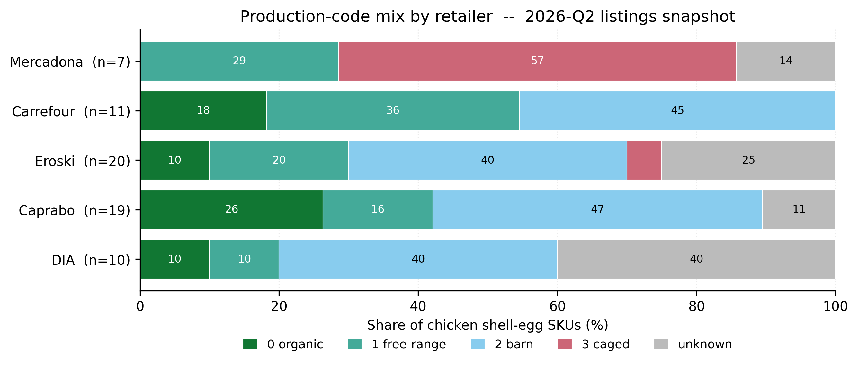 Figure 1. SKU-level production-code mix per retailer (chicken shell eggs only). Mercadona and Eroski are the only retailers with explicitly caged SKUs (4 and 1 respectively); DIA and Eroski carry the highest unknown-classification share. Lidl excluded (no online shell-egg listings).
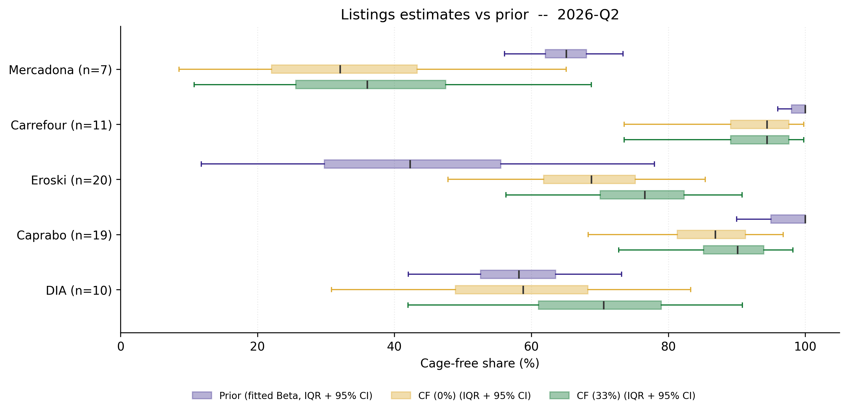 Figure 2. Listings estimates versus prior. Blue boxes = prior (Beta fitted to central + 50% CI); amber boxes = CF (0%) posterior Beta(cf+1, n-cf+1); green boxes = CF (33%) posterior Beta(cf+unknown/3+1, n-cf-unknown/3+1). Each box shows IQR (25th-75th percentile); whiskers = 95% credible interval (2.5th-97.5th).

Interpreting the cage-free estimates
The two estimates should not be read in isolation:
- CF (0%) understates cage-free share. Treating every unknown as caged is conservative. Some cage-free SKUs may lack explicit labelling simply because the retailer’s catalogue system does not surface the information – a data-quality gap, not a housing-system signal. For retailers like Eroski, where 5 of 20 SKUs are unknown but 14 are already classified cage-free, treating all unknowns as caged is implausibly conservative. CF (0%) is best suited for external communications where a defensible lower bound is needed.
- CF (33%) provides a middle-ground estimate but should be validated. Each unknown SKU is counted as 0.33 cage-free, anchored to Spain’s national cage-free production share (approximately 33%, WATTPoultry 2023). For Mercadona (2 cage-free, 4 caged, 1 unknown), CF (33%) gives 33% – only 4 pp above CF (0%) because the unknown share is small. For DIA (6 cage-free, 0 caged, 4 unknown), CF (33%) gives 73% versus CF (0%)’s 60% – a 13 pp difference because unknowns are 40% of the sample and the allocation assumption matters more. Retailers have a marketing incentive to label cage-free products explicitly (“campero,” “ecologico,” “de suelo”), so unlabelled SKUs are more likely caged than cage-free; neither estimate should be taken at face value when unknown shares exceed 20%.
For retailers with few unknowns (Carrefour: 0; Caprabo: 2), the two estimates converge and this distinction is immaterial.

Conclusions
Of the 5 retailers with both listings data and a prior estimate, 1 (Carrefour) has its CF (33%) estimate inside the prior’s 50% CI. Four do not: Mercadona (32 pp below prior), Caprabo (7 pp below), Eroski (35 pp above), DIA (15 pp above). However, the CF (0%) Wilson 95% CIs are wide enough to overlap with the prior 50% CI ranges for all four, and for DIA the prior point estimate (58%) falls inside the CF (0%) 95% CI (31–83%). These gaps are therefore directionally informative but not statistically conclusive at conventional confidence levels given the small sample sizes (n = 7–20).
The asymmetry across the gaps is notable: Mercadona’s gap is downward (4 of 7 SKUs carry explicit criadas en jaulas), while Eroski’s and DIA’s gaps are upward and rest on small n with high unknown counts. For Eroski and DIA, CF (0%) estimates (70% and 60%) sit much closer to their priors.
Mercadona shows the largest gap between stated commitment and observed listing behaviour. With approximately 27% of Spain’s EUR 122 billion grocery market (NielsenIQ 2024; Kantar Worldpanel), its CF (33%) estimate of 33% sits 32 pp below the self-reported 65%. Even under the most generous allocation of unknowns, Mercadona is the only retailer in this sample where explicitly caged SKUs outnumber cage-free ones. Its original end-2022 cage-free commitment has slipped to end-2025. Mercadona’s scale means that its shortfall alone likely accounts for more caged-egg listings than the combined egg catalogues of Eroski and DIA.
Listing-level data is scarce for most retailers, and listings may not represent what is actually sold. This analysis counts SKUs, not sales volume. A retailer with 50% cage-free SKUs could still sell 80% caged eggs by volume if caged products are cheap, high-turnover own-brand lines. Corporate figures and EggTrack tracking are typically volume-weighted, so I treat divergence between listings and reported shares as informative but not as evidence of misreporting. On-site shelf audits and purchase-receipt surveys would be more reliable for establishing actual sales volumes.
On-site shelf audits would ground-truth these listing-level estimates. Eglitis & Kanepajs (2026) reported results from volunteer-conducted shelf audits across Latvian retailers. A similar volunteer-mobilized approach adapted for Spain’s top-5 retailers could close the gap between listing counts and volume shares.
Better data can also come through corporate engagement: cage-free share reporting can be made part of formal agreements during retailer negotiations. But independent on-site investigation remains valuable even with such agreements in place, particularly while standardized reporting practices have not been established across the industry.

Quarterly watchlist
Stable SKU IDs are written into the schema, so 2026-Q3 will distinguish true SKU additions / removals from label rewording. Specific items to track:
- Mercadona: any reduction in the four explicitly caged SKUs (sizes XL/L/L/M, all currently classified Jaula in the API).
- Eroski main: whether Huevos L EROSKI 18u, the single explicitly caged SKU, disappears from the catalogue.
- DIA: whether the four unqualified Huevos M Dia / Huevos L Dia packs become labelled (de suelo, camperos, etc.). Re-labelling toward cage-free would close the CF (0%) vs CF (33%) gap.
- Eroski prior update for Q3: replace the stale 2018 FRS 35% anchor with EINF 2021 (57%) or OBA current (approximately 63%) as the Eroski-main baseline in the blend formula. This reduces the 35 pp gap to a more realistic 15 to 21 pp.
- Carrefour: extension to additional postcodes (Andalusia, Valencia, Galicia, Canarias).

Key sources
Claim | Source | Tier | Supporting quote
Spain national production: 67% caged, 22% barn, 10% free-range, 1% organic (2023 flock) | WATTPoultry, “Egg sales, consumption break records in Spain” | 2 | “Spain houses 67% of its flock in enriched cages.”
Mercadona 65% cage-free, self-reported | OBA, Mercadona page (citing Mercadona July 2025 reporting) | 2 | Mercadona “repeated that its progress was at 65%, without offering a roadmap.”
Carrefour 100% fresh, 35% ingredient eggs | OBA, Carrefour page | 2 | “Carrefour is only at 35% in its commitment regarding the use of cage-free hen eggs as an ingredient in its private-label products.”
Eroski 35% cage-free baseline (2018) | FRS (Food Retail Spain) | 2 | 35% of Eroski’s egg sales from cage-free hens (12 Jun 2018).
Top-5 retailer market share ~51% of Spanish FMCG | Kantar Worldpanel, “Spain top 5 retail chains” | 1 | “Together account for more than half of total FMCG spend.”
Spain grocery spending 2024 = EUR 122 bn | ESM via NielsenIQ, “Spanish grocery spending hits record EUR 122bn” | 2 / 1 | NielsenIQ Consumer Trends 2024.
EU egg production codes (0 organic, 1 free-range, 2 barn, 3 caged) | European Commission, Marketing standards for eggs | 1 | EU regulatory framework.
Soysuper (DIA workaround source) | soysuper.com | 3 | Aggregator; used because dia.es is Akamai-blocked at the edge.
On-site investigation methodology for laying-hen cage-free verification | Eglitis & Kanepajs, 2026 | 2 | Field survey of Latvian retailers using volunteer-mobilized shelf audits.
Tier 1 = primary / regulatory / first-party corporate; Tier 2 = trade press citing primary or independent research; Tier 3 = aggregator or secondary.

Tools used and AI disclosure
Claude Code (Anthropic) was used for scraper development and drafting and editing of this report.

