

## **BLEKINGE TEKNISKA HÖGSKOLA** karlskrona, sweden

**June 01, 2015**

ET1446: SOFTWARE DEVELOPMENT FOR TELECOMMUNICATION SYSTEMS   
  
This is an installation guide for the enterprise system we developed “LetsTalk”. Following it, you will properly install and set the application, in order to be able to use it at your convenience.

INSTALLATION GUIDE V1.0

### **Group: SWAT Kats**

|  |  |
| --- | --- |
| Sokratis Papadopoulos | Jibraan Singh Chahal |
| Johannes Grohmann | Jyoti |
| David Alarcón Prada | Akanksha Gupta |
| Gautam Vij | Rohit Raghav |
| Inanc Gurkan | |

**Publication Date: June 01, 2015 Version Number: V1.0**

# INSTALLATION GUIDE

## **1. system requirements**

* MySQL 5.2 or higher
* JDK 8 or higher

## MYSQL INSTALLATION:

* Follow the link to find the latest mysql version: <https://dev.mysql.com/downloads/mysql/>
* Windows users: Use MSI (recommended)
* Linux users: Type the following in the terminal: sudo apt-get install mysql-server
* Go through the installation guide and set the username as “root” and password as “admin”

## JDK 8 INSTALLATION:

* Follow the link to find the latest JDK version: <http://www.oracle.com/technetwork/java/javase/downloads/index.html>
* It is only necessary to download JAVA SE 8u45

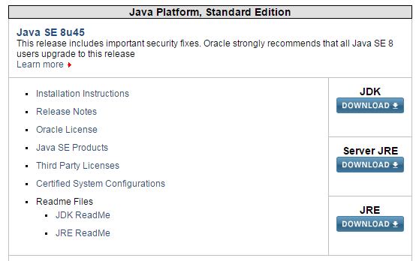

* Click on JDK –DOWNLOAD button and you will see the website where you can download the right version for your operation system.

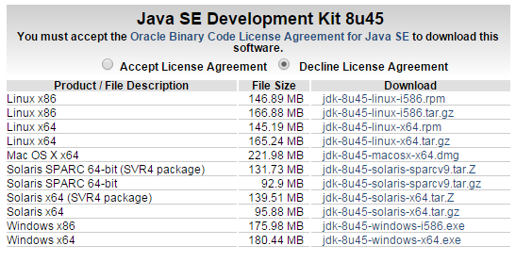

* e.g. for windows x64 select the corresponding .exe file, download and install it following the typical steps

## **2. RUNNING THE APPLICATION**

Once you have successfully completed the requirements and made sure that both Java MySQL & JDK 8 are properly installed on your system, you simply follow the next steps to run the application.

1. Run MySQL Server (if not started on system startup –then it’s running already).
   1. Find the path where it is installed.  
      *(usually C:\Program Files\MySQL\MySQL Server 5.6\bin)*
   2. Run a command window there.
   3. Run the command: mysql –u root –p
   4. Type “admin” as password
2. Run the jar file: LetsTalkServer.jar (this will start the server – run this only once).
3. Run the jar file: LetsTalk.jar (this will start the client)
4. In the login window appeared, enter as credentials (you will have admin rights):
   1. Username: admin
   2. Password: admin
5. The main window of the application should appear.

