

## **BLEKINGE TEKNISKA HÖGSKOLA** karlskrona, sweden

**May 20, 2015**

ET1446: SOFTWARE DEVELOPMENT FOR TELECOMMUNICATION SYSTEMS   
  
This document (SRS) is a description of our software system to be developed, laying out functional and non-functional requirements, and including a set of use cases that describe interactions the users will have with the software.

software requirements specification v1.4

### **Group: SWAT Kats**

|  |  |
| --- | --- |
| Sokratis Papadopoulos | Jibraan Singh Chahal |
| Johannes Grohmann | Jyoti |
| David Alarcón Prada | Akanksha Gupta |
| Gautam Vij | Rohit Raghav |
| Inanc Gurkan | |

**Publication Date: May 20, 2015 Version Number: V1.4**

# SOFTWARE REQUIRMENTS SPECIFICATION

## **1. Preface**

This document contains a software requirements specification to create a chat client called “**LetsTalk**” for XtremeSecurity. The document is specifying the software requirements and use case which are to be executed by our team “**SWAT Kats**”.

In the following we will first provide a glossary with a list of abbreviation in chapter 2. After that, we develop the system architecture that we are going to follow in section 3. Lastly, we analyse the software requirements for our project.

## Version history of this document:

***Release v1.4 on 2015-05-20***

- Added requirement 11 and requirement 12 in user requirements section 4.1

- Added references in section 5.  
 ***Release v1.3 on 2015-05-14***

- Added requirement 4 and requirement 5 in user requirements section 4.1

- Added requirement 5 system requirements section 4.2

***Release v1.2 on 2015-05-05***

- In section 4.1 split old requirement 2 into requirement 2 and 3

- Added creation date and removed test attributes (will be defined in design document) from all requirements in section 4

- Modified Database section 3.3 focusing on *what* the product does and not *how*

- Added abbreviations on section 2

***Release v1.1 on 2015-04-30***

- Added requirement 7 on user requirements in section 4.1

***Release v1.0 on 2015-04-27***

- Initial release

## **2. Glossary and abbreviations**

In this section are defined technical terms that are in this document in alphabetical order.

* **Admin**: Administrator
* **ER diagram**: Entity Relationship diagram
* **ID**: identification
* **REQ**: requirements
* **USR**: User

**3. System architecture**

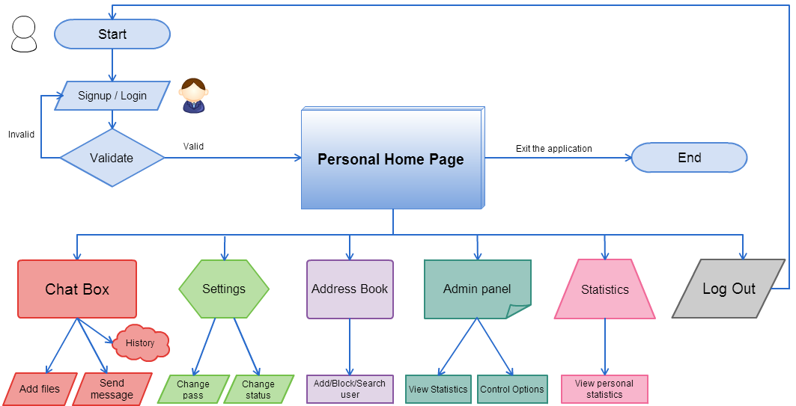Here is a **general flowchart** on how our application works:

3.1 USER CASES DIAGRAM

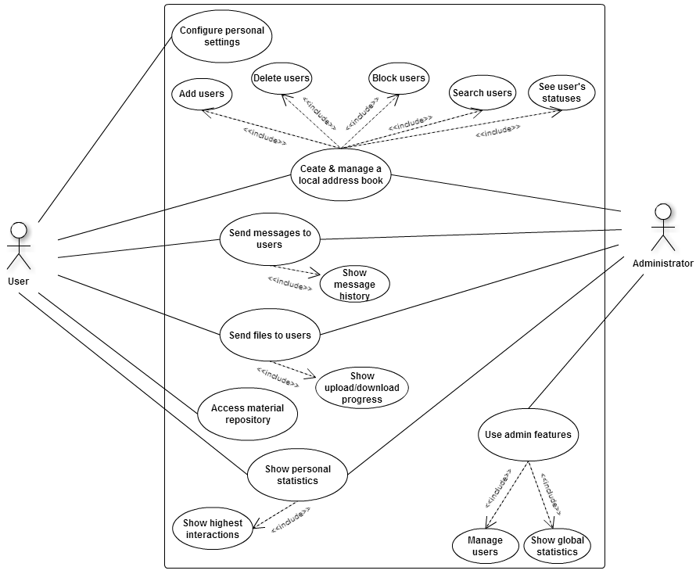Here we present the user cases, showing the activities that each user (and admin) can do with our software.

## 

## 3.2 GUI ARCHITECTURE

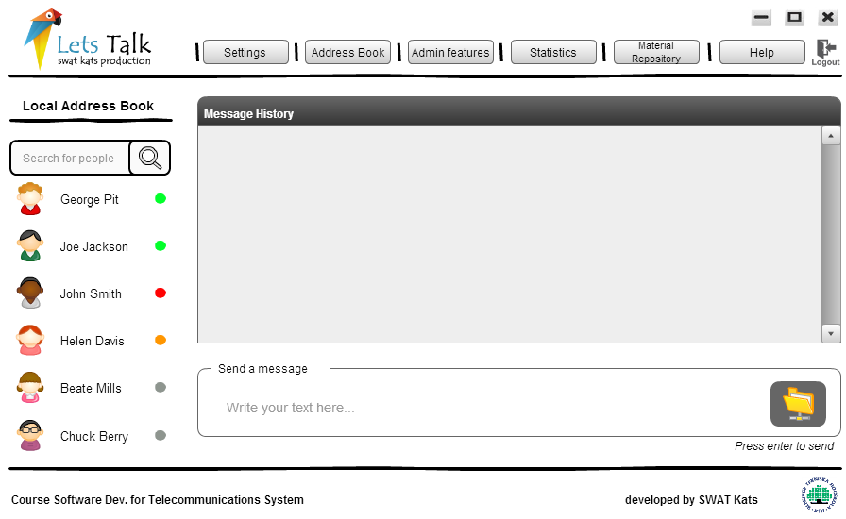Here is the home page architecture design.

## **4. requirements**

## 4.1 USER REQUIREMENTS

1. **Requirement ID**: REQ_USR_1  
   **Requirement**: Registered user must be able to login by inputting his information in login page.  
   **Creation date**:2015-05-05  
   **Module**: General  
   **Type**: functional  
   **Assignee**: Sokratis Papadopoulos (GUI), Johannes (Database Connection), Jibraan Chahal (Database)  
   **Description**:

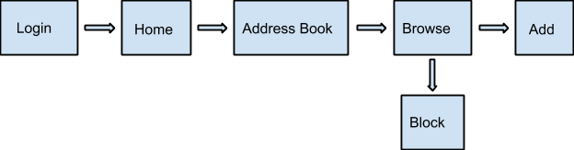

1. **Requirement** **ID**: REQ_USR_2  
   **Requirement**: Registered user must be able to add other registered users in his address book by selecting users from global address book.  
   **Creation date**:2015-05-05  
   **Module**: General  
   **Type**: functional  
   **Dependencies**: REQ_USR_1  
   **Assignee**: David Alacron Prada (GUI) ,Rohit Raghav (Database)
2. **Requirement** **ID**: REQ_USR_3  
   **Requirement**: Registered user must be able to block users in his address book.  
   **Creation date**:2015-05-05  
   **Module**: General  
   **Type**: functional  
   **Dependencies**: REQ_USR_1  
   **Assignee**: David Alacron Prada (GUI) , Gautam Vij (Database)
3. **Requirement** **ID**: REQ_USR_4  
   **Requirement**: Registered user must be able to remove other registered users from his local address book.  
   **Creation date**:2015-05-05  
   **Module**: General  
   **Type**: functional  
   **Dependencies**: REQ_USR_1, REQ_USR_2  
   **Assignee**: David Alacron Prada (GUI) ,Rohit Raghav (Database)
4. **Requirement** **ID**: REQ_USR_5  
   **Requirement**: Registered user must be able to unblock users from his block list.  
   **Creation date**:2015-05-05  
   **Module**: General  
   **Type**: functional  
   **Dependencies**: REQ_USR_1, REQ_USR_2  
   **Assignee**: David Alacron Prada (GUI) , Gautam Vij (Database)
5. **Requirement** **ID**: REQ_USR_6  
   **Requirement**: A user will be able to change his status online/busy by clicking on status field.  
   **Creation date**:2015-05-05  
   **Module**: General  
   **Type**: functional  
   **Dependencies**: REQ_USR_1  
   **Assignee**: David Alarcon Prada (GUI), Akanksha Gupta (Texting / File transfer)
6. **Requirement** **ID**: REQ_USR_7  
   **Requirement**: A user will be able to configure his account, eg changing password.  
   **Creation date**:2015-05-05  
   **Module**: General  
   **Type**: functional  
   **Dependencies**: REQ_USR_1  
   **Assignee**: Sokratis Papadopoulos (GUI), Inanc Gurkan (Database)
7. **Requirement** **ID**: REQ_USR_8  
   **Requirement**: System will allow a user to send text/files to his contacts.  
   **Creation date**:2015-05-05  
   **Module**: General  
   **Type**: functional  
   **Dependencies**: REQ_USR_1, REQ_USR_2  
   **Assignee**: Jyoti(texting/transfer) , Gautam Vij (Database) , David Alacron Prada(GUI)
8. **Requirement** **ID**: REQ_USR_9  
   **Requirement**:  System will allow an admin to view call records and relevant graphs.  
   **Creation date**:2015-05-05   
   **Module**: General  
   **Type**: functional  
   **Dependencies**: REQ_USR_1  
   **Assignee**: Jibraan Chahal (Database), Sokratis Papadopoulos (GUI)
9. **Requirement** **ID**: REQ_USR_10  
   **Requirement**:  System will allow an admin to add and remove users from the application’s database.  
   **Creation date**:2015-05-05   
   **Module**: General  
   **Type**: functional  
   **Dependencies**: REQ_USR_1  
   **Assignee**: Gautam Vij (Database), Sokratis Papadopoulos (GUI)
10. **Requirement** **ID**: REQ_USR_11  
    **Requirement**:  The system must be interactive and the delays involved must be less. So in every action-response of the system, there are no immediate delays. In case of opening windows forms and saving the settings there is delay much below 2 seconds.

**Creation date**:2015-05-05   
**Module**: General  
**Type**: Non - functional  
**Dependencies**: REQ_USR_1  
**Assignee**: Sokratis Papadopoulos (GUI), David Alacron Prada(GUI)

1. **Requirement** **ID**: REQ_USR_12  
   **Requirement**:  security is provided from unwanted use of recognition software.  
   **Creation date**:2015-05-05   
   **Module**: General  
   **Type**: Non - functional  
   **Dependencies**: REQ_USR_1  
   **Assignee**: Johannes (Database Connection)

## 4.2 System Requirements

1. **Requirement** **ID**: REQ_SYS_1  
   **Requirement**: For secure file and text exchange encryption of password, messages and files  
   **Creation date**:2015-05-05  
   **Module**: System  
   **Type**: Non Functional  
   **Description**: All the data sent from the client to the central database gets encrypted and saved in the database.  
   **Assignee**: Johannes Grohmann
2. **Requirement** **ID**: REQ_SYS_2  
   **Requirement**: Central database for user authentication information, user settings information  
   **Creation date**:2015-05-05  
   **Module**: Database  
   **Type**: Non Functional  
   **Description**: First insert in the database and retrieve data for authentication from the database.  
   **Assignee**: Jibraan Chahal (Database), Sokratis Papadopoulos (GUI), Akanksha Gupta
3. **Requirement** **ID**: REQ_SYS_3  
   **Requirement**: Central database for messages.  
   **Module**: Database  
   **Type**: Non Functional  
   **Description**: First insert all the messages in the database and retrieve again from the database to show those on other user’s screen.  
   **Assignee**: Gautam Vij (Database), David Alarcon Prada (GUI), Jyoti (File Transfer)
4. **Requirement** **ID**: REQ_SYS_4  
   **Requirement**: Connecting email and chat  
   **Creation date**:2015-05-05  
   **Module**: System  
   **Type**: Non Functional  
   **Description**: For offline chat, based on the message status (ie. if the message is unread and the user is offline, the user should be informed via email. This needs a connection between chat and email and the access to email account.   
   **Assignee**: Johannes Grohmann
5. **Requirement** **ID**: REQ_SYS_5  
   **Requirement**: Central database for white papers.  
   **Module**: Database  
   **Type**: Non Functional  
   **Description**: Data access permissions and retrieve data quickly   
   **Assignee**: Jibraan Singh Chahal (Database), David Alarcon Prada (GUI), Jyoti (File Transfer)

## **5. ReFERENCES**

* http://aakashtechsupportdocs.readthedocs.org/en/latest/nonfunc.html