

## **BLEKINGE TEKNISKA HÖGSKOLA** karlskrona, sweden

**June 01, 2015**

## **BLEKINGE TEKNISKA HÖGSKOLA** karlskrona, sweden

**June 01, 2015**

## **BLEKINGE TEKNISKA HÖGSKOLA** karlskrona, sweden

**June 01, 2015**

## **BLEKINGE TEKNISKA HÖGSKOLA** karlskrona, sweden

**June 01, 2015**

## **BLEKINGE TEKNISKA HÖGSKOLA** karlskrona, sweden

**June 01, 2015**

## **BLEKINGE TEKNISKA HÖGSKOLA** karlskrona, sweden

**June 01, 2015**

## **BLEKINGE TEKNISKA HÖGSKOLA** karlskrona, sweden

**June 01, 2015**

## **BLEKINGE TEKNISKA HÖGSKOLA** karlskrona, sweden

**June 01, 2015**

ET1446: SOFTWARE DEVELOPMENT FOR TELECOMMUNICATION SYSTEMS   
  
This is a user guide for the product Lets Talk, where we describe the available functionalities of the program. The aim of this document is to teach the program´s users & admins how to use this application.

USER GUIDE V1.0

### **Group: SWAT Kats**

|  |  |
| --- | --- |
| Sokratis Papadopoulos | Jibraan Singh Chahal |
| Johannes Grohmann | Jyoti |
| David Alarcón Prada | Akanksha Gupta |
| Gautam Vij | Rohit Raghav |
| Inanc Gurkan | |

**Publication Date: June 01, 2015 Version Number: V1.0**

ET1446: SOFTWARE DEVELOPMENT FOR TELECOMMUNICATION SYSTEMS   
  
This is a user guide for the product Lets Talk, where we describe the available functionalities of the program. The aim of this document is to teach the program´s users & admins how to use this application.

USER GUIDE V1.0

### **Group: SWAT Kats**

|  |  |
| --- | --- |
| Sokratis Papadopoulos | Jibraan Singh Chahal |
| Johannes Grohmann | Jyoti |
| David Alarcón Prada | Akanksha Gupta |
| Gautam Vij | Rohit Raghav |
| Inanc Gurkan | |

**Publication Date: June 01, 2015 Version Number: V1.0**

ET1446: SOFTWARE DEVELOPMENT FOR TELECOMMUNICATION SYSTEMS   
  
This is a user guide for the product Lets Talk, where we describe the available functionalities of the program. The aim of this document is to teach the program´s users & admins how to use this application.

USER GUIDE V1.0

### **Group: SWAT Kats**

|  |  |
| --- | --- |
| Sokratis Papadopoulos | Jibraan Singh Chahal |
| Johannes Grohmann | Jyoti |
| David Alarcón Prada | Akanksha Gupta |
| Gautam Vij | Rohit Raghav |
| Inanc Gurkan | |

**Publication Date: June 01, 2015 Version Number: V1.0**

ET1446: SOFTWARE DEVELOPMENT FOR TELECOMMUNICATION SYSTEMS   
  
This is a user guide for the product Lets Talk, where we describe the available functionalities of the program. The aim of this document is to teach the program´s users & admins how to use this application.

USER GUIDE V1.0

### **Group: SWAT Kats**

|  |  |
| --- | --- |
| Sokratis Papadopoulos | Jibraan Singh Chahal |
| Johannes Grohmann | Jyoti |
| David Alarcón Prada | Akanksha Gupta |
| Gautam Vij | Rohit Raghav |
| Inanc Gurkan | |

**Publication Date: June 01, 2015 Version Number: V1.0**

ET1446: SOFTWARE DEVELOPMENT FOR TELECOMMUNICATION SYSTEMS   
  
This is a user guide for the product Lets Talk, where we describe the available functionalities of the program. The aim of this document is to teach the program´s users & admins how to use this application.

USER GUIDE V1.0

### **Group: SWAT Kats**

|  |  |
| --- | --- |
| Sokratis Papadopoulos | Jibraan Singh Chahal |
| Johannes Grohmann | Jyoti |
| David Alarcón Prada | Akanksha Gupta |
| Gautam Vij | Rohit Raghav |
| Inanc Gurkan | |

**Publication Date: June 01, 2015 Version Number: V1.0**

ET1446: SOFTWARE DEVELOPMENT FOR TELECOMMUNICATION SYSTEMS   
  
This is a user guide for the product Lets Talk, where we describe the available functionalities of the program. The aim of this document is to teach the program´s users & admins how to use this application.

USER GUIDE V1.0

### **Group: SWAT Kats**

|  |  |
| --- | --- |
| Sokratis Papadopoulos | Jibraan Singh Chahal |
| Johannes Grohmann | Jyoti |
| David Alarcón Prada | Akanksha Gupta |
| Gautam Vij | Rohit Raghav |
| Inanc Gurkan | |

**Publication Date: June 01, 2015 Version Number: V1.0**

ET1446: SOFTWARE DEVELOPMENT FOR TELECOMMUNICATION SYSTEMS   
  
This is a user guide for the product Lets Talk, where we describe the available functionalities of the program. The aim of this document is to teach the program´s users & admins how to use this application.

USER GUIDE V1.0

### **Group: SWAT Kats**

|  |  |
| --- | --- |
| Sokratis Papadopoulos | Jibraan Singh Chahal |
| Johannes Grohmann | Jyoti |
| David Alarcón Prada | Akanksha Gupta |
| Gautam Vij | Rohit Raghav |
| Inanc Gurkan | |

**Publication Date: June 01, 2015 Version Number: V1.0**

ET1446: SOFTWARE DEVELOPMENT FOR TELECOMMUNICATION SYSTEMS   
  
This is a user guide for the product Lets Talk, where we describe the available functionalities of the program. The aim of this document is to teach the program´s users & admins how to use this application.

USER GUIDE V1.0

### **Group: SWAT Kats**

|  |  |
| --- | --- |
| Sokratis Papadopoulos | Jibraan Singh Chahal |
| Johannes Grohmann | Jyoti |
| David Alarcón Prada | Akanksha Gupta |
| Gautam Vij | Rohit Raghav |
| Inanc Gurkan | |

**Publication Date: June 01, 2015 Version Number: V1.0**

Contents

**1.** **Introduction** 3

**2.** **User Utilities** 3

2.1. Login 3

2.2. Settings 4

2.2.1. Change password 4

2.3. Status 6

2.4. Address Book 6

2.4.1. Add/Delete User 6

2.4.2. Block/Unblock User 9

2.5. Statistics 11

2.5.1. Check your stats 11

2.6. Material Repository 12

2.6.1. Open files database 12

2.7. Help 14

2.7.1. About 14

2.8. Chat 15

2.8.1. Sending Text Messages 15

2.8.2. Sending files 16

2.8.3. Group Chat 18

2.9. Others 20

2.9.1. Inactivity message 20

2.9.2. Send email to offline users 21

**3.** **Admin utilities** 21

3.1. Admin Features 21

3.1.1. Open Admin Panel 22

3.2. Material Repository 24

3.2.1. Open Files Database 24

**4.** **CONCLUSION** 24

## **Introduction**

The user guide is divided into several sections, in which you can navigate easily through the **Table of Contents** (just click on the section you want to see).

Each section represents a part of our application, explaining how to use it. There is a section for user utilities (chapter 2) that applies to all users and another one for admin utilities (chapter 3) that applies just to administrators.

## **User Utilities**

## Login

When the user run the program, the first action that he/she has to do is introduce his/her credentials (username and password) into the login window.

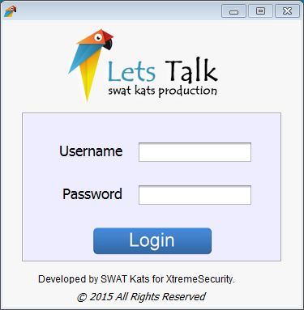

If he/she does not introduce his/her credentials properly a new window will be displayed informing accordingly and after that the user can introduce the credentials again.

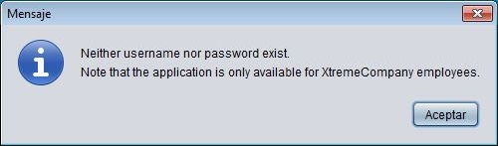

In case that the credentials are correct, the user will see the main window of the program.

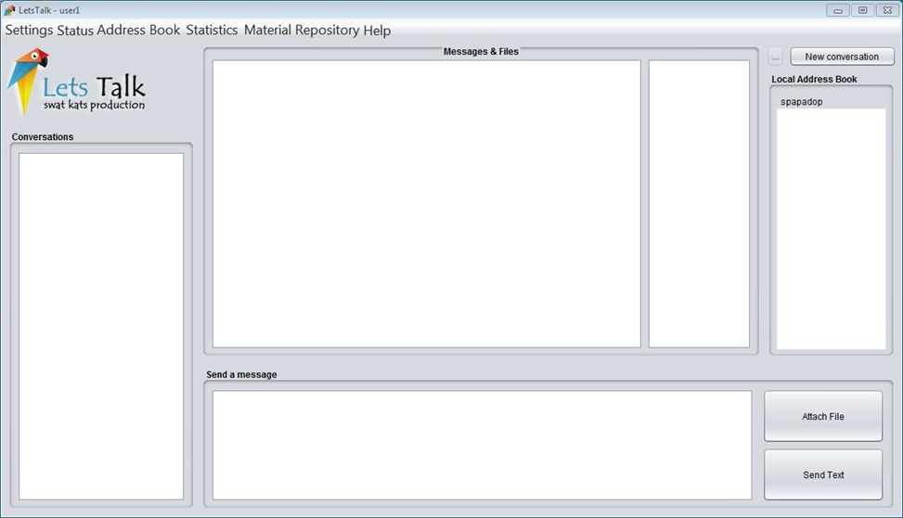

## Settings

On the top of the main window, the user can see different menu labels. The first of them is Settings where the user can change the password.

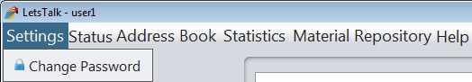

## Change password

If the user clicks on Change Password label…

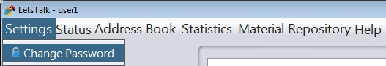

he/she will see the Change Password window.

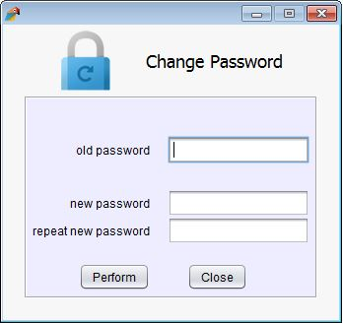

If the password is changed successfully, the user will see a successful message.

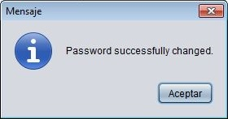

If the new password does not match in both fields (new password and repeat new password), the user will see an information message into a new window.

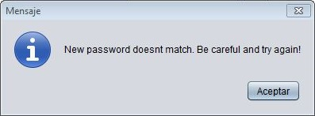

## Status

In the second menu label the user can change his/her status to Busy/Available. The default option is Available.

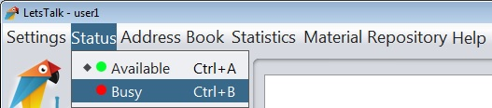

## Address Book

The third menu label available is for managing the local address book.

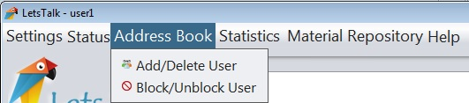

Here, the user can add/delete user and block/unblock them.

## Add/Delete User

If the user clicks on Add/Delete User.

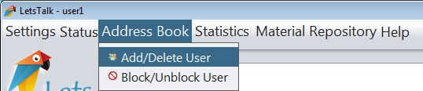

he/she will see the Add/Delete window.

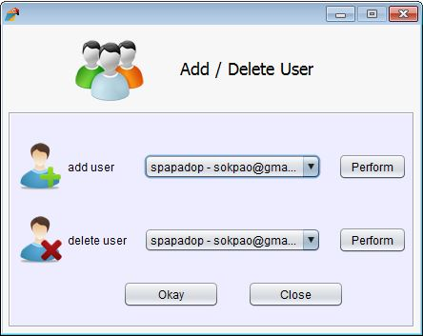

Clicking on add user list, the user can see all the users registered in the system.

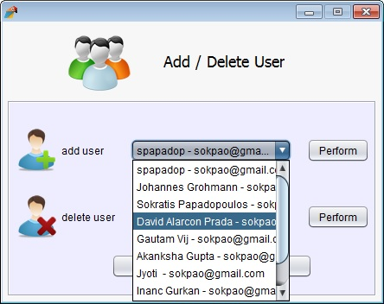

After the user selects one user to add, he/she has to press Perform button for the action to happen. He can then perform another addition if he/she likes.

Now, the user can see the user added into the Local Address Book on the right of the main window.

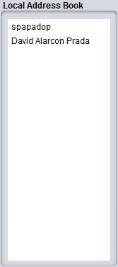

For deleting one user from the Local Address Book, the user must select one from the delete dropdown list and press perform. Then if he/she likes can perform another deletion.

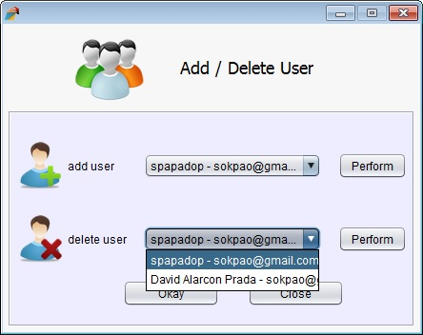

Now, the user can see on the Local Address Book that the user deleted has been removed.

## Block/Unblock User

If the user clicks on Block/Unblock user.

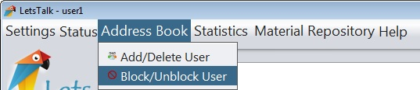

he/she will see the Block/Unblock window.

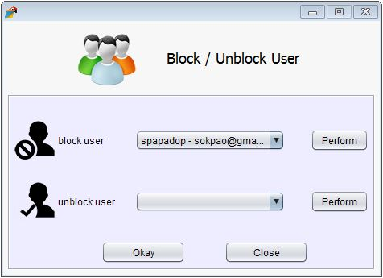

Clicking on the dropdown block user list, the user can see all the users saved in his/her local address book and select one to block.

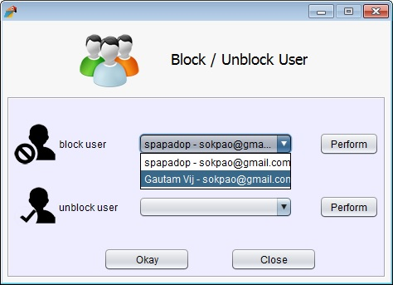

After the user selects one user to block, he/she have to press Perform. In case he wants he can now select another user to block as well. Now that user is blocked and he/she cannot send messages to the original user that blocked him/her (messages will be stored to database but will not appear to the original user, except if he decides at a later point to unblock him).

For unblocking a user of the local address book, the user must click on unblock user list and press Perform button. Multiple unblocks may be done as well in the same window by multiple performs.

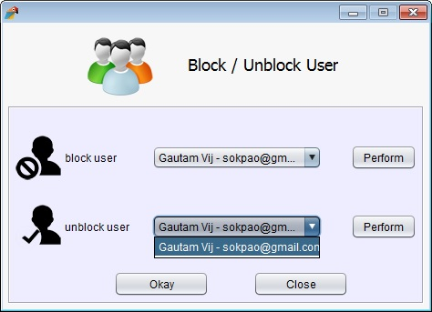

## Statistics

The fourth menu option available is referring to the personal user statistics of program’s usage..

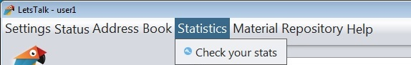

## Check your stats

If the user clicks on “Check your stats”…

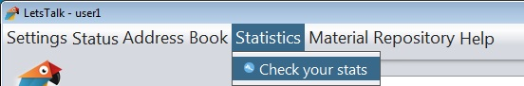

he/she will see the relevant window, where he can see the amount of messages exchanged with the top 10 users he interacted with and the sessions he stablished (session = from the time that a user logins until he logs out).

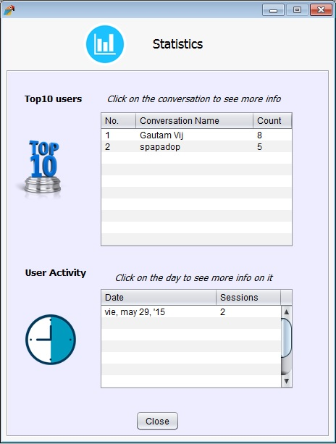

If the user clicks on other user name on the first table he/she will see a new window with the number of messages exchanged and the kind of these messages.

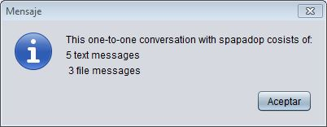

If the user clicks on a session of the second table, he/she will see information relative with it: amount of minutes /hours that he has been connected to the program that day.

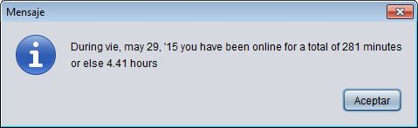

## Material Repository

The fifth menu option available is providing access to files in the Material Repository.

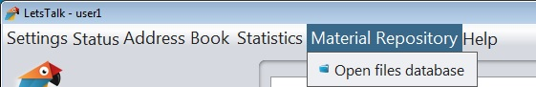

## Open files database

If the user clicks on Open files database…

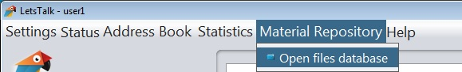

he/she will see a new window with the files available to download from the database.

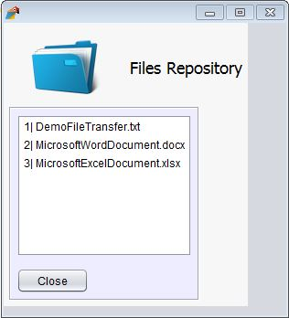

Clicking on one file, the user can save it in the folder that he/she wants.

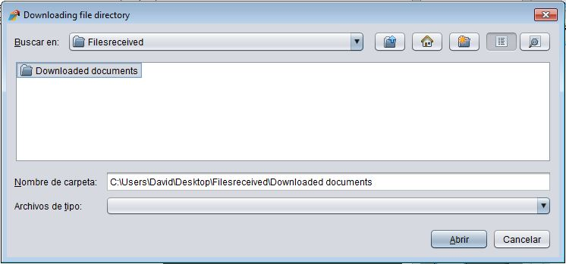

After that, the file will start to download showing the progress bar.

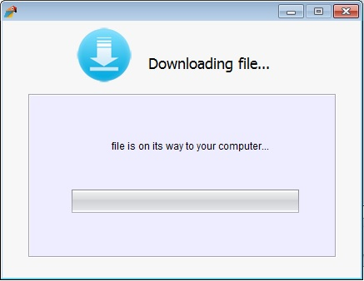

## Help

In the seventh menu label the user can see specific information of the program.

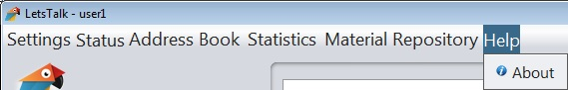

## About

If the user clicks on “About” label…

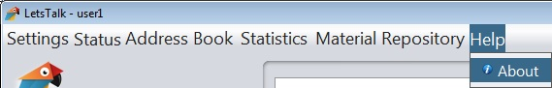

he/she will see the Info window, where he/she can read information of the program.

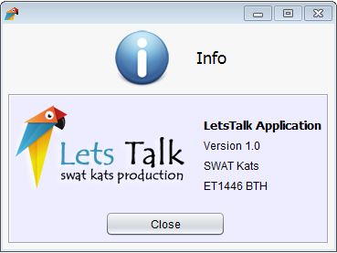

## Chat

## Sending Text Messages

In order to send text messages the user must have the receiver in his/her local address book (see 2.4 ADDRESS BOOK). If the receiver is already in the local address book, the user can create a new conversation with him selecting the properly button available on the main screen.

C:\Users\David\Desktop\Screenshots for users guide II\text messages.JPG

After that, the user will see a new window where he/she can select the receiver and press Create.

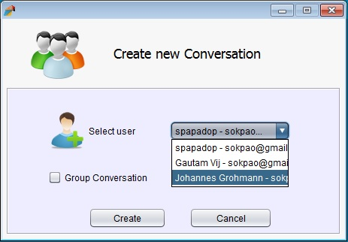

Now, the receiver will be available on the Conversation list on the left side of the main window.

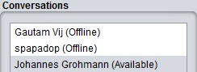

Selecting the appropriate conversation, the user can start to send and receive messages writing on the text panel situated in the low part of the main screen and pressing on the Send Text button (or enter key) to send it.

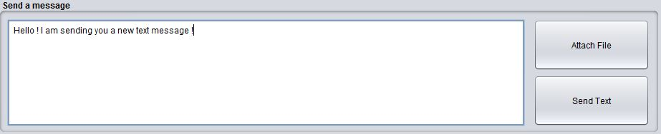

The user can read all the messages which belong to the same conversation in the main text area called Messages & Files.



If the user is speaking with one user and other user sends him/her a message, he/she will see a notification next to the sender user (on the Conversation list).

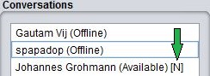

## Sending files

In order to send a file, the conversation must be created as we explained in the previous point. Now, the user can press on Attach file button. A new window will be displayed where the user can select the file which he/she wants to send.

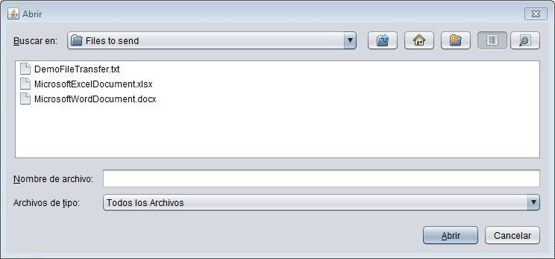

While the file is been sent, the user can see a progress bar and after that a successful message.



Both sender and receiver can see the file into the Messages & Files area.

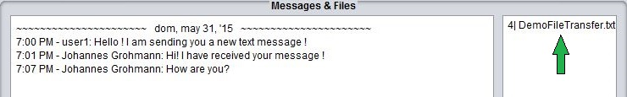

If the receiver clicks on a file a new window will appear in order to let him/her save the file into a specific folder in his computer.

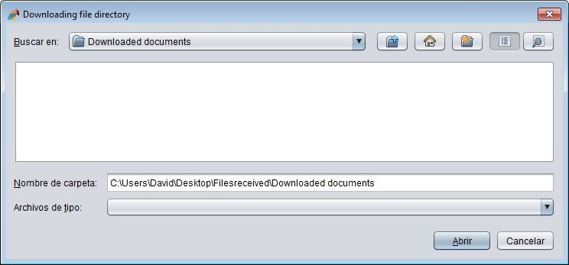

## Group Chat

In order to stablish a group chat conversation, the user must create a new conversation pressing in the New conversation button.

C:\Users\David\Desktop\Screenshots for users guide II\Group Conversation0.JPG

Now, he/she must select “Group Conversation” and provide a name.

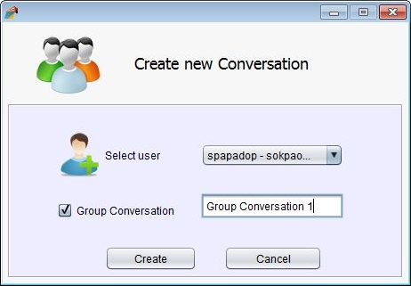

After that, in the Conversations list the user will see the group conversation created.

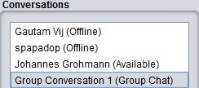

In order to add users to the group chat, the user must select the group conversation from the conversations list and press on the button next to the “New conversation” (that will now be clickable).

C:\Users\David\Desktop\Screenshots for users guide II\Group Conversation3.JPG

In this case, a new window will be displayed where the user can add other users selecting them and pressing Perform button.

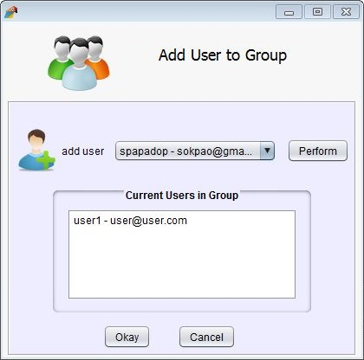

The user can see at any point the other users existing in the group conversation in the in Group panel.

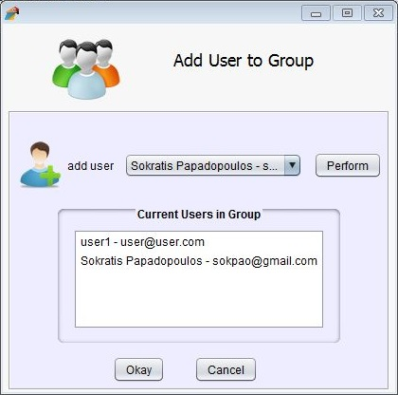

Finally group users can send and receive messages among them and see them in the Messages & Files panel. They can exchange files as we explained in the previous point.

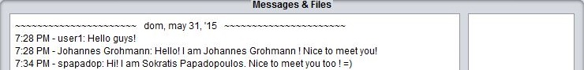

## Others

## Inactivity message

If the user stays inactive in the application (doesn’t do any click or interaction with it) over 1 minute, LetsTalk will set his status as idle and will provide him a message when he comes back in order to select his new status “Available/Busy”.

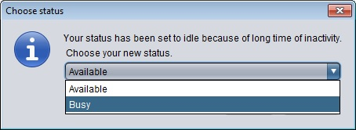

## Send email to offline users

In case a message is sent in a one-to-one or group conversation that includes people offline, an email will be sent to the email address they registered, as shown below.

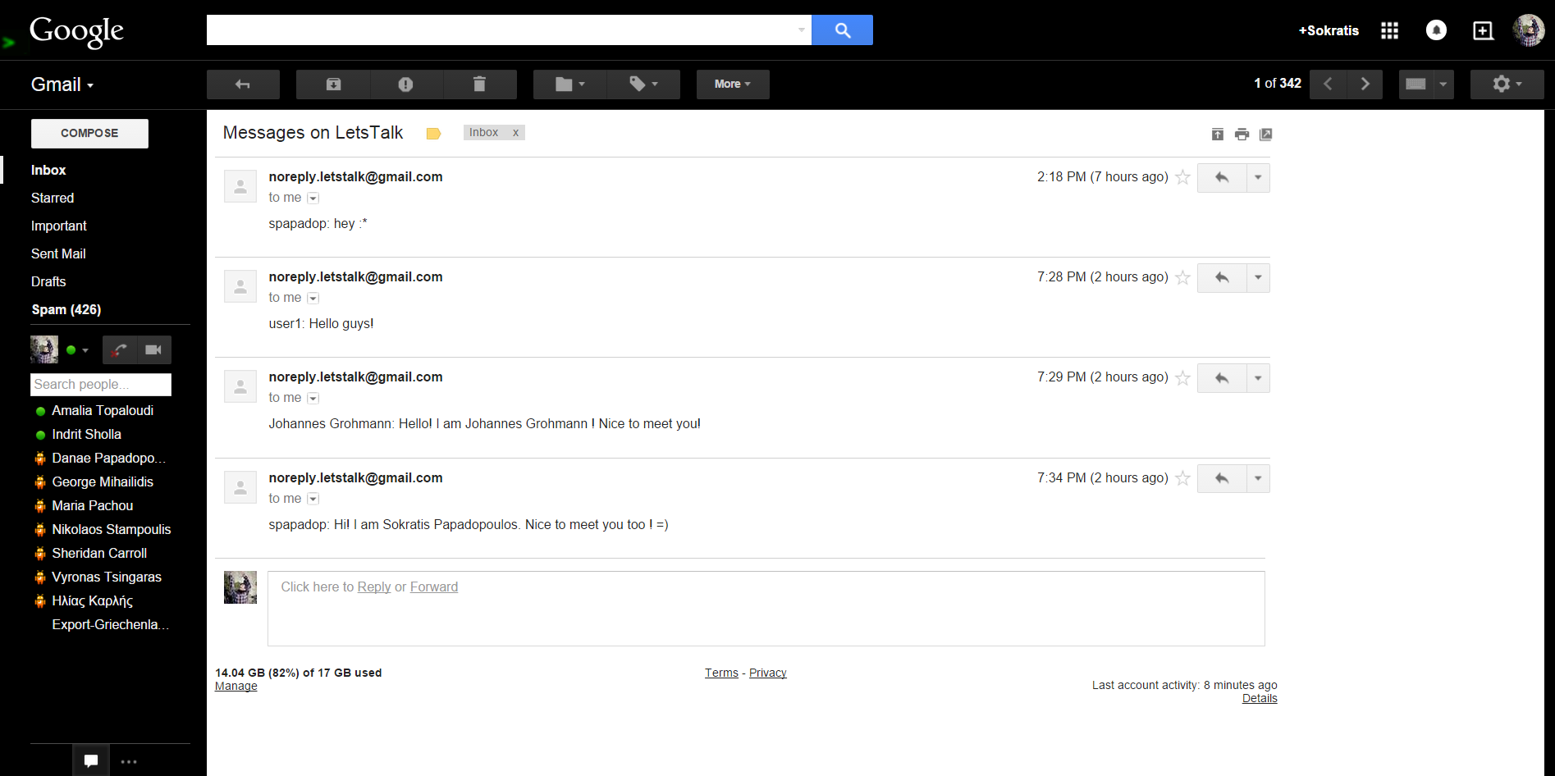

## **Admin utilities**

## Admin Features

The admin has special features, he/she can see it in the Admin Features menu label, which appears only to users identified as admins.

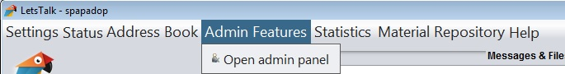

## Open Admin Panel

Clicking on “Open admin panel” the user will see a new window.

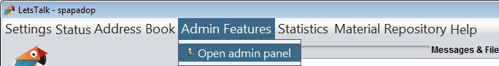

In this window the admin can:

* Add users to the global address book - application.
* Delete users of the global address book - application.
* See the call records of any conversation happened in the application.
* 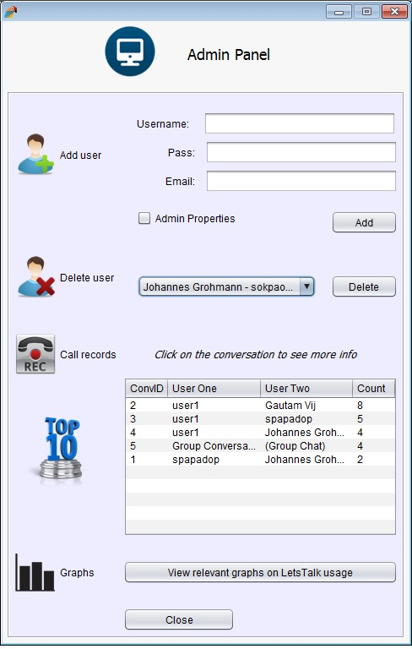 View graphs regarding the application usage.

Clicking on conversation of the Call Records table, the user can see all existing metadata regarding it.

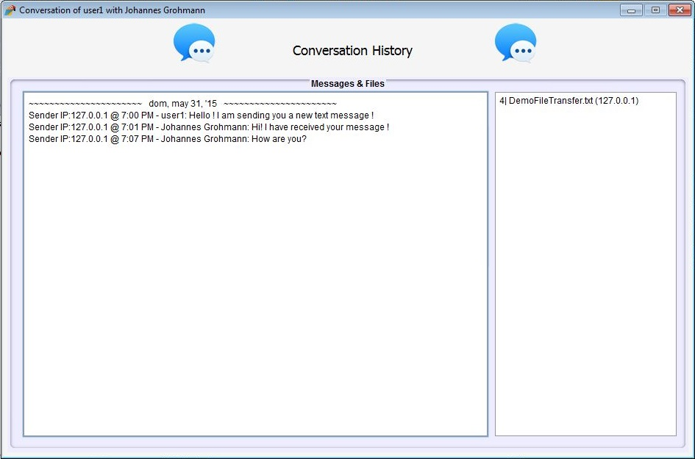

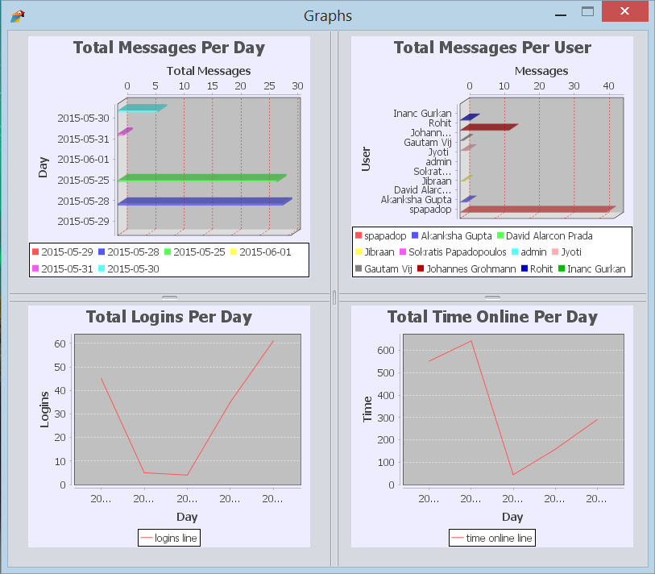Clicking on View relevant graphs on LetsTalk usage button, the user can see different kind of information showed in graphs.

## Material Repository

### The admin can access the files saved in the database clicking on Material repository label.C:\Users\David\Desktop\Screenshots for users guide II\materialRepository7.JPG

## Open Files Database

Clicking on the Open files database option…

### C:\Users\David\Desktop\Screenshots for users guide II\materialRepository8.JPG

the user will see displayed a new window where he/she can add files to the repository (or even download if he would like to).

### C:\Users\David\Desktop\Screenshots for users guide II\materialRepository6.JPG

## **CONCLUSION**

You must be able to use all functionalities of our application properly after reading through all guide. For any questions you may have please contact the SWAT Kats developer team. Find our contacts from your administrator.

**SWAT Kats**