AANN: Absolute Artificial Neural Network

Animesh Karnewar
Pune, Maharashtra – 411016, INDIA
animeshsk3@gmail.com

Abstract—this research paper describes a simplistic architecture named as AANN: Absolute Artificial Neural Network, which can be used to create highly interpretable representations of the input data. These representations are generated by penalizing the learning of the network in such a way that those learned representations correspond to the respective labels present in the labeled dataset used for supervised training; thereby, simultaneously giving the network the ability to classify the input data. The network can be used in the reverse direction to generate data that closely resembles the input by feeding in representation vectors as required. This research paper also explores the use of mathematical abs (absolute valued) functions as activation functions which constitutes the core part of this neural network architecture. Finally the results obtained on the MNIST dataset by using this technique are presented and discussed in brief.
Keywords—artificial neural networks, supervised learning, knowledge representation, Backpropagation.

Introduction
In the field of philosophy, there has been a principle known as ’Ockham’s Razor’ which, in a simplified relevant language states that “Among the available multiple solutions to the same problem, the simplest one is the best one”. For instance, if there are multiple polynomial functions that fit a given data distribution, the lowest degree one would be preferred [13]. The technique AANN is driven by this principle. In spite of being elementary in its construction, an AANN is able to classify inputs in the forward direction while being able to generate them back in the reverse direction. It can be visualized to be doing classification in the forward direction whereas performing a regression task in the backward direction.
A standalone GAN (Generative Adversarial Network) described in [3] is able to create representations of the input data by using a novel technique of generating a distribution that contains the original data points as well as data points generated by the Generator part of the network; the distribution is then used by the Discriminator part of the network to classify the data points as genuine or generated. The representations generated by a GAN, although being very effective in creating undistinguishable data points, are however not interpretable and are also highly entangled [2, 9]. Using an InfoGAN, the problem of entanglement is solved by training in such a way that the network maximizes mutual information within small clusters of related latent representations [2]. Auto-encoder is another technique that uses the concept of encoder-decoder architecture for creating low dimensional representations of the originally very high dimensional input data points. A VAE: Variational Auto-Encoder tries to make the learned representations sparse by using the KL-divergence cost as a regularizer on the final cost of an autoencoder [6]. Various attempts at combining the two techniques of GAN and VAE have also been made in the unsupervised as well as semi-supervised learning directions [9, 8]. However, these techniques kept getting more and more complicated and somewhere in synthesizing these techniques, it is felt that the ‘striving for simplicity’ principle has been neglected.
The Absolute Artificial Neural Network exploits all possible information available in the labeled training datasets to structure the learned representations of the input data. Structurally, an AANN is very similar to a feed forward Neural Network with the distinction that AANN uses the abs function as the activation function of the neurons. Due to this, all the activations produced, including the hidden layer activations, contain positive real number values. Thus, the network runs on the assumption that the input data as well as the label information comes from a positive data distribution. This doesn’t create an issue for the computer vision based tasks. However, for those situations, where this is not possible, the feature values in the input dataset can be easily moved into the positive region of the multi-dimensional input data space.

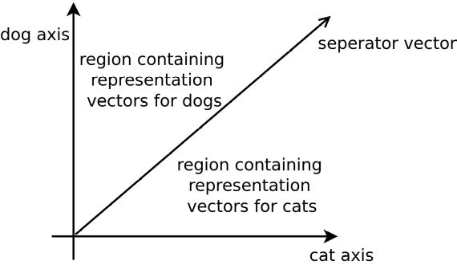
Figure 1: Example of learned representation space created by AANN

The AANN transforms the n-dimensional input data into a space whose number of dimensions are equal to the number of labels used in the training dataset. For instance, presume that, the task is to classify images of cats and dogs and there is a labeled dataset present for achieving this classification. So, the learned representations will contain two dimensions corresponding to each label: cat and dog. The input images are transformed into 2-dimensional vectors by the AANN in such a way that the vectors are as close as possible to their ideal axes. This is achieved by constructing the cost function in a manner that it maximizes the cosine value of the angle formed by the vector with its ideal axis. As a result, the representation space generated by this AANN can be visualized as shown in the Figure 1. The label axes in the representation space are mutually orthogonal; thus the resulting representation vectors become very interpretable.

AANN DESCRIPTION
Figure 2: Bidirectional artificial neuron: the building block of an AANN

The AANN is constructed by using a ’Bidirectional Neuron’ (Figure 2) as the building block for the hidden layers of a preliminary feed forward neural network. This bidirectional neuron uses the abs (mathematical absolute valued) function as the activation function. The computation performed by the neuron is similar in the forward and the backward directions. In the forward direction, the computation is given by:
A_{forward} = | (W_{left} * X_{in}) + b_{forward} |
Whereas, in the backward direction, the neuron computes:
A_{reverse} = | (W_{right} ∗X_{in_rev}) + b_{reverse} |
The weights of the hidden layers of the AANN in forward direction learn to compute a function for transforming the input data into the representation vectors. While in the reverse direction, the weights constitute a function for constructing data points that closely resemble the data points belonging to the input dataset from the representation vectors. It is highly intriguing, and at the same time enigmatic, that the same set of weights constitute two entirely distinct functions.

Forward Pass
The input n-dimensional feature vector is passed through the neural network consisting of hidden layers, constructed from the bidirectional neurons, to obtain an m-dimensional representation vector; where m corresponds to the number of labels. The obtained representation vector is then converted into a unit vector, which primarily corresponds to the cosines of the angles made by the representation vector with the coordinate axes. Finally, the forward cost J_{forward} can be computed as either the Euclidean distance or just the mean absolute difference, which is an estimate of the Euclidean distance, between the unit representation vector Y’ and the one-hot-encoded-label vector Y.
Figure 3: Forward pass of the AANN
The direction cosines of the vector can be obtained by using the formula:
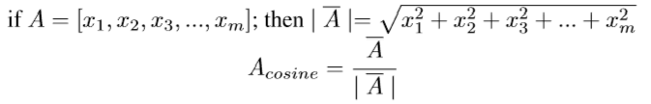
i.e. by scaling every activation value present in the representation vector by the inverse of the magnitude of the vector. This results in a unit vector that only corresponds to the direction of the original vector. As per the forward cost, it is intended to bring this direction vector as close as possible to the ideal label coordinate axis. Due to which, the label axis encodes the input information as representation vectors of different magnitudes converge on it. This visualization demonstrates how information gets encoded along the label axis in various real valued magnitude ranges. The visualization was generated by interpolating a small of range of values, precisely [0−80), along all 10 different axes corresponding to the 10 digits, present in an MNIST dataset, in a sequence by using a trained AANN. It is clearly evident from the visualization that the network creates more than just input output mappings; it creates a function of the learned representations as apparent from the smooth transitions between the different forms of a digit along its dedicated axis.
Figure 4: Reverse pass of the AANN

Reverse Pass
During the reverse pass of the AANN, the representation vector emitted by the network of hidden layers in the forward pass is fed back into the network in the reverse direction 3. The network then performs transpose operations to give off a new vector X’ in the input n-dimensional space. The reverse cost J_{reverse} is computed as either the Euclidean distance or the mean absolute difference between the vectors X’ and X. By deﬁning the reverse cost in such a way, it is intended to obtain the vector X’ as close as possible to the original input vector X. This accords the network the ability to generate data points in the input space in the reverse direction.

Training
The network is trained by using the Backpropagation [12] algorithm to minimize the ﬁnal cost J_{final}. The ﬁnal cost is deﬁned as the sum of the forward and the reverse costs.
J_{final} = J_{forward} + J_{reverse}
It is ultimately this cost with respect to whom the partial derivatives of the parameters are computed. The parameters are then adjusted by using the computed derivatives according to the Adam optimization as described in [5].
This action of performing the forward pass to calculate the forward cost followed by the reverse pass to obtain the reverse cost and then performing Backpropagation on the ﬁnal cost constitutes a single pass of the AANN. The term AANN: Absolute Artiﬁcial Neural Network, which is also the title of the paper, thus refers to this uniﬁed process of training a neural network in such a way.

Experimentation with other activation functions
This section attempts to succinctly describe the process of, and ﬁndings attained by, using other activation functions for the neural network architecture described in the previous section. Since the actual reasons why these activation functions behave in the manner that they do are not fully known, it has been tried to remain faithful while describing the experiments and not to make any unproven, or otherwise philosophical, remarks in this section. The programming implementations of these experiments have been made available at.
Upon using the ReLU, i.e. Rectiﬁed Linear-Unit, function [10] as the activation function for this architecture, all the activations shoot to nan in the forward direction leading to proliferation of nan in the reverse direction as well. If the Linear activation function is used, the network performs poorly in the forward direction, leading to very high classiﬁcation error rates, while, the network converges to the point that it outputs the same structure as shown in (b) of Figure 5 for every possible representation vector. On activating the hidden neurons with a ReLU in the forward direction and with an Abs in the reverse direction, the network kills all the activations, i.e. outputs the zero vector for every input, in the forward direction. In the backward direction, the network converges to the (c) structure. Upon using the Abs function in the forward direction and the ReLU in the backward direction, the network this time kills all the activations in the backward direction as visualized in (d). The (e) in Figure 5 is the output achieved by using the Sigmoid activation function in the network. The result obtained is very similar to the result of using Linear activation function, as in (b).
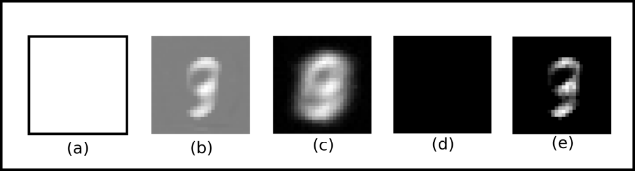
Figure 5: Images generated in the reverse direction by different activation function settings of an AANN. (a) Use of ReLU activation function. (b) Linear activation function. (c) ReLU in the forward direction and Abs in the backward direction. (d) Abs forward and ReLU backward. (e) Use of Sigmoid activation function.
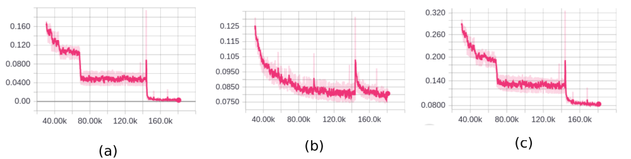
Figure 6: Cost plots obtained upon training the AANN on the MNIST digit dataset. (a) Forward cost. (b) Reverse cost. (c) Final cost.

resulsts on mnist dataset
The AANN architecture was trained on the MNIST digit recognition dataset, regarded as the ‘Drosophila’ of deep learning. This dataset is the standard dataset for experimentation and portraying new findings. It contains [(28 x 28) pixels] sized images of handwritten digits from 0 - 9. The programming implementation using the TensorFlow framework [1] has been made available at the aforementioned link.
There are 42000 images in the training set, of which, 95% were used for train set and remaining 5% images were used for the dev set. i.e. 39900 in the train set and 2100 in the dev set. The network was trained using the Adam [5] optimizer with α=0.001, β₁=0.9, β₂=0.999 and ε=10−8.
The network achieved a classiﬁcation accuracy score of 99.86% on the train set and 97.43% on the dev set in the forward direction. The unseen test set of this version of the dataset used contains another 28000 images for which the network achieved an accuracy of 97.671%. Figure 7 shows the images generated by the network in the reverse direction against the original images fed to the network. It is perceived that the capability of the network should not be evaluated only on the basis of its forward accuracy scores but should be evaluated on the basis of a uniﬁed metric that not only measures the network’s forward performance but also the faithfulness with which the network is able to generate input data points in the reverse direction.
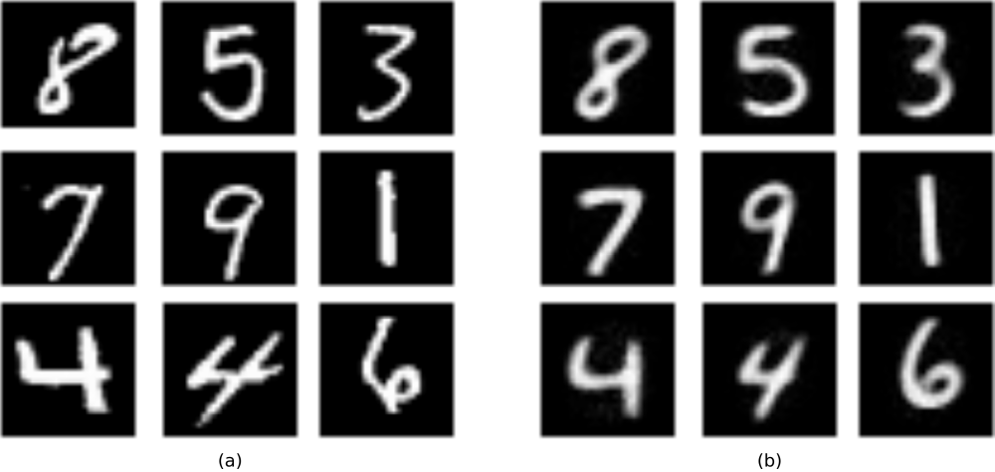
Figure 7: Outputs generated by the AANN in the reverse direction. (a) Original images fed into the network. (b) Images reconstructed by the network in the reverse direction.

Conclusion and future scope
This research paper put forth an elementary but potent neural network architecture, named as AANN, which has the ability to learn in the forward as well as the backward direction. It also proposed the Abs function as a viable activation function for neural network architecture. Due to lack of hardware resources, the experimentation had to be limited to the preliminary MNIST dataset, but it is ﬁrmly believed that the technique will perform equally well upon tackling other robust datasets, because of the theoretical evidence shown in the performed experiments.
The AANN presently encodes the information in real number valued ranges across the dedicated label axes in the representation space. Certain regularization functions can be synthesized in order to stretch these ranges so that more information can be incorporated in them. The number of dimensions of the learned representations can be manually controlled by setting certain number of dedicated axes to a single label and by modifying the forward cost function in such a way that the representation vectors lie inside the space generated by the coordinate axes dedicated to the ideal label. An in depth mathematical study of the Abs activation function could reveal the underlying behaviour of AANN. This forms the future scope for research.
This technique also opens up new research opportunities for considering the AANN architectural modiﬁcations to certain network architectures like [11] for semi-supervised learning. Moreover, it would be interesting to note the implications of applying the corresponding modiﬁcations to more advanced architectures such as Conv-nets [7] and Recurrent Nets with LSTM cells [4].

References
- M. Abadi et al. “Tensorflow: Large-scale machine learning on heterogeneous distributed systems”. Preliminary White Paper, 2015.
- X. Chen et al. “Infogan: Interpretable representation learning by information maximizing generative adversarial nets”. arXiv:1606.03657v1 [cs.LG], 2016.
- I. Goodfellow et al. “Generative adversarial nets”. arXiv:1406.2661v1 [stat.ML], 2014.
- S. Hochreiter and J. Schmidhuber. “Long short-term memory”. Neural Computation 9(8):1735-1780, 1997.
- D. Kingma and J. Ba. “Adam: A method for stochastic optimization”. arXiv:1412.6980v9 [cs.LG], 2017.
- D. Kingma and M.Welling. “Auto-encoding variational bayes”. arXiv:1312.6114v10 [stat.ML], 2014.
- A. Krizhevsky, I. Sutskever and G. Hinton. “Imagenet classification with deep convolutional neural networks”. In Proceedings of the Neural Information Processing Systems Conference, 2012.

- A. Larsen, S. Sonderby, H. Larochelle and O. Winther. “Autoencoding beyond pixels using a learned similarity metric”. arXiv:1512.09300v2, 2016

- A. Makhzani J. Shlens, N. Jaitly, I. Goodfellow and B. Frey. “Adversarial autoencoders”. arXiv:1511.05644v2, 2016.
- V. Nair and G. Hinton. “Rectified linear units improve restricted boltzmann machines”. In Proceedings of the 27 th International Conference on Machine Learning, Haifa, Israel, 2010.
- A. Rasmus, H. Valpola, M. Honkala, M. Berglund and T. Raiko. “Semi-supervised learning with ladder networks”. arXiv:1507.02672v2 [cs.NE], 2015.
- D. Rumelhart, G. Hinton and R. Williams. “Learning representations by back-propagating errors”. Nature, 323:533–536, October 1986.
- S. Russell and P. Norvig. “Artificial Intelligence A Modern Approach”, chapter 18: Learning from examples. Person publications, 3rd edition, 2015

By moving, it is referred to the process of ‘change of origin’ in the Cartesian mathematics.
https://www.youtube.com/watch?v=trtNOrrrXYg
https://github.com/akanimax/my-deity
nan: stands for ‘Not a Number’ in the programming terminologies
http://yann.lecun.com/exdb/mnist/

