Decoder with copy mechanism :

After Dispatcher state we have a final hybrid attention vector (at)... defined by following equation

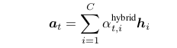

Here, C is the number of content word in a sample field-content pair. We take the maximum length field content pair and will padd with zeros for those samples which are having lesser number of field-content pair. Let Assume the maximum length is “98”. Then for all samples “alpha-t(hybrid)”
will be a dimension of (98 * 1) and “hi” are the hidden state output of encoder LSTM for i-th field-content pair.Let Assume “hi” have dimension (500 * 1). From above equation it is clear that “at” is having dimension of ( 500 * 1).(For this whole discussion I am not using batch size as a separate dimension.But In practice the dimension of “at” will be (batch size * 500 * 1).

At the input to the decoder RNN we have “xt” and “hidden state output of last time step at decoder LSTM”. “y(t-1)” is the embedding of the generated word in the last time step( we need to generate these embedding from the unique set of words from vocabulary of summary corpus UNION all content words for this data sample) .Let us assume the embedding dimension be “300”, And “xt” is defined by following equation:
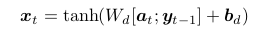

so, if we do column wise concatenation of these “at” and “y(t-1)” ,the resultant vector will have the dimension of ((500+300) * 1) ,i.e. (800 * 1). we will take the dimension of the weight matrix “wd” as (300 * 800) and the dimension of the bias matrix “bd” will also have the dimension (300 * 1).
And the resultant “xt” vector will have dimension ( 300 * 1).

According to the paper, we need to choose the hidden state output of decoder LSTM should be 500.
It is represented as “h(t) prime” in the paper. To compute the score we will be using this vector as shown in the following equation:

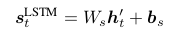

This is basically a fully connected network. The output “ s(t)LSTM” will be having a shape of
( unique set of words from vocabulary of summary corpus UNION all content words for this data sample * 1).

The weight matrix “Ws” will have the shape ( unique set of words from vocabulary of summary corpus UNION all content words * 500). And bias vector “bs” will be having a shape of ( unique set of words from vocabulary of summary corpus UNION all content words for this data sample * 1).

COPY MECHANISM: The equation for calculating copy score is given by the following equation:
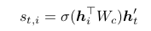

“st,i” is a real number for i = 1, · · · , C (the number ofcontent words). Here “Wc” is a parameter matrix, and “ht-prime” is the hidden state output of decoding LSTM at current time step.
“hi” is the hidden state output of encoder LSTM for i-th field content pair. So, “h” matrix having dimension of ( 98 * 500). “Wc” is having dimension of (500 * 500).And “ht-prime” is having a dimension of (500 * 1).

If a word w occurs multiple times in the table contents, the scores are added, given by

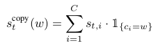

where 1 {c i =w} is a Boolean variable indicating whether the content word c i is the same as the word w we are considering.

FOR EXAMPLE : Suppose the current true “yt” does not belongs to content words for this data sample. Then “st-copy(w)” will be zero. But suppose “yt” belongs to content word at index 7. Then
“st-copy(w)” will be equal to “st,7”.

Finally, the LSTM score and the copy score are added for a particular word and further normalized to obtain a probabilistic distribution, given by
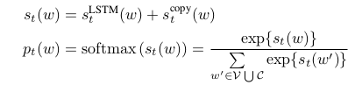

where V refers to the vocabulary list and C refers to the set of content words in a particular data sample.

For each time step t, the word with the largest probability is chosen, given by y t = argmax w p t (w). The decoding process terminates when a special symbol <eos> is generated, indicating the end of a sequence.

