Animacare: Project’s System Design, Algorithms, Dfd And Table Design
Part A: System Design
1. Architecture Overview
AnimaCare uses a 3-Tier Decoupled Client-Server Architecture:
Tier | Technology | Role
Presentation | React.js 18+ (Vite) | SPA Frontend, Role-based dashboards
Application | Django 4+ / Django REST Framework | RESTful API, Business Logic, JWT Auth
Data | PostgreSQL (AWS RDS) / SQLite (Dev) | Relational persistence
Storage | AWS S3 | Pet images, X-Rays, Prescriptions

2. Technology Stack
Frontend:
- React.js with Vite (fast HMR builds)
- React Router DOM (protected role-based routing)
- React Context API (AuthContext for global state)
- Vanilla CSS (module-scoped stylesheets)
Backend:
- Python 3.10+ / Django 4+
- Django REST Framework (serializers, viewsets)
- Custom JWT Authentication (CustomJWTAuthentication using PyJWT + HS256)
- Django ORM (model-driven schema)
Database:
- Production: PostgreSQL on AWS RDS — ACID-compliant, concurrent connections, automated backups
- Development: SQLite3 — Zero-config, file-based for fast local iteration
Cloud:
- AWS S3 — Media file storage (pet photos, diagnostic media)
- AWS RDS — Managed PostgreSQL hosting
3. Module Architecture (RBAC)
The backend is split into 7 Django apps, each serving a specific role:
Module | Django App | User Role | Purpose
1. Authentication | apps.users | All Users | Registration, Login, JWT tokens, Profiles
2. Pet Management | apps.citizens | Citizen | Pet registration, Pet Passport, ownership
3. SOS & Rescue | apps.citizens | Citizen + Civic | SOS alerts, shelter assignment
4. Adoption Portal | apps.shelter | Citizen + Shelter Admin | Browse animals, apply, review applications
5. Clinical Records | apps.clinical | Veterinarian | Consultations, vaccines, prescriptions, media
6. Analytics & AI | apps.analytics | All Roles | Compatibility scoring, health risk flagging
7. Governance | apps.governance | Super Admin | User approvals, audit trails, system health

4. API Routing Architecture
/api/auth/ → apps.users.urls (Login, Register, Profile)
/api/citizens/ → apps.citizens.urls (Pets, SOS Alerts)
/api/shelter/ → apps.shelter.urls (Inventory, Adoptions)
/api/clinical/ → apps.clinical.urls (Consultations, Vaccines, Rx)
/api/v4/ → apps.analytics.urls (AI Scoring, Health Dashboard)
/api/superadmin/ → apps.governance.urls (User Mgmt, Audit Logs)
/api/public-health/ → apps.public_health.urls (Outbreak Analytics)
5. Request Lifecycle
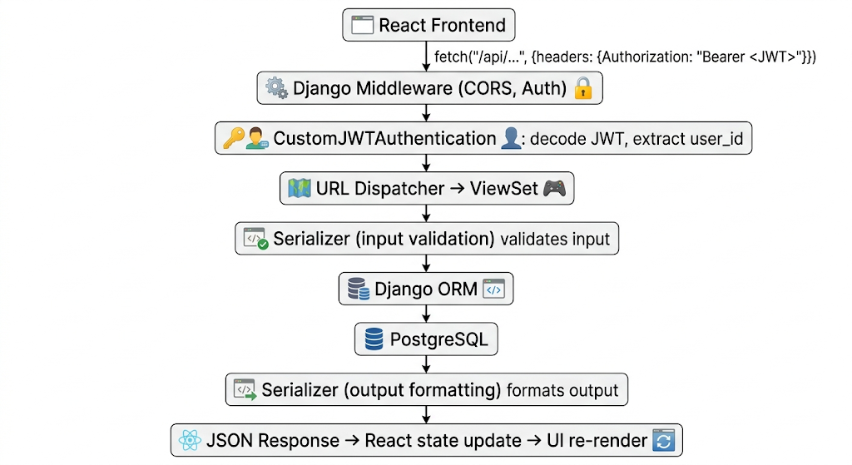
6. Authentication Flow
Registration:
User submits form → Validate fields → Hash password → Save to Users DB
→ If role is citizen: account_status = 'pending' (auto or active)
→ If role is vet/shelter/civic: account_status = 'pending' → Needs SuperAdmin approval
Login:
User submits email + password → Validate credentials against DB
→ If valid and account_status == 'active': Generate JWT (HS256, 30min expiry)
→ Return {access_token, refresh_token, user role}
→ Frontend stores token in AuthContext → Redirects to role-based dashboard
7. Security Architecture
Layer | Mechanism
Authentication | JWT Bearer tokens (PyJWT, HS256 signing)
Authorization | Role check in each View (request.user.role, is_superuser)
Data Integrity | SHA-256 hash on frozen vaccination and prescription records
Audit Trail | Immutable AuditTrail table logs all admin actions with IP
Media Security | AWS S3 pre-signed URLs for file access

Part B: Algorithms
Algorithm 1: Role-Based Access Control (RBAC)
Module: All API Endpoints (Middleware) Purpose: Prevent unauthorized access to role-restricted endpoints.
Pseudocode:
ALGORITHM: RBAC_Verify
INPUT: request (Authorization header, endpoint)
OUTPUT: ALLOW or DENY
BEGIN
token = request.headers["Authorization"].split("Bearer ")[1]
TRY
decoded = JWT.decode(token, SECRET_KEY, "HS256")
CATCH ExpiredError, DecodeError
RETURN DENY (401: "Invalid or expired token")
END TRY
user = DB.get(User, id=decoded.user_id)
role = user.role
PERMISSION_MATRIX = {
"citizen": [Pet_CRUD, SOS_Create, Adoption_Apply],
"veterinarian": [Clinical_CRUD, Prescription_Create, Media_Upload],
"shelter_admin": [Inventory_CRUD, Application_Review],
"civic_authority": [Analytics_View, Rescue_Dispatch],
"admin": [ALL_ACCESS] }
IF request.endpoint IN PERMISSION_MATRIX[role] THEN
RETURN ALLOW
ELSE
RETURN DENY (403: "Forbidden")
END IF
END
Complexity: Time O(n) where n = permissions per role, Space O(1)
Algorithm 2: Pet Duplicate Detection
Module: Citizens (apps.citizens) Purpose: Prevent accidental re-registration of the same pet by the same owner.
Pseudocode:
ALGORITHM: Register_Pet
INPUT: owner_id, pet_data (name, species, breed, dob, photo)
OUTPUT: new_pet_record OR duplicate_warning
BEGIN
IF pet_data.name IS EMPTY OR pet_data.species IS EMPTY THEN
RETURN Error(400, "Name and Species required")
END IF
existing = DB.query(
"SELECT * FROM Pet WHERE owner_id = ?
AND LOWER(name) = LOWER(?) AND species = ?",
owner_id, pet_data.name, pet_data.species
)
IF existing IS NOT EMPTY THEN
RETURN Warning("Similar pet already registered")
END IF
IF pet_data.photo EXISTS THEN
image_url = S3.upload(pet_data.photo)
END IF
new_pet = DB.insert("Pet", {
owner_id, name, species, breed, dob, media_url: image_url
})
RETURN new_pet
END
Complexity: Time O(n) where n = owner's pets, Space O(1)
Algorithm 3: Predictive Health Risk Flagging
Module: Analytics (apps.analytics) Purpose: Detect overweight/underweight risks by comparing a pet's current weight against breed-specific baselines.
Pseudocode:
ALGORITHM: Health_Risk_Analysis
INPUT: all_pets (list of Pet records)
OUTPUT: flags_created (integer count)
BEGIN
flags_created = 0
BREED_BASELINES = {
"Golden Retriever": {ideal: 30.0 kg, variance: 15%},
"Labrador": {ideal: 32.0 kg, variance: 15%},
"Pug": {ideal: 8.0 kg, variance: 10%}
}
FOR EACH pet IN all_pets DO
latest_record = pet.medical_records.latest("date")
current_weight = latest_record.weight_kg OR pet.current_weight_kg
baseline = BREED_BASELINES.get(pet.breed)
IF baseline IS NULL THEN CONTINUE
upper_limit = baseline.ideal * (1 + baseline.variance)
lower_limit = baseline.ideal * (1 - baseline.variance)
IF current_weight > upper_limit THEN
severity = "High" IF current_weight > upper_limit * 1.1 ELSE "Medium"
DB.insert("HealthRiskFlag", {
pet, risk_type: "Overweight", severity,
description: "Weight exceeds safe range for breed"
})
flags_created += 1
ELSE IF current_weight < lower_limit THEN
DB.insert("HealthRiskFlag", {
pet, risk_type: "Underweight", severity: "Medium",
description: "Weight below safe threshold for breed"
})
flags_created += 1
END IF
END FOR
RETURN flags_created
END
Complexity: Time O(n) where n = total pets, Space O(1)

Algorithm 4: SHA-256 Record Immutability (Vaccination & Prescription)
Module: Clinical (apps.clinical) Purpose: Ensure clinical vaccination and prescription records cannot be tampered with after finalization by generating a cryptographic hash.
Pseudocode:
ALGORITHM: Freeze_Clinical_Record
INPUT: record (VaccinationLog or DigitalPrescription)
OUTPUT: record with record_hash set
BEGIN
IF record.is_frozen == TRUE AND record.id IS NULL (new record) THEN
// Build a deterministic data string
IF record IS VaccinationLog THEN
data_string = record.vaccine_name + "-" +
record.batch_number + "-" +
record.date_administered
ELSE IF record IS DigitalPrescription THEN
data_string = STRING(record.medications) +
STRING(record.issued_date)
END IF
// Generate SHA-256 hash
record.record_hash = SHA256(data_string.encode("utf-8")).hexdigest()
END IF
DB.save(record)
RETURN record
END
VERIFICATION ALGORITHM:
To verify integrity later:
recompute_hash = SHA256(same_data_string)
IF recompute_hash == record.record_hash THEN
RETURN "Record is AUTHENTIC"
ELSE
RETURN "Record has been TAMPERED"
END IF
Complexity: Time O(1), Space O(1)
Complexity: Time O(1), Space O(1)
Algorithm 5: Adoption Application State Machine
Module: Shelter (apps.shelter) Purpose: Manage the lifecycle of an adoption application through defined states.
Pseudocode:
ALGORITHM: Process_Adoption_Application
INPUT: application_id, new_status, admin_user
OUTPUT: updated_application
BEGIN
app = DB.get("AdoptionApplication", id=application_id)
// Define valid state transitions
VALID_TRANSITIONS = {
"Pending" → ["Under Review", "Cancelled"],
"Under Review" → ["Interview Scheduled", "Approved", "Rejected"],
"Interview Scheduled" → ["Approved", "Rejected"],
"Approved" → [], // Terminal state
"Rejected" → [], // Terminal state
"Cancelled" → [] // Terminal state
}
IF new_status NOT IN VALID_TRANSITIONS[app.status] THEN
RETURN Error(400, "Invalid state transition")
END IF
app.status = new_status
DB.save(app)
// If approved, update animal status
IF new_status == "Approved" THEN
animal = app.animal
animal.is_adopted = TRUE
animal.is_available = FALSE
DB.save(animal)
END IF
// Log to audit trail
Log_Audit_Trail(admin_user, "APPLICATION_" + new_status, app)
RETURN app
END
Complexity: Time O(1), Space O(1)

Part C: DFD (Data Flow Diagram)

Level 0 — Context Diagram
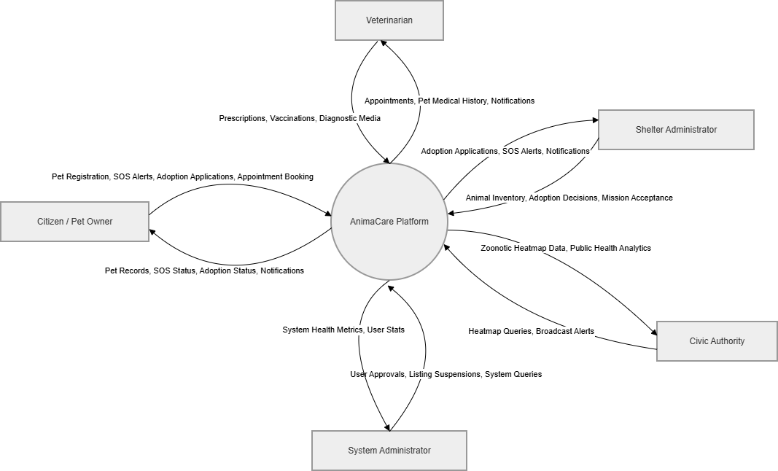
Level 1 — Module 1.0: Users & Authentication

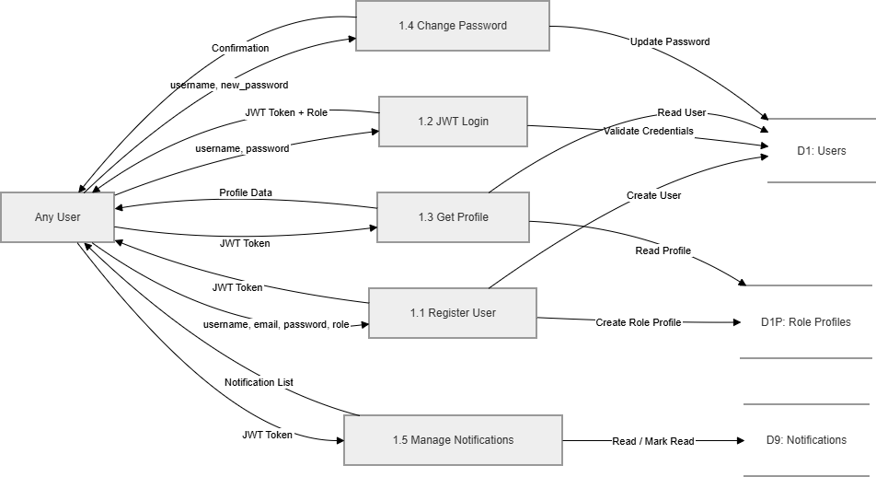
Level 1 — Module 2.0: Citizens

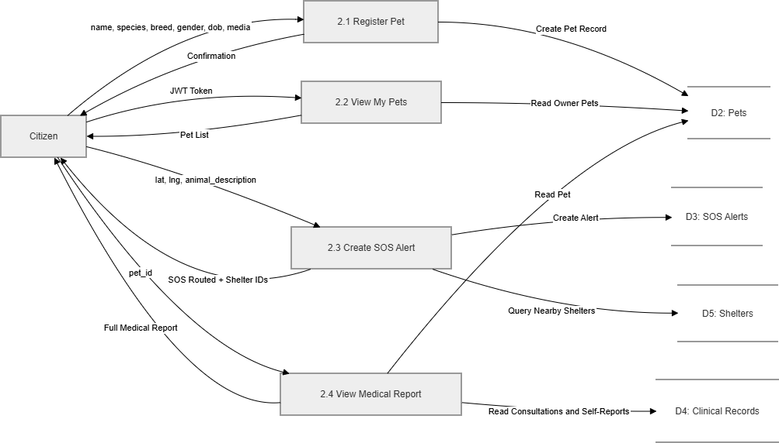
Level 1 — Module 3.0: Clinical

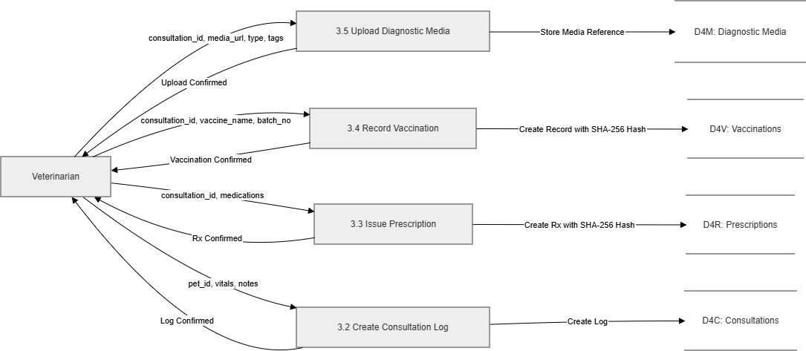

Level 1 — Module 4.0: Shelter & Adoption

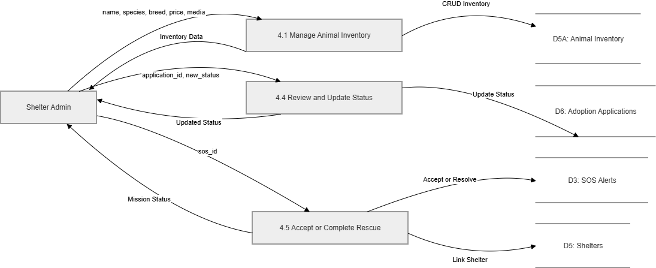

Level 1 — Module 5.0: Governance (Super Admin)

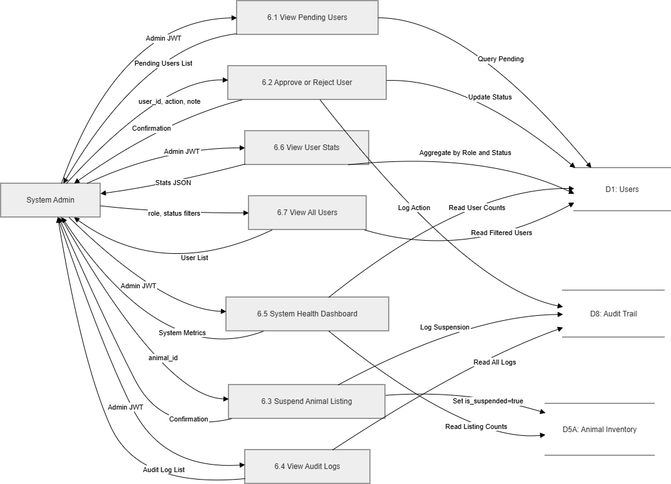

Part D: Table Design
1. Identity & Access Control Tables
Table: Users_User (Custom Base User)
Field Name | Data Type | Constraint | Description
id | Integer | Primary Key, Auto-Increment | Unique identifier for every system user.
email | Varchar(255) | Unique, Not Null | Used as the login credential.
password | Varchar(128) | Not Null | Hashed password.
role | Varchar(50) | Not Null | Enum: Citizen, Vet, ShelterAdmin, Civic.
is_verified | Boolean | Default: False | True if SuperAdmin approved their ID.
date_joined | DateTime | Auto-Now-Add | Timestamp of registration.

Table: Users_VeterinarianProfile
Field Name | Data Type | Constraint | Description
id | Integer | Primary Key | Profile identifier.
user_id | Integer | Foreign Key (Users_User.id) | Links to base user account.
license_no | Varchar(100) | Unique, Not Null | Medical license for validation.
clinic_name | Varchar(200) | Nullable | Current place of practice.
specialization | Varchar(100) | Nullable | e.g. Surgeon, General, Avian.

2. Citizen & Public Action Tables
Table: Citizens_Pet
Field Name | Data Type | Constraint | Description
id | Integer | Primary Key | Unique Pet Passport ID.
owner_id | Integer | ForeignKey (Users_User.id) | The citizen who owns the pet.
name | Varchar(100) | Not Null | Pet's call name.
species | Varchar(50) | Not Null | e.g., Dog, Cat, Bird.
breed | Varchar(100) | Nullable | Specific genetic breed.
age_months | Integer | Nullable | Age representation.
Table: Citizens_SOSAlert

Field Name | Data Type | Constraint | Description
id | Integer | Primary Key | Alert ticket number.
reporter_id | Integer | ForeignKey (Users_User.id) | Citizen logging the alert.
latitude | Decimal(9,6) | Not Null | Geospatial location.
longitude | Decimal(9,6) | Not Null | Geospatial location.
status | Varchar(50) | Default: "Active" | Enum: Active, Rescued, Outbreak.
description | Text | Nullable | Detail of injury or missing animal.
3. Animal Shelter & Adoptions Tables
Table: Shelter_ShelterFacility
Field Name | Data Type | Constraint | Description
id | Integer | Primary Key | Facility identification.
name | Varchar(200) | Not Null | Name of the rescue shelter.
capacity | Integer | Not Null | Maximum allowed animals.
address | Text | Not Null | Physical location.

Table: Shelter_AnimalInventory
Field Name | Data Type | Constraint | Description
id | Integer | Primary Key | Internal tracking tag.
shelter_id | Integer | ForeignKey (ShelterFacility.id) | The facility holding the animal.
species | Varchar(50) | Not Null | Biological class.
health_status | Varchar(50) | Default: "Intake" | Status (e.g. Healthy, Sick, Quarantine).
is_adoptable | Boolean | Default: False | True if cleared by vet.

Table: Shelter_AdoptionApplication

Field Name | Data Type | Constraint | Description
id | Integer | Primary Key | Application form ID.
animal_id | Integer | ForeignKey (AnimalInventory.id) | Animal applied for.
applicant_id | Integer | Foreign Key (Users_User.id) | Citizen applying.
ai_score | Integer | Nullable | Generated compatibility score (0-100).
status | Varchar(50) | Default: "Pending" | Pending, Approved, Rejected.

4. Clinical & Health Tables
Table: Clinical_ConsultationLog
Field Name | Data Type | Constraint | Description
id | Integer | Primary Key | Record sheet ID.
pet_id | Integer | ForeignKey (Citizens_Pet.id) | Patient being checked.
vet_id | Integer | ForeignKey (Users_User.id) | Doctor conducting exam.
diagnosis | Varchar(200) | Not Null | Primary medical finding (for analytics).
datetime | DateTime | Auto-Now-Add | Time of clinical logging.

Table: Clinical_Vaccination
Field Name | Data Type | Constraint | Description
id | Integer | Primary Key | Immutable vaccine token.
pet_id | Integer | ForeignKey (Citizens_Pet.id) | Pet receiving vaccine.
vaccine_type | Varchar(100) | Not Null | e.g. Rabies, DHPP.
administered_by | Integer | ForeignKey (Users_User.id) | Vet who gave the shot.
expiry_date | Date | Not Null | Good-until date.

Table: Clinical_DiagnosticMedia
Field Name | Data Type | Constraint | Description
id | Integer | Primary Key | Media identifier.
consult_id | Integer | ForeignKey (ConsultationLog.id) | Link to the specific visit.
media_url | Varchar(500) | Not Null | AWS S3 URI string where file is hosted.
type | Varchar(50) | Not Null | e.g. X-Ray, Bloodwork PDF.

