Level 0 — Context Diagram
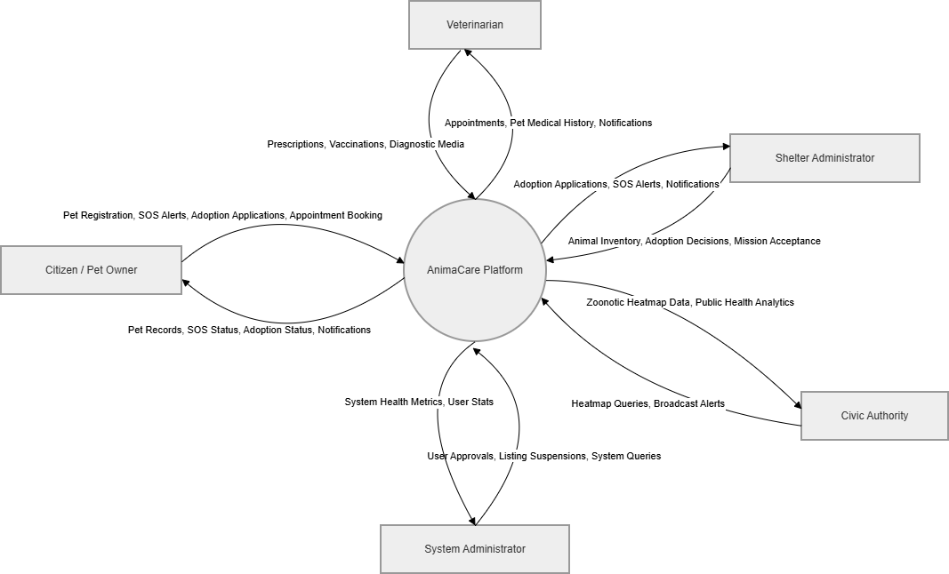

Level 1 — Module 1.0: Users & Authentication
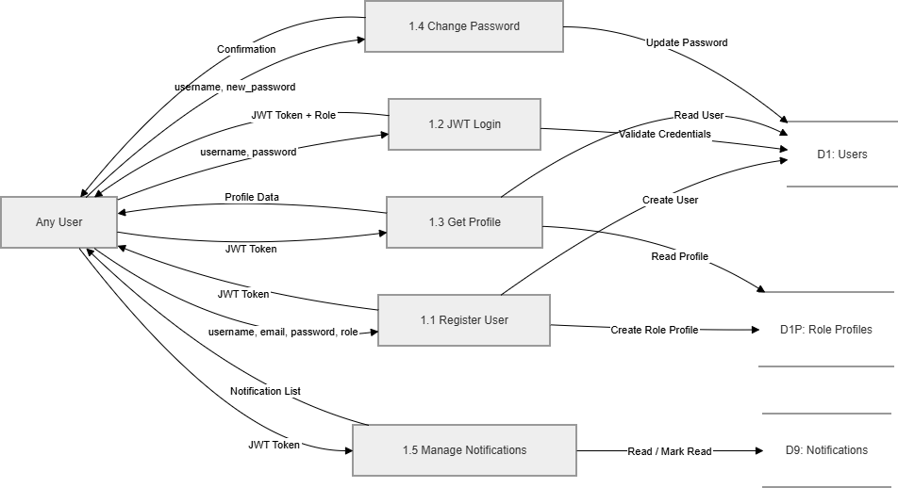
Level 1 — Module 2.0: Citizens
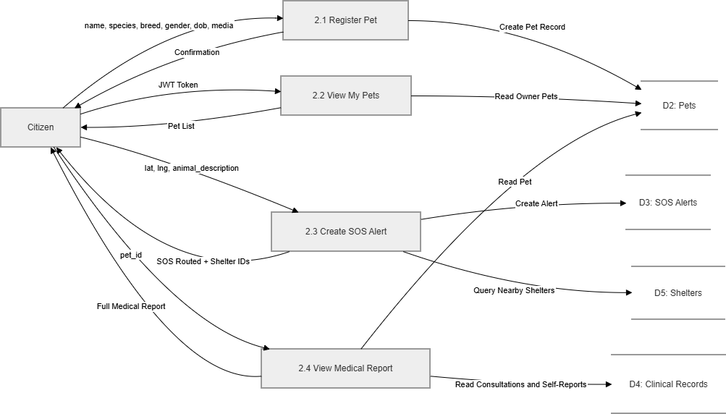
Level12 — Module 3.0: Clinical
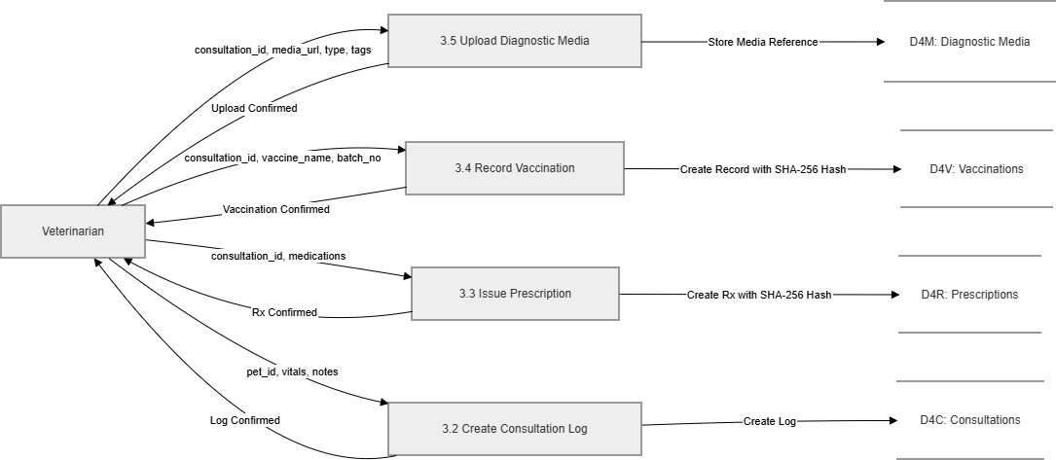

Level 1 — Module 4.0: Shelter & Adoption
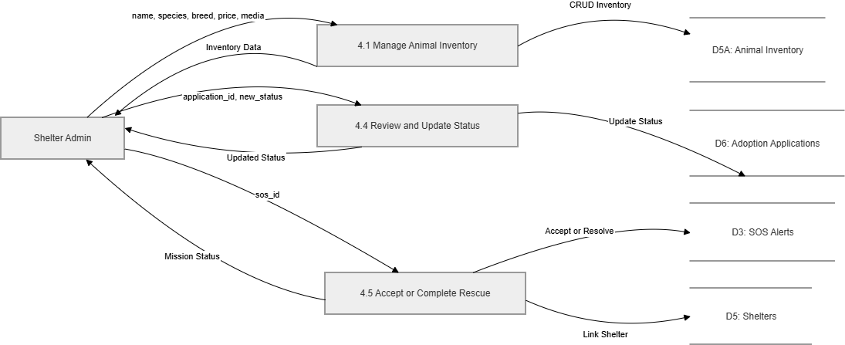
Level 1 — Module 5.0: Governance (Super Admin)
