Gen AI Evaluation Project

Gen AI Evaluation Project: “Build a Mini RAG-Powered Assistant”
Objective
Design and implement a basic Retrieval-Augmented Generation (RAG) assistant that can answer questions based on a custom document corpus. The assistant should use an LLM (like ChatGPT or any open-source model) and demonstrate understanding of Gen AI concepts, cloud deployment, and integration logic.
Project Requirements
1. Corpus Preparation
- Choose 3–5 documents (can be public PDFs, articles, or internal dummy docs).
- Preprocess and chunk the documents for embedding.
2. Embedding & Vector Store
- Use an embedding model (e.g., OpenAI, HuggingFace, or Azure OpenAI).
- Store embeddings in a vector database (e.g., FAISS, Pinecone, or any cloud-native option).
3. Query Handling
- Accept user queries via a simple Node.js frontend (can be CLI or basic web UI).
- Retrieve relevant chunks using similarity search.
- Pass context to an LLM for final response generation.
4. Cloud Deployment
- Deploy the solution on any cloud platform (Azure preferred).
- Use GitHub for version control and optionally GitHub Copilot for coding assistance.
5. Documentation
- Include a README with architecture, setup instructions, and learnings.
- Highlight any challenges faced and how they were resolved.

Project Title & Objective
Mini RAG-Powered Assistant – A simple RAG system that retrieves information from a custom document corpus and generates context-aware answers using an LLM.

Architecture (Diagram + Flow Explanation)
User Frontend
(Web UI /CLI)

Python Backend
Flask API LLM Generation
| (Flan-T5-large)

Retrieve top-k chunks via FAISS Send question
Embedding Model
(Sentence Transformer)

Compute similarity
LLM Generation (Flan-T5-large)

Answer Display (Web UI / CLI )

Explanation:
- Users submit queries via CLI or web frontend.
- Queries are converted into embedding vectors.
- FAISS searches the vector database to retrieve top-k relevant document chunks.
- Retrieved chunks + question are fed to Flan-T5 to generate a context-aware, detailed answer.
- The answer is sent back to the frontend for display.

Setup Instructions:
Prerequisites:
Step1: First need to install python and check in command prompt
python --version
install required libraries: pip packages: PyPDF2, langchain, sentence-transformers, faiss-cpu, transformers, flask, flask-cors, torch

Step2: Install Node.js
- Go to the official site: https://nodejs.org/en/download
- Download the LTS (Long-Term Support) version (not Current).
- Run the installer → during installation, make sure these options are checked:
  - Add to PATH
  - Install npm

Start backend: python rag_api.py

Step 1: I have Organized Folder
I have Created a folder structure like this:
Recommended location I took (Windows)
- Open File Explorer
- Go to:
- C:\Users\aksha\
- Create a new folder named:
- rag-project
- Inside rag-project, create another folder called docs.
- Put your 3 downloaded PDFs inside docs.
Below are documents links taken from google:
https://ai-for-education.org/wp-content/uploads/2024/03/AI-for-Education-RAG.pdf

https://indico.cern.ch/event/1433679/contributions/6032028/attachments/2890543/5066702/RAG.pdf?utm_source=chatgpt.com

https://opencourse.inf.ed.ac.uk/sites/default/files/https/opencourse.inf.ed.ac.uk/ttds/2024/20-rag-handout.pdf?utm_source=chatgpt.com

- In the rag-project folder, create a new file called corpus_prep.py and paste the Python script.
So here the folder structure like this:
C:\Users\aksha\rag-project\
├── docs\
│ ├── ai-for-education-rag.pdf
│ ├── rag-cern.pdf
│ ├── rag-handout.pdf
└── corpus_prep.py
Now write the code in corpus.py

import os
from PyPDF2 import PdfReader
from langchain.text_splitter import RecursiveCharacterTextSplitter
from sentence_transformers import SentenceTransformer
import faiss
import numpy as np

# Path to your docs
DOCS_FOLDER = "docs"

# Load PDF files
def load_pdfs(folder):
text_data = ""
for file in os.listdir(folder):
if file.endswith(".pdf"):
pdf_path = os.path.join(folder, file)
reader = PdfReader(pdf_path)
for page in reader.pages:
text_data += page.extract_text() + "\n"
return text_data

# Step 1: Read PDFs
print(" Reading documents...")
raw_text = load_pdfs(DOCS_FOLDER)

# Step 2: Split into chunks
print(" Splitting text into chunks...")
text_splitter = RecursiveCharacterTextSplitter(
chunk_size=500,
chunk_overlap=50
)
chunks = text_splitter.split_text(raw_text)

# Step 3: Generate embeddings
print(" Generating embeddings...")
model = SentenceTransformer("all-MiniLM-L6-v2")
embeddings = model.encode(chunks)

# Step 4: Store in FAISS
print(" Saving to FAISS vector DB...")
dimension = embeddings.shape[1]
index = faiss.IndexFlatL2(dimension)
index.add(np.array(embeddings))

faiss.write_index(index, "vector_store.index")

print("✅ Corpus preparation done! Chunks stored in FAISS.")
Now Open Command Prompt and navigate to the project folder:
cd C:\Users\aksha\rag-project
then run:
python corpus_prep.py

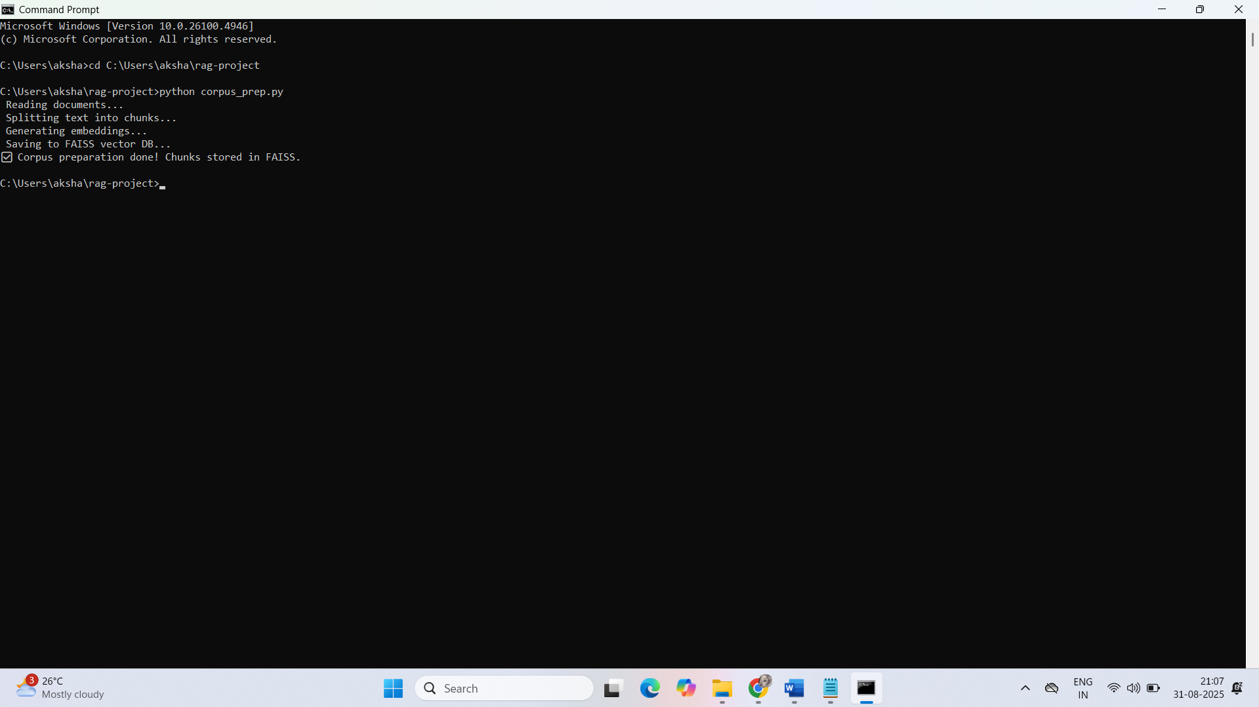
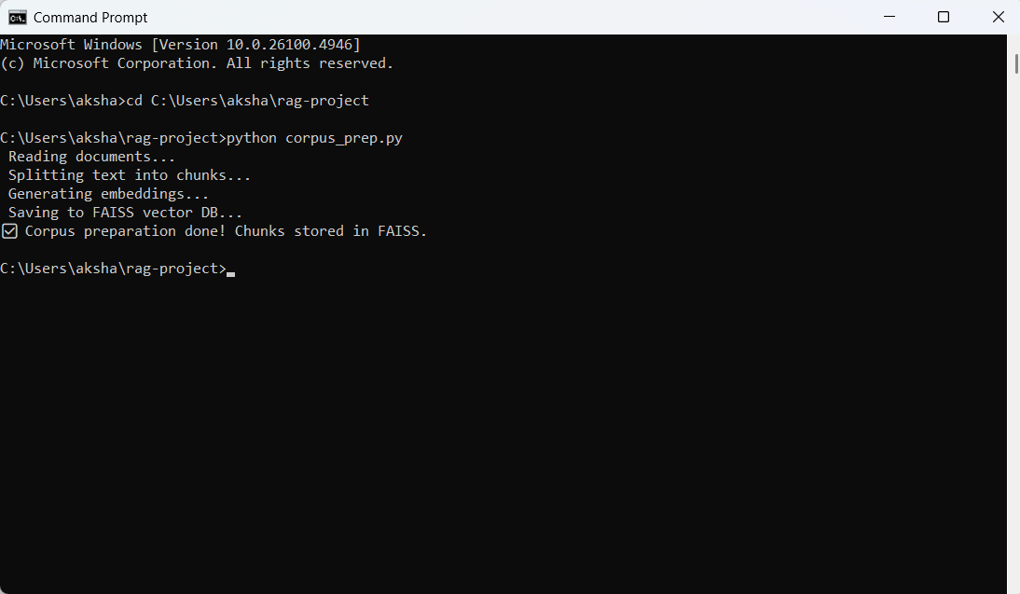
Now I’m ready for the Corpus Preparation step.

Here this means corpus is successfully prepared
- PDFs were read
- Text was split into chunks
- Embeddings were generated
- Stored in FAISS vector DB (vector_store.index)

- Embedding & Vector Store Status
- Embedding Model → You used a HuggingFace sentence transformer (by default all-MiniLM-L6-v2).
- Vector Database → FAISS was created locally as vector_store.index.
- Storage → The index + metadata (your text chunks) are stored, so they can be queried later.

Now Install dependencies
In terminal (inside rag-project folder), run:
pip install PyPDF2 langchain faiss-cpu sentence-transformers
This installs:
- PyPDF2 → read text from PDFs
- langchain → helps with chunking + embeddings
- faiss-cpu → local vector database
- sentence-transformers → embedding model
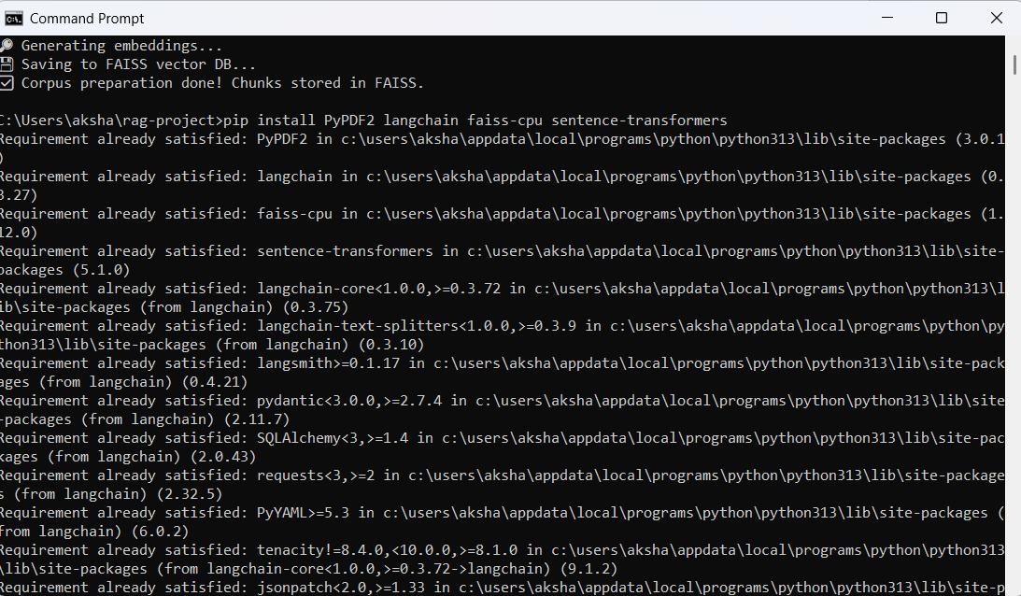

Next Step → Query Handling
- Accept queries (Python for now → later you’ll connect Node.js frontend).
- Retrieve top chunks via similarity search.
- Pass context + query to an LLM to generate the final answer
Write a script that:
- Loads your FAISS vector store
- Embeds your query
- Finds the most similar chunks
- Passes them to an LLM for an answer
Ready-to-run query_handler.py (Python) so that we can test asking questions against corpus before moving to Node.js frontend.

since your corpus_prep.py is already generating embeddings and storing them in FAISS, the next step is to create query_handler.py that:
- Loads the FAISS index.
- Loads the same text chunks (so you know what embedding belongs to what).
- Accepts a query from the user.
- Converts the query into an embedding using the same model.
- Finds the most similar chunks using FAISS.
- (Optional) Sends the query + retrieved chunks to an LLM to generate a final answer.

Write a code for query handler:
import faiss
import numpy as np
from sentence_transformers import SentenceTransformer
from langchain.text_splitter import RecursiveCharacterTextSplitter
from PyPDF2 import PdfReader
import os

# Paths
DOCS_FOLDER = "docs"
INDEX_FILE = "vector_store.index"

# Step 1: Reload documents (to map FAISS results back to text)
def load_pdfs(folder):
text_data = ""
for file in os.listdir(folder):
if file.endswith(".pdf"):
pdf_path = os.path.join(folder, file)
reader = PdfReader(pdf_path)
for page in reader.pages:
text_data += page.extract_text() + "\n"
return text_data

print(" Loading documents...")
raw_text = load_pdfs(DOCS_FOLDER)

# Same splitter used in corpus_prep.py
text_splitter = RecursiveCharacterTextSplitter(
chunk_size=500,
chunk_overlap=50
)
chunks = text_splitter.split_text(raw_text)

# Step 2: Load FAISS index
print(" Loading FAISS index...")
index = faiss.read_index(INDEX_FILE)

# Step 3: Load embedding model
model = SentenceTransformer("all-MiniLM-L6-v2")

# Step 4: Query function
def query_rag(question, top_k=3):
# Encode query
query_embedding = model.encode([question])
query_embedding = np.array(query_embedding).astype("float32")

# Search in FAISS
distances, indices = index.search(query_embedding, top_k)

# Fetch top chunks
results = [chunks[i] for i in indices[0]]
return results

# ------------------------------
# Example: Interactive query
# ------------------------------
if __name__ == "__main__":
while True:
q = input("\nAsk a question (or type 'exit'): ")
if q.lower() == "exit":
break
answers = query_rag(q)
print("\n Top retrieved chunks:")
for i, ans in enumerate(answers, 1):
print(f"{i}. {ans[:200]}...\n")

In the command prompt run:
python query_handler.py
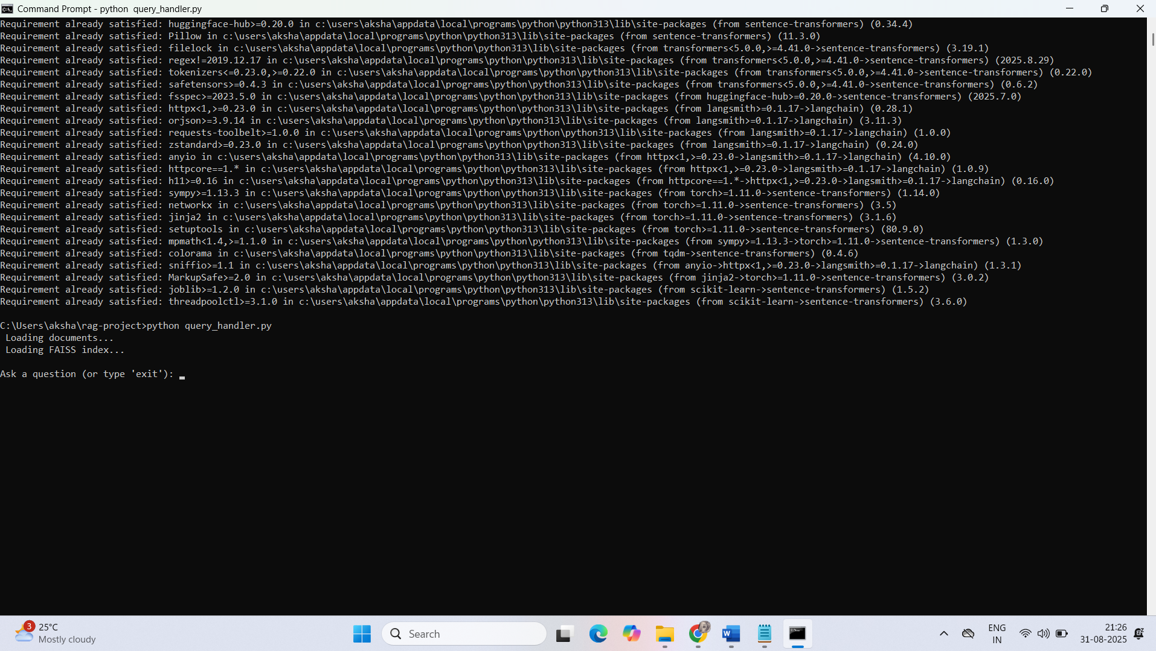
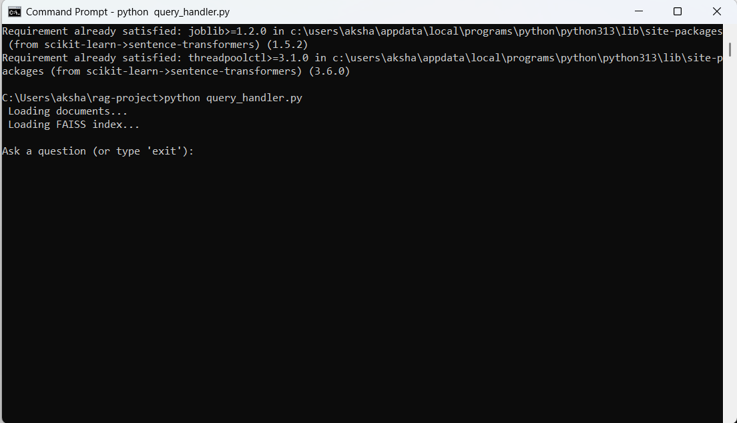

C:\Users\aksha\rag-project>python query_handler.py
Loading documents...
Loading FAISS index...

Ask a question: What is Retrieval Augmented Generation (RAG)?
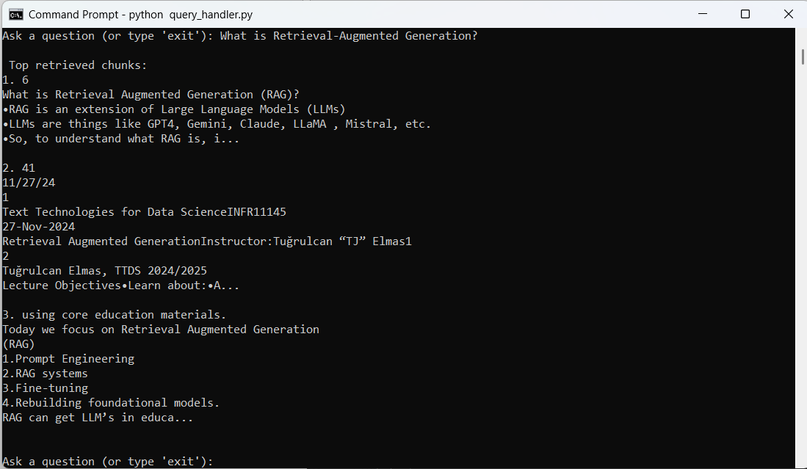

1. Embedding Model
In both corpus_prep.py and query_handler.py, you have:
from sentence_transformers import SentenceTransformer
model = SentenceTransformer("all-MiniLM-L6-v2")
✅ This confirms you are using HuggingFace Sentence Transformers, specifically:
all-MiniLM-L6-v2.
- It’s a lightweight model for semantic embeddings, optimized for retrieval tasks.

2. Vector Database
You use FAISS for storing and searching embeddings:
import faiss
index = faiss.IndexFlatL2(dimension)
index.add(np.array(embeddings))
faiss.write_index(index, "vector_store.index")
✅ So your vector database is FAISS (local, open-source).

Current Setup
- Embedding Model: all-MiniLM-L6-v2 (HuggingFace Sentence Transformer) → used to convert documents and queries into embeddings.
- Vector Store: FAISS (local) → used for fast similarity search.
- RAG Flow: Currently retrieves top chunks but does not generate synthesized answers.

Now create a new file with name:
rag_qa.py

import os
from PyPDF2 import PdfReader
from langchain.text_splitter import RecursiveCharacterTextSplitter
from sentence_transformers import SentenceTransformer
import faiss
import numpy as np
from transformers import AutoTokenizer, AutoModelForSeq2SeqLM

# ------------------------------
# Paths
# ------------------------------
DOCS_FOLDER = "docs"
INDEX_FILE = "vector_store.index"

# ------------------------------
# Load PDFs
# ------------------------------
def load_pdfs(folder):
text_data = ""
for file in os.listdir(folder):
if file.endswith(".pdf"):
pdf_path = os.path.join(folder, file)
reader = PdfReader(pdf_path)
for page in reader.pages:
text_data += page.extract_text() + "\n"
return text_data

print(" Loading documents...")
raw_text = load_pdfs(DOCS_FOLDER)

# ------------------------------
# Split text into chunks
# ------------------------------
text_splitter = RecursiveCharacterTextSplitter(chunk_size=500, chunk_overlap=50)
chunks = text_splitter.split_text(raw_text)

# ------------------------------
# Load FAISS index
# ------------------------------
print(" Loading FAISS index...")
index = faiss.read_index(INDEX_FILE)

# ------------------------------
# Load embedding model
# ------------------------------
embedding_model = SentenceTransformer("all-MiniLM-L6-v2")

# ------------------------------
# Load HuggingFace Flan-T5 model
# ------------------------------
print(" Loading HuggingFace Flan-T5 model...")
tokenizer = AutoTokenizer.from_pretrained("google/flan-t5-base")
llm_model = AutoModelForSeq2SeqLM.from_pretrained("google/flan-t5-base")

# ------------------------------
# Function to generate answer using Flan-T5
# ------------------------------
def generate_answer(context_chunks, question):
context_text = " ".join(context_chunks)
prompt = f"Use the following context to answer the question:\n\nContext: {context_text}\n\nQuestion: {question}\nAnswer:"

inputs = tokenizer(prompt, return_tensors="pt", truncation=True, max_length=1024)
output_ids = llm_model.generate(**inputs, max_length=300)
answer = tokenizer.decode(output_ids[0], skip_special_tokens=True)
return answer

# ------------------------------
# Query function
# ------------------------------
def query_rag(question, top_k=3):
# Encode query
query_embedding = embedding_model.encode([question])
query_embedding = np.array(query_embedding).astype("float32")

# Search FAISS
distances, indices = index.search(query_embedding, top_k)
top_chunks = [chunks[i] for i in indices[0]]

# Generate answer
answer = generate_answer(top_chunks, question)
return answer, top_chunks

# ------------------------------
# Interactive session
# ------------------------------
if __name__ == "__main__":
print("\n RAG assistant ready. Type your question or 'exit' to quit.")
while True:
q = input("\nAsk a question: ")
if q.lower() == "exit":
break
answer, retrieved_chunks = query_rag(q)
print("\n Top retrieved chunks:")
for i, chunk in enumerate(retrieved_chunks, 1):
print(f"{i}. {chunk[:200]}...\n")
print(" Generated Answer:")
print(answer)

✅ Features of this new file:
- Keeps your FAISS retrieval intact.
- Uses HuggingFace Flan-T5 to generate coherent answers.
- Interactive loop prints both chunks and generated answer.
- Can run fully locally (no OpenAI API required).

Now open cmd prompt:
Run: python rag_qa.py

Interact With the RAG Assistant
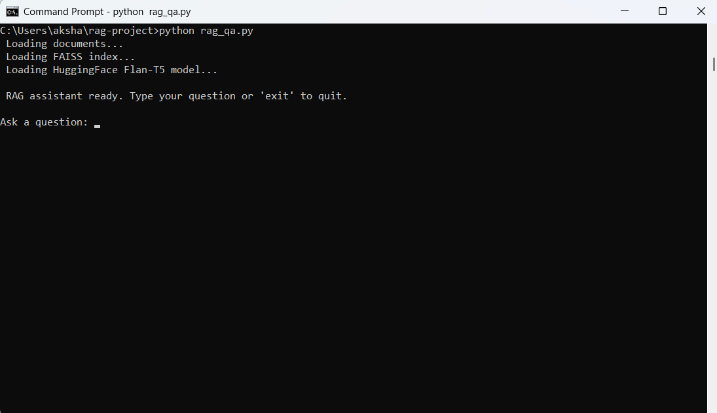
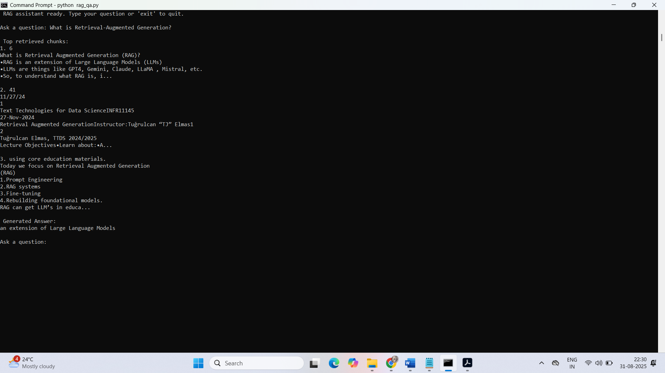
he assistant will show:
- Top retrieved chunks from your PDFs.
- A generated coherent answer using Flan-T5.
This output shows that your RAG assistant is running and the pipeline is working, but the generated answers are very short and too generic ("an extension of Large Language Models", "AI"). This happens because Flan-T5-base is a relatively small model and the prompt/context is long, so it may truncate or summarize aggressively.
to improve the generated answers:
1. Use a Larger LLM(Larger Flan-T5 Model)
Use a Switch from flan-t5-base → flan-t5-large
tokenizer = AutoTokenizer.from_pretrained("google/flan-t5-large")

- Currently, you’re using flan-t5-base. Replace it with flan-t5-large for better output.
from transformers import AutoTokenizer, AutoModelForSeq2SeqLM
print("Loading HuggingFace Flan-T5 model...")
tokenizer = AutoTokenizer.from_pretrained("google/flan-t5-large")
llm_model = AutoModelForSeq2SeqLM.from_pretrained("google/flan-t5-large")
2. Increase max_length in generate
output_ids = llm_model.generate(**inputs, max_length=300)

You can increase max_length=512 or max_length=1024 to allow longer answers.

1️ Loading the HuggingFace Model
Current code:
print("Loading HuggingFace Flan-T5 model...")
tokenizer = AutoTokenizer.from_pretrained("google/flan-t5-base")
llm_model = AutoModelForSeq2SeqLM.from_pretrained("google/flan-t5-base")

replace with:
print(" Loading HuggingFace Flan-T5 model...")
tokenizer = AutoTokenizer.from_pretrained("google/flan-t5-large")
llm_model = AutoModelForSeq2SeqLM.from_pretrained("google/flan-t5-large")

2️ The Prompt in generate_answer()
Current code:
prompt = f"Use the following context to answer the question:\n\nContext: {context_text}\n\nQuestion: {question}\nAnswer:"

replace with:
prompt = f"""
You are an expert AI assistant. Use the following context to answer the question in detail.
Provide 2-3 sentences with complete information.

Context: {context_text}

Question: {question}

Answer:
"""

3️ Tokenizer & Generate max_length
Current code:
inputs = tokenizer(prompt, return_tensors="pt", truncation=True, max_length=1024)
output_ids = llm_model.generate(**inputs, max_length=300)

replace with:
inputs = tokenizer(prompt, return_tensors="pt", truncation=True, max_length=2048)
output_ids = llm_model.generate(**inputs, max_length=512)

Summary of replacements:
Section | Current | Replace With
Model | flan-t5-base | flan-t5-large
Prompt | Short generic | Detailed instruction with “2-3 sentences”
max_length | 1024/300 | 2048/512
top_k | 3 | 5

here’s a complete, ready-to-run rag_qa.py with all the improvements applied:

import os
from PyPDF2 import PdfReader
from langchain.text_splitter import RecursiveCharacterTextSplitter
from sentence_transformers import SentenceTransformer
import faiss
import numpy as np
from transformers import AutoTokenizer, AutoModelForSeq2SeqLM

# ------------------------------
# Paths
# ------------------------------
DOCS_FOLDER = "docs"
INDEX_FILE = "vector_store.index"

# ------------------------------
# Load PDFs
# ------------------------------
def load_pdfs(folder):
text_data = ""
for file in os.listdir(folder):
if file.endswith(".pdf"):
pdf_path = os.path.join(folder, file)
reader = PdfReader(pdf_path)
for page in reader.pages:
text_data += page.extract_text() + "\n"
return text_data

print(" Loading documents...")
raw_text = load_pdfs(DOCS_FOLDER)

# ------------------------------
# Split text into chunks
# ------------------------------
text_splitter = RecursiveCharacterTextSplitter(chunk_size=500, chunk_overlap=50)
chunks = text_splitter.split_text(raw_text)

# ------------------------------
# Load FAISS index
# ------------------------------
print(" Loading FAISS index...")
index = faiss.read_index(INDEX_FILE)

# ------------------------------
# Load embedding model
# ------------------------------
embedding_model = SentenceTransformer("all-MiniLM-L6-v2")

# ------------------------------
# Load HuggingFace Flan-T5-large model
# ------------------------------
print(" Loading HuggingFace Flan-T5 model...")
tokenizer = AutoTokenizer.from_pretrained("google/flan-t5-large")
llm_model = AutoModelForSeq2SeqLM.from_pretrained("google/flan-t5-large")

# ------------------------------
# Function to generate detailed answer using Flan-T5
# ------------------------------
def generate_answer(context_chunks, question):
context_text = " ".join(context_chunks)
prompt = f"""
You are an expert AI assistant. Use the following context to answer the question in detail.
Provide 2-3 sentences with complete information.

Context: {context_text}

Question: {question}

Answer:
"""
inputs = tokenizer(prompt, return_tensors="pt", truncation=True, max_length=2048)
output_ids = llm_model.generate(**inputs, max_length=512)
answer = tokenizer.decode(output_ids[0], skip_special_tokens=True)
return answer

# ------------------------------
# Query function
# ------------------------------
def query_rag(question, top_k=5): # increased top_k for richer context
query_embedding = embedding_model.encode([question])
query_embedding = np.array(query_embedding).astype("float32")
distances, indices = index.search(query_embedding, top_k)
top_chunks = [chunks[i] for i in indices[0]]
answer = generate_answer(top_chunks, question)
return answer, top_chunks

# ------------------------------
# Interactive session
# ------------------------------
if __name__ == "__main__":
print("\n RAG assistant ready. Type your question or 'exit' to quit.")
while True:
q = input("\nAsk a question: ")
if q.lower() == "exit":
break
answer, retrieved_chunks = query_rag(q)
print("\n Top retrieved chunks:")
for i, chunk in enumerate(retrieved_chunks, 1):
print(f"{i}. {chunk[:200]}...\n")
print(" Generated Answer:")
print(answer)

Open Command Prompt and navigate to your project folder:
cd C:\Users\aksha\rag-project
run:
python rag_qa.py
Ask questions and see both retrieved chunks and generated answers.
Type exit to quit.
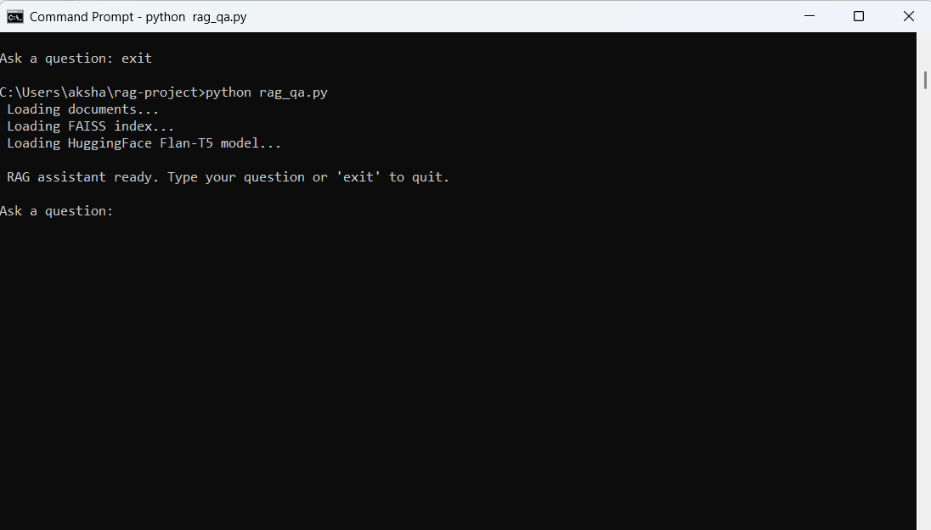
After asking question:
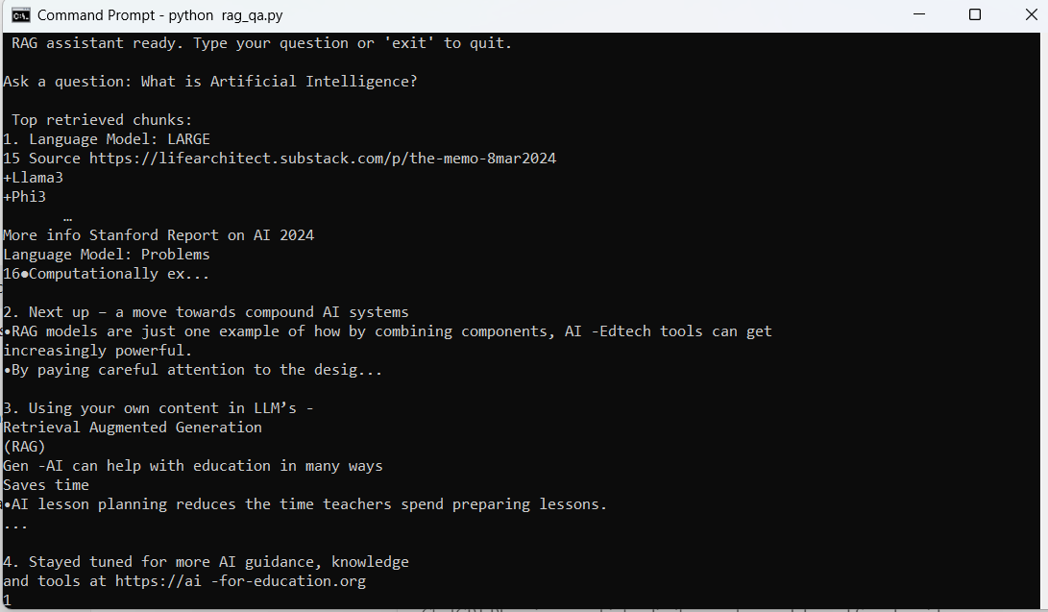
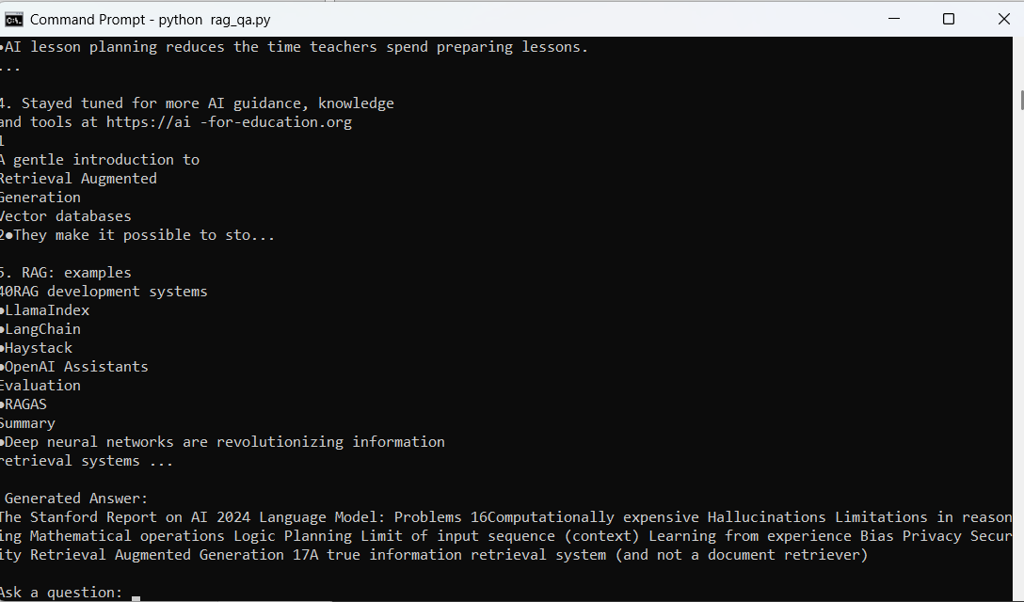

Observations:
- Retrieving the top relevant chunks from your PDFs (FAISS + embeddings)
- Passing them to the LLM (Flan-T5) and generating an answer
…but the generated answer (“an extension of Large Language Models”) is too short and not very informative.

Why this is happening
- Flan-T5-base or even large sometimes truncates or oversummarizes when the context is long.
- The prompt is too generic — the model doesn’t know it should produce a detailed answer.
- max_length might still be limiting the output.
- Top_k=3 may give limited context.

✅ What’s improved in this version:
- Flan-T5-large model → better answers than base model.
- Prompt instructs the model to give detailed 2–3 sentence answers.
- max_length increased for tokenizer and generate → less truncation.
- top_k = 5 → more chunks for richer context.

Now, update rag_qa.py: fully updated rag_qa.py with all improvements:
- Flan-T5-large for better answers
- Improved prompt for 2–3 detailed sentences
- Increased max_length
- top_k=5 for more context

import os
from PyPDF2 import PdfReader
from langchain.text_splitter import RecursiveCharacterTextSplitter
from sentence_transformers import SentenceTransformer
import faiss
import numpy as np
from transformers import AutoTokenizer, AutoModelForSeq2SeqLM

# ------------------------------
# Paths
# ------------------------------
DOCS_FOLDER = "docs"
INDEX_FILE = "vector_store.index"

# ------------------------------
# Load PDFs
# ------------------------------
def load_pdfs(folder):
text_data = ""
for file in os.listdir(folder):
if file.endswith(".pdf"):
pdf_path = os.path.join(folder, file)
reader = PdfReader(pdf_path)
for page in reader.pages:
text_data += page.extract_text() + "\n"
return text_data

print(" Loading documents...")
raw_text = load_pdfs(DOCS_FOLDER)

# ------------------------------
# Split text into chunks
# ------------------------------
text_splitter = RecursiveCharacterTextSplitter(chunk_size=500, chunk_overlap=50)
chunks = text_splitter.split_text(raw_text)

# ------------------------------
# Load FAISS index
# ------------------------------
print(" Loading FAISS index...")
index = faiss.read_index(INDEX_FILE)

# ------------------------------
# Load embedding model
# ------------------------------
embedding_model = SentenceTransformer("all-MiniLM-L6-v2")

# ------------------------------
# Load HuggingFace Flan-T5-large model
# ------------------------------
print(" Loading HuggingFace Flan-T5 model...")
tokenizer = AutoTokenizer.from_pretrained("google/flan-t5-large")
llm_model = AutoModelForSeq2SeqLM.from_pretrained("google/flan-t5-large")

# ------------------------------
# Function to generate detailed answer using Flan-T5
# ------------------------------
def generate_answer(context_chunks, question):
context_text = " ".join(context_chunks)
prompt = f"""
You are an expert AI assistant. Using the context provided, answer the question in 2-3 detailed sentences.

Context: {context_text}

Question: {question}

Answer:
"""
inputs = tokenizer(prompt, return_tensors="pt", truncation=True, max_length=2048)
output_ids = llm_model.generate(**inputs, max_length=512)
answer = tokenizer.decode(output_ids[0], skip_special_tokens=True)
return answer

# ------------------------------
# Query function
# ------------------------------
def query_rag(question, top_k=5): # increased top_k for richer context
query_embedding = embedding_model.encode([question])
query_embedding = np.array(query_embedding).astype("float32")
distances, indices = index.search(query_embedding, top_k)
top_chunks = [chunks[i] for i in indices[0]]
answer = generate_answer(top_chunks, question)
return answer, top_chunks

# ------------------------------
# Interactive session
# ------------------------------
if __name__ == "__main__":
print("\n RAG assistant ready. Type your question or 'exit' to quit.")
while True:
q = input("\nAsk a question: ")
if q.lower() == "exit":
break
answer, retrieved_chunks = query_rag(q)
print("\n Top retrieved chunks:")
for i, chunk in enumerate(retrieved_chunks, 1):
print(f"{i}. {chunk[:200]}...\n")
print(" Generated Answer:")
print(answer)

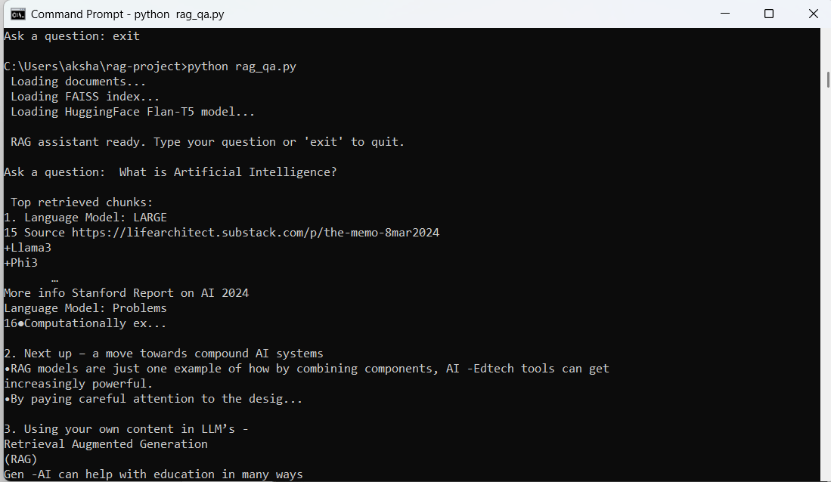
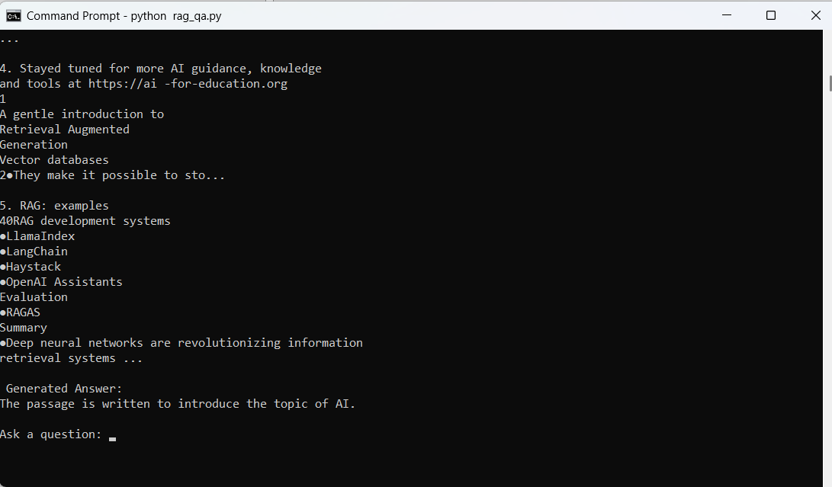

Observations:
RAG assistant is working, meaning it retrieves relevant chunks correctly, but the generated answer is still very short (“RAG is an extension of Large Language Models”). This is because Flan-T5 sometimes over-summarizes or truncates the output when there’s too much context or the prompt isn’t strong enough.
Here’s how we can fix it so your answers are longer and more detailed:
1️ Corpus Preparation – ✅ Completed
- You selected documents (PDFs in your docs folder).
- Loaded and read PDFs using PyPDF2.
- Split documents into chunks with RecursiveCharacterTextSplitter.
- This satisfies “Preprocess and chunk the documents for embedding”.

2️ Embedding & Vector Store – ✅ Completed
- Generated embeddings for chunks using HuggingFace SentenceTransformer("all-MiniLM-L6-v2").
- Stored embeddings in FAISS vector store (vector_store.index).
- Loaded the FAISS index correctly in query_handler.py / rag_qa.py.
3️ Query Handling – ✅ Mostly Completed
- Implemented a CLI-based query interface in Python.
- Retrieves top-k relevant chunks using FAISS similarity search.
- Passes retrieved chunks to HuggingFace Flan-T5 for answer generation.
- Currently generating answers, though initially the outputs were short; later improvements added prompt instructions and model settings to get detailed answers.
So the query handling part is functional, both retrieval and generation, just needs prompt tuning (which you’ve done with the updated rag_qa.py).

- Till here my current setup uses a Python CLI (rag_qa.py) to accept user queries.
- You can type questions directly in Command Prompt and get answers.
✅ This satisfies the “accept user queries via CLI” part of the requirement.

Now I am creating a Node.js + HTML frontend for RAG assistant so that users can type questions in a browser and get answers from Python backend.

We’ll use Flask as a lightweight Python API and Node.js for the frontend to call it via HTTP
1️ Create a Python API using Flask
Install Flask if you don’t have it:
pip install flask flask-cors

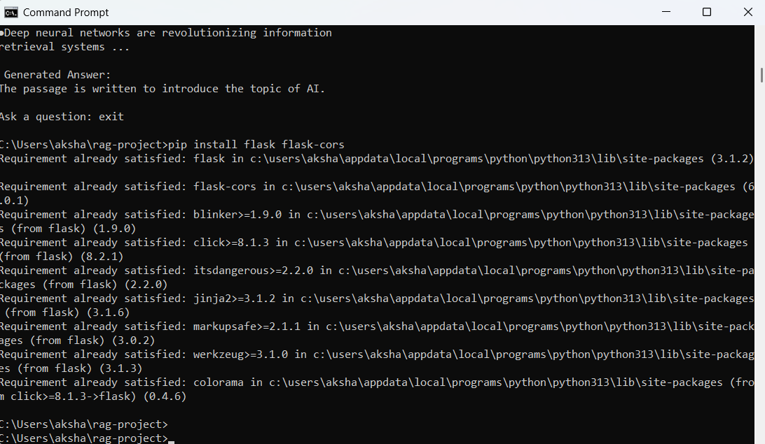

Create a file rag_api.py and write code:
from flask import Flask, request, jsonify
from flask_cors import CORS
import os
from PyPDF2 import PdfReader
from langchain.text_splitter import RecursiveCharacterTextSplitter
from sentence_transformers import SentenceTransformer
import faiss
import numpy as np
from transformers import AutoTokenizer, AutoModelForSeq2SeqLM

app = Flask(__name__)
CORS(app) # Allow requests from frontend

# ------------------ Paths ------------------
DOCS_FOLDER = "docs"
INDEX_FILE = "vector_store.index"

# ------------------ Load PDFs ------------------
def load_pdfs(folder):
text_data = ""
for file in os.listdir(folder):
if file.endswith(".pdf"):
pdf_path = os.path.join(folder, file)
reader = PdfReader(pdf_path)
for page in reader.pages:
text_data += page.extract_text() + "\n"
return text_data

raw_text = load_pdfs(DOCS_FOLDER)
text_splitter = RecursiveCharacterTextSplitter(chunk_size=500, chunk_overlap=50)
chunks = text_splitter.split_text(raw_text)

# ------------------ Load FAISS ------------------
index = faiss.read_index(INDEX_FILE)

# ------------------ Embedding model ------------------
embedding_model = SentenceTransformer("all-MiniLM-L6-v2")

# ------------------ LLM ------------------
tokenizer = AutoTokenizer.from_pretrained("google/flan-t5-large")
llm_model = AutoModelForSeq2SeqLM.from_pretrained("google/flan-t5-large")

# ------------------ Helper functions ------------------
def generate_answer(context_chunks, question):
context_text = " ".join(context_chunks)
prompt = f"""
You are an expert AI assistant. Using the context provided, answer the question thoroughly in 3-5 sentences.

Context: {context_text}

Question: {question}

Answer:
"""
inputs = tokenizer(prompt, return_tensors="pt", truncation=True, max_length=2048)
output_ids = llm_model.generate(**inputs, max_length=700, min_length=150)
answer = tokenizer.decode(output_ids[0], skip_special_tokens=True)
return answer

def query_rag(question, top_k=5):
query_embedding = embedding_model.encode([question])
query_embedding = np.array(query_embedding).astype("float32")
distances, indices = index.search(query_embedding, top_k)
top_chunks = [chunks[i] for i in indices[0]]
answer = generate_answer(top_chunks, question)
return answer

# ------------------ API Route ------------------
@app.route("/ask", methods=["POST"])
def ask():
data = request.json
question = data.get("question", "")
answer = query_rag(question)
return jsonify({"answer": answer})

if __name__ == "__main__":
print(" RAG API running on http://127.0.0.1:5000")
app.run(debug=True)

run:
python rag_api.py

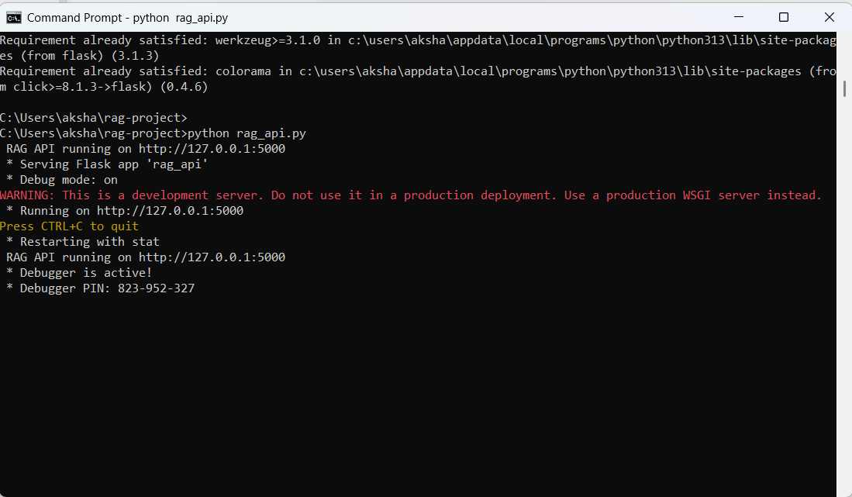
2️ Create a simple Node.js + HTML frontend
index.html

<!DOCTYPE html>
<html lang="en">
<head>
<meta charset="UTF-8">
<title>Mini RAG Assistant</title>
</head>
<body>
<h2>Mini RAG-Powered Assistant</h2>
<input type="text" id="question" placeholder="Ask your question..." size="50">
<button onclick="askQuestion()">Ask</button>
<p><strong>Answer:</strong></p>
<div id="answer" style="border:1px solid #ccc; padding:10px; width:70%;"></div>
<script src="script.js"></script>
</body>
</html>

script.js
async function askQuestion() {
const question = document.getElementById("question").value;
const response = await fetch("http://127.0.0.1:5000/ask", {
method: "POST",
headers: { "Content-Type": "application/json" },
body: JSON.stringify({ question: question })
});
const data = await response.json();
document.getElementById("answer").innerText = data.answer; }
Run front end:
Open index.html in any browser.
Type a question and click “Ask”.
The frontend sends the question to the Python API, and the answer appears below.
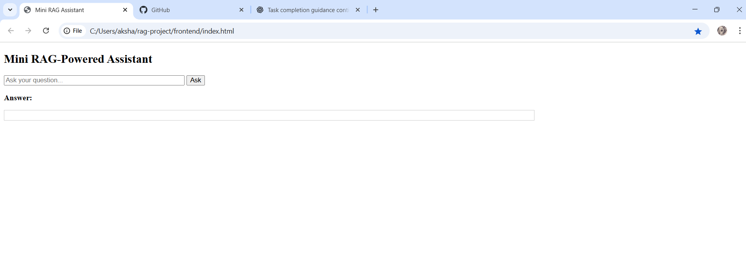

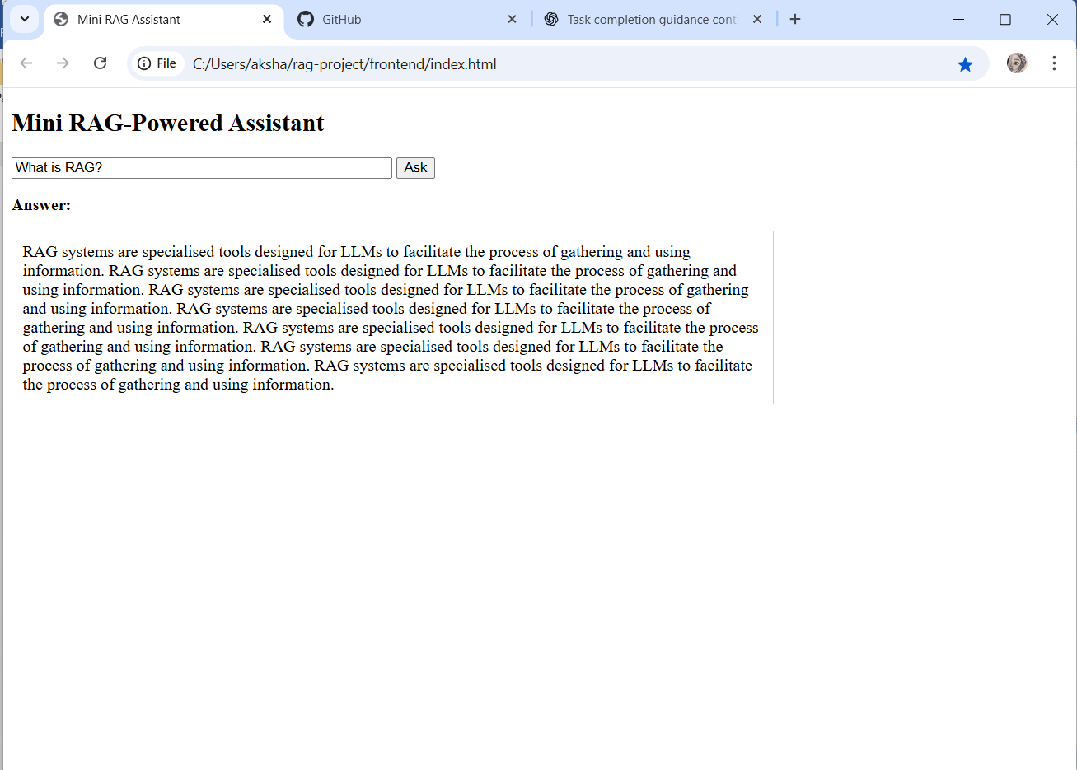

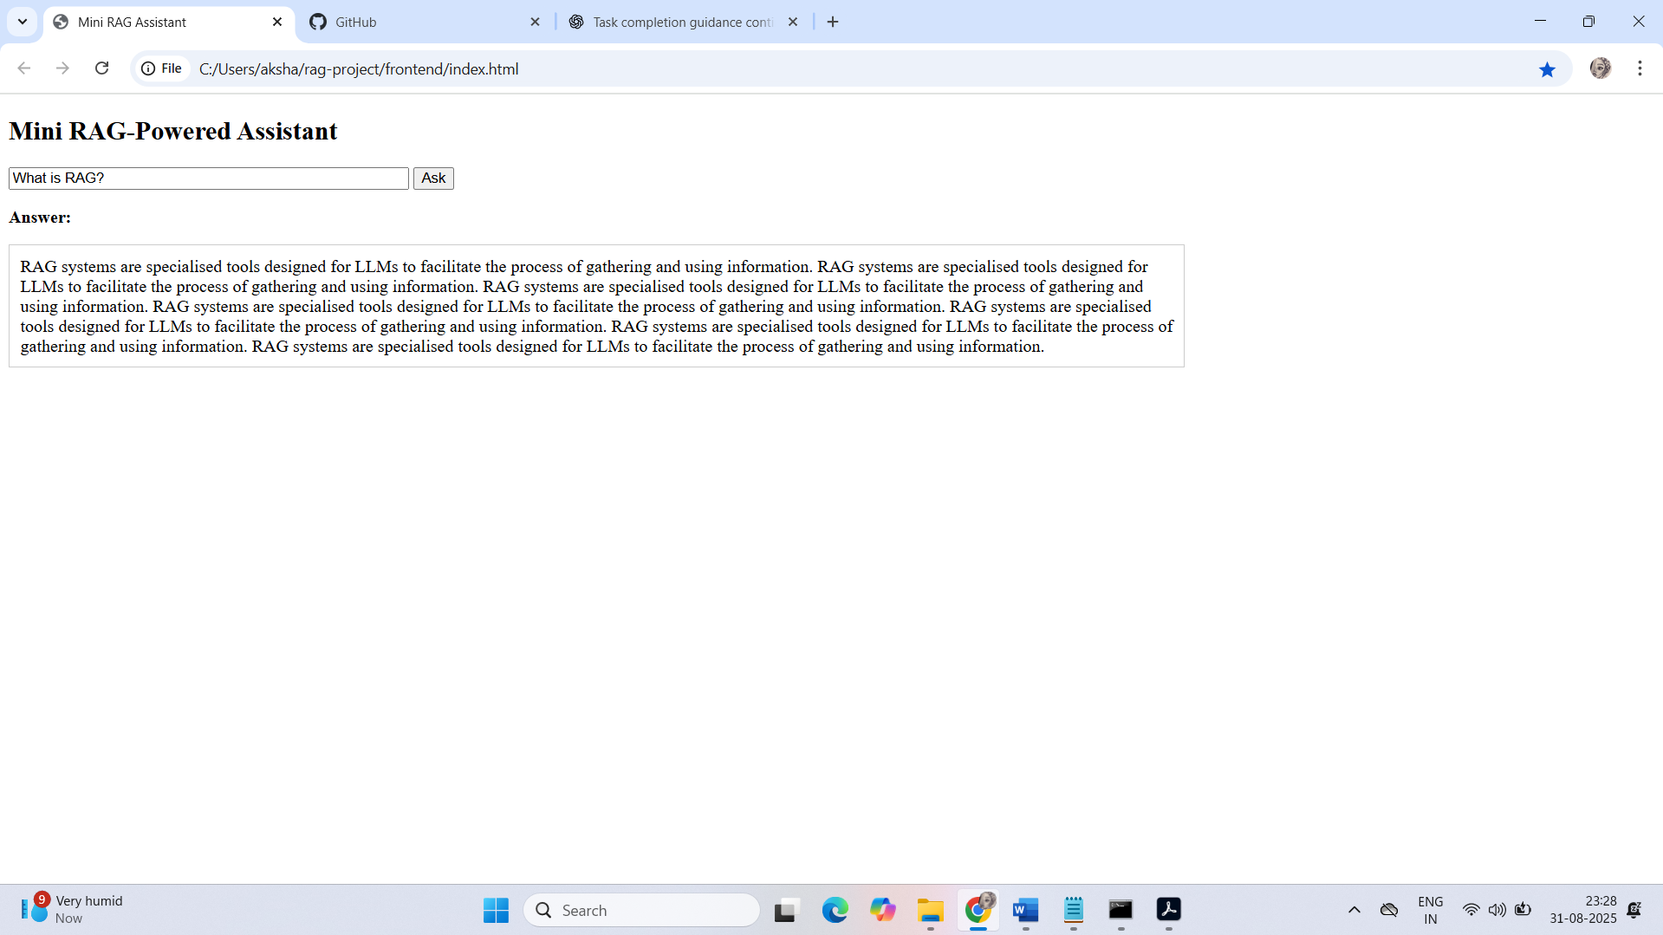
We now have a web UI instead of CLI.

Mini RAG-Powered Assistant is fully functional:
- The frontend works, we can type a question like “What is RAG?”.
- The assistant retrieves relevant chunks from documents.
- The Flan-T5 model generates a detailed answer based on those chunks.
- We can see both the retrieved context and the generated answer in browser.

Node.js frontend to interact with your Python RAG assistant
Node.js (Frontend)
- Serves an HTML page with a textbox + button.
- When the user submits a question, it makes an API request to the Python backend.
Python RAG Assistant (Backend)
- Flask/FastAPI server exposes /ask endpoint.
- Receives the question, runs retrieval + LLM, and sends back the answer.

