Assignments:

Q1.

Read student input with proper labels:

-name

-age

-marks percent

& Display the values with proper labels.

Q2.

Ask user to input days count and convert it into years, months & days & show the response.

Output pattern:

years: x

months: y

days: z

Assumption: There are 365days in a year & 30 days in a month.

Q3. (solve the problem using-conditional-op)

Ask user to input 2 int values and compare which one is greater.

Q4. (solve the problem using-conditional-op)

Create basic calculator allowing +, -, * & \ operation.(using switch and goto)

Q5. (solve the problem using-conditional-op)

Allow user to input book price and if the book price is less than or equals to 400 then show "buy the book", if the price is greater than 400 then find if it is more than 600, if yes then print "don't buy" otherwise print "I'll tell you later".

Q6. --

Ask user to input product name, price per kg & then allow buyer to input quantity and calculate the total cost of product.

Q7.

In previous example ask user to input rate of discount and calculate the total price accordingly.

Q8.

Get 2 inputs and swap the values.

Q3-5 using-if/using if-else/using else-if ladder

Q9.

Allow user to input total-score, and scores-earned. if the earned-score is 60% or more, then show first division, if earned-score is 50% and more, then show second division, if earned-score is 45% and more, then show third division and if earned score is 75% or more then show distinction.

Q10. (Try the same code after learning the goto, while, for and switch)

According to the bank policy, if an account holder is woman then she should maintain 2000 min balance and should get 8% interest. If she is senior citizen then there is no minimum balance needed to maintain and the she should get 12% interest. If she is 22 years old or younger, then she should get 4% interest and no minimum balance needed to be maintained. If the account holder is male and he is senior citizen then he must maintain at least 2000 minimum balance and he will get 11% interest rate. If the person male is student(age<=22) then the rate of interest on savings will be 2% and 500 min. balance is required. Apart from all above mentioned cases for male acc. Holder in general the rate of interest applicable over savings will be 6% and the min balance should be 5000. If any of the acc holder wanted a check book then he/she must maintain (min-balance+500).

Q11.

Grade a student according to the following rule:

Average Marks Grade

80 to 100 Honors

60 to 79 First Div.

50 to 59 Second Div.

40 to 49 Third Div.

0 to 39 Fail

Q12.

Largest of the three number using nested if... else…

Q13. (Loop) goto – for – while – do-while

Ask user to input two int values to calculate x to the power y.

Q14. (Loop) goto – for – while – do-while

Calculate the sum of the first n integer numbers.

Q15. (Loop) goto – for – while – do-while

Calculate the factorial of a given number.

Q16.

Allow user to input n numbers and calculate average of those numbers.

calculate average of even numbers. calculate average of non negative numbers.

Q17.

Calculate H.C.F using loops.

Q18.

Q19. (use looping constructs available)

Ask user to input a number and draw the * diagram.

|  |  |  |  |
| --- | --- | --- | --- |
| *  * *  * * * | * * *  * *  * | * * *  * *  * | *  * *  * * * |

Q20.

|  |  |  |  |
| --- | --- | --- | --- |
| *  *  * | *  *  * | * * *  *  * | *  *  * * * |

Q21.

|  |  |  |  |
| --- | --- | --- | --- |
| * * * *  * * *  * *  * | *  * *  * * *  * * * * | * *  * *  * *  * | *  * *  * *  * * |

Q22.

|  |  |  |  |
| --- | --- | --- | --- |
| 1  2 3  4 5 6 | 1 2 3  4 5  6 | 3 3 3  2 2  1 | 3 3 3  2 2  1 |

Q23.

|  |  |  |  |
| --- | --- | --- | --- |
| *  * *  * * *  * * * *  * * *  * *  * | * * * *  * * *  * *  *  * *  * * *  * * * * | *  * *  * *  * *  * *  * *  * | * *  * *  * *  *  * *  * *  * * |

Q24.

|  |  |  |  |
| --- | --- | --- | --- |
| 1 2 3  4 5  6 | 1  2 3  4 5 6 | 1 1 1 1  3 2 1  2 1  1 | 1 1 1 1  2 2 1  2 1  1 |

Q25.

|  |  |  |  |
| --- | --- | --- | --- |
| 6  5 4  3 2 1 | 6 5 4  3 2  1 | 6 5 4  3 2  1 | 6  5 4  3 2 1 |

Q26.

|  |  |  |  |
| --- | --- | --- | --- |
| 1 2 3 4  5 6 7  8 9  10 | 1  2 3  4 5 6  7 8 9 10 | 1 2  3 4  5 6  7 | 1  2 3  4 5  6 7 |

Q27.

Write a program to compute the sum of the digits of a given integer number.

Q28.

|  |  |  |  |
| --- | --- | --- | --- |
| 1 2 3 4  5 6 7  8 9  10 | 1  2 3  4 5 6  7 8 9 10 | 1 2  3 4  5 6  7 | 1  2 3  4 5  6 7 |

Q28b.

|  |  |  |  |
| --- | --- | --- | --- |
| 1 2 3 2 1  1 2 2 1  1 1 | A B C D E  A B D E  A E |  | 7 |

Q28a.

Draw a pascal’s triangle.

1

1 1

1 2 1

1 3 3 1

1 4 6 4 1

1 5 10 10 5 1

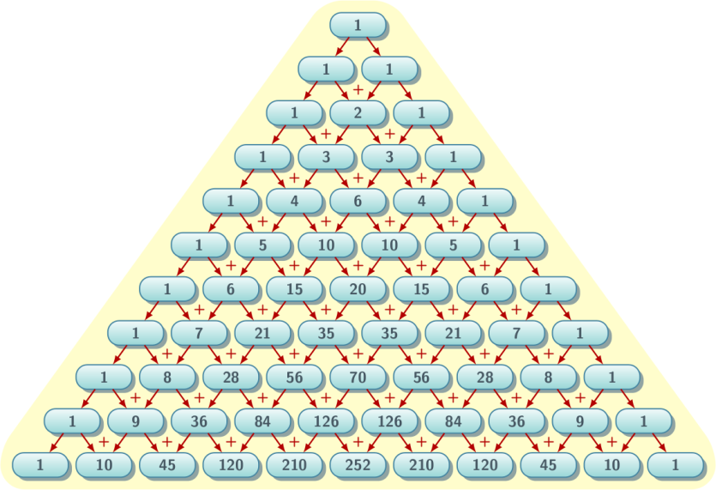

Q29.

Check if the user input is a palindrome!

Ex: 151, 212.

Q30.

Print first n Fibonacci Numbers.

1 1 2 3 5 8 13 21 . . .

Q31.

Armstrong Number:

Input 153

Step1: 13 + 53 + 33  = 153

Q32.

Using while loop reverse a number.

Ex: 12345 -> 54321

For a given array:

int ar[ ] = {23, 56, 79, 12, 90, 34, 41, 67};

Q34.

Traverse the above array using while, for & do-while loops.

Q35.

Traverse the array of integer values and display the odd numbers and their index position in the array.

Q36.

Find the largest and least number in an integer array.

Q37.

Traverse the given array and create an identical array.

Q38.

Traverse the given array and create an array of the same size and store the elements in reverse order.

Q39.

Arrange elements in the ascending or descending order in the given array.

Q40.

Arrange the characters in a character array in ascending or descending order.

Assumption: only alphabetic characters are used.

Q41.

Write a program to traverse a 2D array.

Q42.

Create an identical two dimensional array by using an existing 2D array.

Q43.

Reverse a 2D array.

Q44.

Reverse elements of 1D arrays in a 2D array.

Q45.

Write a program to concat two strings.

Q46.

Write a program to create a substring, according the user index input.

Q47.

Compare two strings for equality.

Q48.

Concat two strings in one.

Q49.

Get the index of a given character in a char-array.

Q50.

Get the character at the user specified index.

Q51.

Replace all occurrence of a given character with the new character.

Q52.

Find all occurrence of a given character in a given char-array.

Q53.

Parse char-array into int, provided all characters in the array are numeric.

Q54.

In a 2D char-array of city names, arrange the city name in ascending order.

Use strcmp() if required.

Q55.

Find the properly created char array length without using sizeof() and strlen().

Q56.

For a given char-array create marquee effect.

Q57.

Convert all characters in a char-array to uppercase or lowercase.

Q58.

|  |  |  |  |  |
| --- | --- | --- | --- | --- |
|  | Potato | Onion | Chili | Cucumber |
| Rate Per Kg. | 20 | 50 | 40 | 10 |

|  |  |  |  |
| --- | --- | --- | --- |
|  | Mohan | Rohan | Dinesh |
| Potato | 2 | 6 | 3 |
| Onion | 5 | 12 | 7 |
| Chili | 30 | 5 | 12 |
| Cucumber | 8 | 12 | 21 |

Calculate the total sell(in kgs)\ of all article by Rohan.

Calculate the total sell(in kgs) of Potatos sold by all sellers.

Calculate the total sales(in Rs) by Mohan.

Calculate the total sales(in Rs.) of Chili.

Q58.

Using Recursion: Print a number in reverse order.

Q59.

Using Recursion: Calculate factorial of user input.

Q60.

Using Recursion: Print Fibonacci Series.

Q61.

Using Recursion: Write a C program to find sum of first n natural numbers using recursion. Note: Positive integers are known as natural number i.e. 1, 2, 3....n

Q62.

Using Recursion: Write a program which takes a sentence from user and reverses that sentence using recursion.

Q63.

Using Recursion: find all the occurrences of a give string in another user input string

Q64.

struct marks{

char nm[50];

int sub1;

int sub2;

int sub3;

}std[3];

Calc subject wise, student wise & overall performance.

