**COVID-19**

We have developed a Chatbot named AUXILIA . Its gives basic information about COVID-19 including:

1. Probability Detector(Symptom check)
2. Requirements Need
3. Help desk
4. Testing center in India

Below there are several screenshots of the Chatbot.

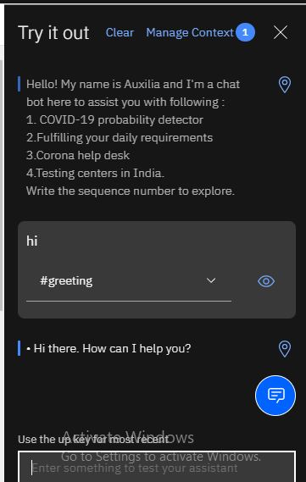

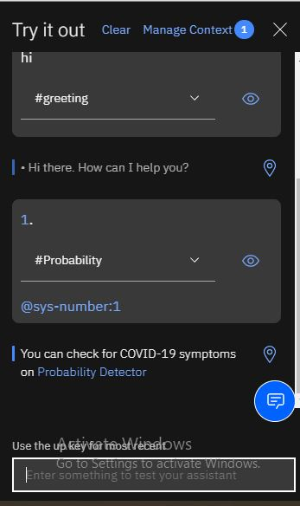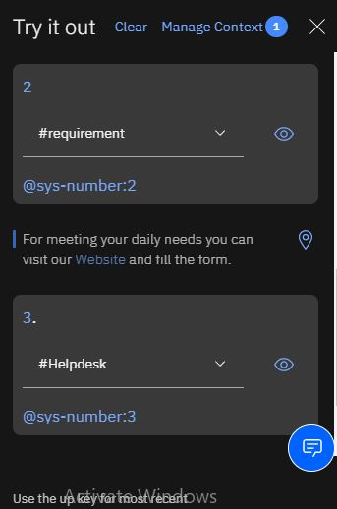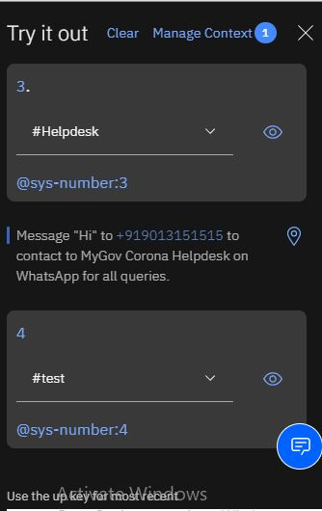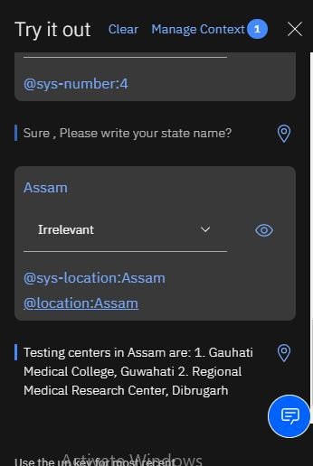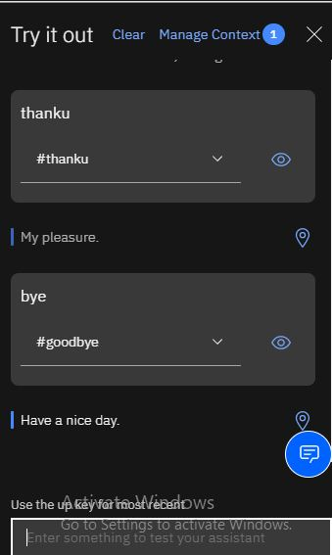

WEB POTALS:

1. Probability check

<https://familydoctor.org/your-health-resources/health-tools/symptom-checker/>

1. Requirements form:

<https://docs.google.com/forms/d/1l5GanHP0XO3iWlAOtx16QPHBTH6nEAQ2Qd8bXPP5Y3U/edit>