Introduction to JAVA

Q-1

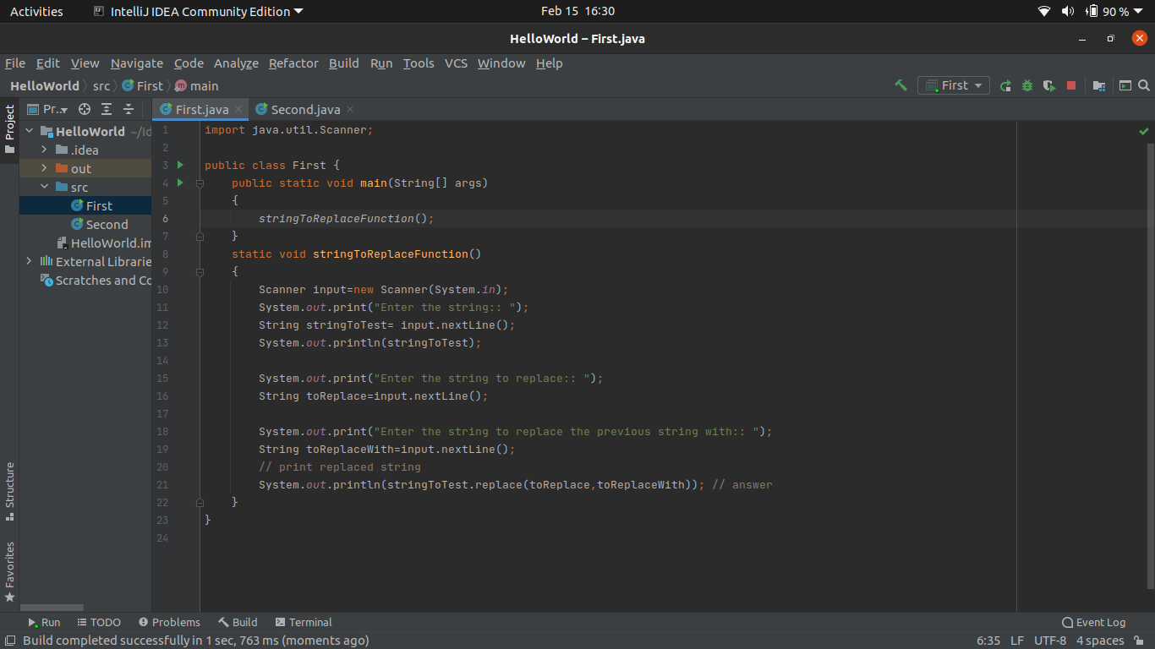

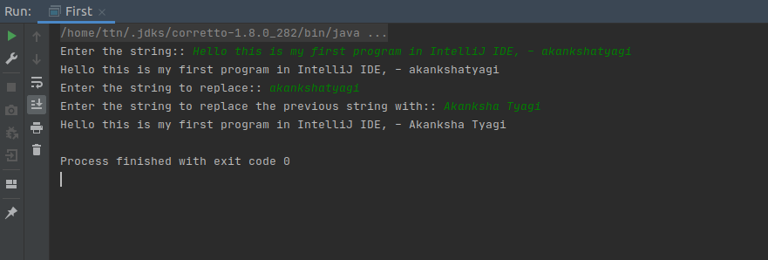

Q-2 Write a program to find the number of occurrences of the duplicate words in a string and print them ?

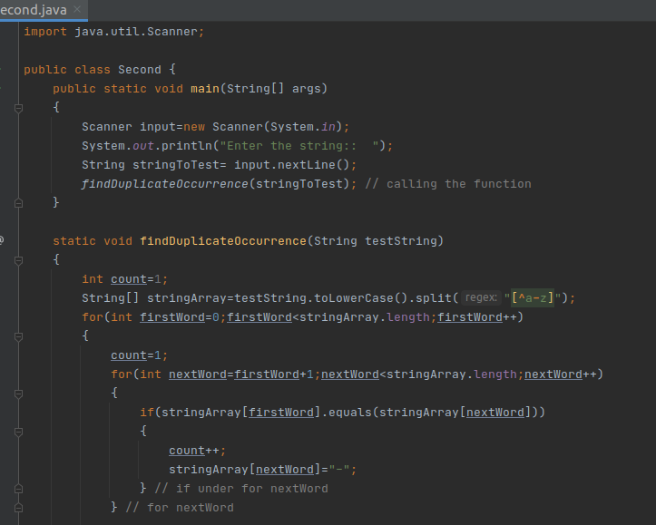

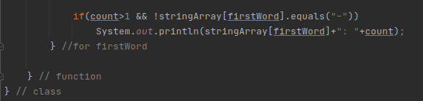

Output: 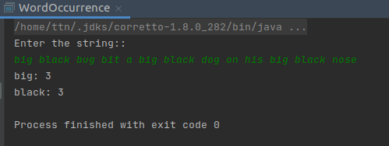

Q-3: Write a program to find the number of occurrences of a character in a string without using a loop?

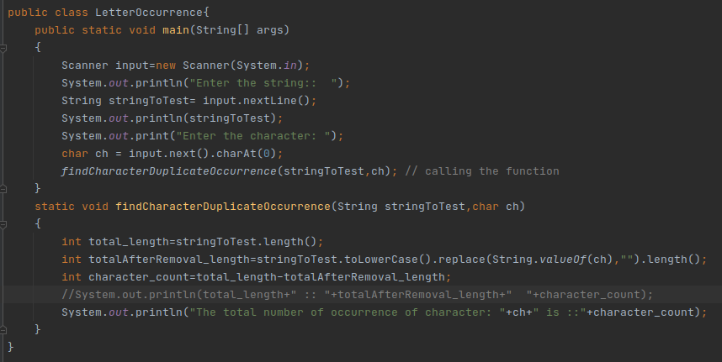

Output: 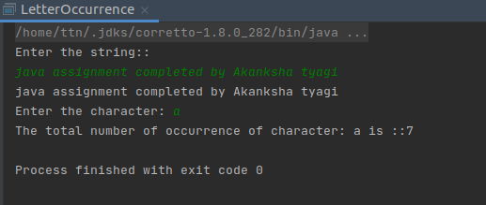

Q-4: Calculate the number & Percentage Of Lowercase Letters,Uppercase Letters, Digits And Other Special Characters In A String.

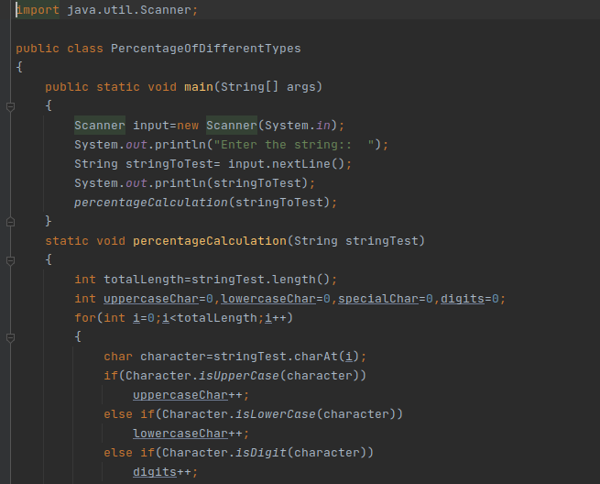



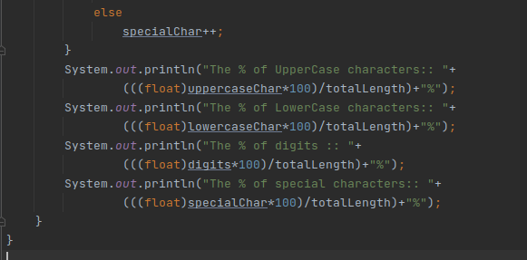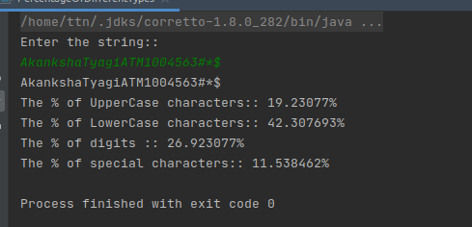

Q- 5. Find common elements between two arrays.

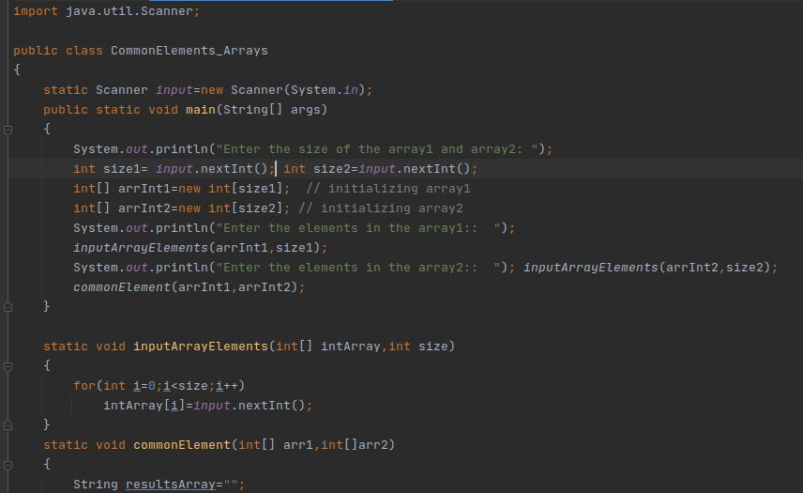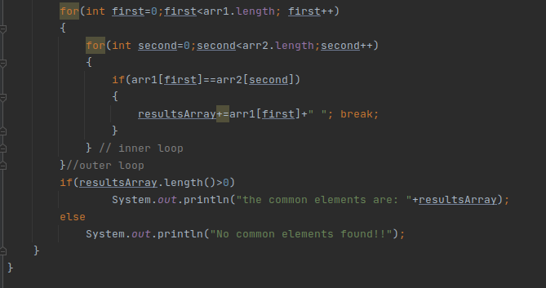Output: Output:: 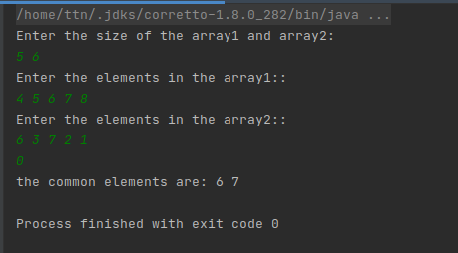

Q-6 There is an array with every element repeated twice except one. Find that element.

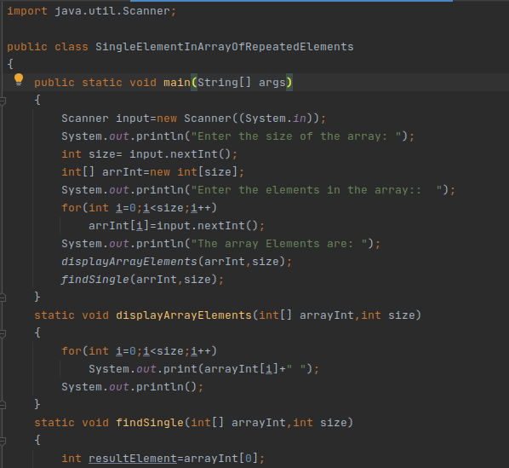

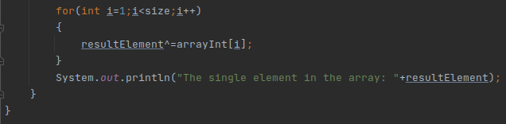

Output: 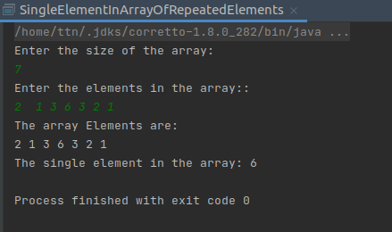

Q-7 Write a program to print your Firstname,LastName & age using static block,static method & static variable respectively.

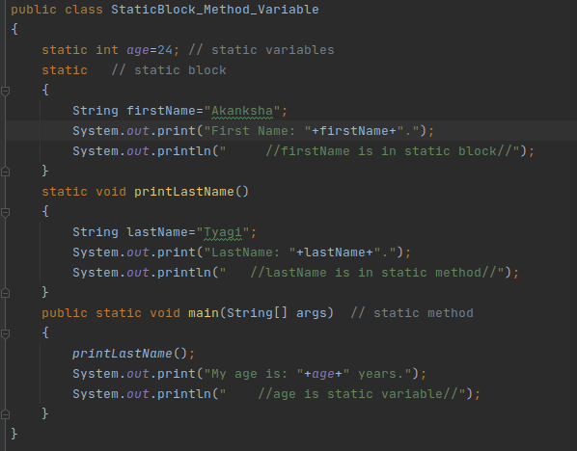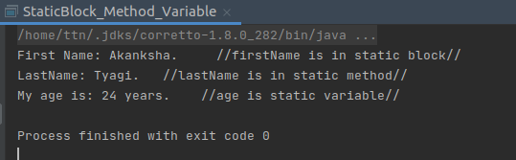

Q-8 Write a program to reverse a string and remove characters from index 4 to index 9 from the reversed string using String Buffer.

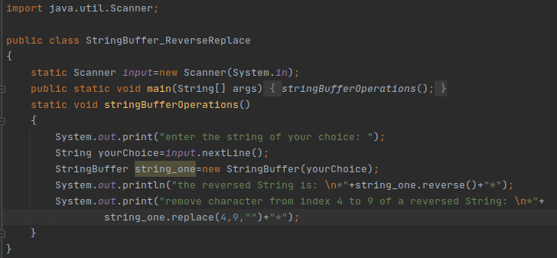Output: 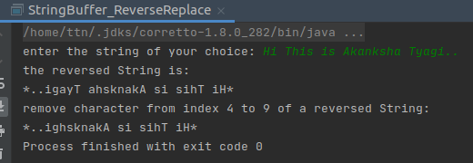

Q-9 Write a program to display values of enums using a constructor & getPrice() method (Example display house & their prices).

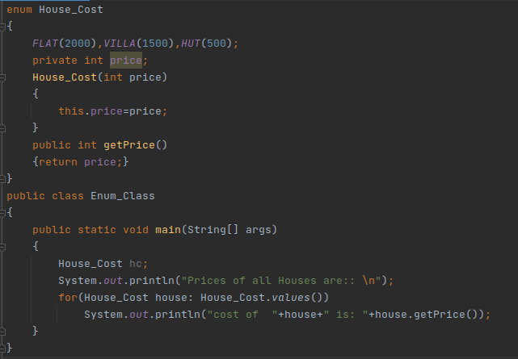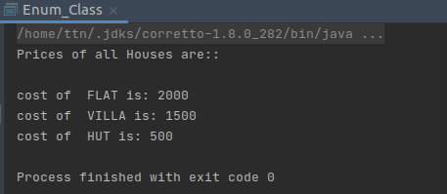

Q-10 Write a single program for following operation using overloading

A) Adding 2 integer number

B) Adding 2 double

C) multiplying 2 float

D) multiplying 2 int

E) concat 2 string

F) Concat 3 String

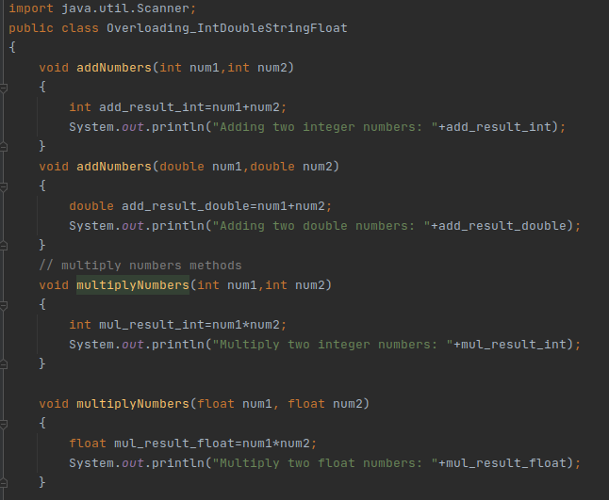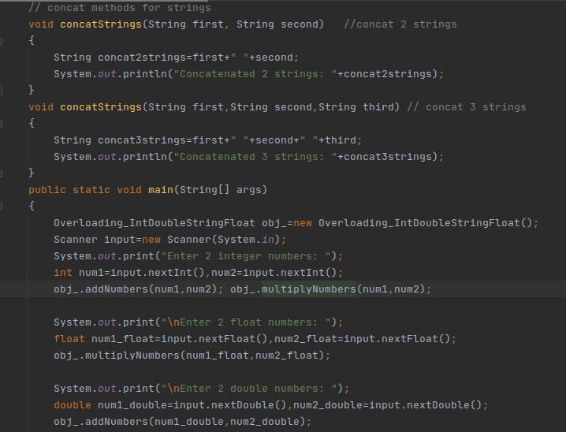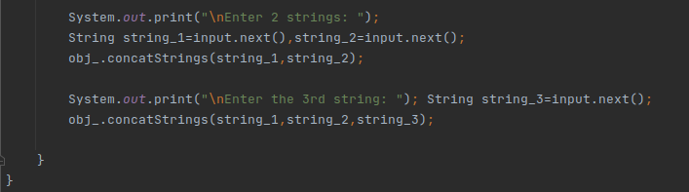

Output: 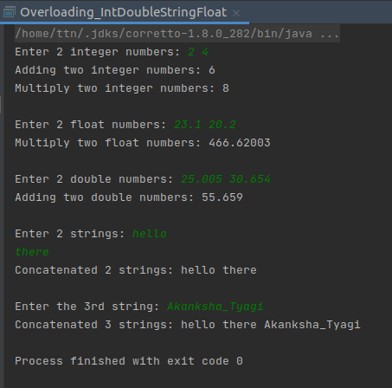

Q-11 Create 3 subclasses of bank SBI,BOI,ICICI all 4 should have a method called getDetails which provide their specific details like rateofinterest etc,print details of every bank.

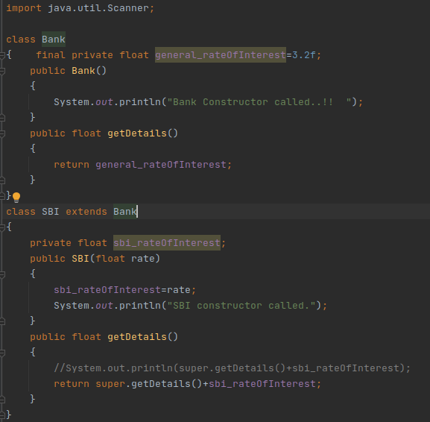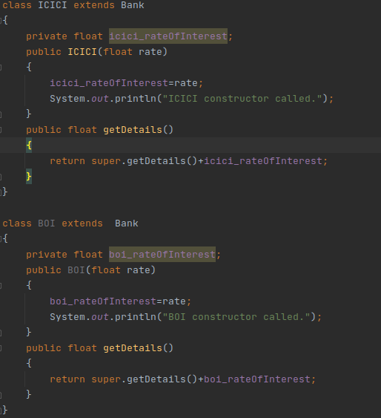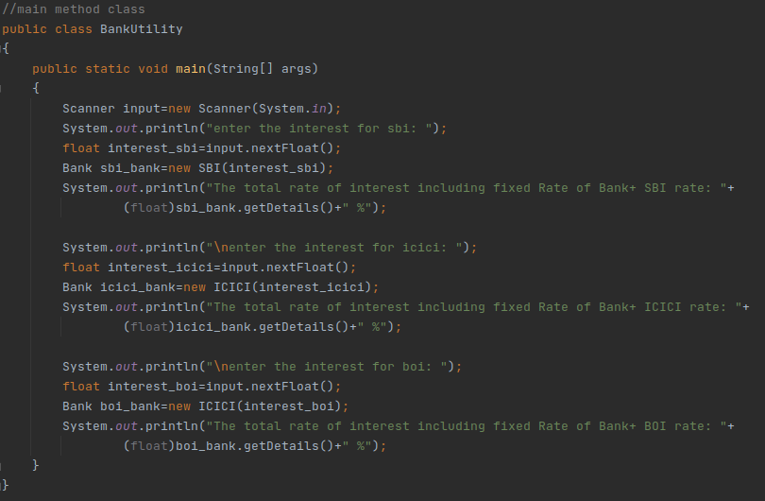 Output: 