**Graph 1 (Varying no. of clients vs Fixed interval)**

|  |  |
| --- | --- |
| No.of Clients | Avg. time/trn (ms) |
| 1 | 47 |
| 20 | 24.5 |
| 40 | 22.02 |
| 70 | 21.27 |
| 100 | 20.7 |

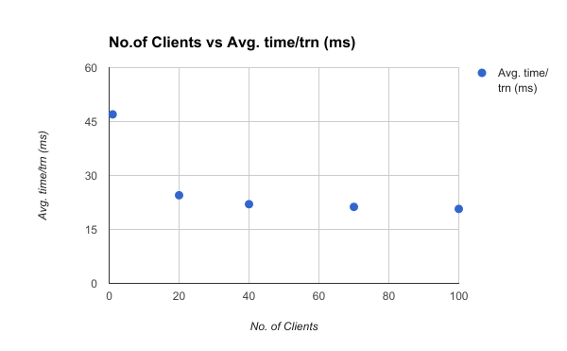

**Graph 2 (Fixed no. of clients vs Varying intervals)**

|  |  |
| --- | --- |
| Wait time | Avg. time/trn (ms) |
| 0.1 | 27.8 |
| 0.3 | 24.4 |
| 0.5 | 18.5 |
| 0.7 | 25.2 |

