Advanced Data Analysis and Visualization in Logistics
Week 3 Task — Logistics Analyzer Project
Internship Data Analytics Track
Prepared using Python (pandas, numpy, matplotlib, seaborn)

1. Objective
This report explores, analyzes, and visualizes a hypothetical logistics dataset in order to build data-driven insight into operational efficiency, cost drivers, and delivery performance. The task follows a structured analytical workflow — data simulation, exploratory data analysis (EDA), visualization, and interpretation — to demonstrate how logistics organizations can use Python-based analytics to support decision-making.
All analysis was performed in Python using pandas and numpy for data handling and statistics, and matplotlib / seaborn for visualization. The full dataset, scripts, and chart outputs referenced in this report are reproducible from the code excerpts included in each section.

2. Data Simulation
A hypothetical dataset of 1,200 shipment records was generated to represent six months of logistics operations (January–June 2026) across 5 regions, 4 transport modes, 4 carriers, and 5 product categories. Relationships between variables were deliberately built into the simulation (e.g., distance driving delivery time and cost; weekend dispatch increasing delay risk) so the dataset would produce realistic, interpretable patterns during analysis.

2.1 Dataset Structure
Variable | Type | Description
shipment_id | String | Unique identifier for each shipment
dispatch_date | Date | Date the shipment left origin
region | Categorical | Origin region (North, South, East, West, Central)
transport_mode | Categorical | Road, Rail, Air, or Sea
carrier | Categorical | Logistics carrier handling the shipment
product_category | Categorical | Electronics, Perishables, Textiles, Machinery, Consumer Goods
distance_km | Numeric | Shipment distance in kilometers
shipment_weight_kg | Numeric | Shipment weight in kilograms
transportation_cost_usd | Numeric | Total cost to transport the shipment
delivery_time_days | Numeric | Actual time taken to deliver
delay_days | Numeric | Actual minus promised delivery time
is_delayed | Boolean | Whether the shipment missed its SLA
customer_satisfaction | Numeric (1-5) | Simulated satisfaction score

2.2 Simulation Logic (Python excerpt)
# Simulate distance (km) based on transport mode
mode_distance_base = {'Road': 450, 'Rail': 900, 'Air': 1800, 'Sea': 3500}
df['distance_km'] = df['transport_mode'].apply(
lambda m: max(20, np.random.normal(mode_distance_base[m], mode_distance_sd[m]))
)
# Cost driven by distance, weight, mode-specific rate, and weekend surcharge
def compute_cost(row):
tons = row['shipment_weight_kg'] / 1000.0
rate = mode_cost_per_km_per_ton[row['transport_mode']]
cost = base_handling_fee[row['transport_mode']] + rate * row['distance_km'] * tons
weekend_surcharge = 1.08 if row['is_weekend'] else 1.0
return max(15, cost * weekend_surcharge * np.random.normal(1.0, 0.08))

3. Exploratory Data Analysis (EDA)
EDA was conducted to understand central tendencies, spread, and relationships among the key numeric variables, and to profile the categorical composition of the shipment data.

3.1 Central Tendency & Dispersion
Metric | Mean | Median | Std Dev | Min | Max
Distance (km) | 1,253.2 | 648.4 | 1,305.7 | 20.0 | 6,822.4
Weight (kg) | 553.0 | 373.8 | 527.2 | 10.0 | 4,330.3
Cost (USD) | 134.4 | 68.1 | 198.9 | 19.6 | 3,142.4
Delivery Time (days) | 3.55 | 2.30 | 3.17 | 0.50 | 16.33
Delay (days) | -0.88 | -0.96 | 1.14 | -5.24 | 6.33
Satisfaction (1-5) | 4.30 | 4.50 | 0.53 | 1.0 | 5.0

Distance, weight, and cost are all right-skewed (skewness > 1.5), reflecting that most shipments are short/light/inexpensive while a smaller number of long-haul, heavy, high-value shipments pull the mean above the median — a typical pattern in logistics data. The negative mean delay (-0.88 days) shows that most shipments arrive ahead of their SLA promise, with delays concentrated in a minority of shipments.

3.2 Categorical Composition
- Transport mode: Road dominates at 54.8% of shipments, followed by Sea (19.2%), Rail (16.2%), and Air (9.9%).
- Region: fairly balanced, ranging from North (22.9%) to East (16.7%).
- Carrier: Carrier A handles the largest share (30.4%), Carrier D the smallest (19.8%).
- Product category: Consumer Goods (26.5%) and Electronics (22.6%) are the largest categories.

3.3 Correlation Highlights
- Distance and delivery time are strongly correlated (r = 0.89) — the expected physical relationship.
- Distance and delay days show a moderate positive correlation (r = 0.55), meaning longer routes carry higher delay risk.
- Customer satisfaction correlates negatively with both delay days (r = -0.44) and distance (r = -0.40), confirming that delay is a primary driver of customer experience.
- Transportation cost correlates with both distance (r = 0.46) and shipment weight (r = 0.38), consistent with distance- and weight-based pricing.

4. Visualizations
Eight visualizations were produced to examine distributions, relationships, and trends relevant to logistics performance. Each chart type was chosen deliberately to match the analytical question being asked.

4.1 Distribution of Delivery Time
Chosen method: histogram with KDE overlay — the most direct way to see both the shape and density of a single continuous variable.
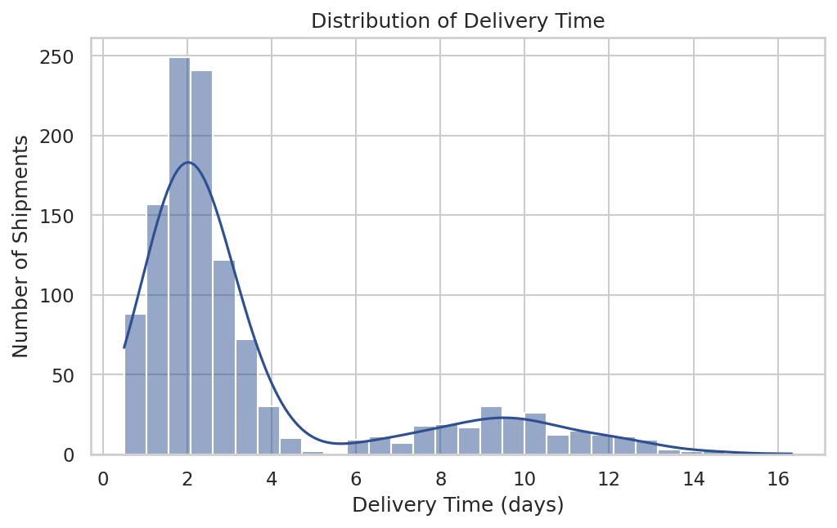
Figure 1. Distribution of delivery time across all shipments.
The distribution is right-skewed: most shipments deliver within 1–4 days, with a long tail extending toward slower, likely Sea/Air long-haul shipments. This shape confirms the skewness observed in the summary statistics and suggests operational focus should target the tail rather than the median.

4.2 Transportation Cost Spread by Mode
Chosen method: boxplot — ideal for comparing spread, median, and outliers of a numeric variable across multiple categories simultaneously.
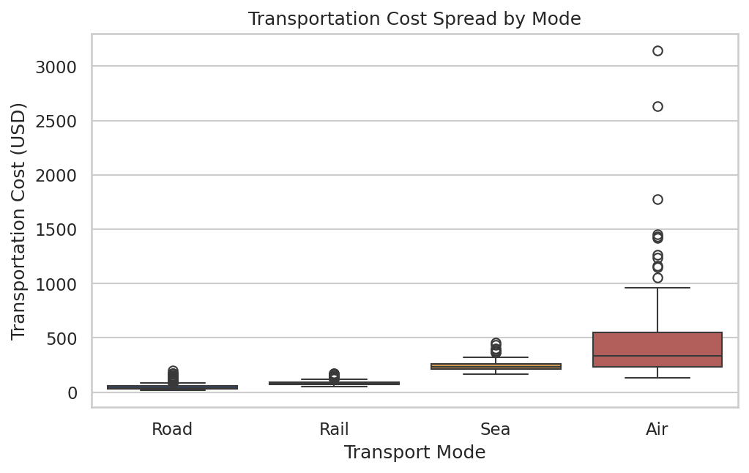
Figure 2. Transportation cost distribution by transport mode.
Air freight shows both the highest median cost and the widest spread, reflecting its premium pricing and sensitivity to shipment weight and distance. Road and Rail show tighter, lower-cost distributions, making them the preferred default for cost-sensitive shipments.

4.3 Distance vs. Delivery Time by Mode
Chosen method: scatter plot colored by category — best for revealing a relationship between two continuous variables while showing how a third categorical variable (mode) moderates that relationship.
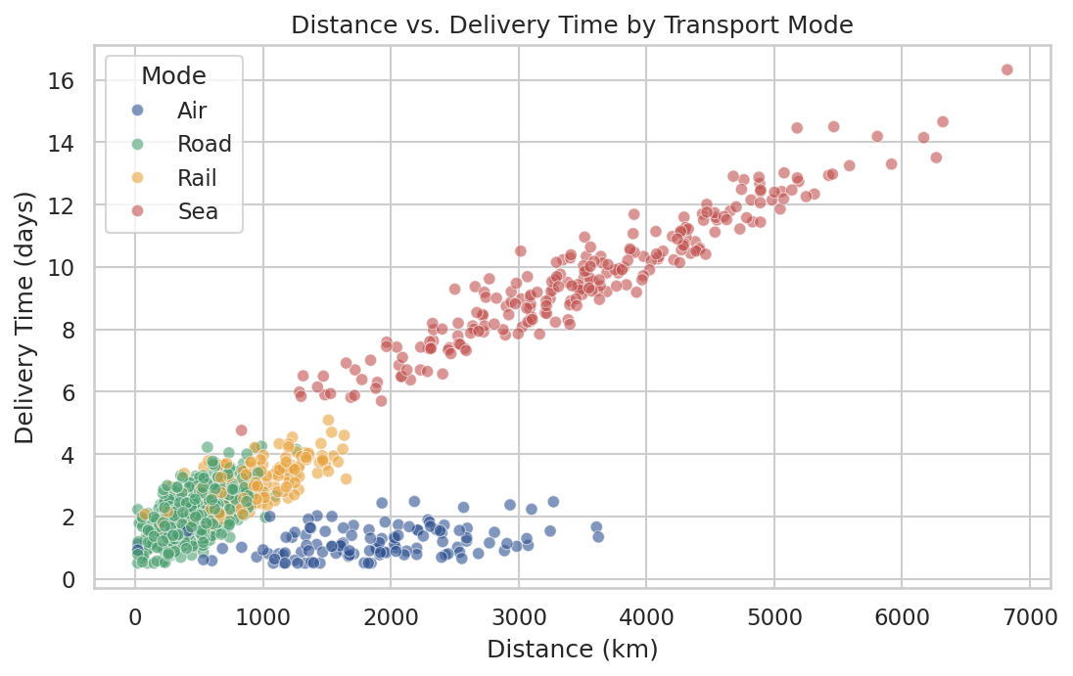
Figure 3. Relationship between distance and delivery time, split by transport mode.
Each mode forms a distinct band, with Air shipments clustering at low delivery times regardless of distance, while Sea shipments show the steepest time-per-kilometer increase. This clarifies that mode choice — not distance alone — is the dominant lever for delivery speed.

4.4 Correlation Matrix
Chosen method: heatmap — the standard way to compactly visualize many pairwise correlations at once and quickly spot the strongest relationships.
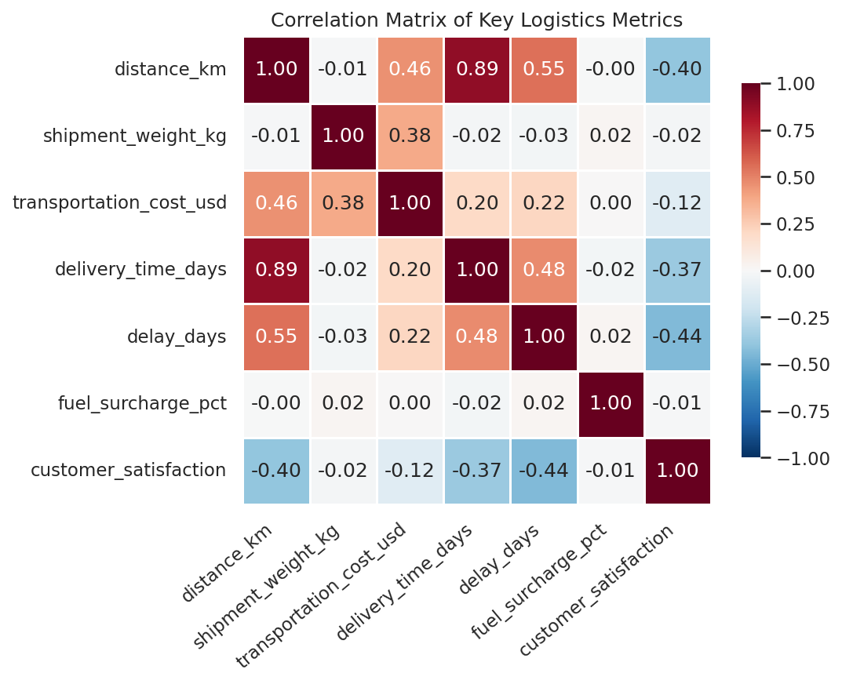
Figure 4. Correlation matrix of key numeric logistics metrics.
The heatmap makes the distance → delivery time → delay → satisfaction chain visually obvious: darker cells trace a path showing how operational metrics ultimately connect to the customer experience.

4.5 Delay Rate by Transport Mode
Chosen method: annotated bar chart — clearest way to rank and compare a single performance metric (delay %) across a small number of categories.
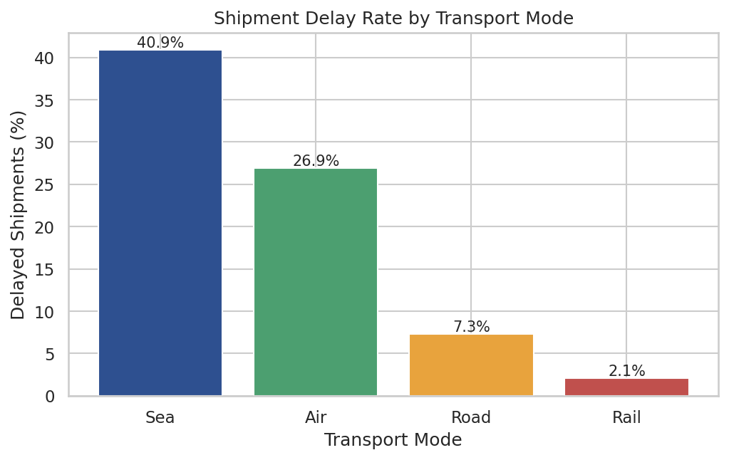
Figure 5. Percentage of shipments delayed, by transport mode.
Sea freight has by far the highest delay rate (40.9%), more than 4× that of Road (7.3%) and nearly 20× that of Rail (2.1%). This identifies Sea shipments as the primary operational bottleneck in the network.

4.6 Monthly Shipment Volume and Cost Trend
Chosen method: dual-axis line chart — appropriate for tracking two related metrics with different scales (count vs. currency) over time.
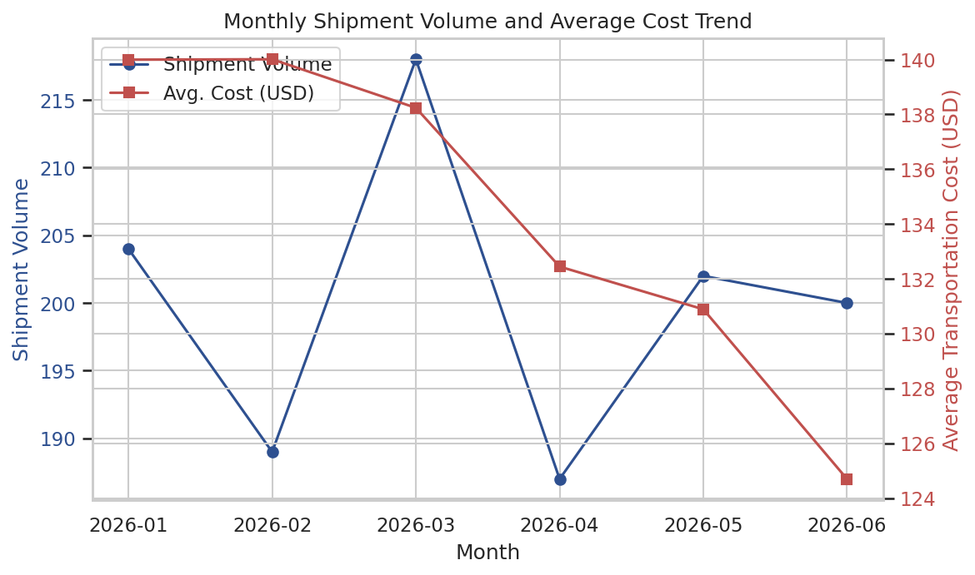
Figure 6. Monthly shipment volume and average transportation cost, Jan–Jun 2026.
Shipment volume and average cost move roughly in tandem through Q1 before both trend downward into Q2, suggesting either a seasonal easing of demand or a shift toward smaller, cheaper shipments later in the period.

4.7 Product Category Volume by Region
Chosen method: stacked bar chart — well suited to showing how a total (shipments per region) is composed of categorical sub-groups (product category).
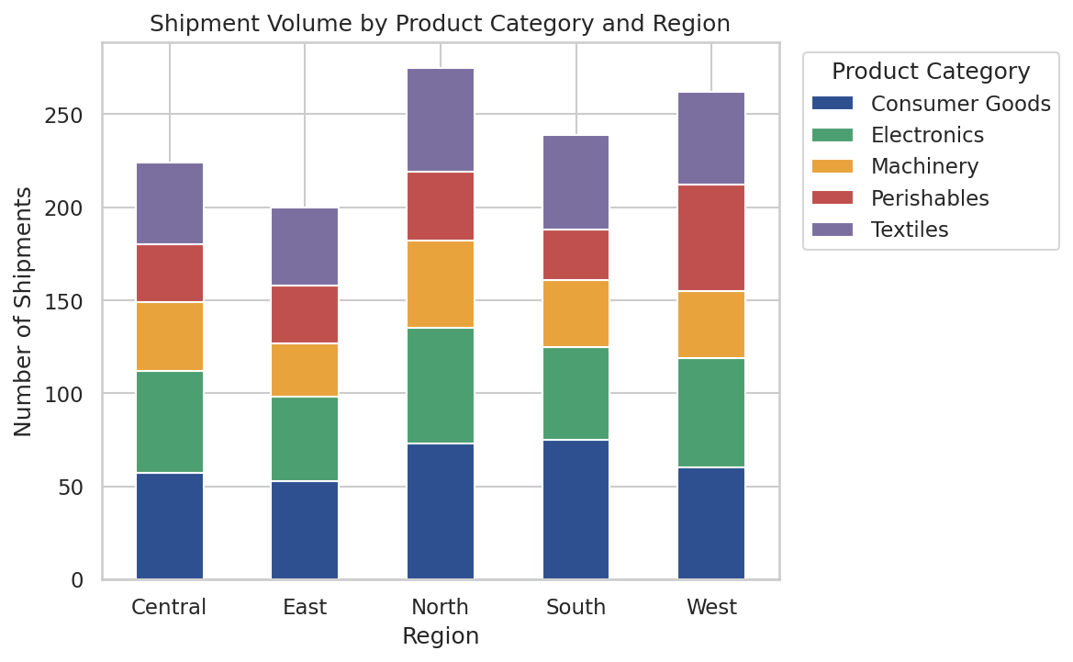
Figure 7. Shipment volume by product category, broken down by region.
Consumer Goods and Electronics are consistently the largest contributors across all regions, indicating these categories should be prioritized when planning regional warehousing and carrier capacity.

4.8 Customer Satisfaction: On-Time vs. Delayed
Chosen method: violin plot — combines a boxplot's summary statistics with a density view, useful here because satisfaction scores cluster at discrete half-point values.
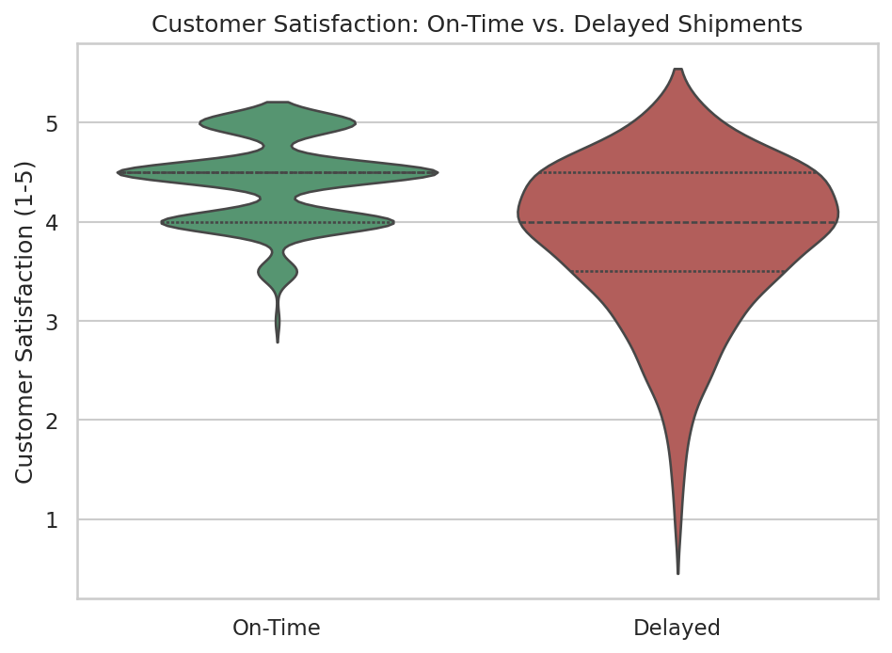
Figure 8. Customer satisfaction distribution for on-time vs. delayed shipments.
On-time shipments cluster tightly near 4.4–4.5, while delayed shipments show a wider, lower distribution centered near 3.8. This visually reinforces that on-time delivery is one of the strongest levers available for improving customer experience.

5. Analytical Insights & Recommendations

5.1 Key Insights
- Sea freight is the network's primary delay bottleneck, with a 40.9% delay rate and the longest average delay (1.57 days) among delayed shipments.
- Delivery time is driven overwhelmingly by distance and mode choice (r = 0.89 with distance), not by shipment weight, which has almost no correlation with delivery time.
- Weekend dispatch nearly triples the delay rate (28.0% vs. 9.6% for weekday dispatch), pointing to reduced weekend handling capacity as an operational gap.
- Customer satisfaction is most strongly driven by delay (r = -0.44), more so than by cost or product category — reliability matters more to customers than price.
- Air freight, while fastest and most reliable relative to Sea, carries by far the highest cost per kilogram ($1.07/kg vs. $0.15/kg for Road), making it suitable only for high-value, time-sensitive shipments.
- Consumer Goods and Electronics dominate shipment volume across every region, representing the largest opportunity for targeted process improvement.

5.2 Recommendations
- Prioritize Sea freight process improvements (e.g., port scheduling, buffer time in SLAs) given its outsized contribution to delays and their downstream effect on satisfaction.
- Re-evaluate weekend staffing and handling capacity to close the weekday/weekend delay gap.
- Reserve Air freight for high-priority, time-sensitive, or high-value shipments only, given its cost premium.
- Set mode-specific SLA promises rather than a single blanket delivery promise, since delivery time profiles differ substantially by mode.
- Track customer satisfaction alongside on-time performance as a joint KPI, since the data shows delay reduction as one of the most direct levers to improve customer experience.

6. Conclusion
This analysis demonstrates how a structured Python-based workflow — simulation, EDA, and visualization — can convert raw logistics data into concrete operational insight. The clearest finding is that transport mode, not shipment size or region, is the dominant driver of both cost and delivery reliability, and that delay (rather than cost) is the strongest predictor of customer satisfaction. These findings point to Sea freight reliability and weekend handling capacity as the two highest-leverage areas for operational improvement.

Appendix: Selected Python Code

A.1 Exploratory Data Analysis
# Central tendency & dispersion
desc = df[numeric_cols].describe().T
desc['median'] = df[numeric_cols].median()
desc['skew'] = df[numeric_cols].skew()
# Delay performance by transport mode
delay_rate = df.groupby('transport_mode')['is_delayed'].mean() * 100
# Correlation matrix
corr = df[numeric_cols].corr(numeric_only=True)

A.2 Visualization Examples
# Correlation heatmap
sns.heatmap(corr, annot=True, fmt='.2f', cmap='RdBu_r', center=0,
vmin=-1, vmax=1, square=True, linewidths=0.5)
# Delay rate bar chart with % labels
delay_rate = (df.groupby('transport_mode')['is_delayed'].mean()*100).sort_values(ascending=False)
bars = ax.bar(delay_rate.index, delay_rate.values, color=PALETTE)
for b in bars:
ax.annotate(f'{b.get_height():.1f}%', (b.get_x()+b.get_width()/2, b.get_height()),
ha='center', va='bottom')

