**Name: Akanksha Pardeshi Roll no: TY C-05 GR No: 1710386**

Assignment 3: C FILE Tokenization

Code:

%{

#include<stdio.h>

#include<stdlib.h>

int a=0,b=0,c=0,d=0,e=0,f=0,g=0,h=0,i=0;

%}

operator "="|"+"|"-"|"*"|"&&"|"||"|"!"|"%"

special "$"|"&"|"."|":"

escape_char "\n"|"\t"|"endl"|"\b"

keywords "define"|"main"|"return"|"break"|"switch"|"continue"

include_files "#include<stdio.h>"|"#include<stdlib.h>"|"#define"|"#include<iostream>"

data_types "int"|"float"|"string"|"double"|"char"

delimiter ";"|","|"("|")"|"{"|"}"|"["|"]"

%%

{include_files} printf("Directive%d: %s\n",++a,yytext);

{data_types} printf("Datatype%d: %s\n",++b,yytext);

{delimiter} printf("Delimiter%d: %s\n",++c,yytext);

{operator} printf("Operator%d: %s\n",++d,yytext);

{escape_char} printf("Escape character\n");

{special} printf("Special character%d: %s\n",++e,yytext);

{keywords} printf("Keyword%d: %s\n",++f,yytext);

[a-zA-Z]+ printf("Variable%d: %s\n",++h,yytext);

[0-9]+ printf("Number%d: %s\n",++i,yytext);

%%

int yywrap(void){}

int main()

{ yyin=fopen("sample.c","r");

yylex();

return 0;

}

**Output:**

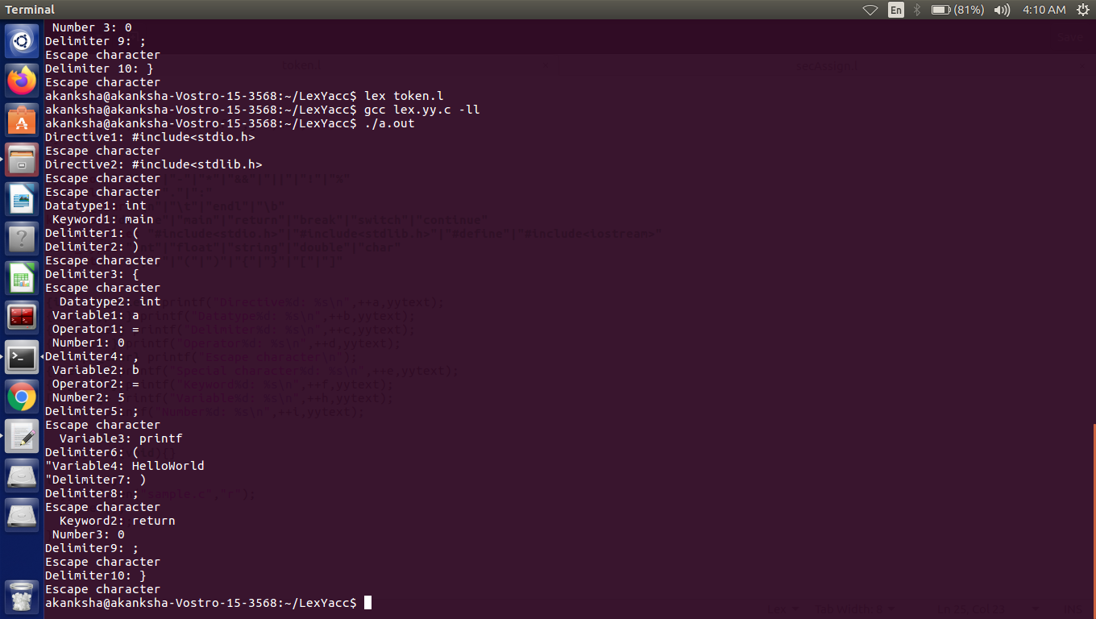

**sample.c file**

**#include<stdio.h>**

**#include<stdlib.h>**

**int main()**

**{**

**int a = 0, b = 5;**

**printf("HelloWorld");**

**return 0;**

**}**