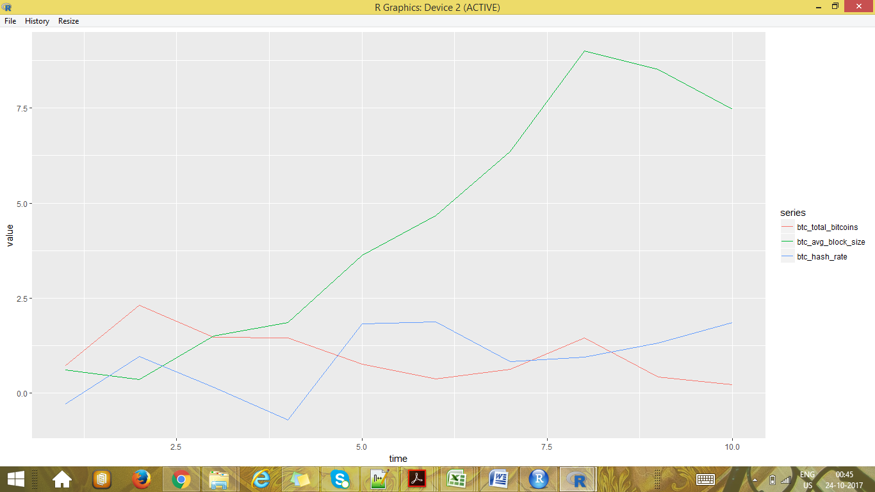
ggplot2 package and reshape package used in R for Visualizing the BitCoinDataSet csv.
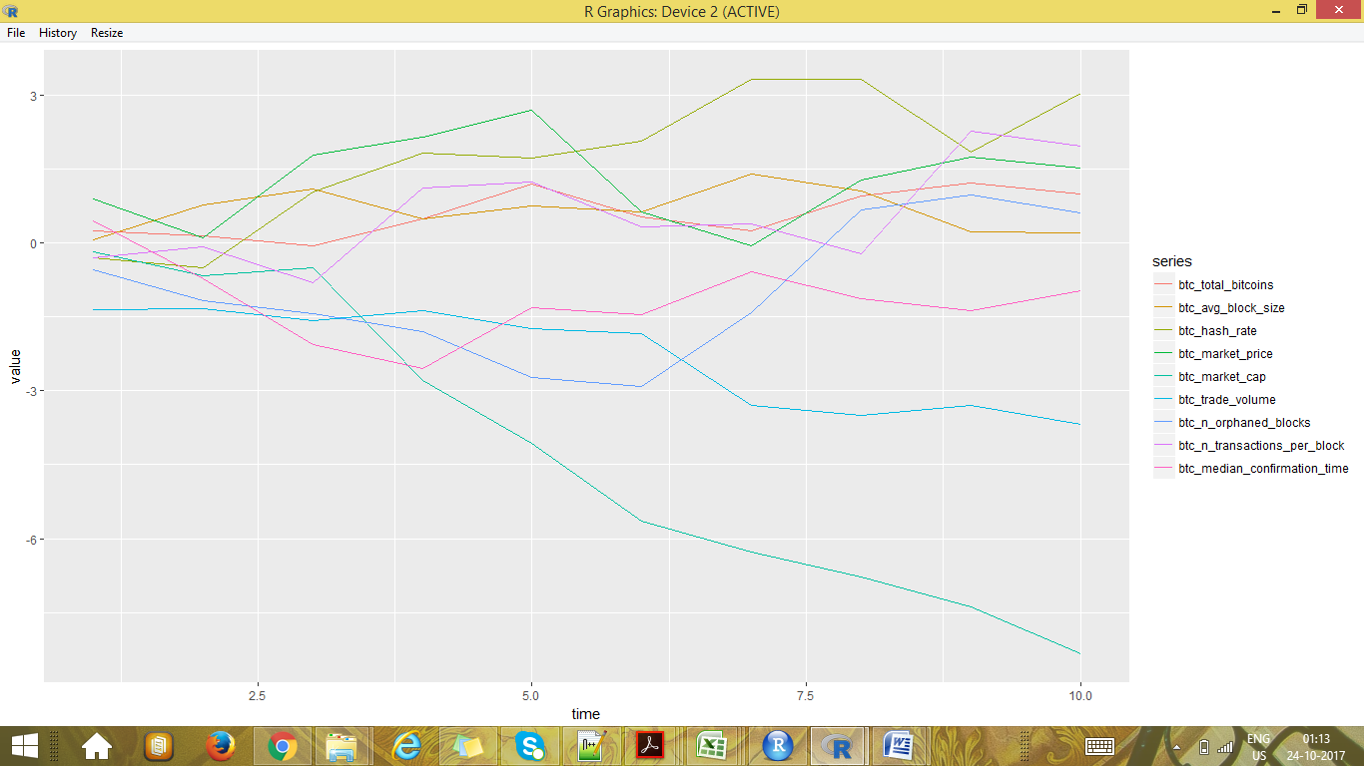
Plotting on same plot
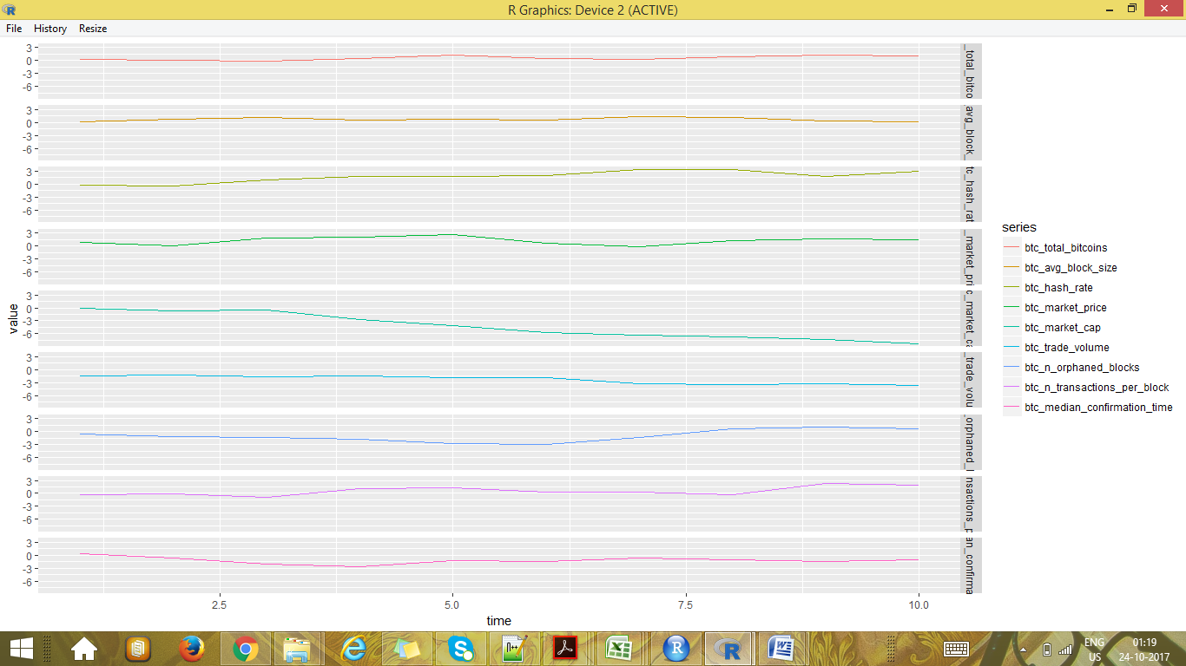
Plotting on different plots

Univariate approach(BoxPlot On single Column or Attribute)

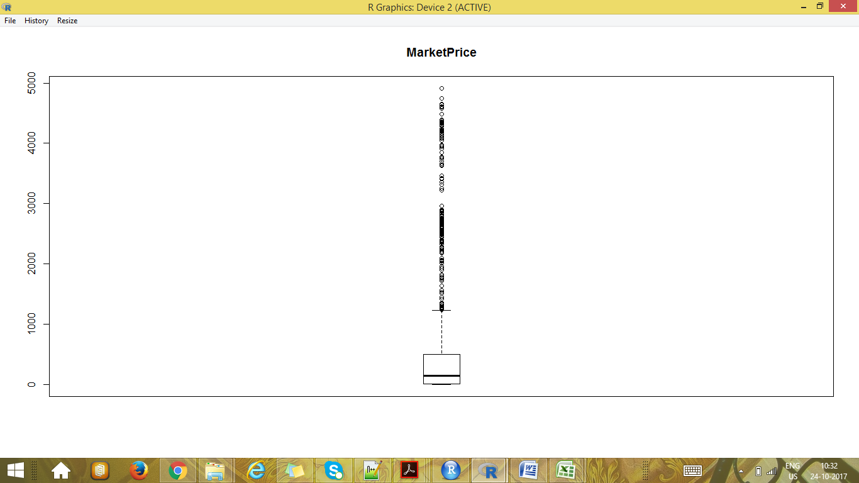

Box Plot on Market Price for BitCoin Dataset.csv.

For a given continuous variable, outliers are those observations that lie outside 1.5 * IQR, where IQR, the ‘Inter Quartile Range’ is the difference between 75th and 25th quartiles. Look at the points outside the whiskers in below box plot.

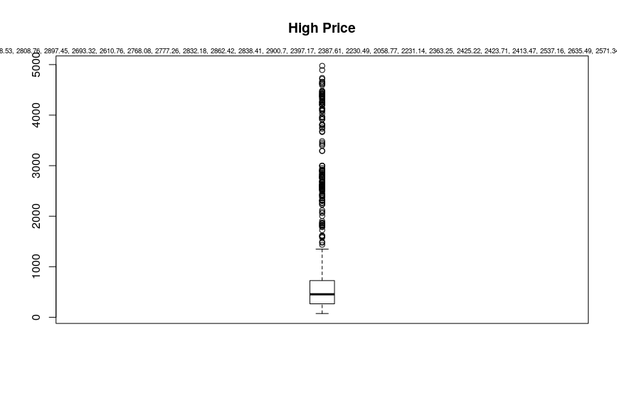Box Plot High Columns for BitcoinPrice.csv. We are plotting only one column or attribute “High” present in the BitcoinPrice.csv

Bivariate approach - Visualize in box-plot of the X and Y, for categorical X’s

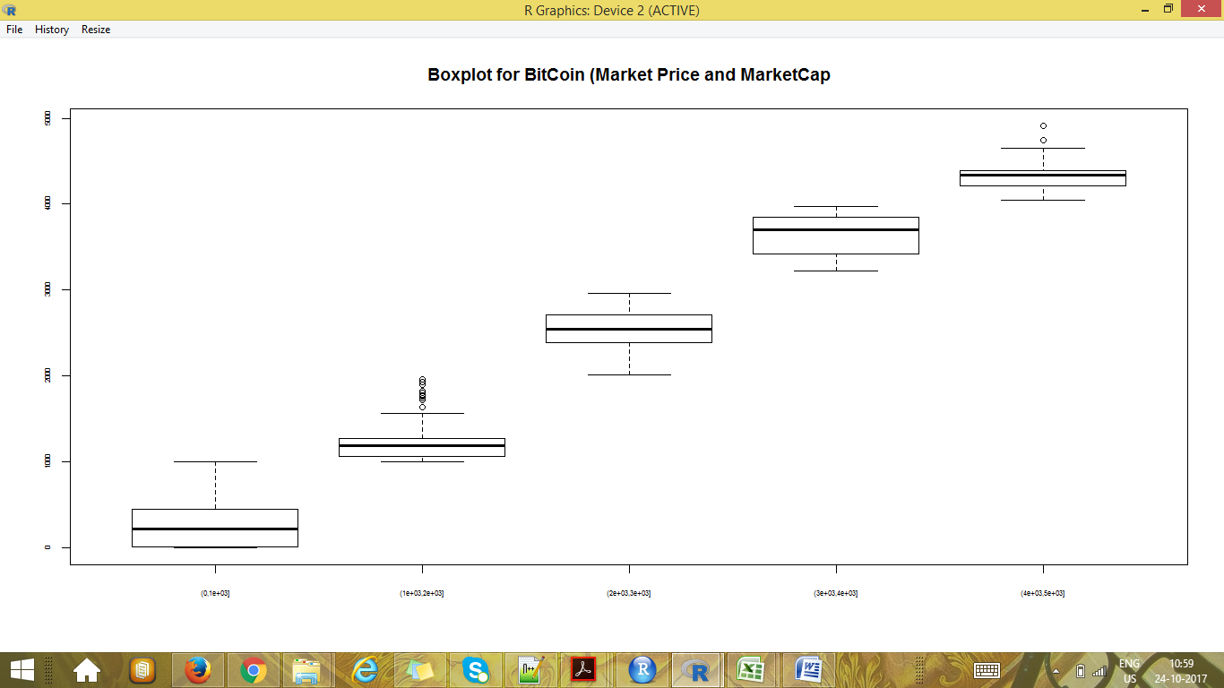

BoxPlot for Market Price and Market Cap for bitcoin datset.csv. We observe outliers which show up as dots.
Bivariate(Categorical Approach)
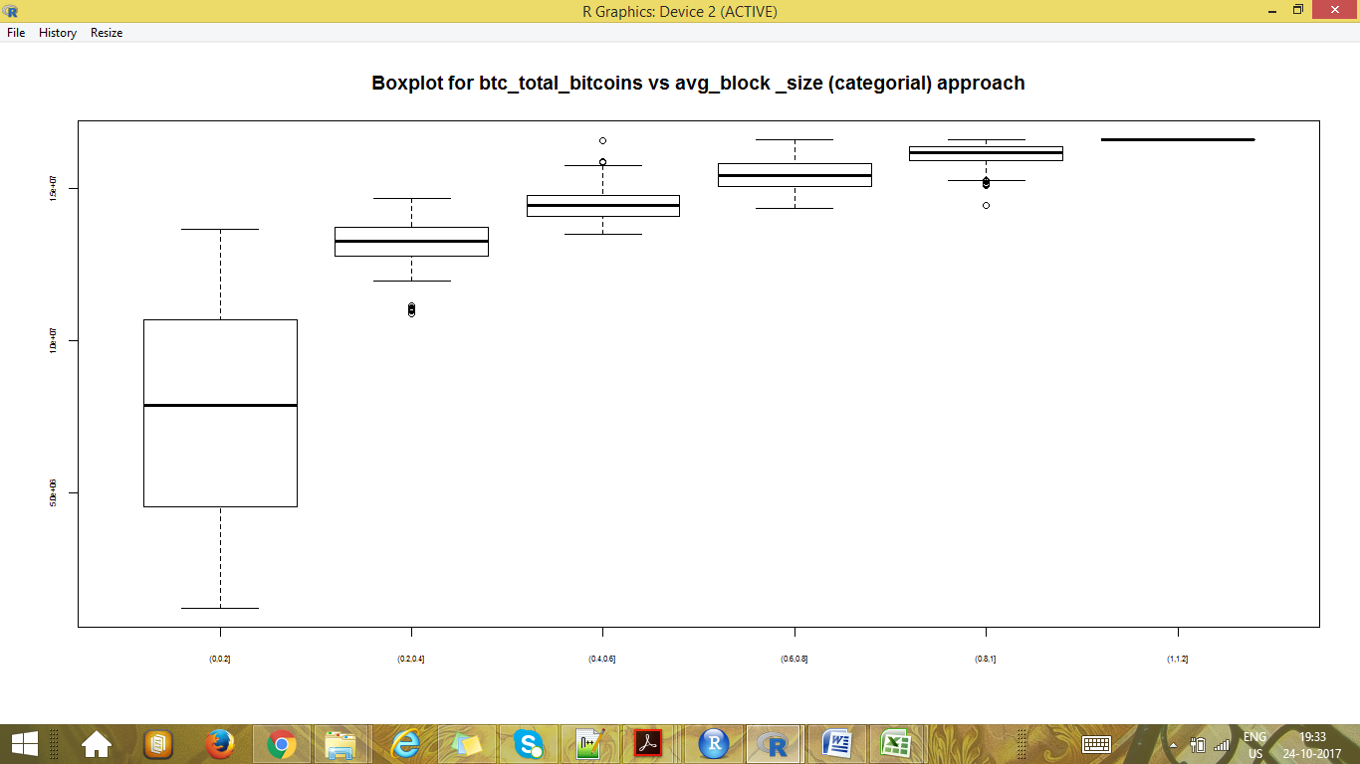

BoxPlot for btc_total_bitcoins versus avg_block_size for bitcoin dataset.csv. We observe there are two outliers which show up as dots outside the whiskers of box plot.

