Exercise 6: Set Operator

In this practice, you write queries using the set operators.
Using the Set Operators

1) The HR department needs a list of department IDs for departments that do not contain
the job ID ST_CLERK. Use the set operators to create this report.

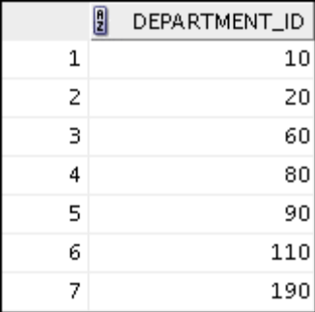
SELECT DEPARTMENT_ID
FROM TBLDEPARTMENTS
MINUS
SELECT D.DEPARTMENT_ID
FROM TBLEMPLOYEES E JOIN TBLDEPARTMENTS D
ON E.DEPARTMENT_ID = D.DEPARTMENT_ID
AND UPPER(JOB_ID) = 'SH_CLERK';

2) The HR department needs a list of countries that have no departments located in
them. Display the country ID and the name of the countries. Use the set operators to
create this report.
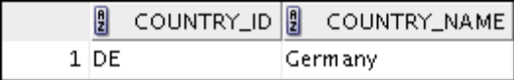

SELECT *
FROM TBLCOUNTRIES

MINUS

SELECT DISTINCT C.*
FROM TBLDEPARTMENTS D JOIN TBLLOCATIONS L
ON D.LOCATION_ID = L.LOCATION_ID
JOIN TBLCOUNTRIES C
ON L.COUNTRY_ID = C.COUNTRY_ID;

3) Produce a list of jobs for departments 10, 50, and 20, in that order. Display the job ID
and department ID by using the set operators.

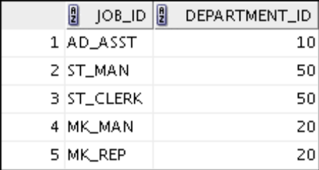

SELECT E.JOB_ID, D.DEPARTMENT_ID
FROM TBLEMPLOYEES E
JOIN TBLDEPARTMENTS D
ON E.DEPARTMENT_ID = D.DEPARTMENT_ID
AND D.DEPARTMENT_ID = 10

UNION

SELECT E.JOB_ID, D.DEPARTMENT_ID
FROM TBLEMPLOYEES E
JOIN TBLDEPARTMENTS D
ON E.DEPARTMENT_ID = D.DEPARTMENT_ID
AND D.DEPARTMENT_ID = 50

UNION

SELECT E.JOB_ID, D.DEPARTMENT_ID
FROM TBLEMPLOYEES E
JOIN TBLDEPARTMENTS D
ON E.DEPARTMENT_ID = D.DEPARTMENT_ID
AND D.DEPARTMENT_ID = 20;

4) Create a report that lists the employee IDs and job IDs of those employees who
currently have a job title that is the same as their job title when they were initially
hired by the company (that is, they changed jobs, but have now gone back to doing
their original job).
SELECT EMPLOYEE_ID,JOB_ID
FROM TBLEMPLOYEES

INTERSECT

SELECT EMPLOYEE_ID, JOB_ID
FROM TBLJOB_HISTORY;

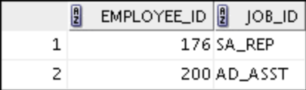

5) The HR department needs a report with the following specifications:
Last name and department ID of all employees from the EMPLOYEES table,
regardless of whether or not they belong to a department

Department ID and department name of all departments from the DEPARTMENTS
table, regardless of whether or not they have employees working in them
Write a compound query to accomplish this.

SELECT LAST_NAME, DEPARTMENT_ID, TO_CHAR('null')
FROM TBLEMPLOYEES
UNION
SELECT TO_CHAR('null'),DEPARTMENT_ID, DEPARTMENT_NAME
FROM TBLDEPARTMENTS;
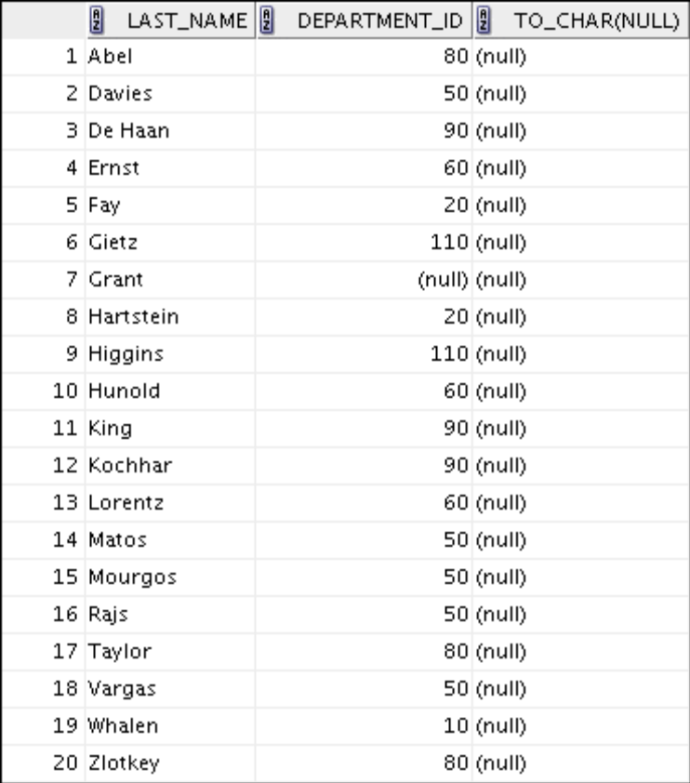
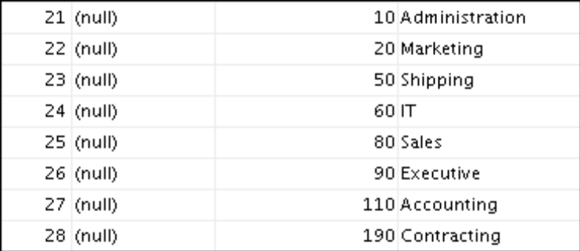

Exercise 7 - Table Creation (DDL)
Create new tables by using the CREATE TABLE statement. Confirm that the new table
was added to the database. You also learn to set the status of a table as READ ONLY and
then revert to READ/WRITE.

Note: For all the DDL and DML statements, click the Run Script icon (or press [F5]) to
execute the query in SQL Developer. This way you get to see the feedback messages on
the Script Output tabbed page. For SELECT queries, continue to click the Execute
Statement icon or press [F9] to get the formatted output on the Results tabbed page.
Using DDL Statements to Create and Manage Tables
1) Create the DEPT table, based on the following table instance chart. Save the statement

in a script called lab_10_01.sql, and then execute the statement in the script to
create the table. Confirm that the table is created.

CREATE TABLE DEPT
(ID NUMBER(7) PRIMARY KEY,
NAME VARCHAR2(25));

DESC DEPT;
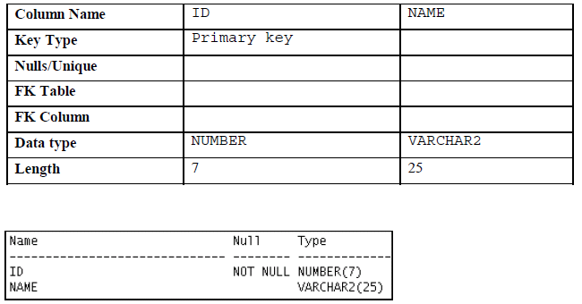
2) Populate the DEPT table with data from the DEPARTMENTS table. Include only
columns that you need.

INSERT INTO DEPT
SELECT DEPARTMENT_ID, DEPARTMENT_NAME
FROM TBLDEPARTMENTS;

3) Create the EMP table based on the following table instance chart. Save the statement
in a script called lab_10_03.sql, and then execute the statement in the script to
create the table. Confirm that the table is created.

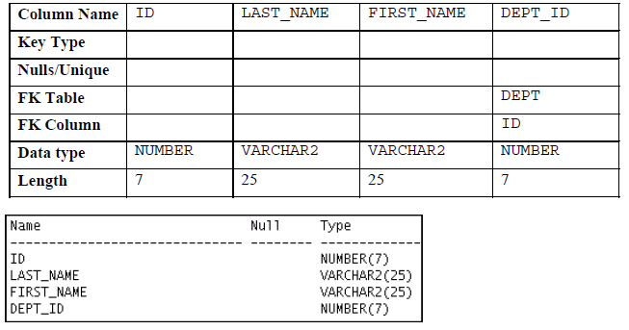

CREATE TABLE EMP
( ID NUMBER(7) ,
LAST_NAME VARCHAR2(25),
FIRST_NAME VARCHAR2(25) ,
DEPT_ID NUMBER(7),
CONSTRAINT EMP_DEP_FK FOREIGN KEY (DEPT_ID) REFERENCES DEPT(ID));

DESC EMP;

4) Create the EMPLOYEES2 table based on the structure of the EMPLOYEES table. Include only the EMPLOYEE_ID, FIRST_NAME, LAST_NAME, SALARY, and DEPARTMENT_ID columns. Name the columns in your new table ID, FIRST_NAME, LAST_NAME, SALARY, and DEPT_ID, respectively.

CREATE TABLE EMPLOYEES2
(ID NUMBER,
FIRST_NAME VARCHAR2(25),
LAST_NAME VARCHAR2(25),
SALARY NUMBER(8,2),
DEPT_ID NUMBER);

INSERT INTO EMPLOYEES2
SELECT EMPLOYEE_ID, FIRST_NAME, LAST_NAME,SALARY, DEPARTMENT_ID
FROM TBLEMPLOYEES;

5) Alter the EMPLOYEES2 table status to read-only.

ALTER TABLE EMPLOYEES2 READ ONLY;

6) Try to insert the following row in the EMPLOYEES2 table:
ID FIRST_NAME LAST_NAME SALARY DEPT_ID
34 Grant 5678 10Marcie

INSERT INTO EMPLOYEES2 VALUES(34, 'Grant', 'Marcie', 5678, 10);

You get the following error message:

Error starting at line : 1 in command -
INSERT INTO EMPLOYEES2 VALUES(34, 'Grant', 'Marcie', 5678, 10)
Error at Command Line : 1 Column : 13
Error report -
SQL Error: ORA-12081: update operation not allowed on table "HR2"."EMPLOYEES2"
12081. 00000 - "update operation not allowed on table \"%s\".\"%s\""
*Cause: An attempt was made to update a read-only materialized view.
*Action: No action required. Only Oracle is allowed to update a
read-only materialized view.

7) Revert the EMPLOYEES2 table to the read/write status. Now, try to insert the same
row again.
ALTER TABLE EMPLOYEES2 READ WRITE;
INSERT INTO EMPLOYEES2 VALUES(34, 'Grant', 'Marcie', 5678, 10);

You should get the following messages:
1 row inserted.

8) Drop the EMPLOYEES2 table.

DROP TABLE EMPLOYEES2;

Oracle Database 11g: SQL Fundamentals I A - 76
______________________________________________________________________________________________

Practice 1-1: Creating Other Schema Objects
Part 1
1) The staff in the HR department wants to hide some of the data in the EMPLOYEES
table. Create a view called EMPLOYEES_VU based on the employee numbers,
employee last names, and department numbers from the EMPLOYEES table. The
heading for the employee name should be EMPLOYEE.

CREATE VIEW EMPLOYEES_VU(EMP_ID, EMPLOYEE, DEPT_ID)
AS
SELECT EMPLOYEE_ID, LAST_NAME, DEPARTMENT_ID
FROM TBLEMPLOYEES;

2) Confirm that the view works. Display the contents of the EMPLOYEES_VU view.

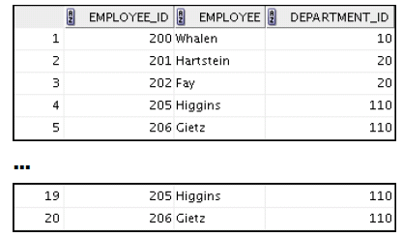

SELECT * FROM EMPLOYEES_VU;

3) Using your EMPLOYEES_VU view, write a query for the HR department to display all
employee names and department numbers.

SELECT EMPLOYEE , DEPT_ID
FROM EMPLOYEES_VU;
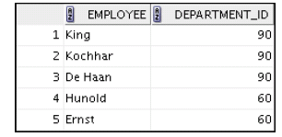
4) Department 50 needs access to its employee data. Create a view named DEPT50 that
contains the employee numbers, employee last names, and department numbers for
all employees in department 50. You have been asked to label the view columns
EMPNO, EMPLOYEE, and DEPTNO. For security purposes, do not allow an employee to
be reassigned to another department through the view.

CREATE OR REPLACE VIEW DEPT50(EMPNO, EMPLOYEE , DEPT_NO)
AS
SELECT EMPLOYEE_ID, LAST_NAME , DEPARTMENT_ID
FROM TBLEMPLOYEES
WHERE DEPARTMENT_ID = 50
WITH CHECK OPTION;

5) Display the structure and contents of the DEPT50 view.

SELECT *
FROM DEPT50;

DESC DEPT50;

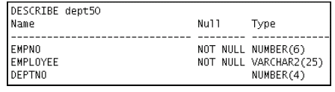

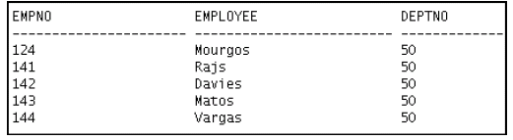

6) Test your view. Attempt to reassign Grant to department 80.

UPDATE DEPT50
SET DEPT_NO = 80
WHERE UPPER(EMPLOYEE) = 'GRANT'; --Gives error

Part 2
7) You need a sequence that can be used with the PRIMARY KEY column of the DEPT
table. The sequence should start at 200 and have a maximum value of 1,000. Have
your sequence increment by 10. Name the sequence DEPT_ID_SEQ.

CREATE SEQUENCE DEPT_ID_SEQ
MINVALUE 200
MAXVALUE 1000
INCREMENT BY 10;

8) To test your sequence, write a script to insert two rows in the DEPT table. Name your
script lab_11_08.sql. Be sure to use the sequence that you created for the ID
column. Add two departments: Education and Administration. Confirm your
additions. Run the commands in your script.

INSERT INTO DEPT VALUES(DEPT_ID_SEQ.NEXTVAL,'Education');

INSERT INTO DEPT VALUES(DEPT_ID_SEQ.NEXTVAL, 'Administration');

9) Create a nonunique index on the NAME column in the DEPT table.

CREATE INDEX name_ind ON DEPT(NAME);

10) Create a synonym for your EMPLOYEES table. Call it EMP1.

CREATE SYNONYM EMP1 FOR EMPLOYEES;

