**UNIT-2**

**AGILE PROCESSES**

**AGILE PROCESSES**

Agile processes refer to a set of principles and practices aimed at improving the flexibility, collaboration, and efficiency of project development, particularly in software development. They are based on the **Agile Manifesto**

**LEAN PRODUCTION**

**Lean Production** (often referred to simply as **Lean**) is a manufacturing philosophy that focuses on reducing waste and improving efficiency in production processes. It originates from **Toyota Production System (TPS)** and aims to optimize resources, minimize costs, and ensure high quality by eliminating waste (referred to as "muda" in Japanese) in every step of production. Lean principles are also applied outside of manufacturing, such as in service industries and software development, to improve processes and create value.

**Core Principles of Lean Production**

Lean production is based on **five key principles**:

1. **Value**:
   * Define value from the perspective of the customer. The customer determines what is valuable, and anything that does not add value is considered waste.
   * Companies must understand customer needs and expectations to deliver the most value efficiently.
2. **Value Stream**:
   * The **value stream** refers to the entire flow of materials and information required to produce a product, from raw materials to finished goods.
   * Identifying the value stream helps in pinpointing wasteful activities and steps that don’t contribute to value creation.
   * The goal is to map out all the steps in the process and eliminate waste.
3. **Flow**:
   * Once the value stream is mapped, Lean aims to ensure a smooth flow of materials and information throughout the process.
   * This involves removing bottlenecks, delays, and inefficiencies that disrupt the flow of production.
   * Work should be done in a continuous and uninterrupted manner to improve productivity.
4. **Pull**:
   * Lean uses a **pull system**, meaning products are only made or moved when there is demand for them, rather than producing in advance based on forecasts.
   * This reduces overproduction, inventory, and the associated costs, while ensuring that production is more closely aligned with customer demand.
5. **Perfection**:
   * Lean is a continuous improvement philosophy. After removing waste and improving flow, companies are encouraged to continually evaluate processes for further opportunities for improvement.
   * A focus on perfection involves striving for excellence in quality, cost, and delivery by constantly refining processes and eliminating inefficiencies.

**Types of Waste in Lean Production (The 7 Wastes)**

Lean identifies **seven types of waste**, also called the "Seven Wastes of Lean" (often referred to by the acronym **TIMWOOD**):

1. **T**ransportation: Unnecessary movement of materials or products.

* Transport is moving materials from one position to another. The transport itself adds no value to the product, so minimizing these costs is essential. This means having one plant closer to another in the production chain, or minimizing the costs of transportation using more efficient methods. Resources and time are used in handling material, employing staff to operate transportation, training, implement safety precautions, and using extra space. Transport can also cause the waste of waiting, as one part of the production chain must wait for material to arrive.
* Environmental costs to waiting include gas emissions, transportation packaging used, possible damage to the product en route, as well as a whole host of other wastes involving transporting hazardous materials.

1. **I**nventory: Excess inventory that ties up resources and storage space.

Inventory waste refers to the waste produced by unprocessed inventory. This includes the waste of storage, the waste of capital tied up in unprocessed inventory, the waste of transporting the inventory, the containers used to hold inventory, the lighting of the storage space, etc. Moreover, having excess inventory can hide the original wastes of producing said inventory.

1. **M**otion: Unnecessary movement of workers or equipment.

Wasteful motion is all of the motion, whether by a person or a machine, that could be minimized. If excess motion is used to add value that could have been added by less, than that margin of motion is wasted. Motion could refer to anything from a worker bending over to pick something up on the factory floor to additional wear and tear on machines, resulting in capital depreciation that must be replaced.

There are many environmental costs from excess motion. One obvious one is the needless waste of materials used to replace worn machines; another one could be the health resources for overburdened employees, who might not have needed them if motion had been minimized.

1. **W**aiting: Idle time when resources (materials, workers, equipment) are waiting.

Waiting refers to wasted time because of slowed or halted production in one step of the production chain while a previous step is completed. To take the classic example, the production line, if one task along the chain takes longer than another, than any time the employee in charge of the next task spends waiting is wasted. The task that takes more time must be made more efficient, other employees must be hired to help, or the workflow must be better coordinated or scheduled in order to make up for this wasted time.

The environmental impact comes from the wasted labor and energy from lighting, heating, or cooling during the waiting period. Additionally, material can be spoiled, and components could be damaged because of an inefficient workflow.

1. **O**verproduction: Producing more than is needed or producing too early.

The most serious of the wastes, overproduction can cause all other types of wastes and results in excess inventory. Stocking too much of a product that goes unused has obvious costs: storage, wasted materials, and excessive capital tied up in useless inventory. Depending, of course, on the product in question, overproduction can have very serious environmental effects. More raw materials than necessary are consumed; the product may spoil or become obsolete, which requires that it be tossed; and, if the product involves hazardous materials, more hazardous materials than necessary are wasted, resulting in extra emissions, extra costs of waste disposal, possible worker exposure, and potential environmental problems resulting from the waste itself.

1. **O**verprocessing: Doing more work than is necessary or adding features that the customer doesn’t value.

Over-processing refers to any component of the process of manufacture that is unnecessary. Painting an area that will never be seen or adding features that will not be used are examples of over-processing. Essentially, it refers to adding more value than the customer requires.

The environmental impact involves the excess of parts, labor, and raw materials consumed in production. Time, energy, and emissions are wasted when they are used to produce something that is unnecessary in a product; simplification and efficiency reduce these wastes and benefit the company and the environment.

1. **D**efects: Producing defective items that require rework or cause quality issues.

Defects refer to a product deviating from the standards of its design or from the customer’s expectation. Defective products must be replaced; they require paperwork and human labor to process it; they might potentially lose customers; the resources put into the defective product are wasted because the product is not used. Moreover, a defective product implies waste at other levels that may have led to the defect to begin with; making a more efficient production system reduces defects and increases the resources needed to address them in the first place.

Environmental costs of defects are the raw materials consumed, the defective parts of the product requiring disposal or recycling (which wastes other resources involved in repurposing it), and the extra space required and increased energy use involved in dealing with the defects.

**Tools and Techniques Used in Lean Production**

Lean production uses a variety of tools and techniques to implement its principles and reduce waste:

1. **5S**: A methodology for organizing the workplace to improve efficiency and reduce waste.
   * **Sort** (remove unnecessary items)
   * **Set in order** (organize tools and materials)
   * **Shine** (keep the workplace clean)
   * **Standardize** (develop standardized work procedures)
   * **Sustain** (maintain and improve over time)
2. **Kaizen (Continuous Improvement)**: A philosophy of making small, incremental improvements regularly. It involves everyone in the organization from top management to workers to contribute ideas for improvements.
3. **Kanban**: A visual scheduling system that helps manage workflow. It’s often used in inventory control to signal when more items need to be produced or ordered.
4. **Just-in-Time (JIT)**: A strategy that aims to produce and deliver products exactly when needed, reducing inventory and minimizing waste. This approach helps optimize storage and reduce costs associated with overproduction.
5. **Poka-Yoke (Error-Proofing)**: Techniques designed to prevent mistakes or defects from occurring during the production process, ensuring quality control at every stage.
6. **Value Stream Mapping (VSM)**: A tool used to visually map out the flow of materials and information through the production process, helping identify wasteful steps and areas for improvement.
7. **SMED (Single-Minute Exchange of Dies)**: A technique used to reduce setup times, allowing faster changeovers between different production runs, and thus increasing flexibility and throughput.
8. **Andon**: A visual system used to alert workers and management to problems in the production process. It helps in addressing issues quickly and ensuring smooth operations.
9. **Cellular Manufacturing**: Arranging workstations in a way that allows a smooth flow of materials and products, reducing transportation time and eliminating bottlenecks.

**Benefits of Lean Production**

When implemented correctly, Lean production provides several benefits:

* **Reduced Costs**: By minimizing waste, reducing inventory, and improving efficiency, companies can cut operational costs.
* **Improved Quality**: Lean encourages a focus on quality at every stage, leading to fewer defects and higher customer satisfaction.
* **Faster Time to Market**: Lean’s focus on continuous flow and pull systems ensures that products are delivered faster to meet customer demand.
* **Increased Flexibility**: Lean practices like JIT and SMED enable businesses to quickly adapt to changes in customer demand and production requirements.
* **Employee Involvement**: Lean promotes a culture of continuous improvement where employees at all levels are encouraged to contribute ideas for making processes more efficient and improving workplace conditions.

**Challenges of Lean Production**

* **Initial Implementation**: Transitioning to a Lean system can be challenging, requiring changes to organizational culture, processes, and sometimes physical layout.
* **Resistance to Change**: Employees and managers may resist changes to established workflows, particularly when it involves shifting responsibilities or relinquishing control.
* **Maintaining Gains**: Lean requires ongoing commitment to continuous improvement, and there is a risk of slipping back into old, inefficient habits without proper leadership and maintenance.

In conclusion, Lean production is a powerful methodology that focuses on eliminating waste, improving efficiency, and enhancing customer value. By adopting Lean principles and tools, companies can create more efficient, high-quality production processes that deliver better products at lower costs.

**SCRUM**

**Scrum** is an Agile framework used to manage and execute complex projects, typically in software development, but it can be applied to a variety of industries. It promotes collaboration, flexibility, and iterative progress, with a focus on delivering high-quality products in a fast-paced, continuously changing environment.

Scrum structures work in time-boxed iterations called **Sprints**, typically lasting 2-4 weeks, where teams produce a potentially shippable product increment. The goal is to deliver small, incremental pieces of value that can be tested and refined based on feedback from stakeholders.

**Key Roles in Scrum**

Scrum has three core roles that are responsible for the success of the project:

1. **Product Owner**:
   * **Responsibilities**: The Product Owner is responsible for defining the product backlog and ensuring that the team is working on the most valuable tasks. They act as a bridge between the development team and the stakeholders (customers, business owners, etc.).
   * **Key Duties**:
     + Prioritize and maintain the **Product Backlog**.
     + Make decisions about what to build and in what order.
     + Communicate with stakeholders and ensure the development team has a clear understanding of the customer needs.
2. **Scrum Master**:
   * **Responsibilities**: The Scrum Master acts as a facilitator for the Scrum team. They ensure that Scrum practices are being followed, remove obstacles (impediments) that may block progress, and help the team stay focused and improve its processes.
   * **Key Duties**:
     + Ensure the Scrum process is being followed.
     + Protect the team from external distractions and interruptions.
     + Facilitate Scrum ceremonies (meetings) and ensure they are effective.
     + Help the team continuously improve its practices through retrospectives and feedback loops.
3. **Development Team**:
   * **Responsibilities**: The Development Team is responsible for building the product increment. They are cross-functional, meaning they possess all the skills required to complete the work in a sprint, such as design, coding, testing, and more.
   * **Key Duties**:
     + Work together to complete tasks in the **Sprint Backlog**.
     + Collaborate with the Product Owner to clarify user stories and requirements.
     + Produce a potentially shippable increment by the end of each Sprint.

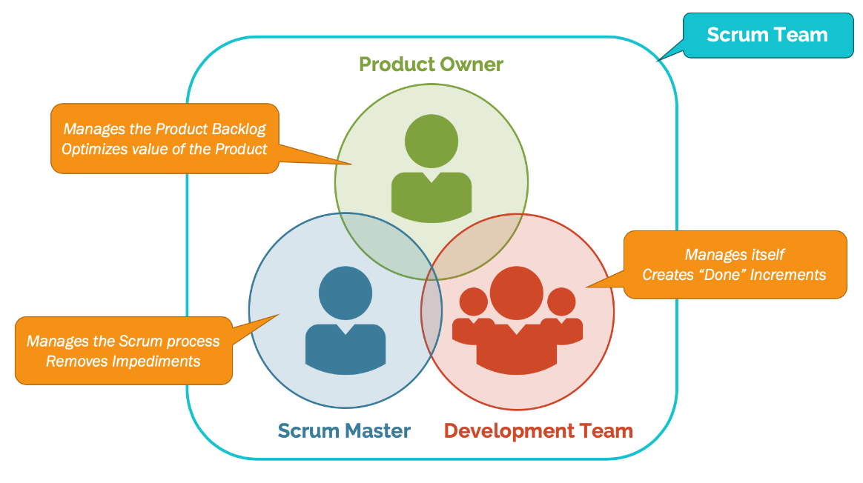

**Scrum Artifacts**

Artifacts are the key outputs of Scrum, providing transparency and focus for the team and stakeholders:

1. **Product Backlog**:
   * A dynamic list of features, functionalities, improvements, and fixes that are required for the product. The Product Owner maintains and prioritizes the backlog.
   * The Product Backlog is a living document that evolves as the project progresses, reflecting changes in customer needs or market conditions.
2. **Sprint Backlog**:
   * The Sprint Backlog is a subset of the Product Backlog that the Development Team commits to working on during a particular Sprint. It consists of user stories, tasks, and any additional work required to complete the Sprint.
   * It is created during **Sprint Planning** and is refined throughout the Sprint.
3. **Increment**:
   * The Increment is the sum of all completed Product Backlog items during a Sprint, along with any previous Sprints' work. It represents a potentially shippable product that can be released to customers or stakeholders.

**Scrum Events (Ceremonies)**

Scrum has five key events, also known as **ceremonies**, that structure the work and communication throughout the project:

1. **Sprint**:
   * A time-boxed iteration (typically 2-4 weeks) during which a shippable increment is produced. A Sprint is essentially a mini-project that results in a working piece of the product.
   * A Sprint is a fixed period of time that cannot be extended, and it starts with a **Sprint Planning** meeting and ends with a **Sprint Review** and **Sprint Retrospective**.
2. **Sprint Planning**:
   * A meeting where the Scrum team (Product Owner, Scrum Master, and Development Team) decides what to work on during the upcoming Sprint. The Product Owner presents the highest priority items from the Product Backlog, and the team selects which items they can complete within the Sprint.
   * The team then breaks the work into tasks and commits to delivering a certain set of features by the end of the Sprint.
3. **Daily Scrum (Daily Standup)**:
   * A short (usually 15-minute) daily meeting where the Development Team synchronizes their work and discusses progress. Each team member answers three questions:
     + What did I do yesterday?
     + What will I do today?
     + Are there any impediments (issues) blocking my progress?
   * This helps identify obstacles early and ensures everyone is aligned on the team's goals.
4. **Sprint Review**:
   * A meeting held at the end of the Sprint where the team demonstrates the completed work (increment) to stakeholders. The Product Owner may accept or reject work based on whether it meets the definition of done.
   * The team and stakeholders also discuss progress, any changes in the product backlog, and future priorities.
5. **Sprint Retrospective**:
   * A meeting held after the Sprint Review and before the next Sprint Planning. The Scrum team reflects on the Sprint and identifies areas for improvement in their processes, communication, or practices.
   * The goal is continuous improvement, and action items from this meeting should be implemented in future Sprints to improve team effectiveness.

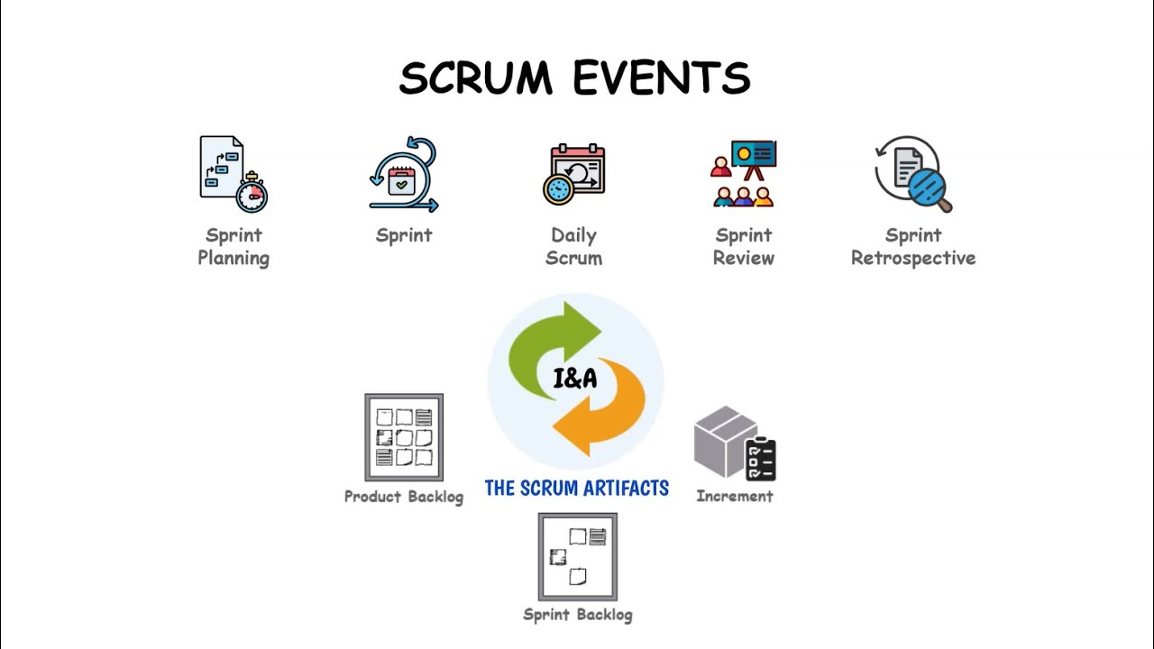

**Scrum Artifacts & Practices for Success**

1. **Definition of Done (DoD)**:
   * A clear and shared understanding of what constitutes "done" for any Product Backlog item. It helps ensure that everyone on the team knows when a task or feature is complete, including development, testing, and documentation.
   * The **DoD** helps avoid unfinished work being considered complete.
2. **Burn-Down Chart**:
   * A visual tool that tracks the progress of a Sprint or project. It shows how much work remains (often in terms of effort or user story points) over time, helping the team and stakeholders gauge the likelihood of meeting Sprint goals.
3. **Velocity**:
   * A measure of the amount of work a team can complete during a Sprint, often calculated using story points or other units of work. It helps teams estimate how much work they can take on in future Sprints.

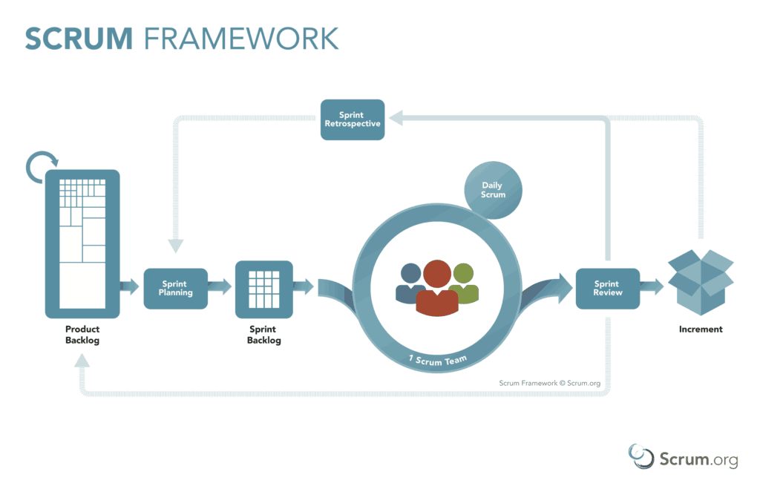

**Benefits of Scrum**

* **Improved Transparency**: Scrum provides visibility into the progress of the project through ceremonies, artifacts, and regular check-ins.
* **Flexibility and Adaptability**: Scrum's iterative nature allows teams to adapt quickly to changing requirements or priorities.
* **Enhanced Collaboration**: Scrum encourages teamwork and continuous communication, ensuring alignment between the Product Owner, Scrum Master, and Development Team.
* **Continuous Improvement**: Scrum promotes learning and self-improvement through Sprint Retrospectives and ongoing refinement of processes.
* **Faster Delivery**: Scrum focuses on delivering working increments at the end of each Sprint, enabling quicker delivery of value to stakeholders.

**Challenges of Scrum**

* **Requires Experienced Teams**: Scrum can be challenging for teams that are new to Agile methodologies or are not accustomed to self-management.
* **Commitment to Scrum Practices**: For Scrum to be effective, all team members must adhere to the ceremonies and principles. If done improperly, Scrum can become just a set of rituals without real benefits.
* **Overcommitment in Sprints**: Teams might take on too much work during Sprint Planning, leading to incomplete or rushed work.

**Conclusion**

Scrum is a powerful and widely-used Agile framework that encourages collaboration, accountability, and continuous improvement. By breaking down work into small, manageable iterations (Sprints) and focusing on delivering value, Scrum enables teams to be more responsive to change and customer needs. It works best in environments where requirements evolve quickly, and there’s a need for flexible, iterative development.

**CRYSTAL**

The Crystal Agile Framework is a family of lightweight and flexible methodologies for software development that focuses on the people involved in the process, emphasizing communication, collaboration, and individual talents. It's an approach that tailors itself to the unique needs of a project or team rather than applying a one-size-fits-all solution.

Crystal was created by Alistair Cockburn, one of the original authors of the Agile Manifesto. The core idea is that each project is unique, so the practices and processes should vary depending on the size, criticality, and complexity of the project.

## Principles of the Crystal agile methodology

The Crystal agile methodology is based on 7 key principles which are also sometimes referred to as its properties. We have explained each principle here.

### 1. Frequent delivery

Regardless of the various factors such as team size, type of project, budget or profit, the priority of the team should be to deliver. So, to keep up with this, the team needs to frequently deliver code that has been tested and is working for real users. This is also useful in making sure that the product is actually something that the users want.

### 2. Reflective improvement

It’s important to understand that there could always be room for improvement. Hence, there is a need to reflect on the performance, see what was done, how, and why. Understand where there is a need for improvement and see what will work and what won’t.

### 3. Osmotic communication

Osmosis means the flow of matter organically. Applying this, Cockburn believed that there was a need for colocation of teams so that information can be perceived by all members, even if they are not actively a part of the discussion.

### 4. Personal safety

The personal safety aspect means that the environment is open and safe for all team members to communicate their ideas and thoughts without feeling like they are ridiculed. Team members should freely present ideas and talk about problems. Open and honest communication is stressed upon.

### 5. Focus on work

The seniors or leaders on a project should set out the priorities in a clear manner. Team members should at any time know what comes next and what is to be done at the given time and focus on it instead of constantly switching between tasks.

### 6. Easy access to subject matter experts and users

Developers should have a link to the real users of the product they create. Qualified people and real users of the product give valuable feedback that the developers can work upon.

### 7. Technical environment

The work environment should be fully equipped. This means that it should have tools for automated testing, configuration management as well as continuous integration and deployment. Errors and mistakes can be identified quickly without the need for humans to intervene when this is the case.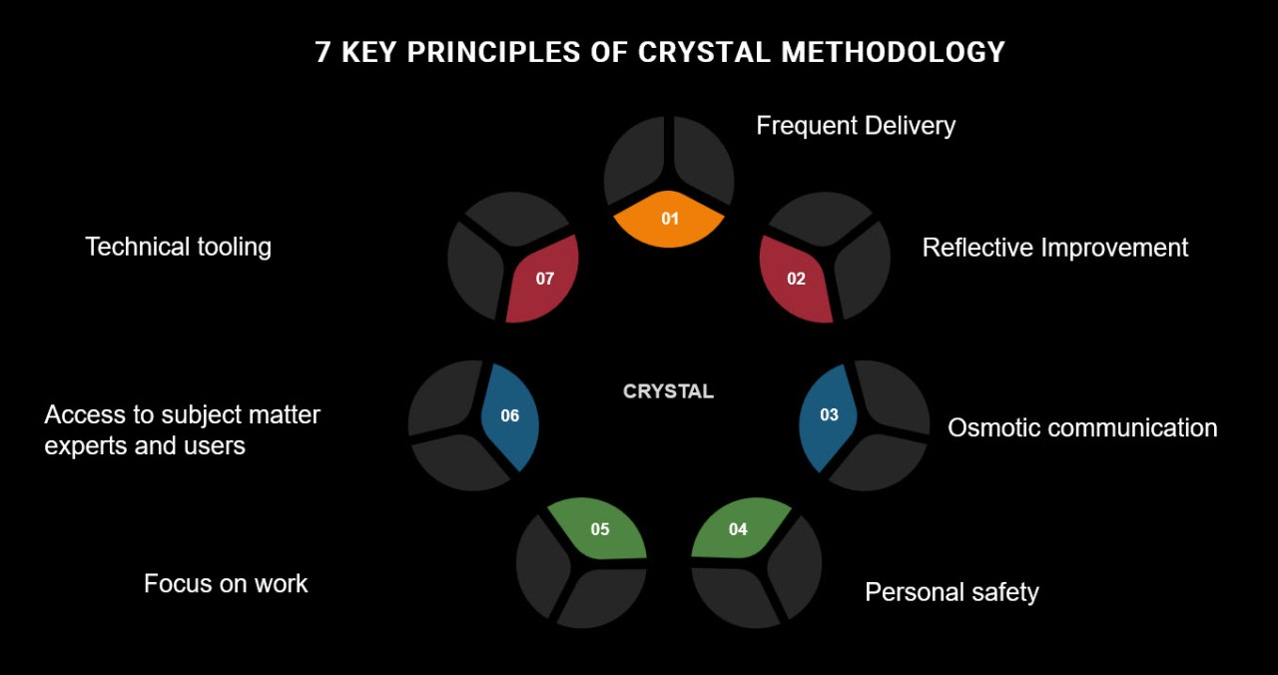The **Crystal Family** is a collection of Agile methodologies, each designed to suit different types of projects based on their size, complexity, and criticality. All of them share core principles that emphasize flexibility, communication, and simplicity but adapt their practices according to the specific needs of the team and project.

Here’s a breakdown of the **Crystal Family** and its different variations:

### 1. ****Crystal Clear****

* **Target**: Small teams (1 to 8 people)
* **Key Features**:
  + Lightweight and minimalistic.
  + Focus on direct communication and collaboration.
  + Frequent delivery of working software.
  + No strict roles; team members wear multiple hats.
  + Emphasizes face-to-face communication, and there's very little documentation.
  + Suitable for projects that are small in scope and complexity.

### 2. ****Crystal Yellow****

* **Target**: Medium-sized teams (around 10 to 20 people)
* **Key Features**:
  + Slightly more structure than Crystal Clear.
  + Adds more formal practices to handle the needs of a growing team.
  + Introduces some level of documentation to improve communication.
  + While still focused on people, there’s a bit more emphasis on having clear goals and organization to coordinate among the team.
  + Suitable for moderately complex projects with a need for some degree of process.

### 3. ****Crystal Orange****

* **Target**: Larger teams (around 20 to 40 people)
* **Key Features**:
  + A more formal approach than Crystal Yellow but still retains flexibility.
  + Teams are larger, so some processes are introduced to manage complexity.
  + Focus on developing effective communication and ensuring that each team member contributes to the project’s success.
  + More sophisticated tracking and management of progress, but it still emphasizes face-to-face interaction.
  + Suitable for medium-to-large projects with more formal needs and coordination.

### 4. ****Crystal Red****

* **Target**: Large teams (40+ people) or high-risk, complex projects
* **Key Features**:
  + Full structure with formal roles, processes, and ceremonies.
  + Strong emphasis on coordination and management due to the large team size and project complexity.
  + More focus on balancing flexibility with enough structure to handle scale.
  + Involves formalized methods for managing complexity and risk, including detailed tracking and communication strategies.
  + Suitable for high-risk projects where it’s critical to ensure everything works smoothly.

### 5. ****Crystal Blue (or other "colors")****

* **Target**: Even larger projects (e.g., 100+ people)
* **Key Features**:
  + This version (along with other higher-tier "colors" like **Crystal Violet**) is designed for very large, complex projects.
  + Focuses on optimizing large-scale project management while keeping Crystal's underlying values of simplicity and flexibility.
  + Requires a more formal structure to maintain coordination, and many of the practices will overlap with larger-scale frameworks like **SAFe** or **LeSS**.
* The **Crystal Family** is designed to be adaptive, with each "color" representing a variation that scales with the size and complexity of the project.
* **Crystal Clear** is ideal for small teams, while **Crystal Red** is suited for larger teams and more complex projects.

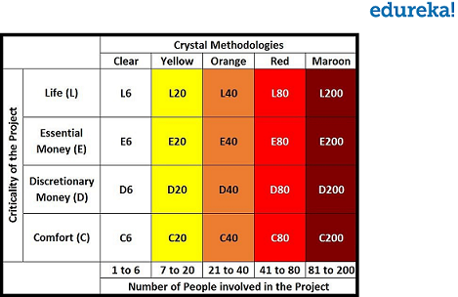

**Strengths of Crystal**

1. **Adaptability**: Flexible to varying project needs and team dynamics.
2. **Lightweight**: Minimal documentation and overhead.
3. **Empowers Teams**: Allows teams to decide on the best practices for their context.
4. **Emphasizes Communication**: Promotes clear, frequent, and informal communication.

**Challenges of Crystal**

1. **Scalability**: Variants like Crystal Clear are better suited for small teams.
2. **Lack of Prescriptive Guidance**: May be challenging for teams new to Agile, as it relies on experience and judgment.
3. **Dependence on Team Proximity**: Original design assumes co-located teams, requiring adaptations for remote work.

**When to Use Crystal**

* Small to medium-sized teams.
* Projects with a high level of uncertainty or changing requirements.
* Teams that value flexibility and have experience with Agile methodologies.

**FEATURE-DRIVEN DEVELOPMENT**

Imagine you’re building a house. Instead of building the entire house all at once, you start with the essentials, like the foundation first, then walls, roofs, and interior. This analogy can be synonymous with a modern software product development framework called Feature Driven Development (FDD) – a step-by-step approach focusing on one specific feature at a time and gradually progressing towards the complete product. As a part of Agile ideology, FDD is anchored to the core concept of iterative and incremental development, where a project is broken down into multiple manageable tasks and developed through agile iterations.

## What is Feature-Driven Development(FDD)?

Feature-Driven Development (FDD) is the brainchild of two prominent software developers, [**Jeff De Luca**](https://en.wikipedia.org/wiki/Jeff_De_Luca) & [**Peter Coad**](https://en.wikipedia.org/wiki/Peter_Coad), looking for an adaptive development that cultivates a customer-centric approach in pre 2000s. Since then, this approach has evolved remarkably and has been widely used by development teams worldwide.

FDD, an agile software development methodology, focuses on progressive delivery, ensuring collaboration and clear feature scoping that satisfies user needs. It offers a structured, iterative and incremental approach to software development. However, one of the common misconceptions is that ‘Feature’ in FDD means a specific feature or functionality. But it is similar to ‘user stories’ in Scrum – a particular user flow to achieve a goal. Examples include creating a user profile, adding items to the shopping cart, etc.

With FDD, people usually work in small groups called feature teams, where each team is responsible for completing one specific feature. These teams collaborate closely and effectively document to ensure everything is progressing towards the goal of developing the user-centric product.

## Five Stages of FDD Process

Feature Driven Development (FDD) involves five crucial steps spanning the entire development lifecycle.

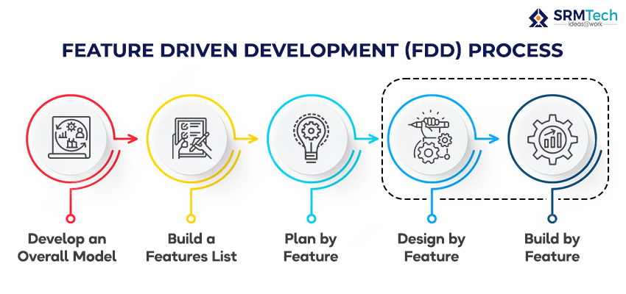

### ****1. Develop an Overall Model****

With a clear understanding of product vision & project scope, the chief architect and team members collaborate to create an object model that caters to the domain problem. This serves as the fundamental base over which the application systems will be built, and features are developed along the way.

### ****2. Build the Features List****

The project team members collaborate and list out the ‘features’ of considering the product vision & the value it offers to the potential users. These features should be translated into small and manageable tasks for the developers, which they should be able to complete in 2 to 10 days.

### ****3. Plan by Feature****

Now, the features are assessed by considering various factors like value creation, required resource bandwidth, expected timeframes, risks and dependencies. Later, the features are organised appropriately and assigned to specific developer teams called feature owners.

### ****4. Design by Feature****

The feature-level detailing happens here; the chief programmer analyses and finalises the features that must be designed and built on high priority. Design packages for each feature will be created and reviewed for development and also help in refining the overall model.

### ****5. Build by Feature****

The complete feature-building activities like development, integration and testing happen here. Then the chief programmer reviews the feature to ensure it aligns with the goals or if it needs iterations. The feature will then be added to the main build upon successful completion and be available for client use.

## FDD Vs Scrum

FDD and [**Scrum**](https://www.scrum.org/resources/what-scrum-module) are the frameworks fundamentally linked to classic Agile Principles. So both Feature-Driven Development(FDD) and Scrum uphold some standard agile ideologies like collaboration, transparency, efficiency & iterative development. However, their differences are evident when we investigate the nuances of the development process.

* One of the polarising differences between FDD and Scrum is that in FDD, the actual product user is involved in the development to enrich the model. In Scrum, the product owner enacts as the end user.
* The FDD emphasises more on domain modelling & domain-driven designing, while Scrum doesn’t.
* In FDD, Feature must be developed in 2 to 10 days. In comparison, Scrum sprints would typically take 2 to 4 weeks.
* FDD follows a complex team structure that involves names like Chief Programmer, Domain expert etc. Meanwhile, Scrum follows a lean team structure like POD teams.
* FDD values documentation processes, but Scrum prefers daily standups and meetings.

## FDD Team Roles

### ****Chief Architect****

The Chief Architect is responsible for the overall technical direction and system design. They are the ones who guide the development team on a high level, addressing technical difficulties.

### ****Chief Programmer****

The most experienced programmer who leads the development team in implementing the features and ensuring the project’s successful execution.

### ****Feature Owners****

Each feature has a designated Feature Owner who takes responsibility for its successful implementation. They collaborate with the Chief Architect and other team members to define, design, and deliver the feature.

### ****Class Owner****

Classes are part of feature development. And the Class Owners are also a team of developers responsible for a specific class of objects or components within the application system & documentation activities.

### ****Domain Expert****

A Domain Expert has in-depth knowledge of the problem domain. They work closely with the team to provide domain insights, clarify requirements, and ensure the system meets business needs.

### ****Project Manager****

The Project Manager oversees the project’s progress, manages schedules, and ensures the development team is on track. They take care of coordination, communication, and resource management to meet project goals.

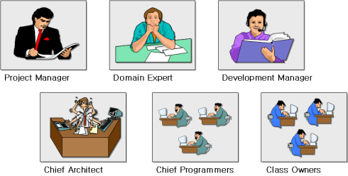

## ****Advantages of FDD****

* The FDD’s idea of involving actual end-user ensures more user-centric product development.
* Domain modelling and planning provide a predictable and controlled development roadmap.
* The structured approach with well-defined steps offers more scalability, making it ideal for large-scale and complex projects.
* The emphasis on effective & clear documentation compounds into improved visibility, productivity, & efficiency for development teams.
* Breaking the project requirements into small and executable tasks makes managing code across the development cycle easier.

## Disadvantages of FDD

* The complex team structure of FDD makes it less suitable for small projects.
* In FDD, team building and training could be a challenge in terms of time & budget.
* Dependencies could hinder the development lifecycle due to technological expertise and interrelated features.
* As FDD emphasizes a well-planned approach from the start, it only offers a little flexibility to make ongoing feature changes.

**When to Use FDD**

* Large-scale projects with multiple teams.
* Projects with well-understood requirements.
* Organizations that require structured Agile approaches with clear deliverables and milestones.

**ADAPTIVE SOFTWARE DEVELOPMENT**

**Adaptive Software Development (ASD)** is an Agile methodology focused on adapting to change and fostering continuous learning throughout the software development process. It was created by **Jim Highsmith** and focuses on complex, uncertain, and rapidly changing environments, making it ideal for projects where requirements are fluid or unknown.

**Adaptive Software Development (ASD)** is an Agile methodology that focuses on responding to change rather than following a strict, predefined process. ASD emphasizes the need for teams to adapt to changing requirements, evolving environments, and the unpredictable nature of software development. It’s designed to handle complex and uncertain projects by embracing flexibility, collaboration, and frequent feedback.

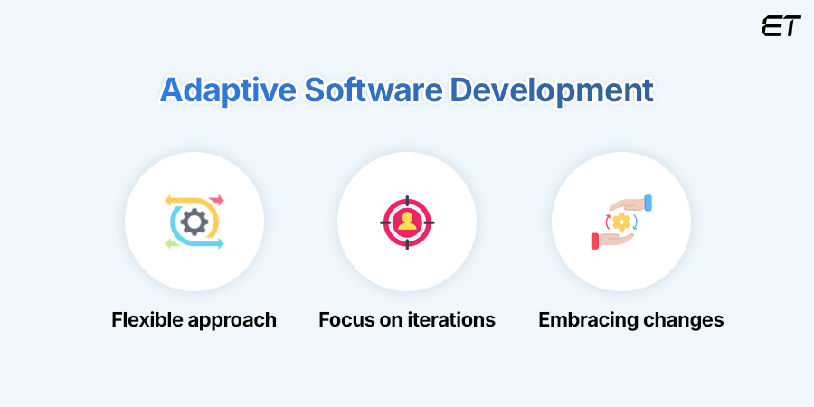

### Key Principles of Adaptive Software Development (ASD):

**1 .Collaborative Development**:

ASD emphasizes collaboration among team members, stakeholders, and end-users. It encourages frequent communication and a team-based approach to problem-solving.

Developers, testers, and business representatives work closely together to understand user needs and to quickly adjust the course of development.

1. **Iterative and Incremental Process**:

Like other Agile methodologies, ASD follows an **iterative** approach, where software is built in small, incremental pieces. Each iteration produces a working version of the product that can be tested and adjusted.

However, unlike Scrum, which uses fixed-length Sprints, ASD iterations can vary depending on the project needs and the team’s ability to deliver value quickly.

1. **Continuous Adaptation**:

The core concept of ASD is **adaptation**. This means that teams need to embrace uncertainty and change. Unlike traditional models that aim to reduce change, ASD sees change as a positive force and works to continuously adapt the product based on emerging requirements or market conditions.

Development work is constantly re-evaluated, with changes to the product and processes happening regularly.

1. **Feedback-Driven Development**:

Feedback is central to ASD. This can come from users, stakeholders, or team members, and it’s used to guide the direction of development. The goal is to constantly evolve the product based on real-time feedback to ensure that the project is always aligned with business goals.

Frequent **reviews** and **retrospectives** allow the team to inspect their work and make adjustments, ensuring that the software evolves according to changing user needs.

1. **Risk Management**:

ASD encourages teams to take on **calculated risks** early in the project to identify problems before they become too large. By focusing on the riskiest or most uncertain areas first, teams can quickly adapt and minimize the impact of potential issues later.

Early prototypes or proof-of-concept builds are often used to address high-risk elements early on, ensuring the team is better equipped to handle uncertainty.

1. **Embrace Uncertainty**:

One of the fundamental philosophies of ASD is that software development is inherently unpredictable, and the process should embrace uncertainty rather than try to eliminate it.

Teams are encouraged to learn as they go, continuously improving both their understanding of the problem space and the solution.

### The ****Three Phases**** of Adaptive Software Development:

1. **Speculation**:

In the Speculation phase, teams make initial assumptions about the project, identifying high-level requirements, goals, and constraints. This phase is about setting direction, but there’s an acknowledgment that these assumptions may change.

Instead of creating a fixed plan, teams will **speculate** about how the project might unfold, identifying risks and preparing for flexibility in approach.

1. **Collaboration**:

Once the initial direction is set, the team enters a phase of **collaboration**, where they work closely with stakeholders, users, and each other. This phase is about sharing knowledge, ideas, and perspectives to ensure everyone is aligned.

Constant collaboration is key here to refine and adjust the product based on what’s being learned throughout the process.

1. **Learning**:

As development progresses, the team will continuously gather **feedback** from stakeholders and real-world usage. This phase is where learning occurs, and assumptions or initial requirements are revisited and refined.

With each iteration, the team learns more about the project’s challenges and the users' needs, which helps guide the evolution of the software.

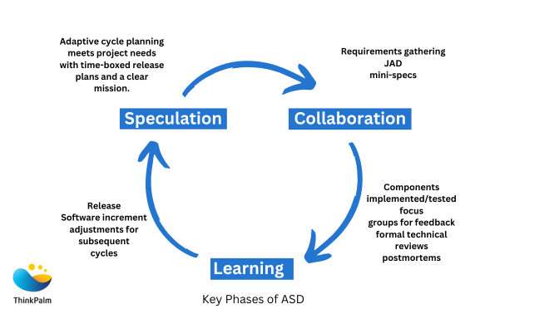

### Core Values of Adaptive Software Development:

* **Embrace Change**: ASD doesn’t see change as something to avoid, but rather as an inevitable and beneficial aspect of software development. It values flexibility and the ability to adapt to shifting requirements.
* **Customer Collaboration**: Close collaboration with customers or stakeholders is encouraged at every stage. Their feedback helps guide the development process.
* **Frequent Delivery of Working Software**: Like other Agile methods, ASD values frequent releases of working software to provide early and continuous delivery of value.
* **Simplicity and Focus**: ASD encourages focusing on the simplest solution that works, minimizing unnecessary complexity and overhead. The focus is on delivering just enough functionality to meet the current needs, with room for adjustment as requirements evolve.

### Differences Between ASD and Other Agile Methodologies:

**ASD vs. Scrum**:

* + While both are Agile methodologies, **Scrum** follows a more structured framework with fixed-length Sprints, defined roles, and specific ceremonies (like Sprint Planning, Daily Standups, Retrospectives). In contrast, **ASD** is more flexible and emphasizes adapting the process to the project’s needs, without the rigid structure that Scrum has.
  + Scrum uses time-boxed Sprints for iteration, while ASD’s iterations may vary in length depending on the project's needs.

**ASD vs. Kanban**:

* + Both **Kanban** and **ASD** focus on flow and flexibility, but **Kanban** is more about managing the flow of work through a visual system (Kanban board) and limiting work-in-progress (WIP). **ASD**, on the other hand, is more focused on adapting to change and is based on speculative planning, collaboration, and continuous learning.
  + **Kanban** doesn’t prescribe roles, and its focus is on visualizing the process to optimize flow, while **ASD** has more structured phases (Speculation, Collaboration, Learning) and emphasizes feedback loops and customer involvement.

**ASD vs. Crystal**:

* + **Crystal** is about adjusting processes according to the size and complexity of the team and project. It offers several "colors" for different project types, making it more flexible in terms of scaling.
  + **ASD** is more focused on embracing uncertainty and responding to change, without the need for specific variations like the "colors" of Crystal.

### When to Use Adaptive Software Development:

* **Uncertain and Complex Projects**: ASD is a good fit for projects where requirements are likely to change over time or are not fully known at the start.
* **High-Risk or Innovative Projects**: If you’re developing a new product or an innovative solution with unknowns or evolving requirements, ASD’s focus on collaboration, learning, and adaptability can help manage risks.
* **Large Teams**: Teams working on larger, more complex software projects may benefit from ASD's emphasis on collaboration and frequent feedback to navigate the complexity and adapt as the project evolves.

**Advantages of ASD**

1. **Flexibility**:
   * Easily adapts to changing requirements or environments.
2. **Customer Satisfaction**:
   * Close collaboration ensures the final product aligns with customer needs.
3. **Team Empowerment**:
   * Encourages innovation and shared ownership.
4. **Continuous Improvement**:
   * Focus on learning ensures process and product enhancements over time.

**Challenges of ASD**

1. **High Collaboration Requirements**:
   * Requires excellent communication and trust among team members and stakeholders.
2. **Ambiguity in Planning**:
   * May feel less structured for teams accustomed to rigid methodologies.
3. **Complexity in Implementation**:
   * Teams need experience and maturity to balance adaptability and structure effectively.

**When to Use ASD**

* Projects with uncertain or evolving requirements.
* High levels of complexity or innovation.
* Teams and organizations that value flexibility, creativity, and continuous learning.

**Extreme Programming (XP)** is an Agile software development methodology that emphasizes high-quality software and responsive customer-centric delivery. It focuses on engineering practices, frequent releases, and fostering collaboration among team members to adapt to changing requirements effectively.

### ****Core Principles of XP****

1. **Communication**:
   * Encourage open, direct communication among developers, customers, and stakeholders.
2. **Simplicity**:
   * Build the simplest solution that works, avoiding unnecessary complexity.
3. **Feedback**:
   * Use continuous feedback from tests, customers, and team members to improve the product.
4. **Courage**:
   * Make bold decisions, such as refactoring code or modifying plans, when necessary.
5. **Respect**:
   * Foster a collaborative environment where all contributions are valued.

### ****Key Practices of XP****

XP revolves around a set of practices that are interdependent and work together to maximize software quality and team efficiency:

#### ****1. Test-Driven Development (TDD)****:

* Write automated tests before writing code to ensure that functionality meets requirements.

#### ****2. Pair Programming****:

* Two developers work together at one workstation to write code, enhancing code quality and knowledge sharing.

#### ****3. Continuous Integration****:

* Integrate and test code changes frequently to detect and fix problems early.

#### ****4. Refactoring****:

* Continuously improve the codebase by simplifying and optimizing the structure without changing functionality.

#### ****5. Small Releases****:

* Deliver small, functional increments of the product frequently to gather feedback and maintain momentum.

#### ****6. Collective Code Ownership****:

* Everyone on the team shares responsibility for the codebase, enabling any team member to work on any part of the system.

#### ****7. Coding Standards****:

* Adhere to agreed-upon guidelines to ensure code consistency and readability.

#### ****8. Sustainable Pace****:

* Avoid overworking the team by maintaining a consistent and manageable workload.

#### ****9. On-Site Customer****:

* Have a customer or their representative available to provide immediate feedback and clarification.

#### ****10. Metaphor****:

* Use simple analogies or shared language to communicate the system’s design and purpose.

### ****Benefits of XP****

1. **High Quality**:
   * Practices like TDD and pair programming enhance the quality of the codebase.
2. **Flexibility**:
   * Can adapt quickly to changes in customer requirements or project scope.
3. **Faster Feedback**:
   * Frequent releases and continuous testing provide rapid insights into the product's performance and usability.
4. **Team Collaboration**:
   * Practices like pair programming and collective ownership strengthen team cohesion and knowledge sharing.
5. **Customer Satisfaction**:
   * Close involvement of customers ensures the product meets their needs.

### ****Challenges of XP****

1. **Steep Learning Curve**:
   * Practices like TDD and pair programming require time and effort to master.
2. **Team Dependency**:
   * Success depends on the commitment and skill of the team members.
3. **Customer Availability**:
   * Requires an on-site customer or consistent access to stakeholders, which may not always be feasible.
4. **Scaling Issues**:
   * May be challenging to implement in large, distributed teams or complex projects.

### ****XP Workflow****

XP operates in short cycles, with the following steps:

1. **Exploration**:
   * Identify and prioritize user stories or requirements.
2. **Planning**:
   * Break stories into tasks and estimate effort required.
3. **Iteration**:
   * Develop, test, and integrate small increments of functionality.
4. **Productionizing**:
   * Prepare and release the product increment.
5. **Maintenance**:
   * Handle changes, feedback, and ongoing improvement.

### ****When to Use XP****

* Projects with rapidly changing requirements.
* Teams that value high-quality code and engineering rigor.
* Environments with high customer involvement.
* Small to medium-sized teams.

### ****Extreme Programming (XP)****: Detailed Overview

### ****1. Method Overview****

**Extreme Programming (XP)** is a lightweight, Agile methodology aimed at producing high-quality software efficiently and adapting to changing requirements. It emphasizes close collaboration, rapid iterations, and strict engineering discipline.

* **Core Values**:
  + **Communication**: Foster clear and open dialogue among team members and stakeholders.
  + **Simplicity**: Implement only what is necessary to meet current requirements.
  + **Feedback**: Continuously gather feedback to guide development and improve the product.
  + **Courage**: Make bold decisions, like discarding bad code or pivoting strategies, when needed.
  + **Respect**: Encourage mutual respect within the team.
* **Goals**:
  + Deliver high-quality software.
  + Increase adaptability to customer needs.
  + Improve team collaboration and efficiency.

### ****2. Lifecycle of XP****

XP operates in short, iterative cycles, making it adaptable to changing requirements. Each cycle includes the following phases:

#### ****a. Exploration Phase****:

* **Objective**: Understand customer requirements.
* **Activities**:
  + Collaborate with customers to create **user stories** that define desired features.
  + Explore the technical feasibility of user stories.

#### ****b. Planning Phase****:

* **Objective**: Prioritize and plan for development.
* **Activities**:
  + Break down user stories into small, manageable tasks.
  + Estimate effort and select tasks for the iteration.

#### ****c. Iteration to Release****:

* **Objective**: Develop and deliver a working product increment.
* **Activities**:
  + Write code using **pair programming**.
  + Validate with **test-driven development (TDD)**.
  + Frequently integrate and test changes.

#### ****d. Productionizing Phase****:

* **Objective**: Prepare for release.
* **Activities**:
  + Conduct final system testing.
  + Release the product increment to the customer.

#### ****e. Maintenance Phase****:

* **Objective**: Handle updates and feedback.
* **Activities**:
  + Respond to bugs or changing requirements.
  + Continue development using XP practices.

#### ****f. Death Phase****:

* **Objective**: Close the project.
* **Activities**:
  + Deliver the completed product.
  + Reflect on lessons learned for future improvement.

### ****3. Work Products in XP****

XP focuses on producing lightweight artifacts to maintain agility while ensuring clarity:

1. **User Stories**:
   * Short, customer-focused descriptions of features or functionality.
2. **Task Cards**:
   * Detailed tasks derived from user stories, often written on physical cards for ease of tracking.
3. **Codebase**:
   * The evolving software, built with strict adherence to quality and coding standards.
4. **Automated Tests**:
   * Unit tests and acceptance tests written to validate the functionality of the system.
5. **Iteration Plan**:
   * A concise plan for the tasks to be completed in the current iteration.
6. **System Metaphor**:
   * A simple, shared concept describing the system’s architecture and functionality.

### ****4. Roles in XP****

XP teams are highly collaborative, with defined roles to ensure efficiency and accountability:

#### ****a. Primary Roles****:

1. **Customer**:
   * Provides user stories and feedback.
   * Prioritizes features and defines acceptance criteria.
2. **Developers**:
   * Write and test code.
   * Participate in practices like **pair programming** and **refactoring**.
3. **Tester**:
   * Develop and run automated tests.
   * Collaborate with the customer to validate acceptance criteria.
4. **Tracker**:
   * Monitor progress and ensure the team stays on track with its commitments.
5. **Coach**:
   * Ensure adherence to XP principles.
   * Provide guidance and resolve issues.

#### ****b. Secondary Roles****:

* **Manager**:
  + Handle resource allocation and external communication.
* **Domain Expert**:
  + Provide specialized knowledge to inform development decisions.

### ****5. Practices in XP****

XP is known for its **12 core practices**, which work together to promote high-quality software and collaboration:

#### ****a. Core Development Practices****:

1. **Test-Driven Development (TDD)**:
   * Write tests before code to define expected behavior and catch issues early.
2. **Pair Programming**:
   * Two developers collaborate on the same code to enhance quality and knowledge sharing.
3. **Continuous Integration**:
   * Frequently integrate and test code changes to detect and resolve issues early.
4. **Refactoring**:
   * Continuously improve the codebase's structure without changing functionality.
5. **Simple Design**:
   * Design only what is necessary to meet current requirements.
6. **Small Releases**:
   * Deliver small, functional increments regularly to get early feedback.

#### ****b. Collaborative Practices****:

1. **Collective Code Ownership**:
   * Everyone shares responsibility for the codebase, encouraging team-wide knowledge.
2. **On-Site Customer**:
   * Have a customer representative available for quick feedback and decision-making.
3. **Coding Standards**:
   * Adhere to consistent conventions to ensure readability and maintainability.

#### ****c. Project Management Practices****:

1. **Planning Game**:
   * Collaboratively prioritize and estimate tasks for each iteration.
2. **Sustainable Pace**:
   * Work at a consistent pace to prevent burnout and maintain quality.
3. **System Metaphor**:
   * Use a shared analogy to guide the system’s architecture and design.

### ****Summary Table****

| **Aspect** | **Details** |
| --- | --- |
| **Method Overview** | Lightweight, iterative, customer-focused Agile methodology. |
| **Lifecycle** | Exploration → Planning → Iteration → Release → Maintenance → Death |
| **Work Products** | User stories, task cards, codebase, automated tests, iteration plan, metaphor. |
| **Roles** | Customer, developer, tester, tracker, coach, manager, domain expert. |
| **Practices** | TDD, pair programming, small releases, refactoring, continuous integration, etc. |

**Case Study: Extreme Programming (XP)**

**Objective**: To understand the practical application, benefits, challenges, and outcomes of implementing Extreme Programming (XP) in a real-world software development project.

**Introduction to Extreme Programming (XP)**

**Extreme Programming (XP)** is an agile software development methodology that emphasizes flexibility, collaboration, and customer satisfaction. Key principles include frequent releases, continuous feedback, and adaptive planning. XP focuses on improving software quality and responsiveness to changing customer requirements.

**Case Study Overview**

**Organization**: A mid-sized software development firm specializing in custom enterprise solutions.

**Project**: Development of a Customer Relationship Management (CRM) platform for a retail client.

**Duration**: 12 months.

**Team**: 8 developers, 1 project manager, 2 quality assurance engineers, 1 user experience designer, and the client as an active stakeholder.

**Implementation of XP in the Project**

1. **Key Practices Used**:
   * **Pair Programming**: Developers worked in pairs to write code, review, and debug in real-time.
   * **Test-Driven Development (TDD)**: Unit tests were written before coding to ensure code correctness.
   * **Frequent Releases**: The team delivered working software every two weeks.
   * **Continuous Integration**: Automated builds and tests ensured that new code did not break existing functionality.
   * **On-Site Customer**: A representative from the client was embedded in the team to provide continuous feedback.
   * **Simplicity**: Only the features required for the current iteration were designed and implemented.
   * **Refactoring**: The team continuously improved code quality without altering functionality.

**Challenges Faced**

1. **Cultural Resistance**:
   * Some team members were initially skeptical about pair programming and TDD due to a lack of familiarity.
2. **Time Constraints**:
   * The two-week release cycle felt aggressive during the initial sprints, particularly for complex features.
3. **Client Involvement**:
   * Having the client available on-site required significant scheduling adjustments, which were not always feasible.
4. **Learning Curve**:
   * Adapting to XP practices, especially TDD and continuous integration, took time and training.

**Benefits Observed**

1. **Improved Collaboration**:
   * Pair programming and daily standups fostered strong team communication and knowledge sharing.
2. **Higher Code Quality**:
   * TDD and continuous integration resulted in fewer bugs and easier debugging.
3. **Customer Satisfaction**:
   * Regular involvement of the client ensured that the final product closely aligned with their expectations.
4. **Adaptability**:
   * The team was able to respond quickly to changing requirements without significant rework.
5. **Team Morale**:
   * The iterative nature and clear goals of each sprint kept the team motivated.

**Project Outcome**

* **Deliverables**:
  + A fully functional CRM system was delivered on time and within budget.
  + The system included features such as customer data management, analytics dashboards, and automated marketing tools.
* **Client Feedback**:
  + The client was highly satisfied with the development process and the final product, citing the collaborative approach as a key factor.
* **Metrics**:
  + Defect rate decreased by 30% compared to previous projects.
  + Development time for features was reduced by approximately 20% due to better planning and teamwork.

**Key Lessons Learned**

1. **Training is Crucial**:
   * Teams adopting XP need adequate training, especially in practices like TDD and pair programming.
2. **Client Commitment is Essential**:
   * Having an on-site customer is valuable but requires their active participation and time investment.
3. **Balance Simplicity and Complexity**:
   * While focusing on the simplest solution for the current iteration is helpful, some long-term considerations are necessary to avoid future bottlenecks.
4. **Tailoring XP**:
   * Not all XP practices may fit every team or project. Customizing the methodology based on specific needs is critical.

**Conclusion**

The case study demonstrates that **Extreme Programming (XP)** can significantly improve the software development process by promoting collaboration, adaptability, and customer-centric development. However, its successful implementation requires commitment from both the development team and the client, as well as a willingness to embrace change and learn new practices. When applied effectively, XP can lead to high-quality software, satisfied customers, and an empowered development team.