1. RESOURCE GROUP

2. CONTAINER REGISTRY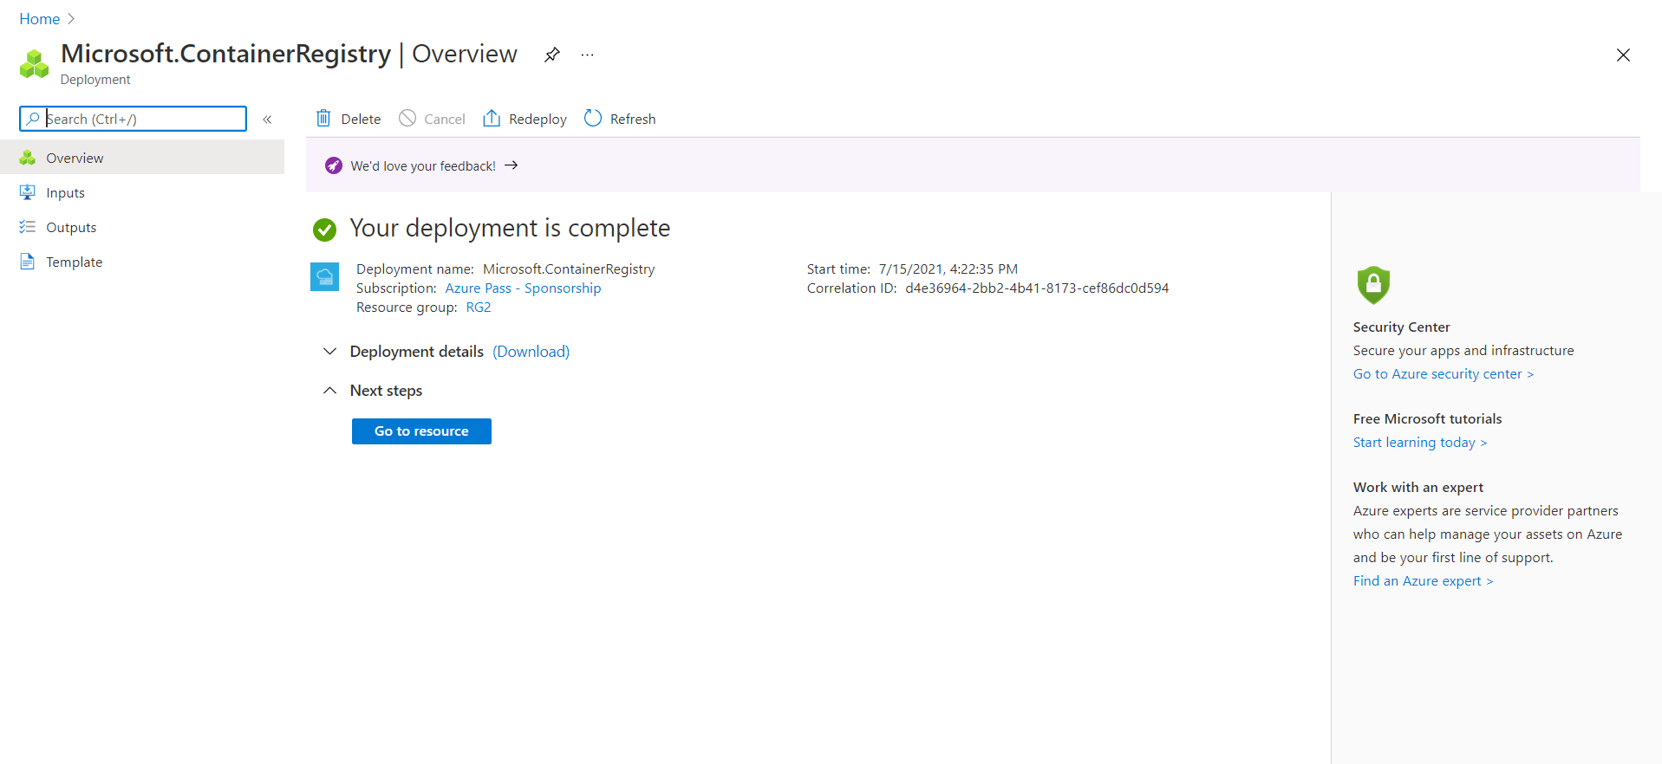

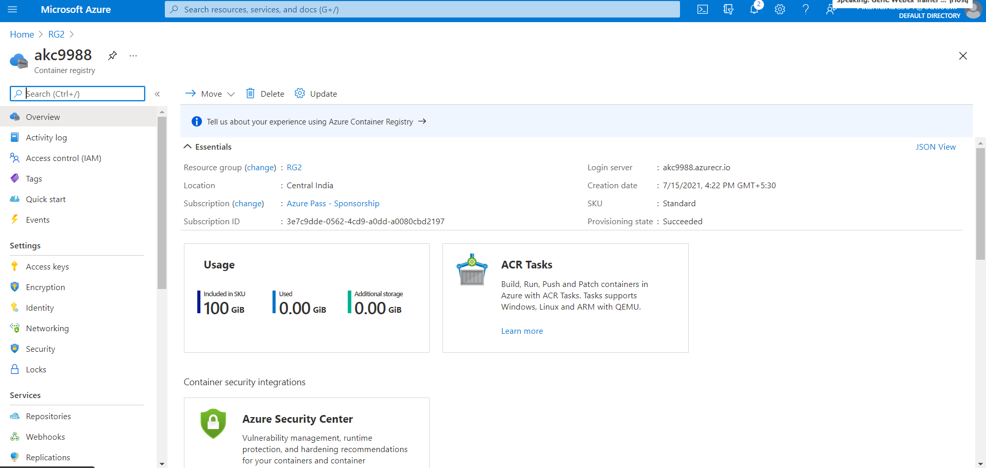

3. ADDING A DATABASE

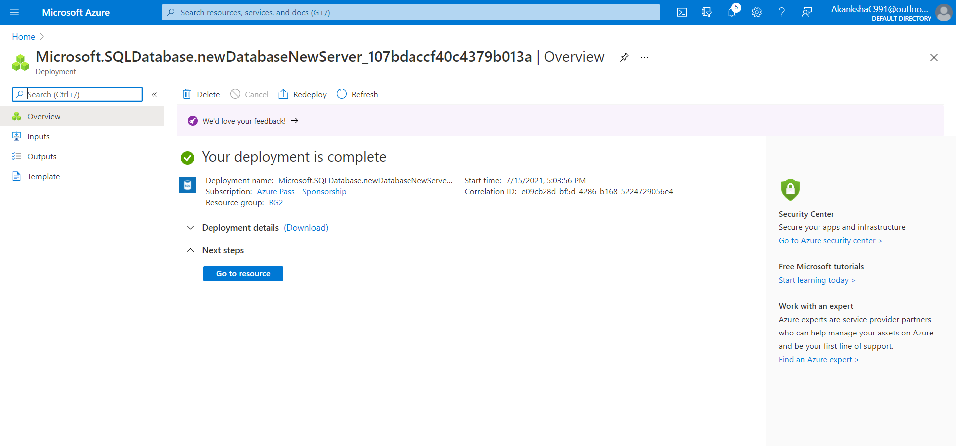

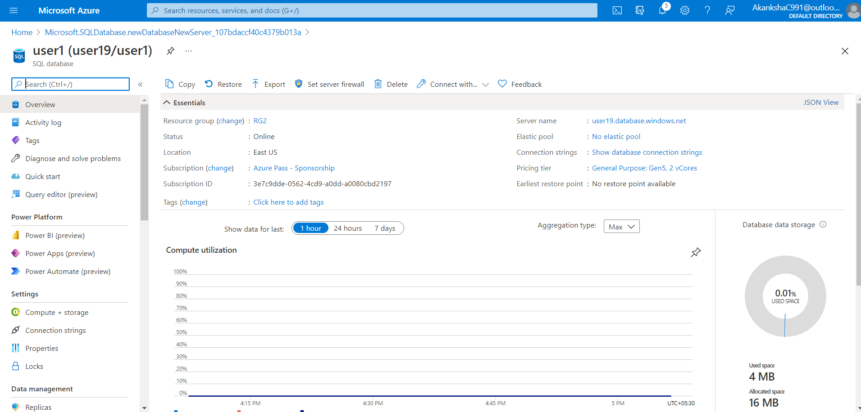

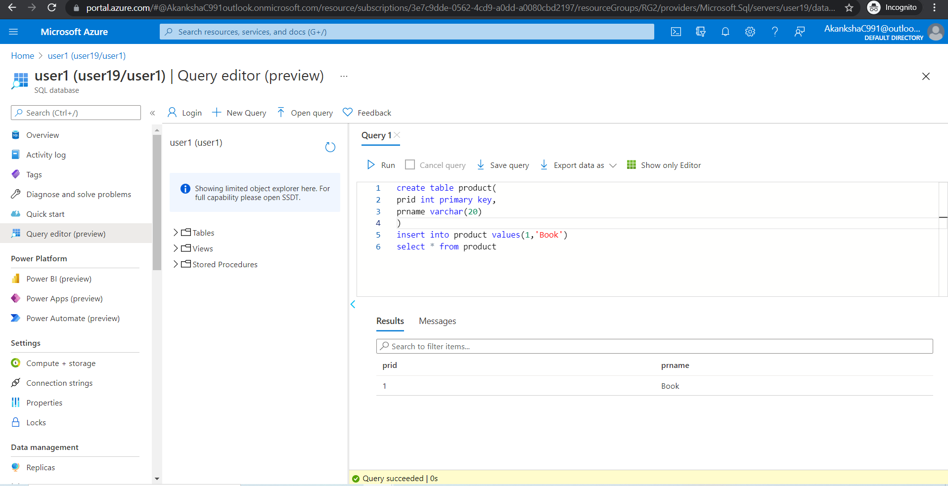

4. LOGIC APPS

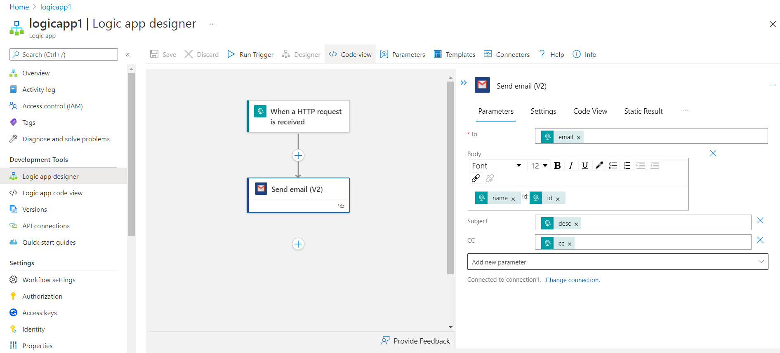

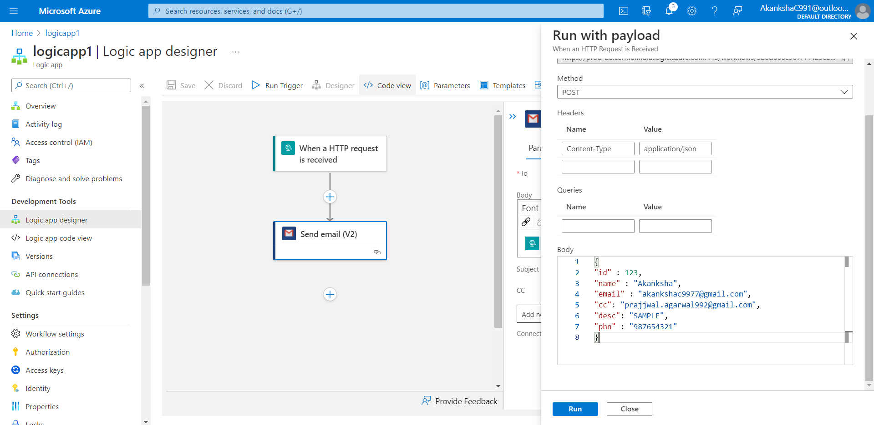

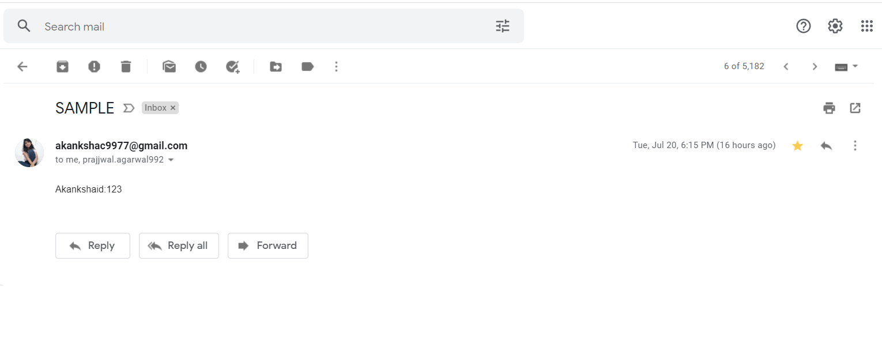

5. STORAGE APPS

6. SERVICE BUS

