# Input

This is the initial input where we enter which agent we want to play against.

Here we input which suit we want to pick or whether we want to let the agent pick the suit first.

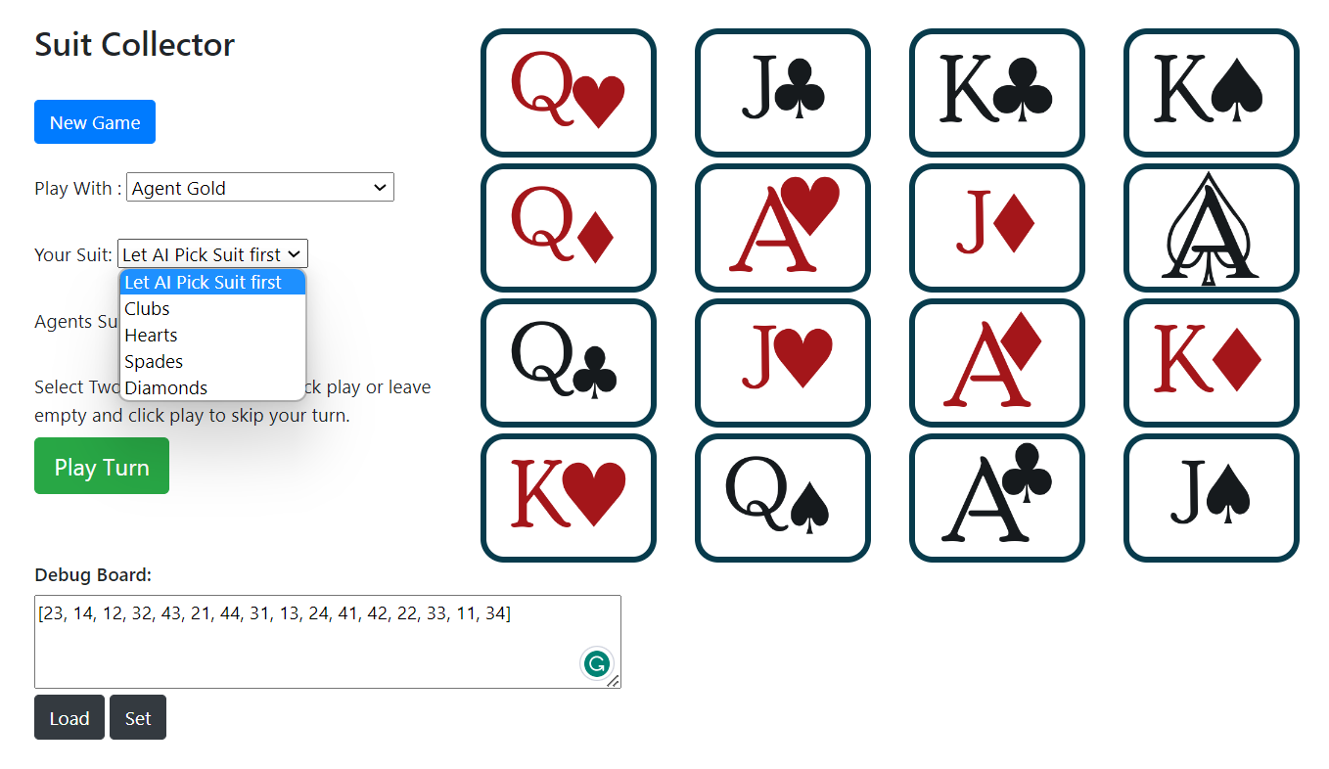

Here as well we will set the Agents Suit according to if we want to pick the suit first or if we want the agent to pick the suit first.

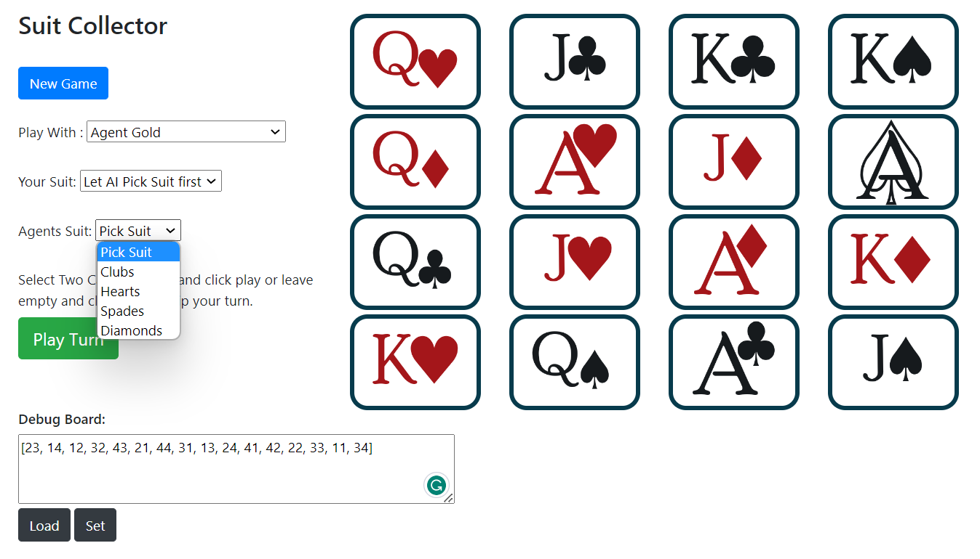

After the agent has picked the suit, we are picking our suit.

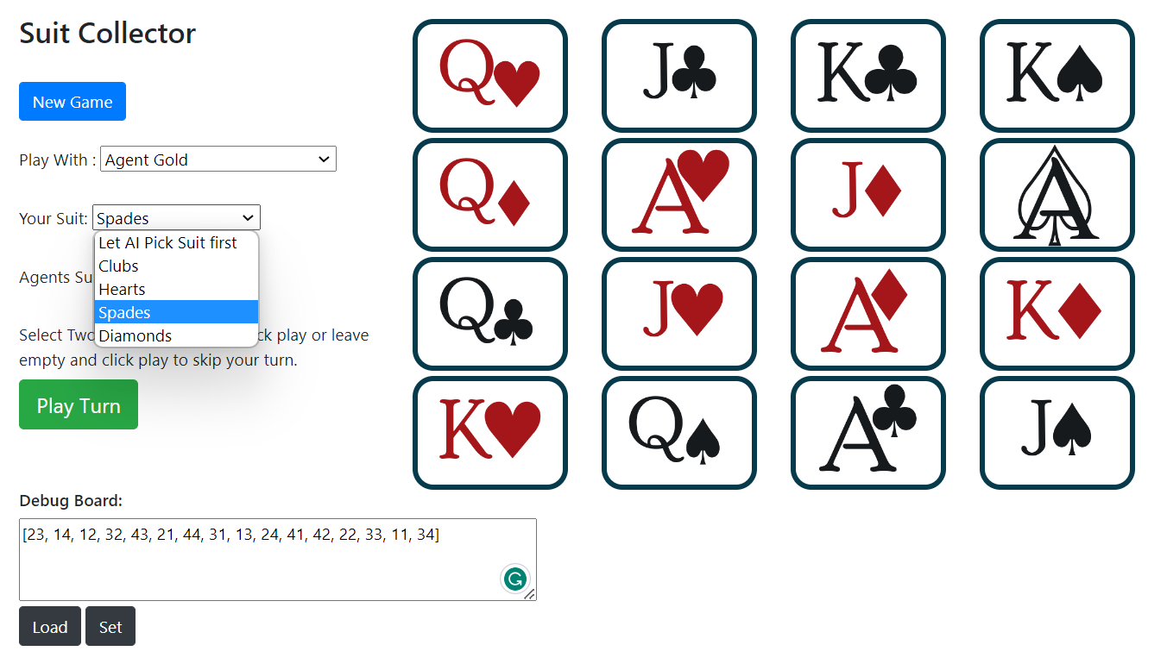

We are playing our move after the agent has played its move. Our move is to move two cards that are highlighted in red.

