**#Name : Akanksha Giri**

**#Roll no : 41**

#Section : 3A

**#Aim : Study and installation of Weka AI tool.**

**#Theory :**

Weka stands for Waikato Environment for Knowledge Analysis, it is software that is used in the data science field for data mining. It is free software. It is written in Java hence it can be run on any system supporting Java, so weka can be run on different operating systems like Windows, Linux, Mac, etc. Weka provides a collection of visualization tools that can be used for data analysis, cleaning, and predictive modeling. Weka can perform a number of tasks like data preprocessing, clustering, classification, regression, visualization, and feature selection.

**Installing Weka on Windows:**

Follow the below steps to install Weka on Windows:

**Step 1:** Visit this [website](https://www.filehorse.com/download-weka-64/) using any web browser. Click on Free Download.

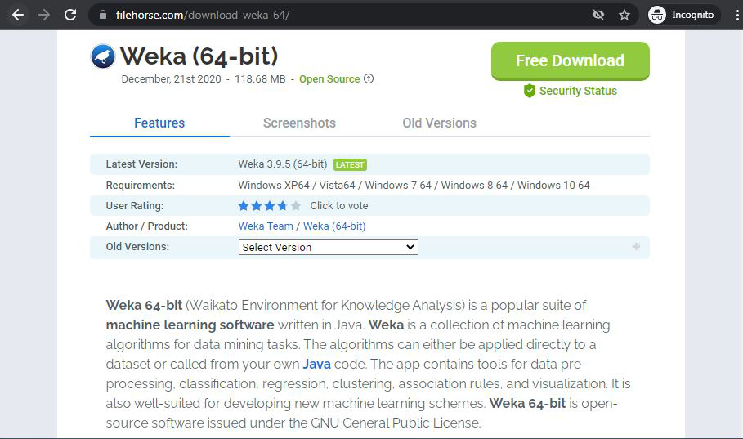

**Step 2:** It will redirect to a new webpage, click on Start Download. Downloading of the executable file will start shortly. It is a big  118 MB file that will take some minutes.

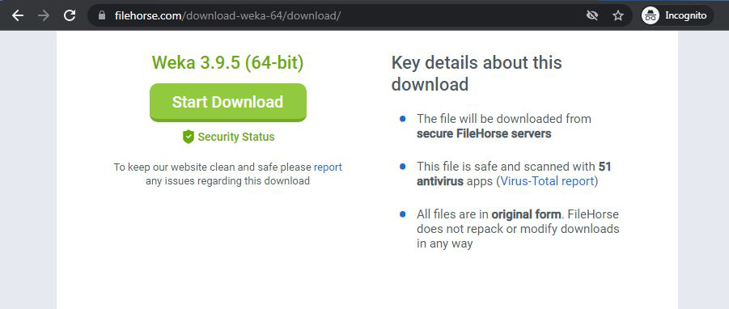

**Step 3:** Now check for the executable file in downloads in your system and run it.



**Step 4:** It will prompt confirmation to make changes to your system. Click on Yes.

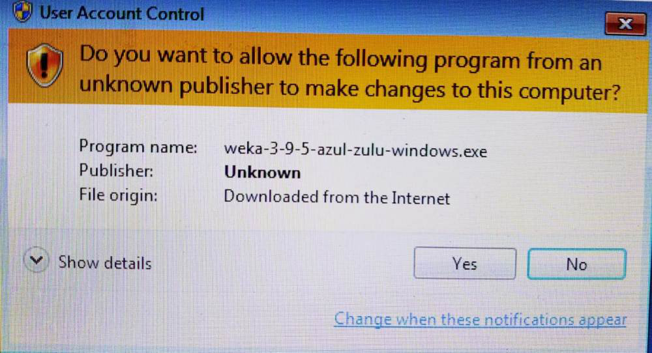

**Step 5:** Setup screen will appear, click on Next.

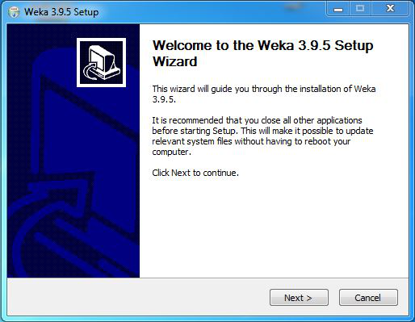

**Step 6:**The next screen will be of License Agreement, click on I Agree.

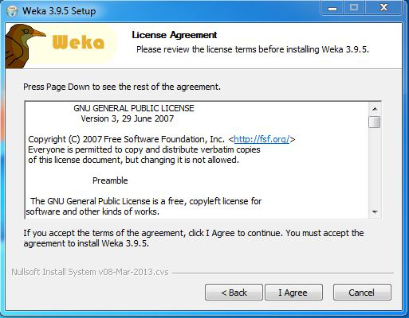

**Step 7:** Next screen is of choosing components, all components are already marked so don’t change anything just click on the Install button.

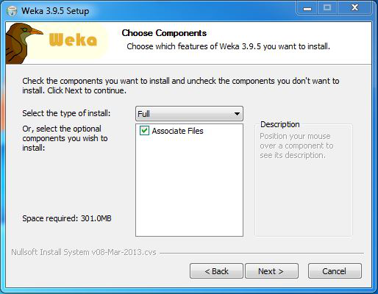

**Step 8:** The next screen will be of installing location so choose the drive which will have sufficient memory space for installation. It needed a memory space of 301 MB.

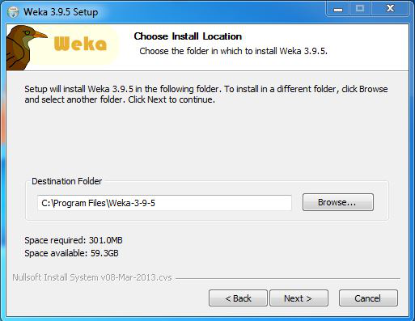

**Step 9:**Next screen will be of choosing the Start menu folder so don’t do anything just click on Install Button.

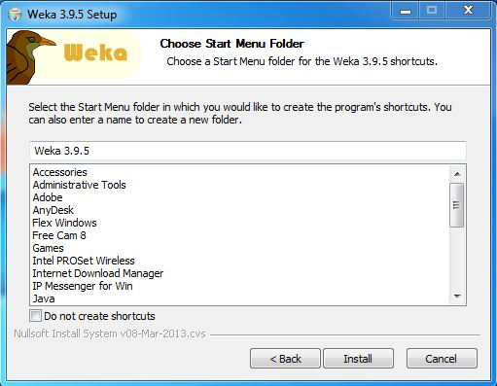

**Step 10:** After this installation process will start and will hardly take a minute to complete the installation.

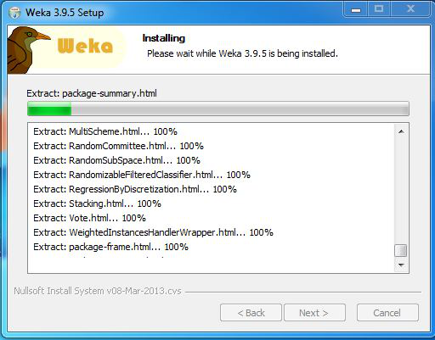

**Step 11:** Click on the Next button after the installation process is complete.

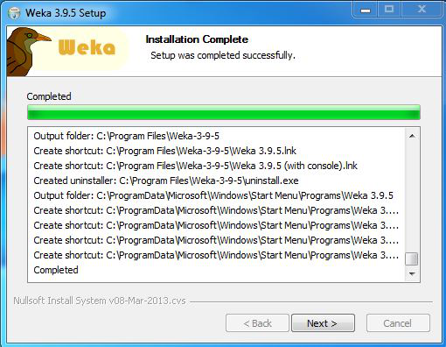

**Step 12:** Click on Finish to finish the installation process.

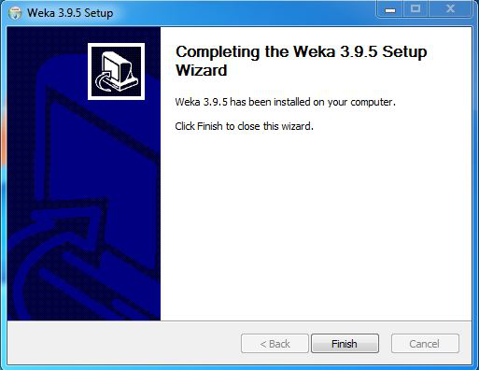

**Step 13:** Weka is successfully installed on the system and an icon is created on the desktop.

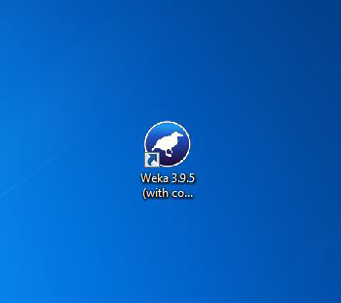

**Step 14:**Run the software and see the interface.

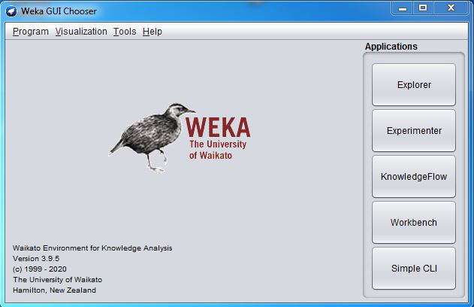

**Conclusion:**

Congratulations!! At this point, we have successfully installed Weka on your windows system.