FINAL PROJECT REPORT

A Statistical Comparison of Human-Written and AI-Generated Code Across Programming Languages
A study of code length, formatting density, and comment characteristics
Probability and Statistics Semester Project | Review 3
Akanksha Gupta (25BAI0033)
Bhargavi Panwar (25BDS0081)
Faculty Guide: Professor Juhi Baroi
SCOPE
October 2026

Executive Summary
This project compares 10,000 code samples labelled as human-written or AI-generated across C, C++, Java and Python. The final analysis includes descriptive statistics, eight language-specific Welch tests with Holm correction, confidence intervals, Cohen’s d, Wilcoxon rank-sum tests, chi-square association testing, Spearman correlation, multiple regression, factorial ANOVA, normalized characters-per-line comparisons, and comment-presence tests.
Main finding
AI-generated samples had a higher median characters-per-line measure and were more likely to contain at least one detectable comment line in each of the four languages. The size of these gaps varied by language. This is an interpretable statistical style comparison, not a validated AI detector and not evidence of code quality or misconduct.

Key results at a glance
- Dataset: 10,000 samples, with 5,000 AI-generated and 5,000 human-written samples overall.
- Overall means: human samples had more lines (29.54 vs 25.54); AI samples had more characters (678.63 vs 557.86).
- Seven of eight language-specific Welch comparisons remained significant after Holm correction; C++ character count was not significant by Welch’s test.
- Median characters per line were higher for AI samples in C (22.62 vs 14.00), C++ (23.91 vs 16.94), Java (29.50 vs 20.78), and Python (27.18 vs 17.39).
- Comment presence was higher for AI samples in all four languages, with gaps of 7.31 to 28.48 percentage points; all four proportion comparisons remained significant after Holm correction.
- Spearman rho between line count and character count was 0.882 overall. In an expanded regression, origin-by-language and line-count-by-origin terms improved fit; factorial ANOVA interactions were significant for both measurements.

Two-line presentation conclusion
In this dataset, AI-generated code tended to have more characters per line and was more likely to contain a detectable comment line, while human-written code had a higher overall mean line count. The magnitude of these differences depended on language, so these features describe group-level patterns—not individual authorship or code quality.

1. Introduction and Motivation
Generative AI systems are widely used to produce code, which creates interest in understanding how generated code differs from human-written code. Rather than training a classifier or claiming to detect authorship, this project studies measurable characteristics of labelled code samples using methods from Probability and Statistics. The focus is deliberately limited to line count, character count, line density and approximate comment characteristics.

1.1 Objectives
- Describe and compare code length measurements for human-written and AI-generated samples.
- Compare results separately for C, C++, Java and Python.
- Test whether observed mean differences persist after multiple-comparison correction and assess effect magnitude.
- Examine the association between line count and character count and model character count while accounting for language and origin.
- Investigate language-by-origin interaction and evaluate comment presence using a transparent approximate rule.
- Interpret results in light of sampling balance, measurement limitations and potential dependence among samples.

1.2 Research questions
- Do AI-generated and human-written samples differ in line count and character count?
- Do these differences vary by programming language?
- How strongly are line count and character count associated?
- Does comment presence differ between origins within each language?
- Do language and origin interact in their relationship with code-length measurements?

1.3 Related work and project contribution
Recent research has released datasets for comparing human-written and AI-generated code and has explored multilingual code stylometry [1–4]. The present project takes a deliberately interpretable statistical route: rather than training a detector, it compares measurable features and asks whether they vary by language. Its added analysis of median characters per line and the proportion of samples with at least one counted comment line provides a more specific description than raw length alone. These measures remain exploratory and are not proposed as standalone authorship indicators.

2. Dataset and Variables
The analysis uses HumanVsAI_CodeDataset.csv, described by Boukili, El Garouani and Riffi (2026). The published dataset contains 10,000 samples: 5,000 ChatGPT-generated and 5,000 human-written code samples from a public repository, spanning C, C++, Java and Python [1]. The CSV fields are problem_id, Sample_Code, Generated, Language and Source.
Dataset check | Observed result
Total rows / original columns | 10,000 / 5
AI-generated / human-written | 5,000 / 5,000
Missing Sample_Code values | 0
Exact duplicate full rows | 0
Languages | C, C++, Java, Python
Samples by language: C / C++ / Java / Python | 1,737 / 2,640 / 2,945 / 2,678
Problem IDs containing both origins | 3

The sample is balanced overall by origin, but not within each language. Consequently, the 50/50 origin split should not be interpreted as the real-world prevalence of AI-written code. Counts and comparisons describe this dataset and may not generalize to other models, prompts, repositories or languages.

2.1 Operational definitions
Measure | Definition used | Important caveat
Line count | Number of newline-separated code segments, with trailing empty segments removed. | Not the same as logical statements or non-empty lines of code.
Character count | Number of stored characters in Sample_Code. | Includes whitespace and newline characters.
Characters per line | Character count divided by line count (minimum denominator of 1). | Approximate normalized density; newline characters remain included in the numerator.
Comment presence | Whether the refined heuristic counts at least one comment line. | Heuristic only; not a full language parser.
Comment lines per 100 lines | Counted comment lines divided by line count, multiplied by 100. | Can miss inline or unusual comments and may misread strings/block-comment structures.

3. Statistical Methods and PAS Integration

3.1 Modules 1 and 2: random variables, expectation, variance and distributions
Line count, character count and comment characteristics are treated as measured random variables. Means, medians, standard deviations, minima and maxima describe their centres and spread. Histograms and boxplots are used to inspect asymmetry and extreme observations. No claim is made that a named theoretical distribution (such as Normal, Poisson or Weibull) has been fitted to these measurements; the distribution module is integrated through empirical distribution analysis and interpretation of skewness.

3.2 Module 3: hypothesis testing
Welch two-sample t-tests compare AI and human means without assuming equal population variances. Two-sided tests use alpha = 0.05. The mean difference is defined as AI minus Human, and 95% confidence intervals are reported. Holm correction is applied across the eight language-specific line/character comparisons. Cohen’s d summarizes standardized effect magnitude. Wilcoxon rank-sum tests provide a rank-based comparison. A chi-square test of independence evaluates association between origin and programming language in the sample counts.

3.3 Module 4: correlation and regression
Spearman rank correlation evaluates the monotonic association between line count and character count overall and within each language. Multiple regression models log(1 + character count) from log(1 + line count), origin and language; the final expanded model includes origin-by-language and line-count-by-origin interactions. R-squared is an in-sample fit statistic, not evidence of out-of-sample predictive performance.

3.4 Module 5: factorial analysis of variance
A factorial linear model evaluates log-transformed line count and character count with programming language, origin and their interaction. Nested-model F-tests assess the language effect adjusted for origin, the origin effect adjusted for language, and the additional language-by-origin interaction over an additive model. The interaction tests whether the origin-associated pattern differs across languages. The data are observational, not a randomized experiment, so the study does not estimate causal effects and does not force CRD/RBD/LSD experimental designs onto the dataset. Unequal language-by-origin cell sizes and model assumptions still warrant cautious interpretation.

4. Results

4.1 Overall descriptive statistics
Measure | AI mean | Human mean | Interpretation
Line count | 25.54 | 29.54 | Human samples had about 4.01 more lines on average.
Character count | 678.63 | 557.86 | AI samples had about 120.77 more characters on average.
Samples with ≥1 counted comment (refined) | 34.40% | 17.60% | AI samples were more likely to contain an identifiable comment line; language-specific tests follow.

The raw measurements have wide ranges and large standard deviations. For example, line count ranges from 1 to 499 in the human group and from 2 to 230 in the AI group. This indicates substantial variability and the presence of unusually long samples; the mean alone cannot describe every sample.

4.2 Mean comparisons by language
Language | Lines AI | Lines Human | Characters AI | Characters Human
C | 27.57 | 20.47 | 653.78 | 294.17
C++ | 28.94 | 38.10 | 716.33 | 702.63
Java | 29.01 | 33.50 | 854.15 | 705.00
Python | 18.22 | 20.01 | 503.79 | 360.01

AI samples have a higher mean character count in all four languages, but the line-count direction changes: AI is higher in C, while human samples are higher in C++, Java and Python. In C++, average character counts are close.

4.3 Welch tests and effect sizes
Language | Measure | AI-Human mean diff. | 95% CI | Holm p | Cohen d | Significant
C | Line count | +7.10 | [5.74, 8.46] | 2.37e-23 | 0.476 | Yes
C | Characters | +359.60 | [322.46, 396.75] | 5.47e-72 | 0.873 | Yes
C++ | Line count | -9.16 | [-10.90, -7.42] | 1.03e-23 | -0.395 | Yes
C++ | Characters | +13.70 | [-29.71, 57.11] | 0.536 | 0.024 | No
Java | Line count | -4.49 | [-6.41, -2.58] | 1.34e-05 | -0.164 | Yes
Java | Characters | +149.15 | [100.95, 197.35] | 5.89e-09 | 0.223 | Yes
Python | Line count | -1.79 | [-2.91, -0.67] | 0.00356 | -0.122 | Yes
Python | Characters | +143.78 | [116.71, 170.86] | 4.59e-24 | 0.392 | Yes

Seven of eight comparisons are statistically significant after Holm correction. The exception is C++ character count: the estimated mean difference is small and its confidence interval includes zero. Cohen’s d indicates the largest standardized difference is C character count (d ≈ 0.87); C++ character count is negligible (d ≈ 0.02). Statistical significance is not synonymous with practical importance.

4.4 Normalized formatting density: new central result
To compare code shape rather than raw size alone, character count was normalized by line count. The median characters-per-line measure was higher for AI-generated samples in every language. This result is more specific than the original overall length comparison and is the clearest new descriptive insight in the final analysis.
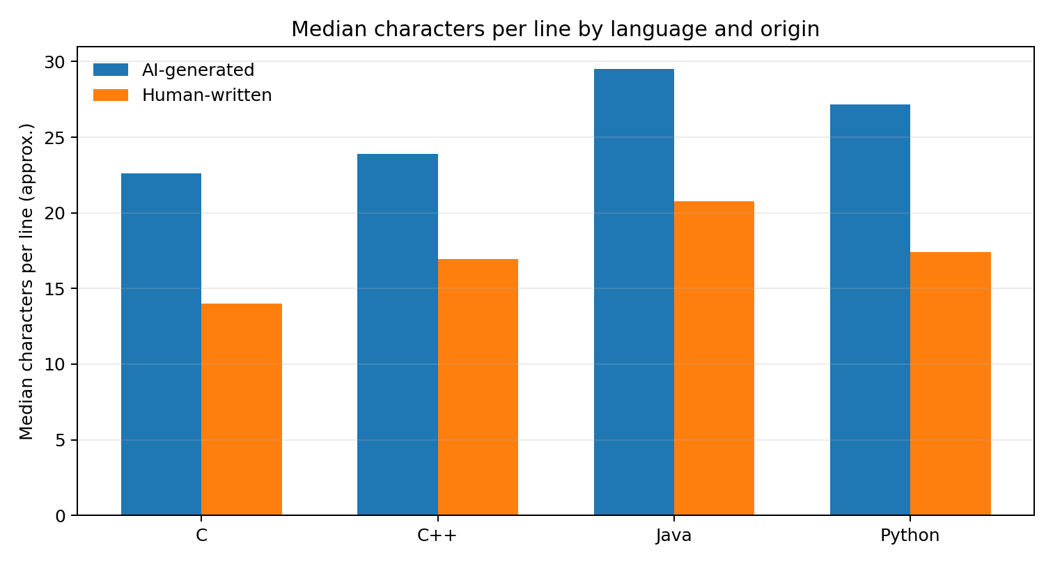
Language | AI median | Human median | Difference (AI-Human) | Adjusted Wilcoxon result
C | 22.62 | 14.00 | +8.62 | p < 0.001
C++ | 23.91 | 16.94 | +6.97 | p < 0.001
Java | 29.50 | 20.78 | +8.72 | p < 0.001
Python | 27.18 | 17.39 | +9.79 | p < 0.001

The reported Wilcoxon p-values for this analysis are displayed as zero by R because they fall below its numeric reporting precision; they are not literally zero. The effect-size calculation for Cliff’s delta in the exploratory script used an incorrect transformation of R’s Wilcoxon statistic, so those displayed Cliff’s delta values are not used in this report. The direction and significance are instead supported by the group medians and the rank-test results.

4.5 Comment presence: a second new finding
The refined heuristic asks whether each sample contains at least one identifiable comment line, rather than only comparing average comment counts. This separates comment presence from comment volume and avoids treating a few heavily commented samples as the entire story.
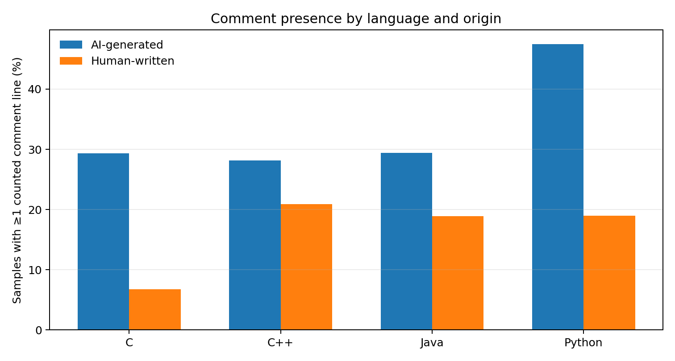
Language | AI with comment | Human with comment | Difference | 95% CI (pp) | Holm p
C | 29.34% | 6.76% | +22.58 pp | [19.20, 25.95] | 7.96e-32
C++ | 28.17% | 20.86% | +7.31 pp | [4.02, 10.61] | 1.23e-05
Java | 29.40% | 18.88% | +10.52 pp | [7.42, 13.63] | 4.42e-11
Python | 47.45% | 18.97% | +28.48 pp | [25.10, 31.86] | 5.34e-53

Every language shows a higher percentage of AI samples with at least one counted comment line, and all four comparisons remain significant after Holm correction. The largest gap is Python (+28.48 percentage points), followed by C (+22.58 points). This finding concerns the presence of detectable comments under the chosen heuristic; it does not imply better documentation or code quality.

Comment presence versus comment volume
Language | Mean comments/sample AI | Mean comments/sample Human | Median AI/Human | Mean comments per 100 lines AI/Human | Holm p for count test
C | 0.669 | 0.248 | 0 / 0 | 2.43 / 0.76 | < 2.2e-16
C++ | 0.574 | 0.941 | 0 / 0 | 2.19 / 1.54 | 1.68e-04
Java | 0.719 | 0.730 | 0 / 0 | 2.56 / 1.53 | 1.13e-09
Python | 0.995 | 0.584 | 0 / 0 | 6.07 / 1.86 | < 2.2e-16

This comparison adds an important nuance: comment presence and comment volume are not interchangeable. Although AI samples were more likely to contain at least one counted comment line in every language, human C++ samples had a higher mean counted-comment count per sample (0.941 vs 0.574); Java mean counts were nearly identical. The median was zero in both groups for every language, indicating that the mean differences are driven by the minority of samples with positive comment counts. All four within-language rank-sum count tests were significant after Holm correction, but the direction was not uniformly AI-higher. The figures remain approximate because the comment counter is heuristic.

4.6 Correlation and regression
Analysis | Result | Interpretation
Overall Spearman correlation | rho = 0.882; p < 2.2e-16 | Strong positive monotonic association: code samples with more lines generally have more characters.
C correlation | rho = 0.864; p < 2.2e-16 | Strong positive association within C.
C++ correlation | rho = 0.891; p < 2.2e-16 | Strong positive association within C++.
Java correlation | rho = 0.863; p < 2.2e-16 | Strong positive association within Java.
Python correlation | rho = 0.890; p < 2.2e-16 | Strong positive association within Python.
Regression: adding language x origin | F(3, 9991) = 64.17; p = 4.34e-41 | Adding language-specific origin differences significantly improves the model.
Regression: adding line-count x origin | F(1, 9990) = 10.08; p = 0.00151 | In the fuller model, the line-count/character-count slope differs modestly by origin after accounting for language-by-origin differences.
Earlier simpler regression | R-squared = 0.903; slope interaction p = 0.289 | The simpler model omitted language-by-origin interaction; its non-significant slope term is not the final model comparison.

The improved regression models log(1 + character count) using log(1 + line count), language, origin, and origin-by-language and line-count-by-origin interactions. The nested-model comparison found strong evidence that origin differences vary by language, and a smaller but statistically significant improvement when the line-count-by-origin slope interaction was added (p = 0.00151). The interaction is conditional on the other terms in the model and should not be interpreted as a causal effect.
The earlier simpler model had R-squared = 0.903, but a high in-sample R-squared is expected because line count and character count are related measures of code size. It is not external predictive validation. The diagnostic plots show departures from normality in the residual tails and possible non-constant variance, so coefficient and p-value interpretations should remain exploratory.
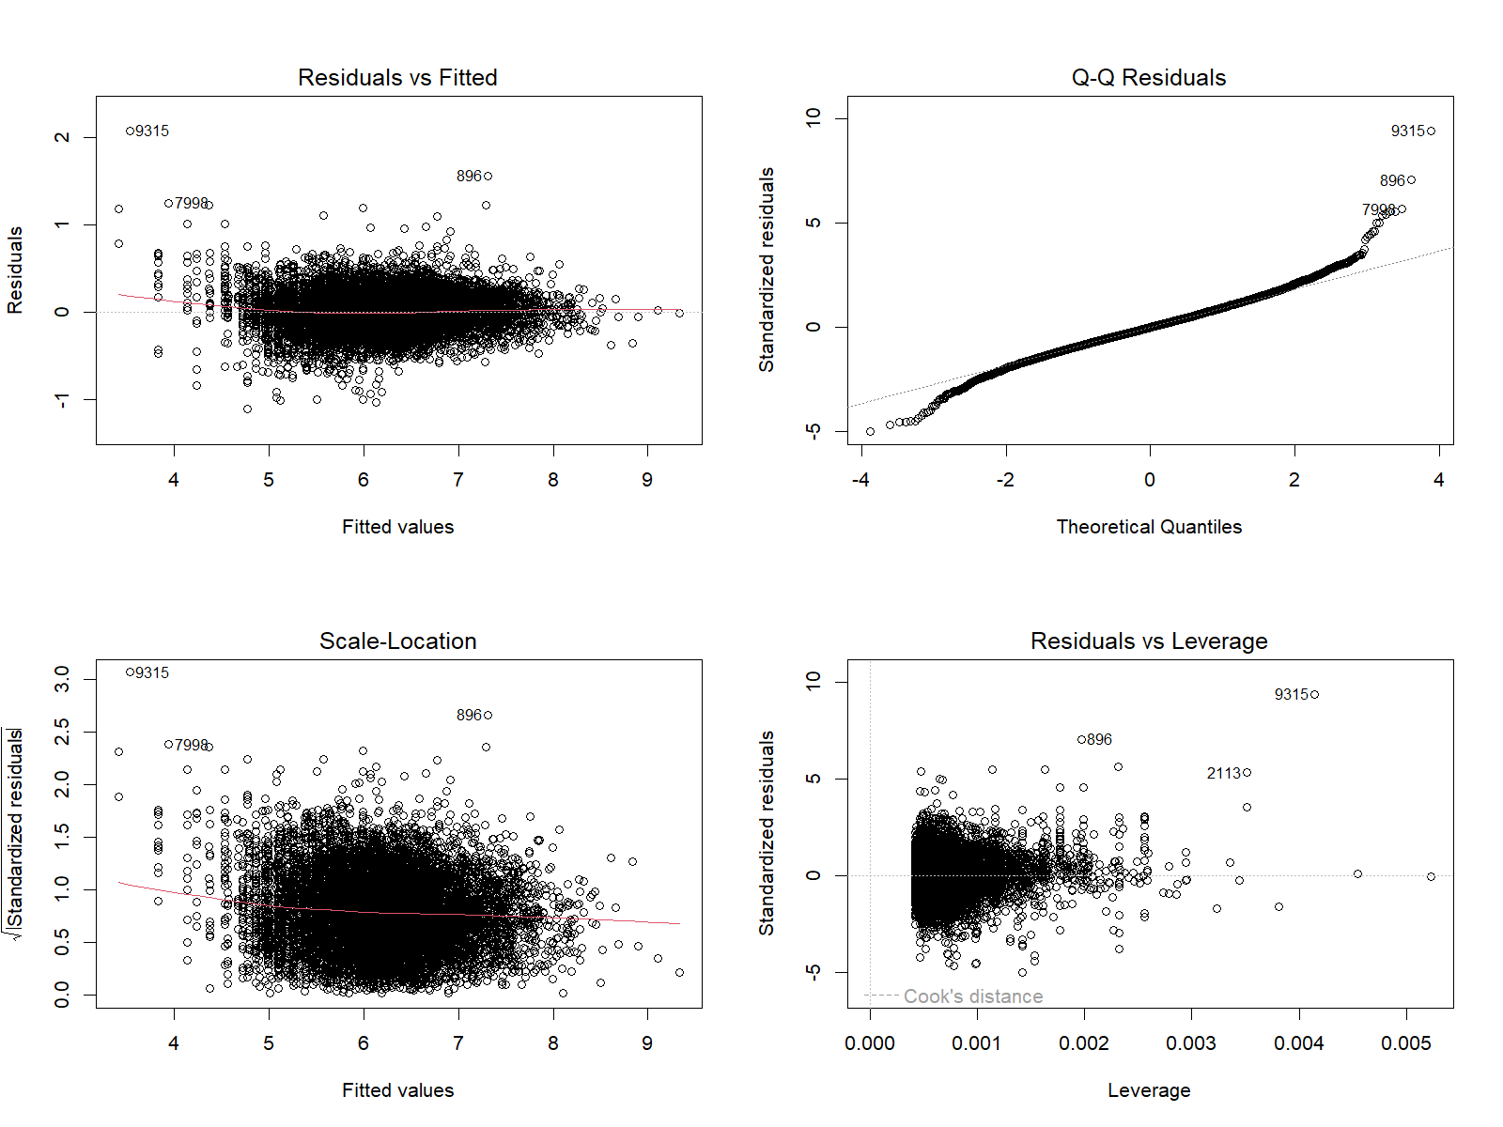
Figure: Standard regression diagnostics for the simpler fitted model. The Q-Q plot shows heavy residual tails; this flags limitations in normal-error assumptions.

4.6.1 Final regression coefficients
Model term | Estimate | p-value
Intercept (Human, C reference) | 2.4967 | < 2.2e-16
log(1 + line count) | 1.0294 | < 2.2e-16
AI origin term at reference values | 0.4060 | 1.43e-54
C++ term for Human reference group | 0.2087 | 8.78e-91
Java term for Human reference group | 0.4020 | < 2.2e-16
Python term for Human reference group | 0.2185 | 5.40e-101
log line count x AI origin | +0.0243 | 0.00151
AI x C++ interaction | -0.1560 | 5.06e-29
AI x Java interaction | -0.1517 | 3.76e-29
AI x Python interaction | -0.0384 | 0.00548

Reference categories are Human origin and C language. Because interactions are in the model, coefficients for origin and language represent conditional contrasts at the reference values; they should not be read as universal effects in isolation. The AI-by-language interaction estimates show that the origin-associated character-count pattern differs from the C reference pattern in the other languages. The line-count-by-origin coefficient is small but statistically significant in the expanded model.

4.7 Factorial ANOVA: main effects and interaction
Outcome (log scale) | Effect tested | F statistic | Holm-adjusted p | Partial eta-squared
Line count | Language, adjusted for origin | 532.10 | < 0.001 | 0.138
Line count | Origin, adjusted for language | 48.70 | < 0.001 | 0.0048
Line count | Language x origin | 69.46 | < 0.001 | 0.020
Character count | Language, adjusted for origin | 601.61 | < 0.001 | 0.153
Character count | Origin, adjusted for language | 544.51 | < 0.001 | 0.052
Character count | Language x origin | 105.18 | < 0.001 | 0.031

The refined factorial analysis compares nested models so language, origin and the language-by-origin interaction can each be assessed conditional on the other relevant terms. All listed effects remained significant after Holm adjustment within each outcome. The interaction supports the conclusion that the origin-related pattern varies by language. Partial eta-squared shows that statistical significance is not a complete measure of practical magnitude: the origin main effect is comparatively small for log line count (about 0.005), while language accounts for more variation in both outcomes.
Because the sample counts differ across language-origin cells and the data were not generated by a randomized experiment, this is an observational factorial analysis. It does not establish that language or origin causes the measured characteristics.

4.8 Chi-square association and robustness check
The chi-square test of independence produced X-squared = 87.519 with 3 degrees of freedom and p < 2.2 × 10^-16. This indicates that the distribution of language labels differs by origin within this dataset. It is an association in the dataset and does not show that origin causes a particular language to be used. The Wilcoxon tests broadly identified distributional differences across language/measurement pairs; importantly, they disagreed with Welch’s test for C++ character count (Wilcoxon significant after correction while Welch was not). That disagreement should be reported rather than concealed.

5. How the Project Integrates the Five PAS Modules
PAS module | What the project applies | Evidence in report
1. Probability and Random Variables | Random-variable measurements, means, medians, variance/SD, association and independence considerations. | Descriptive tables; repeated problem-ID check; Spearman correlation.
2. Probability Distributions | Empirical distributions, spread, skewness and outliers from histograms/boxplots. | Distribution graphs and discussion of long right tails. No theoretical distribution fitting claimed.
3. Testing of Hypotheses | Welch t-tests, confidence intervals, Holm correction, Cohen d, Wilcoxon and chi-square. | Eight corrected mean tests, comment-presence tests and origin-language association.
4. Correlation and Regression | Spearman rank correlation and regression of log character count on log line count, origin and language. | Correlation coefficients and model summary/diagnostic files.
5. ANOVA and Design of Experiments | Factorial model of language, origin and interaction on log-transformed measurements. | Language-by-origin interaction tests. Data are observational; randomized DOE claims are not made.

The project integrates relevant methods from all five modules; it does not cover every listed syllabus topic. For example, it does not fit Binomial/Poisson/Normal/Weibull distributions, run every test in Module 3, or use randomized CRD/RBD/LSD designs. Those methods are not necessary or appropriate for the current observational dataset merely to claim broader coverage.

6. Discussion
The final additions move beyond raw code-length comparisons. Normalizing character count by line count shows that AI samples have a higher median characters-per-line measure in all four languages. A separate binary outcome—whether a sample has at least one counted comment line—shows a higher proportion for AI samples in every language, with the largest gap in Python (+28.48 percentage points) and C (+22.58 points). The fuller regression also finds that origin-associated differences vary by language; adding a line-count-by-origin term provides a further, smaller improvement after accounting for language-by-origin interaction.
The evidence is not uniform across every metric or test. C++ character-count means were close and did not differ significantly under Welch’s test, while the Wilcoxon rank-sum test was significant after correction. This is a method-sensitive result, and it should be reported as such. Some significant comparisons have small effect sizes. Large samples can make small differences statistically significant, so confidence intervals, effect sizes, diagnostics and measurement validity matter alongside p-values.

7. Limitations and Threats to Validity
- Limited provenance: the dataset uses ChatGPT-generated samples and human code collected from a public source; other models, prompts, developers and languages may behave differently [1].
- Balanced origin counts: 5,000/5,000 is a dataset design feature, not a real-world prevalence estimate.
- Approximate measures: character counts include whitespace/newlines; line counts are not logical statements; characters per line is only an approximate density measure.
- Comment heuristic: the refined method detects selected full-line comment forms, but can miss inline comments, unusual formatting, comments after code, language-specific docstrings and complex block-comment cases. It does not validate comment quality.
- Dependence: only three problem IDs contain both origins, but other IDs may repeat within one origin. Repeated rows may violate a simple independent-observations assumption; a fully clustered analysis was not completed.
- Multiple testing: Holm adjustment was used for the eight primary Welch comparisons and for the language-specific comment presence tests. Any additional exploratory testing should be described transparently.
- Observational analysis: statistical associations and group differences do not establish causal mechanisms, authorship of individual snippets, code correctness, readability, maintainability or academic misconduct.
- Regression/ANOVA assumptions: the residual Q-Q plot has heavy tails and other diagnostics suggest possible non-constant variance. The interaction analysis is exploratory, and model fit is in-sample; no external validation or detector performance metrics were computed.
- Wilcoxon versus Welch discrepancy: C++ character count differs by test; the result is method-sensitive and should be interpreted cautiously.

8. Conclusion
This project found systematic but language-dependent differences in measurable properties of human-written and AI-generated code in a 10,000-sample dataset. AI-generated samples had more characters on average, and—under normalized analysis—higher median characters per line in all four languages. They were also more likely to contain at least one detectable comment line under the refined heuristic. Line count and character count were strongly associated, and factorial analysis found significant language-by-origin interactions. However, C++ character count was not significant under Welch’s test, test methods differed for that comparison, and comment measurements remain approximate. The findings support statistical comparisons of coding-style characteristics, not a reliable authorship detector or a claim about code quality.
Final takeaway
The main contribution is not that AI code is simply longer or shorter. It is that normalized text density and comment presence reveal additional, language-specific differences, and the five-module PAS toolkit helps quantify those patterns while exposing uncertainty and measurement limitations.

9. Future Work
- Validate comment detection with language-aware parsers or manual annotation on a stratified subset.
- Use problem_id and any available task metadata to investigate clustering and design matched comparisons where genuinely paired samples exist.
- Report adjusted model comparisons for all main effects and interactions and inspect model assumptions/residuals.
- Consider additional normalized characteristics such as blank-line proportion, indentation/whitespace, token count and comment type, with definitions fixed before testing.
- Replicate on additional datasets, models and prompt styles before making broader claims.
- If a detector is ever proposed, evaluate it separately with held-out data, precision, recall, calibration and fairness/error analysis; these analyses do not constitute a detector.

References
[1] Boukili, G., El Garouani, S., & Riffi, J. (2026). A dataset for human-written and AI-generated code source classification. Data in Brief, 65, 112527. https://doi.org/10.1016/j.dib.2026.112527. Dataset: https://data.mendeley.com/datasets/kjh95n54f8/1
[2] Demirok, B., Kutlu, M., & Mergen, S. (2026). MultiAIGCD: A comprehensive dataset for AI generated code detection covering multiple languages, models, prompts, and scenarios. Neural Computing and Applications, 38, Article 687. https://doi.org/10.1007/s00521-026-12336-0
[3] Gurioli, A., Gabbrielli, M., & Zacchiroli, S. (2024). Is This You, LLM? Recognizing AI-written Programs with Multilingual Code Stylometry. arXiv:2412.14611. https://arxiv.org/abs/2412.14611
[4] Demirok, B., & Kutlu, M. (2024). AIGCodeSet: A New Annotated Dataset for AI Generated Code Detection. arXiv:2412.16594. https://arxiv.org/abs/2412.16594
Reproducibility note: Final_Review3_Analysis.R and the CSV/PNG analysis outputs should be retained with the submitted report.

Appendix B. Supplementary graphs from R
The following figures are the saved plots generated by the final R analysis. Boxplots show medians, interquartile ranges and outlying observations; histograms reveal the strongly right-skewed measurement distributions. These figures support the numerical analyses and also illustrate why means should be interpreted alongside medians and spread.

Figure B1. Line-count distributions
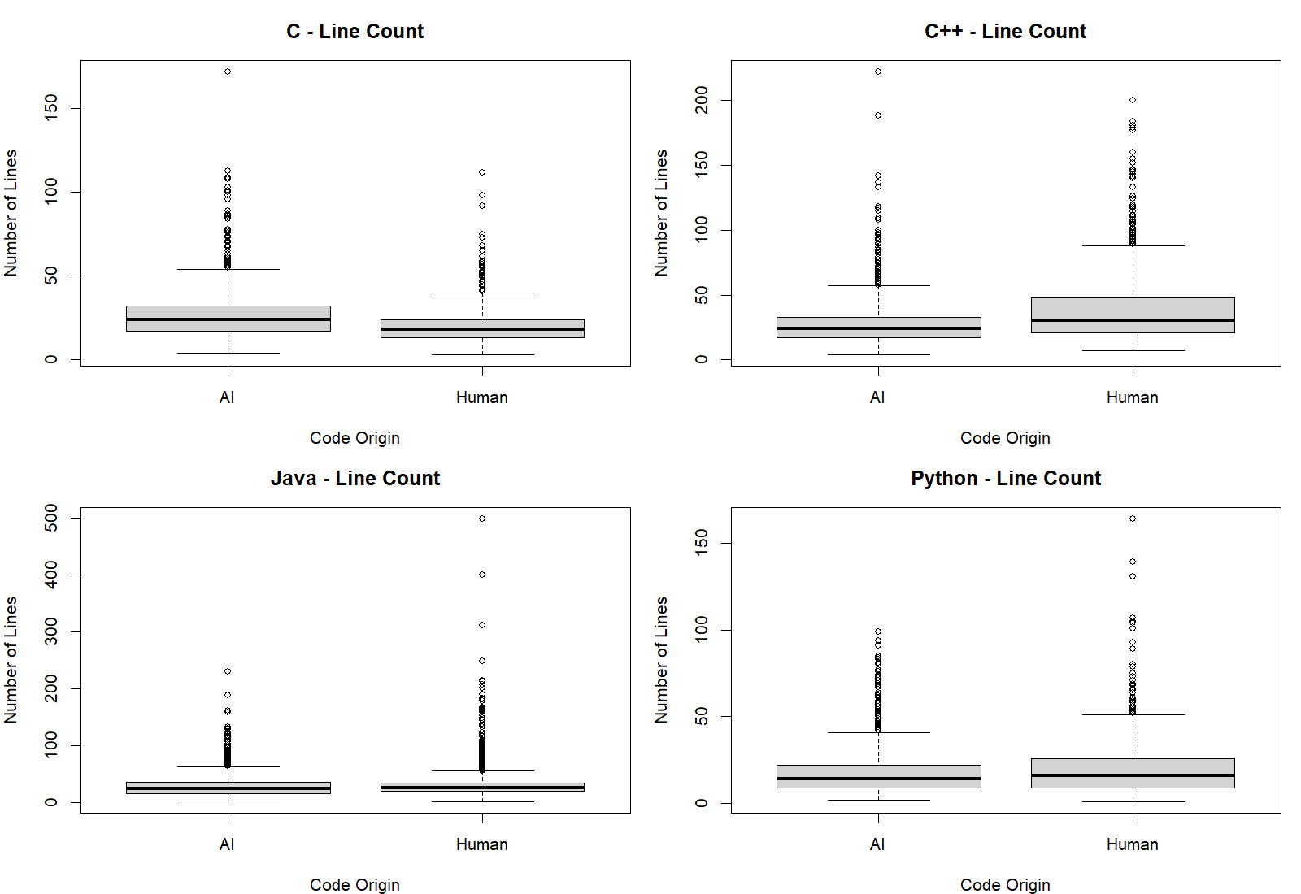
Figure B1. Line-count boxplots split by programming language and code origin. The distributions contain long upper tails and outliers.

Figure B2. Character-count distributions
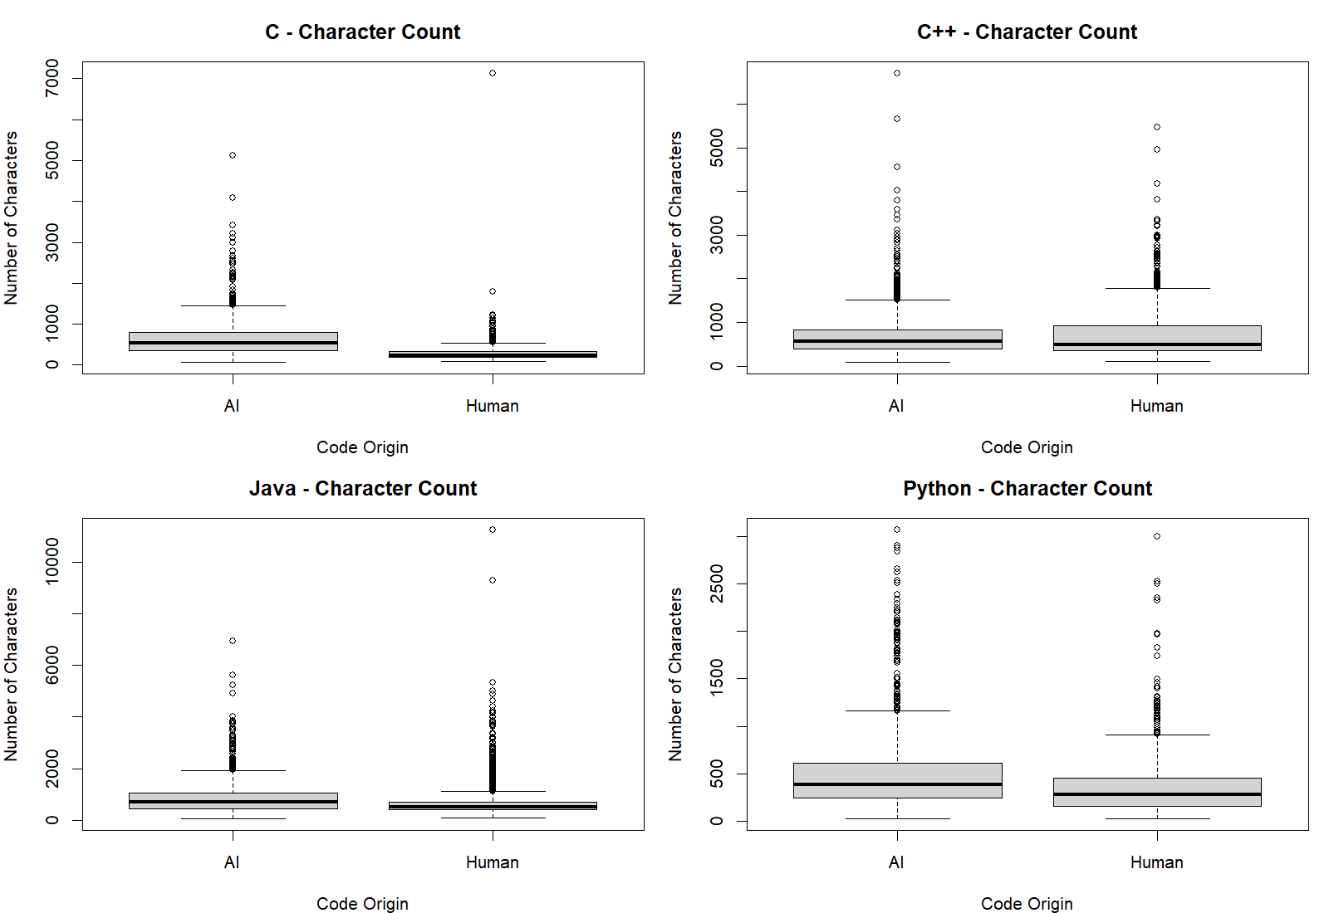
Figure B2. Character-count boxplots by language and origin. AI and human samples overlap, and the amount of separation varies by language.

Figure B3. Empirical distributions
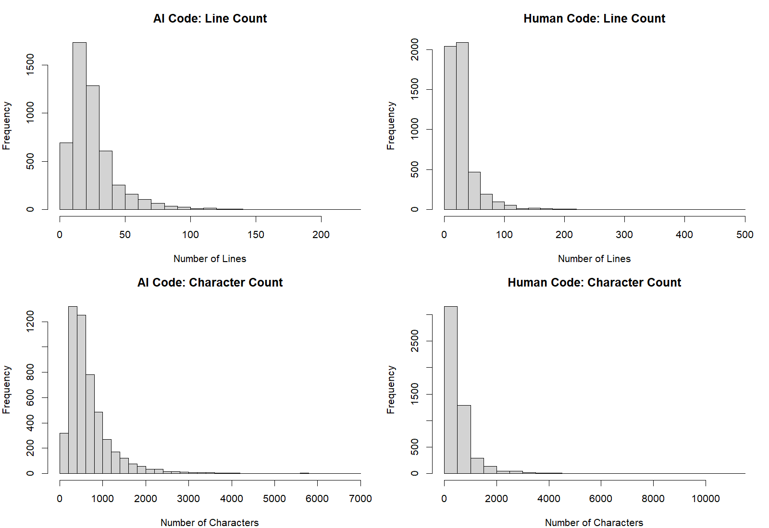
Figure B3. Histograms of line and character counts for AI-generated and human-written samples. Both measures are right-skewed, especially character count.

Figure B4. Characters per line
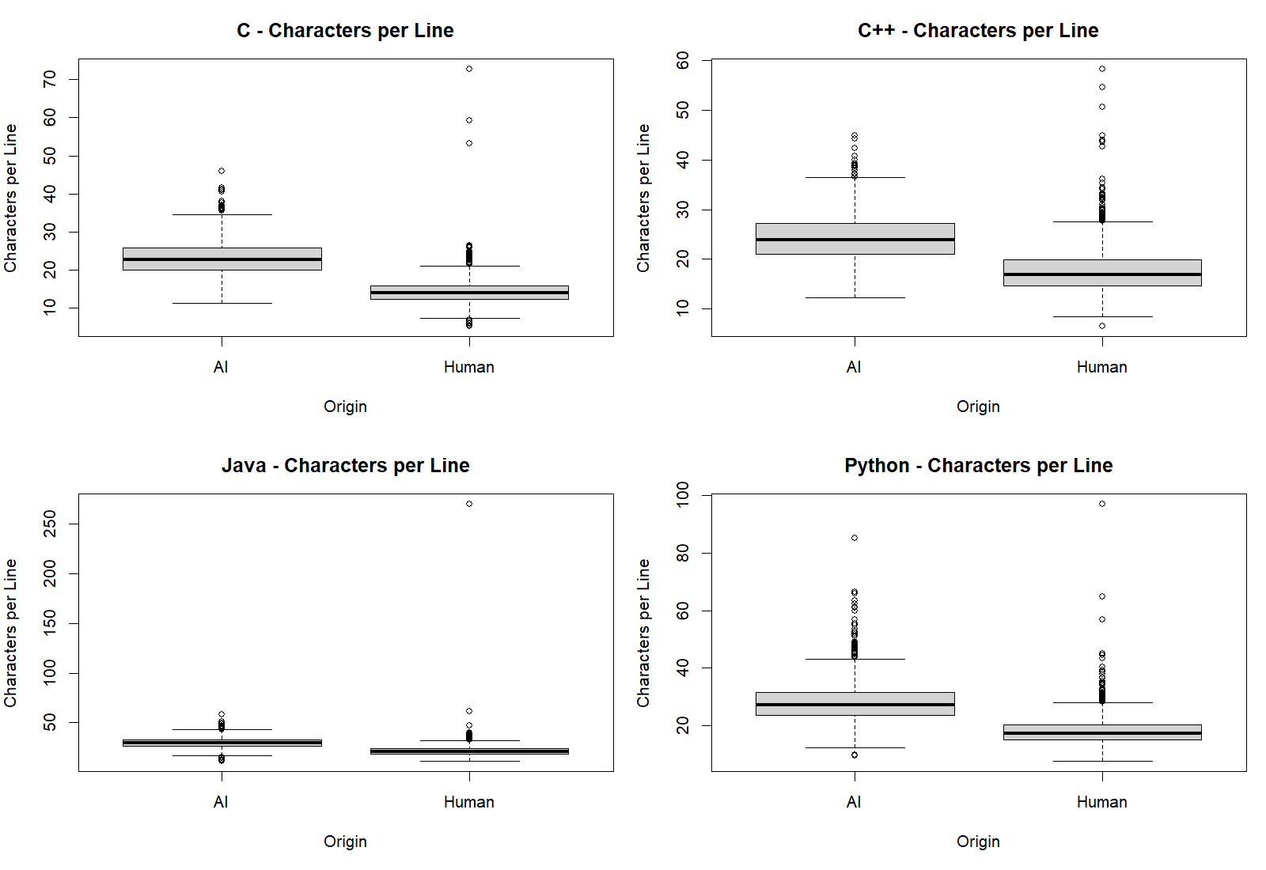
Figure B4. Characters-per-line distributions by language and origin. AI medians are higher in each language in the current dataset.

