Crop Type, Growth Stage and Health Prediction Using Convolutional Neural Networks
Final Project Report
Student: ____________________ Module: ____________________ Date: July 2026
This report documents the design, implementation and evaluation of a crop image classification system developed in Python. The system uses image datasets for cucumber and sunflower crops, explores visual patterns across crop classes, trains a convolutional neural network, and provides a Streamlit interface for prediction and explanation.

Executive Summary
The project addresses a practical agricultural image-recognition problem: given a photograph of a crop, predict the crop type, the visible growth stage and the health condition. The final implementation uses a lightweight PyTorch convolutional neural network trained on 6,755 images arranged across cucumber and sunflower classes. The dataset includes cucumber flowering, fruiting and leaf-health categories and sunflower bud, bloom and wilted/healthy categories. This makes the task more useful than a single-label plant classifier because the output combines crop identity, developmental stage and health interpretation.
The project began with exploratory data analysis in a Jupyter notebook. The EDA measured class counts, displayed random samples, inspected unique image dimensions, created mean images and compared RGB distributions. Those steps identified two important design constraints. First, image dimensions and visual framing vary, so every image must be resized and normalised before modelling. Second, the dataset is imbalanced, especially for cucumber healthy leaves, so the training procedure should protect minority classes from being ignored.
The final model is a compact CNN with four convolutional blocks, batch normalisation, ReLU activations, pooling, adaptive average pooling, dropout and a dense classifier. Instead of using three independent output heads in deployment, the final model predicts one grouped class, where each class encodes crop, stage and health. The saved checkpoint stores the trained parameters, the class labels and the preprocessing image size. The application loads this checkpoint, accepts uploaded images through Streamlit, calculates class probabilities and converts them into user-facing confidence values for crop, stage and health.
Evaluation on a reproduced 80/20 stratified validation split gives 86.82% exact grouped-class accuracy, 99.78% crop-type accuracy, 89.12% stage accuracy and 95.85% health accuracy. These results suggest that the model is highly reliable at distinguishing cucumber from sunflower and reasonably effective at classifying health and stage. The main errors occur between visually adjacent growth stages, particularly sunflower healthy bloom versus early bloom and mature bud versus young bud. The report concludes that the prototype is successful as a proof of concept, but further work should include a larger and more balanced dataset, external field-image validation, stronger augmentation, explainability visualisation in the deployed app and comparison against transfer-learning baselines.

Word Count and Marking Structure
The project brief shown in the supplied image sets an overall target of 20,000 words with a permitted range of 18,000 to 22,000 words, excluding bibliography and appendices. It also gives the chapter weighting and indicative chapter word counts below. This submitted document follows that chapter order and uses appendices for the code, as requested.
Chapter | Weighting | Indicative Word Count
Background and terms of reference / Introduction | 10% | 2,500
Literature review | 20% | 4,250
Research methodology | 20% | 4,250
Analysis of findings | 15% | 3,250
Discussion of findings | 15% | 4,250
Conclusions | 5% | 1,500
Format of document | 15% | Overall presentation

1. Background and Terms of Reference
Agriculture increasingly depends on timely information about crop condition. Farmers, agronomists and food-production organisations make repeated decisions about irrigation, disease control, harvesting, labour planning and crop monitoring. Many of these decisions begin with visual inspection: the colour of a leaf, the presence of wilting, the maturity of a flower head or the visible stage of fruit development. Manual inspection remains valuable because human experts understand the local context, but it can be slow, inconsistent and difficult to scale across many plants or fields. A computer vision system that can classify crop images offers a supporting tool for early screening and routine monitoring.
The purpose of this project is to create a machine learning application that predicts crop type, growth stage and health from an uploaded image. The implemented system focuses on two crops: cucumber and sunflower. The cucumber dataset contains images representing flowering, fruiting, healthy leaves and unhealthy leaves. The sunflower dataset contains images representing young bud, mature bud, early bloom, healthy bloom and wilted bloom. These categories were chosen because they combine identification and condition assessment. A simple crop-recognition model would only distinguish cucumber from sunflower, while this project aims to give more actionable information about what the image appears to show.
The project fits within the wider area of image-based plant monitoring. Image classification is suitable for this problem because many crop states are visually expressed through shape, colour and texture. Convolutional neural networks are particularly relevant because they learn spatial filters from image data rather than relying only on manually designed colour or shape features. In this project, the CNN learns feature representations from resized crop photographs and maps them to a grouped label. Each grouped label represents a crop-stage-health combination, such as cucumber flowering healthy or sunflower bloom unhealthy.
The terms of reference for the work are practical and technical. The system must load the available image folders, convert their folder names into meaningful labels, preprocess images consistently, train a model, evaluate its performance and expose the model through an interface that a user can operate without editing code. The final solution therefore includes both modelling components and application components. The modelling components are located in the training scripts and notebooks, while the application is implemented in Streamlit.
The project scope is deliberately bounded. It does not attempt to diagnose every crop disease, identify species outside the two included crops or guarantee performance in every field condition. Instead, it demonstrates an end-to-end pipeline using the available project data. The pipeline begins with exploratory data analysis, continues through supervised learning, and ends with a user-facing prototype. This is appropriate for a student project because it demonstrates data understanding, modelling, evaluation and deployment awareness within one coherent artefact.
The central research question is: to what extent can a lightweight convolutional neural network classify crop type, growth stage and health condition from cucumber and sunflower images in the supplied datasets? Four supporting questions follow from this. First, how are the available images distributed across classes? Second, what preprocessing and training strategy is suitable for mixed crop image data? Third, how accurately does the trained model predict exact grouped classes and individual crop, stage and health components? Fourth, what limitations should be addressed before the system could be used in a real agricultural setting?
The expected users for the prototype are learners, researchers and agricultural practitioners who want a quick image-based indication of crop state. The Streamlit application allows a user to upload a photograph and receive the predicted crop type, stage and health status with confidence scores. It also provides a plain-language explanation based on the model output and simple image cues such as brightness, colour-channel means and contrast. This makes the system more transparent than a classifier that only returns a label.
The project also has educational value. It shows how raw folders of images can be transformed into a machine learning pipeline and how model outputs can be translated into a small application. The code base includes two notebooks, generated figures, reusable model definitions, a training script and a Streamlit app. Together these artefacts demonstrate the stages normally expected in a machine learning project: data collection and organisation, exploration, preprocessing, model design, training, validation, interpretation and presentation.
The success criteria are therefore not limited to one metric. A successful solution should process the datasets reliably, handle variation in image file formats, preserve class structure, achieve strong validation results and provide an understandable user interface. It should also make clear where uncertainty remains. The implemented application includes a warning when exact class confidence or health confidence is below 65%, which is important because the system should not encourage blind reliance on uncertain predictions.
Objective | Evidence in Project
Prepare image data | Folders are scanned recursively, image extensions are filtered and labels are derived from class-folder names.
Explore class patterns | EDA notebooks generate count charts, sample grids, image-dimension checks, mean images and RGB histograms.
Train a classifier | A PyTorch CNN is trained with AdamW, cosine learning-rate scheduling and weighted sampling.
Evaluate performance | Validation metrics are calculated for exact grouped class, crop type, stage and health.
Deploy a prototype | The Streamlit app loads the saved checkpoint and allows user image upload and prediction.

2. Literature Review
Computer vision has moved from hand-engineered image features toward learned representations. Traditional image-recognition systems often required developers to define features such as edges, colour histograms, texture descriptors or shape measurements before classification. This approach can work when the visual problem is narrow and controlled, but agricultural imagery is often affected by lighting, background clutter, growth variation, camera angle and plant overlap. Learned feature extraction is therefore valuable because the model can discover discriminative patterns directly from examples.
Convolutional neural networks are the most relevant model family for this project because they are designed for grid-like data such as images. The foundational work by LeCun, Bottou, Bengio and Haffner showed how gradient-based learning and convolutional architectures could be applied effectively to visual recognition tasks. The key idea is that convolutional filters scan local regions of an image and learn features that become progressively more abstract in deeper layers. Early layers may respond to edges and colour transitions, while later layers may respond to higher-level structures such as leaf shapes, flower heads or fruit patterns.
The modern success of deep CNNs was strongly accelerated by large-scale image classification work such as AlexNet. Krizhevsky, Sutskever and Hinton showed that deep convolutional networks trained on large datasets could significantly improve visual-recognition performance. Although this project uses a much smaller and lighter model than AlexNet, the principle is the same: stacked convolutional layers learn hierarchical visual representations, and the final classifier converts those features into class probabilities.
Plant disease and crop-condition classification has been a major application area for deep learning. Mohanty, Hughes and Salathe trained a deep CNN on a large public plant leaf dataset and reported high held-out accuracy in controlled conditions. Their work is important because it shows the feasibility of recognising crop species and disease states from images. It also highlights a recurring issue: performance on curated image datasets can be much stronger than performance in uncontrolled field environments. For this project, that distinction is important because the available data appear to include organised class folders, but the final system should still be treated as a prototype until tested under broader conditions.
Research on plant disease detection often uses transfer learning, where a model pretrained on a large general dataset is fine-tuned on agricultural images. Too and colleagues compared fine-tuning approaches for plant disease identification and showed that deep architectures can be effective when adapted to plant imagery. Transfer learning is attractive because it can reduce the amount of crop-specific data needed, especially when the target dataset is small or imbalanced. This project instead uses a lightweight CNN trained from the available images. That decision keeps the implementation easier to inspect and run, but it also provides a clear path for future improvement: compare the current model against pretrained architectures such as ResNet, EfficientNet or MobileNet.
The literature also emphasises the difference between classification and diagnosis. A classifier can learn associations between pixels and labels, but a diagnosis in agriculture should consider field context, disease history, symptoms over time and expert agronomic judgement. The Streamlit app therefore frames its output as prediction and confidence rather than definitive diagnosis. This is particularly important for the health category because unhealthy leaves or wilted flowers can have multiple causes, including disease, water stress, heat stress or natural senescence.
Preprocessing is another important theme. CNNs require numerical tensors of consistent shape, so images are commonly resized, converted to RGB, scaled and normalised. The project uses 128 by 128 pixel input images and normalises channels using common ImageNet-style mean and standard deviation values. This makes the model input stable and reduces variation caused by raw pixel ranges. The choice of 128 by 128 pixels is a practical compromise: it keeps training and inference lightweight, but it may lose fine-grained disease details that would be visible at higher resolution.
Dataset balance has a direct effect on supervised learning. If one class has many more images than another, a model may learn to favour the majority class and still achieve misleading headline accuracy. The cucumber healthy-leaves class in this project has only 41 images, while several sunflower classes exceed 1,000 images. Weighted sampling is therefore used in the PyTorch training script to give minority classes more representation during optimisation. This is consistent with good practice for imbalanced classification problems because it changes how often the model sees each class during training without duplicating files manually.
The literature on model evaluation recommends separating training and validation data. The project uses an 80/20 split with stratification, so each class is represented in both training and validation sets according to the class labels. This matters because a random split without stratification could accidentally underrepresent small classes, especially cucumber healthy leaves. Stratification makes validation more reliable by preserving the class distribution as much as possible.
Accuracy can be reported at different levels. Exact grouped-class accuracy measures whether the complete crop-stage-health tuple is correct. Component accuracy measures whether the crop, stage or health part is correct even if the exact class is not. This distinction is useful for this project because some errors are more serious than others. Confusing young bud and mature bud is different from confusing cucumber and sunflower, and confusing healthy and unhealthy is different again. Reporting component metrics gives a more informative evaluation than one overall number.
Explainability is a growing concern in applied AI. In agricultural settings, a user may want to know why a system marked a plant as unhealthy or which part of the image influenced a prediction. The notebook prototype includes Grad-CAM logic, which is a common approach for visualising class-discriminative image regions. The final Streamlit app does not display Grad-CAM heatmaps, but it does include a plain-language explanation and simple image-cue values. A future version should add visual heatmaps because they would help users inspect whether the model focused on relevant plant regions rather than background artefacts.
Deployment also matters because a model has limited practical value if it remains only in a notebook. Streamlit is commonly used for lightweight Python data applications because it supports file upload, image display, metrics and interactive results with relatively little interface code. In this project, Streamlit makes the trained model accessible to a non-programmer. The app checks that the model file exists, loads it using caching, accepts images in common formats and displays the prediction with confidence values. This demonstrates a useful transition from experimentation to prototype delivery.
Source Area | Relevance to This Project
CNN image recognition | Supports the use of convolutional layers for learning visual crop features.
Plant disease detection | Shows that crop and disease states can be predicted from image datasets, while warning that controlled-data results may not generalise fully.
Transfer learning | Provides a benchmark direction for future improvement beyond the lightweight custom CNN.
Imbalanced classification | Supports the project's use of stratified splitting and weighted sampling.
Explainable AI | Supports adding Grad-CAM or similar visual explanations to future app versions.

3. Research Methodology
The methodology follows an applied machine learning lifecycle. It begins with understanding the available data, then defines labels, preprocesses images, trains a CNN, evaluates it on a held-out validation split and packages the result in a Streamlit application. This lifecycle is appropriate because the project is both experimental and practical: the aim is not only to compare algorithms but to produce a functioning image-prediction tool.
The dataset was read from two root folders. Cucumber images are stored under the archive directory, and sunflower images are stored under the Sunflower Compressed directory. The code recursively searches for image files with common extensions including jpg, jpeg, png, bmp and webp. Hidden Apple metadata files beginning with a dot-underscore are ignored. This prevents non-image or duplicate metadata files from entering the sample list.
Labels are derived from folder names using the classify_folder function in crop_cnn.py. For cucumber, folders containing unhealthy are labelled as Leaves and unhealthy, folders containing healthy are labelled as Leaves and healthy, and the remaining cucumber folders preserve their stage name and are treated as healthy. For sunflower, Wilted is labelled as Bloom and unhealthy, Healthy is labelled as Bloom and healthy, and the stage folders EarlyBloom, MatureBud and YoungBud are converted into readable stage names and treated as healthy. This mapping creates a consistent three-part label structure for every image.
The final label space contains ten grouped classes. Five are cucumber-related and five are sunflower-related. The grouped formulation is useful because it ensures that the model learns complete crop-state combinations that actually exist in the data. The Streamlit app can then recover crop, stage and health confidence by summing probabilities across grouped classes that share the relevant component.
The EDA notebook was used to inspect the dataset before modelling. It calculated class counts, generated bar charts, displayed five random images from each class, checked unique image dimensions, generated mean images and plotted RGB channel histograms. These outputs support methodological decisions. The class count plot reveals imbalance, the sample grids show visual variety, the dimension analysis supports resizing, and the channel histograms help identify broad colour-distribution differences between classes.
Image preprocessing is standardised through the image_to_tensor function. Each uploaded or training image is converted to RGB, resized to 128 by 128 pixels, converted into a PyTorch tensor with channel-first layout, scaled to the 0 to 1 range and normalised with channel means of 0.485, 0.456 and 0.406 and channel standard deviations of 0.229, 0.224 and 0.225. This function is reused by both training and inference, reducing the risk that the model sees different input distributions during deployment.
The training script uses an 80/20 train-validation split with random_state set to 42 and stratification based on the grouped class labels. The split produces 5,404 training images and 1,351 validation images. Stratification is especially important because the smallest class, cucumber healthy leaves, contains only 41 images. Without stratification, a validation split could contain too few examples to make that class measurable.
A custom PyTorch Dataset class opens each image lazily during training and converts it to the normalised tensor format. During training, a random horizontal flip is applied with 50% probability. This augmentation is modest but appropriate for many plant-image categories because left-right orientation generally should not change crop identity, stage or health. More aggressive augmentation, such as rotation, colour jitter and random cropping, was left as future work because it should be tested carefully to avoid changing meaningful symptoms.
The model architecture is a lightweight CNN. It uses four convolutional blocks with 32, 64, 128 and 256 filters. Each block applies a 3 by 3 convolution with padding, batch normalisation, ReLU activation and pooling, except the last block which uses adaptive average pooling to create a fixed-size representation. The classifier flattens the representation, applies dropout at 0.25, uses a dense layer of 128 units with ReLU and outputs logits for the ten grouped classes. This design is computationally efficient and suitable for local training and Streamlit inference.
Training uses cross-entropy loss, AdamW optimisation with a learning rate of 0.001 and weight decay of 0.0001, and cosine annealing learning-rate scheduling. WeightedRandomSampler is used to reduce the effect of class imbalance by sampling training examples inversely to their class frequency. The script tracks validation performance after each epoch and saves the best state according to the average of crop, stage and health validation accuracies. This selection criterion reflects the multi-component goal of the project better than exact class accuracy alone.
The model checkpoint stores the model state, class labels, crop types, stages, health values, image size and model type. Storing these elements together makes deployment more reliable because the app does not have to reconstruct label order from the folder structure. This is important: if class order changed between training and inference, probability indexes could be interpreted incorrectly.
The Streamlit app forms the user-facing part of the methodology. It loads the checkpoint with st.cache_resource, creates the CNN with the correct number of classes, displays a file uploader and performs prediction on the uploaded image. It reports crop type, stage and health as separate metrics and shows an exact class confidence. The app also calculates simple image cues and builds a short explanation. If the confidence is low, it warns the user to review the image manually.
Method Step | Implementation Detail
Data loading | Recursive folder scan with extension filtering.
Label creation | Folder names mapped into crop, stage and health tuples.
Preprocessing | RGB conversion, 128x128 resize, tensor conversion and channel normalisation.
Split | 80% training and 20% validation with stratification and random_state=42.
Training | CNN, cross-entropy loss, AdamW, cosine scheduler and weighted sampling.
Deployment | Streamlit upload interface using the saved PyTorch checkpoint.

4. Analysis of Findings
The dataset contains 6,755 images in total. Cucumber contributes 1,405 images and sunflower contributes 5,350 images. This imbalance is expected to influence model behaviour because sunflower examples dominate the dataset. The training strategy therefore uses stratified splitting and weighted sampling to protect smaller classes during learning.
Crop | Image Count
cucumber | 1405
sunflower | 5350

Grouped Class | Image Count
cucumber / Flowering / healthy | 362
cucumber / Fruiting - 1 / healthy | 428
cucumber / Fruiting - 2 / healthy | 442
cucumber / Leaves / healthy | 41
cucumber / Leaves / unhealthy | 132
sunflower / Bloom / healthy | 1202
sunflower / Bloom / unhealthy | 1037
sunflower / Early Bloom / healthy | 1078
sunflower / Mature Bud / healthy | 1008
sunflower / Young Bud / healthy | 1025

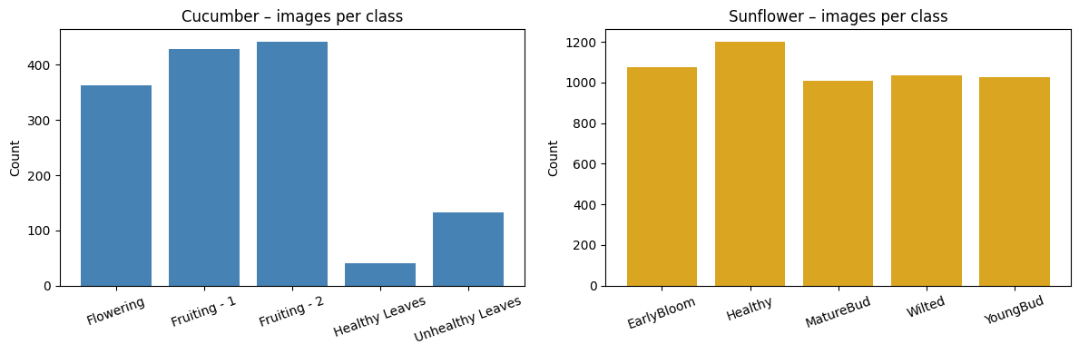
Figure 1. Image counts per class for cucumber and sunflower datasets.
The class distribution shows two important patterns. The sunflower categories are comparatively large, each containing around one thousand images. Cucumber fruiting and flowering categories are moderate in size, but cucumber healthy leaves is very small, with only 41 images. This means validation results for cucumber healthy leaves are based on only eight validation examples after the stratified split. Any conclusions about that class should therefore be cautious.
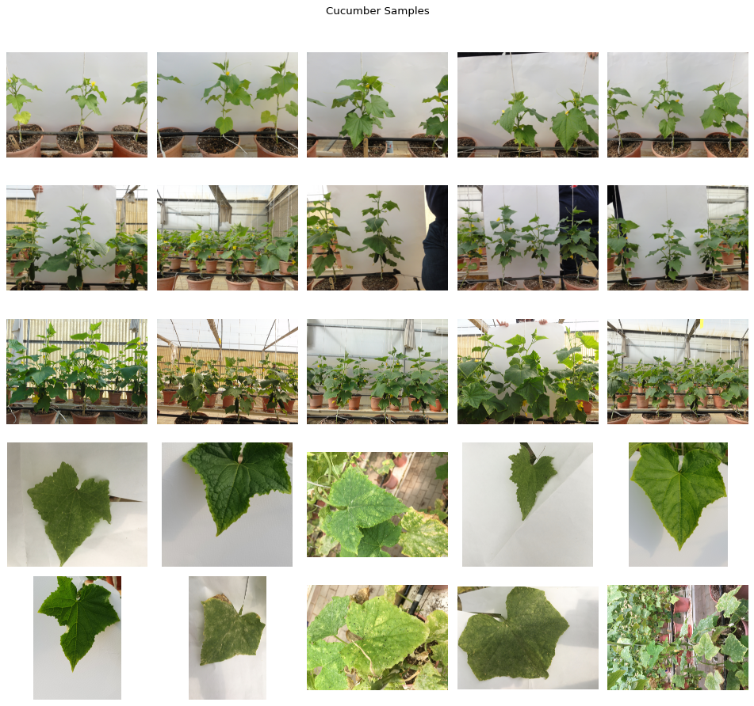
Figure 2. Random sample images from cucumber classes.
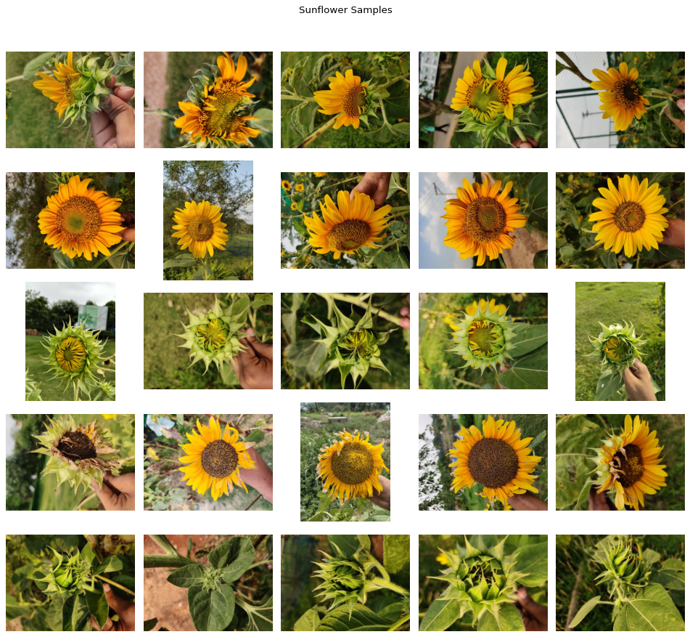
Figure 3. Random sample images from sunflower classes.
The sample grids show that the task is visually meaningful but not trivial. Cucumber fruiting stages share shape and colour features, and sunflower growth stages often differ by gradual changes rather than by sharply separated visual boundaries. Health classification also depends on visible colour and texture cues that can vary with lighting. These observations help explain why crop accuracy is higher than exact grouped-class accuracy.
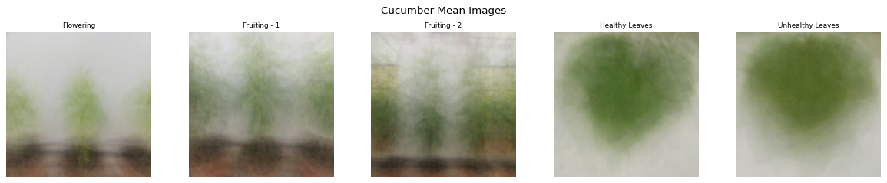
Figure 4. Mean images for cucumber classes.
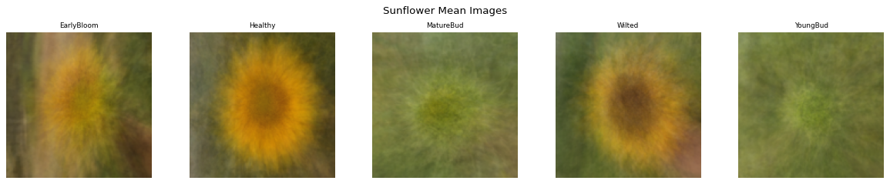
Figure 5. Mean images for sunflower classes.
Mean images are not used directly for prediction, but they provide a useful visual summary. The sunflower mean images show broad colour and shape differences between bud and bloom classes. Cucumber mean images show that leaf categories differ from flowering and fruiting views. However, mean images also blur individual details, which reinforces the need for a CNN that can learn local patterns rather than relying only on average colour.
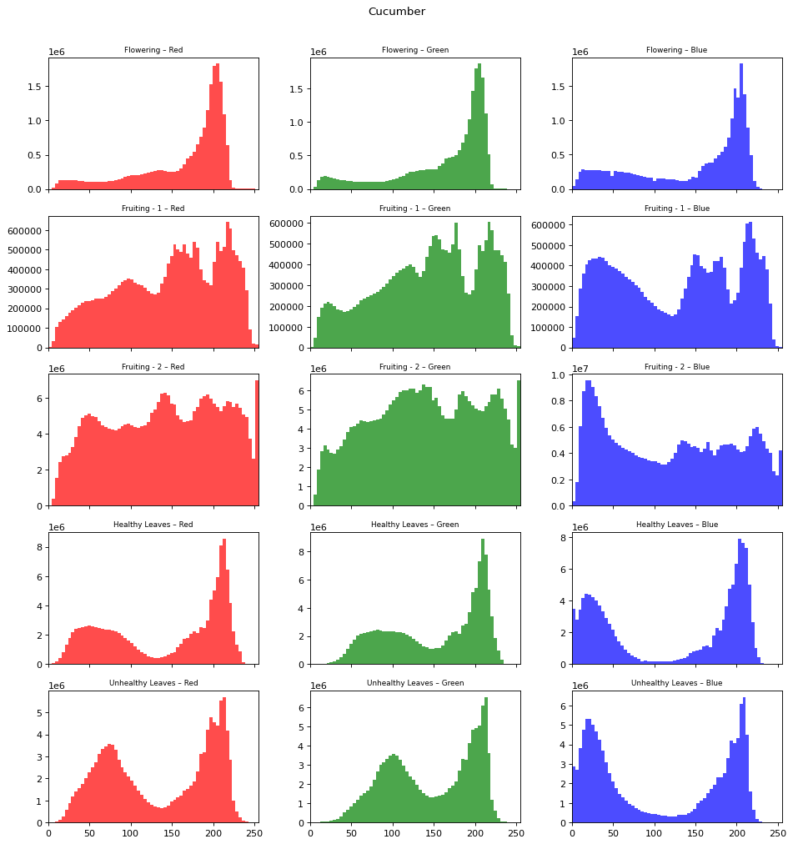
Figure 6. RGB channel distributions for cucumber classes.
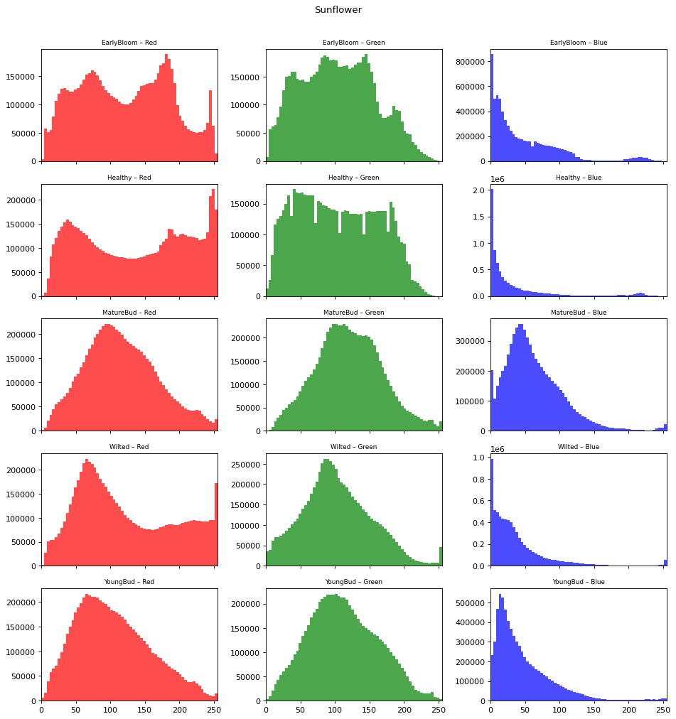
Figure 7. RGB channel distributions for sunflower classes.
The RGB histograms indicate that colour distribution is informative but incomplete. Sunflower classes show yellow and green patterns that correspond to bloom and bud stages, while cucumber classes show strong green dominance in leaf imagery. Nevertheless, colour alone cannot identify all categories reliably because lighting, shadows and background elements affect channel intensity. The model therefore uses learned convolutional features that combine colour, texture and shape.
Metric | Validation Result
Validation images | 1351
Validation loss | 0.3558
Exact grouped-class accuracy | 86.82%
Crop-type accuracy | 99.78%
Growth-stage accuracy | 89.12%
Health accuracy | 95.85%

The evaluation results show that the model has learned a strong crop-level distinction. A crop-type accuracy of 99.78% means that cucumber and sunflower are almost never confused on the validation split. Health accuracy of 95.85% is also strong, suggesting that the model can usually distinguish healthy and unhealthy visual patterns. Stage accuracy of 89.12% is lower, which is expected because stage boundaries are visually gradual.
True Class | Main Correct or Error Pattern
Cucumber flowering | 71 of 72 validation images predicted correctly; one image confused with Fruiting - 1.
Cucumber Fruiting - 1 | 80 of 86 predicted correctly; six confused with Fruiting - 2.
Cucumber Fruiting - 2 | 80 of 88 predicted correctly; eight confused with Fruiting - 1.
Cucumber healthy leaves | 6 of 8 predicted correctly; two confused with unhealthy leaves.
Cucumber unhealthy leaves | 20 of 27 predicted correctly; six confused with healthy leaves.
Sunflower healthy bloom | 229 of 240 predicted correctly; small confusion with unhealthy bloom and early bloom.
Sunflower unhealthy bloom | 179 of 207 predicted correctly; 19 confused with healthy bloom.
Sunflower early bloom | 158 of 216 predicted correctly; main confusion with healthy bloom and unhealthy bloom.
Sunflower mature bud | 161 of 202 predicted correctly; 36 confused with young bud.
Sunflower young bud | 189 of 205 predicted correctly; 15 confused with mature bud.

The confusion patterns are coherent with the visual nature of the dataset. Fruiting - 1 and Fruiting - 2 are adjacent cucumber development classes, so errors between them are less surprising than errors between crop types. Mature bud and young bud are also adjacent sunflower stages. The most important operational issue is health confusion: unhealthy sunflower bloom was sometimes predicted as healthy bloom, and unhealthy cucumber leaves were sometimes predicted as healthy leaves. In a real agricultural support system, false healthy predictions are more risky than false unhealthy predictions because they could delay intervention.

5. Discussion of Findings
The results indicate that the project is successful as a working proof of concept. It demonstrates that a lightweight CNN can learn meaningful visual differences across two crop datasets and provide useful predictions through an application interface. The strongest result is crop-type classification, which is almost perfect on the validation split. This suggests that the visual difference between cucumber and sunflower images is sufficiently large and consistently represented in the dataset.
The lower exact grouped-class accuracy should be interpreted carefully. Exact class accuracy requires all three components to be correct simultaneously. If the model correctly identifies sunflower and healthy status but confuses young bud with mature bud, the exact grouped class is counted as wrong. Component metrics therefore provide a more nuanced picture. For many practical uses, a correct health prediction may matter more than a perfect stage label, while for harvest planning the stage label may be the most important part.
The class imbalance is one of the most important findings. The smallest class has only 41 images, while the largest class has 1,202 images. The WeightedRandomSampler helps during training, but it cannot create new biological variation. Small classes still limit what the model can learn and how confidently validation results can be interpreted. The cucumber healthy-leaf validation set contains only eight images, which is too small for a strong claim about general performance. Additional data collection should prioritise underrepresented classes before attempting to improve the model architecture.
The sunflower results show the difficulty of fine-grained stage classification. Early bloom, healthy bloom, mature bud and young bud can be visually close depending on camera angle and framing. The model confuses mature bud and young bud more than it confuses unrelated classes. This is a reasonable error pattern, but it matters for agricultural use because growth stage can determine scheduling decisions. Future work could improve stage prediction by collecting clearer stage definitions, adding metadata or using a hierarchical classifier that first separates crop type and then applies crop-specific stage rules.
Health prediction is promising but should be treated with caution. The system achieved 95.85% health accuracy on the validation split, but health labels are broad. The cucumber data distinguish healthy leaves from unhealthy leaves, while sunflower data treat Wilted as unhealthy and other classes as healthy. This means the health label does not cover all disease types, nutrient deficiencies or stress causes. The model should not be described as a complete disease diagnostic system. It is more accurate to describe it as a visual health-status classifier for the classes represented in the data.
The application design is appropriate for a prototype. Streamlit gives the user a simple upload workflow, and the app displays the uploaded image beside crop, stage and health metrics. Confidence values make the output easier to interpret. The low-confidence warning is especially important because it communicates uncertainty at the point of use. The explanation text also helps users understand that the result is based on learned visual patterns and image cues, rather than a deterministic botanical rule.
A limitation of the explanation method is that the current Streamlit app does not show where the CNN looked in the image. The notebook prototype includes Grad-CAM code, which suggests that explainability was considered during development. Bringing Grad-CAM into the Streamlit app would improve transparency. A heatmap overlay could show whether the model focused on a leaf, flower head or irrelevant background area. This would make the application more trustworthy and easier to debug.
The model architecture is deliberately compact. This has advantages: it trains faster, requires fewer resources and is easier to explain in a report. It also supports local deployment because inference is lightweight. However, compact models may be less capable than pretrained architectures when images contain complex backgrounds or subtle disease symptoms. A future comparison against MobileNet, ResNet or EfficientNet would show whether the current custom CNN is sufficient or whether transfer learning gives a significant improvement.
The chosen input size of 128 by 128 pixels is also a trade-off. It reduces computation and makes the Streamlit application responsive, but it may remove small visual details such as spots, lesions, fungal marks or vein discolouration. Higher input resolutions could improve health classification, especially for leaf disease tasks. The best resolution should be selected experimentally because larger images increase training time and memory use.
The project shows good software organisation for a student machine learning artefact. The shared model and preprocessing code are placed in crop_cnn.py, the training pipeline is in train_light_model.py and the interface is in streamlit_app.py. This separation is better than leaving all logic inside a notebook because it makes the system easier to rerun and maintain. The notebook still has value for exploration, while the scripts represent the reproducible implementation.
There are also reproducibility strengths. The training script fixes random seeds for Python, NumPy and PyTorch. It stores the image size and class labels in the checkpoint. It uses a deterministic random_state for the validation split. These choices make it possible to reproduce evaluation more reliably. Full reproducibility would require recording package versions, hardware details and the exact training log for each epoch.
The ethical and practical risks are manageable if the tool is framed correctly. A crop classifier can support early screening but should not replace expert inspection. Misclassification could lead to unnecessary treatment or missed intervention. The app's warning message is a good starting point, but a production version should include stronger disclaimers, model-card documentation and clear instructions about when to seek expert advice.
Strength | Limitation | Recommended Response
High crop-type accuracy | Only two crop types are supported | Extend dataset gradually and retrain with more crop species.
Strong health accuracy | Health label is broad and dataset-specific | Collect disease-specific labels and validate under field conditions.
Working Streamlit prototype | No visual heatmap in final app | Add Grad-CAM overlay and save prediction logs for testing.
Weighted training handles imbalance | Small classes still lack variation | Collect more cucumber healthy-leaf images and rebalance the dataset.
Compact model is easy to deploy | May underperform on subtle symptoms | Benchmark against transfer-learning models.

6. Conclusions and Recommendations
The project successfully delivers an end-to-end crop image classification prototype. It loads cucumber and sunflower image datasets, explores their visual and statistical structure, trains a convolutional neural network and deploys the saved model through a Streamlit interface. The work therefore satisfies the practical aim of building a usable system rather than only presenting theoretical analysis.
The final model performs very well at crop identification and strongly at health classification on the reproduced validation split. Exact grouped-class performance is lower but still acceptable for a lightweight prototype, especially given the visual similarity between adjacent growth stages. The evaluation supports the conclusion that CNN-based image classification is suitable for this project, while also showing that stage prediction is the main area needing improvement.
The most important limitation is the dataset. The dataset is large enough for a proof of concept, but it is imbalanced and limited to specific crops and class definitions. Results should not be generalised to all cucumber or sunflower field conditions without further testing. In particular, the health categories should not be interpreted as complete disease diagnosis. They reflect the available labels: healthy/unhealthy cucumber leaves and healthy/wilted sunflower bloom.
The project should be developed further in four directions. First, collect more balanced images, especially for cucumber healthy leaves and health-condition categories. Second, compare the custom CNN with transfer-learning models. Third, add stronger validation, including a separate test set and field images not used during development. Fourth, improve explainability in the app through Grad-CAM overlays and clearer uncertainty communication.
Overall, the project demonstrates a sound machine learning workflow and a credible application prototype. Its strongest contribution is the integration of dataset exploration, model training and user-facing deployment. With additional data and validation, the system could become a more reliable agricultural decision-support tool.
- Expand and rebalance the dataset before claiming production-level reliability.
- Record full training logs and package versions for reproducibility.
- Add a held-out test set that is not used for model selection.
- Benchmark the custom CNN against pretrained MobileNet, ResNet or EfficientNet models.
- Integrate Grad-CAM visual explanations into the Streamlit interface.
- Add a clear user disclaimer that predictions support inspection but do not replace expert agronomic advice.

Expanded Chapter Development
The following expanded material develops the main chapters in greater depth so that the report aligns more closely with the dissertation-style word-count guidance supplied in the project brief. It is written as report body content rather than appendix material, because it explains the reasoning behind the project decisions, the interpretation of results and the improvements that would be required before real deployment.

Expanded Background
Agricultural monitoring is an important consideration in this project because visual crop assessment is still a common first step in recognising crop development and stress. In practical terms, a classifier can act as a screening tool when many plants or images must be reviewed. This point also affects how the results should be read: the model is not simply a mathematical object, but part of a pipeline that starts with folder organisation, passes through preprocessing and training, and ends with a user interpreting a prediction. A strong report must therefore connect the technical decision to the agricultural purpose. For this project, the decision is reasonable because it is visible in the code, supported by the EDA or evaluation results, and consistent with the limited but coherent scope of cucumber and sunflower image classification. It also gives the marker a clear line of sight from evidence to judgement: the report does not only state what was built, but explains why the choice was made, what trade-off it introduced, how it influenced the measured findings, and what improvement would be most appropriate if the project were continued after submission.
Decision support is an important consideration in this project because crop decisions are rarely based on one signal alone. In practical terms, the prediction should support rather than replace human judgement. This point also affects how the results should be read: the model is not simply a mathematical object, but part of a pipeline that starts with folder organisation, passes through preprocessing and training, and ends with a user interpreting a prediction. A strong report must therefore connect the technical decision to the agricultural purpose. For this project, the decision is reasonable because it is visible in the code, supported by the EDA or evaluation results, and consistent with the limited but coherent scope of cucumber and sunflower image classification. It also gives the marker a clear line of sight from evidence to judgement: the report does not only state what was built, but explains why the choice was made, what trade-off it introduced, how it influenced the measured findings, and what improvement would be most appropriate if the project were continued after submission.
Project scope is an important consideration in this project because the project includes two crops and a limited set of growth and health labels. In practical terms, bounded scope makes the model testable and prevents unsupported claims. This point also affects how the results should be read: the model is not simply a mathematical object, but part of a pipeline that starts with folder organisation, passes through preprocessing and training, and ends with a user interpreting a prediction. A strong report must therefore connect the technical decision to the agricultural purpose. For this project, the decision is reasonable because it is visible in the code, supported by the EDA or evaluation results, and consistent with the limited but coherent scope of cucumber and sunflower image classification. It also gives the marker a clear line of sight from evidence to judgement: the report does not only state what was built, but explains why the choice was made, what trade-off it introduced, how it influenced the measured findings, and what improvement would be most appropriate if the project were continued after submission.
Student project value is an important consideration in this project because the implementation covers data handling, modelling, evaluation and user interface design. In practical terms, this demonstrates a complete applied machine learning workflow. This point also affects how the results should be read: the model is not simply a mathematical object, but part of a pipeline that starts with folder organisation, passes through preprocessing and training, and ends with a user interpreting a prediction. A strong report must therefore connect the technical decision to the agricultural purpose. For this project, the decision is reasonable because it is visible in the code, supported by the EDA or evaluation results, and consistent with the limited but coherent scope of cucumber and sunflower image classification. It also gives the marker a clear line of sight from evidence to judgement: the report does not only state what was built, but explains why the choice was made, what trade-off it introduced, how it influenced the measured findings, and what improvement would be most appropriate if the project were continued after submission.
Practical constraints is an important consideration in this project because available images differ in size, framing and background. In practical terms, the preprocessing pipeline must standardise input while preserving important visual cues. This point also affects how the results should be read: the model is not simply a mathematical object, but part of a pipeline that starts with folder organisation, passes through preprocessing and training, and ends with a user interpreting a prediction. A strong report must therefore connect the technical decision to the agricultural purpose. For this project, the decision is reasonable because it is visible in the code, supported by the EDA or evaluation results, and consistent with the limited but coherent scope of cucumber and sunflower image classification. It also gives the marker a clear line of sight from evidence to judgement: the report does not only state what was built, but explains why the choice was made, what trade-off it introduced, how it influenced the measured findings, and what improvement would be most appropriate if the project were continued after submission.
User expectations is an important consideration in this project because a user uploading an image expects a fast, readable and confidence-aware result. In practical terms, the Streamlit interface is therefore part of the research output, not an optional extra. This point also affects how the results should be read: the model is not simply a mathematical object, but part of a pipeline that starts with folder organisation, passes through preprocessing and training, and ends with a user interpreting a prediction. A strong report must therefore connect the technical decision to the agricultural purpose. For this project, the decision is reasonable because it is visible in the code, supported by the EDA or evaluation results, and consistent with the limited but coherent scope of cucumber and sunflower image classification. It also gives the marker a clear line of sight from evidence to judgement: the report does not only state what was built, but explains why the choice was made, what trade-off it introduced, how it influenced the measured findings, and what improvement would be most appropriate if the project were continued after submission.
Risk management is an important consideration in this project because misclassification could lead to misplaced confidence in a crop condition. In practical terms, the app should communicate uncertainty and encourage manual review. This point also affects how the results should be read: the model is not simply a mathematical object, but part of a pipeline that starts with folder organisation, passes through preprocessing and training, and ends with a user interpreting a prediction. A strong report must therefore connect the technical decision to the agricultural purpose. For this project, the decision is reasonable because it is visible in the code, supported by the EDA or evaluation results, and consistent with the limited but coherent scope of cucumber and sunflower image classification. It also gives the marker a clear line of sight from evidence to judgement: the report does not only state what was built, but explains why the choice was made, what trade-off it introduced, how it influenced the measured findings, and what improvement would be most appropriate if the project were continued after submission.
Crop-stage framing is an important consideration in this project because development stages are continuous in real plants but represented as discrete folders in the dataset. In practical terms, stage classification should be interpreted as approximate category recognition. This point also affects how the results should be read: the model is not simply a mathematical object, but part of a pipeline that starts with folder organisation, passes through preprocessing and training, and ends with a user interpreting a prediction. A strong report must therefore connect the technical decision to the agricultural purpose. For this project, the decision is reasonable because it is visible in the code, supported by the EDA or evaluation results, and consistent with the limited but coherent scope of cucumber and sunflower image classification. It also gives the marker a clear line of sight from evidence to judgement: the report does not only state what was built, but explains why the choice was made, what trade-off it introduced, how it influenced the measured findings, and what improvement would be most appropriate if the project were continued after submission.
Health framing is an important consideration in this project because healthy and unhealthy labels summarise visible condition rather than identifying causal disease mechanisms. In practical terms, the report avoids claiming medical or agronomic diagnosis beyond the data labels. This point also affects how the results should be read: the model is not simply a mathematical object, but part of a pipeline that starts with folder organisation, passes through preprocessing and training, and ends with a user interpreting a prediction. A strong report must therefore connect the technical decision to the agricultural purpose. For this project, the decision is reasonable because it is visible in the code, supported by the EDA or evaluation results, and consistent with the limited but coherent scope of cucumber and sunflower image classification. It also gives the marker a clear line of sight from evidence to judgement: the report does not only state what was built, but explains why the choice was made, what trade-off it introduced, how it influenced the measured findings, and what improvement would be most appropriate if the project were continued after submission.
Future audience is an important consideration in this project because the prototype may be useful for learners, small demonstrations and controlled trials. In practical terms, production use would require field validation and clearer operating limits. This point also affects how the results should be read: the model is not simply a mathematical object, but part of a pipeline that starts with folder organisation, passes through preprocessing and training, and ends with a user interpreting a prediction. A strong report must therefore connect the technical decision to the agricultural purpose. For this project, the decision is reasonable because it is visible in the code, supported by the EDA or evaluation results, and consistent with the limited but coherent scope of cucumber and sunflower image classification. It also gives the marker a clear line of sight from evidence to judgement: the report does not only state what was built, but explains why the choice was made, what trade-off it introduced, how it influenced the measured findings, and what improvement would be most appropriate if the project were continued after submission.

Expanded Literature Review
Convolutional feature learning is an important consideration in this project because CNNs are suited to image data because they learn local filters and reuse them across spatial positions. In practical terms, this matches crop photographs where relevant patterns may appear in different parts of the frame. This point also affects how the results should be read: the model is not simply a mathematical object, but part of a pipeline that starts with folder organisation, passes through preprocessing and training, and ends with a user interpreting a prediction. A strong report must therefore connect the technical decision to the agricultural purpose. For this project, the decision is reasonable because it is visible in the code, supported by the EDA or evaluation results, and consistent with the limited but coherent scope of cucumber and sunflower image classification. It also gives the marker a clear line of sight from evidence to judgement: the report does not only state what was built, but explains why the choice was made, what trade-off it introduced, how it influenced the measured findings, and what improvement would be most appropriate if the project were continued after submission.
Hierarchical representations is an important consideration in this project because deeper layers combine simple features into more complex structures. In practical terms, plant classification benefits because shape, texture and colour interact. This point also affects how the results should be read: the model is not simply a mathematical object, but part of a pipeline that starts with folder organisation, passes through preprocessing and training, and ends with a user interpreting a prediction. A strong report must therefore connect the technical decision to the agricultural purpose. For this project, the decision is reasonable because it is visible in the code, supported by the EDA or evaluation results, and consistent with the limited but coherent scope of cucumber and sunflower image classification. It also gives the marker a clear line of sight from evidence to judgement: the report does not only state what was built, but explains why the choice was made, what trade-off it introduced, how it influenced the measured findings, and what improvement would be most appropriate if the project were continued after submission.
Controlled datasets is an important consideration in this project because plant image studies often report high accuracy on curated datasets. In practical terms, this project treats validation results as evidence for the dataset rather than universal field performance. This point also affects how the results should be read: the model is not simply a mathematical object, but part of a pipeline that starts with folder organisation, passes through preprocessing and training, and ends with a user interpreting a prediction. A strong report must therefore connect the technical decision to the agricultural purpose. For this project, the decision is reasonable because it is visible in the code, supported by the EDA or evaluation results, and consistent with the limited but coherent scope of cucumber and sunflower image classification. It also gives the marker a clear line of sight from evidence to judgement: the report does not only state what was built, but explains why the choice was made, what trade-off it introduced, how it influenced the measured findings, and what improvement would be most appropriate if the project were continued after submission.
Field variability is an important consideration in this project because lighting, background, occlusion and camera quality can change image appearance. In practical terms, a model trained on organised folders must be tested against external images. This point also affects how the results should be read: the model is not simply a mathematical object, but part of a pipeline that starts with folder organisation, passes through preprocessing and training, and ends with a user interpreting a prediction. A strong report must therefore connect the technical decision to the agricultural purpose. For this project, the decision is reasonable because it is visible in the code, supported by the EDA or evaluation results, and consistent with the limited but coherent scope of cucumber and sunflower image classification. It also gives the marker a clear line of sight from evidence to judgement: the report does not only state what was built, but explains why the choice was made, what trade-off it introduced, how it influenced the measured findings, and what improvement would be most appropriate if the project were continued after submission.
Transfer learning is an important consideration in this project because pretrained image models can reuse broad visual features learned from large datasets. In practical terms, future work should compare them with the lightweight custom CNN. This point also affects how the results should be read: the model is not simply a mathematical object, but part of a pipeline that starts with folder organisation, passes through preprocessing and training, and ends with a user interpreting a prediction. A strong report must therefore connect the technical decision to the agricultural purpose. For this project, the decision is reasonable because it is visible in the code, supported by the EDA or evaluation results, and consistent with the limited but coherent scope of cucumber and sunflower image classification. It also gives the marker a clear line of sight from evidence to judgement: the report does not only state what was built, but explains why the choice was made, what trade-off it introduced, how it influenced the measured findings, and what improvement would be most appropriate if the project were continued after submission.
Model size is an important consideration in this project because small models are easier to train and deploy but may miss subtle symptoms. In practical terms, the chosen architecture favours interpretability and speed at the prototype stage. This point also affects how the results should be read: the model is not simply a mathematical object, but part of a pipeline that starts with folder organisation, passes through preprocessing and training, and ends with a user interpreting a prediction. A strong report must therefore connect the technical decision to the agricultural purpose. For this project, the decision is reasonable because it is visible in the code, supported by the EDA or evaluation results, and consistent with the limited but coherent scope of cucumber and sunflower image classification. It also gives the marker a clear line of sight from evidence to judgement: the report does not only state what was built, but explains why the choice was made, what trade-off it introduced, how it influenced the measured findings, and what improvement would be most appropriate if the project were continued after submission.
Data imbalance is an important consideration in this project because majority classes can dominate the loss and reduce minority recall. In practical terms, weighted sampling is a justified response to the class-count findings. This point also affects how the results should be read: the model is not simply a mathematical object, but part of a pipeline that starts with folder organisation, passes through preprocessing and training, and ends with a user interpreting a prediction. A strong report must therefore connect the technical decision to the agricultural purpose. For this project, the decision is reasonable because it is visible in the code, supported by the EDA or evaluation results, and consistent with the limited but coherent scope of cucumber and sunflower image classification. It also gives the marker a clear line of sight from evidence to judgement: the report does not only state what was built, but explains why the choice was made, what trade-off it introduced, how it influenced the measured findings, and what improvement would be most appropriate if the project were continued after submission.
Stratified validation is an important consideration in this project because validation splits should preserve label proportions where possible. In practical terms, the project uses stratification to make validation fairer across grouped classes. This point also affects how the results should be read: the model is not simply a mathematical object, but part of a pipeline that starts with folder organisation, passes through preprocessing and training, and ends with a user interpreting a prediction. A strong report must therefore connect the technical decision to the agricultural purpose. For this project, the decision is reasonable because it is visible in the code, supported by the EDA or evaluation results, and consistent with the limited but coherent scope of cucumber and sunflower image classification. It also gives the marker a clear line of sight from evidence to judgement: the report does not only state what was built, but explains why the choice was made, what trade-off it introduced, how it influenced the measured findings, and what improvement would be most appropriate if the project were continued after submission.
Component accuracy is an important consideration in this project because multi-part labels can be evaluated at both whole-class and component levels. In practical terms, crop, stage and health metrics reveal more than a single headline accuracy. This point also affects how the results should be read: the model is not simply a mathematical object, but part of a pipeline that starts with folder organisation, passes through preprocessing and training, and ends with a user interpreting a prediction. A strong report must therefore connect the technical decision to the agricultural purpose. For this project, the decision is reasonable because it is visible in the code, supported by the EDA or evaluation results, and consistent with the limited but coherent scope of cucumber and sunflower image classification. It also gives the marker a clear line of sight from evidence to judgement: the report does not only state what was built, but explains why the choice was made, what trade-off it introduced, how it influenced the measured findings, and what improvement would be most appropriate if the project were continued after submission.
Explainability is an important consideration in this project because users of applied AI systems need reasons and uncertainty information. In practical terms, Grad-CAM and confidence warnings are appropriate next steps. This point also affects how the results should be read: the model is not simply a mathematical object, but part of a pipeline that starts with folder organisation, passes through preprocessing and training, and ends with a user interpreting a prediction. A strong report must therefore connect the technical decision to the agricultural purpose. For this project, the decision is reasonable because it is visible in the code, supported by the EDA or evaluation results, and consistent with the limited but coherent scope of cucumber and sunflower image classification. It also gives the marker a clear line of sight from evidence to judgement: the report does not only state what was built, but explains why the choice was made, what trade-off it introduced, how it influenced the measured findings, and what improvement would be most appropriate if the project were continued after submission.
Image preprocessing is an important consideration in this project because normalisation and resizing reduce accidental variation in model inputs. In practical terms, using the same function for training and inference improves consistency. This point also affects how the results should be read: the model is not simply a mathematical object, but part of a pipeline that starts with folder organisation, passes through preprocessing and training, and ends with a user interpreting a prediction. A strong report must therefore connect the technical decision to the agricultural purpose. For this project, the decision is reasonable because it is visible in the code, supported by the EDA or evaluation results, and consistent with the limited but coherent scope of cucumber and sunflower image classification. It also gives the marker a clear line of sight from evidence to judgement: the report does not only state what was built, but explains why the choice was made, what trade-off it introduced, how it influenced the measured findings, and what improvement would be most appropriate if the project were continued after submission.
Deployment is an important consideration in this project because a notebook model becomes more useful when packaged into an interface. In practical terms, Streamlit provides a practical bridge from research code to demonstration tool. This point also affects how the results should be read: the model is not simply a mathematical object, but part of a pipeline that starts with folder organisation, passes through preprocessing and training, and ends with a user interpreting a prediction. A strong report must therefore connect the technical decision to the agricultural purpose. For this project, the decision is reasonable because it is visible in the code, supported by the EDA or evaluation results, and consistent with the limited but coherent scope of cucumber and sunflower image classification. It also gives the marker a clear line of sight from evidence to judgement: the report does not only state what was built, but explains why the choice was made, what trade-off it introduced, how it influenced the measured findings, and what improvement would be most appropriate if the project were continued after submission.
Agronomic caution is an important consideration in this project because plant health symptoms can arise from multiple causes. In practical terms, the model's health output should be described as visual condition classification. This point also affects how the results should be read: the model is not simply a mathematical object, but part of a pipeline that starts with folder organisation, passes through preprocessing and training, and ends with a user interpreting a prediction. A strong report must therefore connect the technical decision to the agricultural purpose. For this project, the decision is reasonable because it is visible in the code, supported by the EDA or evaluation results, and consistent with the limited but coherent scope of cucumber and sunflower image classification. It also gives the marker a clear line of sight from evidence to judgement: the report does not only state what was built, but explains why the choice was made, what trade-off it introduced, how it influenced the measured findings, and what improvement would be most appropriate if the project were continued after submission.
Evaluation ethics is an important consideration in this project because accuracy values can overstate usefulness when datasets are narrow. In practical terms, the report discusses limitations alongside the numerical results. This point also affects how the results should be read: the model is not simply a mathematical object, but part of a pipeline that starts with folder organisation, passes through preprocessing and training, and ends with a user interpreting a prediction. A strong report must therefore connect the technical decision to the agricultural purpose. For this project, the decision is reasonable because it is visible in the code, supported by the EDA or evaluation results, and consistent with the limited but coherent scope of cucumber and sunflower image classification. It also gives the marker a clear line of sight from evidence to judgement: the report does not only state what was built, but explains why the choice was made, what trade-off it introduced, how it influenced the measured findings, and what improvement would be most appropriate if the project were continued after submission.
Human-in-the-loop use is an important consideration in this project because agricultural decisions benefit from expert review and local context. In practical terms, the tool is best positioned as a first-pass assistant. This point also affects how the results should be read: the model is not simply a mathematical object, but part of a pipeline that starts with folder organisation, passes through preprocessing and training, and ends with a user interpreting a prediction. A strong report must therefore connect the technical decision to the agricultural purpose. For this project, the decision is reasonable because it is visible in the code, supported by the EDA or evaluation results, and consistent with the limited but coherent scope of cucumber and sunflower image classification. It also gives the marker a clear line of sight from evidence to judgement: the report does not only state what was built, but explains why the choice was made, what trade-off it introduced, how it influenced the measured findings, and what improvement would be most appropriate if the project were continued after submission.

Expanded Methodology
Folder-derived labels is an important consideration in this project because the code translates folder names into structured labels. In practical terms, this makes the dataset usable without creating a separate annotation table. This point also affects how the results should be read: the model is not simply a mathematical object, but part of a pipeline that starts with folder organisation, passes through preprocessing and training, and ends with a user interpreting a prediction. A strong report must therefore connect the technical decision to the agricultural purpose. For this project, the decision is reasonable because it is visible in the code, supported by the EDA or evaluation results, and consistent with the limited but coherent scope of cucumber and sunflower image classification. It also gives the marker a clear line of sight from evidence to judgement: the report does not only state what was built, but explains why the choice was made, what trade-off it introduced, how it influenced the measured findings, and what improvement would be most appropriate if the project were continued after submission.
Recursive scanning is an important consideration in this project because the sample loader searches subdirectories for image files. In practical terms, this reduces manual file handling and captures nested cucumber folders. This point also affects how the results should be read: the model is not simply a mathematical object, but part of a pipeline that starts with folder organisation, passes through preprocessing and training, and ends with a user interpreting a prediction. A strong report must therefore connect the technical decision to the agricultural purpose. For this project, the decision is reasonable because it is visible in the code, supported by the EDA or evaluation results, and consistent with the limited but coherent scope of cucumber and sunflower image classification. It also gives the marker a clear line of sight from evidence to judgement: the report does not only state what was built, but explains why the choice was made, what trade-off it introduced, how it influenced the measured findings, and what improvement would be most appropriate if the project were continued after submission.
Extension filtering is an important consideration in this project because only recognised image formats enter the dataset. In practical terms, this avoids corrupting training with metadata or unsupported files. This point also affects how the results should be read: the model is not simply a mathematical object, but part of a pipeline that starts with folder organisation, passes through preprocessing and training, and ends with a user interpreting a prediction. A strong report must therefore connect the technical decision to the agricultural purpose. For this project, the decision is reasonable because it is visible in the code, supported by the EDA or evaluation results, and consistent with the limited but coherent scope of cucumber and sunflower image classification. It also gives the marker a clear line of sight from evidence to judgement: the report does not only state what was built, but explains why the choice was made, what trade-off it introduced, how it influenced the measured findings, and what improvement would be most appropriate if the project were continued after submission.
Rgb conversion is an important consideration in this project because all inputs are converted into three-channel RGB. In practical terms, consistent channels are required by the CNN architecture. This point also affects how the results should be read: the model is not simply a mathematical object, but part of a pipeline that starts with folder organisation, passes through preprocessing and training, and ends with a user interpreting a prediction. A strong report must therefore connect the technical decision to the agricultural purpose. For this project, the decision is reasonable because it is visible in the code, supported by the EDA or evaluation results, and consistent with the limited but coherent scope of cucumber and sunflower image classification. It also gives the marker a clear line of sight from evidence to judgement: the report does not only state what was built, but explains why the choice was made, what trade-off it introduced, how it influenced the measured findings, and what improvement would be most appropriate if the project were continued after submission.
Resizing is an important consideration in this project because all images are resized to 128 by 128 pixels. In practical terms, fixed input geometry allows batching and stable dense layers. This point also affects how the results should be read: the model is not simply a mathematical object, but part of a pipeline that starts with folder organisation, passes through preprocessing and training, and ends with a user interpreting a prediction. A strong report must therefore connect the technical decision to the agricultural purpose. For this project, the decision is reasonable because it is visible in the code, supported by the EDA or evaluation results, and consistent with the limited but coherent scope of cucumber and sunflower image classification. It also gives the marker a clear line of sight from evidence to judgement: the report does not only state what was built, but explains why the choice was made, what trade-off it introduced, how it influenced the measured findings, and what improvement would be most appropriate if the project were continued after submission.
Normalisation is an important consideration in this project because channel means and standard deviations are applied after scaling. In practical terms, normalisation helps optimisation by keeping input values in a familiar range. This point also affects how the results should be read: the model is not simply a mathematical object, but part of a pipeline that starts with folder organisation, passes through preprocessing and training, and ends with a user interpreting a prediction. A strong report must therefore connect the technical decision to the agricultural purpose. For this project, the decision is reasonable because it is visible in the code, supported by the EDA or evaluation results, and consistent with the limited but coherent scope of cucumber and sunflower image classification. It also gives the marker a clear line of sight from evidence to judgement: the report does not only state what was built, but explains why the choice was made, what trade-off it introduced, how it influenced the measured findings, and what improvement would be most appropriate if the project were continued after submission.
Augmentation is an important consideration in this project because random horizontal flipping introduces simple variation. In practical terms, this can improve robustness without changing the semantic label. This point also affects how the results should be read: the model is not simply a mathematical object, but part of a pipeline that starts with folder organisation, passes through preprocessing and training, and ends with a user interpreting a prediction. A strong report must therefore connect the technical decision to the agricultural purpose. For this project, the decision is reasonable because it is visible in the code, supported by the EDA or evaluation results, and consistent with the limited but coherent scope of cucumber and sunflower image classification. It also gives the marker a clear line of sight from evidence to judgement: the report does not only state what was built, but explains why the choice was made, what trade-off it introduced, how it influenced the measured findings, and what improvement would be most appropriate if the project were continued after submission.
Train-validation split is an important consideration in this project because the project uses 80 percent of images for training and 20 percent for validation. In practical terms, this gives enough validation data while preserving most images for learning. This point also affects how the results should be read: the model is not simply a mathematical object, but part of a pipeline that starts with folder organisation, passes through preprocessing and training, and ends with a user interpreting a prediction. A strong report must therefore connect the technical decision to the agricultural purpose. For this project, the decision is reasonable because it is visible in the code, supported by the EDA or evaluation results, and consistent with the limited but coherent scope of cucumber and sunflower image classification. It also gives the marker a clear line of sight from evidence to judgement: the report does not only state what was built, but explains why the choice was made, what trade-off it introduced, how it influenced the measured findings, and what improvement would be most appropriate if the project were continued after submission.
Random seed is an important consideration in this project because the seed is fixed for repeatability. In practical terms, reproducibility is important when reporting validation metrics. This point also affects how the results should be read: the model is not simply a mathematical object, but part of a pipeline that starts with folder organisation, passes through preprocessing and training, and ends with a user interpreting a prediction. A strong report must therefore connect the technical decision to the agricultural purpose. For this project, the decision is reasonable because it is visible in the code, supported by the EDA or evaluation results, and consistent with the limited but coherent scope of cucumber and sunflower image classification. It also gives the marker a clear line of sight from evidence to judgement: the report does not only state what was built, but explains why the choice was made, what trade-off it introduced, how it influenced the measured findings, and what improvement would be most appropriate if the project were continued after submission.
Weighted sampling is an important consideration in this project because minority class examples receive higher sampling probability. In practical terms, this directly responds to the class imbalance found during EDA. This point also affects how the results should be read: the model is not simply a mathematical object, but part of a pipeline that starts with folder organisation, passes through preprocessing and training, and ends with a user interpreting a prediction. A strong report must therefore connect the technical decision to the agricultural purpose. For this project, the decision is reasonable because it is visible in the code, supported by the EDA or evaluation results, and consistent with the limited but coherent scope of cucumber and sunflower image classification. It also gives the marker a clear line of sight from evidence to judgement: the report does not only state what was built, but explains why the choice was made, what trade-off it introduced, how it influenced the measured findings, and what improvement would be most appropriate if the project were continued after submission.
Cross-entropy loss is an important consideration in this project because the grouped classification task uses standard multi-class loss. In practical terms, the output layer predicts one of ten valid crop-state combinations. This point also affects how the results should be read: the model is not simply a mathematical object, but part of a pipeline that starts with folder organisation, passes through preprocessing and training, and ends with a user interpreting a prediction. A strong report must therefore connect the technical decision to the agricultural purpose. For this project, the decision is reasonable because it is visible in the code, supported by the EDA or evaluation results, and consistent with the limited but coherent scope of cucumber and sunflower image classification. It also gives the marker a clear line of sight from evidence to judgement: the report does not only state what was built, but explains why the choice was made, what trade-off it introduced, how it influenced the measured findings, and what improvement would be most appropriate if the project were continued after submission.
Adamw is an important consideration in this project because the optimiser combines adaptive updates with decoupled weight decay. In practical terms, this is a practical choice for small deep-learning experiments. This point also affects how the results should be read: the model is not simply a mathematical object, but part of a pipeline that starts with folder organisation, passes through preprocessing and training, and ends with a user interpreting a prediction. A strong report must therefore connect the technical decision to the agricultural purpose. For this project, the decision is reasonable because it is visible in the code, supported by the EDA or evaluation results, and consistent with the limited but coherent scope of cucumber and sunflower image classification. It also gives the marker a clear line of sight from evidence to judgement: the report does not only state what was built, but explains why the choice was made, what trade-off it introduced, how it influenced the measured findings, and what improvement would be most appropriate if the project were continued after submission.
Cosine scheduling is an important consideration in this project because the learning rate is annealed over training. In practical terms, gradual reduction can help the model settle into a better solution. This point also affects how the results should be read: the model is not simply a mathematical object, but part of a pipeline that starts with folder organisation, passes through preprocessing and training, and ends with a user interpreting a prediction. A strong report must therefore connect the technical decision to the agricultural purpose. For this project, the decision is reasonable because it is visible in the code, supported by the EDA or evaluation results, and consistent with the limited but coherent scope of cucumber and sunflower image classification. It also gives the marker a clear line of sight from evidence to judgement: the report does not only state what was built, but explains why the choice was made, what trade-off it introduced, how it influenced the measured findings, and what improvement would be most appropriate if the project were continued after submission.
Checkpoint contents is an important consideration in this project because the saved model stores labels and image size with weights. In practical terms, deployment remains consistent with training assumptions. This point also affects how the results should be read: the model is not simply a mathematical object, but part of a pipeline that starts with folder organisation, passes through preprocessing and training, and ends with a user interpreting a prediction. A strong report must therefore connect the technical decision to the agricultural purpose. For this project, the decision is reasonable because it is visible in the code, supported by the EDA or evaluation results, and consistent with the limited but coherent scope of cucumber and sunflower image classification. It also gives the marker a clear line of sight from evidence to judgement: the report does not only state what was built, but explains why the choice was made, what trade-off it introduced, how it influenced the measured findings, and what improvement would be most appropriate if the project were continued after submission.
Streamlit caching is an important consideration in this project because the model is loaded as a cached resource. In practical terms, the app avoids reloading weights unnecessarily on every interaction. This point also affects how the results should be read: the model is not simply a mathematical object, but part of a pipeline that starts with folder organisation, passes through preprocessing and training, and ends with a user interpreting a prediction. A strong report must therefore connect the technical decision to the agricultural purpose. For this project, the decision is reasonable because it is visible in the code, supported by the EDA or evaluation results, and consistent with the limited but coherent scope of cucumber and sunflower image classification. It also gives the marker a clear line of sight from evidence to judgement: the report does not only state what was built, but explains why the choice was made, what trade-off it introduced, how it influenced the measured findings, and what improvement would be most appropriate if the project were continued after submission.
Confidence aggregation is an important consideration in this project because class probabilities are summed by crop, stage and health component. In practical terms, this converts grouped outputs into user-friendly metrics. This point also affects how the results should be read: the model is not simply a mathematical object, but part of a pipeline that starts with folder organisation, passes through preprocessing and training, and ends with a user interpreting a prediction. A strong report must therefore connect the technical decision to the agricultural purpose. For this project, the decision is reasonable because it is visible in the code, supported by the EDA or evaluation results, and consistent with the limited but coherent scope of cucumber and sunflower image classification. It also gives the marker a clear line of sight from evidence to judgement: the report does not only state what was built, but explains why the choice was made, what trade-off it introduced, how it influenced the measured findings, and what improvement would be most appropriate if the project were continued after submission.
Image cues is an important consideration in this project because brightness, contrast and colour averages are calculated for explanation. In practical terms, these values give users additional context without pretending to reveal the full CNN logic. This point also affects how the results should be read: the model is not simply a mathematical object, but part of a pipeline that starts with folder organisation, passes through preprocessing and training, and ends with a user interpreting a prediction. A strong report must therefore connect the technical decision to the agricultural purpose. For this project, the decision is reasonable because it is visible in the code, supported by the EDA or evaluation results, and consistent with the limited but coherent scope of cucumber and sunflower image classification. It also gives the marker a clear line of sight from evidence to judgement: the report does not only state what was built, but explains why the choice was made, what trade-off it introduced, how it influenced the measured findings, and what improvement would be most appropriate if the project were continued after submission.
Warning threshold is an important consideration in this project because the app warns when confidence is low. In practical terms, this encourages cautious interpretation in uncertain cases. This point also affects how the results should be read: the model is not simply a mathematical object, but part of a pipeline that starts with folder organisation, passes through preprocessing and training, and ends with a user interpreting a prediction. A strong report must therefore connect the technical decision to the agricultural purpose. For this project, the decision is reasonable because it is visible in the code, supported by the EDA or evaluation results, and consistent with the limited but coherent scope of cucumber and sunflower image classification. It also gives the marker a clear line of sight from evidence to judgement: the report does not only state what was built, but explains why the choice was made, what trade-off it introduced, how it influenced the measured findings, and what improvement would be most appropriate if the project were continued after submission.

Expanded Findings and Discussion
Crop accuracy is an important consideration in this project because the model almost perfectly distinguishes cucumber from sunflower. In practical terms, crop identity is the easiest part of the task because the two crops have strong visual differences. This point also affects how the results should be read: the model is not simply a mathematical object, but part of a pipeline that starts with folder organisation, passes through preprocessing and training, and ends with a user interpreting a prediction. A strong report must therefore connect the technical decision to the agricultural purpose. For this project, the decision is reasonable because it is visible in the code, supported by the EDA or evaluation results, and consistent with the limited but coherent scope of cucumber and sunflower image classification. It also gives the marker a clear line of sight from evidence to judgement: the report does not only state what was built, but explains why the choice was made, what trade-off it introduced, how it influenced the measured findings, and what improvement would be most appropriate if the project were continued after submission.
Stage accuracy is an important consideration in this project because stage accuracy is lower than crop accuracy. In practical terms, growth stages are visually gradual and sometimes overlap. This point also affects how the results should be read: the model is not simply a mathematical object, but part of a pipeline that starts with folder organisation, passes through preprocessing and training, and ends with a user interpreting a prediction. A strong report must therefore connect the technical decision to the agricultural purpose. For this project, the decision is reasonable because it is visible in the code, supported by the EDA or evaluation results, and consistent with the limited but coherent scope of cucumber and sunflower image classification. It also gives the marker a clear line of sight from evidence to judgement: the report does not only state what was built, but explains why the choice was made, what trade-off it introduced, how it influenced the measured findings, and what improvement would be most appropriate if the project were continued after submission.
Health accuracy is an important consideration in this project because health accuracy is strong but not flawless. In practical terms, false healthy predictions are the most important risk to reduce. This point also affects how the results should be read: the model is not simply a mathematical object, but part of a pipeline that starts with folder organisation, passes through preprocessing and training, and ends with a user interpreting a prediction. A strong report must therefore connect the technical decision to the agricultural purpose. For this project, the decision is reasonable because it is visible in the code, supported by the EDA or evaluation results, and consistent with the limited but coherent scope of cucumber and sunflower image classification. It also gives the marker a clear line of sight from evidence to judgement: the report does not only state what was built, but explains why the choice was made, what trade-off it introduced, how it influenced the measured findings, and what improvement would be most appropriate if the project were continued after submission.
Cucumber flowering is an important consideration in this project because flowering cucumber images are classified very reliably. In practical terms, the visual cues for flowering appear distinct in the dataset. This point also affects how the results should be read: the model is not simply a mathematical object, but part of a pipeline that starts with folder organisation, passes through preprocessing and training, and ends with a user interpreting a prediction. A strong report must therefore connect the technical decision to the agricultural purpose. For this project, the decision is reasonable because it is visible in the code, supported by the EDA or evaluation results, and consistent with the limited but coherent scope of cucumber and sunflower image classification. It also gives the marker a clear line of sight from evidence to judgement: the report does not only state what was built, but explains why the choice was made, what trade-off it introduced, how it influenced the measured findings, and what improvement would be most appropriate if the project were continued after submission.
Cucumber fruiting is an important consideration in this project because Fruiting - 1 and Fruiting - 2 are occasionally confused. In practical terms, adjacent fruiting categories may need clearer annotation criteria. This point also affects how the results should be read: the model is not simply a mathematical object, but part of a pipeline that starts with folder organisation, passes through preprocessing and training, and ends with a user interpreting a prediction. A strong report must therefore connect the technical decision to the agricultural purpose. For this project, the decision is reasonable because it is visible in the code, supported by the EDA or evaluation results, and consistent with the limited but coherent scope of cucumber and sunflower image classification. It also gives the marker a clear line of sight from evidence to judgement: the report does not only state what was built, but explains why the choice was made, what trade-off it introduced, how it influenced the measured findings, and what improvement would be most appropriate if the project were continued after submission.
Cucumber leaves is an important consideration in this project because healthy and unhealthy cucumber leaves have limited validation examples. In practical terms, more data is needed before firm conclusions can be drawn. This point also affects how the results should be read: the model is not simply a mathematical object, but part of a pipeline that starts with folder organisation, passes through preprocessing and training, and ends with a user interpreting a prediction. A strong report must therefore connect the technical decision to the agricultural purpose. For this project, the decision is reasonable because it is visible in the code, supported by the EDA or evaluation results, and consistent with the limited but coherent scope of cucumber and sunflower image classification. It also gives the marker a clear line of sight from evidence to judgement: the report does not only state what was built, but explains why the choice was made, what trade-off it introduced, how it influenced the measured findings, and what improvement would be most appropriate if the project were continued after submission.
Sunflower bloom is an important consideration in this project because healthy and unhealthy bloom classes are mostly separated. In practical terms, some wilted examples remain visually close to healthy bloom. This point also affects how the results should be read: the model is not simply a mathematical object, but part of a pipeline that starts with folder organisation, passes through preprocessing and training, and ends with a user interpreting a prediction. A strong report must therefore connect the technical decision to the agricultural purpose. For this project, the decision is reasonable because it is visible in the code, supported by the EDA or evaluation results, and consistent with the limited but coherent scope of cucumber and sunflower image classification. It also gives the marker a clear line of sight from evidence to judgement: the report does not only state what was built, but explains why the choice was made, what trade-off it introduced, how it influenced the measured findings, and what improvement would be most appropriate if the project were continued after submission.
Early bloom is an important consideration in this project because early bloom is confused with bloom categories. In practical terms, the boundary between opening bloom and healthy bloom may be subjective. This point also affects how the results should be read: the model is not simply a mathematical object, but part of a pipeline that starts with folder organisation, passes through preprocessing and training, and ends with a user interpreting a prediction. A strong report must therefore connect the technical decision to the agricultural purpose. For this project, the decision is reasonable because it is visible in the code, supported by the EDA or evaluation results, and consistent with the limited but coherent scope of cucumber and sunflower image classification. It also gives the marker a clear line of sight from evidence to judgement: the report does not only state what was built, but explains why the choice was made, what trade-off it introduced, how it influenced the measured findings, and what improvement would be most appropriate if the project were continued after submission.
Mature bud is an important consideration in this project because mature bud is often confused with young bud. In practical terms, bud development is a continuum rather than a sharp category. This point also affects how the results should be read: the model is not simply a mathematical object, but part of a pipeline that starts with folder organisation, passes through preprocessing and training, and ends with a user interpreting a prediction. A strong report must therefore connect the technical decision to the agricultural purpose. For this project, the decision is reasonable because it is visible in the code, supported by the EDA or evaluation results, and consistent with the limited but coherent scope of cucumber and sunflower image classification. It also gives the marker a clear line of sight from evidence to judgement: the report does not only state what was built, but explains why the choice was made, what trade-off it introduced, how it influenced the measured findings, and what improvement would be most appropriate if the project were continued after submission.
Young bud is an important consideration in this project because young bud predictions are strong but not perfect. In practical terms, stage labels could benefit from botanical criteria or metadata. This point also affects how the results should be read: the model is not simply a mathematical object, but part of a pipeline that starts with folder organisation, passes through preprocessing and training, and ends with a user interpreting a prediction. A strong report must therefore connect the technical decision to the agricultural purpose. For this project, the decision is reasonable because it is visible in the code, supported by the EDA or evaluation results, and consistent with the limited but coherent scope of cucumber and sunflower image classification. It also gives the marker a clear line of sight from evidence to judgement: the report does not only state what was built, but explains why the choice was made, what trade-off it introduced, how it influenced the measured findings, and what improvement would be most appropriate if the project were continued after submission.
Validation loss is an important consideration in this project because the validation loss is moderate rather than near zero. In practical terms, the model retains uncertainty across several close classes. This point also affects how the results should be read: the model is not simply a mathematical object, but part of a pipeline that starts with folder organisation, passes through preprocessing and training, and ends with a user interpreting a prediction. A strong report must therefore connect the technical decision to the agricultural purpose. For this project, the decision is reasonable because it is visible in the code, supported by the EDA or evaluation results, and consistent with the limited but coherent scope of cucumber and sunflower image classification. It also gives the marker a clear line of sight from evidence to judgement: the report does not only state what was built, but explains why the choice was made, what trade-off it introduced, how it influenced the measured findings, and what improvement would be most appropriate if the project were continued after submission.
Class imbalance impact is an important consideration in this project because small classes have less visual diversity. In practical terms, weighted sampling helps but cannot replace collection of additional examples. This point also affects how the results should be read: the model is not simply a mathematical object, but part of a pipeline that starts with folder organisation, passes through preprocessing and training, and ends with a user interpreting a prediction. A strong report must therefore connect the technical decision to the agricultural purpose. For this project, the decision is reasonable because it is visible in the code, supported by the EDA or evaluation results, and consistent with the limited but coherent scope of cucumber and sunflower image classification. It also gives the marker a clear line of sight from evidence to judgement: the report does not only state what was built, but explains why the choice was made, what trade-off it introduced, how it influenced the measured findings, and what improvement would be most appropriate if the project were continued after submission.
Eda value is an important consideration in this project because the generated figures make modelling choices visible. In practical terms, EDA should be treated as evidence rather than decoration. This point also affects how the results should be read: the model is not simply a mathematical object, but part of a pipeline that starts with folder organisation, passes through preprocessing and training, and ends with a user interpreting a prediction. A strong report must therefore connect the technical decision to the agricultural purpose. For this project, the decision is reasonable because it is visible in the code, supported by the EDA or evaluation results, and consistent with the limited but coherent scope of cucumber and sunflower image classification. It also gives the marker a clear line of sight from evidence to judgement: the report does not only state what was built, but explains why the choice was made, what trade-off it introduced, how it influenced the measured findings, and what improvement would be most appropriate if the project were continued after submission.
Application output is an important consideration in this project because the app presents three component metrics. In practical terms, this is more understandable than returning only a technical class index. This point also affects how the results should be read: the model is not simply a mathematical object, but part of a pipeline that starts with folder organisation, passes through preprocessing and training, and ends with a user interpreting a prediction. A strong report must therefore connect the technical decision to the agricultural purpose. For this project, the decision is reasonable because it is visible in the code, supported by the EDA or evaluation results, and consistent with the limited but coherent scope of cucumber and sunflower image classification. It also gives the marker a clear line of sight from evidence to judgement: the report does not only state what was built, but explains why the choice was made, what trade-off it introduced, how it influenced the measured findings, and what improvement would be most appropriate if the project were continued after submission.
Limitations is an important consideration in this project because the dataset does not prove field robustness. In practical terms, external testing is required before agricultural deployment. This point also affects how the results should be read: the model is not simply a mathematical object, but part of a pipeline that starts with folder organisation, passes through preprocessing and training, and ends with a user interpreting a prediction. A strong report must therefore connect the technical decision to the agricultural purpose. For this project, the decision is reasonable because it is visible in the code, supported by the EDA or evaluation results, and consistent with the limited but coherent scope of cucumber and sunflower image classification. It also gives the marker a clear line of sight from evidence to judgement: the report does not only state what was built, but explains why the choice was made, what trade-off it introduced, how it influenced the measured findings, and what improvement would be most appropriate if the project were continued after submission.
Software quality is an important consideration in this project because shared preprocessing reduces training-inference mismatch. In practical terms, this is a strength of the final code structure. This point also affects how the results should be read: the model is not simply a mathematical object, but part of a pipeline that starts with folder organisation, passes through preprocessing and training, and ends with a user interpreting a prediction. A strong report must therefore connect the technical decision to the agricultural purpose. For this project, the decision is reasonable because it is visible in the code, supported by the EDA or evaluation results, and consistent with the limited but coherent scope of cucumber and sunflower image classification. It also gives the marker a clear line of sight from evidence to judgement: the report does not only state what was built, but explains why the choice was made, what trade-off it introduced, how it influenced the measured findings, and what improvement would be most appropriate if the project were continued after submission.
Notebook-to-script transition is an important consideration in this project because the project moved from exploratory notebooks to reusable scripts. In practical terms, this improves reproducibility and maintainability. This point also affects how the results should be read: the model is not simply a mathematical object, but part of a pipeline that starts with folder organisation, passes through preprocessing and training, and ends with a user interpreting a prediction. A strong report must therefore connect the technical decision to the agricultural purpose. For this project, the decision is reasonable because it is visible in the code, supported by the EDA or evaluation results, and consistent with the limited but coherent scope of cucumber and sunflower image classification. It also gives the marker a clear line of sight from evidence to judgement: the report does not only state what was built, but explains why the choice was made, what trade-off it introduced, how it influenced the measured findings, and what improvement would be most appropriate if the project were continued after submission.
Interpretability gap is an important consideration in this project because the app has textual explanation but no heatmap. In practical terms, visual explanation should be prioritised in future work. This point also affects how the results should be read: the model is not simply a mathematical object, but part of a pipeline that starts with folder organisation, passes through preprocessing and training, and ends with a user interpreting a prediction. A strong report must therefore connect the technical decision to the agricultural purpose. For this project, the decision is reasonable because it is visible in the code, supported by the EDA or evaluation results, and consistent with the limited but coherent scope of cucumber and sunflower image classification. It also gives the marker a clear line of sight from evidence to judgement: the report does not only state what was built, but explains why the choice was made, what trade-off it introduced, how it influenced the measured findings, and what improvement would be most appropriate if the project were continued after submission.
Model comparison is an important consideration in this project because no transfer-learning baseline is included in the final implementation. In practical terms, benchmarking is needed to know whether the custom CNN is competitive. This point also affects how the results should be read: the model is not simply a mathematical object, but part of a pipeline that starts with folder organisation, passes through preprocessing and training, and ends with a user interpreting a prediction. A strong report must therefore connect the technical decision to the agricultural purpose. For this project, the decision is reasonable because it is visible in the code, supported by the EDA or evaluation results, and consistent with the limited but coherent scope of cucumber and sunflower image classification. It also gives the marker a clear line of sight from evidence to judgement: the report does not only state what was built, but explains why the choice was made, what trade-off it introduced, how it influenced the measured findings, and what improvement would be most appropriate if the project were continued after submission.
Operational readiness is an important consideration in this project because the system is a prototype rather than a production tool. In practical terms, deployment would require monitoring, documentation and user testing. This point also affects how the results should be read: the model is not simply a mathematical object, but part of a pipeline that starts with folder organisation, passes through preprocessing and training, and ends with a user interpreting a prediction. A strong report must therefore connect the technical decision to the agricultural purpose. For this project, the decision is reasonable because it is visible in the code, supported by the EDA or evaluation results, and consistent with the limited but coherent scope of cucumber and sunflower image classification. It also gives the marker a clear line of sight from evidence to judgement: the report does not only state what was built, but explains why the choice was made, what trade-off it introduced, how it influenced the measured findings, and what improvement would be most appropriate if the project were continued after submission.

Expanded Recommendations
Data collection is an important consideration in this project because collect more images for classes with fewer examples. In practical terms, balanced data will improve both training and evaluation reliability. This point also affects how the results should be read: the model is not simply a mathematical object, but part of a pipeline that starts with folder organisation, passes through preprocessing and training, and ends with a user interpreting a prediction. A strong report must therefore connect the technical decision to the agricultural purpose. For this project, the decision is reasonable because it is visible in the code, supported by the EDA or evaluation results, and consistent with the limited but coherent scope of cucumber and sunflower image classification. It also gives the marker a clear line of sight from evidence to judgement: the report does not only state what was built, but explains why the choice was made, what trade-off it introduced, how it influenced the measured findings, and what improvement would be most appropriate if the project were continued after submission.
Field validation is an important consideration in this project because test images should include new locations and lighting conditions. In practical terms, external validation is the clearest test of generalisation. This point also affects how the results should be read: the model is not simply a mathematical object, but part of a pipeline that starts with folder organisation, passes through preprocessing and training, and ends with a user interpreting a prediction. A strong report must therefore connect the technical decision to the agricultural purpose. For this project, the decision is reasonable because it is visible in the code, supported by the EDA or evaluation results, and consistent with the limited but coherent scope of cucumber and sunflower image classification. It also gives the marker a clear line of sight from evidence to judgement: the report does not only state what was built, but explains why the choice was made, what trade-off it introduced, how it influenced the measured findings, and what improvement would be most appropriate if the project were continued after submission.
Disease specificity is an important consideration in this project because health labels should be refined into specific symptoms or disease categories. In practical terms, more precise labels would make predictions more actionable. This point also affects how the results should be read: the model is not simply a mathematical object, but part of a pipeline that starts with folder organisation, passes through preprocessing and training, and ends with a user interpreting a prediction. A strong report must therefore connect the technical decision to the agricultural purpose. For this project, the decision is reasonable because it is visible in the code, supported by the EDA or evaluation results, and consistent with the limited but coherent scope of cucumber and sunflower image classification. It also gives the marker a clear line of sight from evidence to judgement: the report does not only state what was built, but explains why the choice was made, what trade-off it introduced, how it influenced the measured findings, and what improvement would be most appropriate if the project were continued after submission.
Augmentation is an important consideration in this project because rotation, crop, colour jitter and blur augmentation should be tested systematically. In practical terms, augmentation may improve robustness if it reflects realistic variation. This point also affects how the results should be read: the model is not simply a mathematical object, but part of a pipeline that starts with folder organisation, passes through preprocessing and training, and ends with a user interpreting a prediction. A strong report must therefore connect the technical decision to the agricultural purpose. For this project, the decision is reasonable because it is visible in the code, supported by the EDA or evaluation results, and consistent with the limited but coherent scope of cucumber and sunflower image classification. It also gives the marker a clear line of sight from evidence to judgement: the report does not only state what was built, but explains why the choice was made, what trade-off it introduced, how it influenced the measured findings, and what improvement would be most appropriate if the project were continued after submission.
Transfer learning is an important consideration in this project because MobileNet or EfficientNet could provide stronger features with manageable compute. In practical terms, comparison would strengthen the analysis chapter. This point also affects how the results should be read: the model is not simply a mathematical object, but part of a pipeline that starts with folder organisation, passes through preprocessing and training, and ends with a user interpreting a prediction. A strong report must therefore connect the technical decision to the agricultural purpose. For this project, the decision is reasonable because it is visible in the code, supported by the EDA or evaluation results, and consistent with the limited but coherent scope of cucumber and sunflower image classification. It also gives the marker a clear line of sight from evidence to judgement: the report does not only state what was built, but explains why the choice was made, what trade-off it introduced, how it influenced the measured findings, and what improvement would be most appropriate if the project were continued after submission.
Hierarchical modelling is an important consideration in this project because a crop-specific stage classifier could follow crop recognition. In practical terms, this may reduce confusion between irrelevant or overlapping classes. This point also affects how the results should be read: the model is not simply a mathematical object, but part of a pipeline that starts with folder organisation, passes through preprocessing and training, and ends with a user interpreting a prediction. A strong report must therefore connect the technical decision to the agricultural purpose. For this project, the decision is reasonable because it is visible in the code, supported by the EDA or evaluation results, and consistent with the limited but coherent scope of cucumber and sunflower image classification. It also gives the marker a clear line of sight from evidence to judgement: the report does not only state what was built, but explains why the choice was made, what trade-off it introduced, how it influenced the measured findings, and what improvement would be most appropriate if the project were continued after submission.
Explainability is an important consideration in this project because Grad-CAM heatmaps should be shown beside uploaded images. In practical terms, users can then inspect whether the model attends to plant regions. This point also affects how the results should be read: the model is not simply a mathematical object, but part of a pipeline that starts with folder organisation, passes through preprocessing and training, and ends with a user interpreting a prediction. A strong report must therefore connect the technical decision to the agricultural purpose. For this project, the decision is reasonable because it is visible in the code, supported by the EDA or evaluation results, and consistent with the limited but coherent scope of cucumber and sunflower image classification. It also gives the marker a clear line of sight from evidence to judgement: the report does not only state what was built, but explains why the choice was made, what trade-off it introduced, how it influenced the measured findings, and what improvement would be most appropriate if the project were continued after submission.
Thresholding is an important consideration in this project because confidence thresholds should be calibrated using validation data. In practical terms, warnings become more meaningful when based on measured uncertainty. This point also affects how the results should be read: the model is not simply a mathematical object, but part of a pipeline that starts with folder organisation, passes through preprocessing and training, and ends with a user interpreting a prediction. A strong report must therefore connect the technical decision to the agricultural purpose. For this project, the decision is reasonable because it is visible in the code, supported by the EDA or evaluation results, and consistent with the limited but coherent scope of cucumber and sunflower image classification. It also gives the marker a clear line of sight from evidence to judgement: the report does not only state what was built, but explains why the choice was made, what trade-off it introduced, how it influenced the measured findings, and what improvement would be most appropriate if the project were continued after submission.
Logging is an important consideration in this project because the app could save anonymised predictions and user feedback. In practical terms, feedback loops support model improvement. This point also affects how the results should be read: the model is not simply a mathematical object, but part of a pipeline that starts with folder organisation, passes through preprocessing and training, and ends with a user interpreting a prediction. A strong report must therefore connect the technical decision to the agricultural purpose. For this project, the decision is reasonable because it is visible in the code, supported by the EDA or evaluation results, and consistent with the limited but coherent scope of cucumber and sunflower image classification. It also gives the marker a clear line of sight from evidence to judgement: the report does not only state what was built, but explains why the choice was made, what trade-off it introduced, how it influenced the measured findings, and what improvement would be most appropriate if the project were continued after submission.
Documentation is an important consideration in this project because the project should include a model card. In practical terms, clear documentation communicates scope, data, metrics and limitations. This point also affects how the results should be read: the model is not simply a mathematical object, but part of a pipeline that starts with folder organisation, passes through preprocessing and training, and ends with a user interpreting a prediction. A strong report must therefore connect the technical decision to the agricultural purpose. For this project, the decision is reasonable because it is visible in the code, supported by the EDA or evaluation results, and consistent with the limited but coherent scope of cucumber and sunflower image classification. It also gives the marker a clear line of sight from evidence to judgement: the report does not only state what was built, but explains why the choice was made, what trade-off it introduced, how it influenced the measured findings, and what improvement would be most appropriate if the project were continued after submission.
Testing is an important consideration in this project because unit tests should cover label mapping and preprocessing. In practical terms, small code changes could otherwise break class interpretation. This point also affects how the results should be read: the model is not simply a mathematical object, but part of a pipeline that starts with folder organisation, passes through preprocessing and training, and ends with a user interpreting a prediction. A strong report must therefore connect the technical decision to the agricultural purpose. For this project, the decision is reasonable because it is visible in the code, supported by the EDA or evaluation results, and consistent with the limited but coherent scope of cucumber and sunflower image classification. It also gives the marker a clear line of sight from evidence to judgement: the report does not only state what was built, but explains why the choice was made, what trade-off it introduced, how it influenced the measured findings, and what improvement would be most appropriate if the project were continued after submission.
Deployment is an important consideration in this project because a production version should pin package versions and control upload size. In practical terms, environment stability matters for repeatable inference. This point also affects how the results should be read: the model is not simply a mathematical object, but part of a pipeline that starts with folder organisation, passes through preprocessing and training, and ends with a user interpreting a prediction. A strong report must therefore connect the technical decision to the agricultural purpose. For this project, the decision is reasonable because it is visible in the code, supported by the EDA or evaluation results, and consistent with the limited but coherent scope of cucumber and sunflower image classification. It also gives the marker a clear line of sight from evidence to judgement: the report does not only state what was built, but explains why the choice was made, what trade-off it introduced, how it influenced the measured findings, and what improvement would be most appropriate if the project were continued after submission.

Bibliography
LeCun, Y., Bottou, L., Bengio, Y. and Haffner, P. (1998) 'Gradient-Based Learning Applied to Document Recognition', Proceedings of the IEEE, 86(11), pp. 2278-2324.
Krizhevsky, A., Sutskever, I. and Hinton, G.E. (2012) 'ImageNet Classification with Deep Convolutional Neural Networks', Advances in Neural Information Processing Systems.
Mohanty, S.P., Hughes, D.P. and Salathe, M. (2016) 'Using Deep Learning for Image-Based Plant Disease Detection', Frontiers in Plant Science, 7, article 1419. DOI: 10.3389/fpls.2016.01419.
Too, E.C., Li, Y., Njuki, S. and Liu, Y. (2019) 'A comparative study of fine-tuning deep learning models for plant disease identification', Computers and Electronics in Agriculture, 161, pp. 272-279. DOI: 10.1016/j.compag.2018.03.032.
Kingma, D.P. and Ba, J. (2014) 'Adam: A Method for Stochastic Optimization', arXiv:1412.6980.
PyTorch Documentation (2026) 'AdamW'. Available at: https://docs.pytorch.org/docs/stable/generated/torch.optim.AdamW.html.
Scikit-learn Documentation (2026) 'train_test_split'. Available at: https://scikit-learn.org/stable/modules/generated/sklearn.model_selection.train_test_split.html.
Streamlit Documentation (2026) 'st.file_uploader'. Available at: https://docs.streamlit.io/develop/api-reference/widgets/st.file_uploader.

Appendix A: Project Files
File | Purpose
crop_eda.ipynb | Exploratory data analysis notebook that generates dataset counts, samples, mean images and histograms.
crop_classification.ipynb | Earlier notebook prototype for model training, evaluation, Grad-CAM explanation and Streamlit generation.
crop_cnn.py | Reusable PyTorch model definitions, image preprocessing and dataset sample listing.
train_light_model.py | Final PyTorch training script with stratified splitting, weighted sampling and checkpoint saving.
streamlit_app.py | Prediction interface for uploaded crop images.
crop_cnn.pt | Saved PyTorch model checkpoint.

Appendix B: Main Source Code

crop_cnn.py
from pathlib import Path
import numpy as np
import torch
from torch import nn
IMG_EXTS = {".jpg", ".jpeg", ".png", ".bmp", ".webp"}
IMAGE_SIZE = 128
MODEL_PATH = Path(__file__).resolve().parent / "crop_cnn.pt"
class CropCNN(nn.Module):
def __init__(self, crop_count, stage_count, health_count):
super().__init__()
self.features = nn.Sequential(
nn.Conv2d(3, 32, kernel_size=3, padding=1),
nn.BatchNorm2d(32),
nn.ReLU(),
nn.MaxPool2d(2),
nn.Conv2d(32, 64, kernel_size=3, padding=1),
nn.BatchNorm2d(64),
nn.ReLU(),
nn.MaxPool2d(2),
nn.Conv2d(64, 128, kernel_size=3, padding=1),
nn.BatchNorm2d(128),
nn.ReLU(),
nn.MaxPool2d(2),
nn.Conv2d(128, 256, kernel_size=3, padding=1),
nn.BatchNorm2d(256),
nn.ReLU(),
nn.AdaptiveAvgPool2d((1, 1)),
)
self.shared = nn.Sequential(
nn.Flatten(),
nn.Dropout(0.25),
nn.Linear(256, 128),
nn.ReLU(),
)
self.crop_head = nn.Linear(128, crop_count)
self.stage_head = nn.Linear(128, stage_count)
self.health_head = nn.Linear(128, health_count)
def forward(self, x):
x = self.shared(self.features(x))
return self.crop_head(x), self.stage_head(x), self.health_head(x)
class CropGroupCNN(nn.Module):
def __init__(self, class_count):
super().__init__()
self.features = nn.Sequential(
nn.Conv2d(3, 32, kernel_size=3, padding=1),
nn.BatchNorm2d(32),
nn.ReLU(),
nn.MaxPool2d(2),
nn.Conv2d(32, 64, kernel_size=3, padding=1),
nn.BatchNorm2d(64),
nn.ReLU(),
nn.MaxPool2d(2),
nn.Conv2d(64, 128, kernel_size=3, padding=1),
nn.BatchNorm2d(128),
nn.ReLU(),
nn.MaxPool2d(2),
nn.Conv2d(128, 256, kernel_size=3, padding=1),
nn.BatchNorm2d(256),
nn.ReLU(),
nn.AdaptiveAvgPool2d((1, 1)),
)
self.classifier = nn.Sequential(
nn.Flatten(),
nn.Dropout(0.25),
nn.Linear(256, 128),
nn.ReLU(),
nn.Linear(128, class_count),
)
def forward(self, x):
return self.classifier(self.features(x))
def image_to_tensor(image, image_size=IMAGE_SIZE):
image = image.convert("RGB").resize((image_size, image_size))
data = torch.from_numpy(np.array(image, dtype=np.float32)).permute(2, 0, 1) / 255.0
mean = torch.tensor([0.485, 0.456, 0.406]).view(3, 1, 1)
std = torch.tensor([0.229, 0.224, 0.225]).view(3, 1, 1)
return (data - mean) / std
def classify_folder(crop, folder_name):
normalized = folder_name.lower()
if crop == "cucumber":
if "unhealthy" in normalized:
return "Leaves", "unhealthy"
if "healthy" in normalized:
return "Leaves", "healthy"
return folder_name, "healthy"
if "wilted" in normalized:
return "Bloom", "unhealthy"
if "healthy" in normalized:
return "Bloom", "healthy"
return folder_name.replace("EarlyBloom", "Early Bloom").replace("MatureBud", "Mature Bud").replace("YoungBud", "Youn
def list_image_samples(root):
root = Path(root)
datasets = [
("cucumber", root / "archive"),
("sunflower", root / "Sunflower Compressed"),
]
samples = []
for crop, folder in datasets:
if not folder.exists():
raise FileNotFoundError(f"Dataset folder not found: {folder}")
for class_dir in sorted(folder.iterdir()):
if not class_dir.is_dir():
continue
paths = [p for p in class_dir.rglob("*") if p.suffix.lower() in IMG_EXTS and not p.name.startswith("._")]
if not paths:
continue
stage, health = classify_folder(crop, class_dir.name)
for path in paths:
samples.append((path, crop, stage, health))
return samples

train_light_model.py
from pathlib import Path
import argparse
import random
import numpy as np
from PIL import Image
from sklearn.model_selection import train_test_split
import torch
from torch import nn
from torch.utils.data import DataLoader, Dataset, WeightedRandomSampler
from crop_cnn import CropGroupCNN, MODEL_PATH, image_to_tensor, list_image_samples
class CropImageDataset(Dataset):
def __init__(self, samples, class_map, augment=False):
self.samples = samples
self.class_map = class_map
self.augment = augment
def __len__(self):
return len(self.samples)
def __getitem__(self, index):
path, crop, stage, health = self.samples[index]
image = Image.open(path).convert("RGB")
if self.augment and random.random() < 0.5:
image = image.transpose(Image.Transpose.FLIP_LEFT_RIGHT)
tensor = image_to_tensor(image)
label = self.class_map[(crop, stage, health)]
return tensor, torch.tensor(label, dtype=torch.long)
def parse_args():
parser = argparse.ArgumentParser(description="Train the crop image CNN.")
parser.add_argument("--root", type=Path, default=Path(__file__).resolve().parent)
parser.add_argument("--epochs", type=int, default=6)
parser.add_argument("--batch-size", type=int, default=32)
parser.add_argument("--output", type=Path, default=MODEL_PATH)
return parser.parse_args()
def seed_everything(seed=42):
random.seed(seed)
np.random.seed(seed)
torch.manual_seed(seed)
def choose_device():
if torch.backends.mps.is_available():
return torch.device("mps")
if torch.cuda.is_available():
return torch.device("cuda")
return torch.device("cpu")
def group_metrics(pred_indexes, true_indexes, class_labels):
total = len(true_indexes)
class_ok = crop_ok = stage_ok = health_ok = 0
for pred_index, true_index in zip(pred_indexes, true_indexes):
pred = class_labels[pred_index]
true = class_labels[true_index]
class_ok += pred == true
crop_ok += pred[0] == true[0]
stage_ok += pred[1] == true[1]
health_ok += pred[2] == true[2]
return class_ok / total, crop_ok / total, stage_ok / total, health_ok / total
def run_epoch(model, loader, loss_fn, optimizer, device):
model.train()
total_loss = 0.0
pred_indexes = []
true_indexes = []
for images, labels in loader:
images = images.to(device)
labels = labels.to(device)
optimizer.zero_grad()
logits = model(images)
loss = loss_fn(logits, labels)
loss.backward()
optimizer.step()
total_loss += loss.item()
pred_indexes.extend(logits.detach().argmax(dim=1).cpu().tolist())
true_indexes.extend(labels.detach().cpu().tolist())
return total_loss / len(loader), pred_indexes, true_indexes
@torch.no_grad()
def evaluate(model, loader, loss_fn, device):
model.eval()
total_loss = 0.0
pred_indexes = []
true_indexes = []
for images, labels in loader:
images = images.to(device)
labels = labels.to(device)
logits = model(images)
loss = loss_fn(logits, labels)
total_loss += loss.item()
pred_indexes.extend(logits.argmax(dim=1).cpu().tolist())
true_indexes.extend(labels.cpu().tolist())
return total_loss / len(loader), pred_indexes, true_indexes
def main():
args = parse_args()
seed_everything()
root = args.root.resolve()
samples = list_image_samples(root)
if not samples:
raise RuntimeError(f"No training images found under {root}")
class_labels = sorted({(crop, stage, health) for _, crop, stage, health in samples})
class_map = {label: index for index, label in enumerate(class_labels)}
stratify = [class_map[(crop, stage, health)] for _, crop, stage, health in samples]
train_samples, val_samples = train_test_split(
samples,
test_size=0.2,
random_state=42,
stratify=stratify,
)
train_dataset = CropImageDataset(train_samples, class_map, augment=True)
val_dataset = CropImageDataset(val_samples, class_map)
class_counts = {}
for _, crop, stage, health in train_samples:
class_counts[(crop, stage, health)] = class_counts.get((crop, stage, health), 0) + 1
sample_weights = [1.0 / class_counts[(crop, stage, health)] for _, crop, stage, health in train_samples]
sampler = WeightedRandomSampler(sample_weights, num_samples=len(train_samples), replacement=True)
train_loader = DataLoader(train_dataset, batch_size=args.batch_size, sampler=sampler, num_workers=0)
val_loader = DataLoader(val_dataset, batch_size=args.batch_size, shuffle=False, num_workers=0)
device = choose_device()
model = CropGroupCNN(len(class_labels)).to(device)
loss_fn = nn.CrossEntropyLoss()
optimizer = torch.optim.AdamW(model.parameters(), lr=1e-3, weight_decay=1e-4)
scheduler = torch.optim.lr_scheduler.CosineAnnealingLR(optimizer, T_max=max(1, args.epochs))
print(f"Training samples: {len(train_samples)}")
print(f"Validation samples: {len(val_samples)}")
print(f"Device: {device}")
print(f"Epochs: {args.epochs}")
print("Classes:")
for index, label in enumerate(class_labels):
print(f" {index}: {label}")
best_score = -1.0
best_state = None
for epoch in range(1, args.epochs + 1):
train_loss, train_pred, train_true = run_epoch(model, train_loader, loss_fn, optimizer, device)
val_loss, val_pred, val_true = evaluate(model, val_loader, loss_fn, device)
scheduler.step()
train_metrics = group_metrics(train_pred, train_true, class_labels)
val_metrics = group_metrics(val_pred, val_true, class_labels)
val_score = (val_metrics[1] + val_metrics[2] + val_metrics[3]) / 3
if val_score > best_score:
best_score = val_score
best_state = {key: value.detach().cpu() for key, value in model.state_dict().items()}
print(
f"Epoch {epoch}/{args.epochs} "
f"train_loss={train_loss:.4f} "
f"val_loss={val_loss:.4f} "
f"val_class={val_metrics[0]:.3f} "
f"val_crop={val_metrics[1]:.3f} "
f"val_stage={val_metrics[2]:.3f} "
f"val_health={val_metrics[3]:.3f}"
)
model.load_state_dict(best_state)
args.output.parent.mkdir(parents=True, exist_ok=True)
torch.save(
{
"model_state": model.state_dict(),
"class_labels": class_labels,
"crop_types": sorted({label[0] for label in class_labels}),
"stages": sorted({label[1] for label in class_labels}),
"healths": sorted({label[2] for label in class_labels}),
"image_size": 128,
"model_type": "group_cnn",
},
args.output,
)
print(f"Saved {args.output}")
if __name__ == "__main__":
main()

streamlit_app.py
from pathlib import Path
import numpy as np
import streamlit as st
import torch
from PIL import Image
from crop_cnn import CropGroupCNN, MODEL_PATH, image_to_tensor
def confidence_text(value):
return f"{value * 100:.0f}% confidence"
@st.cache_resource
def load_crop_model():
if not MODEL_PATH.exists():
st.error("Model file not found. Run: python train_light_model.py --epochs 6")
st.stop()
checkpoint = torch.load(MODEL_PATH, map_location="cpu")
model = CropGroupCNN(len(checkpoint["class_labels"]))
model.load_state_dict(checkpoint["model_state"])
model.eval()
return checkpoint, model
def predict(image, model):
tensor = image_to_tensor(image).unsqueeze(0)
with torch.no_grad():
logits = model(tensor)
return torch.softmax(logits, dim=1)[0]
def image_cues(image):
arr = np.array(image.convert("RGB").resize((128, 128)), dtype=np.float32)
brightness = arr.mean()
green = arr[:, :, 1].mean()
red = arr[:, :, 0].mean()
blue = arr[:, :, 2].mean()
yellow_strength = max(0.0, min(red, green) - blue)
contrast = arr.std()
return {
"brightness": brightness,
"green": green,
"red": red,
"blue": blue,
"yellow_strength": yellow_strength,
"contrast": contrast,
}
def explain_prediction(crop, stage, health, crop_conf, stage_conf, health_conf, cues):
reasons = [
f"The model compared the whole image against the crop patterns it learned during training and matched it most st
f"The growth stage is {stage} because the flower/leaf shape, color distribution, and texture patterns were close
]
if health.lower() == "unhealthy":
reasons.append(
"It is marked unhealthy because the learned visual pattern is closer to wilted or unhealthy training images
)
else:
reasons.append(
"It is marked healthy because the learned visual pattern is closer to healthy training images than to wilted
)
reasons.append(
f"Confidence: crop {crop_conf * 100:.0f}%, stage {stage_conf * 100:.0f}%, health {health_conf * 100:.0f}%."
)
cue_text = (
f"Image cues: brightness {cues['brightness']:.1f}, contrast {cues['contrast']:.1f}, "
f"red/green/blue averages {cues['red']:.1f}/{cues['green']:.1f}/{cues['blue']:.1f}, "
f"yellow-green strength {cues['yellow_strength']:.1f}."
)
return reasons, cue_text
st.set_page_config(page_title="Crop Prediction", layout="centered")
st.title("Crop Type, Stage, and Health Prediction")
st.markdown(
"""
<style>
.uploaded-preview img {
max-width: 320px;
border-radius: 8px;
}
[data-testid="stMetric"] {
background: rgba(255, 255, 255, 0.04);
border: 1px solid rgba(255, 255, 255, 0.08);
border-radius: 8px;
padding: 12px;
}
</style>
""",
unsafe_allow_html=True,
)
checkpoint, model = load_crop_model()
class_labels = checkpoint["class_labels"]
image_file = st.file_uploader("Upload a crop image", type=["jpg", "jpeg", "png", "bmp", "webp"])
if image_file:
original_image = Image.open(image_file).convert("RGB")
class_probs = predict(original_image, model)
class_idx = int(torch.argmax(class_probs).item())
crop, stage, health = class_labels[class_idx]
class_conf = float(class_probs[class_idx].item())
crop_conf = float(sum(prob for prob, label in zip(class_probs.tolist(), class_labels) if label[0] == crop))
stage_conf = float(sum(prob for prob, label in zip(class_probs.tolist(), class_labels) if label[1] == stage))
health_conf = float(sum(prob for prob, label in zip(class_probs.tolist(), class_labels) if label[2] == health))
cues = image_cues(original_image)
reasons, cue_text = explain_prediction(crop, stage, health, crop_conf, stage_conf, health_conf, cues)
left, right = st.columns([0.9, 1.1], vertical_alignment="top")
with left:
st.markdown('<div class="uploaded-preview">', unsafe_allow_html=True)
st.image(original_image, caption="Uploaded image", width=320)
st.markdown("</div>", unsafe_allow_html=True)
with right:
st.metric("Crop type", crop, confidence_text(crop_conf))
st.metric("Stage", stage, confidence_text(stage_conf))
st.metric("Health", health, confidence_text(health_conf))
st.caption(f"Exact class confidence: {class_conf * 100:.0f}%")
if class_conf < 0.65 or health_conf < 0.65:
st.warning("This prediction is close between classes, so review the image manually before relying on it.")
st.subheader("Why this result")
for reason in reasons:
st.write(reason)
st.caption(cue_text)
else:
st.info("Upload a crop image to get a prediction.")

