COVID-19 Analysis
Final Report
TEAM 10

ANKUSH KUMAR AHIR
AKANKSHA JAGDALE
SUMIT SAPRA
YOGESH TAJAVE

EXECUTIVE SUMMARY
We are mining the COVID-19 data containing interval data of total confirmed cases, recovered cases and total deaths from the month of January to present. We have performed Clustering Analysis to create optimum clusters based on the reported, recovered and total deaths. We have further given Travel, Social Distancing and Work from Home recommendations based on the output of clusters. We have then used two supervised learning techniques to predict the number of cases based on independent variables using Linear Regression and SIR Model. SIR Model is an epidemiological model which calculates the theoretical number of people infected with a contagious illness in a closed population over time.

First, we have loaded the data into object data frames and have performed summary statistics and Exploratory Data Analysis (EDA) to visually analyze change of cases each month till now which include global confirmed cases, recovered cases and total death cases. Then for a side-by-side comparison we have plotted a single line chart that shows confirmed, recovered and total deaths along with the timestamp line when WHO declared COVID-19 as a global pandemic. Finally, in EDA, we have plotted the daily increase in number of confirmed cases, number of deaths and number of recoveries.
Next, we have implemented an unsupervised learning data mining technique of k-means clustering to segment the data into a set of homogeneous clusters of records. Based on the number of Confirmed cases, Deaths, Recovered Cases and Active Cases in each country, we have made three clusters and India, USA & Brazil have been placed in cluster 1 by k-means clustering. We have also made some recommendations based on Cluster Analysis that must be followed to limit the spread of the virus.

Then we have a implemented a supervised learning data mining technique of Linear Regression analysis to predict the number of Confirmed, Recovered and Death cases for the countries India, USA and Brazil which are placed in Cluster 1. We have achieved an accuracy rate of >85% for the predictions we have made for all the countries.

We have explored different statistical models used in epidemiology to predict the spread of infectious disease. After exploring different models, we have implemented the classic SIR model that is based on compartmentalising the population into different sections i.e., Susceptible, Infected and Removed. We have implemented the SIR model for the cluster 1 countries using the differential equations on our dataset. This model helped us to predict the infected individuals in the population over a specific period and then we cross analysed the predicted number with the confirmed cases. The cross analysis of confirmed and predicted helped to understand the discrepancy in the two graphs which points to the external factors such as Social Distancing, Masks Usage and Sanitisation practices. In our analysis we have also tried to evaluate the effect of lockdown on the total infected. We found that lockdown is effective to suppress the curve and delayed the growth that helped various nations to better prepare for the pandemic by increasing the testing capacity and upgrading the health facilities.
Statistical modelling is a widely used practise in the epidemiology and our analysis is a step forward to join the researchers trying to gauge the uncertain nature of COVID-19.

Contents
EXECUTIVE SUMMARY 1
Contents 2
Figure Index 3
PROJECT MOTIVATION 4
DATA DESCRIPTION 5
R PACKAGES 5
Exploratory Data Analysis (EDA) 6
Summary Statistics 6
Confirmed Cases 7
Total Deaths 7
Recovered Cases 9
Combined Graph Representing all three variables: 10
Daily Rise 11
Confirmed: 11
Deaths: 12
Recovered: 13
Data Mining Techniques 14
Cluster Analysis 14
Objective: 14
Method: 14
Summary Statistics: 15
Recommendations based on Cluster Analysis: 17
Travel Advisory 17
Lockdown Recommendation 17
Healthcare Initiatives recommended based on Clustering 18
Key Takeaways from Cluster Analysis 18
Pareto Principle: 18
Regression Analysis: 19
Definition 19
Method: 19
Observations: 19
STATISTICAL MODEL IN EPIDEMIOLOGY 22
SIR Modelling for India 24
SIR Modelling for USA 26
SIR Modelling for Brazil 27
Effect of Lockdown on the COVID-19 Spread 28
Lockdown in India 28
Lockdown in USA 29
Lockdown in Brazil 30
Inferences from the above graphs 31
Key Takeaways from SIR Model 31
CONCLUSIONS 32
References: 33

Figure Index
Figure 1: COVID- 19 Information Dashboard by CSSE, JHU
Figure 2: Cumulative confirmed cases (World)
Figure 3: Cumulative death cases (World)
Figure 4: Cumulative recovered cases (World)
Figure 5: Combined COVID-19 cases (World)
Figure 6: Daily rise in confirmed cases (World)
Figure 7: Daily rise in Death (World)
Figure 8: Daily rise in recovered cases (World)
Figure 9: Cluster Characteristic - Box Plot
Figure 10: Clustering Analysis (K-means)
Figure 11: Top 10 contributor
Figure 12: Daily rise in Confirmed, Death, Recovered (India)
Figure 13: Daily rise in Confirmed, Death, Recovered (US)
Figure 14: Daily rise in Confirmed, Death, Recovered (Brazil)
Figure 15: S-I-R Model
Figure 16: SIR Model (India)
Figure 17: SIR Model (India) – Detailed
Figure 18: SIR Model (United States)
Figure 19: SIR Model (Brazil)
Figure 20: Impact of lockdown on Ro (India)
Figure 21: Impact of lockdown on Ro (United States)
Figure 22: Impact of lockdown on Ro (Brazil)

PROJECT MOTIVATION
How this pandemic will end? Still a question for all the researchers and scientists. Rising daily cases along with surging death rate is alarming for the whole humanity. We have explored the publicly available data sets to understand its spread and performed techniques such as Clustering Analysis, Linear Regression, and SIR Model.
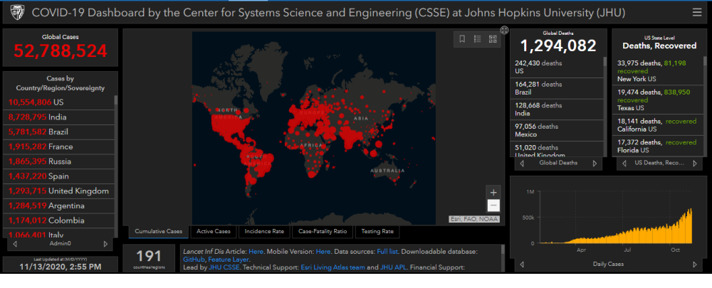
Figure 1: COVID- 19 Information Dashboard by CSSE, JHU ^{[1]}
2019 Novel Coronavirus Disease: COVID-19 is a contagious respiratory and vascular disease caused by severe acute respiratory syndrome coronavirus 2 (SARS-CoV-2). It is believed to be first identified in Wuhan, China in December 2019 and has later spread to other parts of world including America, Europe and South Asia.
World Health Organization (WHO) declared COVID-19 as a global pandemic on 11th March 2020.^{[2]}This led to sudden drastic changes round the world such as travel bans, closure of public-transport services and nation-wide lock downs but still the virus spread from China to other parts of the world. Currently after 7 months, USA, India and Brazil are the global hotspots of COVID-19.^{[3]}
As of today 13th November, there are 52,788,524 global cases out of which 17,312,220 are global active cases. 34.181,795 people have been reported as recovered while 1,294,082 have unfortunately died due to COVID-19 pandemic.
We decided to do this project as it is an ongoing pandemic which on macro level is affecting economies and on micro level is affecting lives of every individual in this world. We plan to use the analytical techniques learnt in the class to inspect, transform and model data with the goal to discover useful information, draw conclusions based on data led evidence and support decision-making.
In this project, we perform Data Analytics on the publicly available COVID-19 datasets using the techniques of Exploratory Data Analysis (EDA), Unsupervised Learning and Supervised Learning in R that we have learnt in MIS/BUAN 6356 class.

DATA DESCRIPTION

Currently, we are working on second-hand data set from John Hopkins University’s Center for Systems Science and Engineering (JHU CSSE). This data contains daily active cases recovered cases and deaths in all the countries whose population is infected from this virus. This is a dynamic dataset and cases are being updated daily by John Hopkins University at the time of writing this report. To fetch the confirmed, deaths and recovered time series data into data frame objects starting from 22nd Jan 2020 we are using a package in R called ‘covid19.analytics. This package has inbuilt functions to fetch the confirmed, deaths and recovered time series data from COVID-19 Data Repository maintained by JHU.
There is no provision to fetch recent country wise data from ‘covid19.analytics’ package, so we are directly fetching it from the web hosted csv file from COVID-19 Data Repository maintained by JHU into the data frame ‘recent.df ‘.

Following is the web link to the COVID-19 Data Repository by the Center for Systems Science and Engineering (CSSE) at Johns Hopkins University:
https://github.com/CSSEGISandData/COVID-19

R PACKAGES
Below is a list and brief description of the R packages that we have used for this project:
- dplyr: This package is used to enable data manipulation for data frame like objects. We have used the pipe operator %>% and functions such as select(), summarize(), mutate() in our code from dplyr.
- ggplot2: This package is used to create elegant data visualizations and is based on ‘Grammar of Graphics’ where each function returns a layer and all the layers are combined together for an elegant plot.
- tidyverse: It is basically a collection of packages (ggplot2, dplyr, tidyr etc) that one is likely to use in everyday data analysis. Installing this one parent package can save the hassle of installing individual packages.
- plotly: Plotly is another graphing package which helped us in creating ‘interactive graphs. It uses already created objects from ’ggplot2’ and makes them interactive.
- reshape2: This package is used to transform data between wide and long format. In our code, we have used the melt() function from this package to convert an object to molten dataframe.
- covid19.analytics: We are using this package to load live COVID-19 time-series data from Johns Hopkins University Center for Systems Science and Engineering (JHU CSSE) data repository.
- caret: Caret package (Classification And Regression Training) contains functions to streamline the model training process for regression and classification. We have used the predict() function from caret package.
- tmap: We have used the package tmap (Thematic maps) to plot COVID-19 data on world map. In our code, tmap is used to get the geometry of each country in multi polygon object.
- shinySIR: We have used this package to run SIR models based of different parameters such as susceptible population, infected population and recovered population.
- deSolve: SIR model is based on differential equations, we have used deSolve to solve ordinary differential equation ode function.

Exploratory Data Analysis (EDA)

Summary Statistics

Before we jump into the data mining techniques, we have created summary statistics to get a better idea of the data and how we can use the data for our further analysis. We have used the “dim”, “head”, “tail”, “length” and “summary” functions to get a bird’s eye view of the huge data set. As we have different datasets (csv files) related to confirmed, recovered and total deaths, we have different summary statistics for each case status.

The “dim” function gives us the dimensions of each parameter. Here we have calculated the dimensions for the confirmed number of cases, the number of deaths, and the number of cases recovered.

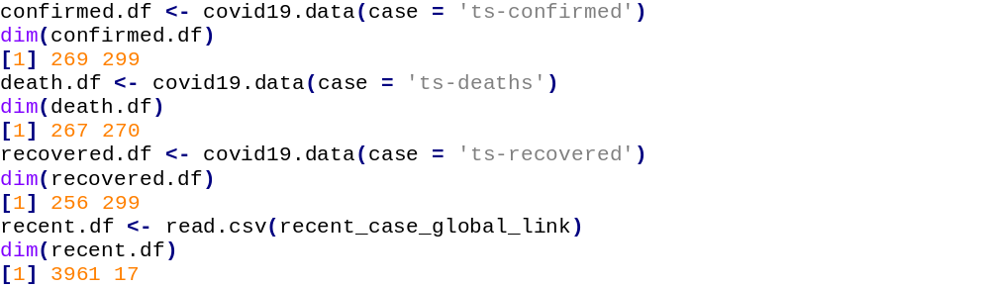
The “length” function gives the total length of the object. We have calculated the lengths for Confirmed, Death and Recovered cases.
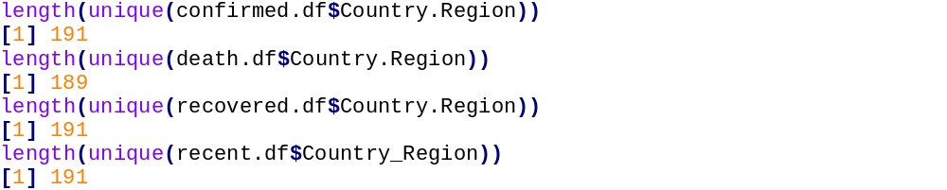

Confirmed Cases

Confirmed Cases are defined as the cases reported daily by different authorities for different countries. In the early phase many countries reported zero cases and later on few countries showed exponential growth in the confirmed cases.

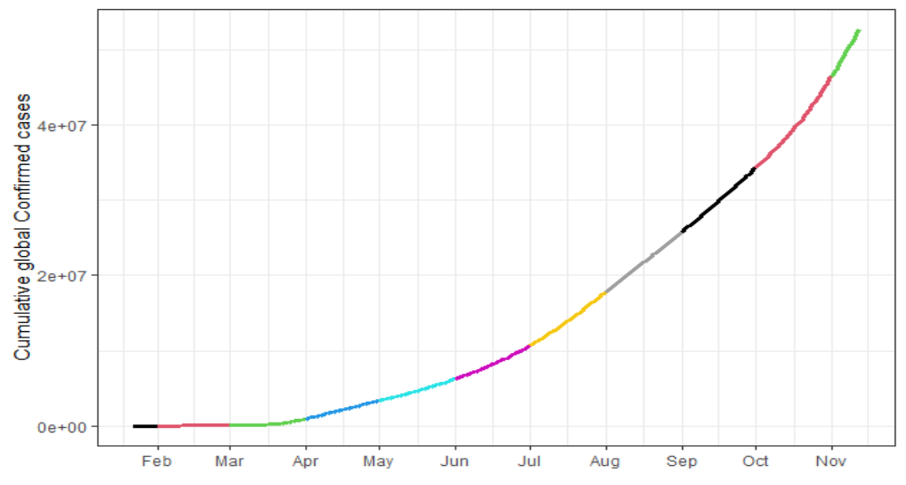
Figure 2: Cumulative confirmed cases (World)

As we can see from the graph above, the confirmed cases have been increasing exponentially starting from April. Coloring bands on the graph represent the months.
This visualization helps us to understand how confirmed cases have increased over a period.

Total Deaths

The total deaths variable is defined as an interval data containing total deaths reported by the authorities over the period.

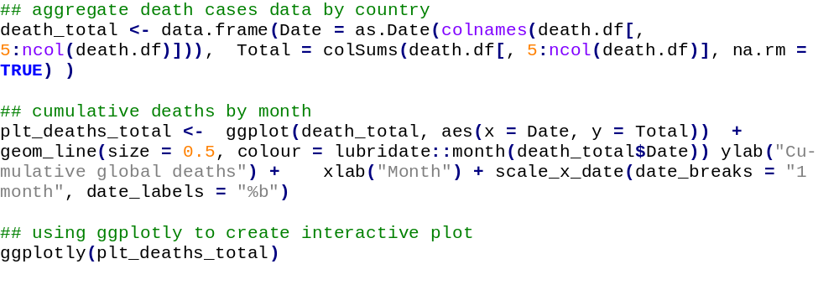

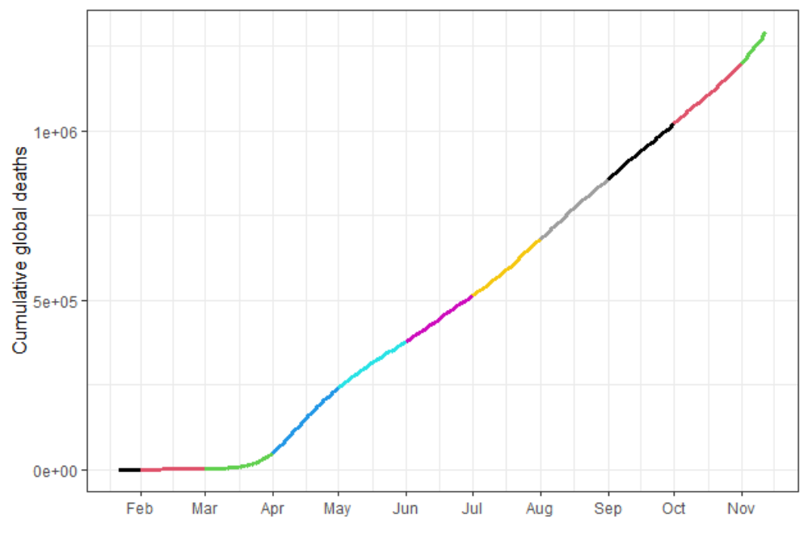
Figure 3: Cumulative death cases (World)
We can see from the above graph, how deaths have increased over a period reaching 1 million mark on 27th September. There is an exponential increase in the total number of deaths which is very alarming for the world.

Recovered Cases

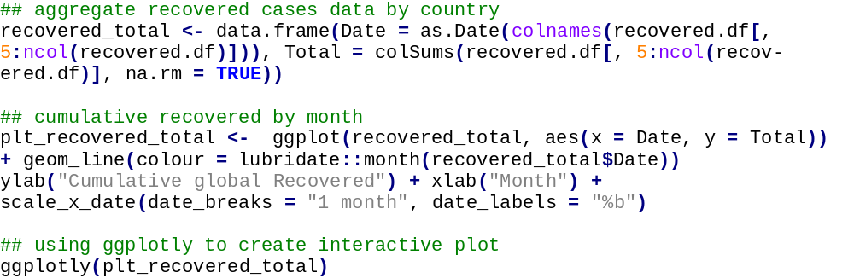

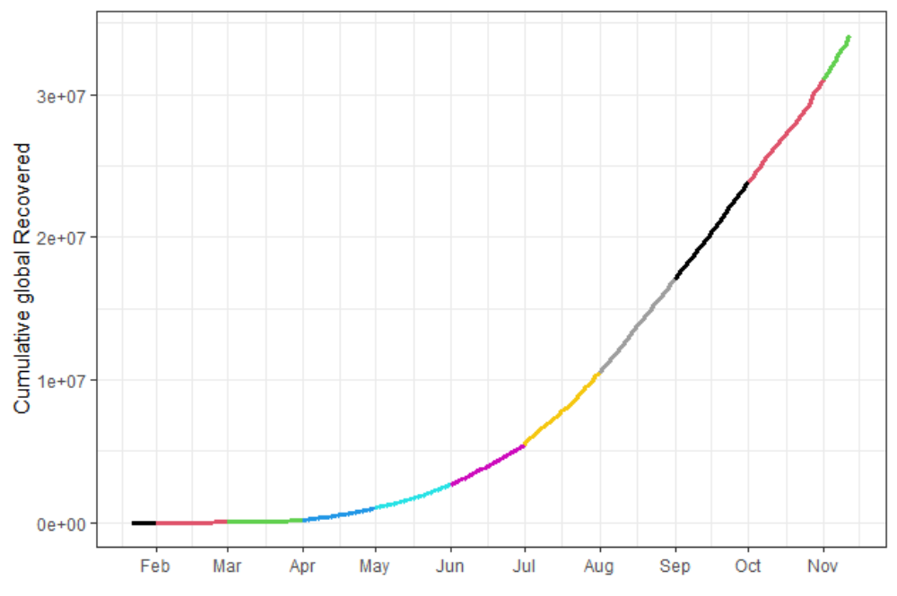
Figure 4: Cumulative recovered cases (World)
As we can see in the above graph, recovered cases have increased exponentially over a period which is a positive sign. Recovered cases have reached 25 million on 7th October. We can see from above graph that recovered cases increased in each month which can be attributed to the increased total number of cases around the world.

Combined Graph Representing all three variables:
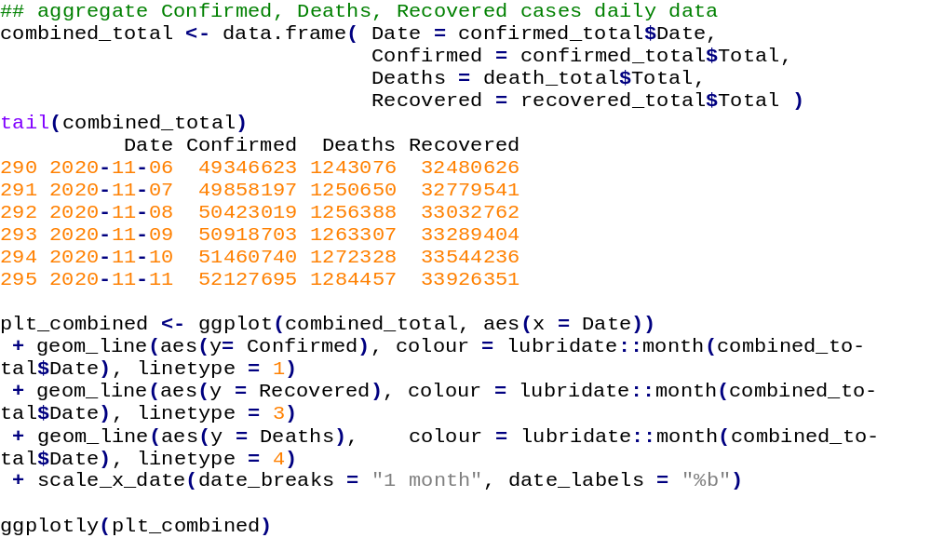

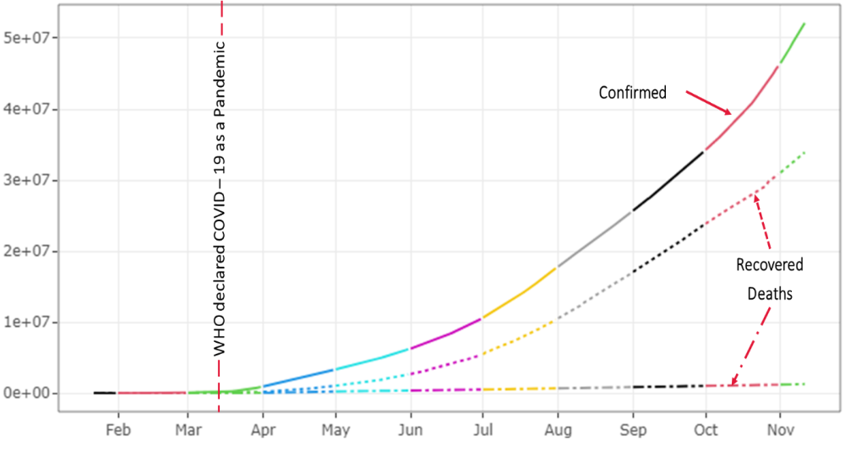
Figure 5: Combined COVID-19 cases (World)
Three lines representing the confirmed, recovered and deaths are plotted on the graph. We can see that the recovered cases have increased with around same rate as confirmed cases which is good sign. Number of deaths as compared to the total confirmed cases is very low which is a good sign but at the same time when we look at the death’s figures individually, it is very alarming.

Daily Rise
Here, we have plotted the daily increase in the number of confirmed cases, the death cases, and the recovered cases.

Confirmed:

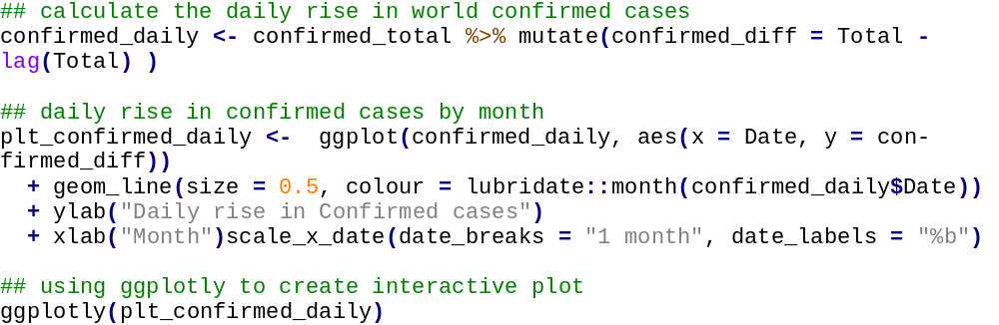
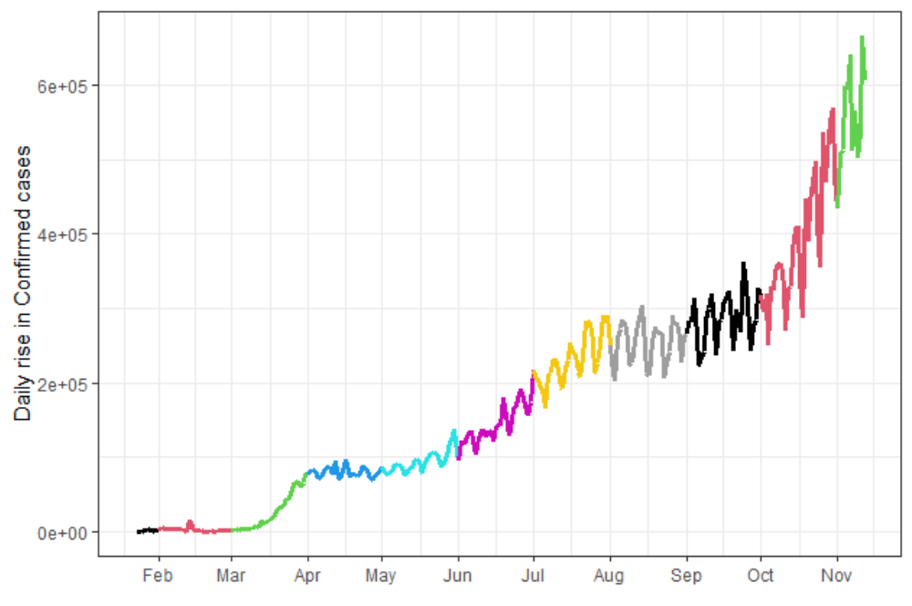
Figure 6: Daily rise in confirmed cases (World)
As we can see from the graph, the rate of increase in the daily confirmed cases from May to July was comparatively lower as compared to the rate at which the number of daily confirmed cases has been increasing from October onwards. This could be due to lockdown implemented in various countries from May to July.

Deaths:

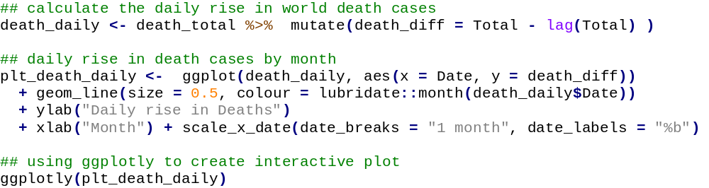
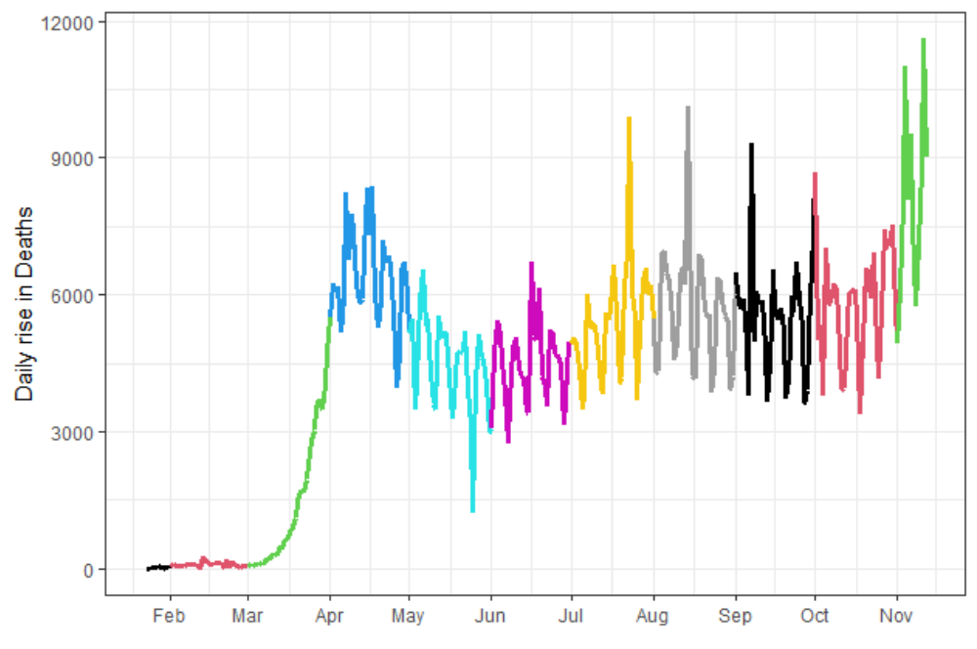
Figure 7: Daily rise in Death (World)
As, we can see from the graph, the rate of daily rise in Deaths started to increase exponentially from March but was constant from April to October and it has started to increase again from October.

Recovered:
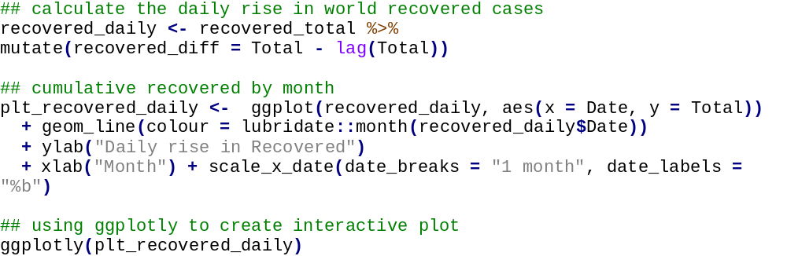
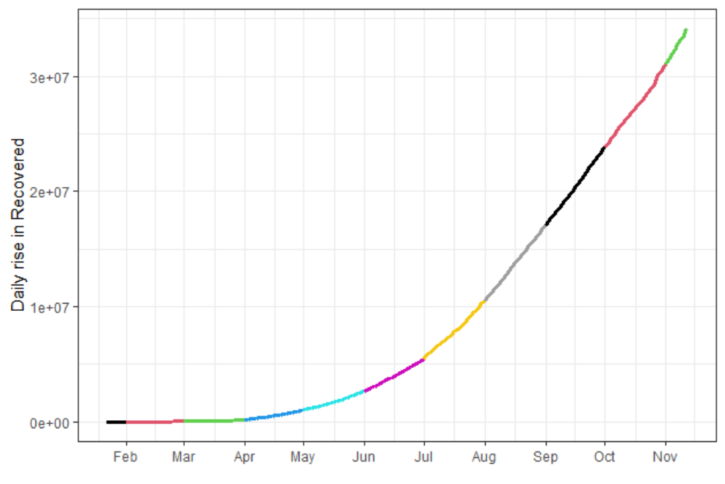
Figure 8: Daily rise in recovered cases (World)
As we can see in the above graph, daily rise in the number of recovered cases have increased exponentially over a period which is a good sign and this would be due to proper sanitizations, use of masks, and social distancing.

Data Mining Techniques

Cluster Analysis

Objective:

The objective of clustering is to segment the data into a set of homogeneous clusters of records for the purpose of generating insight. Separating a dataset into clusters of homogeneous records will provide further support required for supervised tasks

Method:

- We have used k-means clustering and have segmented the countries into 3 clusters based on the number of Confirmed cases, Deaths, Recovered Cases and Active Cases in each country.
- K=3 was set based on trial and error.
- Thus Cluster 1 consists of 3 countries – US, India and Brazil, which have contributed to the maximum number of overall cases. Cluster 2 consists of 10 countries and Cluster 3 consists of the remaining countries.
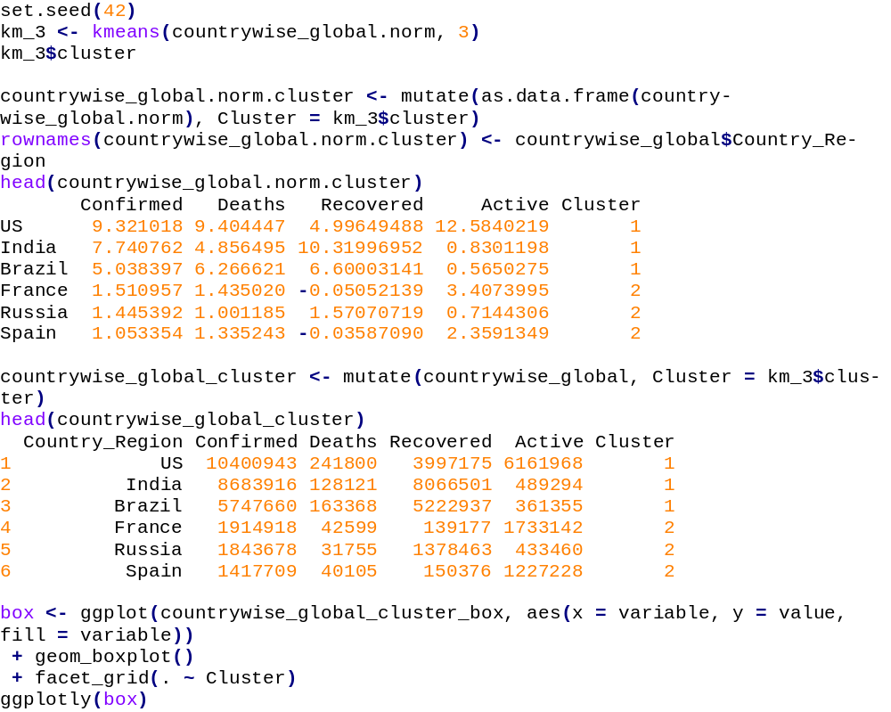

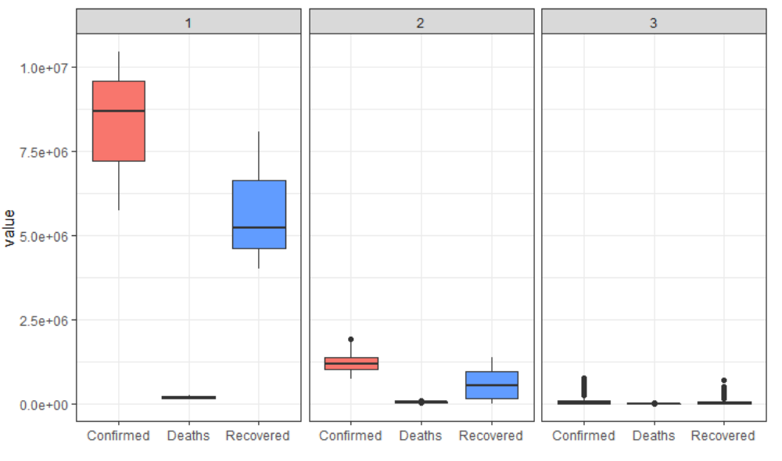
Figure 9: Cluster Characteristic - Box Plot

Summary Statistics:
The above box plot gives us the following statistics:

Table 1: Cluster Characteristic - Summary
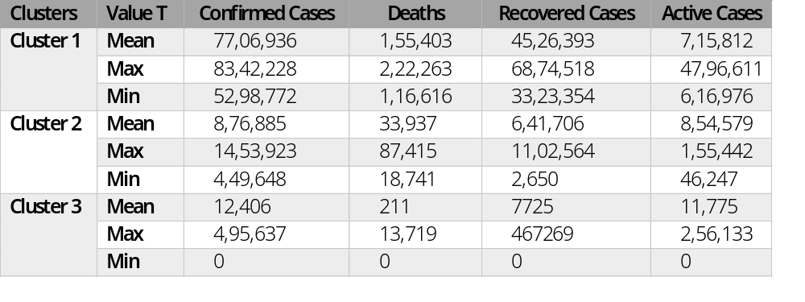

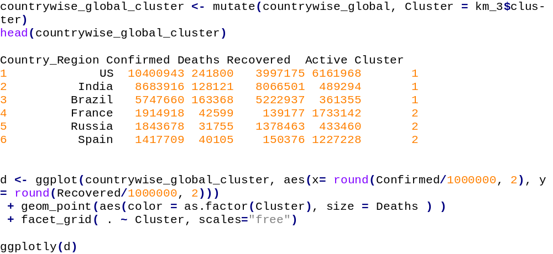
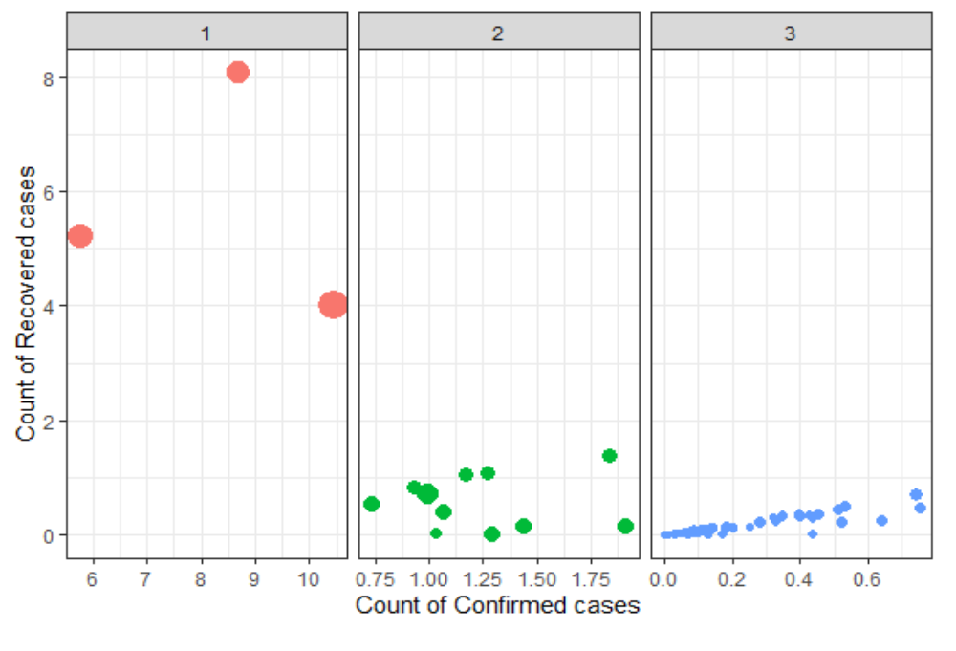
Figure 10: Clustering Analysis (K-means)

Recommendations based on Cluster Analysis:

Travel Advisory
Based on the clustering analysis we have performed; we have created a travel advisory system and recommended the following travel advisory:

Level 1: High Risk
- People should strictly avoid travelling to countries that fall into cluster 1 i.e., India, USA, and Brazil
- Covid test should be made mandatory for the people before travelling and a quarantine period of 14 days after the travel.

Level 2: Medium Risk
- We would recommend people should postpone the nonessential travel to the countries that fall in this cluster.
- If travelling, people should follow a quarantine period of 14 days
- Countries that fall in this category: France, Russia, UK

Level 3: Low Risk
- In this category, travel can resume normally but with precautionary measures such as thermal screening and use of face shields.
- Countries that fall into this category: Japan, UAE

Lockdown Recommendation
As we have analyzed later in the SIR model, lock down is an effective way to suppress the total infected curve and can introduce a delay in the total cases growth that can help countries to prepare better.

Cluster 1: Lockdown Recommended
- The lockdown should be extended until a decrease in the rate of confirmed cases is observed

Cluster 2: Partial Lockdown Recommended
- A partial lockdown is recommended, but people should follow proper measures such as social distancing, use of face masks, and avoiding social gatherings.
- Countries that fall in this category: France, Russia, UK

Cluster 3: No Lockdown
- The lockdown can be lifted in these countries but still the people should follow the precautionary measures.
- Countries that fall into this category: Japan, UAE

Healthcare Initiatives recommended based on Clustering

Testing Capability: The testing capabilities should be increased for countries in Cluster 1 as the chances of people getting affected is higher as compared to countries in other clusters.
Isolation Wards: The number of COVID-Care centers should be increased. Along with public and private hospitals, these centers should be setup in hotels, stadiums, etc.
Comprehensive Vaccination Roadmap: The countries that are affected the most should be prioritized for the vaccinations.
Integrated Patient Database: A database to monitor and report the COVID-19 patients should be maintained which can help clinicians and health-care managers connect with high-risk members.

Key Takeaways from Cluster Analysis

Three clusters are created using k-means clustering. These clusters help us to understand how number of cases are distributed among different clusters created and how we can utilize these clusters to create a warning system for passengers entering different countries based on the clusters. US, India and Brazil contributed to the maximum number of overall cases. Cluster 2 consists of 11 countries and Cluster 3 consists of the remaining countries. Above visual representations provide us the summary of different clusters in a succinct manner.

Pareto Principle:
- Out of the total 189 countries, only 10 countries contribute to the 80% of the total number of cases worldwide.
- We will be focusing on these 10 countries for the further analysis.

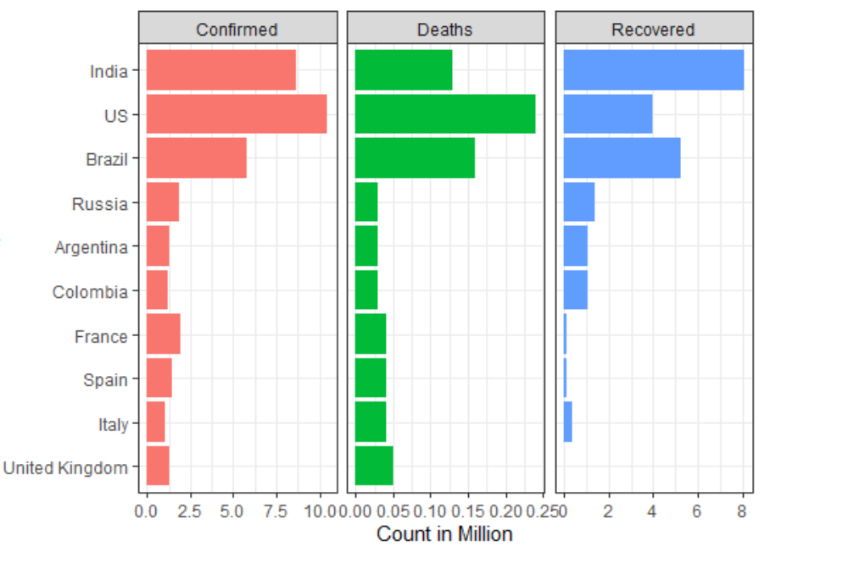
Figure 11: Top 10 contributor

Regression Analysis:
Definition:
Regression analysis is a statistical method used for the estimating the relationship between a dependent variable and an independent variable. It is useful in accessing the strength of the relationship between variables.

Training Data - The observations in the training set form the experience that the algorithm uses to learn.
Test Data - The test set is a set of observations used to evaluate the performance of the model using some performance metric.

Method:
- We have performed the predictions on the countries from Cluster 1 – US, India and Brazil.
- 70 % of the data has been used as the training data and 30% of the data as test data.
- We have defined Confirmed cases variable as the independent variable and the Date variable as the dependent variable.

Observations:

(a) India

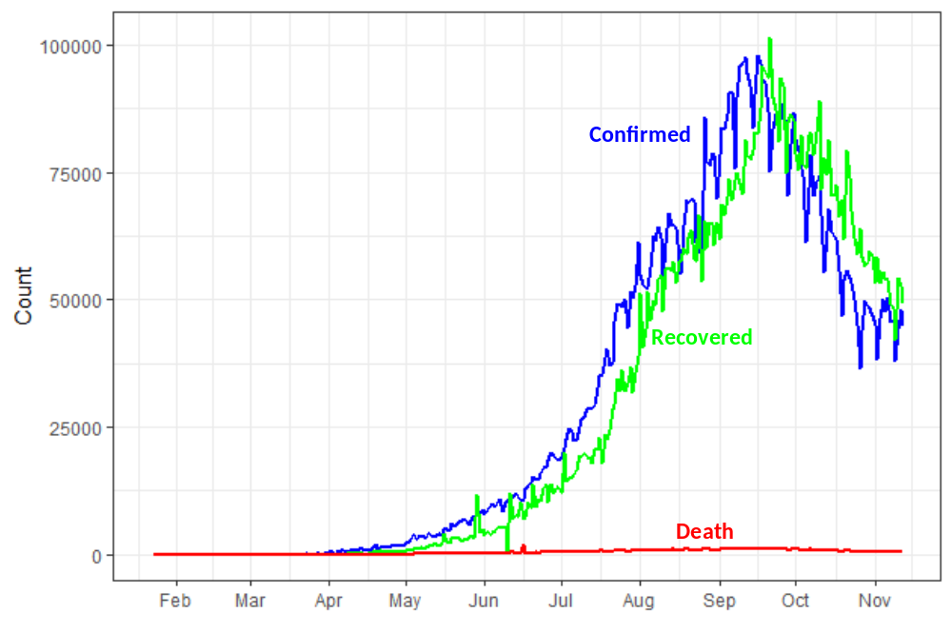
Figure 12: Daily rise in Confirmed, Death, Recovered (India)

From the model,
Accuracy for train dataset= 0.8618589 = 86.18%
Accuracy for test dataset = 0.8428053 = 84.28%

As seen from the above plot for India, the number of confirmed cases increased exponentially from the month of April and reached its peak on 16th September. However, a decrease in the number of confirmed cases is seen from 21st September. This is due to the measures taken by the Government such as implementing lockdowns, to control the situation. Also, because the number of confirmed cases started to decrease, the number of recovered cases also dropped from 24th September.

(b) USA

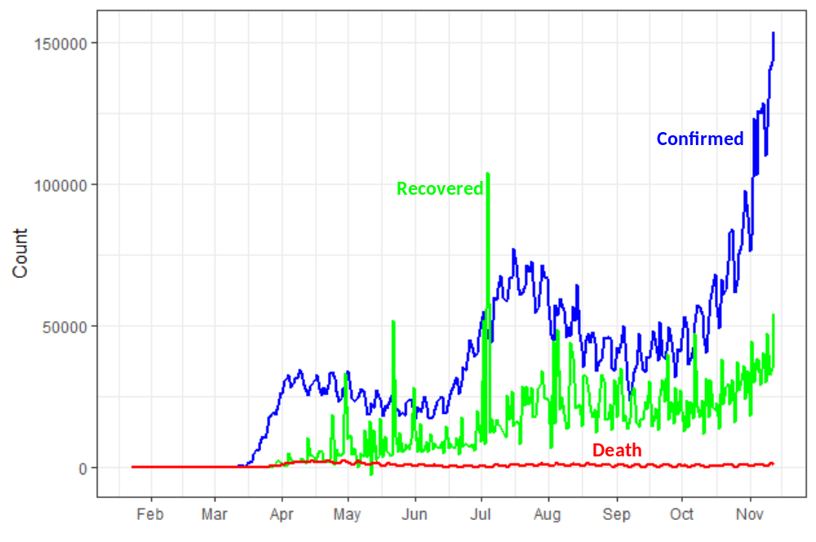
Figure 13: Daily rise in Confirmed, Death, Recovered (US)
Accuracy for train dataset= 0.8246173 = 82.46%
Accuracy for test dataset= 0.8551353 = 85.51%

For US, the number of confirmed cases has increased exponentially from March and as seen from the plot above, we can say that US is yet to reach its peak in terms of number of confirmed cases. The number of recovered cases were maximum during July and the rate has been increasing from August.

(c) Brazil

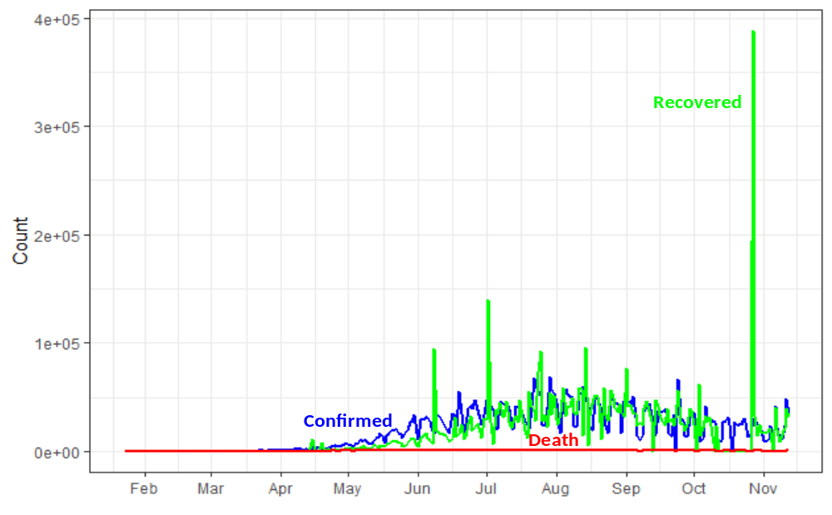
Figure 14: Daily rise in Confirmed, Death, Recovered (Brazil)
Accuracy for train dataset= 0. 0.6378023 = 63.78%
Accuracy for test dataset= 0. 0.6483017 = 64.83%

For Brazil, we observe that the number of confirmed cases has gradually increased, and it recorded the highest number of confirmed cases in July and September. The recovery rate has been comparatively higher than the number of confirmed cases. The number of death cases has been low as compared to confirmed and recovered cases.

STATISTICAL MODEL IN EPIDEMIOLOGY

Statistical modeling techniques are becoming most important analytical tools to predict the nature of infectious disease and to provide a practical framework for causal problems. Most models used the compartmental models i.e., dividing the population into a small number of compartments each representing the identical status with respect to the disease. We have basically focused on the classical SIR model, where population is divided into three compartments.

Susceptible: Individuals who have no immunity to the infectious disease and can become infected in future

Infectious: Individuals who are currently infected and can transmit the disease to the susceptible population.

Recovered/Removed: Individuals who either become immune after getting infected or individuals who died due to infectious disease.

As we are dealing with Covid-19, it is highly complicated to implement the statistical models as the pandemic is currently going on. There are various modified SIR models available to predict the scenarios but due to lack of data, and highly complex and unknown nature of the Covid-19, we only tried to implement the classical SIR model based on following equations.

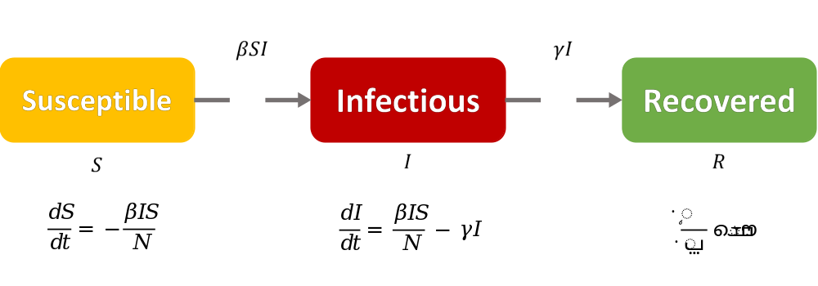
Figure 15: S-I-R Model

Beta is defined as expected amount of people an infected person infects per day and$γ$ is defined as the proportion of infected recovering per day.

$γ$ = $\frac{1}{D}$

D is the average days to recover from infection.

We can estimate the nature of the disease in terms of the power of infection that is called basic reproduction number.

$R_{0}$ is the average number of people infected from already infected person

$R_{0}$ = Reproduction number = $\frac{βN}{γ}$

Using the above SIR equations, we have tried to implement the SIR model for the cluster 1 countries i.e., USA, India and Brazil. We have utilised the “ShinySIR” package in R to implement the above differential equation and predict the infected and removed value against the confirmed cases value.

SIR Model created using differential equations mentioned above:
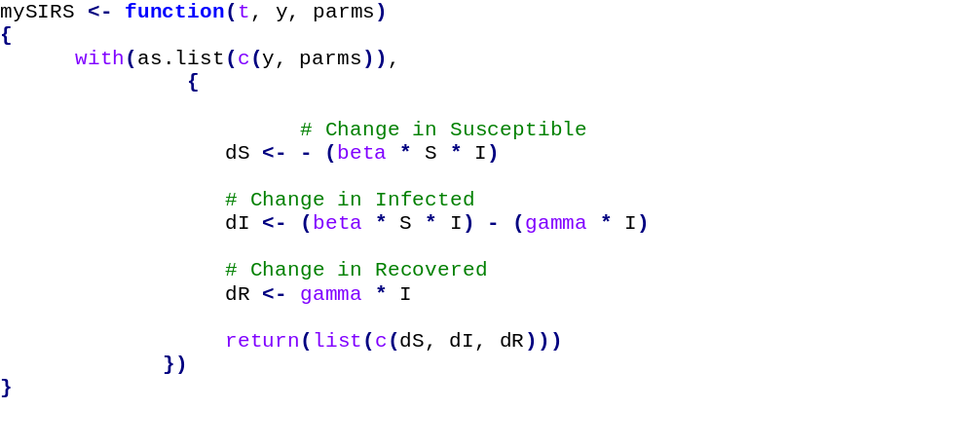

SIR Modelling for India
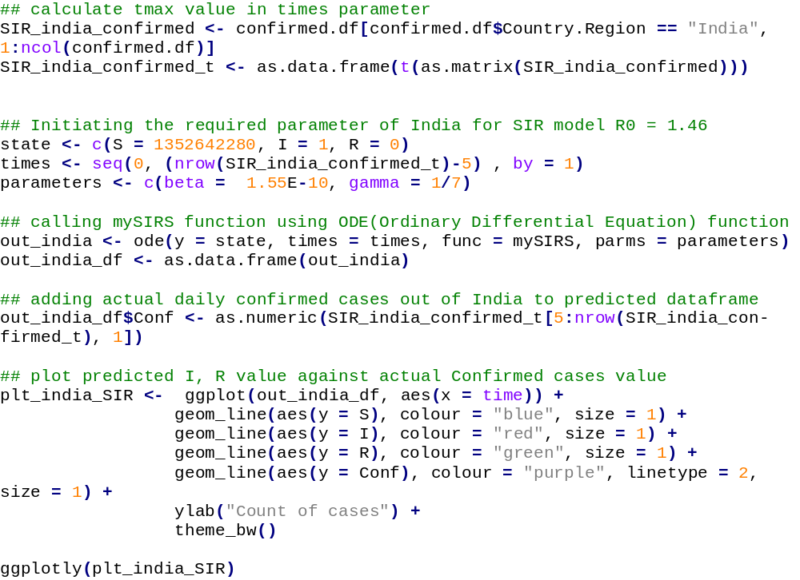

S₀ value for India is the total population of India i.e., 1352642280 as every individual is susceptible to get infected.
Gamma value for the Covid-19 is considered as 7 by the scientific community and R₀ value for India is 1.46. As we have gamma and R0 value, we can calculate β value and it is 1.55E-10 after calculation.
After determining the values of constants, we ran the SIR model and plotted the infected and removed value against the confirmed cases that we explored in the above section.

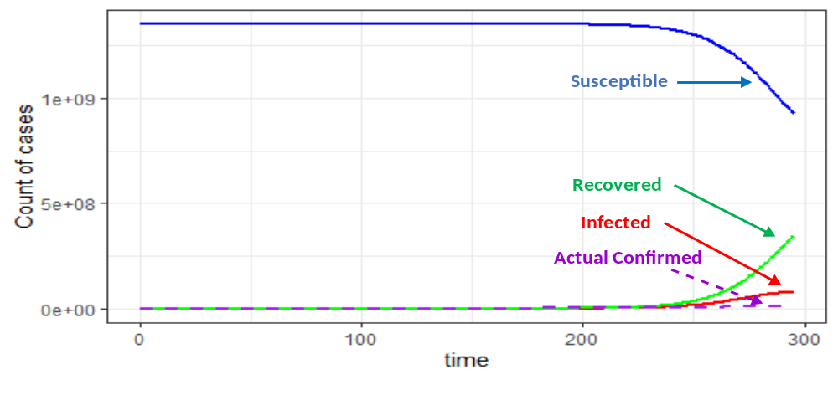
Figure 16: SIR Model (India)
In the above we graph, we can see that infected individuals predicted by this model were below the confirmed cases until 230 days but after 230th day infected individuals will increase exponentially according to this model which is not the case when we compare it with confirmed cases. This discrepancy in the number of infected cases can be due to additional external factors such as social distancing practice and increased masks usage.
In this model, we can clearly see how susceptible population decreases with time as recovered population increases in parallel.
These findings are very much in line with our expectation with respect to infected prediction but the discrepancy in the below curve can be attributed to the additional external factors as our model is not considering those factors.

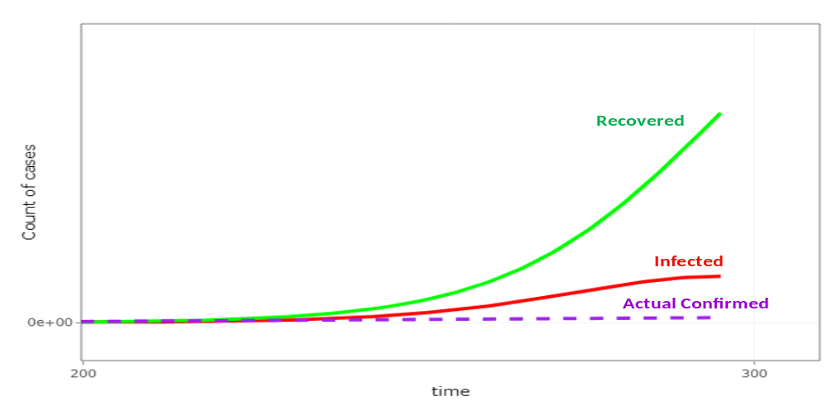
Figure 17: SIR Model (India) – Detailed

SIR Modelling for USA

S₀ value for USA is the total population of USA i.e., 331722709 as every individual is susceptible to get infected.
Gamma value for the Covid-19 is considered as 7 by the scientific community and R₀ value for USA is 1.62. As we have gamma and R₀ value, we can calculate β value and it is 6E-10 after calculation.
After determining the values of constants for USA, we ran the SIR model and plotted the infected and removed value against the confirmed cases that we explored in the above section.

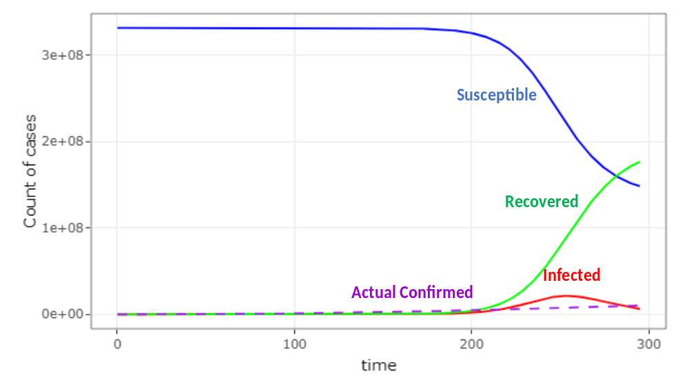
Figure 18: SIR Model (United States)
As we can see in the above graph, curves are quite different when we compare them with the above graph, but they follow the same pattern. Curves are different due to the different R₀ value and different initial susceptible population. Predicted Infected cases are very much in line with the confirmed cases until 215 days and after 215th day there is a discrepancy in the predicted infected and actual confirmed cases. Again, this can be explained by external factors that are not taken into account by the classical model such as Social distancing practices, increased masks usage or more sanitization.

SIR Modelling for Brazil
S₀ value for Brazil is the total population of Brazil i.e., 212559417 as every individual is susceptible to get infected.
Gamma value for the Covid-19 is considered as 7 by the scientific community and R₀ value for Brazil is 1.46. As we have gamma and R₀ value, we can calculate β value and it is 9.8E-10 after calculation.
After determining the values of constants for Brazil, we ran the SIR model and plotted the infected and removed value against the confirmed cases that we explored in the above section.
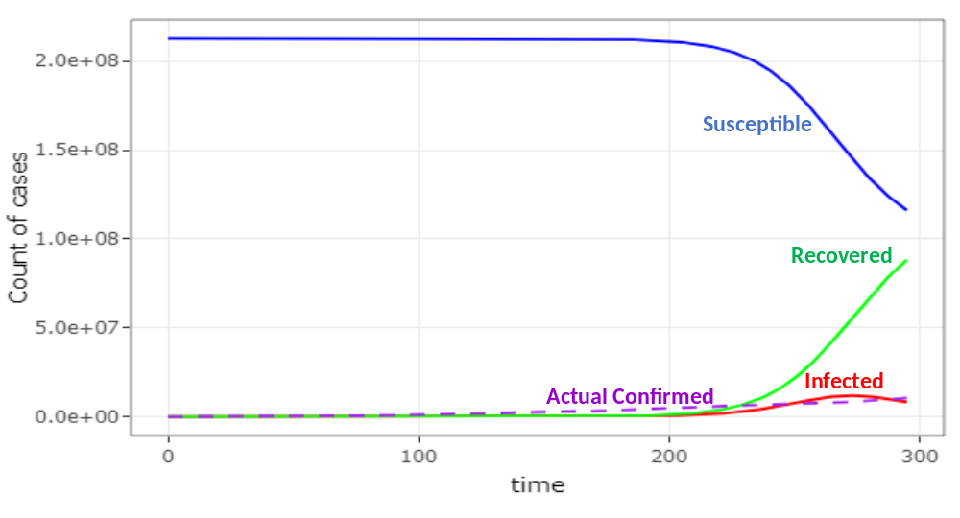
Figure 19: SIR Model (Brazil)
This graph is very much like the graph that we plotted for India. In fact, all the three graphs are in line with our expectation. Each graph shows how susceptible cases decreases in parallel to the increase in recovered cases. There is a discrepancy in the predicted infected as it shows the peak at around 280 days but that is not the case. We can also say that external factors as mentioned above might have contributed this slowdown of case increase.
Overall, we can say that the classical SIR model is good for understanding the nature of epidemic and how epidemic is going to spread depending upon the constants, but this classical model is too simplistic in nature as it doesn’t take other factors into account. There are various modified versions of classical SIR model that consider other factors such as number of exposed individuals who are not counted in infected category, natural birthrate and death rate of a country, and how vaccination launch can affect the predicted cases.
The pandemic we are dealing with in our project is unique and it is currently going on so anything we predict we can’t be sure how these mathematical models are going to accurately represent the real picture. We are also short of reliable data to use other modified versions of SIR models. So, currently we have explored only classical SIR model that is considered the gold standards in the epidemiology statistical modeling.

Effect of Lockdown on the COVID-19 Spread

We have utilized the SIR model to better understand the effect of lockdown on disease spread. As we have determined all the constants in the above section to implement the SIR model. The constant in which we are most interested in determining the effect of lockdown on the disease spread is R₀ which is defined is defined as the expected number of secondary cases produced by a single (typical) infection in a completely susceptible population. We can clearly see in our graph that by changing the value of R₀, how we can suppress the curve and delay the growth of number of infective cases.

Lockdown in India
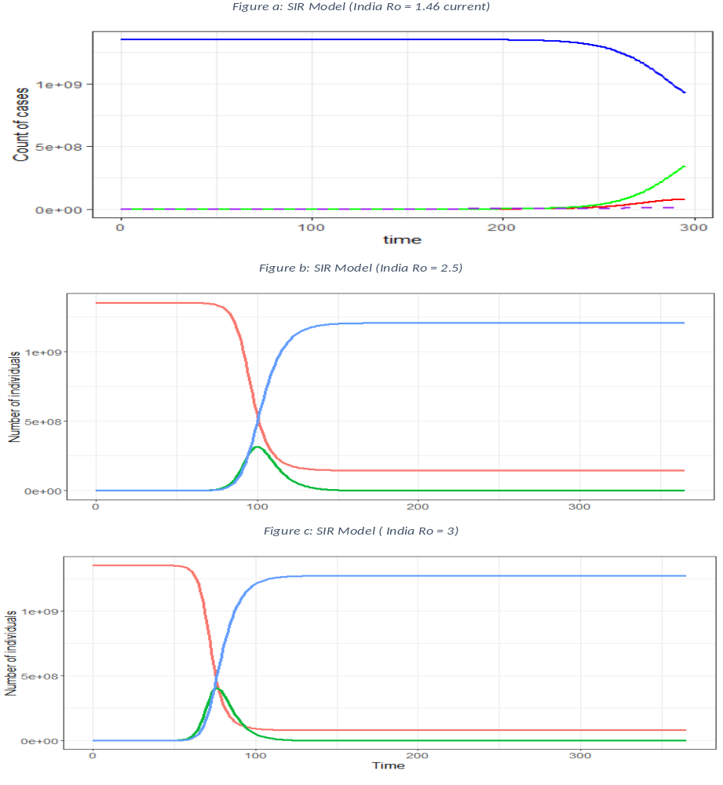
Figure 20: Impact of lockdown on Ro (India)

Lockdown in USA
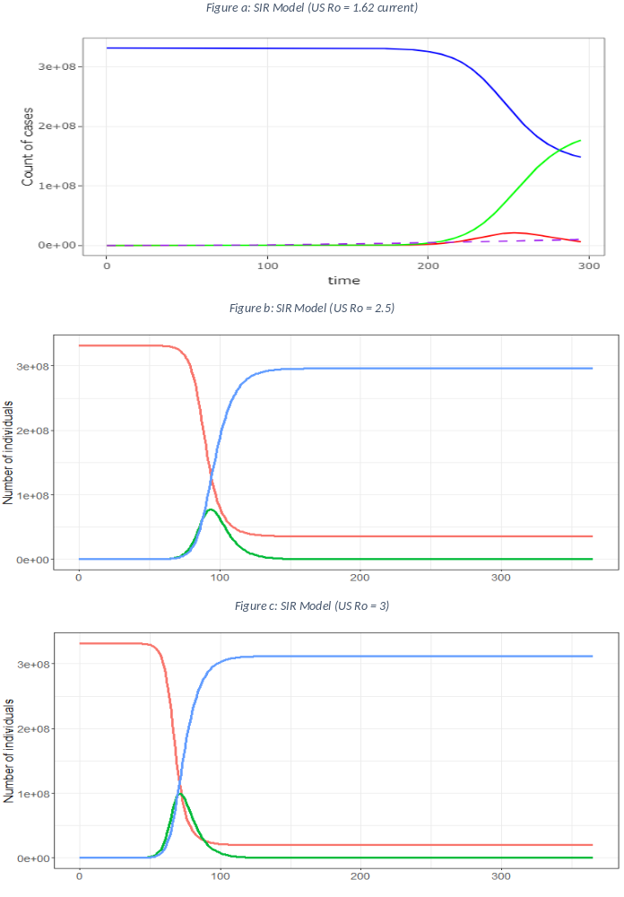
Figure 21: Impact of lockdown on Ro (United States)

Lockdown in Brazil

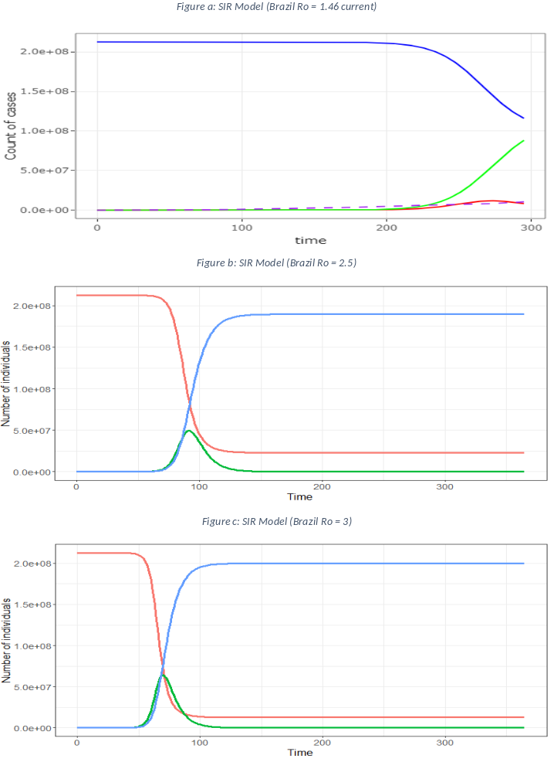Figure 22: Impact of lockdown on Ro (Brazil)

Inferences from the above graphs

R₀ value is a variable that is directly proportional to the social distancing practice. As Lockdown has direct effect on the social distancing which in turn directly impact the R₀ value. We have compared the three curves which were plotted using SIR model with three different R₀ value and we can clearly see that how increase in the R₀ value directly affect the curve to reach the peak in much less time with greater number of cases. We can see the uniformity in the change of curves for all the three countries that we have analyzed in SIR model.

Key Takeaways from SIR Model

- Lockdown is an effective measure to extend the total infected curve and can introduce a delay in the total cases growth that can help countries to better prepare.
- This model is effective in predicting the infected cases, but it cannot be solely relied on to predict as it doesn't take other factors into account such as social distancing, vaccination, masks usage and dynamic death rate and birth rate of country. Modified version are available but due to lack of reliable data and uncertain nature of covid-19, we have only implemented classical SIR model.

CONCLUSIONS

- We have used the k-means Clustering to create the clusters of countries that we used to develop passenger warning system and lockdown recommendation.
- After exploring the different statistical models, we have used classical SIR model to predict the Infected, recovered and susceptible population which aligns with the confirmed cases with few discrepancies.
- We have determined how lockdown impacts the disease spread using SIR model. Lockdown has been very effective according to our model as it decreases the Ro value which delays the growth of curve and peak height also decreases in comparison.

References:

- https://coronavirus.jhu.edu/map.html
- https://www.who.int/director-general/speeches/detail/who-director-general-s-opening-remarks-at-the-media-briefing-on-covid-19---11-march-2020
- https://en.wikipedia.org/wiki/Coronavirus_disease_2019
- https://en.wikipedia.org/wiki/Compartmental_models_in_epidemiology

- https://www.lewuathe.com/covid-19-dynamics-with-sir-model.html
- Lecture Notes in Mathematics 1945) David J. D. Earn (auth.), Fred Brauer, Pauline van den Driessche, Jianhong Wu (eds.) - Mathematical Epidemiology-Springer-Verlag Berlin Heidelberg (2008)
- https://en.wikipedia.org/wiki/Compartmental_models_in_epidemiology
- https://web.stanford.edu/~jhj1/teachingdocs/Jones-on-R0.pdf

https://en.wikipedia.org/wiki/Compartmental_models_in_epidemiology

