Abstract

Alpha-Beta pruning is one of the most powerful and fundamental Minimax search improvements.It was designed for sequential two-player zero-sum perfect information games.In this paper we introduce an Alpha-Beta-like sound pruning method for the more general class of “stacked matrix games” that allow for simultaneous moves by both players.This is accomplished by achieving higher efficiency and speedup against serial execution and Minimax implementation.Empirical data shows considerable savings in terms of expanded nodes compared to serial execution with pruning of trees .

Introduction

The task of searching trees of possible alternatives is usual a variety of programs. The efficiency with which these trees can be searched is of critical importance to these programs, since the trees are typically very large. This paper is concerned with measuring the speedup achieved by using the optimization technique of pruning in the games of chess, tic-tac-toe and checkers. (citation http://repository.cmu.edu/cgi/viewcontent.cgi?article=2700&context=compsci)

Alpha beta pruning(Knuth and Moore 1975; Russell and Norvig 2010) is a search algorithm that is aimed to reduce the number of nodes that are calculated by the minmax algorithm in it's search tree. The advantage of this algorithm lies in the fact that the branches of the search tree, which do not affect the final result of the move, can be eliminated in the evaluation process. By this method, the search could be limited to the subtree which is actually useful and a more depth-focused search could be performed. It applies to sequential zero-sum two-player games with perfect information such as Chess and Checkers. Alpha-Beta maintains upper and lower value bounds to decide whether branches can be cut. This type of pruning can lead to considerable search reductions — essentially doubling the search depth over the original MiniMax algorithm when given the same search time. (yaha par iss paper ka citation daalo https://skatgame.net/mburo/ps/aaai12-sbs.pdf ).

In this paper, for the initial analysis, the serial code of the respective games are executed and the time taken is noted down for each input size. Thereafter, the code is parallelized with OpenMP and the same input sizes are utilized. A graph is plotted with the serial and parallelized time and then the trends are observed for each game and for each logic of parallelization. The speedup is calculated for each of the games from the time of execution, which was observed before.

The layout of the paper is as follows: First, we give the necessary technical background before we go into the implementation details of each game. We then describe in detail the results obtained from every parallel code and the speedup achieved.. We conclude the paper with ideas for future work in this area.

Literature Survey

1. Background

1.1 MinMax and AlphaBeta

The MiniMax estimation of a diversion tree is computed taking into account the presumption that the two players, called Max and Min, will pick their best course of action such that when the ball is in Max's court he will choose the activity that expands his addition while Min will choose the one that minimizes it on his turn. MiniMax qualities are engendered from the leaves of the diversion tree to its root utilizing this principle. Alpha-beta uses the MiniMax esteem to prune a subtree when it has verification that a move won't influence the choice at the root hub. This happens when a halfway pursuit of the subtree uncovers that the rival has the chance to bring down an officially settled MiniMax esteem went down from an alternate subtree.

1.2 OpenMP

OpenMP is a usage of multithreading, a strategy for parallelizing whereby an expert string (a progression of directions executed sequentially) forks a predetermined number of slave strings and the framework separates an errand among them. The strings then run simultaneously, with the runtime environment assigning strings to distinctive processors.

The segment of code that is intended to keep running in parallel is stamped likewise, with a preprocessor order that will bring about the strings to shape before the segment is executed.Each string has an id appended to it which can be acquired utilizing a method (called omp_get_thread_num()). The string id is a whole number, and the master string has an id of 0. After the execution of the parallelized code, the strings join over into the master string, which proceeds with forward to the end of the system.

As a matter of course, every string executes the parallelized segment of code freely. Work-sharing develops can be utilized to partition an assignment among the strings so that every string executes its apportioned a portion of the code. Both undertaking parallelism and information parallelism can be accomplished utilizing OpenMP as a part of along these lines.

The runtime environment assigns strings to processors contingent upon use, machine burden and different variables. The runtime environment can dole out the quantity of strings in view of environment variables, or the code can do as such utilizing capacities. The OpenMP capacities are incorporated into a header document named omp.h in C/C++.

1.3 Speedup

In PC building design, speedup is a metric for development in execution between two frameworks handling the same issue. All the more in fact, is it the change in rate of execution of an undertaking executed on two comparative architectures with diverse assets. The idea of speedup was set up by Amdahl's law, which was especially centered around parallel preparing. In any case, speedup can be utilized all the more for the most part to demonstrate the impact on execution after any asset improvement.

The formula for speedup used in this paper is:
Speedup= Time for serial execution/Time for parallel execution

2. Outcome of Literature Survey

The study of all the three technical aspects involved in our implementation motivated us to set a new benchmark for the execution time of the game codes for chess, tic-tac-toe and checkers. The implementation first involves understanding the fucntionality of each of the games and then coding them in a language supported by the OpenMP API. After the serail code is executin successfully for each of the games, then the techniques of parallelization were thought upon, keeping in mind the details of OpenMP documentation. The parallelization of the algorithm resulted in a considerable speedup in each of the game code execution and thus, the amalgamation of all three concepts in the technical background resulted in a faster implememtation of this optimization.

2.3 Problem Statement

In this paper, we aim at achieving considerable amount of speedups by parallelizing the serial Alpha-Beta pruning algorithms used in games using OpenMP. The games which we have considered here: Chess, Checkers and Tic-Tac-Toe have a large amount of work load and the serial implemetation would take a large amount of time; hence by parallelizing the Alpha-Beta code in these games, we intend to reduce the execution time and get considerable amount of speedups.

2.4 Objectives

The main objectives of this paper are:

1. Maintaining consistency: Understanding the Alpha-Beta algorithm; analyzing how it can be parallelized and making sure that the results produced in serial implementation are the same as that produced in parallel implementation.
2. Testing the amount of speedup achieved by deploying different numbers of threads, and then finalizing the number of threads through which we can get maximum speedup.
3. Recording the results in an appropriate manner so as to clearly distinguish improvements over various datapoints; as for varying number of threads and work load, we sometimes get deteoriated results.
4. To prove Gustafon's Law.

3. Methodology (Give heading alpha beta algorithm)

Alpha beta pruning algorithm

The alpha-beta pruning algorithm emerged as an improvement over the usual mini-max algorithm which is implemented in the Artificial Intelligence games. Both of these algorithms find out the best available move to the player and will return the exact utility regarded with that move, but the key point to be noted here is the execution time. Alpha-beta pruning algorithms are comparitively faster than our oldschool minimax algorithms as they cut down the branches by not exploring them. The reason being, that the values/utilities calculated from these branches would not affect the final result. Since, time is not spent on exploring the other branches, these algorithms affectively cut down the execution time. (write more)

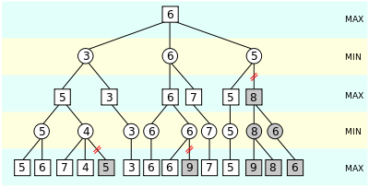

Consider a smaller version of a game tree in figure 1. In this figure, nodes corresponding to the maximizing player are shown as squares whereas, nodes corresponding to the minimizing player are shown by circles. Here, in the second last layer, where it's the turn of the minimizing player, he prunes away the node 5, as he will only explore that subtree if the parent of the subtree has a value lesser than or equal to 4. Similarly in the second layer, the minimizing player prunes away the entire subtree rooted with 8, as there's no point in exploring that subtree as it already has got a low value in 5.

The pseudcode: (change the variables)

function alphabeta(node, depth, α, β, maximizingPlayer)
if depth = 0 or node is a terminal node
return the heuristic value of node
if maximizingPlayer
v := -∞
for each child of node
v := max(v, alphabeta(child, depth - 1, α, β, FALSE))
α := max(α, v)
if β ≤ α
break (* β cut-off *)
return v
else
v := ∞
for each child of node
v := min(v, alphabeta(child, depth - 1, α, β, TRUE))
β := min(β, v)
if β ≤ α
break (* α cut-off *)
return v

Implementation (checkers)

1. Work Done

The implementation of the serial code of checkers is done in C++. In this implementation the board is declared as a structure int which there is a vector which stores the board variables and a boolean variable called turn, which specifies the turn of each side. There are structures of piece, move and move score as well in which the propertries of each piece in the board, each move possible on the boards and the score corresponding to each move is declared. After th board hs been initialized, the turn of the player is defined along with the vector of moves which are legal on that board. The major logic of this game is evaluated by the game tree using the alpha-beta pruning algorithm. The algorithm makes the game tree in such a fashion that the maximizers and the minimizers are called alternatively and the value of each legal move is stored in the leaf nodes of the game tree. The minimizing function selects the minimum value amongst the moves with repect to alpha and beta. Similarly the maximizing function selects the maximum value. After evaluating the game tree and determining the best possible move, rest of the capturing moves are generated by a method. The capturing moves generated in the end should match with the legal moves and each capturing move will reduce the number of pieces of the opposite player.

In the process of parallelization, majorly the evaluation of the game tree has been parallelized. Essentially, each branch of the game tree could be parallely evaluated. Thus, the alpha and beta values are propagated at once to each of the node at the first level and the minimizing and coressponding maximizing moves are evaluated simultaneously in all the branches. The final result of all the branches is collected by the main thread and the best move is computed with respect to the alpha and beta values of each branch. It should be noted that the pruning of branches is independent of the other branches, so the evaluation of braches comes under the category of embrarrasingly parallel algorithms.

2. Results and analysis

The above graph is plotted with the x-axis as board size and the y-axis as the time elapsed for the evaluation of the best move in the game tree. As we can clearly see that in absolute sense, the time taken for parallel execution of the evaluate method is considerably lesser thn the time taken for the parallel execution of the same. Also, as the game board size increases, the gradient of serial time execution rises rapidly as compared to the parallel time execution.

This clearly denotes that the parallelization of the evaluation of the game tree of alpha-beta pruning algorithm is efficient and it consumes a lot lesser overhead time of combination and propagation of results as well. That is why even when the board size is increased by 10 times, the rise in the time of execution of evaluate function is negligible in parallel as compared to the serial implementation.
This trend could also be observed from the table below:
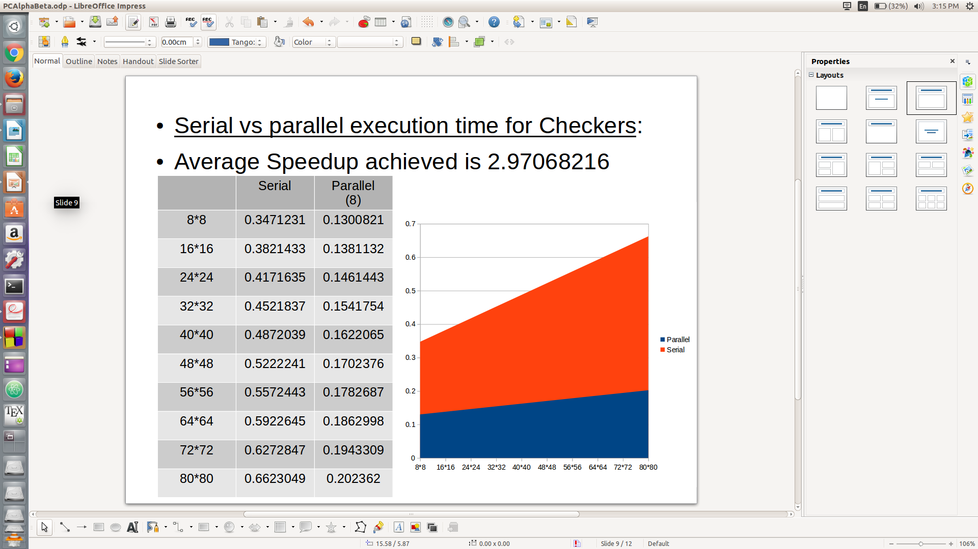

Average Speedup achieved is 2.97068216.

Work done(TIc Tac Toe)
Tic Tac Toe seems to be dumb,but it actually requires us to lookahead the opponent's move to ensure that we will not lose.However we need to consider opponent's move for our next move.So,a heuristic evaluation function is used for current board position and it requires deeper search.
The serial implementation of Tic Tac Toe is done in C.In this implementation the board is a structure with 2D array of positions and number of empty positions on board at any time such that only number of rows * number of columns -number of empty positions gives the number of moves taken by both players. The board is initialised with empty spaces and position(1,1) is taken by 1st player and henceforth all possible moves are calculated for alternate player and and alternate player is allowed to move based on heuristic value.The scores are computed for all winning strategy and sum is obtained.

The principle of minimax is to minimize the maximum possible loss.The algorithm evaluates the leaf nodes using the heuristic evaluation function,obtaining the best possible move for computer.Computer(or the maximizing player) chooses the maximum value from the child nodes while minimizing player chooses minimum value .The algorithm continues evaluating the maximum and minimum values of the child nodes alternately until it reaches the root node,where it chooses the move with the maximum value.This is the move that the player should make in order to minimize the maximum possible loss.

The parallel implementation divide the search tree and spread it out across several processors.The search tree is separated at the top level and have each processor investigate a single move.However,in alpha-beta cutoffs,each branch of tree evaluates independent of other branch of search tree.The possible move function is parallelised by the master.The master search for the idle slave and sends the message for the work to be done.Initially,the master evaluates the leftmost branch of the tree before distributing the work to slaves to get the boundary.After that master distributes the work and send it to slaves and when slaves returns ,the master processes returned information and after all the moves have been evaluated,the best score and move is returned to the maximizing player.

Results and analysis:

The graph shows the time elapsed for each move on y-axis with Nth move on x-axis on a 4*4 Tic Tac Toe board game. As we can clearly see that in absolute sense, the time taken for parallel execution of the evaluate method is considerably lesser thn the time taken for the serial execution of the same. Also, as the nth move increases, the serial time execution decreses more rapidly as compared to the parallel time execution and for the last few moves ,it becomes almost same as most of the time other slaves are idle since not all the branches are needed to compute.Hence,it becomes equal to serial execution.

The clear depiction of parallelization of the evaluation of the game tree is best for the number of the threads=4.This trend could also be observed from the table below.Since,as the number of threads is increased,the time taken to distrubute the work among slaves increases and even after small computation of branch tree by slave,the slave remains idle.Hence,for a 4 * 4 board size,it is well suited to implement parallelism for 4 threads.Among all number of threads varied,still serial takes more time as could be depicted that it almost overlapped with parallel execution with 16 threads.
Average Speedup achieved:1.8655

Work done (Implementation)

The implementation of serial chess has been done in C++ and has been majorily divided into 3 sections namely: chess board, chess pieces and the algorithms. The chess-board part first deals with checking the validity of the moves and then orienting them upon the chess board by directing them. Associating a distinct character, value and utility to each chess piece is handled in the chess-pieces part wherein a set of classes denote proper identity to each of the chess piece. Lastly, the algorithms section deals with the artificial intelligence part of playing the game with the user and consist of Alpha-Beta pruning algorithms. The algorithms incorporated build away the game tree similar to Figure 1 using recursion and makes the system play the game in accordance with the moves of the user.

The Alpha -beta pruning algorithm used in the chess program maintains two variables: alpha and beta wherein alpha stands for the lower bound and beta stand for the upper bound of the utililty achieved by the user whose turn is there. The algorithm recursively works and build the game tree in a bottom-up fashion wherein at each minimizing player's turn; the minimization occurs on the maximum results achived from the lower layers or vice-versa. The alpha and beta variables are used to determine the branches which can be prune away as maybe the node heading the pruned branch is lower than alpha or greater than beta. Hence, it can be seen that one player's upper bound can be another player's lower bound and vice versa.

The parallelizaion of the alpha-beta algorithm concerned with chess can be applied during the iteration through all the possible moves available to the curent player and the choosing the best alternative throgh recursion. The algorithm also has another aspect of replacing the values of alpha and beta if they find out the moves which are lower than alpha or higher than beta respectively. In this case, the parallelization for various available moves must be done independently of each other, preferably maintaining a critical section so that one thread at a time alters the values of alpha, beta and finally choosing the best possibe move. Also, when a thread encounters a subtree rooted with he node which is out of bounds of alpha and beta; itcan prune that branch away by not choosing to explore in that side; since the branches can be pruned independent of each other, we can effeciently make use of the threads to reduce the computation time.

Result and analysis

In the above graph, we have gone uptil the depth of 8 in the game tree (x-axis). The user enters his/her move and waits for the system to respond with its best possible strategy. The time take by the system has been recorded for each of its 8 chances. The y-axis indicates the time taken in seconds. The graph clearly shows the trend of the serial and parallel implementation for various number of threads (4, 8, 16) so as to determine the best possible parallelization scheme. We see that the boundary of the area covered by the graph with 4 threads is quite lower than the serial implementation of the same program. We also conclude from the graph that as the size of the game tree increases as we go to higher depths (here after depth-4) the time difference between the serial and parallel implementation also increases rapidly; i.e. for higher workloads, the parallel Alpha-Beta algorithm performs much better than its serial counterpart.

CONCLUSION:
The result suggest that parallel implementation of alpha-beta pruning can add considerable performance to computer chess,tic-tac-toe and checkers program.This is evident from the result and analysis part of all the three game strategy which is followed above.Significant speedups and efficiency is achieved which is best for a particular game under specific number of processors and threads and board size for the game.

FUTURE WORK.

There is a lot of suite for experimentation with the parallel search algorithms.Inthis work,we explored the performance of parallel alpha-beta approach over serial execution.While these game trees mimic most of the behavior of real game trees,there is no substitute for experimentation on real game trees.These game trees has served researchers as the main source of game trees nad once again these game trees can be used for neural network approach.The results described here are based on simulations.This can be extended by performing the same experiments on a real shared memory multiprocessor with search trees to achieve better speedups and performance than what is observed now.

