1.Write a query to display account number, customer’s number, customer’s firstname, lastname, account opening date. Display the records sorted in ascending order based on account number.

Query:

Select a.account_number,c.customer_number,c.FIRSTNAME,c.lastname,a.account_opening_date from customer_master c join account_master a on c.customer_number=a.customer_number order by account_number;

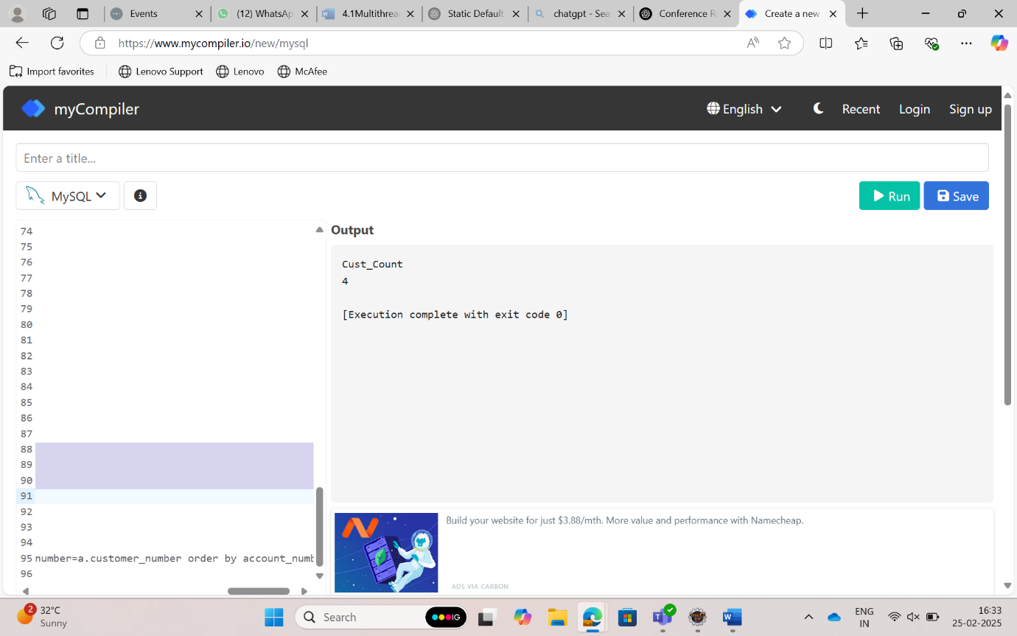

2.Write a query to display the number of customer’s from Delhi. Give the count an alias name of Cust_Count.

Query:

select count(*) as Cust_Count from customer_master where CUSTOMER_CITY='Delhi';

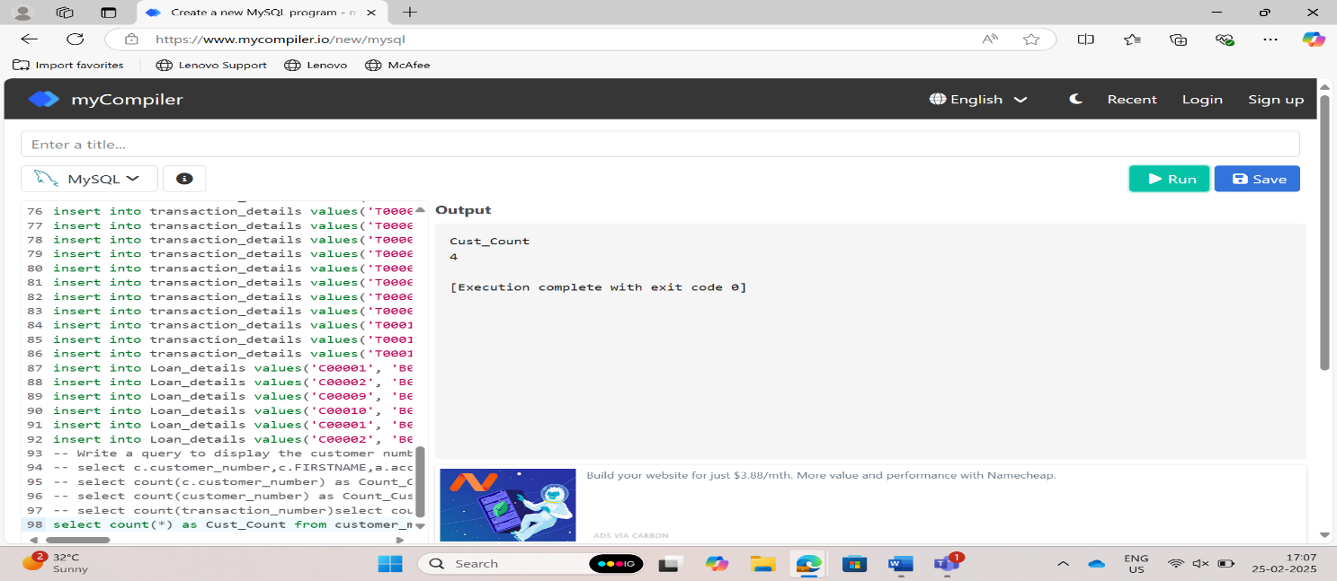3. Write a query to display the customer number, customer firstname, account number for the customer’s whose accounts were created after 15th of any month. Display the records sorted in ascending order based on customer number and then by account number.

Query:

select c.customer_number,c.FIRSTNAME,a.account_number from customer_master c join account_master a on c.customer_number=a.customer_number where DAY(a.account_opening_date)>15 order by a.customer_number asc,a.customer_number ;

4. Write a query to display the number of customers who have registration but no account in the bank. Give the alias name as Count_Customer for number of customers.

Query:

select count(customer_number) as Count_Customer from customer_master where customer_number NOT IN (select customer_number from account_master);

5. Write a query to display the total number of withdrawals and total number of deposits being done by customer whose customer number ends with 001. The query should display transaction type and the number of transactions. Give an alias name as Trans_Count for number of transactions. Display the records sorted in ascending order based on transaction type.

Query:

SELECT t.transaction_type, COUNT(t.transaction_number) AS Trans_Count FROM transaction_details t JOIN account_master a ON t.account_number = a.account_number WHERE a.customer_number LIKE '%001' GROUP BY t.transaction_type ORDER BY t.transaction_type ASC;

