Software Requirements Specification
for
DDOS ATTACK DETECTION AND MITIGATION SYSTEM
Prepared by: 1)Ankita Vaid 2) Akanksha Mahajan 3)Peerzada Musadiq
College of Engineering, Pune.
19-11-2019
Table of Contents
Table of Contents ii
1. Introduction 1
1.1 Purpose 1
1.2 Document Conventions 1
1.3 Intended Audience and Reading Suggestions 1
1.4 Product Scope 1
1.5 References 2
2. Overall Description 2
2.1 Product Perspective 2
2.2 Product Functions 3
2.3 User Classes and Characteristics 3
2.4 Operating Environment 3
2.5 Assumptions and Dependencies 3
3. External Interface Requirements 3
3.1 User Interfaces 3
3.2 Hardware Interfaces 4
3.3 Software Interfaces 4
3.4 Communications Interfaces 4
4. System Features 4
4.1 DDOS Attack
5. Other Nonfunctional Requirements 5
5.1 Performance Requirements 5
5.2 Safety Requirements 5
5.3 Security Requirements 5
5.4 Software Quality Attributes 5
5.5 Business Rules 5
6. Other Requirements 5
Appendix A: Glossary 5
Appendix B: Analysis Models 5
Appendix C: To Be Determined List

Introduction

Purpose
- Today, the internet is evolving at a very fast rate. We live in the world of Internet which has made great impact on computing and communications. Because of this the impact of DDoS attacks on internet security is growing excessively.
- These attacks hinder the services to the legitimate users. There are various ways by which attacks are done like flooding, (slow), etc
- Here, we propose a model which will detect and mitigate TCP and HTTP flood attacks in a timely manner and in very efficient way. But to detect them we have to first make a system which will do these attacks.

Document Conventions
- DDoS: Distributed-Denial of Service
- DoS: Denial of Service
- HTTP(S): Hyper Text Transfer Protocol (Secure)
- TCP: Transport Control Protocol
- ICMP: Internet Control Message Protocol
- RFC: Request For Comments IP: Internet Protocol
- MAC: Media Access Protocol SYN: Synchronize ACK: Acknowledgement

Intended Audience
End Users:
- Content Delivery Networks (CDNs) : CDNs are the target of a large no. of DDoS attacks.
- Banks: In today's world, where we are going to a cashless state, all the transactions are carried over Internet and the bank servers always need to be up to allow transactions. If it goes down even for a smaller time, it would result to havoc.
- Companies: Servers of all leading companies need to be up all the time and provide access to legitimate users rapidly. All servers, websites, e

Product Scope
- Name: -
Distributed Denial of Service Attack and Mitigation

- Purpose:
To help reduce the effect of denying the services to a legitimate user and prevent losses faced by the companies due to downtime of the servers
.
- Objective:
Using traffic analysis and expected incoming traffic to detect a DDoS attack and the prevent/ mitigate it by denying access to the illegitimate traffic.

- Goals:
1. Detecting DDoS attacks.
2. Mitigate/prevent DDoS attack.
3. Secure network from illegitimate traffic.
4. Ensure rapid access to legitimate traffic.

References
- https://www.cpomagazine.com/cyber-security/11-eye-openingcyber-security-statistics-for-2019/
- https://en.wikipedia.org/wiki/DDoS_mitigation/

Overall Description
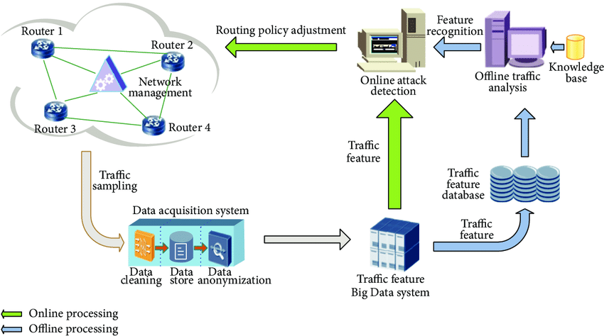

Product Perspective
- With rapid growth of networking communications, there is threat to financial data, business analytics data, etc by DDoS attacks. So the perspective of our system will be to detect and mitigate this attacks so that victim must not be affected.
- Because some system going down for a second may pose great threat.
- As many application layer protocols who don’t want their data to be lost uses TCP protocol, so our main aim will be to handle TCP flooding SYN/ACK attacks.

Product Functions
1)Demonstrating DDoS Attack:
It will perform DDoS Attack on one node in the network where other attackers may also attack at same time.

2)DDoS attack:

1)Detection: By analysing the packets coming on node, software will detect the attack

2)MitiGation: after analysing and detecting attack, there is a need to firewall the packets coming from ip address of attacker for short period of time.

User Classes and Characteristics
1. Network Administrators
2. Cloud Networking
3. Independent Servers
4. Companies, institutions, etc

Operating Environment
- This software is compatible with Linux or Windows with JDK (32-64bit)
- The system will not interrupt any other process though it will run continuously.
- This software is developed in JAVA.

Assumptions and Dependencies
- Attackers are distributed by IP Spoofing.
- Internet Connection
- JAVA Gcc
- WireShark
- Server System

External Interface Requirements

User Interfaces
- GUI depicting the coming packets one by one and shows the number of attacks happened in timebound frame.
- Also it will give the graphical view of the traffic on the system

Hardware Interfaces
All devices like Personal Computers, Mainframe Computers with Linux or Windows Operating System

Software Interfaces
- Operating system: windows or linux (32-64 bit)
- Database system: MySQL
- Backend: JAVA
- Frontend: JAVA
- Dependencies: wireshark

Communications Interfaces
- High level use of socket programming
- Use http, icmp, tcp, protocols
- To detect the packets, packet sniffing is done for all layers

System Features

DDOS ATTACK:
4.1.1 CREATING
The software provides a feature to create a DDoS attack. However it should be noted that this feature is for testing/checking the security of server against DDoS attacks and should not be used for any illegal purpose.

4.1.2 DETECTION

The software has a feature of detecting a DDoS attack. It detects an attack when there is enormous incoming traffic, more than what it experiences usually. It detects when there is traffic from a machine with a spoofed IP address, or even multiple machines sending malicious traffic, to deny service to the legitimate users and/or to breakdown the server. It distinguishes the spoofed IP address from the real ones by checking the MAC addresses of the incoming traffic.

4.1.3 MITIGATION

Mitigating: The software service to reduce the severity of the DDoS attack. This feature of mitigation ensures that the attack causes no or minimum damage to the server in addition of providing access to the genuine users. The mitigation is done by restricting the access to spoofed IP addresses.

Other Nonfunctional Requirements

Performance Requirements
- The detection of an attack is very rapid. Earlier the attack detected, lesser is the severity of the attack.
- Accurate distinguishment is made between legitimate and illegitimate traffic

Safety Requirements
- Although there is a lot of incoming traffic which needs to be analyzed, there should be no crashes and the server should always stay up.
- The data of the server should always remain safe.

Security Requirements
- The incoming data to the server may have any confidential information, so must be kept safe and no one should access that.
- To create DDoS attacks for testing, the user should be authenticated first.

Software Quality Attributes
- The software will be reliable.
- The server admins can be able to trust the software for protection against DDoS attacks.

Business Rules
- It should be operated every time along with the server.
- If you close this application while your server is running, attacker may attack the system and hinder the process.
- It will mostly be used by the system handling large traffic.

Other Requirements
Appendix A: Glossary
DoS– Denial of Service
DDoS – Distributed Denial of Service
RFC – Request For Comments
Mitigation – the action of reducing the severity of something.
Legitimate User – A user conforming to the law or to rules.
Malicious User – A user with an intention to do harm.

Appendix B: Analysis Models
