**OBJECTIVE:**

The aim of this submission is the creation of a relational database for a Railway system. The purpose here is to design and develop a system which contains all the details of the trains and their schedule, stations and the passengers boarding it. The details of the trains include its name, number, source and destination stations and routes. The passenger booking gives details such as the booked train name, from and to station, coach number, seat number and the passenger name. The database further gives details of tracks, train schedules, duration of time between two different stations. Hence it provides comprehensive detail to a railway company to run the trains effectively and efficiently.

**OVERVIEW OF THE TABLES:**

|  |  |
| --- | --- |
| **ENTITES** | **ATTRIBUTES** |
| TRAIN | TRAIN_NO, TRAIN_NAME |
| STATION | STATION_ID, STATION_NAME |
| TRAIN_SCHEDULE | TRAIN_ID, STATION_ID, TIME_IN, TIME_OUT |
| PASSENGER_BOOKING | Passenger_ID, TRAIN_ID, FIRST_NAME, M_NAME, L_NAME, DATE, FROM_STATION, TO_STATION, SEAT, COACH |
| TRACK | Track_ID, Track_Name, Track_Location |

**ER DIAGRAM:**

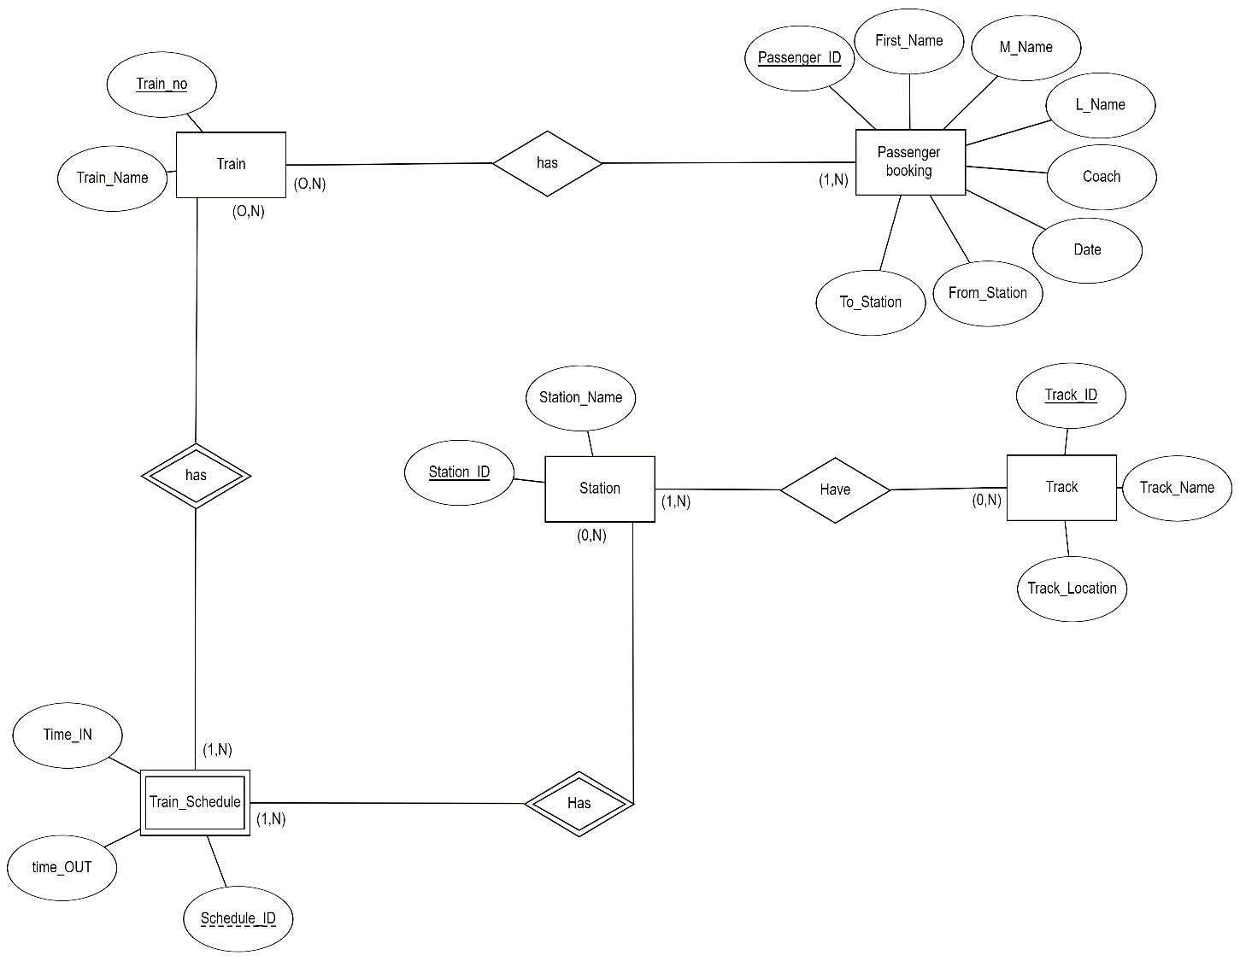

**RELATIONAL MODEL:**

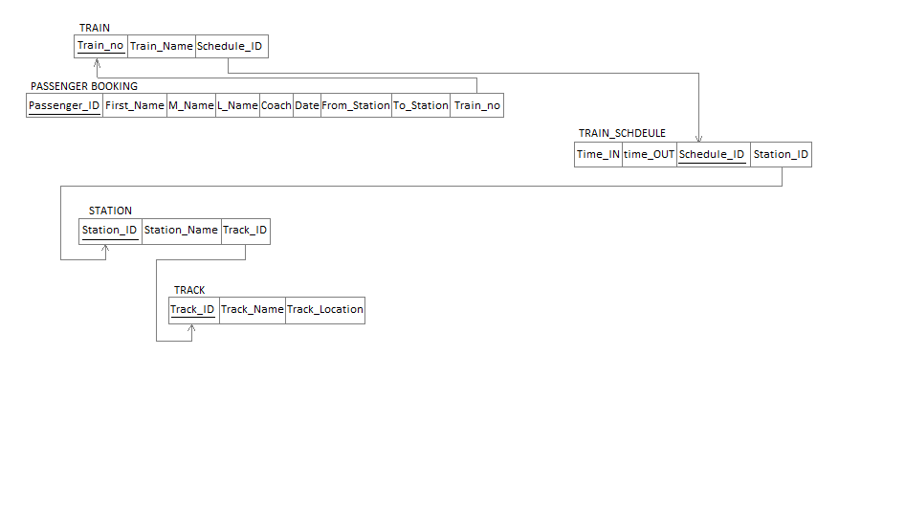The above Relational Model is in 3rd normal form. All attributes depend on nothing but the primary key. Hence there are no partial or transitive dependencies.

Create script for all tables:



Insert script for all tables:

