


Session Details:
Title of the session:
Workshop on Product-Market Fit; Prototype/Process Design and MVP Development
Date with Month & Year: 2nd April 2026
Duration (in hours): 5 hours
Mode: Offline
Venue / Platform: II Floor AV Hall, D Block, CMR Institute of Technology.
Activity Category: IIC Calendar Activity
Objective of the Activity:
To make pre final year students and IInd year ISE students to understand the concept of Product-Market Fit; Prototype/Process Design and MVP Development with real life examples and demonstration.
Activity Led by: Institute Council
Theme: (Innovation, Entrepreneurship, IPR, Startup): Entrepreneurship and Startup
Expert/Speaker Details:
Name: Mr. Sriharsha Nallamilli
Designation: Head - Strategic Partnerships
Organization/Institution: Wadhwani Foundation, Bangalore.
Brief about Expert/Speaker:
He is a marketer by craft and an educator by purpose. With 15+ years of experience in marketing, branding, and demand generation, he has worked closely with founders, small businesses, and institutions to help them grow with clarity. Through Markepreneur, he brought together marketing, AI tools, and entrepreneurial thinking to create hands-on learning experiences that prepare students for the real world. His work spans immersive workshops, masterclasses, and campus engagements where students don’t just learn entrepreneurship—they think like problem solvers, understand how startups truly operate, and build skills that matter across careers. He has trained and mentored 20,000+ students and professionals across colleges and startup ecosystems, focusing on practical skills in entrepreneurship, marketing, personal branding, and business.
Objective:
The workshop aimed to provide practical knowledge on the concepts of Entrepreneurship, Design, Product, prototyping, Minimum Viable Product and Market Fit.
Summary:
The event was comprising of two phases,
Phase 1:
The speaker started with the definition of what is “Entrepreneurship”—one who organizes, manages, and assumes the risks of a business or enterprise—and exhibited famous successful entrepreneurs all over the world. This was followed by the actual meaning of the product: “An article or substance that is manufactured or refined for sale,” with live examples showing variations of tangible and intangible products. He then continued his discussion, stating that “people will not buy an idea, but they purchase the product.”. and often, the product is the face of the company. The speaker also explained, how the design of the product is important and discussed the various aspects of design. Design should consider design thinking principles and satisfy the qualities of industrial design. The importance of design was emphasized, along with careful consideration of feasibility analysis of the product, such as market feasibility, financial analysis, capacity utilization, competition, site analysis, and supply and demand. The speaker also emphasized that, If everything goes in the right direction, then prototyping is carried out through various ways such as:
• Better drawings/sketching
• Modelling – clay/metal/wood
• Cardboard/Sunboard/MDF
• Assembling ready materials
• 3D printing
He continued his discussion that these are then shown to people to get feedback. This helps to improve the products and make them very useful. Then the speaker started with the next stage called “Market Fit,” which focuses on whether the market needs your product or not, based on understanding the needs of the market. Finally, resource person quoted some real-life examples with demonstrated of how an idea can be converted into a Minimum Viable Product.
Phase II:
During this phase, the speaker made students sit in team-wise to apply all the concepts they have learned in Phase 1 and evaluated some of the ideas. As a result, a conclusion was drawn on how many functional prototypes were ready among the participants, and it was ensured that those many prototypes could be submitted on the Yukti portal.
Benefits:
Students got a clear understanding of the topics viz., Problem-solving, Design, Product, Customer feedback, problem-solution fit, Market Fit, Minimum Viable product and Entrepreneurship.
Key Outputs / Measurable Parameters:
No. of functional prototypes developed/tested: 10
- Interview problem solving platform with real time feedback
- Voice to Text Converter
- An AI-Based Virtual Assistant System for Disabled and Paralytic Patients/ Civic issue reporting and resolution system
- Real-Time Personality Prediction from Social Media for Psychological and Criminological Analysis
- DrishtiSign: Intelligent Sign Language Interpreter for Indian Languages
- A Real-Time Hospital Crowd Monitoring and Patient Wait-Time Transparency System
- SheTrust- Crowdsourced Women Safety Index
- Brain Tumor detection using Deep Learning
- Mobile App for Mental Health Monitoring Using NLP and Sentiment Analysis
- Fine Motor Task Analysis for Early Parkinson’s Disease Detection
KPIs (with Quantified Metrics):
≥5 functional prototypes developed, Deposited/Updated in YUKTI Innovation Repository:
Yes. All the above 10 protypes will be submitted in yukti portal under Innovation/Protypes Category.

Registration details:
https://forms.gle/LTcFi7bhBFRmj3bH8
Attendance sheet Drive Link: https://drive.google.com/file/d/1vxQRSiJB8amfFk20NzbRPOd-NIwE2CJ2/view?usp=sharing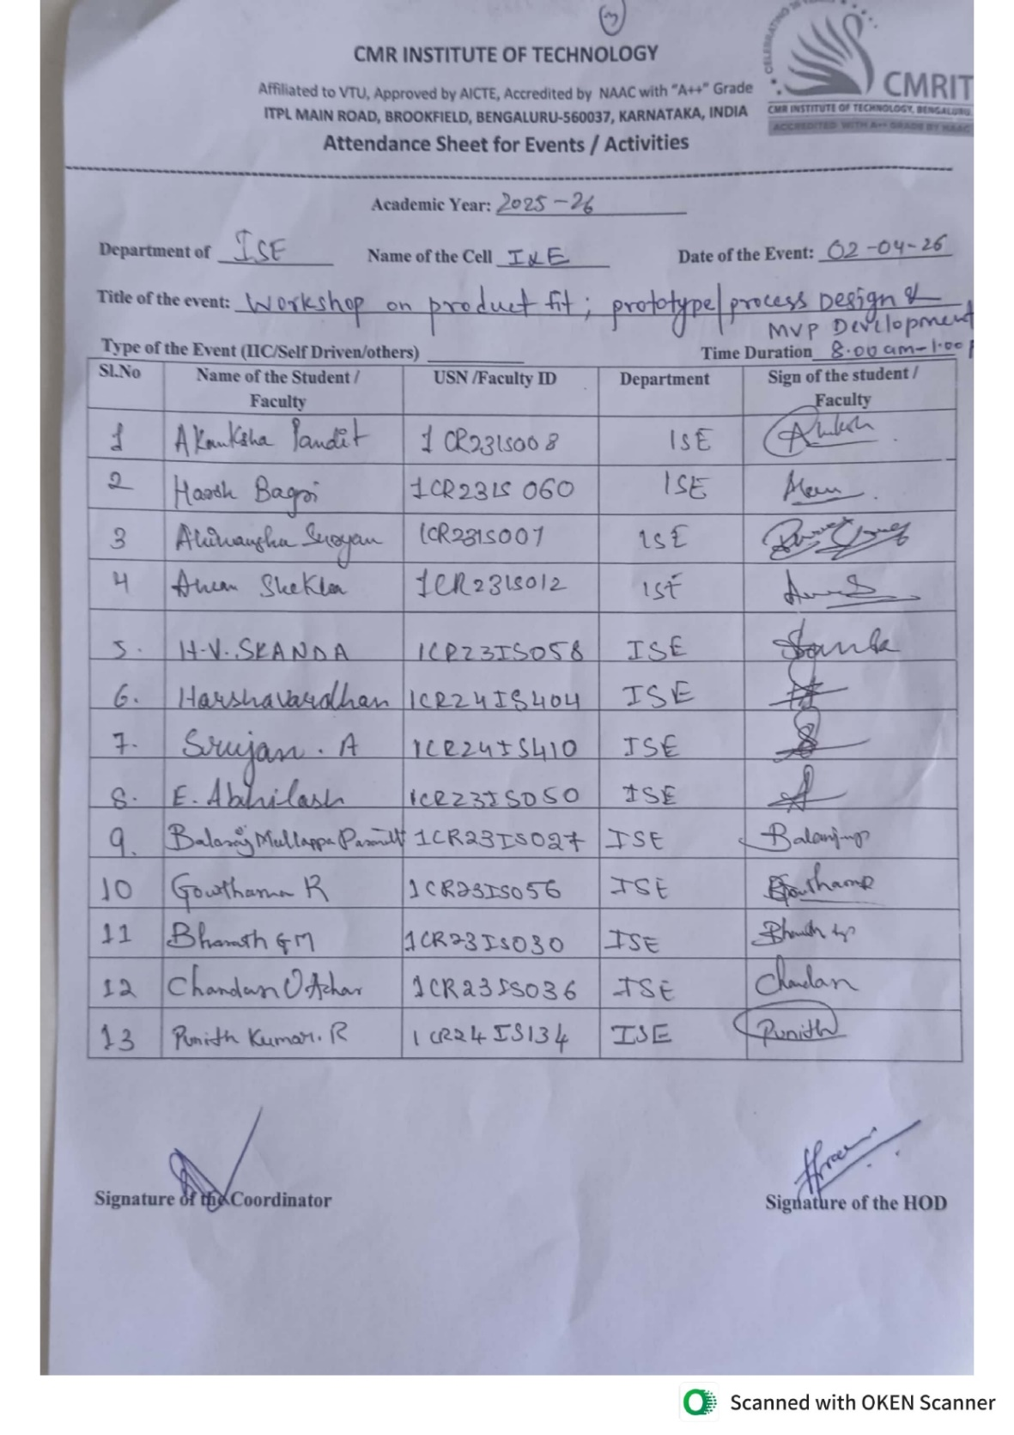

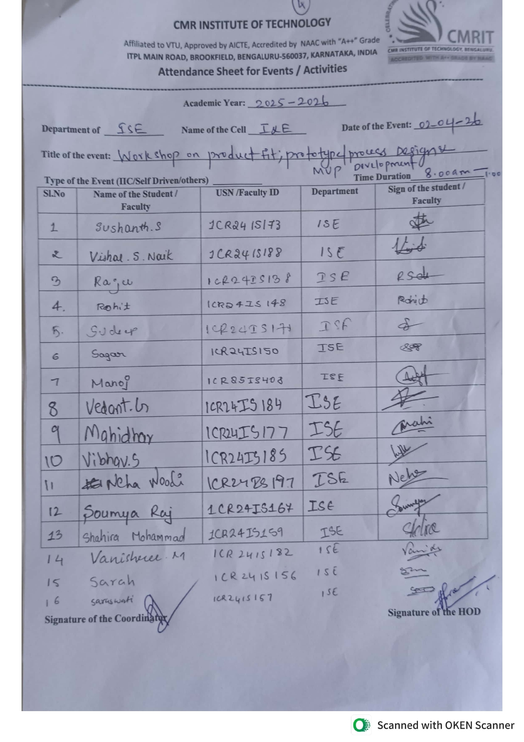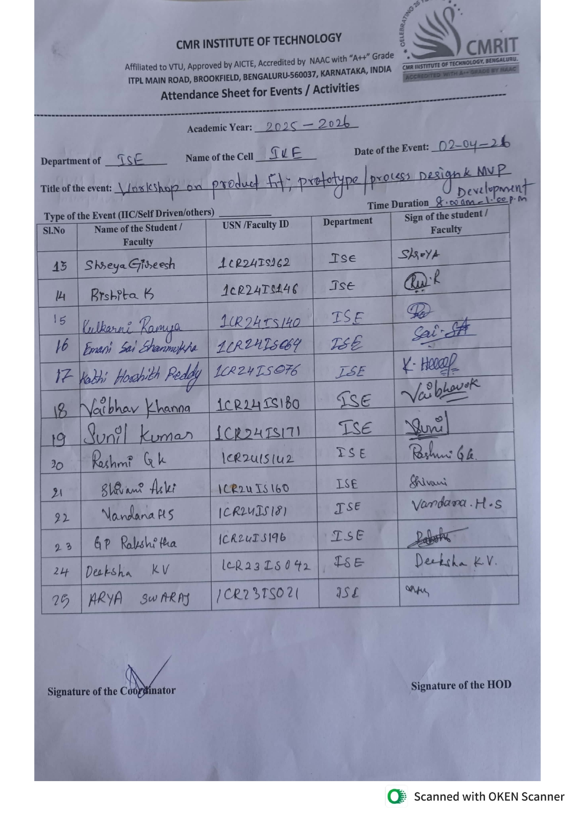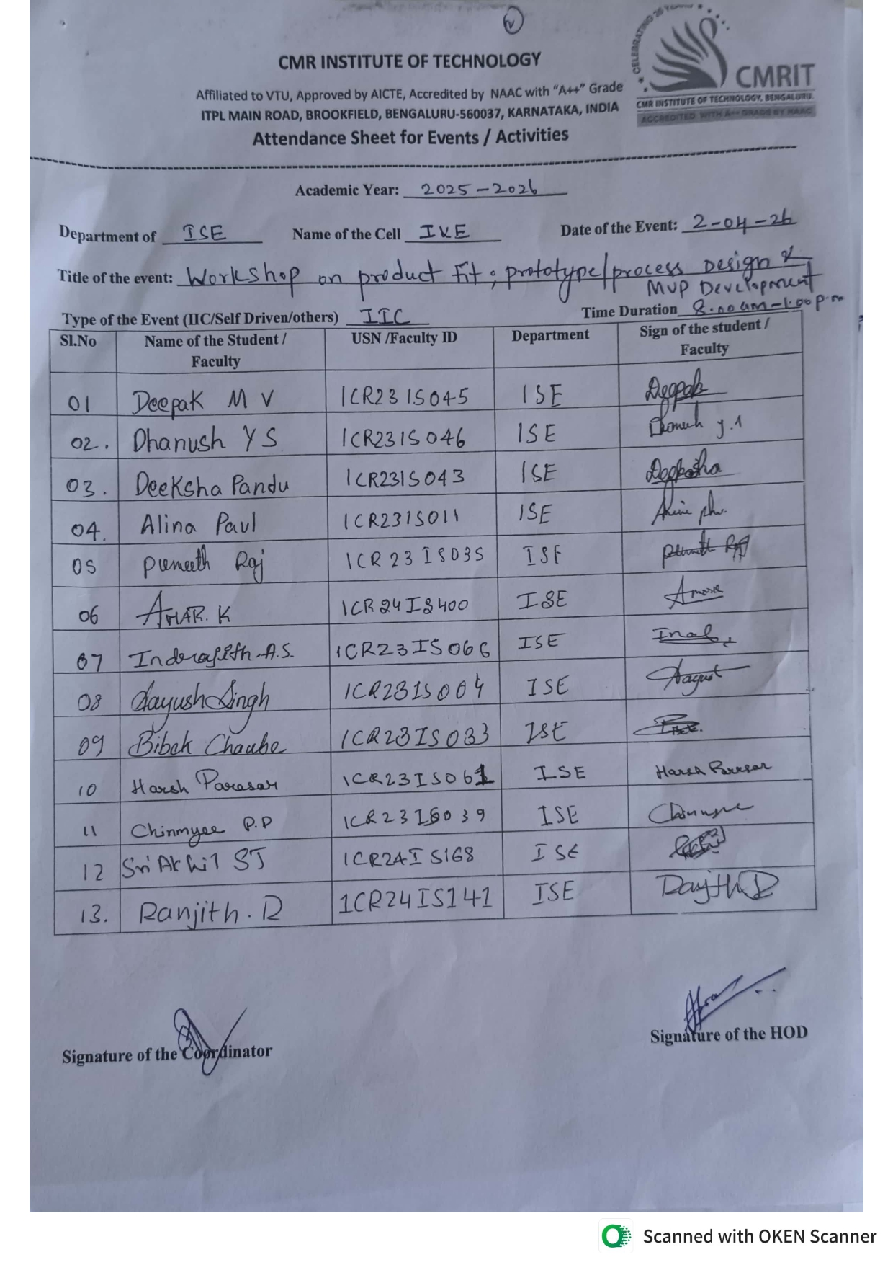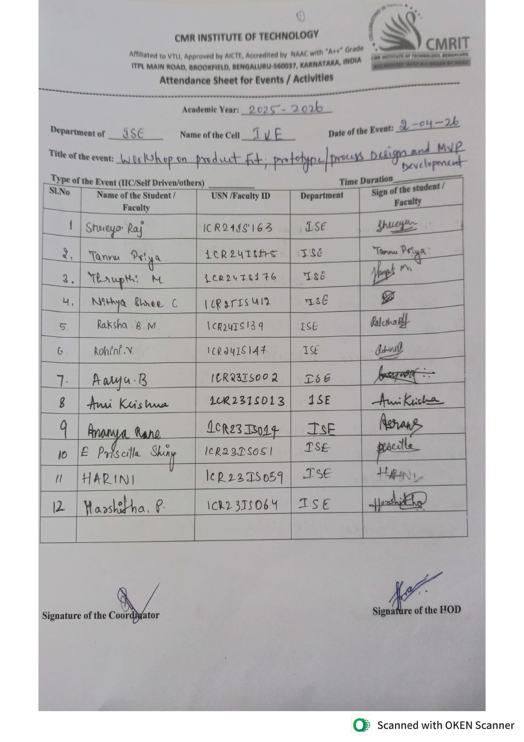
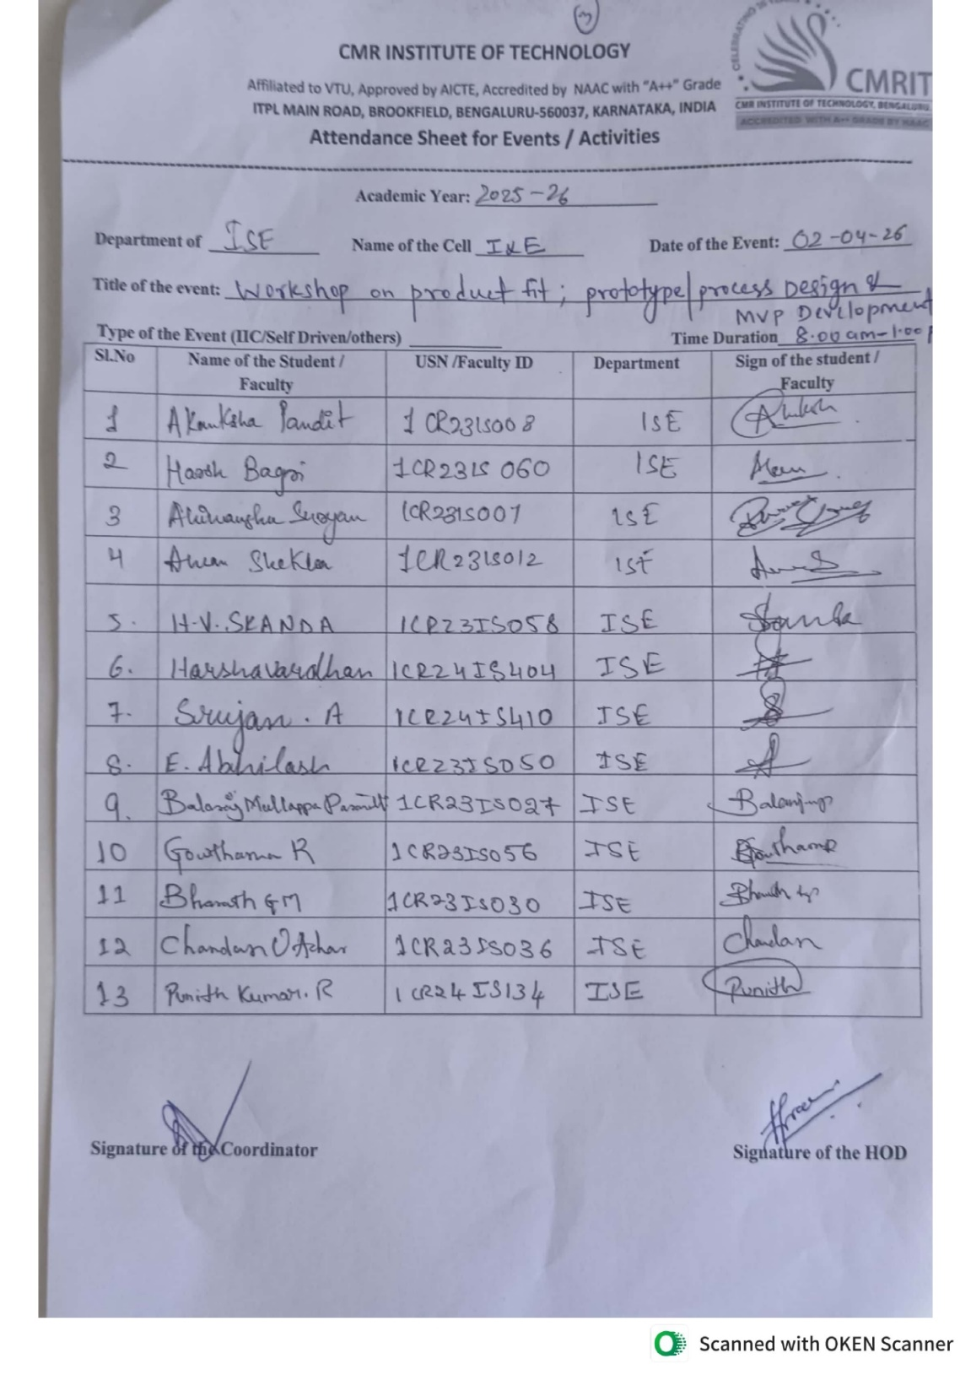

Feedback link:
https://forms.gle/ry5pX2gFvTXcaRCGA
Sample Feedback(screenshot)

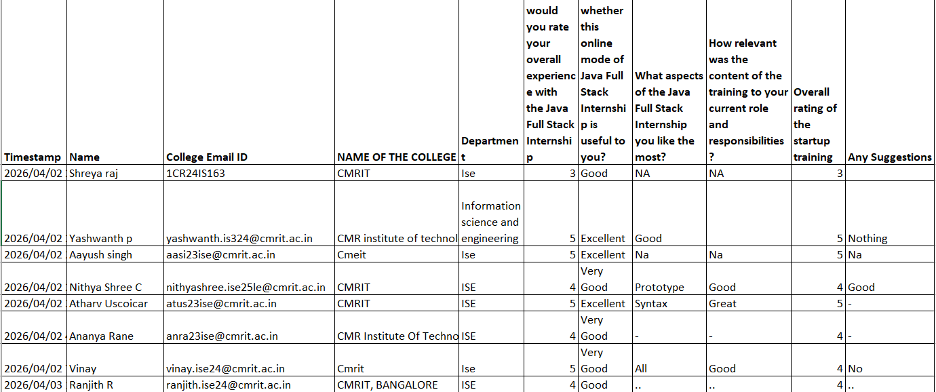 Photo – Collage
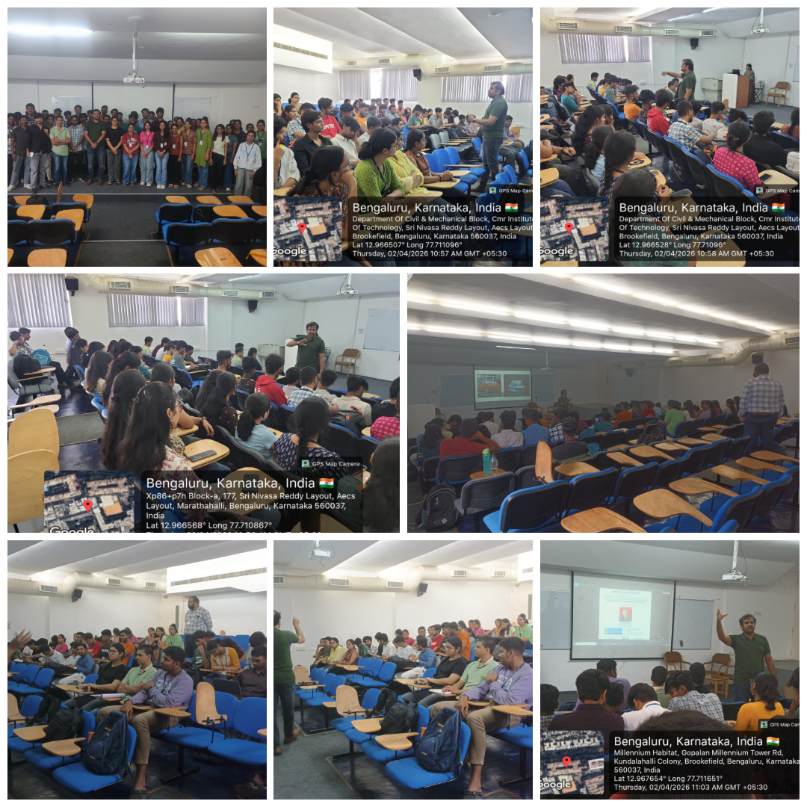

Photos:
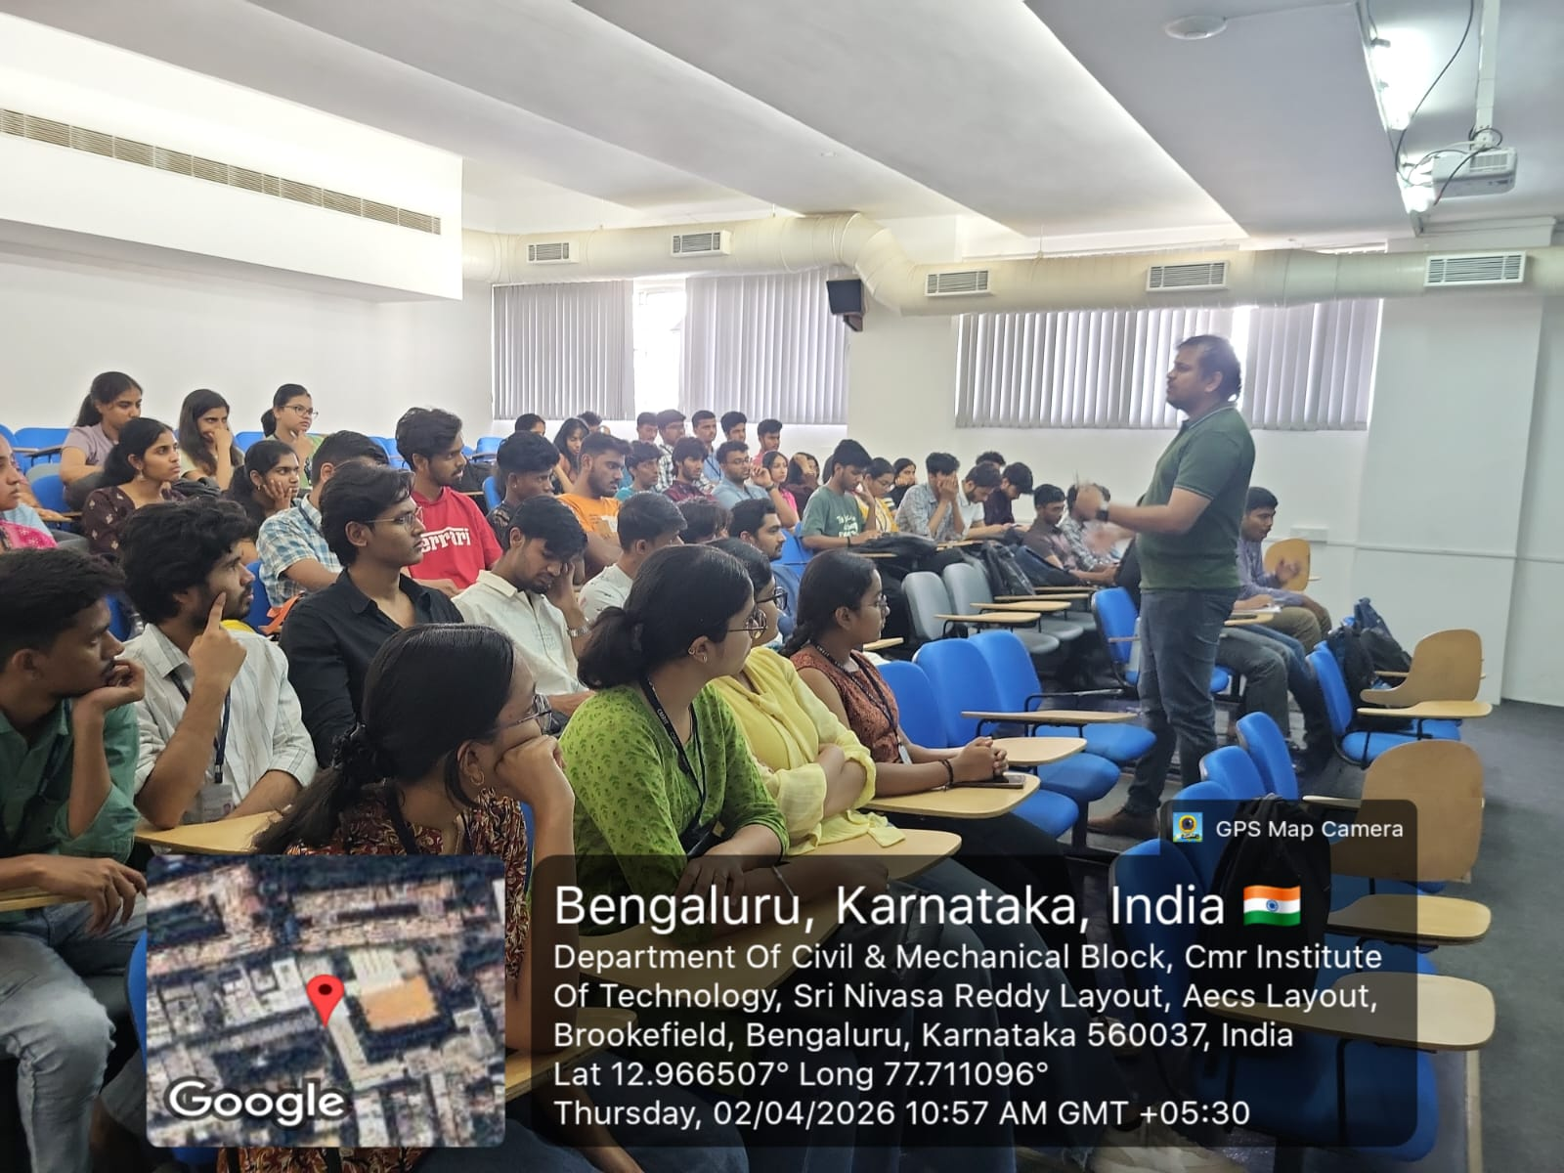

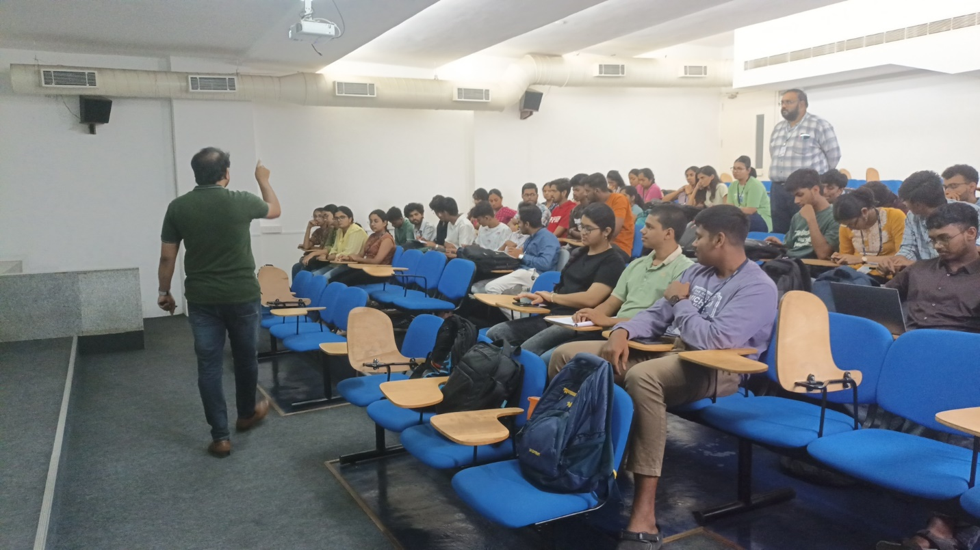

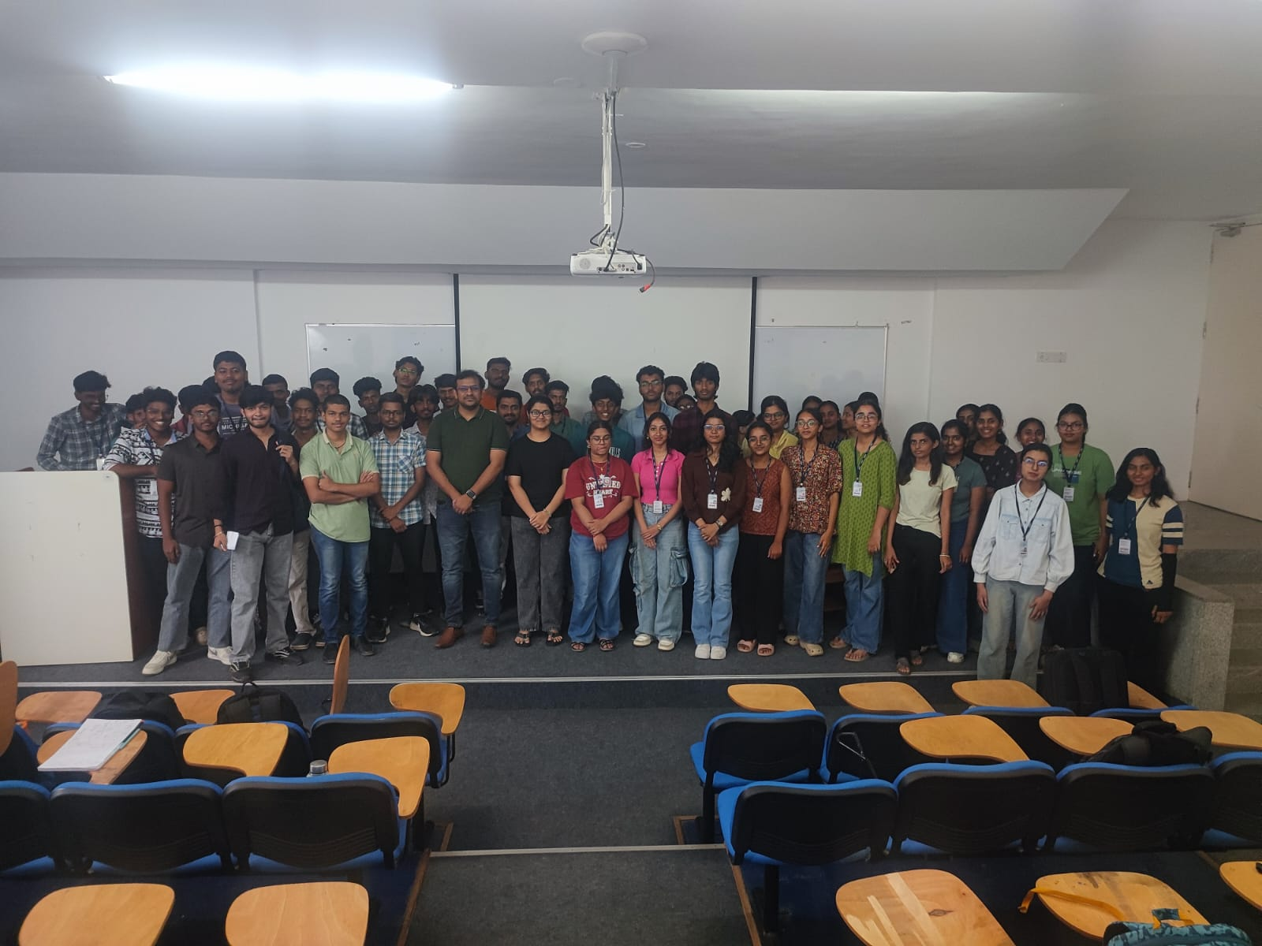

Photo 1 – poster:
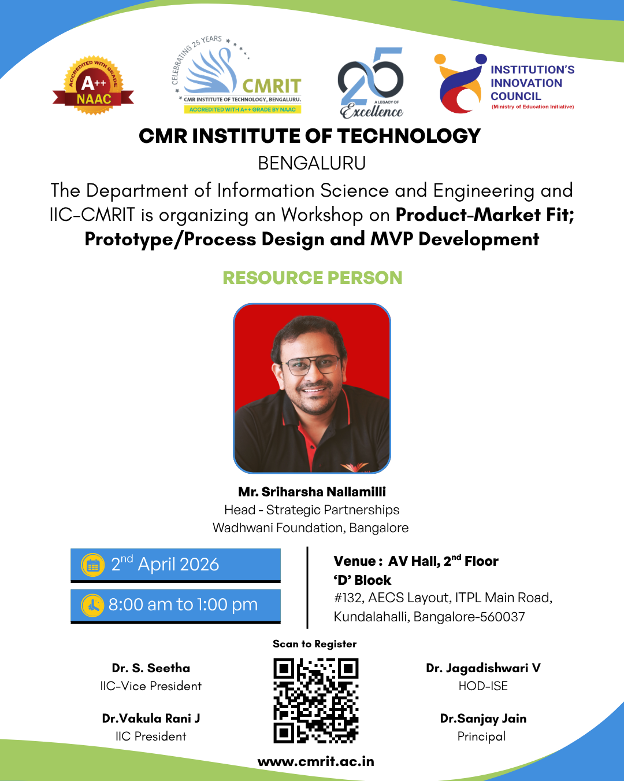

Social Media Links
Twitter | https://x.com/i/status/2039008565818728610
Facebook | https://www.facebook.com/share/p/1DpX4BfZgW/
Instagram | https://www.instagram.com/p/DWjfRDkAW7z/?igsh=MWNqeG02M29qbjA4cg==

S. No | Particulars | Details
1 | Name of the Resource Person | Mr. Sriharsha Nallamilli
2 | Designation | Head - Strategic Partnerships Wadhwani Foundation, Bangalore.
3 | Contact Details - Mobile | 88848 95888
4 | Contact Details – e-mail id | https://www.linkedin.com/in/subramaniancm/
5 | Date of event (If more than 1 day, mention from and to date) | 02-April-26
6 | Duration in mins | 300 min
7 | Number of student participations | 67
8 | Number of faculty participations | 3
9 | Number of external participations | -
10 | Name of the Organizer | Dr. S. Seetha, IIC Vice President and Professor, ISE dept  Contact No:7708406505

