IIC ACTIVITY REPORT

Title of the Session
6th Anniversary of National Education Policy (NEP) 2020

Date with Month & Year
29th July 2026

Duration (in hours)
2 Hours

Mode
Offline

Venue / Platform
AV Hall, 2nd Floor 'D' Block #132, AECS Layout, ITPL Main Road, Kundalahalli, Bangalore-560037

Activity Category
IIC Calendar Activity

Objective of the Activity
To commemorate the 6th Anniversary of the National Education Policy (NEP) 2020, this session aimed to elucidate its core principles and implementation strategies. Organized by the ISE Department and IIC, CMRIT, the event sought to foster a deeper understanding among participants regarding innovation in higher education, the importance of multidisciplinary learning, and emerging research avenues as envisioned by NEP 2020, thereby aligning institutional practices with national educational reforms.

Activity Led by
Dr. S. Seetha IIC Vice President, Dr. Vakula Rani J IIC President, Dr. Jagadishwari V HOD-ISE, Dr. Shyam P Joy Dean REl HOD -AI&ML, Dr. Sanjay Jain Principal

Theme
Innovation & Design Thinking

Expert / Speaker Details
Name:
Dr. Shreekanth M. Prabhu

Designation:
Professor & Head, Dept. of CSE

Organization / Institution:
Cambridge Institute of Technology, Bengaluru

Brief Description of the Activity
Session on the 6th Anniversary of NEP 2020 organized by ISE Department and IIC, CMRIT. Dr. Shreekanth M. Prabhu explained the key features and implementation of NEP 2020, innovation in higher education, multidisciplinary learning, and research opportunities. The session concluded with participant interaction and a Q&A.

Participant details:
Total no. of Student participation: 56
Total no. of Staff (Teaching/Non-teaching) participation:
Total no of External participation:

Key Highlights:
Briefly mention the most important moments, insights, and engagement points of the activity in 5-8 lines (in short bullet points (5–8 points) that help to understand what made the session meaningful).

Outcome of the activity:
Clearly mention what participants gained. The outcome should align with and reflect the KPIs mentioned in the activity details on the IIC portal.

Key Outputs / Measurable Parameters:
No. of functional prototypes developed/tested: 10
1. Interview problem solving platform with real time feedback
2. Voice to Text Converter
3. An AI-Based Virtual Assistant System for Disabled and Paralytic Patients/ Civic issue
reporting and resolution system
4. Real-Time Personality Prediction from Social Media for Psychological and Criminological
Analysis
5. DrishtiSign: Intelligent Sign Language Interpreter for Indian Languages
6. A Real-Time Hospital Crowd Monitoring and Patient Wait-Time Transparency System
7. SheTrust- Crowdsourced Women Safety Index
8. Brain Tumor detection using Deep Learning
9. Mobile App for Mental Health Monitoring Using NLP and Sentiment Analysis
10. Fine Motor Task Analysis for Early Parkinson’s Disease Detection

KPIs (with Quantified Metrics):
≥5 functional prototypes developed, Deposited/Updated in YUKTI Innovation

Feedback / Reflection:
Include 2–3 participants feedback
Feedback link:
https://docs.google.com/forms/d/e/1FAIpQLSeLksQpFTh7ft10emED_gNjH7pEHR_sPfngxqAuK-VZu7HqfA/viewform
Sample Feedback(screenshot)
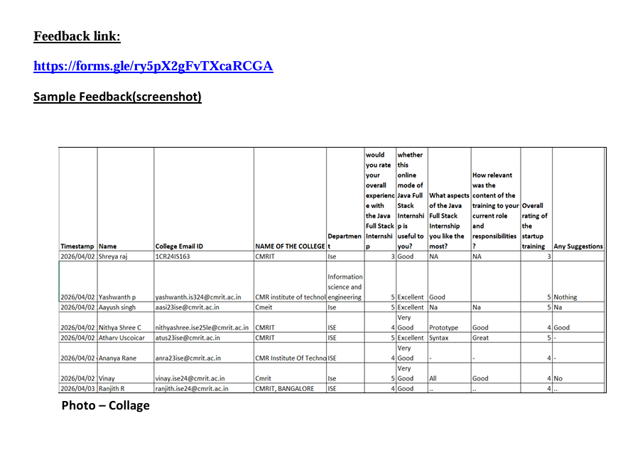

Organizing Team Members Details:
N/A

Photographs/Screenshots:
4 to 5 Photographs/Screenshots (1 Photo can be geotagged) that show the 1) Print/Soft copy of Banner used for the activity, 2) Speakers/Dais Photo with banner in the background, 3) Participation of students and Staffs(Teaching/Non-teaching) in the activity (one photo can be captured covering guest and participants from front and back, if conducted any physical activity), 4) Unique/Activity moments, where candid moments can be captured to get broader view of the activity engagement level.
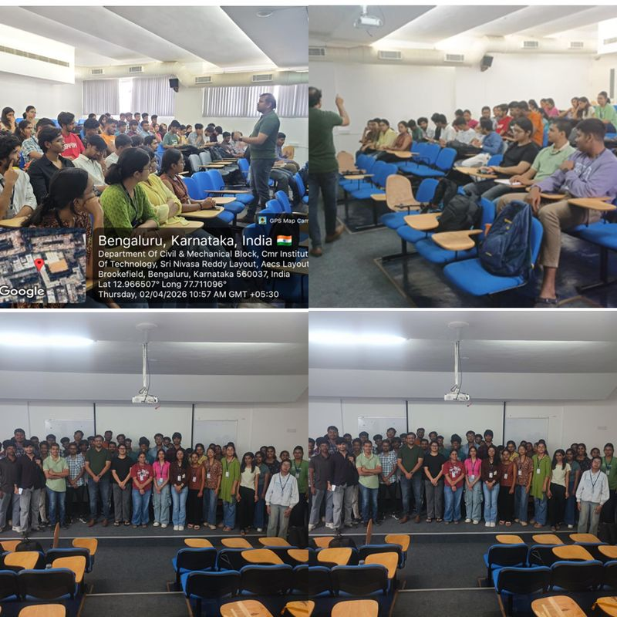

Media Coverage and Pre & Post Activity Social Media Post screenshot:
Screenshots of pre-activity announcements and post-activity updates shared on the institute's social media platforms should be included. If available, attach photo/screenshots of media coverage such as newspaper articles, online news portals, or institutional newsletters highlighting the activity.

N/A

Registration Link:
https://docs.google.com/forms/d/e/1FAIpQLSeLksQpFTh7ft10emED_gNjH7pEHR_sPfngxqAuK-VZu7HqfA/viewform

Attendance details:
Proof of signed Attendance sheet
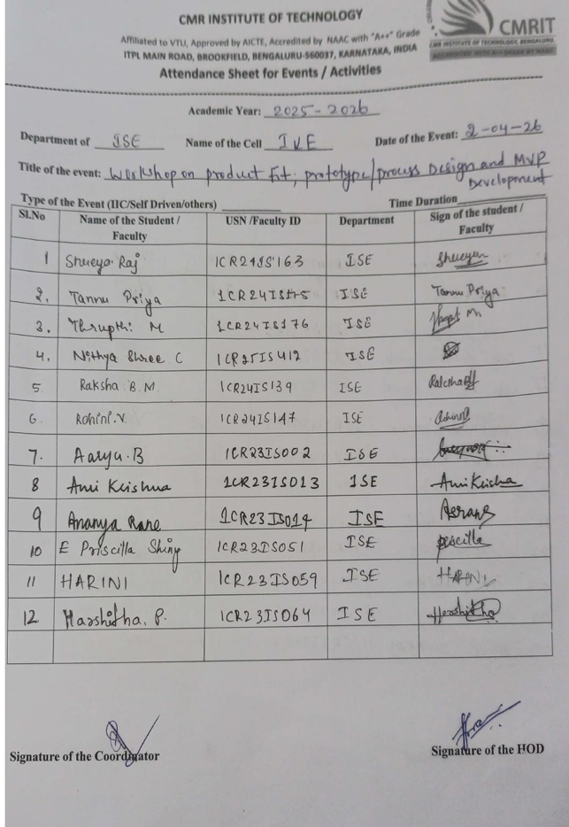
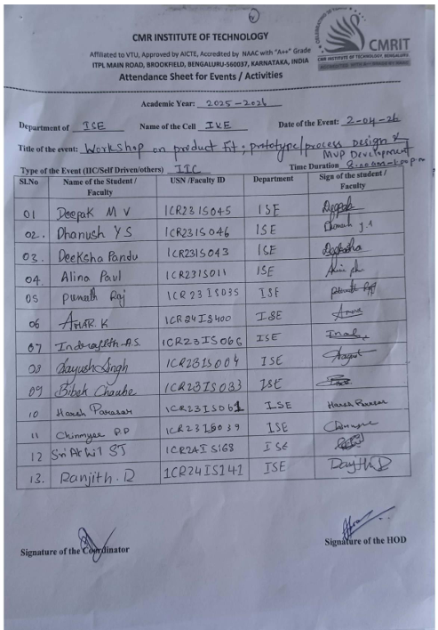
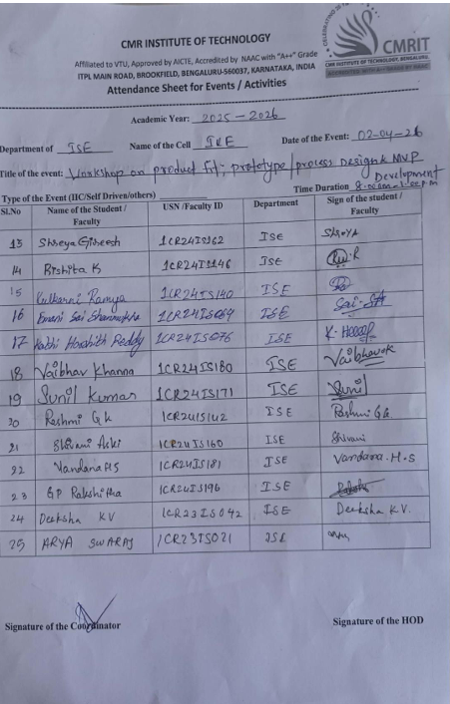

Social Media and Video Links
Platform | Link
Twitter | https://x.com/CMRIT_Bengaluru/status/2039008565818728610
Facebook | https://www.facebook.com/story.php?story_fbid=1410758247517954&id=100057513756324&rdid=TzWaZgszhZ3xNk7N#
Instagram | https://www.instagram.com/p/DWjfRDkAW7z/?igsh=MWNqeG02M29qbjA4cg%3D%3D
LinkedIn | https://www.facebook.com/story.php?story_fbid=1410758247517954&id=100057513756324&rdid=TzWaZgszhZ3xNk7N#
Video / Drive Link | https://x.com/CMRIT_Bengaluru/status/2039008565818728610

Event Poster
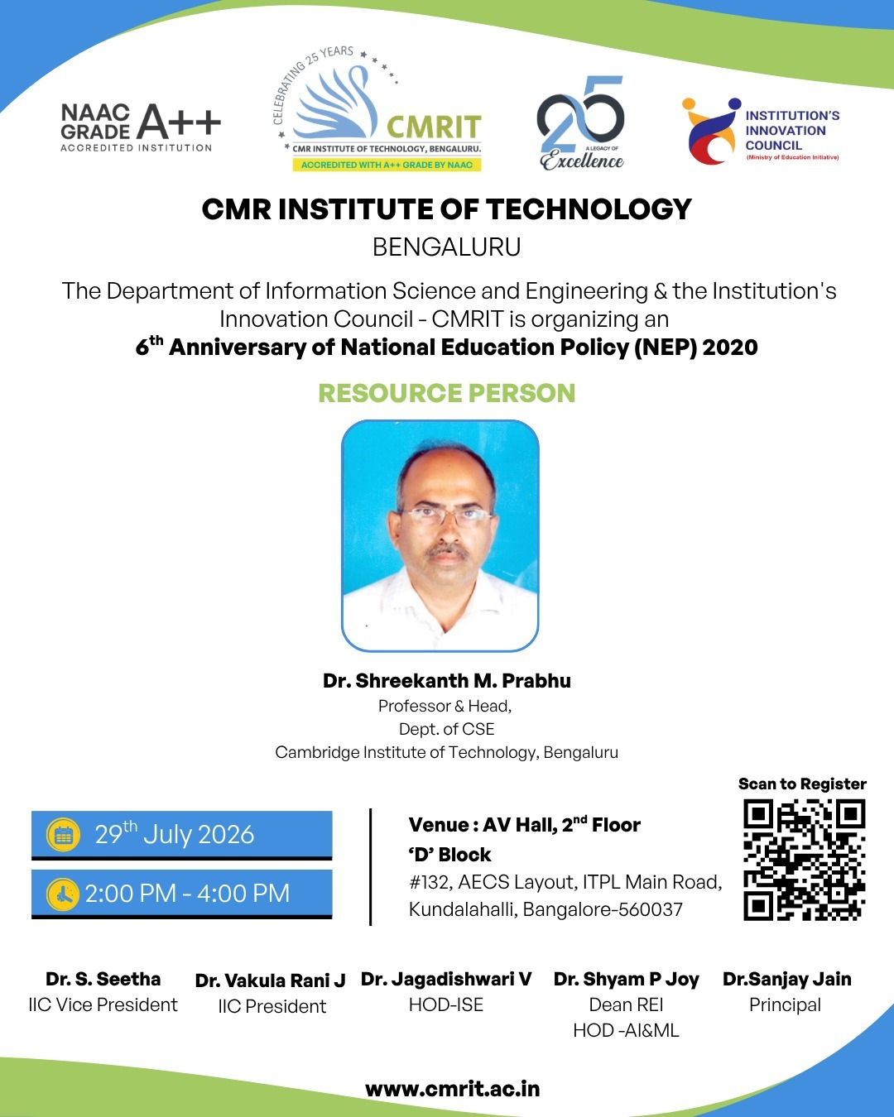

S. No | Particulars | Details
1 | Name of the Resource Person | Dr. Shreekanth M. Prabhu
2 | Designation | Professor & Head, Dept. of CSE
3 | Contact Details - Mobile | 5689876532
4 | Contact Details – e-mail id | https://www.linkedin.com/in/subramaniancm/
5 | Date of event (If more than 1 day, mention from and to date) | 29th July 2026
6 | Duration in mins | 120 min
7 | Number of student participations | 55
8 | Number of faculty participations | 5
9 | Number of external participations | 0
10 | Name of the Organizer | dr. seestha  Contact No:7703765452

