ASSIGNMENT-4

AKANKSHA.PARVATHANENI

700758979

GITHUB LINK:

<https://github.com/akankshaparvathaneni/akanksha>

1. Follow the instruction below and then report how the performance changed.(apply all at once)
   * Convolutional input layer, 32 feature maps with a size of 3×3 and a rectifier activation function.
   * Dropout layer at 20%.
   * Convolutional layer, 32 feature maps with a size of 3×3 and a rectifier activation function.
   * Max Pool layer with size 2×2.
   * Convolutional layer, 64 feature maps with a size of 3×3 and a rectifier activation function.
   * Dropout layer at 20%.
   * Convolutional layer, 64 feature maps with a size of 3×3 and a rectifier activation function.
   * Max Pool layer with size 2×2.
   * Convolutional layer, 128 feature maps with a size of 3×3 and a rectifier activation function.
   * Dropout layer at 20%.
   * Convolutional layer,128 feature maps with a size of 3×3 and a rectifier activation function.
   * Max Pool layer with size 2×2.
   * Flatten layer.
   * Dropout layer at 20%.
   * Fully connected layer with 1024 units and a rectifier activation function.
   * Dropout layer at 20%.
   * Fully connected layer with 512 units and a rectifier activation function.
   * Dropout layer at 20%.
   * Fully connected output layer with 10 units and a Softmax activation function

Did the performance change?

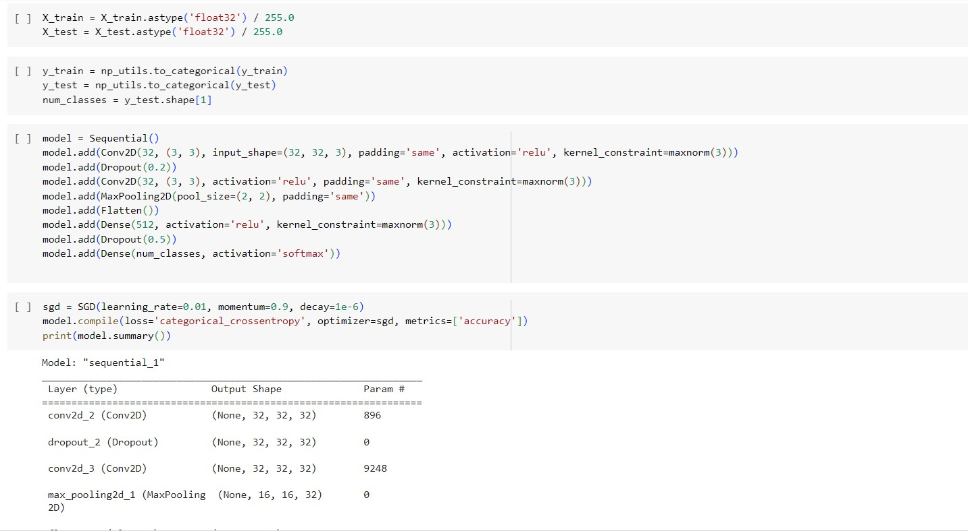

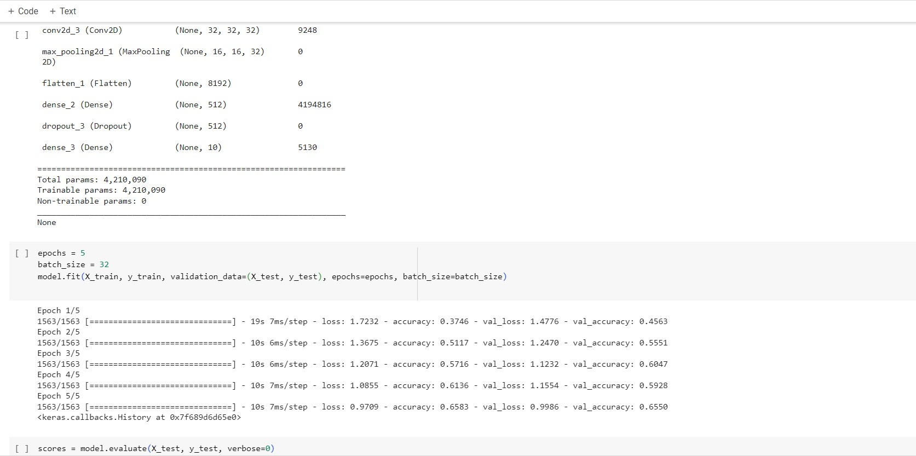

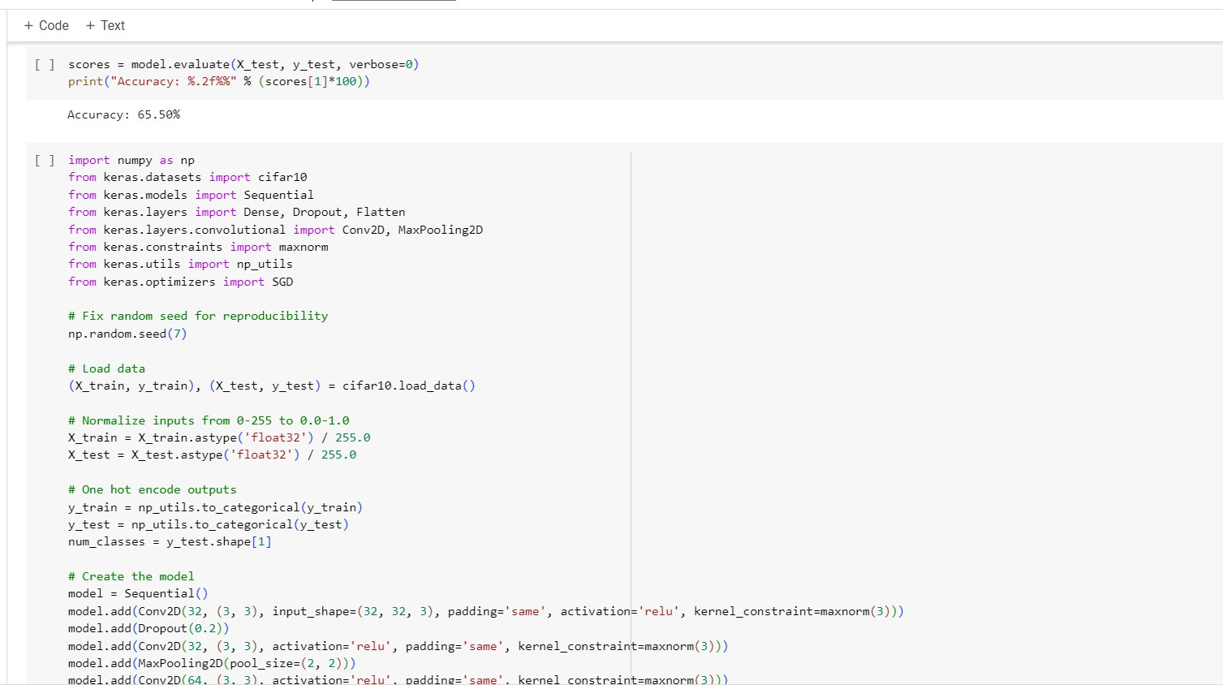

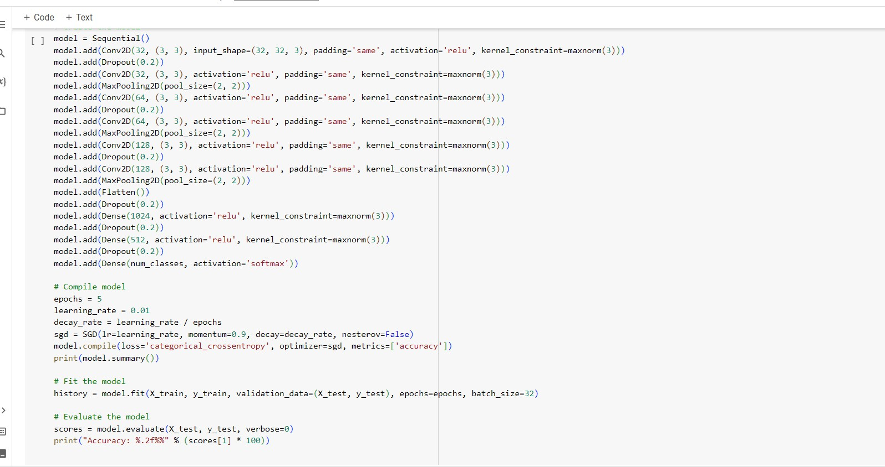

Output:

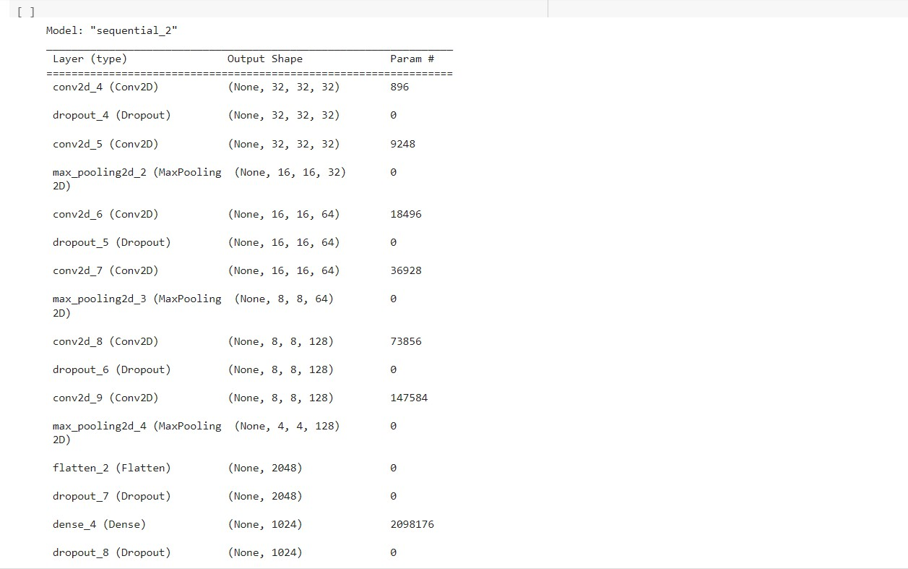

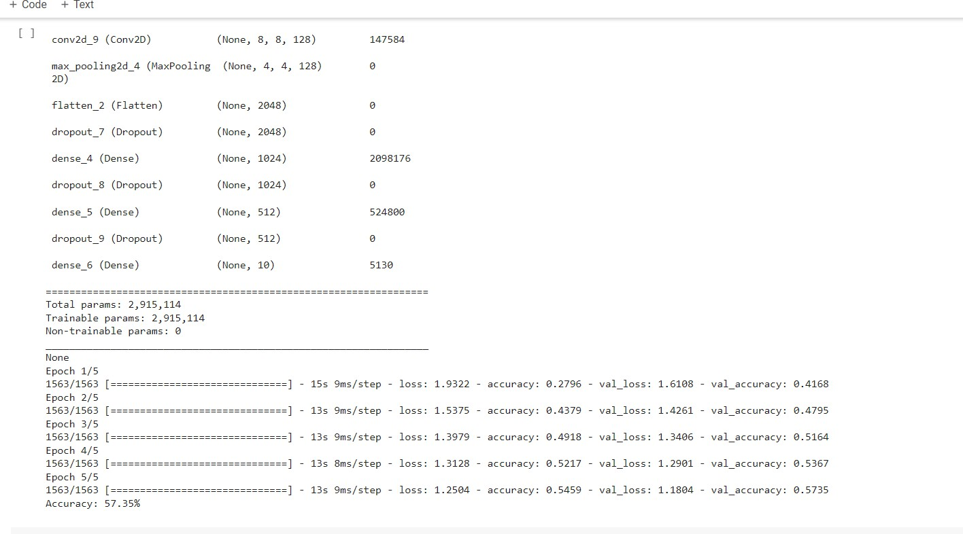

1. Predict the first 4 images of the test data using the above model.

Then, compare with the actual label for those 4

images to check whether or not the model has predicted correctly.

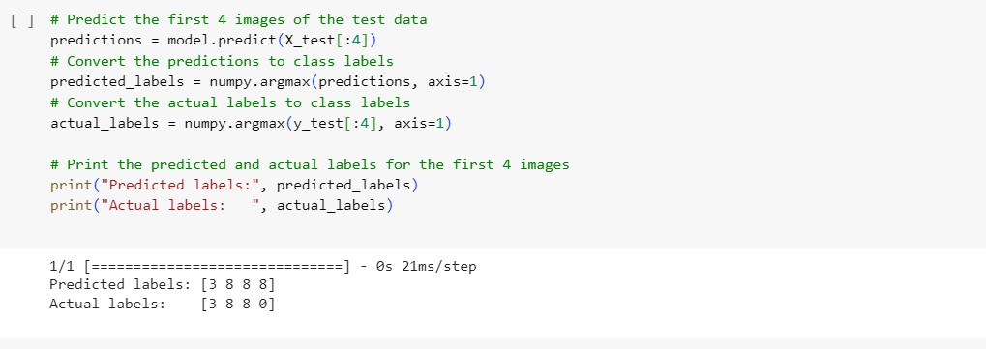

1. Visualize Loss and Accuracy using the history object

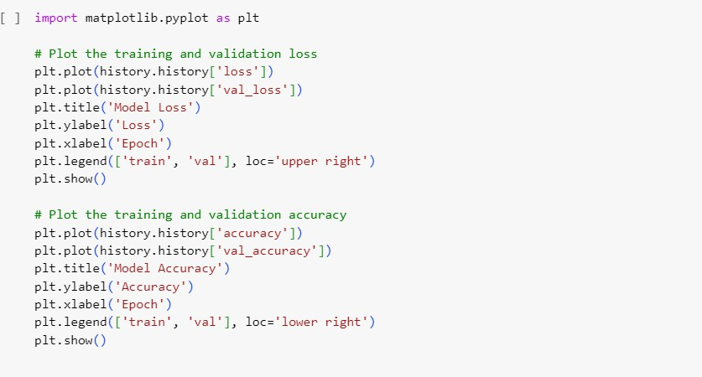

Output:

