DATA 260 - Homework 1
Rental Housing Listings — Akanksha Shukla

Value | Result | Calculation
SID4 | 7838 | Last four digits of student ID
PORT_BASE | 8638 | 8000 + (7838 mod 900)
PREFIX | s7838 | "s" + SID4
SEED | 7838 | SID4
VERIFY_SEED | 267838 | 260000 + SID4
DOMAIN_ID | 6 | 7838 mod 8 (Rental Housing Listings)

Hardware: MacBook Pro, Apple M4 Pro, 48 GB RAM
Local model used (Parts 2-4): qwen2:7b, served through Ollama
Tagged commit hash: hw1 (see repository)

Part 1: HTML, JavaScript, and Deployment

Domain and schema
Assigned domain: Rental Housing Listings (DOMAIN_ID 6). Before writing any HTML,
DOMAIN_SCHEMA.md was created to define the entity's fields: propertyTitle, propertyLocation, submitterEmail, propertyDescription, propertyCategory, and termsAccepted, along with the four category values (Apartment, House, Condo, Townhouse) and the validation rules.

HTML
The page is titled HW1-Akanksha and uses an h1 tag reading "Rental Housing Listing" as the largest heading. The form includes: a required, autofocused text input for the property title (primary field), a required text input for the property location (secondary field), a required email input for the submitter's email, a required textarea for the property description, a dropdown with four categories, a checkbox labeled "I agree to the terms and conditions.", and a submit button labeled "Publish Rental Listing". The script tag is placed at the end of the body.

JavaScript
An arrow function (validateForm) checks that the description is longer than 25 characters and that the terms checkbox is checked, alerting the user if either rule fails. On successful submission the form data is converted to a JSON string with JSON.stringify and logged, then parsed back with JSON.parse. Object destructuring pulls out propertyTitle and submitterEmail and logs them individually. The spread operator copies the parsed object and adds a submissionDate field, and a closure (submissionCounter) keeps a private count that increments and is logged on every successful submission.

Screenshot: form submission (local file)
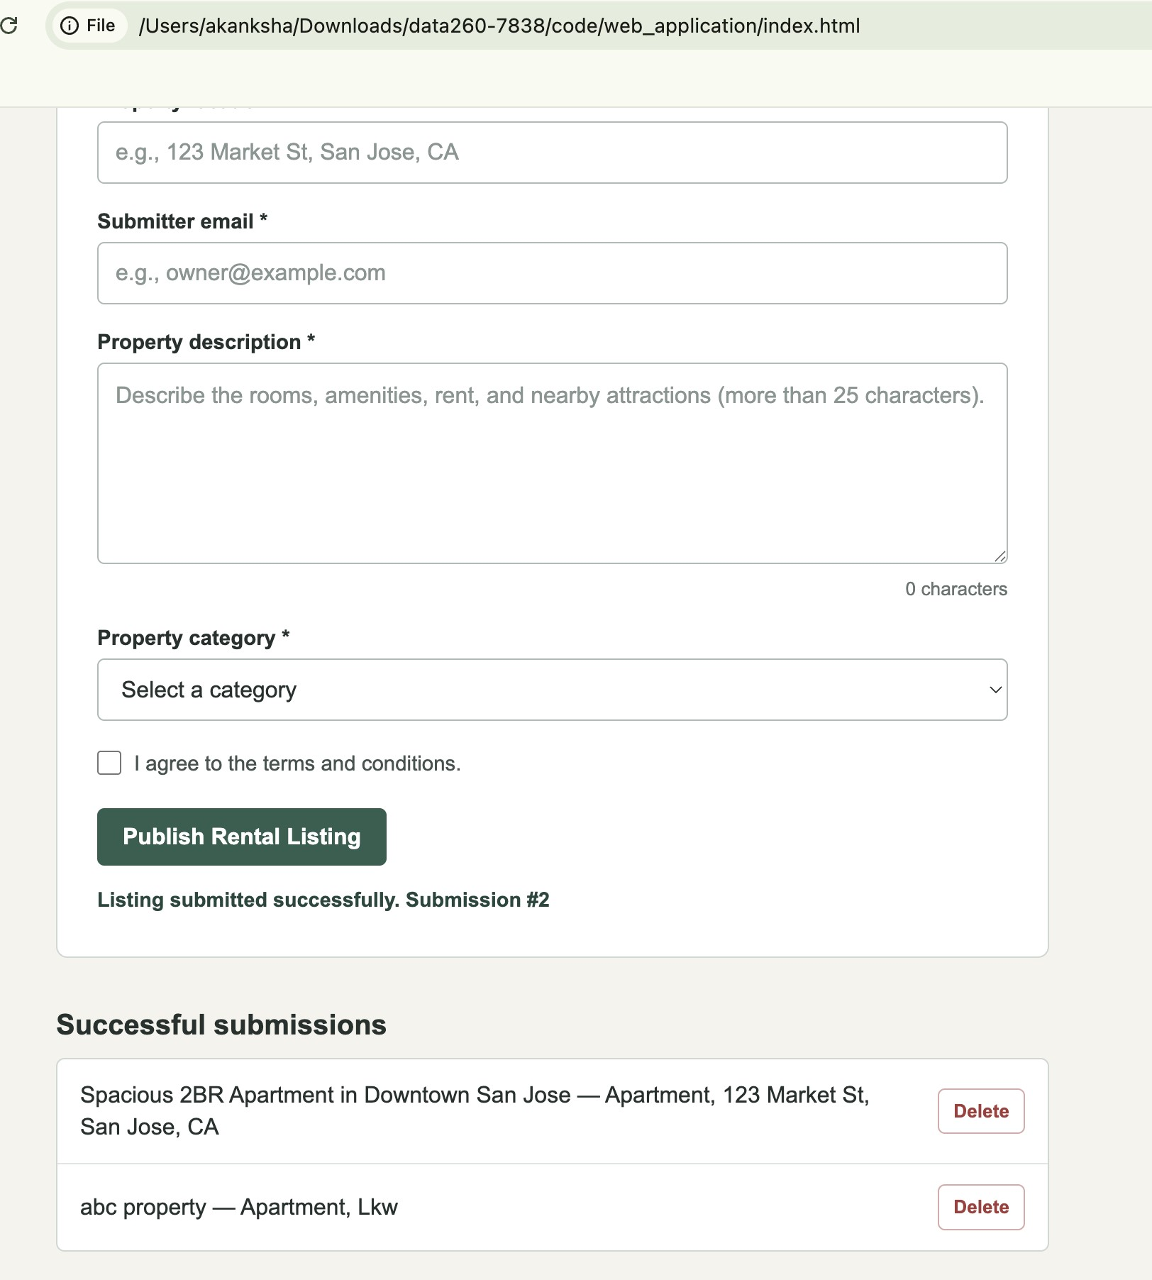
The form accepts input, validates it, and adds the new listing to the Successful submissions list after publishing.

Screenshot: console output for the same submission
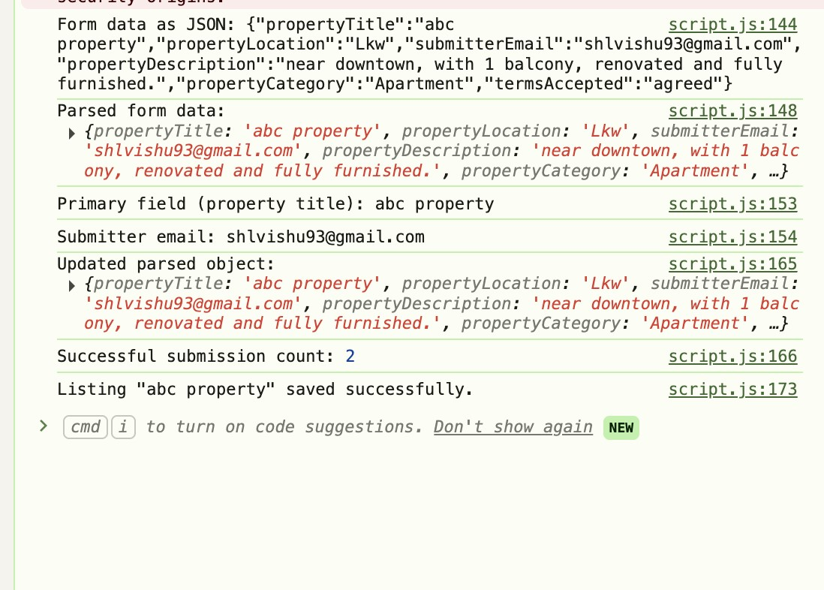
Console shows the JSON string, the parsed object, the destructured title and email, the updated object after the spread operator, and the submission count from the closure.

Docker deployment
The application is built into a Docker image using an Nginx Alpine base image (hw1-rental-listings:1.0) and run as a container named s7838-rental-housing, published on port 8638 (PORT_BASE), matching the calculated configuration value.
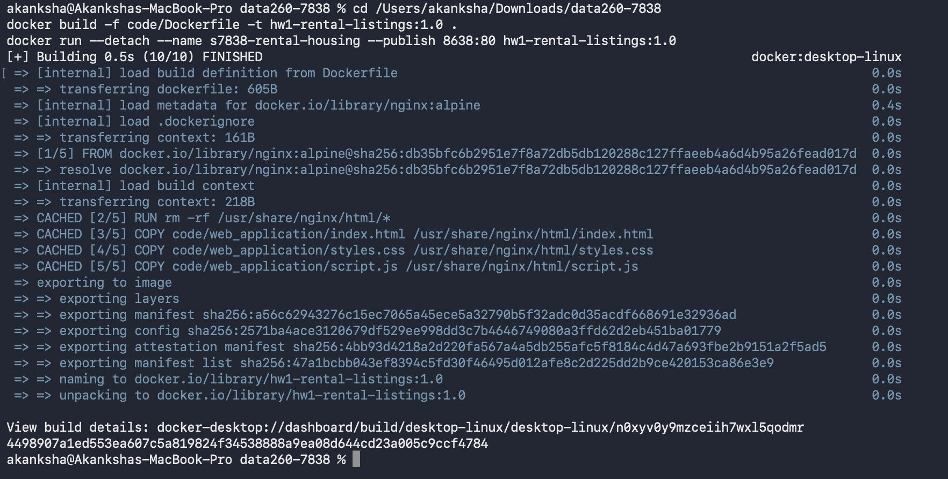
docker build and docker run completing successfully.
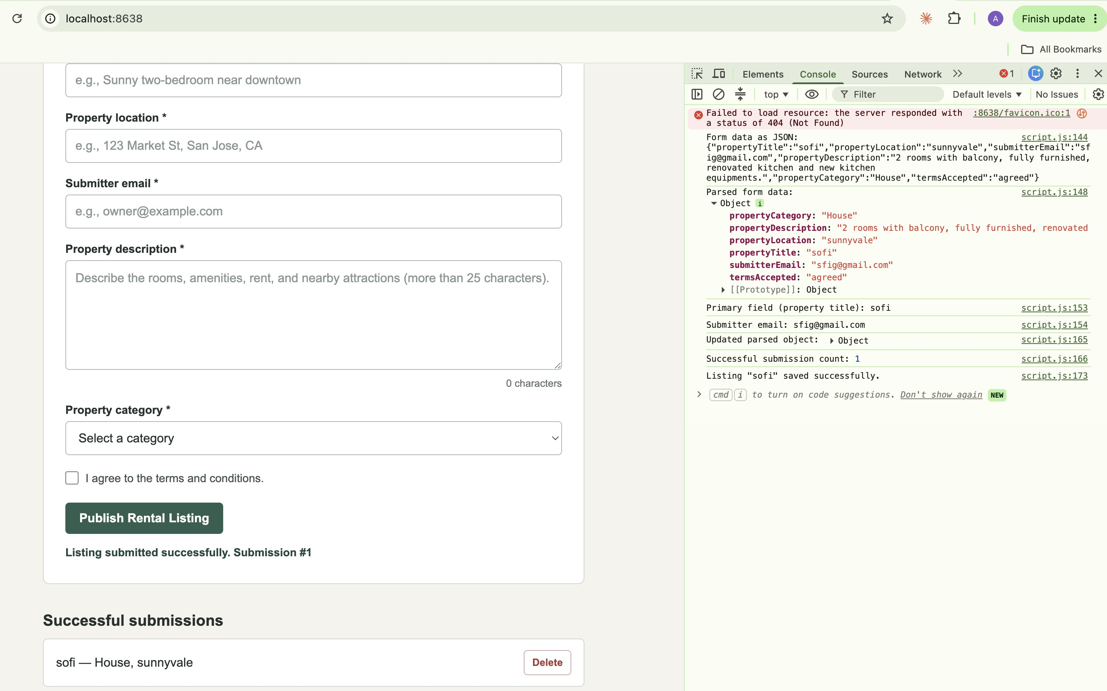
The app running at localhost:8638 inside the container, with the same console behavior verified again.

AWS ECS deployment
The same Docker image was deployed as a single-task AWS ECS service. The screenshot below shows the form loaded and a listing submitted successfully from the task's public IP address (32.192.189.237), confirming the container is reachable outside localhost.
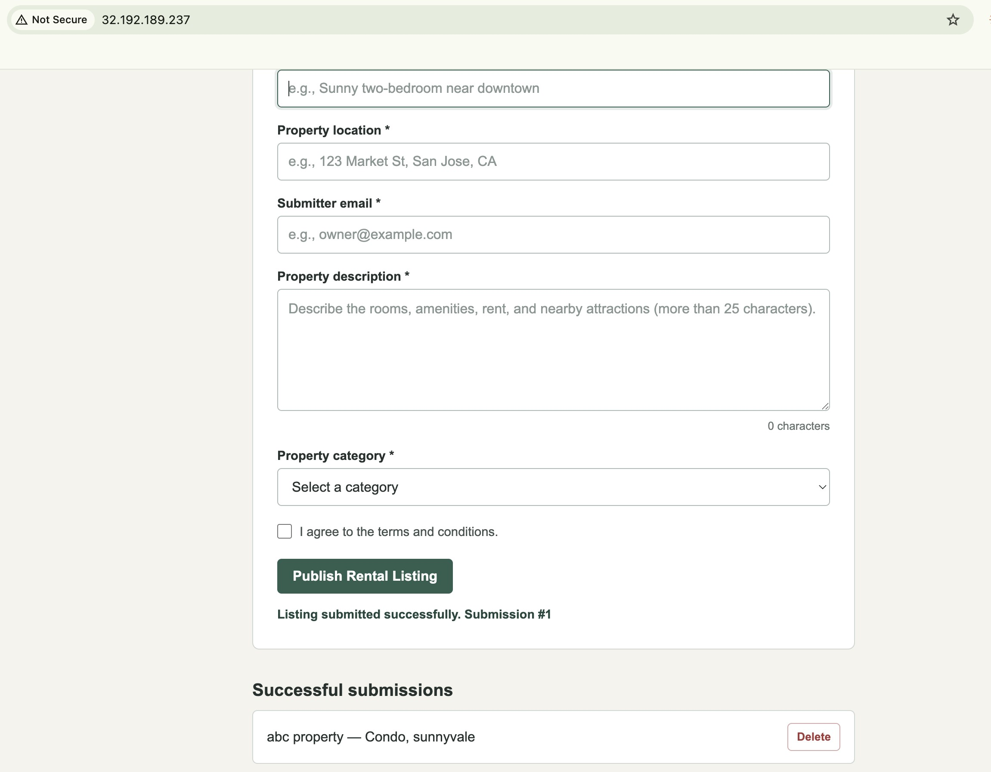
App running at the ECS task's public IP.

Part 2: Agentic AI (Planner, Reviewer, Finalizer)
Command used: python agents_demo.py (run from the code/ directory, with Ollama serving qwen2:7b on localhost:11434).
agents_demo.py sends the input title and content to a Planner agent, which returns 3 tags and a summary as strict JSON (format="json" on the Ollama call). A Reviewer agent then looks at the same title/content plus the Planner's output and either keeps it or improves it, marking changed true or false. A Finalizer step takes whichever output is better (Reviewer's if changed, Planner's otherwise), trims the tag list down to exactly 3, and checks the summary is at most 25 words. Neither prompt references the rental domain by name or by a fixed keyword list; both work only from the title and content passed in, so the same code would work for a different domain's listing.

Input used
Title: "Spacious 2BR Apartment in Downtown San Jose". Content: renovated 2-bedroom apartment, hardwood floors, in-unit washer/dryer, city view balcony, fitness center, rooftop garden, 24/7 security, pet-friendly, move-in special.

Screenshot: Planner output
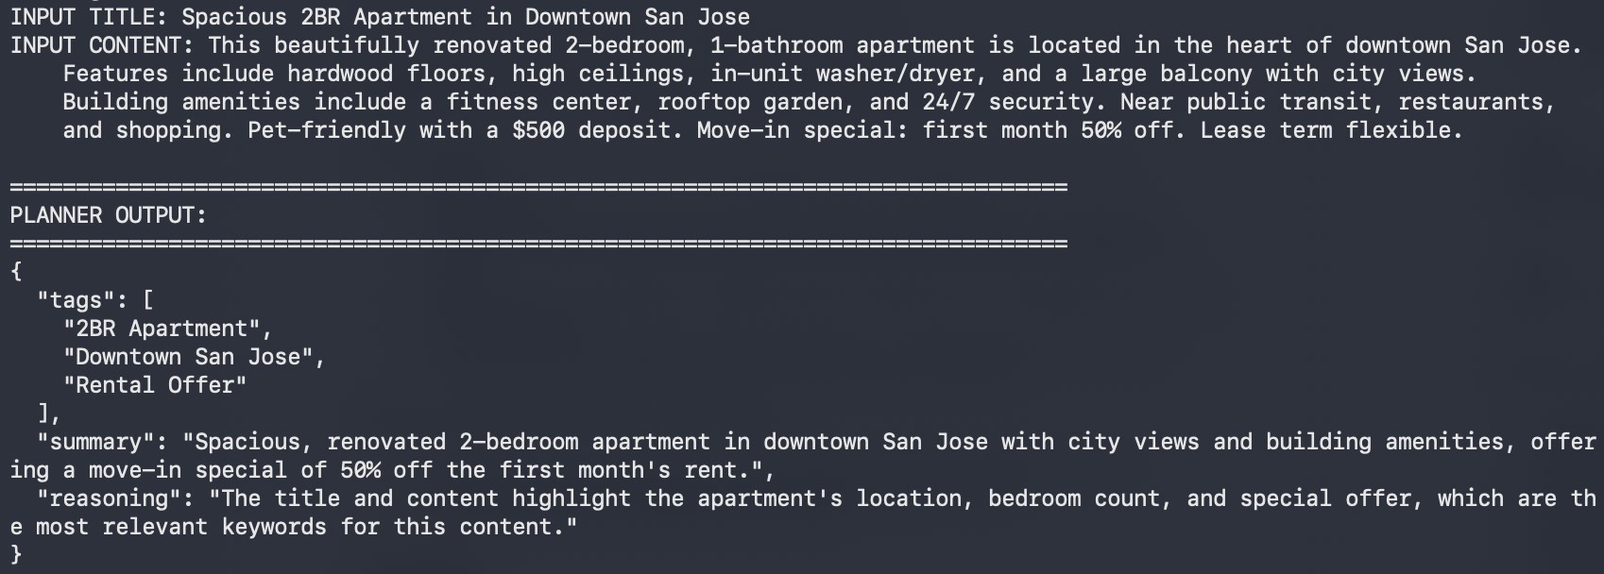

Screenshot: Reviewer output
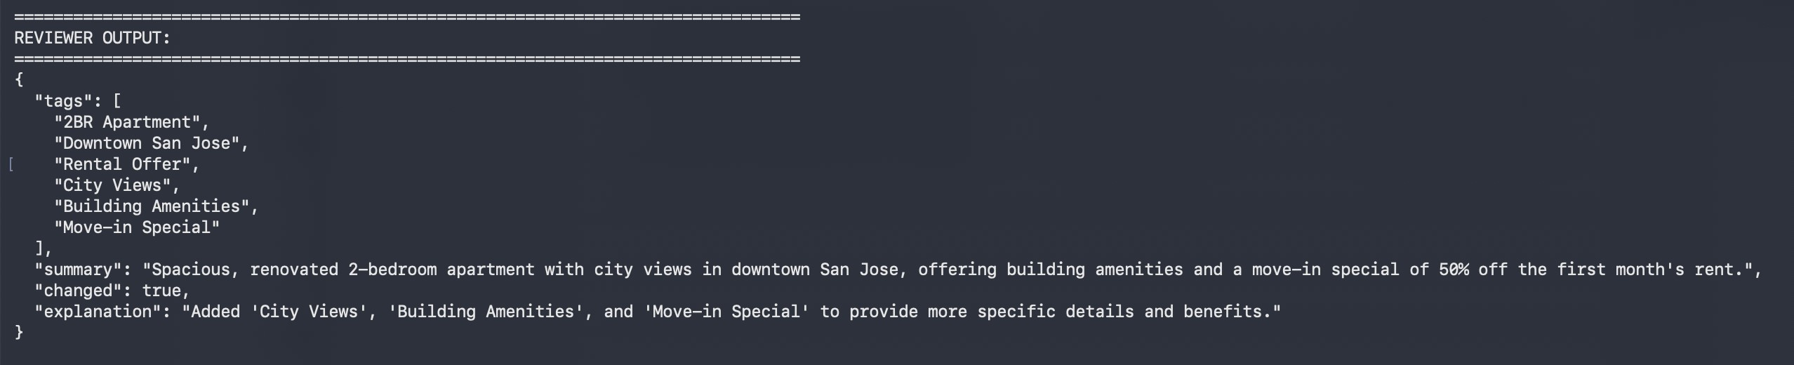

Screenshot: Finalizer step
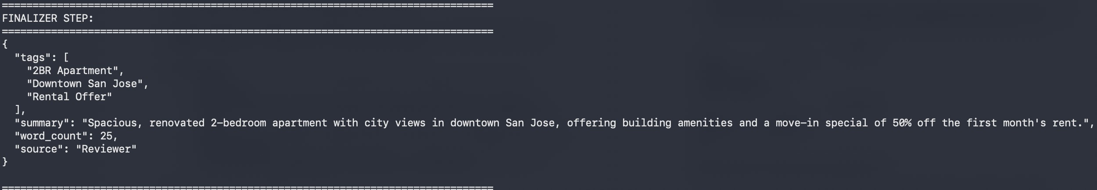

Screenshot: final published JSON
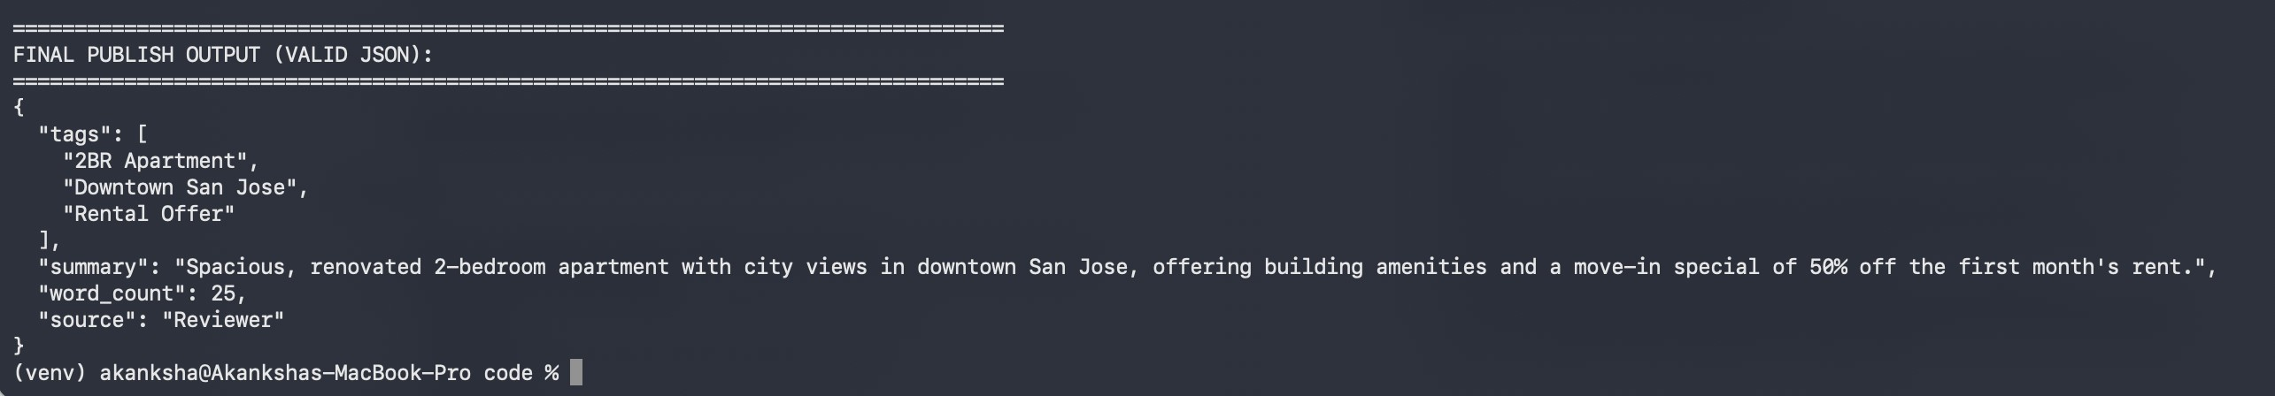
Q1. The 3 final tags obtained
2BR Apartment, Downtown San Jose, Rental Offer

Q2. The final summary (at most 25 words)
"Spacious, renovated 2-bedroom apartment with city views in downtown San Jose, offering building amenities and a move-in special of 50% off the first month's rent."
Q3. Did the Reviewer agent change anything?
Yes. The Reviewer kept the Planner's original 3 tags but added City Views, Building Amenities, and Move-in Special, and marked changed: true with the explanation "Added 'City Views', 'Building Amenities', and 'Move-in Special' to provide more specific details and benefits." The Finalizer then cut the Reviewer's 6 tags back down to the required 3.

Part 3: Measuring Non-Determinism
The same agents_demo.py pipeline was run 40 times on one fixed input (saved unchanged as reports/hw01/cases/nondeterminism_input.json): 20 runs at temperature 0.7 and 20 runs at temperature 0.0. agents_demo.py was extended to accept an input file path and a temperature as command-line arguments, so the exact same pipeline code used in Part 2 produced every run.

Command used
python run_nondeterminism_tests.py, which calls python agents_demo.py reports/hw01/cases/nondeterminism_input.json <temperature> forty times and saves every result to reports/hw01/raw/nondeterminism_results.json. Then python analyze_nondeterminism.py computes the statistics below and writes reports/hw01/METRICS.md.

Screenshot: start of the 40-run test
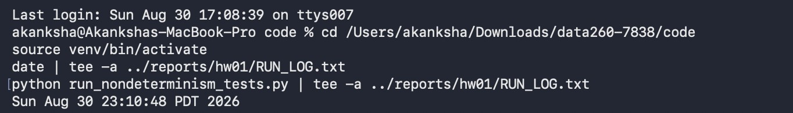

Screenshot: all 40 runs completing

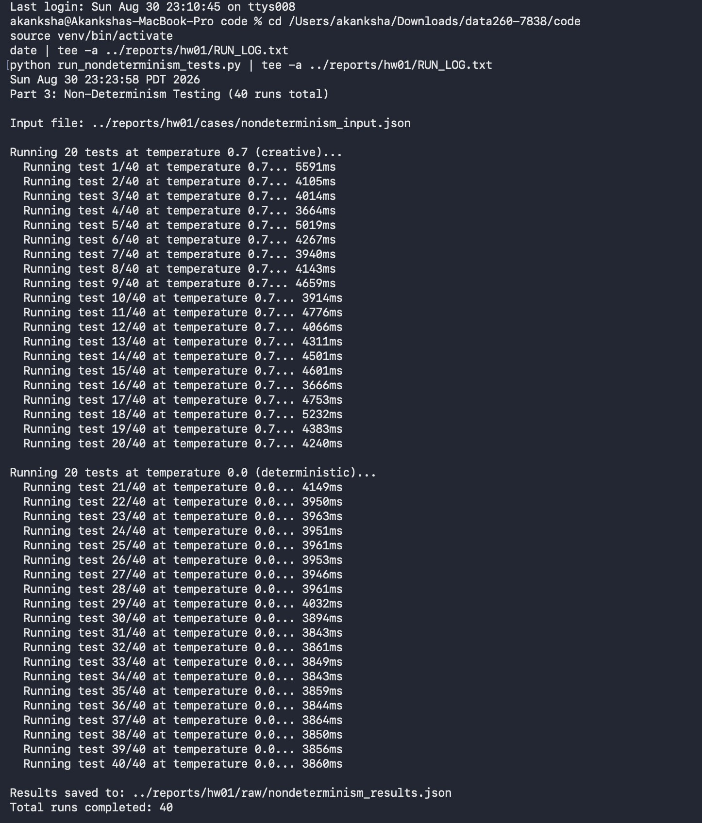

Screenshot: analysis step and generated METRICS.md
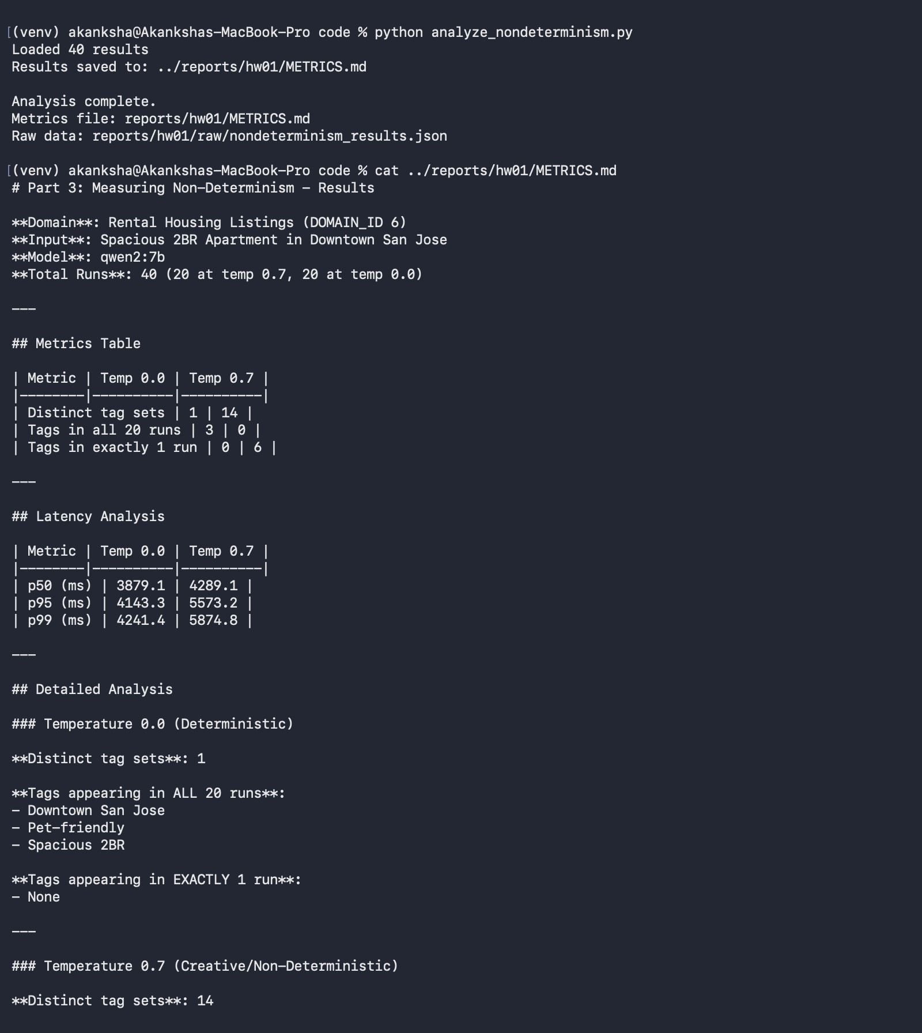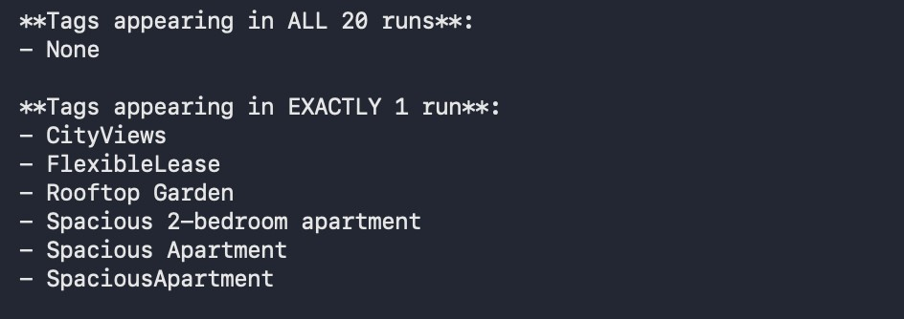

Results
Metric | Temp 0.0 | Temp 0.7
Distinct tag sets | 1 | 14
Tags in all 20 runs | 3 | 0
Tags in exactly 1 run | 0 | 6
Metric | Temp 0.0 | Temp 0.7
p50 (ms) | 3879.1 | 4289.1
p95 (ms) | 4143.3 | 5573.2
p99 (ms) | 4241.4 | 5874.8
At temp 0.0, all 20 runs produced the identical tag set (Downtown San Jose, Pet-friendly, Spacious 2BR) fully reproducible. At temp 0.7, only 14 of 20 runs shared a tag set, and 6 tags (CityViews, FlexibleLease, Rooftop Garden, and three variants of "Spacious apartment") each appeared in only one run.

What two users sending identical input might see
At temperature 0.7, two real runs on the identical input produced: ['SpaciousApartment', 'CityViews', 'FlexibleLease'] versus ['Spacious 2BR Apartment', 'Downtown San Jose', 'Pet-friendly']. Both describe the same listing, but with different word choices and different aspects emphasized, because temperature above 0 makes the model sample among likely next words instead of always choosing the single most probable one. At temperature 0.0, both users get the identical tag set every time, since the model always picks the most probable token and there is no randomness left to vary the output.

Example where variation is acceptable
Browsing/search tagging, like this exact use case. If one user's results show "Pet-friendly" and another's show "Animal-Friendly," it does not change their decision to view the listing - the meaning is preserved even if the wording differs.

Example where variation is NOT acceptable
Calculating a number, such as monthly rent after a stated percentage increase. The answer must be identical every time it is computed from the same inputs, so temperature 0.0 is required; any variation would be a bug, not a feature.

Part 4: Model Client and Token Accounting
src/model_client.py defines ModelClient with a stable complete(messages, tools=None) interface; every model call in the demo goes through this method. hw1_client.py is an interactive command-line demo that imports the adapter: the user types messages, and the adapter tracks input/output/total tokens per turn plus cumulative totals across the session. Typing /stats prints turn count, cumulative token counts, and the length of the serialized (JSON) conversation history, without calling the model or altering that history.

Code review against AGENT.md
AGENT.md asks for a strict, bullet-only review of src/model_client.py and hw1_client.py covering correctness, token tracking, design quality, and error handling. Running that review surfaced a real bug: complete() was appending the incoming messages list onto self.conversation_history on every call, but the caller also reconstructs the full history each turn and passes it back in - so history (and therefore input token counts) was roughly doubling every turn instead of growing linearly. It was fixed so complete() replaces history with exactly what was sent plus the new reply. A second issue - hw1_client.py's `from src.model_client import ModelClient` failed with ModuleNotFoundError when run normally, since src/ was not on the import path - fixed by inserting the repo root into sys.path. A third issue conversation_history_length summed raw message text instead of a serialized length - fixed to measure len(json.dumps(...)) of the history instead.

Command used
python hw1_client.py (run from the code/ directory, with Ollama serving qwen2:7b). The conversation covered the Rental Housing Listings domain: what to include in a listing description, amenities that stand out, fixed-term vs. month-to-month leases, factors affecting rent, and red flags to watch for in a listing. /stats was invoked after turn 3 and after turn 5.

Screenshot: /stats after turn 3
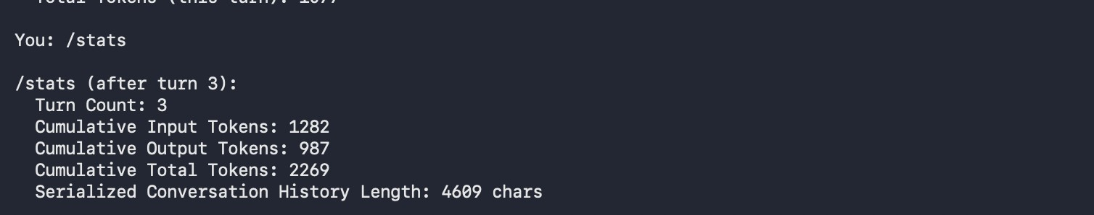

Screenshot: /stats after turn 5
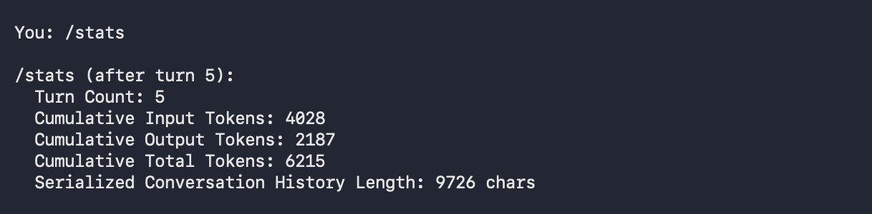

Screenshot: final cumulative summary on exit
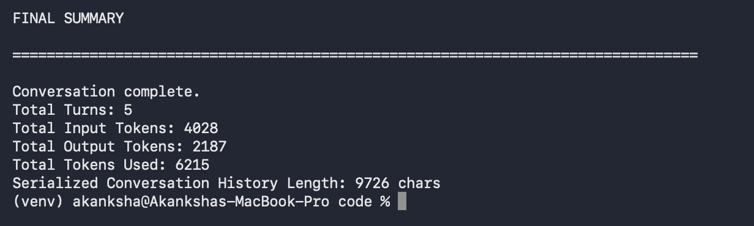

Results
Checkpoint | Turn Count | Cum. Input | Cum. Output | Cum. Total | History (chars)
After turn 3 | 3 | 1282 | 987 | 2269 | 4609
After turn 5 / exit | 5 | 4028 | 2187 | 6215 | 9726

Per-turn input tokens grew across the conversation (56, 462, 764, 1094, 1652 for turns 1-5), confirming linear growth from resending history each turn rather than the exponential growth that the pre-fix duplication bug would have produced.

Understanding Tokens and Context
Why is prior conversation context resent with every turn?
The model itself is stateless. It has no memory between separate API/invoke calls. The only way it can respond consistently with earlier turns is if the caller resends the full prior conversation (system prompt, all previous user messages, and all previous assistant replies) alongside the new message every single time.
How is a system prompt different from a user message?
A system prompt sets the assistant's behavior and rules ("be concise, answer directly") and is written by the application, not the end user. A user message is the actual question or request from the person using the app. Both count as input tokens and both get resent every turn, but a system prompt is an instruction to the model while a user message is data for the model to respond to.
Why do input tokens grow over a conversation?
Because each turn's input is the system prompt plus every prior user and assistant message plus the new user message. Nothing already sent is ever removed, so the input keeps growing turn over turn. This run measured it directly: input tokens per turn were 56, 462, 764, 1094, then 1652 for turns 1 through 5 climbing every turn because turn N's input contains all of turns 1 through N-1.
What eventually limits that growth?
The model's context window is the hard limit - qwen2:7b can only accept a fixed maximum number of tokens per call, and once the resent history plus the new message exceeds that, older turns would have to be dropped or summarized. Before hitting that hard limit, cost and latency are practical limits: more tokens sent per turn means slower responses and, on paid APIs, higher cost per turn, which is why production systems often truncate, summarize, or cap history length rather than resending an ever-growing transcript indefinitely.

