Capstone Project


Retail Store Project (walmart)

By

AKANKSHA SINGH

Table of Contents
- Problem Statement
- Project Objective
- Data Description
- Data Pre-processing Steps
- Choosing the Algorithm for the Project

- Motivation and Reasons For Choosing the Algorithm
- Training with SARIMAX model
- Forecasting
- Conclusion
- References

1. Problem Statement

A retail store that has multiple outlets across the country are facing issues in managing the inventory - to match the demand with respect to supply.

2. Project Objective

With the help of weekly sales data for various outlets of Wallmart and by using the statistical analysis, EDA, outlier analysis, various insights that can give them a clear perspective on the following are to be explored:

a. If the weekly sales are affected by the unemployment rate, if yes - which stores are suffering the most?
b. If the weekly sales show a seasonal trend, when and what could be the reason?
c. Does temperature affect the weekly sales in any manner?

d. How is the Consumer Price index affecting the weekly sales of various stores? e. Top performing stores according to the historical data.

f. The worst performing store, and how significant is the difference between the highest and lowest performing stores.

By using predictive modelling techniques sales forecast is to be generated for each store for the next 12 Weeks.

3. Data Description:

The walmart.csv data file contains 6435 rows and 8 columns with Features Name and Description as shown below.
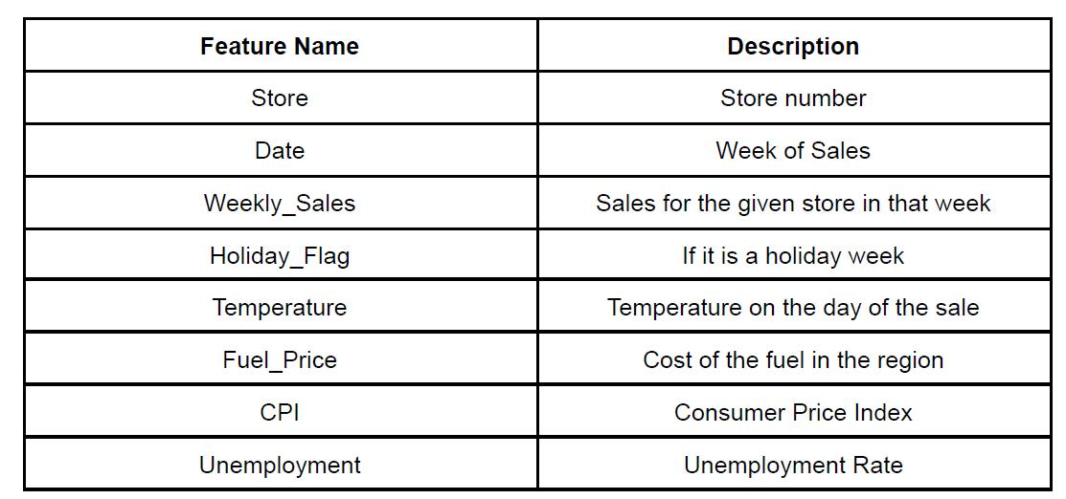

The data set is loaded in Jupiter and details such as features and shape of the data set is checked.
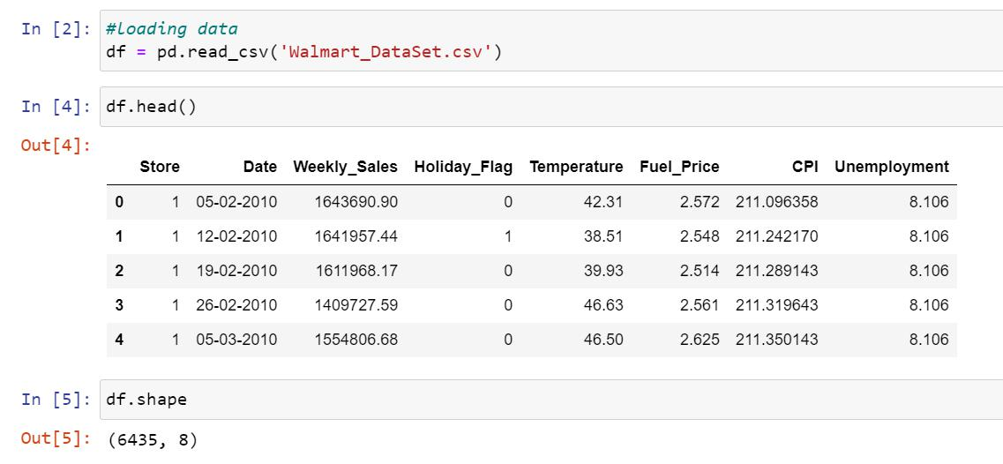

The data set is checked for null and duplicated values
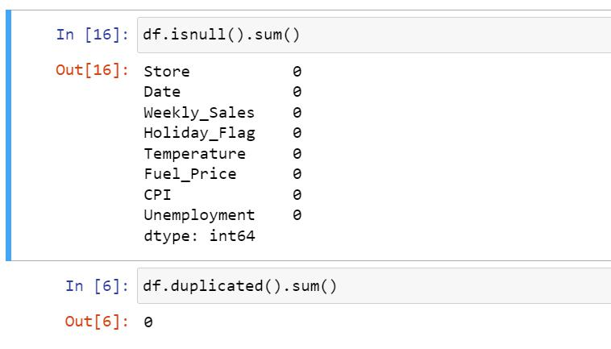

Information regarding data type for each feature is also acquired
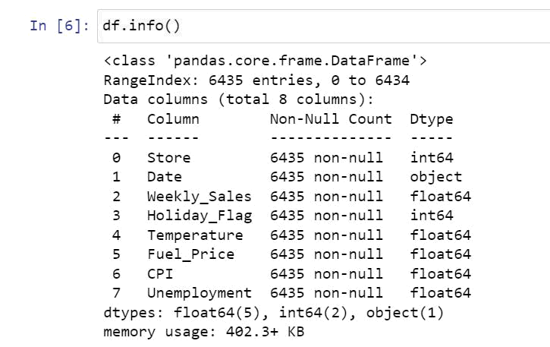

The df.describe() function was used to study the minimum and max values for all the features
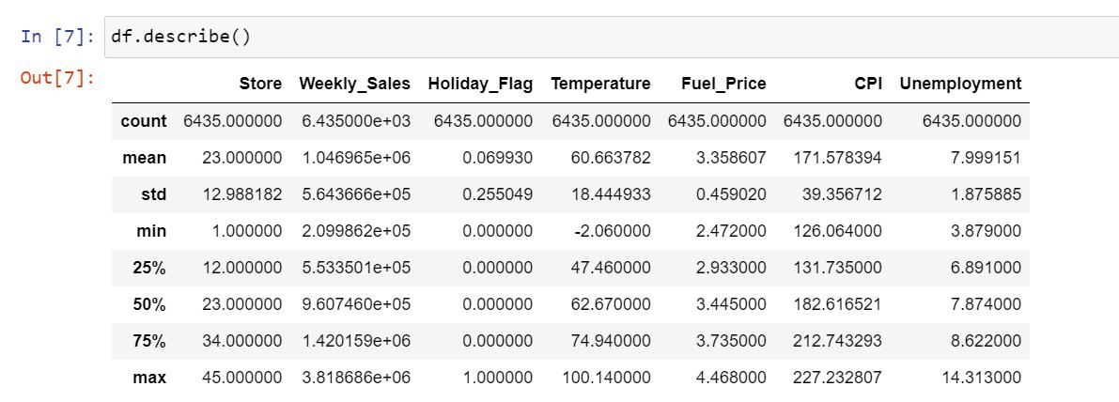

4. Data Pre-Processing

The datatype of date was an ‘object’ and was changed to ‘Date’ type using the below code.

- Date column to datetime df['Date']=pd.to_datetime(df['Date'])

The data will be analyzed to check the following-

- If the weekly sales are affected by the unemployment rate, if yes - which stores are suffering the most?
- If the weekly sales show a seasonal trend, when and what could be the reason?
- Does temperature affect the weekly sales in any manner?
- How is the Consumer Price index affecting the weekly sales of various stores?
- Top performing stores according to the historical data.

- The worst performing store, and how significant is the difference between the highest and lowest performing stores.

If the weekly sales are affected by the unemployment rate, if yes - which stores are suffering the most?

To check the impact of unemployment over weekly sales, a scatter plot was drawn as shown below-
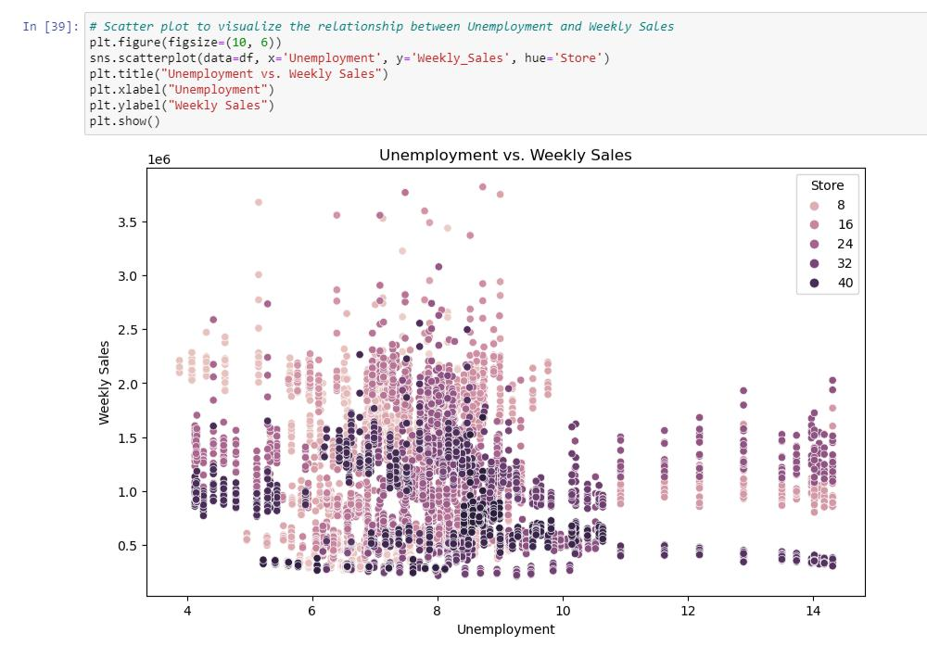

The above plot clearly shows that there is no much impact of unemployment rate on weekly sales.
Similarly scatter plot was drawn to study the impact of temperature on weekly sales.
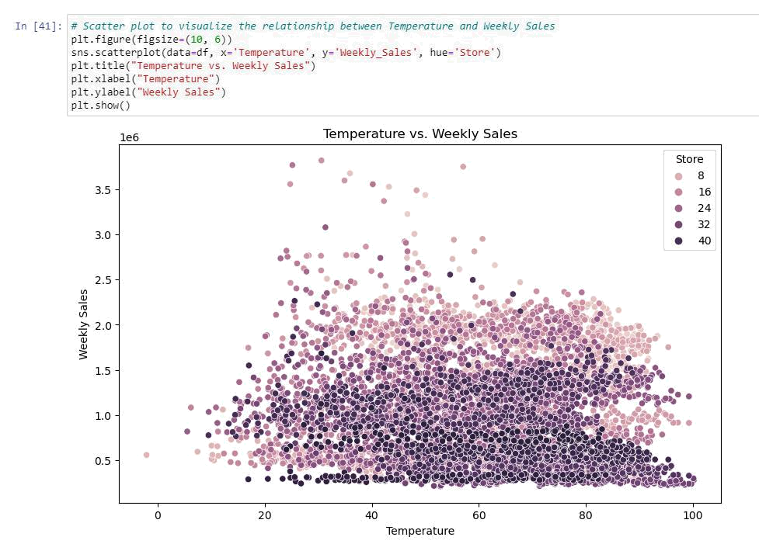

The plot above shows that the weekly sales is uniformly distributed for the entire temperature between 20 to 90 degree F. hence we can conclude that temperature had no effect on sales.

The below code plots the scatter plot to show the impact of CPI over weekly sales.
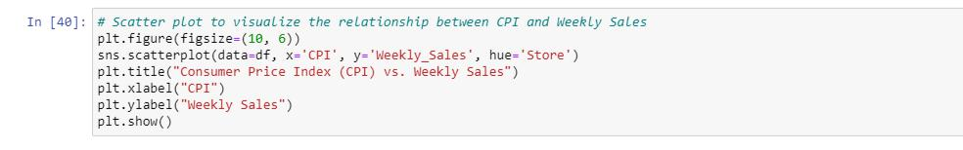

It can be seen from the below scatter plot that CPI and negligible impact on weekly sales.
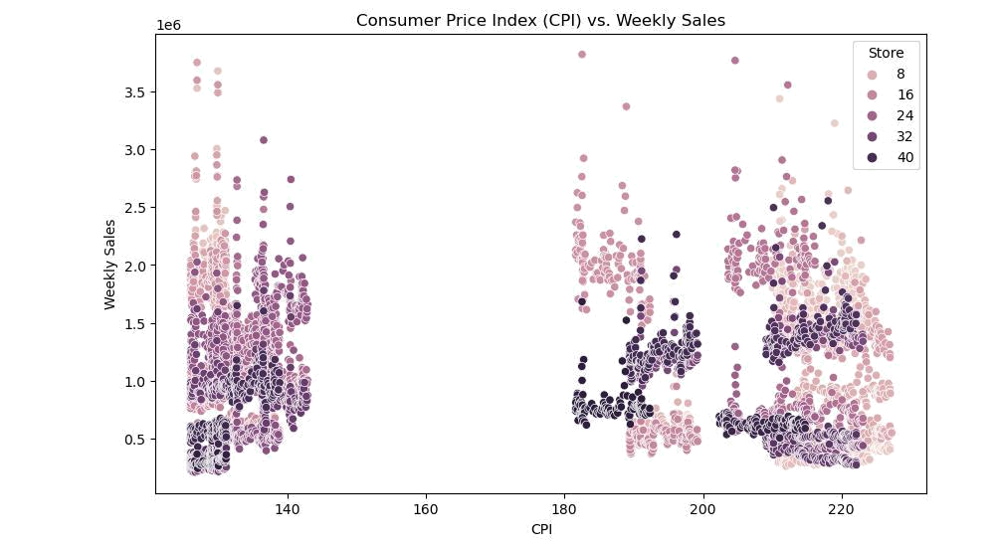

The correlation for Weekly sales with respect to other factors was studied using the heat map below.
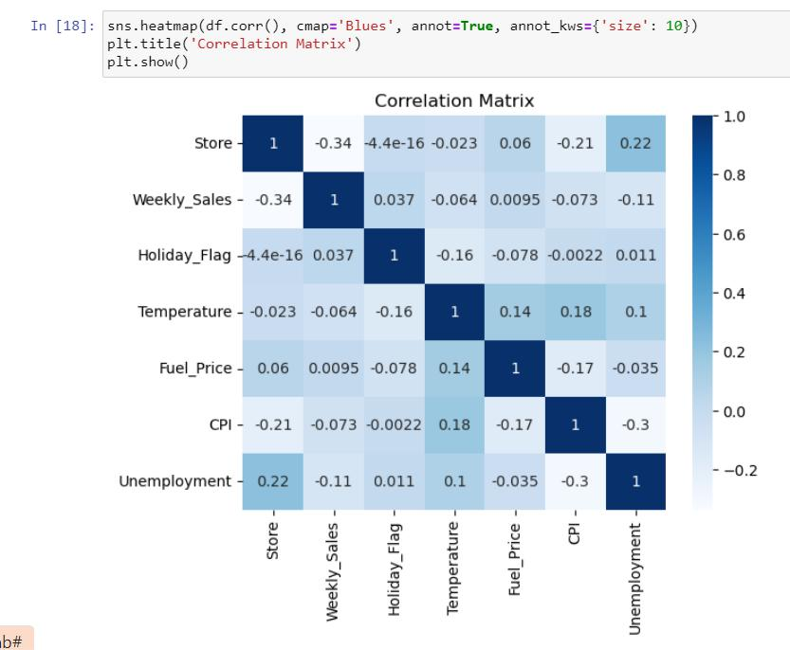

The table below specifically gives the correlation values with respect to Weekly sales and the result shows that factors like Temperature, Unemployment and CPI have very less correlation with the weekly sales
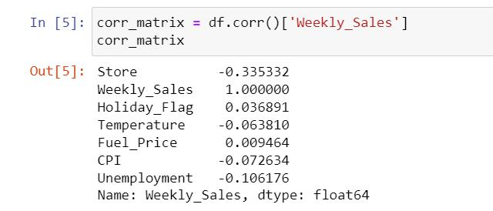

Seasonal Trend

To study the seasonal trend, the date format is split into date, month and year and additional column by name ‘week’ is created
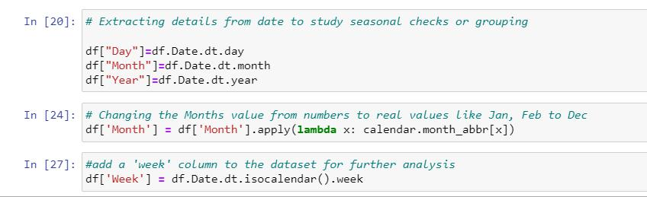

We can now plot the overall sales with respect to weeks for all the three years from 2010 to 2012.
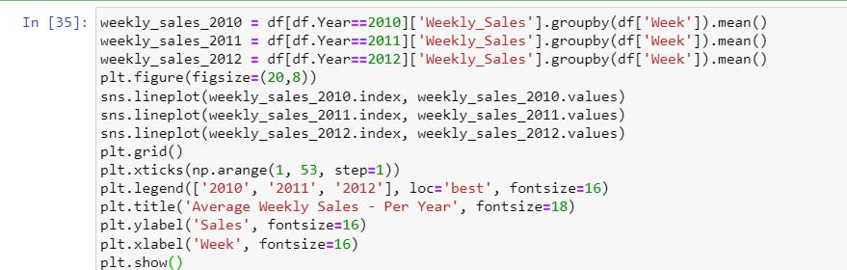
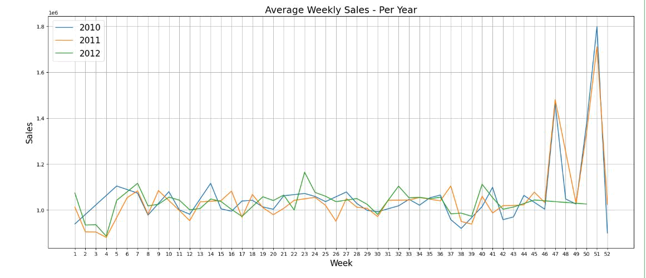

The above plot shows every year the sales go up during week 47 and week 51.

Stores Performance

Performance of stores was studied with the help of weekly sales data and best performing and worst performing stores were identified. The difference between the sales of best performing and worst performing stores was also calculated.

The total sales for all the stores were tabulated using ‘group by’ function
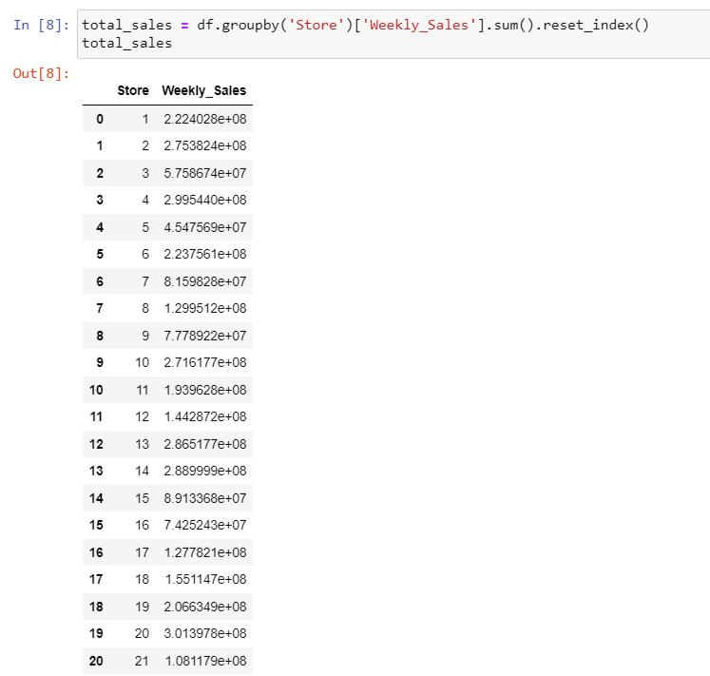
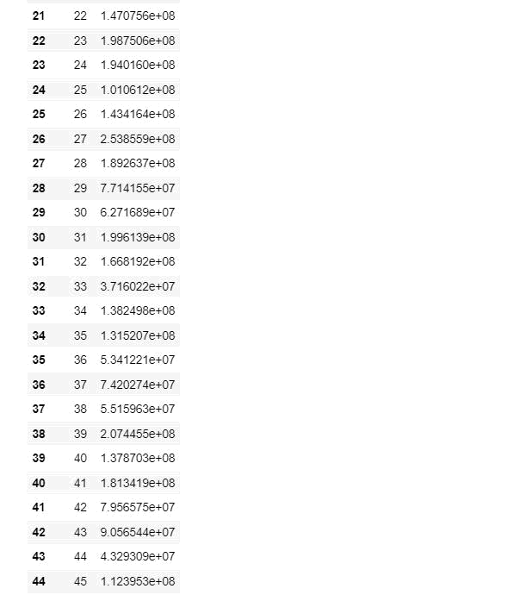

The below analysis shows that store no. 22 is the best performing store with total sales of 301397800 USD and store no. 33 has the lowest sales of 37160221 USD
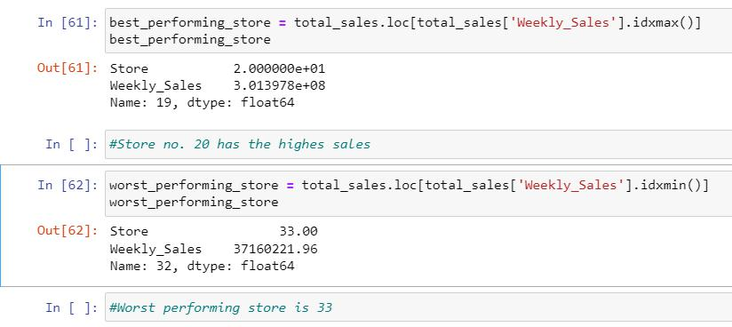

The difference in total sales between the best performing and the worst performing stores is 264237570.5 USD

The below bar plot shows the performance of each store by considering the average sales for three years.
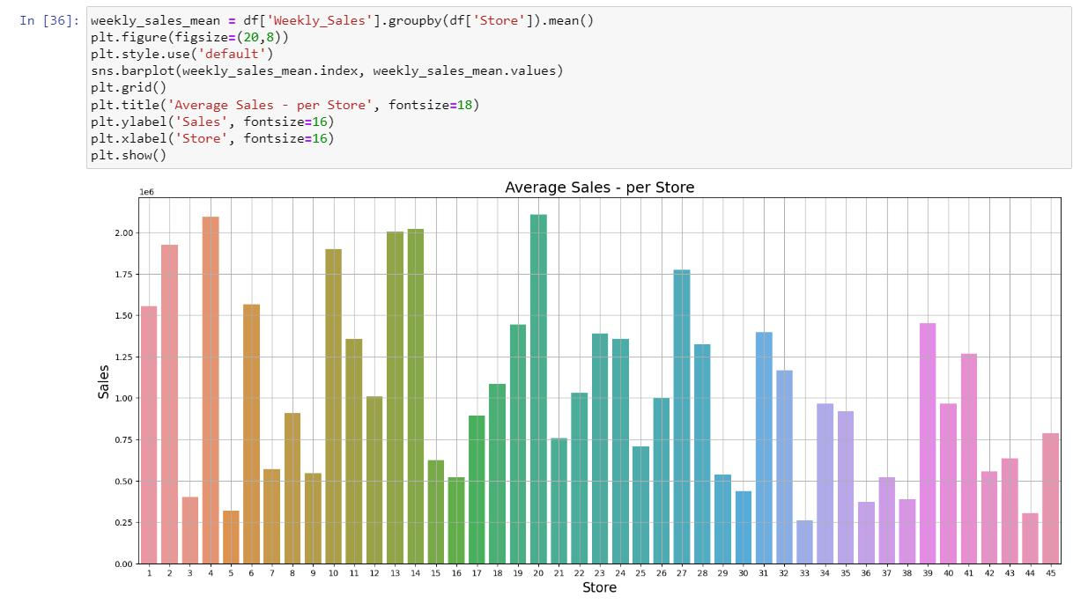

Stage 2:

Well, now all the data preprocessing part is done and one can easily go for the model building phase to build a machine learning model for Walmart’s sales forecasting for next 12 weeks.

- Choosing the algorithm for the project

Several models can be considered for making sales predictions viz. Decision trees, Regression, Time series etc.

Decision trees

Decision trees are a machine learning technique used to make predictions by analyzing data. The technique involves creating a tree-like model to represent the decisions and relationships between variables, such as Unemployment, CPI, Temperature etc.

In the context of sales forecasting, decision trees can be used to make predictions about future sales by considering multiple factors that impact sales. The decision tree model can be trained on historical sales data and relevant variables to identify patterns and trends that impact sales.

Regression

Regression analysis is a machine learning technique used to understand the relationship between different variables. In the context of sales forecasting, it can be used to understand how changes in one variable, such as unemployment, impact sales.

Regression analysis involves fitting a statistical model to historical data to identify the relationship between the variables. The model is then used to make predictions about future sales based on changes in the independent variable, such as Unemployment, CPI, Temperature etc.

Time-series analysis

Time-series analysis is a popular machine-learning technique for sales forecasting. It involves analyzing data collected over time, such as sales data, and modeling historical trends and patterns to make predictions about the future.

Time-series analysis is useful for predicting sales because it takes into account historical patterns and trends, such as seasonality and long-term trends, to make accurate predictions.

The technique can also identify anomalies or unexpected events that may impact future sales, allowing businesses to make necessary adjustments to their strategy.

In our current dataset, since we don’t see any much impact of variables such as Unemployment, CPI, Temperature etc. over sales, Time series analysis seems to be the best model for making predictions.

6. Motivation and Reasons for Choosing the Algorithms

ARIMA, short for “Auto-Regressive Integrated Moving Average,” is a powerful statistical modelling technique for time series analysis. It’s particularly effective when the time series we are analyzing follows a clear pattern, like seasonal changes in sales.

The first step in the ARIMA modeling approach is determining whether a time series is stationary. There are various tests to determine the stationary of a time series, such as Kwiatkowski–Phillips–Schmidt–Shin, Augmented Dickey-Fuller, or Phillips–Perron. These tests systematically check a time series and measure the results against the null hypothesis, providing an indicator of the trustworthiness of the results.

We have taken Store No.1 for further analysis. A new data frame by name store1 is created with week as index and Weekly Sales indicate the average weekly sales for 3 years.
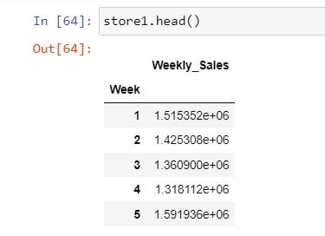

We have tested the stationarity by Augmented Dickey-Fuller method using the below code and the P value was found to be 0.71 which clearly shows the data is not stationary.

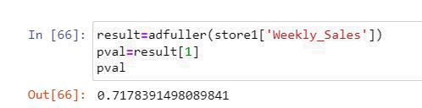

Even though no trend is seen, we can see some seasonality during Nov -Dec months in the data. Using the shift method and window size of 52, seasonality is being removed
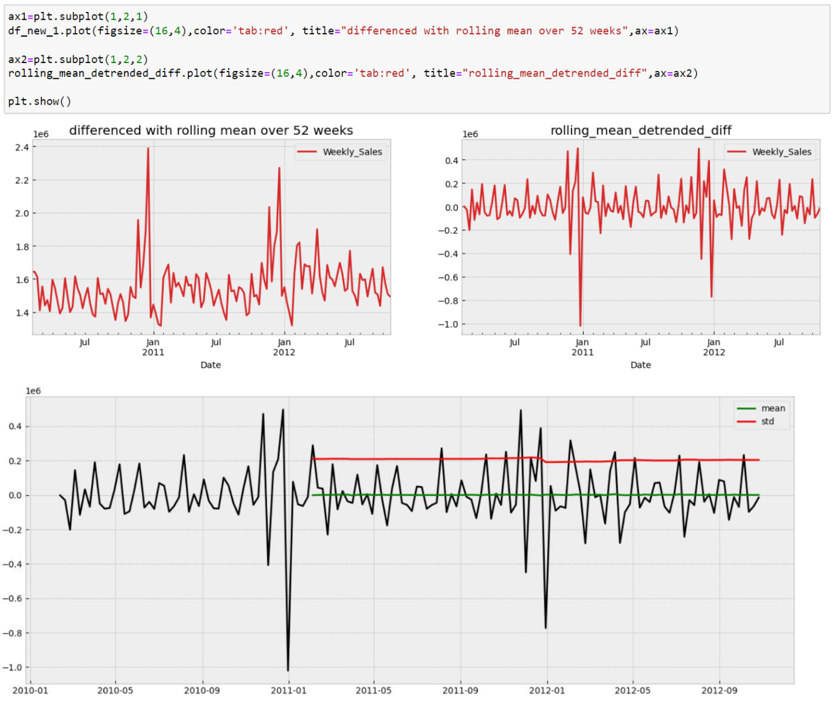

By looking into the mean and std deviation, it looks like the data set is now stationary. The summary after implementing ARIMA model is shown below
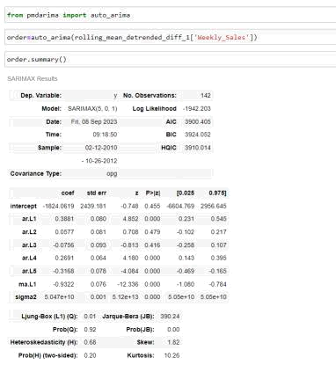

From the above summary chart, we can find that our model may well perform with the SARIMAX value of (5,0,1). This can be confirmed using ACF and PACF graphs as shown below.
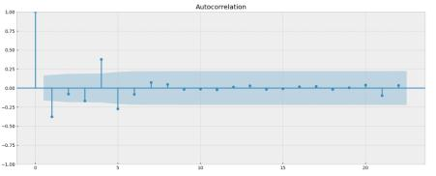
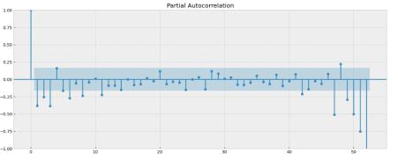

From the ACF and PACF graph, we can interpret that the AR value from the PACF graph has 6 major spikes and the MA value from the ACF graph is 1 as the mean difference occurs at point 2, so we can take either point value as 1 or 3, so from the ACF and PACF graph the SARIMAX value tends to be (6,0,1). This SARIMAX value is considered for our model building

7. Training with SARIMAX Model

A window size of 52 is considered for this model.
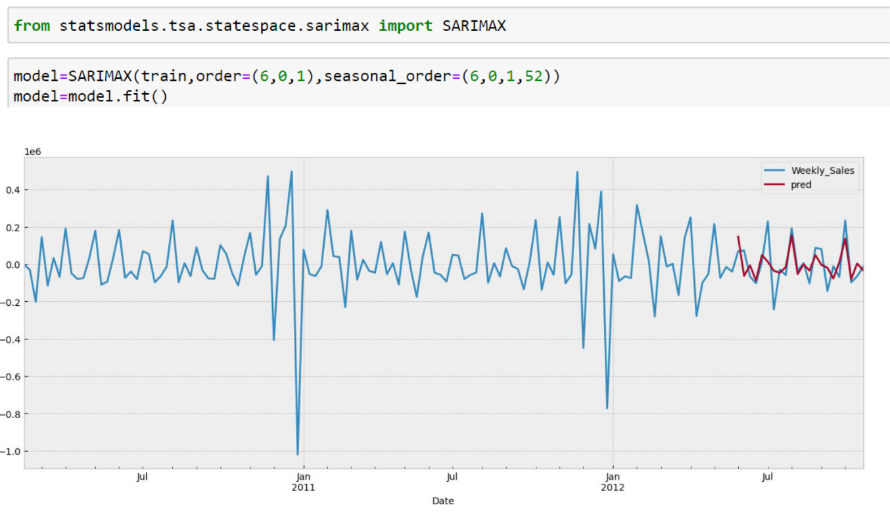

It can be seen that the predicted model closely matches with the actual value.
8. Forecasting

The below graph gives forecasting for coming 52 weeks
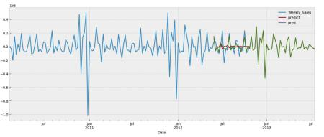

9. Conclusion

Since the data provided is the sales data of a retails store and future sales has to be predicted based on the previous sales history, Time series Analysis seems to be the right method for forecasting future sales. Also by implementing ARIMA model and training the model by SARIMAX we could find close match between the predicted value and the actual value. Hence by implementing this model forecast for the next 52 weeks was made.

10. References

- Intellipaat Study materials & Hands on session
- Time Series Forecasting with ARIMA, SARIMA, and SARIMAX by Brendan Artley
- A Brief Introduction to ARIMA and SARIMAX Modeling in Python

